Aquatic Baseline Monitoring of Select Streams within the Sheboygan River
Area of Concern

John Masterson and Travis Motl
Wisconsin Department of Natural Resources
Plymouth Service Center

March 2013

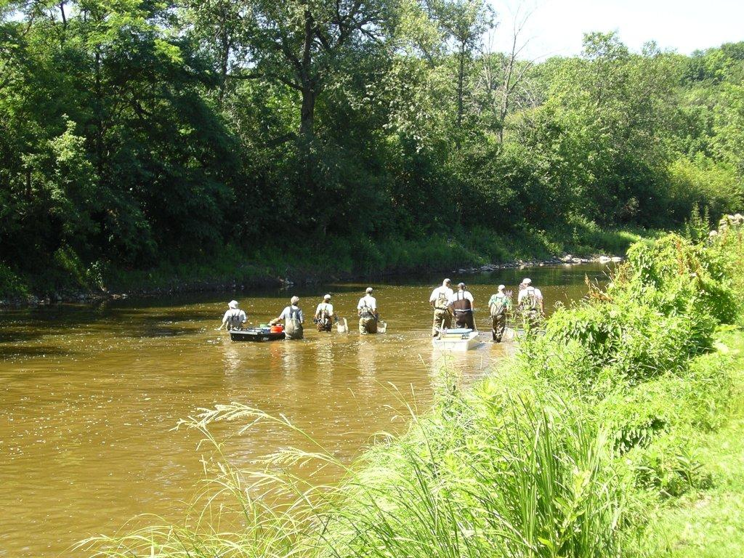

TABLE OF CONTENTS

Abstract 3
Introduction 3
Materials and Methods 4
Results and Discussion 8
References 22

Figures

Figure 1 Sample site locations for fish, benthic macroinvertebrates, stream habitat, and aquatic macrophyte surveys.

Figure 2 Length frequency of smallmouth bass from 2011 surveys broken down by survey reach.
Figure 3 Length frequency of smallmouth bass from 2011 Onion River surveys at Ourtown Road.
Figure 4 Aquatic plant survey sample locations, using point-intercept method, for Wildwood Island Area on the Sheboygan River, Sheboygan, Wisconsin.
Figure 5 Aerial photos and locations for Sheboygan River sites SR 02 (top) and SR 03 (bottom).

Tables

Table 1 Site locations and information for Sheboygan River AOC monitoring stations, Sheboygan County, Wisconsin. SR 03 is small wetland and had aquatic plant survey only.

Table 2 Fish community and benthic macroinvertebrate index of biotic integrities (IBIs), and stream habitat ratings for Sheboygan River AOC and tributaries. * indicates cold water IBI, ** indicates cool water IBI.

Table 3 Individual fish species and classifications (Origin/Tolerance/Temperature) from all sample sites. (N=Native, I=Introduced/I=Intolerant, IM=Intermediate Tolerance, T=Tolerant/W=Warmwater, T=Cold-Warm Transitional).
Table 4 Benthic macroinvertebrate assemblage information from one-time surveys conducted in November 2011 at 19 stream sites within the Sheboygan River AOC. * indicates samples that were collected in 2009 or ** for 2010. SR 01 is a nonwadable site.

Table 5 Stream habitat scores and ratings for sites that are < 10 meters wide. * site surveyed in 2009.

Table 6 Stream habitat score for sites that are > 10 meters wide. * site surveyed in 2009. ** site surveyed in 2010.

Table 7 Summary of aquatic plant survey data for site SR 02 on the Sheboygan River. Sample points within upland areas were not included in survey.
ABSTRACT

Aquatic surveys of the Sheboygan River Area of Concern (AOC), as well as tributaries within its project boundaries, were done in order to establish a baseline for biological and physical characteristics of these waters. Surveys included fish, benthic macroinvertebrate, and macrophyte communities, and stream habitat. Data derived from these surveys provide valuable information on the physical, chemical, and biological condition of streams. Aquatic plant surveys were done at two locations to determine the potential to support northern pike spawning. Monitoring was done from April through November of 2009, 2010, and 2011. Overall, the stream sites rated fair to excellent for fish and invertebrate communities and stream habitat. There were a few sites that rated poor for fish and invertebrate communities. These “poor” ratings may be attributed to degraded habitat. Aquatic plant surveys were also limited because of degraded habitat.

INTRODUCTION

The Sheboygan River Area of Concern (AOC) encompasses the lower 14-miles of the Sheboygan River, downstream from the Sheboygan Falls Dam including the entire harbor and nearshore Lake Michigan. Areas of Concern (AOCs) are severely degraded geographic areas within the Great Lakes. These areas – 43 within the Great Lakes region – were designated as AOCs primarily due to contamination of river and harbor sediments by toxic pollutants. The Sheboygan River AOC is one of five Areas of Concern in Wisconsin.

It was designated as an AOC primarily due to polychlorinated biphenyl (PCB) and polycyclic aromatic hydrocarbon (PAH) contamination in Sheboygan River sediments. One primary source of PCBs was an industrial facility operated by Tecumseh Products Company; a primary source of PAHs was a manufactured gas plant (MGP) operated by Wisconsin Public Service Corporation (WPSC) (WDNR 2012).

Cleaning up these severely degraded areas is a first step toward restoring the chemical, physical, and biological integrity of the lakes as required by the Great Lakes Water Quality Agreement. When the areas have been cleaned up to the point where they are not more degraded than other, comparable non-AOC areas, they are “delisted” as AOCs. Since designation as an AOC, much progress has occurred to address pollutant sources.

These sources of impairment led to designation of nine of the possible fourteen beneficial use impairments (BUIs) as applicable to the AOC (WDNR 2012). Two of the nine BUIs, “degradation of fish and wildlife populations” and” loss of fish and wildlife habitat”, are being addressed through monitoring and habitat improvement projects within the AOC.

Efforts to improve the Sheboygan River accelerated in 2010 when the United States Environmental Protection Agency (USEPA) selected the Sheboygan River AOC as a focus for BUI removal. Careful planning throughout 2011 led to a great deal of activity in 2012 to remove contaminated sediments and enhance navigation through dredging, enhance habitat, and assess the status of selected BUIs.

Assessing the current status of biological and physical conditions of the Sheboygan River AOC will help determine the current health of the ecosystem and aid in choosing habitat improvement projects that are best suited to improve the aquatic resource. Fish and benthic macroinvertebrate assemblages and stream habitat were assessed to determine baseline ecosystem health of select streams.

MATERIALS AND METHODS

Site Selection

Site selection was done to allow for spatial coverage within the AOC area and include the tributaries where fish passage existed. Four individual water bodies were chosen for the study and included the lower 14-miles of the Sheboygan River, from the confluence with Lake Michigan upstream to the Sheboygan Falls Dam; Willow Creek; Weedens Creek; and the Onion River, from the confluence with the Sheboygan River upstream to the Hingham Dam. Sixteen individual sites were monitored for fish, macroinvertebrate, and habitat; two sites for aquatic plant community; and data from 2009 and 2010 was included for three sites on the Onion River. This was done to provide better spatial coverage of the Onion River. Therefore, a total of 20 sites were monitored or data included in the survey (Figure 1 and Table 1).

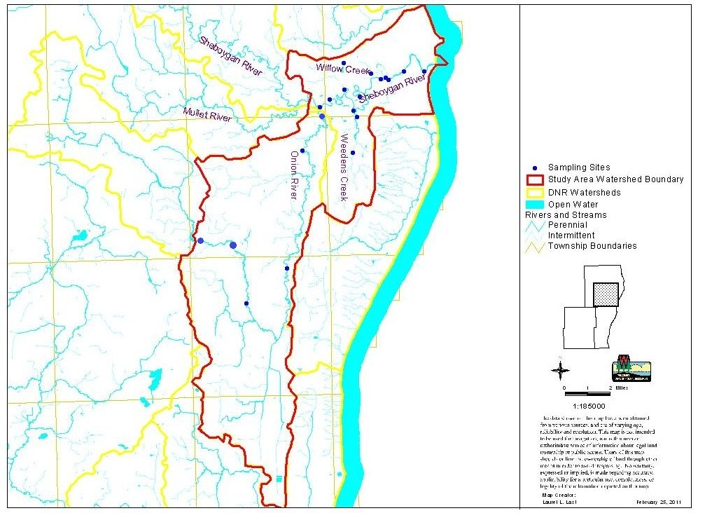
Figure 1. Sample site locations for fish, benthic macroinvertebrates, stream habitat, and aquatic macrophyte surveys.
Table 1. Site locations and information for Sheboygan River AOC monitoring stations, Sheboygan County, Wisconsin. SR 03 is small wetland and had aquatic plant survey only. NA – Not Applicable.

Site | Stream | Location | Legal Description | Latitude  Longitude* | Stream Order
SR 01 | Sheboygan River | Upstream of 8TH Street. | T15N, R23E, Sec. 26, NE1/4 of NW1/4 | 43.74451  -87.71285 | 5
SR 02 | Sheboygan River | Upstream of New Jersey Avenue. | T15N, R23E, Sec. 27, NE1/4 of NW1/4 | 43.74463  -87.73079 | 5
SR 03 | Sheboygan River | SE Corner of Taylor and Indiana Avenue. | T15N, R23E, Sec. 28, SE1/4 of NE1/4 | 43.73970  -87.74424 | NA
SR 04 | Sheboygan River | Upstream of CTHY PP at Esslingen Park. | T15N, R23E, Sec. 28, SE1/4 of NW1/4 | 43.74027  -87.75094 | 5
SR 05 | Sheboygan River | Upstream of Village of Kohler Municipal Garage. | T15N, R23E, Sec. 32, NE1/4 of NW1/4 | 43.72987  -87.76962 | 5
SR 06 | Sheboygan River | Upstream of Weedens Creek Confluence. | T15N, R23E, Sec. 32, SW1/4 of SW1/4 | 43.72083  -87.77571 | 5
SR 07 | Sheboygan River | Upstream of Walderhaus Dam. | T15N, R23E, Sec. 30, SE1/4 of SE1/4 | 43.73442  -87.78287 | 5
SR 08 | Sheboygan River | Adjacent to Kohler Stables Property. | T15N, R23E, Sec. 31, NE1/4 of SW1/4 | 43.72825  -87.79589 | 5
SR 09 | Sheboygan River | Upstream of Onion River Confluence. | T15N, R22E, Sec. 36, NW1/4 of SE1/4 | 43.72372  -87.80483 | 5
WC 01 | Willow Creek | Upstream of confluence with Sheboygan River. | T15N, R23E, Sec.28, SW1/4 of NE1/4 | 43.74105  -87.74696 | 2
WC 02 | Willow Creek | Upstream of Greendale Road. | T15N, R23E, Sec.28, NW1/4 of NW1/4 | 43.74423  -87.75937 | 1
WC 03 | Willow Creek | Upstream of Woodlake Road. | T15N, R23E, Sec.19, SE1/4 of SE1/4 | 43.75103  -87.78274 | 1
WE 01 | Weedens Creek | Upstream STHY 28 | T14N, R23E, Sec. 05, NE1/4 of NW1/4 | 43.71708  -87.77284 | 3
WE 02 | Weedens Creek | Upstream of CTHY A | T14N, R23E, Sec. 08, NW1/4 of SW1/4 | 43.69432  -87.77714 | 3
OR 01 | Onion River | Upstream of Broadway Avenue. | T15N, R22E, Sec. 36, SW1/4 of SE1/4 | 43.72117  -87.80590 | 4
OR 02 | Onion River | Upstream of Ourtown Road. | T14N, R22E, Sec. 11, SE1/4 of SW 1/4 | 43.69667  -87.82086 | 4
OR 03 | Onion River | Upstream of CTHY A | T13N, R22E, Sec. 02, NW1/4 of SW1/4 | 43.62282  -87.83698 | 4
OR 04 | Onion River | Upstream of Risseeuw Road. | T13N, R22E, Sec. 09, SE1/4 of SW1/4 | 43.60161  -87.87305 | 3
OR 05 | Onion River | Upstream of CTHY W | T14N, R22E, Sec. 32, SE1/4 of NE1/4 | 43.63817  -87.88370 | 3
OR 06 | Onion River | Downstream of CTHY I | T14N, R22E, Sec. 31, SE1/4 of NW1/4 | 43.64120  -87.91029 | 3
* WGS 84 Datum

Fish Surveys

Representative fish community samples were collected at each site using backpack-mounted, towed-barge, or boat-mounted electrofishing units. Individuals were counted, weighed and measured as appropriate and data was applied to an index of biotic integrity (IBI) (Lyons 1992; Lyons 2006; Lyons et al. 2001; WDNR 2001). The fish IBI relates community structure to community health and water quality.

All fish observed were collected with small nets. Fish were identified to species and the number of each species was recorded. Fish that could not be identified in the field were placed into 10% formalin for later identification.

A fyke netting survey was also executed near the intersection of Taylor Drive and Indiana Avenue at site SR 04. This survey was carried out following Spring Netting I protocols from WDNR Lakes Sampling Procedures (WDNR 2008). The goal of this netting was to establish presence/absence of adult northern pike in a targeted project area. A backwater area was netted at this location with a 2 foot X 6 foot fyke net for a total of 6 net nights.

Benthic Macroinvertebrates Surveys

Macroinvertebrates were collected using standard WDNR protocols for wadable streams (WDNR 2000). One sample was collected at each site using a D-framed kick net. Specimens were preserved in ethanol for later identification. Samples were collected during October and November of 2010. Identification and enumeration of invertebrate taxa (generally genus and species) were done by the Benthic Invertebrate Laboratory at the University of Wisconsin – Stevens Point, Stevens Point, Wisconsin. Data was applied to several biotic indices.

One site (SR 01) was nonwadable and the following sampling approach was used for this site (Weigel and Dimick, 2011). We collected macroinvertebrates using modified Hester-Dendy (H-D) artificial substrate samplers during summer 2011, basing sampler construction and deployment upon Ohio EPA (1987). Each sampler used an eyebolt to hold eight 7.6 cm x 7.6 cm (3 inch x 3 inch) plates made of 3.2 mm (1/8 inch) thick masonite hardboard. Spacing between the plates allowed for colonization; spacing was 3.2 mm between each of the first three plates, 6.4 mm between each of the next three plates, and 9.6 mm between the last two plates. We fastened three samplers to an 18 kg cinder block and suspended it 1.5 m below the water surface, at low flow. The sampler was suspended by a rope off of a wooden piling upstream of the bridge crossing. We avoided placement of the samplers on the bottom substrate so the device would not be inundated with sediment, for example, shifting sand or soft substrates. Velocity should be 0.09 - 0.5 m/sec. Samplers were placed to maintain 0.75 – 1.5 m of water above the sampler at low flow. Samplers were left to colonize macroinvertebrates for six-weeks within the window from mid-June through September. After six weeks, we retrieved the samplers, scraped/rinsed off the organisms, combined the sample contents, and preserved them in ethanol. All samples were delivered to the lab for identification and enumeration.

Water quality was assessed at 19 sites by examining the biological communities and their characteristics, such as number of individuals, number and types of taxa, pollution tolerance, and other traits. Computed metrics for invertebrate samples included the number of invertebrate taxa, Shannon Diversity Index, the percentage of invertebrate individuals or genera in the orders Ephemeroptera-Plecoptera-Tricoptera (EPT), and an invertebrate Index of Biotic Integrity (IBI) (Weigel, 2003). Assemblage information and metrics for invertebrate samples were provided in the BUG database from the Benthic Invertebrate Laboratory at the University of Wisconsin – Stevens Point, Stevens Point, Wisconsin.

Habitat Assessment

Stream habitat was evaluated at 19 sites using qualitative procedures (WDNR 2007) during August and September, 2011. Seven different variables for stream less than 10 meters wide are visually estimated for qualitative habitat assessment. Each habitat parameter is given a rating of excellent, good, fair, or poor, and the associated individual numeric scores are summed to provide an overall rating of stream habitat quality. Variables measured included riparian buffer width, bank erosion, pool area, width:depth ratio, riffle:riffle or bend:bend ratio, fine sediment, and cover for fish. For streams greater than 10 meters wide, variables measured included bank stability, maximum thalweg depth, riffle:riffle or bend:bend ratio, rocky substrate, and cover for fish.

Aquatic Macrophytes Surveys

Two individual aquatic plant surveys were done at sites SR 02 and SR 03. SR 02 was done using the point-intercept (PI) method protocol (Hauxwell et al, 2010). The PI method was designed for lake surveys, so the method was slightly modified for use on this section of the Sheboygan River. Monitoring was done on September 20, 2011 on 106 sample points, spaced 20 meters apart. Sample points were identified using GPS (Figure 3). Depth, substrate type, aquatic plant species, and individual species density (rake fullness) were recorded at each sample point. SR 03 was a small wetland, approximately three acres in size, and the PI method could not be applied at the site. Therefore, a simple visual inspection was applied to this site, also on September 20, 2011.

RESULTS AND DISCUSSION

The assessment of biological and physical stream conditions can be used to assess the overall health of a given water body. Individual species and assemblages may determine biological integrity and water quality conditions. Stream habitat also has a major role in supporting fish, macroinvertebrate, and macrophyte communities.

Fish

The Sheboygan River fish community assessments included nine of the 20 monitoring locations. Two of these survey sites (SR 01 and SR 02), were located within the lower portion of the River in the City of Sheboygan. These sites were within the proposed dredging project boundaries and were also not wadable due to deeper water depths. Non-wadable protocols were followed at these sites (WDNR 2003). Both sites scored 60/100, resulting in a rating of “good” using a warmwater IBI (Table 2). Smallmouth bass catch rates were 1.7 per mile for site SR 01 and 7 per mile for site SR 02. These catch rates are relatively average when considering species potential based on physical criteria of the river (Lyons 2006). The other fish from these sites had intermediate tolerance and were characterized as warmwater/transitional species (Table 3). One introduced species, the common carp, was found at these sites.

It should be noted that hydraulic dredging operations were occurring during the survey period which may have affected catch. For comparison, previous surveys occurred in 2003 and 2010 in the same river reach as SR 02 following the same sampling protocols. In 2003 the survey resulted in a score of 75/100 or a rating of “excellent” using a warmwater IBI. A total of 23 smallmouth bass were caught yielding a catch rate of 25.6 per mile which is above statewide average when referencing the criteria discussed previously. In 2010 survey results were very similar to 2011 with a score of 65/100 or a rating of “excellent” and a smallmouth bass catch rate of 1 per mile. The 2010 survey may have been influenced by the salmonid run which was occurring during the sampling period.

The Sheboygan Harbor, including lower reaches of the Sheboygan River, were the subject of another survey from 2003 and 2005 (Hirethota and Burzynski 2006). This survey compared smallmouth bass distribution and abundance among 4 harbors of Lake Michigan in southeastern Wisconsin. Of the 4 harbors compared, Sheboygan Harbor was noted as having the highest abundance of smallmouth bass.

Table 2. Fish community and benthic macroinvertebrate index of biotic integrities (IBIs), and stream habitat ratings for Sheboygan River AOC and tributaries. * indicates cold water IBI, ** indicates cool water IBI. NA – Not Assessed. SR 01 is nonwadable site.

Site | Fish Community IBI | Macroinvertebrate IBI | Stream Habitat Rating
SR 01 | Good | Very Poor | NA
SR 02 | Good | Fair | Fair
SR 04 | Excellent | Fair | Good
SR 05 | Excellent | Fair | Excellent
SR 06 | Excellent | Fair | Good
SR 07 | Excellent | Excellent | Fair
SR 08 | Fair | Good | Good
SR 09 | Excellent | Fair | Excellent
WC 01 | Very Poor* | Fair | Good
WC 02 | Very Poor* | Good | Good
WC 03 | Good | Fair | Fair
WE 01 | Fair | Fair | Good
WE 02 | Poor | Fair | Fair
OC 01 | Good | Fair | Fair
OC 02 | Excellent | Good | Excellent
OC 03 | Good | Poor | Fair
OC 04 | Good | Fair | Fair
OC 05 | Good** | Fair | Fair
OC 06 | Fair** | Poor | Good

During 2011 six other sites were surveyed in the Sheboygan River AOC using either warmwater wadeable or non-wadeable protocols (Figure 1) (Table 1). In general the upstream habitat was significantly different with more course substrate and narrower stream widths. These differences carried over to fish survey results with 5 of 6 sites having an average score of 87/100 or a rating of “excellent” using a warmwater IBI (Table 2). Smallmouth bass catch rates at these 5 sites were all above statewide average again considering species potential based on physical criteria of the river (Lyons 2006). One of the five sites (SR 09) even yielded an impressive 652.8 smallmouth bass per mile. The one site that was an outlier scored a 45 placing it in the “fair” category and no smallmouth bass were found there. This site (SR 08) was unique likely because of influences from what is locally known as Riverbend Dam. A total of 3 intolerant fish species were documented in these upstream sites (northern hog sucker, rock bass and smallmouth bass). There were 26 native fish species found at these sites that were tolerant/intermediate, warmwater/transitional species (Table 3). Two exotic species were also sampled from these upstream sites, the common carp and round goby.

When considering smallmouth bass as the focal species of the fishery only 3.4% of the fish sampled would meet the 14 inch minimum length regulation in place on the Sheboygan River (Figure 2). Another metric used to summarize length data is Relative Stock Density (RSD). RSD is a ratio of the total catch of relatively large fish to the total catch of all medium and large fish. For this analysis we compared the total number of fish 14 inches and greater to the total number of fish 8 inches and greater. An RSD of 10.67% was calculated for all smallmouth bass surveyed in 2011. This falls within the “acceptable” range for southern warmwater wadable streams and “below average” for southern non-wadable rivers (Lyons 2006). Currently no harvest should be occurring because of the “do not eat resident fish” consumption advisory so we might expect these numbers to be higher. However it should again be noted that surveys of the lower reaches of the river where we might expect to find some of the larger individuals may have been affected by hydraulic dredging operations.

Looking at length ranges broken down by river section the length frequencies showed distinct variation (Figure 2). In the lower river sites (SR01 and SR02) lengths ranged from 7 inches to 11 inches. These sites were sampled with non-wadable protocols and non-wadable surveys are biased against small and nocturnal species. This fact coupled with difference in habitat with upstream reaches may account for the lack of smaller individuals. Larger individuals may be absent because of the previously mentioned dredging operations. In the middle river sites (SR04, SR05 and SR06) sizes ranged from our overall minimum of 1 inch to our overall maximum of 17 inches. All of these sites were surveyed with wadable warmwater protocols and included excellent habitat variation which probably accounts for the wide range of observed sizes. In the upper river sites (SR07, SR08 and SR09) sizes ranged from 2 inches to 13 inches. These sites were surveyed with a combination of wadable and non-wadable protocols. The survey site furthest upstream (SR 09) includes a riffle area that yielded the highest smallmouth bass catch rates of any of the 2011 surveys. That survey accounts for most of the 3-6 inch fish surveyed and points to the fact that this riffle may be an important nursery habitat.

Downstream portions of the AOC also serve as a corridor for migratory fish in spring and fall. Although no quantitative data exists, qualitative observations of numerous species stacking up at the Waelderhaus Dam (the 1st barrier upstream of Lake Michigan) do exist. In the spring these species include: northern pike, walleye, white sucker, steelhead and three redhorse species. The fall run would include brown trout, chinook salmon, coho salmon and steelhead.

A fyke netting survey was also executed near the intersection of Taylor Drive and Indiana Avenue (SR 03). This survey was carried out following Spring Netting I protocols from WDNR Lakes Sampling Procedures (WDNR 2008). The goal of this netting was to establish presence/absence of adult northern pike in a targeted project area. A backwater area was netted at this location with a 2 foot X 6 foot fyke net for a total of 6 net nights. A total of 14 northern pike were documented, 3 juveniles of unknown sex, 5 males and 6 females. Sex differentiation was possible due to the expression of reproductive product. The presence of spawning size northern pike in this backwater area supports the idea that the creation of spawning marshes along the Sheboygan River may be of great benefit to this species.

In summary, based on these recent surveys and observations, the fish communities of the Sheboygan River proper within the AOC are relatively healthy based on species abundance and diversity. However consumption advisories for certain fish species with the Sheboygan River remain due to elevated PCB levels found in fish tissue.

Willow Creek has portions of the headwaters that have been impacted from past development. This includes filling of wetlands, straightening of the stream channel for flood control, storm sewer discharges, thermal impacts, nutrient and sediment loading from nonpoint source runoff, and diversion of groundwater discharge to the stream.

Poor water quality and excess stream flows are factors that can influence the type of fish community found in a stream. In this basin, past land use practices have degraded the water quality and biological integrity of Willow Creek. Future development in the watershed may further impact the stream. However, sufficient evidence based on monitoring, shows that sections of Willow Creek meet the criteria for classification as a Class II trout stream (Masterson, 2006 and 2008). Therefore, the lower 1.6 miles of Willow Creek and its tributaries were reclassified as a Class II trout stream in 2008 to protect the biological integrity of this unique stream.

Past fishery surveys have documented smolt from all three salmonid species stocked into Lake Michigan and its tributaries. These species include chinook salmon, coho salmon and steelhead trout. Native brook trout have also been documented previously (Masterson 2006 and 2008). The presence of these species indicates Willow Creek has the potential to support a coldwater fishery.

The survey included three electrofishing samples using a backpack shocker following coldwater protocols (WDNR 2001). This survey documented only one coldwater species, a salmonid smolt, at the three sites sampled. The remainder of the 11 species found were tolerant/intermediate, warmwater/transitional fish (Table 3). One introduced, exotic species, the round goby, was found at the site nearest the confluence with the Sheboygan River (WC 01). Using a Coldwater Index of Biotic Integrity (IBI) (Lyons 1996), two sites, WC 01 and WC 02, rated very poor with scores of zero (Table 2). The Small Stream IBI (Lyons 2006) was used for Site WC 03 and resulted in a rating of good.

The documentation of a salmonid smolt by this survey is encouraging and confirmed by a separate survey conducted by WDNR staff from the Southern Lake Michigan Fisheries Team. They took two electrofishing samples from consecutive weeks in August, 2011 and found a total of 27 steelhead smolts. This survey will be repeated for one more year and will be a valuable baseline as changes occur on the property surrounding Willow Creek. This survey only documents the presence or absence of salmonid smolts; it does not utilize standard protocols or the fish IBI.

In a true coldwater community the expectation is to find relatively few fish species with trout and sculpin dominating. As discussed previously this type of community was not documented at any of the 2011 survey sites. Coldwater streams are best described as flowing waters with maximum summer water temperatures that are typically below 22 degrees Celsius. The watersheds of these streams are usually less than 100 square miles, and the streams exhibit mean annual flow rates of less than 50 cubic feet per second. Most of these conditions have been documented at Willow Creek (Masterson 2006 and 2008). However, portions of the Willow Creek watershed are developed from agriculture and urban land use and this does contribute to a flashy flow regime which has degraded stream habitat and the biological community of Willow Creek.

Weedens Creek is generally characterized as a warmwater resource. Its official classification is that of cool-warm transition headwater. Two sites were surveyed within Weedens Creek (Figure 1) (Table 1).

This survey included two electrofishing samples using a backpack shocker following warm water protocols (WDNR 2001). At the downstream site (WE 01) steelhead smolt were documented for the first time. Young of the year northern pike were also found indicating Weedens Creek may function as a nursery area for certain species. Future monitoring would be important to determine the significance of these findings.

Of the remaining fish one intolerant warmwater species, the banded darter, was documented at the downstream site (WE 01). The remaining 11 species documented were tolerant/intermediate, warmwater/transitional fish (Table 3). Using a warmwater IBI, the two sites scored 35/100 and 20/100 or ratings of “fair” and “poor” respectively moving upstream (Table 2). Only one introduced species, the steelhead, was documented.

In summary, the fish communities of Weedens Creek are somewhat degraded. Upstream reaches of the stream are impacted by agricultural practices and downstream reaches are subject to a severely flashy regime causing erosion issues. However the presence of young of the year fish is encouraging and future monitoring would be warranted.

The Onion River is the largest of the three tributaries surveyed within the Sheboygan River AOC. The lower Onion River extends from the Village of Waldo Dam downstream to its confluence with the Sheboygan River at Rochester Park. Six sample sites were included in this survey (Figure 1) (Table 1). All monitoring sites were located downstream of the Village of Hingham Dam. This dam is located downstream of the Village of Waldo Dam and is the first major impairment to fish passage.

Overall the Onion River’s water quality is fair to poor in the lower reach below Waldo Dam. Water quality is still good to excellent in the river’s upstream reaches (above Waldo). The upper portions do have coldwater segments that support a healthy, naturally reproducing brown trout community. The lower section of the Onion River flows through vast acreage of farmland, where intensive cropland and pasturing contributes to erosion and sedimentation of the stream substrate. Soil type mainly consists of clays. Water clarity is typically turbid during the growing season, because of runoff from farm fields and bioturbidation, from carp feeding on the stream bottom.

In 2011, three sites on the Onion River were surveyed with a stream shocker following warmwater wadable protocols (WDNR 2001). The site farthest downstream (OR 02) yielded the best results with a warmwater IBI score of 90/100 or a rating of “excellent” (Table 2). This was the only site where smallmouth bass were documented with a total catch of 41 or a catch rate of 82.5 per mile. This catch rate is above exceptional when considering species potential based on physical criteria of the river (Lyons 2006). The habitat at this site was significantly different than the two upstream sites. There was abundance of course substrate with good gradient and run – riffle – pool sequences.

When considering smallmouth bass as the focal species of the fishery only 1 fish, or 2.4% of the fish sampled, would meet the 14 inch minimum length regulation in place on the Onion River (Figure 3). Another metric used to summarize length data is Relative Stock Density (RSD). RSD is a ratio of the total catch of relatively large fish to the total catch of all medium and large fish. For this analysis we compared the total number of fish 14 inches and greater to the total number of fish 8 inches and greater. An RSD of 7.1% was calculated for all smallmouth bass surveyed in 2011. This section of the Onion River is designated as southern wadable smallmouth bass nursery waters. As such, the RSD value is somewhat non-applicable, but does allow comparison with the Sheboygan River RSD discussed previously.

The upstream sites were dominated by fine substrate and lacked both gradient and geomorphic diversity as they were more closely bordered by agricultural lands. The sites upstream (OR 03 and OR 04) yielded warmwater IBI scores of 70/100 and 50/100 or a ratings of “excellent” and “good”, respectively. As noted previously no smallmouth bass were documented at either site but northern pike were found at both in low abundance.

In total two intolerant warmwater species (rock bass and smallmouth bass) were found in this survey. The remainder of the species were tolerant/intermediate, warmwater/transitional species (Table 3). All of the species documented in the Onion River survey were native to waters of Wisconsin.

A comparison of other recent surveys allows increased spatial and temporal coverage of results. The sites are comparable as they were sampled with a stream shocker following warmwater wadable IBI protocols without the gamefish extension (WDNR 2001). The farthest downstream site (OR 01) was surveyed in 2009 and scored a 52/100 or a rating of “good” with a warmwater IBI. Smallmouth bass were not documented in any of the previous surveys, however largemouth bass were found at every site. A total of two largemouth bass were documented at OR 01, yielding a catch rate of 8 per mile.

The final 2 sites (OR 05 and OR 06) were surveyed in 2009 and 2010, respectively, and located farther upstream than any of the 2011 sites. A cool – warmwater transition IBI (Lyons et al, 2009) was used to evaluate these sites as it represented the best fit for natural community type. They scored 60/100 and 50/100 or ratings of good and fair respectively. A total of 5 largemouth bass were captured at OR 05 for a catch rate of 25 per mile. A total of 9 largemouth bass were captured at OR 06 for a catch rate of 37.44 per mile.

In general, results from these recent surveys indicate fish communities in the Onion River represent a relatively healthy and balanced warmwater fishery. Throughout this stretch of the river habitat changes related to land use practices probably have the largest impact on the health of fish communities. This issue is an overriding one throughout the Sheboygan River watershed
Table 3. Individual fish species and classifications (Origin/Tolerance/Temperature) from all sample sites. (N=Native, I=Introduced/I=Intolerant, IM=Intermediate Tolerance, T=Tolerant/W=Warmwater, T=Cold-Warm Transitional).

SPECIES | SR 01 | SR 02 | SR 04 | SR 05 | SR 06 | SR 07 | SR 08 | SR 09 | WC 01 | WC 02 | WC 03 | WE 01 | WE 02 | OC 01 | OC 02 | OC 03 | OC 04 | OC 05 | OC 06
BANDED DARTER (N/I/W) |  |  |  |  |  |  |  |  |  |  |  | 11
BIGMOUTH SHINER (N/IM/W) |  |  |  |  |  |  |  | 18 |  |  |  |  |  |  |  |  | 1 | 1 | 2
BLACK BULLHEAD (N/T/W) |  |  | 2 |  |  |  |  |  | 2 | 1 | 2
BLACKSIDE DARTER (N/IM/W) |  |  | 5 |  | 17 |  |  | 17 |  |  |  |  |  | 13 | 2 |  | 4 |  | 14
BLUEGILL (N/IM/W) |  |  | 8 | 3 | 5 |  |  |  | 1 | 3 | 15 | 10 | 3 | 2 |  |  |  |  | 1
BLUNTNOSE MINNOW (N/T/W) |  |  |  | 26 | 8 |  |  | 10 | 5 |  | 1 | 9 |  | 1 |  |  |  | 22 | 142
BROOK STICKLEBACK (N/T/T) |  |  |  |  |  |  |  |  | 3 | 1 | 9 | 1 | 6
CENTRAL MUDMINNOW (N/T/T) |  |  | 3 |  |  |  |  |  | 2 |  | 5 |  | 4 |  |  |  |  | 2
CENTRAL STONEROLLER (N/IM/W) |  |  |  |  | 2
CHANNEL CATFISH (N/IM/W) |  |  | 5 |  | 1
CHINOOK SALMON SMOLT (I/IM/W) |  |  |  |  |  |  |  |  | 2
COMMON CARP (I/T/W) | 5 |  |  |  | 2 | 2 | 5 | 2 |  |  |  |  |  |  |  |  |  |  | 29
COMMON SHINER (N/IM/W) | 2 |  | 15 | 3 | 28 |  |  | 434 | 1 |  |  |  |  | 1 | 490 | 8 | 25 | 24 | 305
CREEK CHUB (N/T/T) |  |  |  |  |  |  |  |  |  | 14 | 3 |  | 57 |  | 8 |  | 29 | 95 | 124
FANTAIL DARTER (N/IM/W) |  |  |  |  |  |  |  |  |  |  |  |  | 1
FATHEAD MINNOW (N/T/W) |  |  |  |  |  |  |  |  |  |  |  | 2 | 1 |  |  |  |  |  | 2
GIZZARD SHAD (N/IM/W) | 27 | 127 | 42
GOLDEN REDHORSE (N/IM/W) |  |  | 1 | 6 | 7 | 7 | 1 | 43 |  |  |  |  |  | 10 | 30 | 9
GREEN SUNFISH (N/T/W) |  |  | 10 | 2 | 13 |  |  |  |  |  |  |  |  | 30 | 12 |  |  | 1 | 6
HORNYHEAD CHUB (N/IM/W) |  |  |  |  | 5 |  |  | 55 |  |  |  |  |  | 6 | 243 |  |  |  | 1
JOHNNY DARTER (N/IM/T) |  |  | 2 | 4 | 22 |  |  | 9 | 6 |  |  | 73 | 8 | 12 | 9 |  | 1 | 52 | 5
LARGEMOUTH BASS (N/IM/W) |  |  | 4 |  | 1 |  |  |  |  |  |  |  |  | 2 |  |  |  | 5 | 9
LOGPERCH (N/IM/W) |  |  |  |  | 5 |  |  | 48 |  |  |  |  |  |  | 12
LONGNOSE DACE (N/IM/T) |  |  | 8 | 3 | 124 |  |  | 40 | 1 | 4 |  |  |  |  | 278 |  | 2 | 17 | 18
NORTHERN HOG SUCKER (N/I/T) |  |  |  |  |  |  |  | 2
NORTHERN PIKE (N/IM/T) |  | 1 | 18 |  | 3 |  |  | 1 |  |  |  | 2 | 10 |  |  | 4 | 2 | 2
PUMPKINSEED (N/IM/W) |  |  |  |  |  |  |  | 1 |  |  |  |  |  |  |  |  |  | 4 | 12
PUMPKINSEED X UNKNOWN (N/IM/W) |  |  |  |  |  |  |  |  |  |  |  | 1
RAINBOW TROUT SMOLT (I/IM/C) |  |  |  |  |  |  |  |  |  |  |  | 4
ROCK BASS (N/I/W) |  |  | 12 | 9 | 13 | 1 |  | 14 |  |  |  |  |  | 41 | 37 | 7 | 2
ROUND GOBY (I/IM/W) |  |  | 422 | 55 | 23 |  |  |  | 5
SAND SHINER(N/IM/W) |  |  |  |  | 4 |  |  | 26 |  |  |  |  |  | 13 |  |  |  | 58 | 1
SHORTHEAD REDHORSE (N/IM/W) |  |  | 2 |  | 7
SMALLMOUTH BASS (N/I/W) | 2 | 9 | 21 | 16 | 40 | 3 |  | 143 |  |  |  |  |  |  | 41
SPOTFIN SHINER (N/IM/W) |  |  | 2 |  | 5 |  |  | 2 |  |  |  |  |  |  |  | 3
STONECAT(N/IM/W) |  |  | 5 | 5 | 10 |  |  | 14 |  |  |  |  |  | 6 | 8 |  | 1 |  | 15
WESTERN BLACKNOSE DACE (N/T/T) |  |  | 1 |  |  |  |  |  |  | 4 | 6 | 10 |  |  |  |  | 3
WHITE SUCKER (N/T/T) |  |  | 17 | 1 | 5 | 3 | 1 | 76 | 7 | 9 |  | 4 |  | 2 | 98 | 15 | 54 | 86 | 285
YELLOW BULLHEAD (N/T/W) |  |  |  |  |  |  |  |  |  |  |  |  |  |  |  |  |  |  | 1
YELLOW PERCH (N/IM/T) | 1
Total Number of Fish | 37 | 137 | 658 | 133 | 350 | 16 | 7 | 955 | 35 | 36 | 41 | 127 | 92 | 139 | 1268 | 46 | 124 | 369 | 972
Total Individual Species | 5 | 3 | 21 | 12 | 23 | 5 | 3 | 19 | 11 | 7 | 7 | 11 | 9 | 13 | 13 | 6 | 11 | 13 | 18

Figure 2. Length frequency of smallmouth bass from 2011 surveys broken down by survey reach.

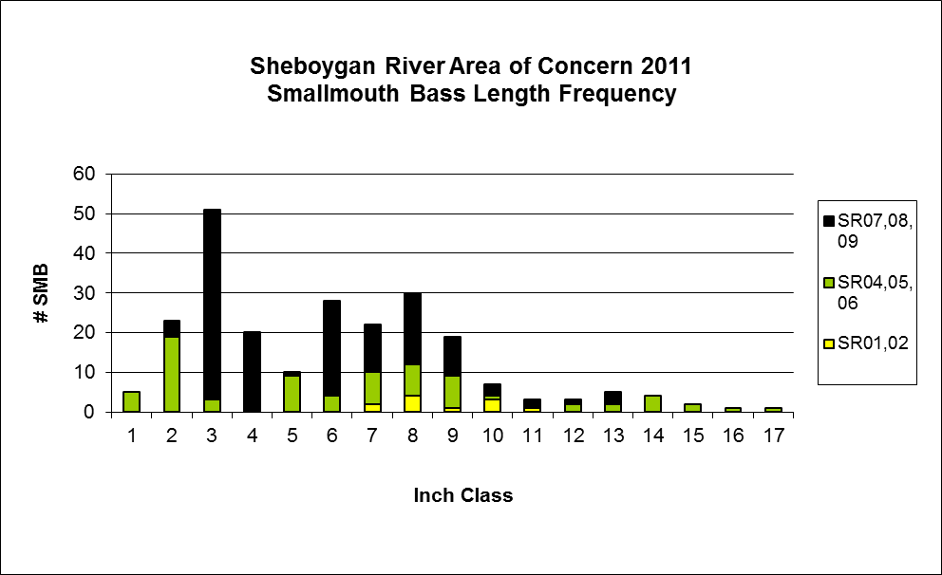

Figure 3. Length frequency of smallmouth bass from 2011 Onion River surveys at
Ourtown Road.

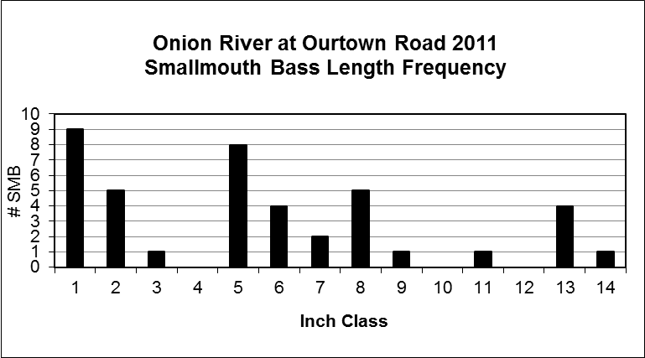

Benthic Macroinvertebrates

Benthic macroinvertebrate communities are used as indicators of water quality. For this study, we evaluated the number of invertebrate taxa, Shannon Diversity Index, percentage of taxa or individuals in the insect orders Ephemeroptera-Plecoptera-Tricoptera (EPT; also known as mayflies, stoneflies, and caddisflies), and the Index of Biotic Integrity (Table 4).

The number of taxa and Shannon Diversity Index scores generally decrease with degrading water quality. The highest number of taxa (50 species and 46 genera) were found on the Onion River at OR 02. The highest Shannon diversity score was 4.37 on the Sheboygan River at SR 07. The lowest number of taxa (12 species and 11 genera) were found on Willow Creek (WC 02). The lowest Shannon diversity score was 1.45 and was found on Weedens Creek (WE 02). Higher numbers of taxa and higher diversity are typically found on larger streams compared to smaller streams, if conditions are the same. We do see that trend for the data. Site OR 06 on the Onion River had lower number of taxa (13 species and 13 genera) and a low Shannon diversity score of 1.74. One possible explanation for this is that this site is downstream and relatively close to the Village of Hingham dam and impoundment.

EPT invertebrates are generally considered to be relatively intolerant of degraded water quality (Lenat 1988). Therefore, the percentages of EPT individuals and genera tend to decrease as water quality degrades. The highest percentages of EPT taxa were found on the Onion River (OR 02) and Sheboygan River (SR 09), and were 42 percent and 40 percent, respectively. The lowest percentages of EPT taxa were 6 percent for both the Sheboygan River (SR 01) and Willow Creek (WC 03). The low percentages for these two sites may be attributed to the fine sediments and that dominate the stream substrate at both locations.

The biotic index used to assess invertebrate assemblages was an Index of Biotic Integrity (IBI) developed by Weigel (2003) for the wadable sites, and Weigel and Dimick (2011) for the one nonwadable site (SR 01). Invertebrate IBI values can range from 0.00 (“very poor” water quality) to 10.00 (“excellent” water quality). Ratings for the sites ranged from “very poor” on the Sheboygan River (SR 01) to “excellent” on the Sheboygan River (SR 07) and Onion River (OR 02). The majority of the sites (12 of 19) rated “fair”. Two sites on the Onion River rated “poor” (OR 03 and OR 06). These two sites are in an area that is dominated by agricultural land use and this may account for the ‘poor” rankings.

Stream Habitat

Stream habitat is important when assessing the biological integrity of streams. The physical environment can play an important role in supporting fish and macroinvertebrate populations. Loss of fish cover and sedimentation can have severe impacts on biological communities. All wadable sites rated “fair” to “excellent” (Tables 5 and 6). One site (SR 01) was non-wadable and habitat assessment was not done because protocols are not available at this time.

Table 4. Benthic macroinvertebrate assemblage information from one-time surveys conducted in November 2011 at 19 stream sites within the Sheboygan River AOC.
EPT, Ephemeroptera, Plecoptera, and Trichoptera; IBI, Index of Biotic Integrity;
* indicates samples that were collected in 2009 or ** for 2010; SR 01 is a nonwadable site.

Site | Species Richness | Genera Richness | Shannon's Diversity Index | % EPT Individuals | % EPT Genera | IBI¹
 |  |  |  |  |  | Value | Rating
SR 01 | 20 | 18 | 2.32 | 0 | 6 | 0 | Very Poor
SR 02 | 37 | 36 | 4.32 | 41 | 25 | 4.28 | Fair
SR 04 | 19 | 18 | 2.95 | 81 | 39 | 2.88 | Fair
SR 05 | 26 | 25 | 3.78 | 19 | 28 | 4.61 | Fair
SR 06 | 39 | 37 | 3.07 | 66 | 38 | 4.49 | Fair
SR 07 | 46 | 45 | 4.37 | 10 | 13 | 7.78 | Excellent
SR 08 | 27 | 26 | 3.21 | 64 | 38 | 5.01 | Good
SR 08 (2) | 31 | 29 | 3.62 | 41 | 31 | 5.62 | Good
SR 09 | 27 | 25 | 2.94 | 40 | 40 | 4.27 | Fair
WC 01 | 15 | 15 | 2.55 | 82 | 27 | 2.92 | Fair
WC 02 | 12 | 11 | 2.52 | 63 | 36 | 5.4 | Good
WC 03 | 32 | 32 | 2.78 | 1 | 6 | 3.76 | Fair
WE 01 | 17 | 16 | 2.62 | 44 | 31 | 3.55 | Fair
WE 02 | 15 | 15 | 1.45 | 3 | 13 | 3.85 | Fair
OR 01* | 30 | 29 | 3.93 | 41 | 21 | 4.43 | Fair
OR 02 | 33 | 31 | 3.95 | 63 | 42 | 6.59 | Good
OR 02 (2) | 50 | 46 | 4.23 | 49 | 28 | 8.16 | Excellent
OR 03 | 31 | 31 | 3.79 | 28 | 10 | 2.36 | Poor
OR 04 | 23 | 23 | 3.13 | 43 | 22 | 2.63 | Fair
OR 05* | 23 | 23 | 2.84 | 30 | 30 | 3.23 | Fair
OR 06** | 13 | 13 | 1.74 | 87 | 31 | 1.62 | Poor

¹ Weigel, 2003.
Weigel and Dimick, 2011 (Site SR 01)

For most sites less than 10 meters wide, the limiting factor for habitat appears to be bank erosion, lack of pool areas, and fine sediments. Ranking for these sites were “fair to “good”. For stream sites that were greater than 10 meters wide, ranking ranged from “fair” to “excellent”. For sites that rated “fair”, limiting factors for habitat were bank stability, riffle:riffle or bend:bend ratio, lack of rocky substrate and cover for fish.

Table 5. Stream habitat scores and ratings for sites that are < 10 meters wide. * site surveyed in 2009.

Site | Riparian Buffer Width | Bank Erosion | Pool Area | Width:Depth Ratio | Riffle:Riffle or Bend:  Bend Ratio | Fine Sediments | Cover for Fish | Total Score | Rating
OR 04 | 10 | 5 | 3 | 5 | 5 | 0 | 10 | 38 | Fair
OR 05* | 15 | 5 | 0 | 5 | 15 | 5 | 0 | 45 | Fair
WC 01 | 15 | 5 | 3 | 5 | 10 | 10 | 5 | 53 | Good
WC 02 | 15 | 5 | 3 | 5 | 10 | 10 | 10 | 58 | Good
WC 03 | 15 | 10 | 3 | 10 | 5 | 0 | 5 | 48 | Fair
WE 01 | 15 | 0 | 7 | 10 | 15 | 10 | 10 | 67 | Good
WE 02 | 5 | 5 | 0 | 10 | 5 | 10 | 10 | 45 | Fair
Top Score | 15 | 15 | 10 | 15 | 15 | 15 | 15 | 100 | Excellent

Table 6. Stream habitat score for sites that are > 10 meters wide. * site surveyed in 2009. ** site surveyed in 2010. NA – Not Assessed.

Site | Bank Stability | Maximum Thalweg Depth | Riffle:Riffle or Bend:Bend Ratio | Rocky Substrate | Cover for Fish | Total Score | Rating
SR 01 |  |  |  |  |  |  | NA
SR 02 | 8 | 16 | 0 | 16 | 8 | 48 | Fair
SR 04 | 8 | 16 | 12 | 25 | 16 | 77 | Good
SR 05 | 8 | 16 | 12 | 25 | 25 | 86 | Excellent
SR 06 | 8 | 8 | 12 | 25 | 25 | 78 | Good
SR 07 | 4 | 25 | 4 | 8 | 16 | 57 | Fair
SR 08 | 4 | 8 | 8 | 16 | 25 | 61 | Good
SR 09 | 4 | 16 | 12 | 25 | 25 | 82 | Excellent
OR 01* | 4 | 8 | 12 | 8 | 0 | 32 | Fair
OR 02 | 12 | 8 | 12 | 25 | 25 | 82 | Excellent
OR 03 | 4 | 8 | 0 | 8 | 8 | 28 | Fair
OR 06** | 8 | 8 | 12 | 25 | 16 | 69 | Good
Top Score | 12 | 25 | 12 | 25 | 25 | 99 | Excellent

Aquatic Macrophytes

Aquatic macrophyte surveys were conducted at two locations (SR 02 and SR 03) to determine their potential to support annual Northern Pike spawning in the spring. Figure 4 and Table 7 summarizes select data for the SR 02 site survey. Figure 5 further illustrates site locations for the two sites. Only 76 of 106 sample points were included in the data collection, because 30 of the sample points were located in upland areas. This was due to the number of small islands within the sample site. Two species of aquatic plants were found within the sample site, filamentous algae and sago pondweed. Filamentous algae (Cladophora sp.) were the main species found at the site, located in 37 percent of the sample sites, but in low density. Rake density or fullness, was one out of three. This is the lower of the ratings for density. Sago pondweed (Potamogeton pectinatus) was only found at one sample point and accounted for 1.3 percent aquatic plant coverage. Rake density was also one. SR 03 was a small wetland, approximately three acres in size, and the PI method could not be applied at the site. Therefore, a simple visual inspection was applied to this site. This wetland (SR 03) was dominated with broad-leaved cattail and reed canary grass. Neither of the two sites appears to have a macrophyte community that would support natural reproduction and a nursery for Northern Pike spawning.

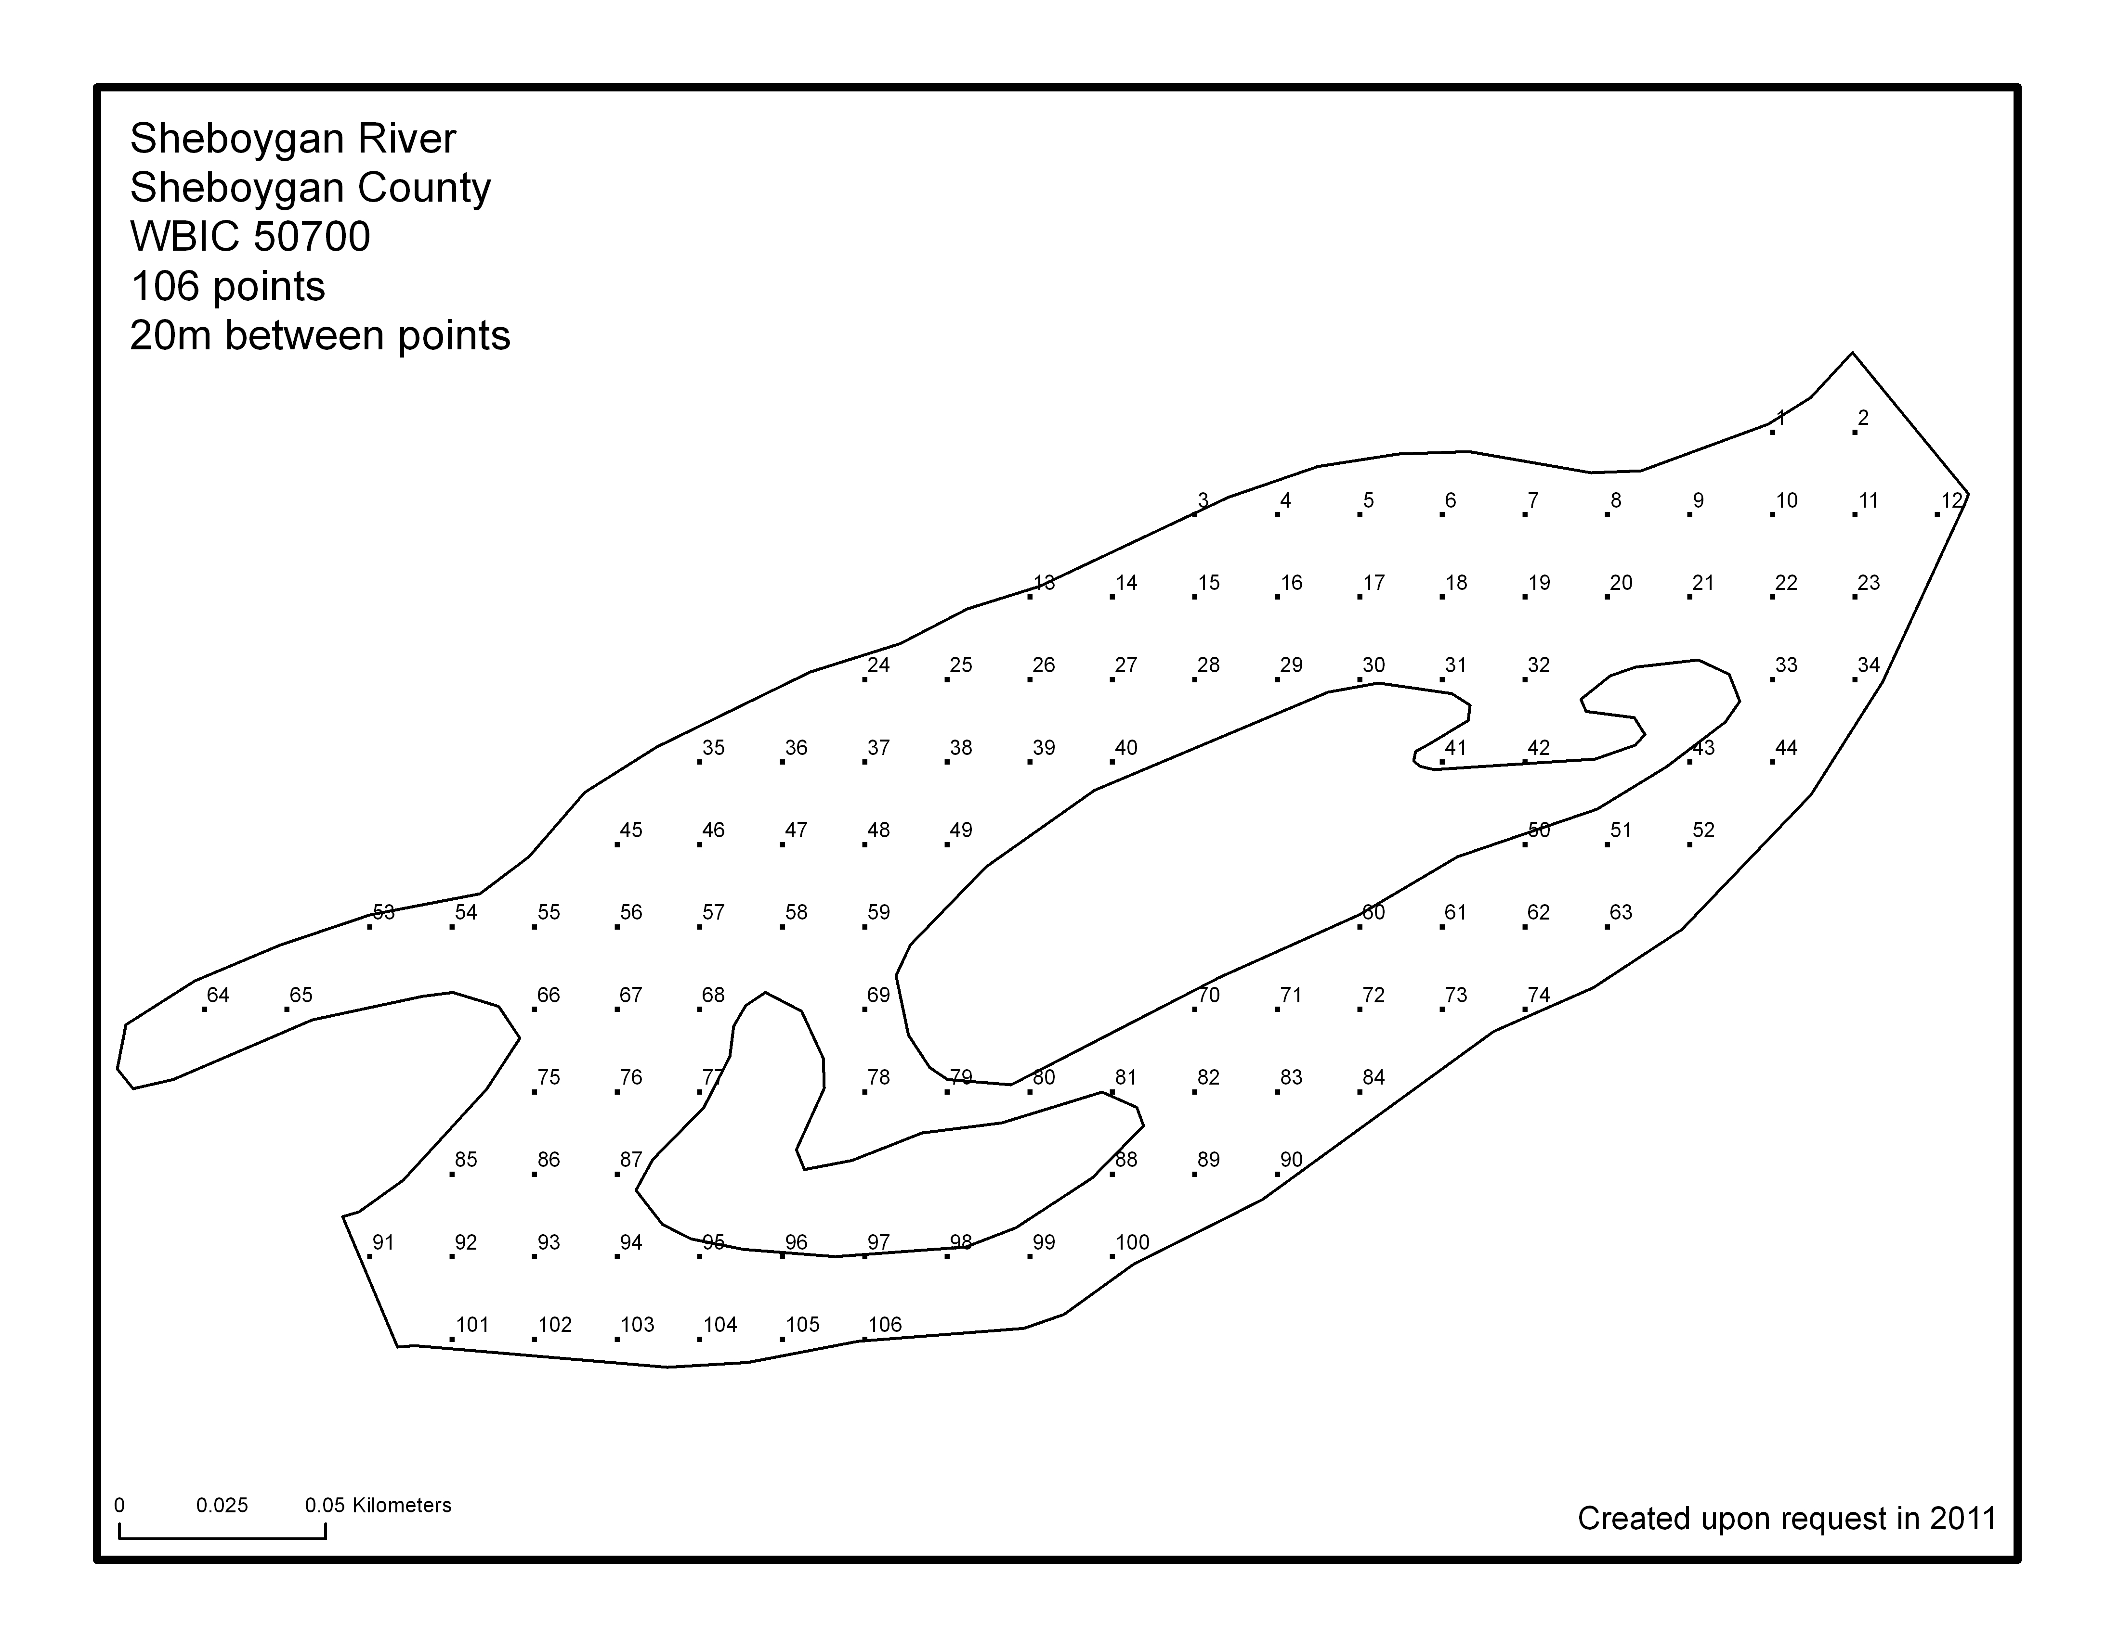
Figure 4. Aquatic plant survey sample locations, using point-intercept method, for Wildwood Island Area on the Sheboygan River (SR 02), Sheboygan, Wisconsin.

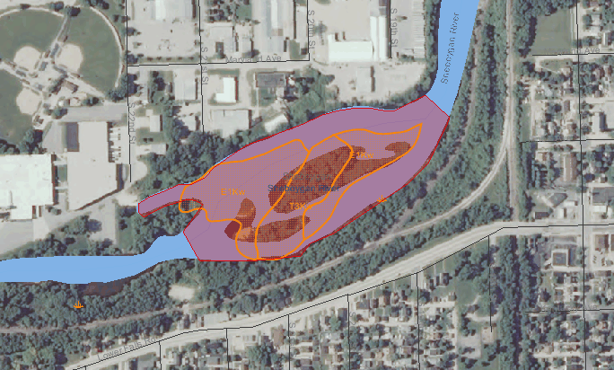

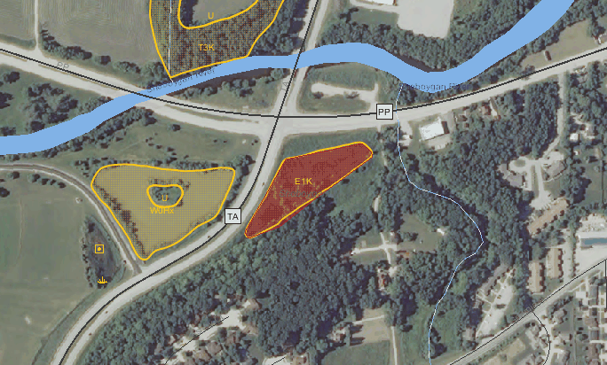

Figure 5. Aerial photos and locations for Sheboygan River sites SR 02 (top) and SR 03
(bottom).
Table 7. Summary of aquatic plant survey data for site SR 02 on the Sheboygan River. Sample points within upland areas were not included in survey.

Total sample points | 106
Sample points within upland areas | 30/106 (28%)
Sample points included in survey | 76
Filamentous algae | 28/76 (37%)
Sago pondweed | 1/76 (1.3%)
Gravel substrate | 48/76 (63%)
Sand substrate | 13/76 (17%)
Muck substrate | 15/76 (20%)
Depth range | 0.1 – 4.5 feet
Average depth | 1.6 feet

REFERENCES

Hauxwell, J., S. Knight, K. Wagner, A. Mikulyuk, M. Nault, M. Porzky and S. Chase.
2010. Recommended baseline monitoring of aquatic plants in Wisconsin:
sampling design, field and laboratory procedures, data entry and analysis, and applications. Wisconsin Department of Natural Resources Bureau of Science Services, PUB-SS-1068 2010. Madison, Wisconsin, USA.

Hirethota, P. and T. Burzynski, 2006. Smallmouth bass distribution and abundance in
selected harbors of Southeastern Wisconsin Lake Michigan, 2003-2005. Wisconsin Department of Natural Resources: PUB-FH-512-2006. 18 p.

Lenat, D.R., 1988. Water quality assessment of streams using a qualitative collection
method for benthic macroinvertebrates: Journal of the North American
Benthological Society, v. 7. No. 3, p. 222-233.

Lyons, J. 2006. A Fish-Based Index of Biotic Integrity To Assess Intermittent
Headwater Streams in Wisconsin, USA. Environmental Monitoring and Assessment (2006) 122: 239-258.

Lyons, J., 2006. A sampling framework for smallmouth bass in Wisconsin’s streams and
rivers. 21 p.

Lyons, J., 1996. Development and validation of an Index of Biotic Integrity for
coldwater streams in Wisconsin. North American Journal of Fisheries
Management 16:241-256.

Lyons, J., R. Piette, and K. Niermeyer, 2001. Development, validation, and application
of a fish-based Index of Biotic Integrity for Wisconsin’s large warmwater rivers.
Transactions of the American Fisheries Society 130:1077-1094.

Lyons, J., T. Zorn, J. Stewart, P. Seelbach, K. Wehrly, and L. Wang, 2009. Defining and
characterizing coolwater streams and their fish assemblages in Michigan and Wisconsin, USA. North American Journal of Fisheries Management 29:1130-1151.

Lyons, J., 1992. Using the Index of Biotic Integrity (IBI) to measure environmental
quality in warmwater streams of Wisconsin, General Technical Report NC-149:
U.S. Department of Agriculture, Forest Service, North Central Experiment Station, St. Paul, Minn., 51 p.

Masterson, J., 2006. Willow Creek baseline monitoring report – Sheboygan River Basin.
18 p.

Masterson, J. 2008. Willow Creek class II trout stream classification request. 6 p.

Ohio EPA Environmental Protection Agency), 1987. Biological criteria for the
protection of aquatic life. Volume II: Users manual for biological field
assessment of Ohio surface waters. Surface Waters Section, Division of
Water Quality Monitoring and Assessment, Ohio Environmental Protection
Agency, Columbus, Ohio. (Available from: Ohio Environmental Protection
Agency, P.O. Box 1049, Columbus, Ohio 43216-1049 USA).

WDNR, 2003. Baseline monitoring – non-wadable streams protocols. 7 p.

WDNR, 2008. Fisheries assessments – lakes 2007-09 sampling procedures. 10 p.

WDNR, 2001. Guidelines for assessing fish communities of wadable streams in
Wisconsin. 12 p.

WDNR, 2000. Guidelines for collecting macroinvertebrate samples from wadable
streams. 12 p.

WDNR, 2007. Guidelines for qualitative physical habitat evaluation of wadable streams.
2 p.

WDNR, 2012. Remedial Action Plan Update for the Sheboygan River Area of Concern.
72 p.

WDNR, 2002. Wisconsin Department of Natural Resources Guidelines for Evaluating
Habitat of Wadable Streams. Wisconsin Department of Natural Resources. May 2000 revision. 22 pages.

Weigel, B.M., 2003. Development of stream macroinvertebrate models that predict
watershed and local stressors in Wisconsin: Journal of the North American
Benthological Society, v. 22, no. 1, p. 123-142.

Weigel, B.M. and J.J. Dimick, 2011. Development, validation, and application of a
macroinvertebrate-based Index of Biotic Integrity for nonwadeable rivers of
Wisconsin. Journal of the North American Benthological Society, v. 30, no. 3,
p. 665-679.

