Scope of Work for Aid Agreement

with the Village and Town of Somers
for Neumiller Woods Wetland Restoration

Project Contacts:

Village and Town of Somers
William Morris
Village Administrator
7511 – 12th Street
Somers, WI 53171
bmorris@somers.org
(262) 859-2822
Wisconsin Department of Natural Resources
Cheryl Bougie
Project Manager, Sediment & WQ Monitoring Coordinator
2984 Shawano Avenue
Green Bay, WI 54313
cheryl.bougie@wisconsin.gov
(920) 662-5170

I. Background
Neumiller Woods Park is a 7.9-acre is a passive park along the Somers Branch of the Pike River – a highly-impaired Lake Michigan tributary. Surrounding development and upstream agricultural parcels, along with invasive reed canary grass have degraded this unique wetland habitat. Increased runoff pollution and flooding issues, contributing sediment and phosphorus to the park and downstream to the Pike River are also issues. Wisconsin DNR supported this project and issued a letter of support. Much of the Neumiller Woods parcel is within the floodplain and has great potential for biological diversity for aquatic and vegetative species alike. Fish, amphibian and other wildlife habitat in the natural area is limited because of the excessive sedimentation and invasive plant species.
In 2013, the Village and Town of Somers received a grant from Fund for Lake Michigan to conduct an eco-hydrological analysis and restoration feasibility study of the entire Somers Branch of the Pike River, as well as site-specific restoration plans for two town-owned properties totaling just over 33 acres – including Neumiller Woods. Neumiller Woods Park has many areas that are still in pre-settlement condition, one of the few remnants in the area of active development. Root-Pike WIN is working with the Village and Town of Somers, and other communities, landowners, and stakeholders to fund and implement 9KE recommendations from three completed plans within the Root-Pike basin. The Neumiller Woods project is one such recommendation. In addition, Root-Pike WIN also conducts the outreach and education recommendations of the 9KE plans to demonstrate the public value of projects like Neumiller Woods through the Southeastern Wisconsin Clean Water Network.
The purpose of implementing this plan is to restore Neumiller Woods by removing excess sediment, replanting the area around the wetland scrape, providing additional fish and wildlife habitat, and increasing human recreational and educational opportunities within the park. The Neumiller Woods Park is a highly-visible property in the heart of the Village and Town of Somers. Successful completion of this project will be communicated in numerous media channels through Root-Pike WIN and the Village and Town of Somers.

II. Responsibilities of Partners

The Village and Town of Somers will:
- Provide access to past reports and documents as requested
- Provide three hard copies & an electronic version PDF of final engineering plans and specifications, reports and findings of investigations associated with Neumiller Woods
- Provide access to its properties and provide a good faith effort(request written or verbal approval from landowner to gain access)- to obtain access to properties owned by others for the purpose of implementing this scope of work
- Release requests for bids (RFB) and hire qualified (the Village and Town of Somers will pre-qualify contractors as part of the bid process) contractors to perform the work outlined in Section III. Scope of Work.
- Assure the scope of work is completed according to the Final Plans and Specifications.
- Obtain necessary approval from the Board of Trustees to award the contracts necessary to complete the work outlined in Section III. Scope of Work provided funding is available from EPA to complete the project.
- Submit invoices to WDNR for reimbursement with required reports and documentation
- Utilize GLRI funding for the execution of this scope of work in the amount specified in Section V. Funding
- Participate in weekly progress meetings and assure quarterly progress reports are submitted to WNDR on schedule
- Work with Root-Pike Watershed Initiative Network to help position the project for success and communicate the pre, during, and post-construction activities
- Assure permit compliance

The Wisconsin Department of Natural Resources will:
- Facilitate WDNR permits and assist with permit issues as required
- Provide funding for the execution of this scope of work in the amount specified in Section V. Funding
- Provide general coordination and troubleshooting assistance as needed
- Promptly notify the Village and Town of Somers of any WDNR concerns, including those related to invoices
- Provide relevant information from other habitat related projects to aid in the development of the ecological restoration plan
- Utilizing monitoring data, as built reports, and other documentation to record project metrics and outcomes.
- Participate in weekly progress meetings
- Report to EPA semi-annually
- Work with Root-Pike Watershed Initiative Network to help position the project for success and communicate the pre, during, and post-construction activities

Project Management Structure
The Village and Town of Somers shall administer the funding, hire the contractors, and carry out the scope of work. The Village Administrator will serve as the Project Lead on behalf of the Village and Town of Somers. The WDNR will provide general coordination and troubleshooting assistance as needed. The oversight consultant will report to the project team. The WDNR will report to the USEPA. Thompson and Associates will provide consultation from the bid phase to implementation and through the three-year maintenance. Root-Pike Watershed Initiative Network will assist in compiling the bid documents, provide consultation to the team, and help promulgate the goals, schedule, and project outcomes to watershed stakeholders.

Project Team
A project team made up of representatives from the WDNR, the Village and Town of Somers, Thompson and Associates, and Root-Pike WIN will be assembled to ensure coordination and continuous interaction between parties. The project team will be led by the Village and Town of Somers Village Administrator, Board President and Attorney. Participating staff from the WDNR will include the Lake Michigan Sediment & WQ Monitoring Coordinator or Great Lakes Quality Assurance Coordinator with support from other WDNR staff as needed. All representatives from the Village and Town of Somers and WDNR need not participate in every project team meeting. To the extent feasible, remote participation should be an option.

The project team will develop the RFBs to solicit contracting firms, participate in pre-bid contractor meetings, participate in weekly progress meetings, discuss change orders, and provide updates. With the help of Thompson and Associates and Root-Pike WIN, the Village and Town of Somers will develop a draft RFB for the project team for review and comment. The team shall function within the framework of funding regulations, state statues, Village and Town of Somers ordinances and procurement procedures.

Decision Making Structure
The Village and Town of Somers and WDNR are entering into this project with a shared vision of restoration and an approach of collaboration. It is the intent of both parties to conduct activities that benefit the Somers Branch and the Pike River restoration efforts and in turn the community. The project team will utilize collaborative decision when working with Thompson and Associates for project coordination and inspection, when discussing change orders, and for other decisions.

The project team will hold weekly on-site progress meetings when on-site work is taking place. The General Contractor will provide a progress update during the meeting which includes: work completed since the last update, issues encountered and resolved, anticipated progress for the upcoming week, and any suggested change orders. Afterword, the project team will meet privately to discuss the update and proposed change orders.

Change orders will be reviewed by the Project Team, all change orders require approval by the WDNR prior to implementation and the Village and Town of Somers is responsible for signing all change orders since they hold the contracts with the contractors. If a change order requires immediate action, it may be discussed outside of progress meetings. A log of all change orders will be kept and reported during weekly progress meetings.

Coordination with Root-Pike WIN and the Parks Committee
The project team will utilize the technical expertise provided by Root-Pike WIN as needed. Public outreach will be conducted with input from Village and Town of Somers’ Parks Committee as well as Root-Pike WIN. Coordination of the project’s communications will be provided by Root-Pike WIN with the support and guidance of WDNR and the Village and Town of Somers.

Selecting Contractors and Consultants
The Project Team will develop a prequalification form for selecting qualified contractors and consultants. The Project Team will also host a mandatory pre-bid meeting. Contracting work will be publically bid according to state law and federal award conditions.

The project team shall develop a RFQ for General Contracting services included in this scope of work. Contractors shall meet mandatory requirements outlined in the RFQ including Contractor qualifications and experience. The Contractor must have completed similar past projects and have staff or sub-consultants with experience in the appropriate disciplines. The Village and Town of Somers will follow their procurement policy in reviewing the bid proposals. The Village and Town of Somers, project team shall review proposals from potential contractors. The evaluation of Contractors’ proposals will be done by the project team and rating of the proposals should use criteria defined in the RFQ. It is anticipated that Thompson and Associates will oversee the wetland scrape’s excavation and ecological restoration.

III. Scope of Work
Subject to State and Federal bidding and prevailing wage laws, the Village and Town of Somers will hire contractors to perform this scope of work. Duties specific to each contractor are below. Environmental permits necessary to complete the scope have been prepared and applied for by the Village and Town of Somers, except for those that require additional information from contractors prior to issuance. All necessary tasks to accomplish these items will be included in the scope, including meetings and coordination with the project team and regulators.

The focus of the scope of work is the partial restoration of Neumiller Woods Park including: a wetland scrape, relocation of the excavated spoils on-site, and restoration of fish and wildlife habitat within the newly created wetland channel and where the spoils were relocated. All of these actions are necessary to achieve the recommendations in the Somers Branch Eco-hydrological Report from 2013, and as part of the DNR/EPA-approved Nine Key Element Watershed Restoration Plan for the Pike River.

Creation of the Wetland Scrape

Recommendations Addressed by Project
These activities are design to enhance the hydrological functions, which address the loss of vegetative diversity and wildlife habitat and degradation of fish and wildlife population impairments. More on how this aspect of the Neumiller Wetland Scrape Project contributes towards restoration the Somers Branch of the Pike River is available in the Nine Key Element Watershed Restoration Plan (2013) and in the Eco-hydrological Analysis and Restoration Plan (2014).

Activity Goals
• Improved wetland functionality by removing sediment buildup to a non-floodplain area.
• Increased macroinvertebrate and amphibian populations.
• Diverse and functional amphibians are present in order to increase natural recruitment.
• A healthy and diverse native vegetation community has been restored.
• Improved awareness and educational opportunities related to wetland functions

Specific Activities and Timeline
The contractor hired to complete these activities will do so by implementing plans developed by Thompson and Associates, and RA Smith. Necessary specifics will be included within the RFB. In general, the contractor will:
- Re-meander the wetland channel and increase the depth of the wetland basin in a predominately treeless area overrun with reed canary grass and sediment deposition
  - Excavate the wetland channel to
- Relocate the uncontaminated sediment on-site
  - Uncontaminated sediment will be beneficially reused as part of habitat restoration activities in an area adjacent to the wetland scrape, but still within the Parks’ boundaries but not within the wetland/floodplain as suggested by Kenosha County’s land conservationist
- Replant the excavated area with a prescribed mix of native vegetation
- Schedule: As a restoration project involving establishing plant communities, the timeline for this project is highly dependent on weather and the timing of the contracting processes:
  - Finalize Aid Agreement March 1, 2018
  - Re-bid Project March 20, 2018
  - All Necessary Permits Secured April 1, 2018
  - Site Construction May 15, 2018
  - Initial Vegetation Establishment June 30, 2018
  - Follow up maintenance (3 seasons) November 30, 2021
  - Final report and invoicing December 30, 2021

Ecological Restoration

Nine Key Element Recommendations Addressed by Project
Impaired beneficial uses of the Somers Branch addressed by these activities include loss of fish and wildlife habitat and degradation of wetland plant and tree diversity. More on how this aspect of the Neumiller Woods Wetland Scrape Project contributes towards restoration the Somers Branch of the Pike River is available in the Somers Branch Eco-hydrological Analysis and Restoration Planning (2014) and the Pike River Watershed Restoration Plan (2013). The ecological restoration portion of the project will be completed per the final design and specifications and implemented under the Grant Agreement between WDNR and the Village and Town of Somers upon receiving GLRI funds.

Activity Goals
- Provide shallow water, emergent vegetation areas suitable for native fish species
- Provide foraging and loafing opportunities for native amphibians, reptiles, and waterfowl
- Contribute towards the achievement of restoration goals and objectives found within the Nine Key Element Watershed Restoration Plan (2013) by increasing diversity in the wetland habitat.

Specific Activities and Timeline
The contractors hired to complete these activities will do so by implementing plans developed by Thompson and Associates, and RA Smith. In general, the contractor will:
- Restore <1 acre of wetland and aquatic habitat in the Village and Town of Somers, (Northwest of the Village Hall adjacent to CTH E) and as specified in RA Smith. Restoration is subject to receiving approval from the Village and Town of Somers under the terms and conditions set for the third bullet point of Section II. Responsibilities of the Partners, The Village and Town of Somers will:
- Conduct control efforts on <1 acre of invasive plants including reed canary as specified in Ayres Drawing (drawing will be more complete upon final design & specifications). Control efforts are subject to receiving approval from landowner(s) under the terms and conditions set forth under the third bullet point of Section II. Responsibilities of the Partners, The Village and Town of Somers will:
- Follow up monitoring and maintenance of plantings and invasive plant treatment/control areas
Site Utilization Map
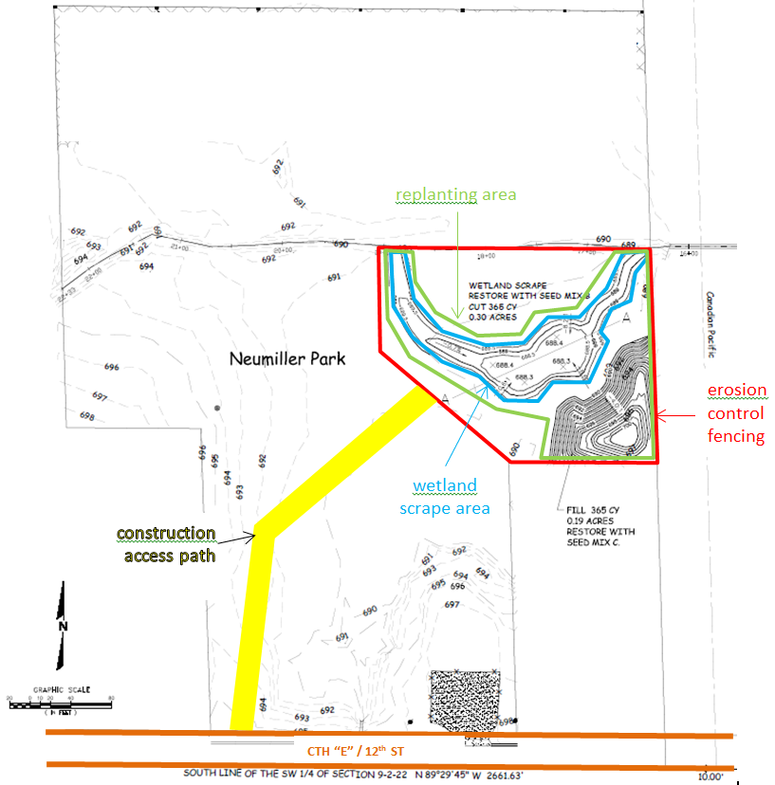

Schedule Summary

- 2018 | J | F | M | A | M | J | J | A | S | O | N | D
Develop Aid Agreement
Permit Application
Re-bid Project
Construction Contracting
Site Construction
Initial Vegetation Establishment
Quarterly Report**
* The critical path items are the permit application and the site construction. Site construction is highly dependent on weather conditions as the Neumiller Woods area is often very wet. The actual construction activities will take days rather than months,
but the proposed timeframes are indicated in months to allow for slots in the schedule when site work can actually occur.
** Quarterly reporting is expected through the life of the entire project

Oversight

Activity Goals
- Oversee and ensure contractor compliance with plans and specifications

Specific Activities and Timeline
The Consultant hired to complete construction oversight will;
- Facilitate and participate in weekly progress meetings, provide agendas and weekly update reports for the team.
- Report progress, issues encountered, and other pertinent information to the project team
- Assist the Village and Town of Somers with review of monthly invoices
- Schedule all pay items in the contract including quantities and materials
- Review and assess all proposed contractor changes and make recommendations to project team
- Inspect all construction activities and assure conformance with the plans. specifications and permit conditions
- Prepare as-built drawings
- Provide information and updates to WDNR on a quarterly basis.
Quarterly reports are due on the following schedule for each year of the grant:
  - April 10
  - July 10
  - October 10
  - January 10

IV. Deliverables
The following deliverables will be provided by the Village and Town of Somers:
  - Provide final bid plans and specifications for the wetland scrape, relocation of the spoils, re-vegetation plan, and construction access and staging
- Final ecological restoration plan and specifications
- Final signed copies of all QAPPs (wetland restoration)
- Quarterly project progress reports
- Oversight of project—(construction records)
- Timely submittal of invoices
- Final construction documentation report (as built reports) of wetland ecological restoration.
- Ecological restoration monitoring, maintenance and invasive species control reports will be provided based on the final ecological restoration plans and specifications

All work products must be approved by WDNR.

V. Funding
Funding shall be provided to the Village and Town of Somers for the project from a Great Lakes Restoration Initiative Grant received by WDNR. In addition to this Scope of Work, an Aid Agreement will be in place and signed by both the Village and Town of Somers and WDNR. The Village of Somers’ financial contribution is $0.00. The scope of work includes three years of maintenance and monitoring in addition to the wetland scrape, plantings and site preparation. The GLRI and Fund for Lake Michigan funds will be used together for the pre-bid documentation, permitting, implementation and maintenance. For the scope of work, the GLRI funding allocation shall be:

2015 2017
Fund for Lake Michigan $27,000 $0
WDNR(GLRI grant) $0 $32,000
Project Total $59,000

- Staff time for project management and other administrative costs directly attributable to the project incurred by the Village and Town of Somers are reimbursable by the project funding or considered as an in-kind contribution. Final reports and deliverables must be approved by the WDNR before final payment is made. Provide three hard copies and an electronic version PDF of final engineering plans (as built), reports and findings of investigations, or any additional reports listed in the specifications, as associated with Neumiller Woods Park.

Invoicing & Payment
- Method of Payment ‐ Reimbursement for expenses incurred on invoice.
- Invoices can be made on a monthly basis to WDNR as defined in the grant agreement between WDNR and the Village and Town of Somers
- The Village and Town of Somers will review all invoices before submission to assure that all work included is complete.
- Invoices will be sent to Cheryl Bougie, WDNR Project Manager, or other point of contact as specified by her for approval along with details/description of work invoiced.
- Invoices approved by Cheryl Bougie will be forwarded to WDNR Madison for payment.
- Invoices will be processed and disbursed within 30 days of receipt of approved invoice.
- Village and Town of Somers shall maintain records and supporting paperwork for all invoices as outlined in the grant agreement.

The Village and Town of Somers is responsible for payment to contractors and consultants.

VI. Schedule

Wetland Scrape, Spoil Placement, Revegetation and Maintenance
Wetland Scrape, Spoil Placement, and Revegetation Schedule
2018 | J | F | M | A | M | J | J | A | S | O | N | D
Develop Aid Agreement
Permit Application
Re-bid Project
Construction Contracting
Site Construction
Initial Vegetation Establishment
Construction Report
* The critical path items are the permit application and the site construction. Site construction is highly dependent on weather conditions as the Neumiller Woods area is often very wet. The actual construction activities will take days rather than months,
but the proposed timeframes are indicated in months to allow for slots in the schedule when site work can actually occur.

Maintenance Schedule
 | 2019 |  |  |  | 2020 |  |  |  | 2021
 | Q1 | Q2 | Q3 | Q4 | Q1 | Q2 | Q3 | Q4 | Q1 | Q2 | Q3 | Q4
Plant Maintenance
Plant and Habitat Monitoring
Plant and Habitat Reporting
* The critical path items are the permit application and the site construction. Site construction is highly dependent on weather conditions as the Neumiller Woods area is often very wet. The actual construction activities will take days rather than months,
but the proposed timeframes are indicated in months to allow for slots in the schedule when site work can actually occur.

