Scope of Work – Amendment 1

Project Title: Milwaukee Estuary Area of Concern Baseline Wildlife Population Assessment
Applicant name: Julia Robson – Assistant Natural Areas Coordinator
NOTE: Send project agreement to Project Manager (Julia Robson), but with John Dargle, Director, as signatory
Organization name: Milwaukee County Department of Parks, Recreation and Culture
Street/Mailing address: 9480 Watertown Plank Road, Wauwatosa, WI 53226
Phone number: (414).257.8081
Email address: Julia.Robson@milwaukeecountywi.gov
DUNS Number: 172896383
Project Manager’s name and contact info: same as above

Proposed Work
This is an expansion upon a three year project to conduct wildlife surveys to support setting habitat restoration priorities within the Milwaukee Estuary Area of Concern (AOC). Work will build upon data mining activities conducted during the target refinement study and baseline wildlife assessments implemented during 2014, 2015, and 2016. The year 1 baseline surveys targeted areas with known data gaps, while years 2 and 3 targeted areas with data gaps found through the data mining component. In 2017, wildlife surveys will be conducted in additional AOC target areas outside of the 2014-2016 AOC focus areas. Additional surveys within the 2014-2016 focus areas will also be conducted for species of local conservation interest (SLCI) that have been identified as having low detection probabilities within the AOC.

The Milwaukee County Park Natural Areas Program will conduct specific surveys using standardized protocols as described below in addition to those already included in 2014-2015 and 2016 scopes of work:
- Migratory bird surveys at 3 sites (Bay View Park, Juneau Lagoon, Sheridan Park);
- Breeding bird surveys at 3 sites (Bay View Park, Juneau Lagoon, Sheridan Park);
- Cover object surveys for snakes at 1 site (Sheridan Park);
- Additional visual encounter and acoustic surveys for salamanders and other amphibians;
- Additional aquatic egg mass surveys;
The number and location of survey sites are subject to change based on the results of the historical literature and data review and availability of suitable habitat for surveys. Additionally, the DPRC will focus heavily on data analysis and final report preparation during 2017.
Project Location
In 2017, Milwaukee County Park’s survey efforts will focus on Bay View Park, Juneau Lagoon, and Sheridan Park (see Figure 2). Additional data capture efforts for SLCIs will occur within suitable habitat on land owned by Milwaukee County Parks along portions of the Little Menomonee River, Menomonee River, Milwaukee River and their tributaries. A half-mile buffer surrounding these waterways defines the general lateral extent of the survey area, (see Figure 1).

Budget
Amendment 1- Year 4
 | Total cost
Personnel:  ( 2) DPRC Staff (hourly rate + fringe) x 6 months | $23,000
Equipment | $0
Supplies:  binoculars, spotting scope, kestrel meter thermometers, snake boards, cautery pens, spring scales | $2000
Contractual | $0
Other | $0
Total Direct Cost | $25,000
Indirect cost (%)
Total Cost | $25,000

For reference the following is a total budget for the project, including the original agreements:
Agreements Year 1 & 2 $90,000*
Agreement Year 3 $15,000
First Amendment (Year 4) $25,000
Project Total $130,000

*Year 1 & 2 funds were awarded in a separate agreement. This updated SOW is an amendment to the Year 3 agreement.

Timetable
Survey start times are weather dependent. General timetable listed below is subject to change depending on weather and other environmental conditions. Any changes to timing below will be through written notification from County Parks Project Manager to WDNR Project manager (email acceptable).

September 7, 2016 – November 2016
- Fall migratory bird transects
March 2017 – May 2017
- Visual encounter, egg mass, and acoustic surveys for salamanders and other amphibians
- Spring migratory bird transects (April – May)
May 2017 – July 2017
- Breeding bird point count surveys
- Snake cover object surveys
September 2017
- Amend final report to include additional findings

Deliverables
The following are the deliverables for the entire project. The status of each is given in the column on the right.
Deliverable | Status
- Quarterly Reports – Reports will be submitted by April 1, July 1, October 1 and January 1. Reports will identify amount expended per quarter, activities conducted, and planned activities for the following quarter, along with identification of any issues encountered (including delays or deviations from the original schedule or other setbacks) during the time and how they were addressed. Reports should be submitted to WDNR and the Milwaukee County Department of Parks, Recreation and Culture. | Quarterly reports complete through July 2016
- Surveys & Survey Data – DPRC staff shall perform ephemeral pond, aquatic funnel trapping (Crayfish & Salamanders), visual encounter & egg mass surveys, turtle basking surveys, turtle trapping surveys, snake cover object survey, bird surveys, and camera monitoring surveys at the sites listed in Table 1 and shown on Figures 1 & 2. Survey data will be submitted in electronic format, which includes location information (i.e. lat/long, decimal degrees, etc.). Acceptable formats include, Microsoft Access, Microsoft Excel, or ArcGIS geo-database. | Incomplete/ Progress to Date in Table 1. Expected Completion March 31, 2017 and September 30, 2017
- Project Documentation - Completed data sheets, photographs, recordings and other documentation will be submitted in the appropriate format, with electronic format preferred. Species identification verification through voucher specimens, recordings or photographs. Recordings and photographs should be of the highest available resolution and provide needed information for species identification purposes. Documentation requirements:  - For all field work, accurate location information for survey sites, boundaries, species occurrence, etc. must be collected using GPS with 95% accuracy, so data can be used in geographic information systems, including ArcGIS 10.3.1. The referencing system and datum (i.e. WGS84, WTM 83/91) must be documented for all data collected.  - Species identification (with the exception of birds) must be verified through collections of voucher specimens, recordings, or photographs with minimum of 2 mega pixel resolution to the extent allowable by local, state, and federal regulations. The recordings and photographs must provide the needed information for species identification purposes (i.e. identifying marks, size, etc). This verification must be linked to collection date, time and specific location. | Incomplete/ Expected Completion March 31, 2017 and September 30, 2017
- Reporting to Natural Heritage Inventory - Documentation showing that rare, threatened or endangered species observed have been reported to the WDNR Natural Heritage Inventory Program. | Incomplete/ Expected Completion March 31, 2017 and September 30, 2017
- Presentations to Fish and Wildlife Tech Team - Prepare a presentation and report interim findings after the 2014, 2015 and 2016 field seasons, and final findings upon completion of the report in person at a minimum of two meetings to the Wildlife Subcommittee or the Milwaukee AOC Fish and Wildlife Technical Team. | Two of four presentations complete (Sept. 2015)
- An interim report shall be prepared with the following elements which shall incorporate data/findings collected through 2016 by March 31, 2017. A final report shall be prepared to incorporate all data/findings by September 30, 2017. Prepare a final report including the following elements, working in conjunction with UWM Field Station and Fish and Wildlife Tech Team:  - Wildlife survey results  - Maps of existing plant and animal communities with survey points/transects and survey areas shown. Include existing habitat mapping efforts in evaluation (i.e., SEWRPC, Milwaukee County Parks, DNR). (Per the approval of the grantor in the “Final Report: Wildlife Population Target Refinement for the Milwaukee Estuary AOC”, this deliverable was agreed to be a work in progress with development continuing into Phase 2 funding. In order to avoid the production of multiple versions, and potential use of preliminary data by other partners which could result in confusion and errors, metadata are delivered here describing the databases. Final tabular and GIS data will be made available at the end of 2016.).  - Comparison of historic vs. existing species richness  - Identify broad biological constraints limiting species richness and restoration opportunities; develop a decision support chart to determine feasible restorations  - Determine focal species with stakeholder input; include umbrella, keystone, and flagship species concepts  - Identify short list of Species of Local Conservation Interest (SLCIs) and other target species with stakeholders and list their critical habitat requirements (biological constraints) for guiding habitat restorations and decision support. Consider a wide array of species ranging from very tolerant to very intolerant as restoration targets  - Recommendations for goals for habitat restoration and connectivity, addressing:  - AOC Beneficial Use Impairments and measures of success.  - Social constraints on restoration feasibility (i.e., land ownership, existing development extents, funding levels, etc.)  - Identify and prioritize specific projects that will address the BUIs of impaired wildlife habitat and populations. Projects will have a direct connection to the stream. Projects will be prioritized for maximum benefit for increasing wildlife biodiversity and/or restoring or sustaining SCLIs (such as Endangered or Threatened Species). Projects will have measures of success identified. | Incomplete/ Expected Completion March 31, 2017 and September 30, 2017

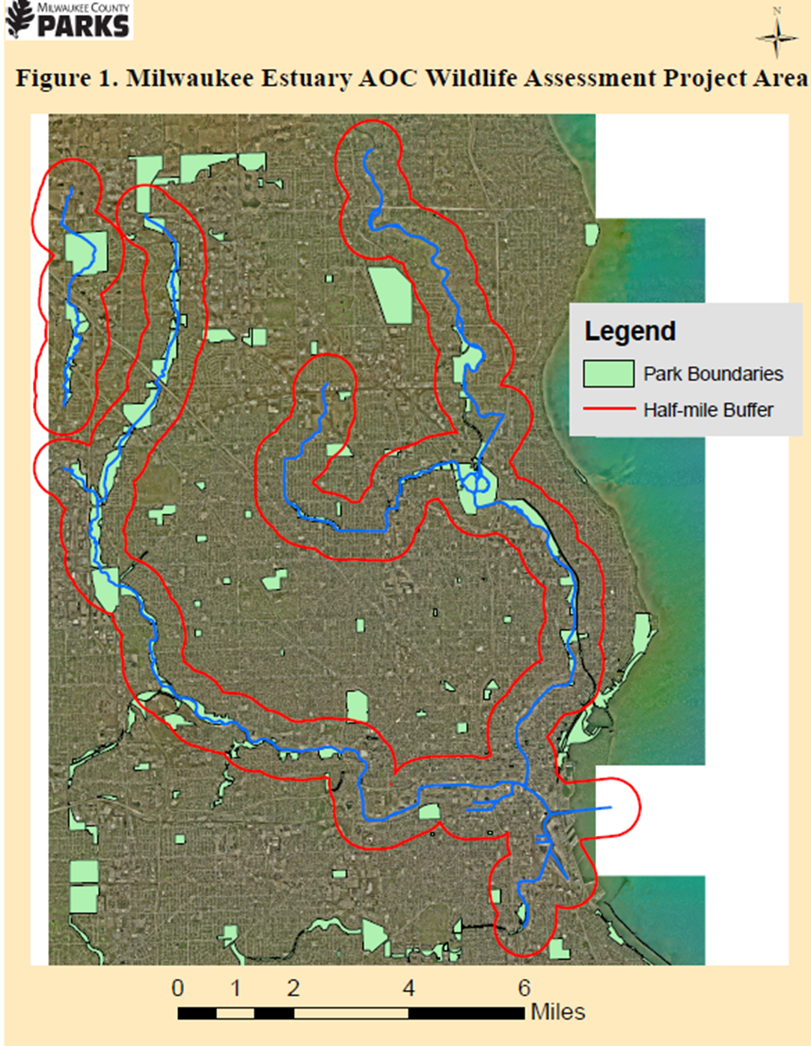

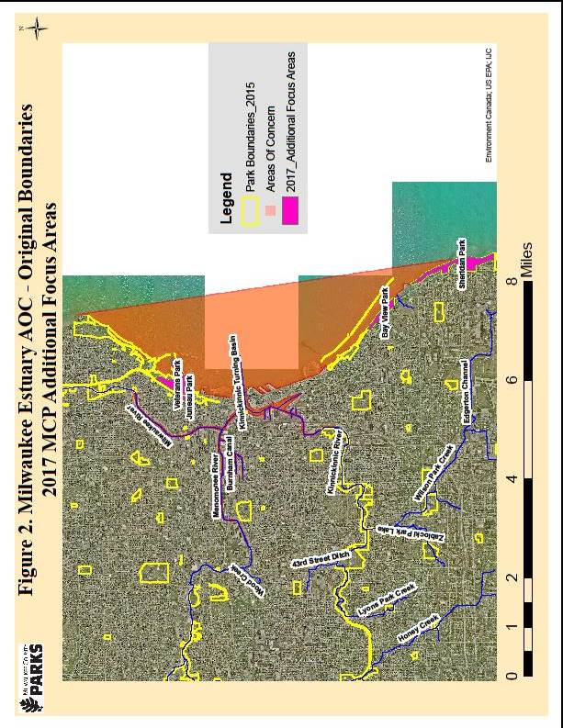
Table 1
