SCOPE OF WORK

Project Title: Burnham Canal Ecosystem Restoration Project – Wetland Base East of S. 11th Street Bid – Bid Document Preparation and Advertisement

DNR Project Manager: Stacy Hron, Milwaukee Estuary Area of Concern (AOC) Coordinator

Contact Information: 2300 N. Dr. Martin Luther King Jr. Dr., Milwaukee, WI 53212;
414.263.8625, stacy.hron@wisconsin.gov

Partner Project Manager: Patrick Elliott, Senior Project Manager

Contact Information: Milwaukee Metropolitan Sewerage District (MMSD), 260 W. Seeboth Street, Milwaukee, WI 53204; 414-225-2168, pelliott@mmsd.com

DUNS#: 094361409

Milwaukee Estuary Area of Concern (AOC) Project Location: Burnham Canal between 1-43 overpass and S. 15th Street Extended (Figure 1)

Project Landowners: MMSD, Miller Compressing Company and other private riparian landowners.

PROJECT DESCRIPTION

The Burnham Canal Ecosystem Restoration Project will restore 6.7 acres of wetland to the Menomonee River Valley in the City of Milwaukee, Milwaukee County, Wisconsin. The wetland restoration was designed by the U.S. Army Corps of Engineers (USACE) in October 2017 (Figures 1 & 2). The USACE proposes the construction be completed in two phases. The initial phase is creating the base for the proposed wetland (Wetland Base). This consists of adding granular fill to build up the bottom of the existing canal to elevation -7.0 City of Milwaukee Datum. No construction activity will take place for an estimated 2-5 years following the construction of the Wetland Base to allow the underlying sediments to compress. When the compression of the sediments has stabilized, the final phase, construction of the wetland, will proceed which includes the installation of the remaining fill, wetland soils and substrate, wetland vegetation and post construction vegetation establishment period.

This agreement only consists of the tasks necessary to prepare and advertise bid documents for the construction of the Wetland Base east of S. 11th Street based on the USACE design plan and specification submittals in October 2017.

A. BACKGROUND

The Burnham Canal is located in the City of Milwaukee, Milwaukee County, Wisconsin. The Canal is within Township 7 North, Range 22 East, Sections 31 and 32. The Canal was dredged out of wetlands in the 1870s to provide access to the Menomonee River for industries located in the southern portion of the Menomonee River Valley. The Canal was a federally-authorized channel until the mid-1980s when the portion west of 11th Street was declared non-navigable to allow for construction by the City of a fixed bridge at 11th Street. The Canal east of 11th Street was last dredged in 1987. Under the Water Resources Development Act (WRDA) of 2014, Section 3006, the remainder of Burnham Canal was deauthorized. Navigation is now limited to small watercraft due the low clearances beneath the 11th Street bridge and the Canadian Pacific Railroad bridge at the east end of the Canal.

The Canal serves as a discharge point for stormwater runoff from the surrounding area including point source (pipes) and non-point source runoff. The Milwaukee Metropolitan Sewer District (MMSD) owns five combined sewer outfalls (CSOs) located throughout the canal. In addition, there are several smaller diameter City of Milwaukee and privately-owned storm sewer outfalls that drain land immediately adjacent to the Canal.

The Canal is surrounded by primarily industrial land use, and each of these land owners abutting the Canal have riparian rights to the Canal. At the west end, and north of the west end, is the former Miller Compressing Corporation (MCC) metals recycling facility. This operating facility is now owned by Alter Trading Company. Alter mostly uses the north side of the Canal for parking of semi-trailers. East of Alter on the north side of the Canal are the former Manitowoc Cement Company west of 11th Street, and Huron Portland Cement Company east of 11th Street. The former Manitowoc Cement Company property appears to be abandoned and no longer in use, whereas the former Huron Portland Cement Company property appears to be currently used as an auto salvage operation. Properties on the south side of the Canal appear to be used for mixed light industry and commercial operations.

B. MCC Environmental Liability

On May 30, 2008, MCC entered into an Administrative Settlement Agreement and Administrative Order on Consent with the U.S. Environmental Protection Agency Region 5 Superfund Unit (USEPA) to conduct a remedial investigation (RI) and feasibility study (FS) on the Burnham Canal west of the 11th Street Bridge to address elevated copper and polychlorinated aromatic hydrocarbons (PAHs) levels in the Canal sediments. USEPA issued a Record of Decision (ROD) to MCC in September 2011 which included a remedy consisting of a small quantity of soil and sediment at the west end of the Canal, and placing an engineered cap of granular materials over the remaining sediments east to the 11th Street bridge. The cap is to be nominally 12 in. thick (minimum of 9 in.) to address ecological and human health risks. MCC, with its design consultant Natural Resource Technology, Inc. (NRT), have completed design of the capping remedy and received USEPA approval to proceed with remedy implementation. The Wisconsin Department of Natural Resources (DNR) has been involved throughout this process.

C. Wetland Restoration Project

Multiple stakeholders including USEPA, DNR, the City, the USEPA Great Lakes National Program Office (GLNPO), MMSD, and MCC have been collaborating on filling in the Burnham Canal to restore wetlands in this area of the Menomonee Valley and address beneficial use impairments (BUIs) in the Milwaukee Estuary Area of Concern (AOC) (Figure 4).

MCC proposes to not only install the capping remedy, but also increase the depth of this cap in order to provide the wetland base for the wetland project area west of S. 11th Street. DNR is submitting a funding request to the EPA for funds to construct the wetland base for the project area east of S. 11th Street. It is anticipated that this would be followed by construction of the wetland for the entire project area and post construction vegetation establishment (Figure 5).

D. Anticipated Schedule

For administrative purposes, planning is ongoing for DNR to take over the lead environmental agency role from USEPA for both the MCC remedial action and the MMSD wetland restoration project. The anticipated schedule for construction activities is currently:

MCC Construction of Cap and Wetland Base West of 11th Street | 2018 – 2020
MMSD Construction of Wetland Base East of 11th Street | 2019 – 2021
MMSD Wetland Construction | TBD

E. Wetland Restoration Project Design

In the WRDA Bill of 1990, Congress authorized the U.S. Army Corps of Engineers (USACE) to support the development and implementation of Remedial Action Plans (RAPs) at U.S. Great Lakes AOCs. Section 401 of this Act enables USACE to provide technical support to State and local governments. MMSD retained USACE to prepare design plans and specifications for the wetland restoration project, which were completed and submitted to MMSD in early October 2017. The USACE deliverable did not include final permitting, real estate or preparation of bid documents. The Federal portion of the cost-shared design project was funded under GLRI, whereas the MMSD’s non-federal sponsor portion was funded through a grant from The Fund for Lake Michigan.

Project Rationale

Habitat rehabilitation in the Burnham Canal has been identified as a management action for the Loss of Fish and Wildlife Habitat BUI in the Milwaukee Estuary AOC Remedial Action Plan Update for 2016. The Burnham Canal Ecosystem Restoration project will contribute one management action. The management action projects were selected by DNR in consultation with the Fish and Wildlife Technical Advisory Committee (Tech Team). The Tech Team identified the following necessary project elements, fish and wildlife goals addressed by the project, and metrics for evaluating the project. These elements, goals and metrics will be included in the final design and implementation of the project (see Appendix C, 2015 Milwaukee Estuary AOC Remedial Action Plan Update).

The necessary Burnham Canal Ecosystem Restoration Project elements include:

- A seiche wetland with a passively controlled hydrologic connection to the estuary. The connection should be passable by aquatic organisms, with northern pike the target species to use for design purposes.
- A design that incorporates a variety of wetland types and includes improvements for other wetland dependent Species of Local Conservation Interest is recommended (e.g., birds, herptiles) in addition to fish.
- The vegetation plans should be designed to be as resistant to invasive species as possible.
- An invasive species and vegetation management plan (aquatic and terrestrial) that will be implemented in both a short and long-term basis.
- Include submergent and emergent vegetation cover types. Shoreline and wetland vegetation should be selected to maximize food resources for breeding and migratory birds.
- Some type of permanent conservation protection for the site (conservation easement, deed restriction or equivalent).

Fish and Wildlife Goals Addressed by this Project

- Enhance/improve aquatic habitat by:

A. Identifying and enhancing fish spawning sites from Lake Michigan to the tributaries and headwaters where opportunities exist (e.g., inner and outer harbors, Milwaukee River downstream of the North Ave. Dam pedestrian bridge), and/or

B. Improving lateral connectivity by connecting aquatic habitat to floodplain wetland with suitable hydroperiod from Lake Michigan to the tributaries and headwaters where opportunities exist.

- Improve aquatic habitat connectivity by:

- Improving linear connectivity by restoring or enhancing fish and aquatic organism passage from Lake Michigan to the tributaries and headwaters.

3. Enhance/improve terrestrial, semi‐aquatic, and/or riparian habitat by:

A. Expanding habitat buffer width to a minimum of 75 feet, and/or Improve terrestrial riparian habitat connectivity by expanding riparian buffer habitat quality and continuity.

Criteria/Metric for Evaluating Goals and Objectives are Met for this project:

- Establishment of a functional seiche wetland with suitable Northern Pike spawning habitat on site.
- Spawning of Northern Pike demonstrated.
- An increase of acres of wetland and other wildlife habitat present on site.
- An increase in the number of species of local conservation interest utilizing the site, as measured by appropriate occupancy documentation.
- Creation of 6.7 acres of wetland habitat.

Responsibilities of Partners, Collaboration & Decision Making
MMSD and DNR are entering into this project with a shared vision of restoration and an approach of collaboration. It is the intent of all to complete a project that benefits the fish and wildlife of the river and in turn the community, while fitting into the site and regulatory constraints. It is recognized that the project must meet the funding goals and criteria. It is DNR's responsibility through the funding to ensure satisfaction of these goals and criteria for meeting the delisting of the Beneficial Use Impairments (BUIs).

A project team made up of representatives from the DNR and MMSD will ensure coordination and continuous interaction between parties. At a minimum, the project team will include the respective project managers for both agencies. The project team will utilize collaborative decision making.

The project team will develop the scopes of work for contracting firms, participate in progress meetings, discuss change orders, and provide updates. The team shall function within the framework of funding regulations, state statutes, local ordinances, and MMSD procurement procedures.

It is recognized that project outputs must meet GLRI and AOC goals and criteria. It is DNR's responsibility to ensure satisfaction of these goals and criteria.

MMSD shall:

- Obtain and hold access agreements from riparian landowners to gain access to properties where this future work is to be conducted.
- Seek public input including public education information meetings.
- Administer the funding according to the aid agreement and this scope of work.
- Hire qualified consultants and carry out this scope of work.
- Execute necessary permitting and obtain necessary approval from local entities.
- Work with the DNR to ensure the project continues to meet the AOC fish and wildlife habitat goals to the DNR's satisfaction.
- Review all consultant's invoices to assure that all work included is complete before submitting an invoice to DNR for reimbursement.
- Provide a project manager.
- Assure the scope of work has been completed by June 30, 2019.

DNR shall:
- Provide funding for the execution of this scope of work for the total tasks and deliverables in the amount specified in section Project Funding & Invoicing.
- Provide oversight of this funding agreement.
- Provide any available information collected as part of other AOC and wildlife and fisheries related projects.
- Review and approve drafts, work products, invoices and deliverables in a timely manner.
- Provide a project manager.
- Assist the District with navigating local and state permit processes.

Project Goal and Scope

The goal of the Burnham Canal Ecosystem Restoration Project – Wetland Base East of 11th - Bid Document Preparation is to perform all necessary tasks to prepare and advertise bid documents for the construction of the Wetland Base east of S. 11th Street as designed by the USACE in their Burnham Canal Ecosystem Restoration Project (October, 2017) . The specific components of the USACE design included in this bid document preparation include the following:

- Install a low-head, steel sheet pile (SSP) wall at the eastern extend of the project, just west of the I43 bridge. Install a silt curtain in the Canal upstream and downstream of the SSP wall before its installation.

- Place a high-strength geotextile on the sediment surface between the 11th Street bridge and the SSP wall, working from west to east.

- Place wetland granular fill materials over the high-strength geotextile, from the 11th Street bridge to the SSP wall, to Elevation -7.0 feet (ft), City of Milwaukee Datum (CMD).

The scope excludes the construction of the Wetland Base and complete Wetland Restoration.

Tasks and Deliverables

The following is a list of tasks that must be completed for the project along with the deliverables associated with each task. All work products must be approved by Wisconsin Department of Natural Resources (DNR) and will be retained as property of DNR. All work deliverables should be submitted to the DNR Project Manager.

Task 1: Hire a Qualified Consulting Firm
MMSD previously utilized a competitive selection process to award a contract with O’Brien & Gere Engineers, Inc. (OBG, formerly Natural Resource Technology, Inc.). This project will use that contract.
Deliverables:
a) Contract between MMSD and OBG (electronic)

Task 2: Regulatory Analysis and Permitting
Identify all local, state and federal regulatory requirements and permits for Burnham Canal Ecosystem Restoration – Wetland Base East of 11th Street including reviews for endangered and archeological resources. Prepare and submit applications and obtain the applicable permits. In-water and land-based construction activities will follow DNR practices and permit requirements for preventing the spread of aquatic invasive species (AIS). Prepare and gain approval for a Quality Assurance Project Plan (QAPP) or appropriate quality documentation for the activities within this scope of work from DNR and the US Environmental Protection Agency (EPA).
Deliverables:
a) Copies of all permit applications, regulatory correspondence and approved permits.
b) Completed QAPP in electronic format

Task 3: Access Agreements
Identify and obtain all access rights needed to construct the Burnham Canal Ecosystem Restoration – Wetland Base East of 11th Street.
Deliverables:
a) Copies of all access agreements.

Task 4: Burnham Canal Ecosystem Restoration – Wetland Base East of 11th Street Bid Documents
Utilize the USACE design to develop construction bid documents for the Wetland Base East of S. 11th Street. Prepare essentially complete bid documents (includes plans and specifications) and cost estimates for MMSD and DNR review and comment. Incorporate review comments, prepare final camera-ready construction bid documents and cost estimates and submit for DNR review. Prepare a draft and final bid document summary memo and a detailed construction schedule.
Deliverables:
- Essentially complete bid documents and cost estimates (electronic formats)
- Final camera-ready bid documents and cost estimates (electronic formats)
- Bid document preparation summary memo and construction schedule (draft and final – electronic formats)

Task 5: Coordination with Stakeholders
MMSD will collaborate with the DNR via the DNR project manager and other appropriate staff throughout the project. Appropriate public input processes and notices will be included in addition to soliciting input from the Tech Team during the design phase of the project. The DNR Project Manager will facilitate input via the Tech Team.
Deliverables:
a) Summary of public feedback, public meeting minutes and stakeholder (DNR, and Tech Team) meeting minutes (electronic)

Task 6: Complete Bid and Award
Advertise the contract documents, conduct pre-bid meeting, respond to contractor's questions, issue addenda (if required). This task is contingent upon MMSD receiving outside funding to cover all labor and expenses for the construction of the Wetland Base east of S. 11th Street.
Deliverables:
a) Copy of all bidding documents (electronic)
b) Copy of bid tabulation (electronic)

Task 7: Prepare and Submit Quarterly Reports and Final Report
Prepare and submit quarterly grant reports, quarterly invoices and a final report. Reports will be submitted July 1, October 1, January 1, and April 1. Reports will identify amount expended per quarter, activities conducted, and planned activities for the following quarter. Reports will also include identification of any issues encountered and their resolution plan (i.e. delays or deviations from the original schedule.)
Deliverables:
a) Quarterly project reports from receipt of fully executed funding agreement or pre­award cost eligibility through project close out. (electronic)

Project Schedule
The following project schedule is subject to change based on receipt of funding, permitting and timing of contract document bidding. Any changes to timing below will be through written notification from the MMSD Project Manager to the DNR Project Manager.

March 26, 2018 – June 2018 Preliminary Bid Document Preparation

June 2018 - February 2019 Regulatory Permitting

February 2019 - March 2019 Final Bid Document Preparation

March 2019 – June 2019 Contract Document Bidding & Award

Project Funding & Invoicing
Total Tasks and Deliverables Cost $229,798

 | Total
Personnel | $30,460
Fringe Benefits (99.6%)* | $30,338
Travel
Equipment:
Supplies: Survey Rental Equipment | $5,000
Contractual: Professional Services Contract | $149,000
Other Costs: Permit costs ($5k); Public Meeting Outreach ($5k), Real Estate Cost ($5k) | $15,000
Total Direct Charges | $229,798
Indirect Charges (%) | **
Total Cost | $229,798
*USEPA Cognizant Agency 2017 approved negotiation rate
**MMSD elects not to claim any Indirect Costs for this project

The method of payment is reimbursement for expenses incurred by MMSD. Those expenses include Consultant and Contractor expenses and MMSD labor and other miscellaneous expenses. Invoices will be submitted to DNR on a quarterly basis, but can be submitted monthly if desired. Documentation of allocation of project costs to this and any other funding sources must be included in each invoice. Invoices must also include details/description of work invoiced and copies of MMSD and MMSD consulting firm and contractor's invoices.

Figure 1 – Burnham Canal Ecosystem Restoration Project Limits
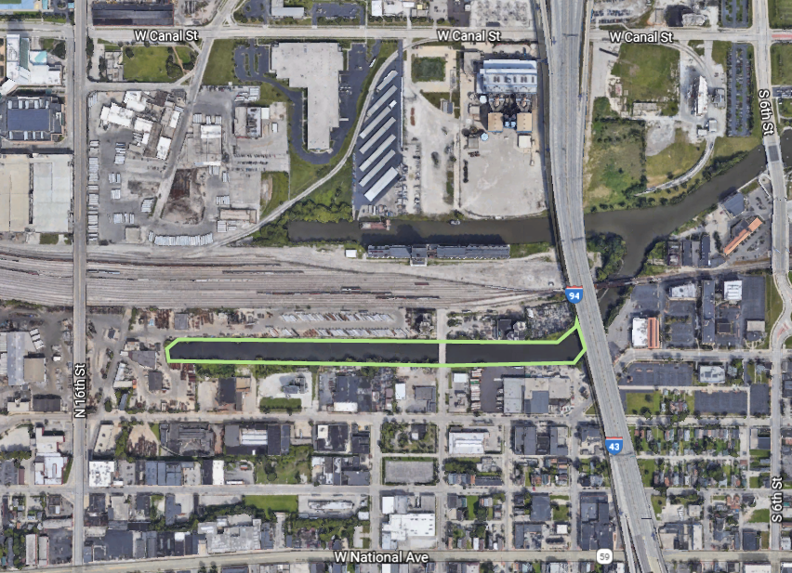
S 11th St
Figure 2 – Existing Conditions
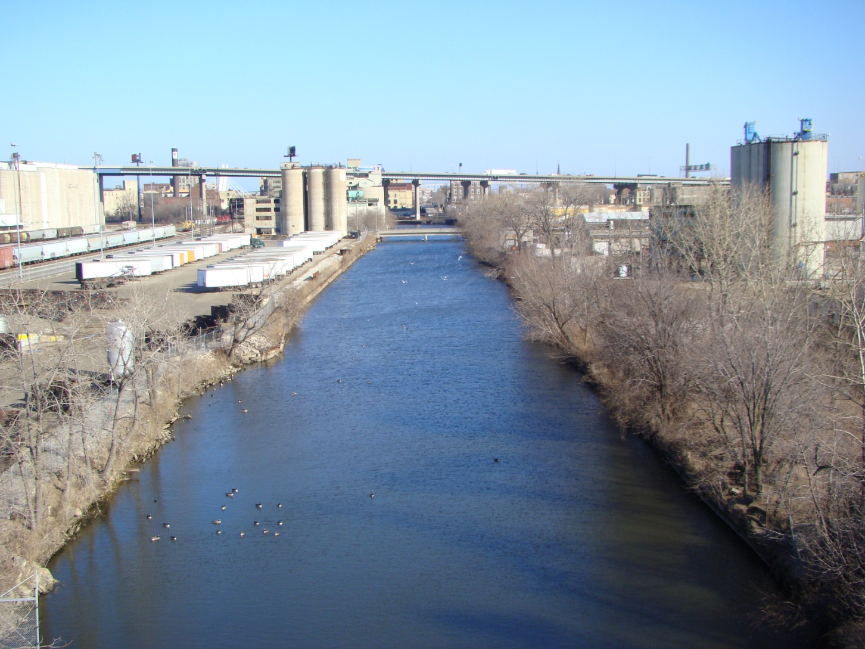

Figure 3 – USACE’s Design Rendering of the Proposed Wetland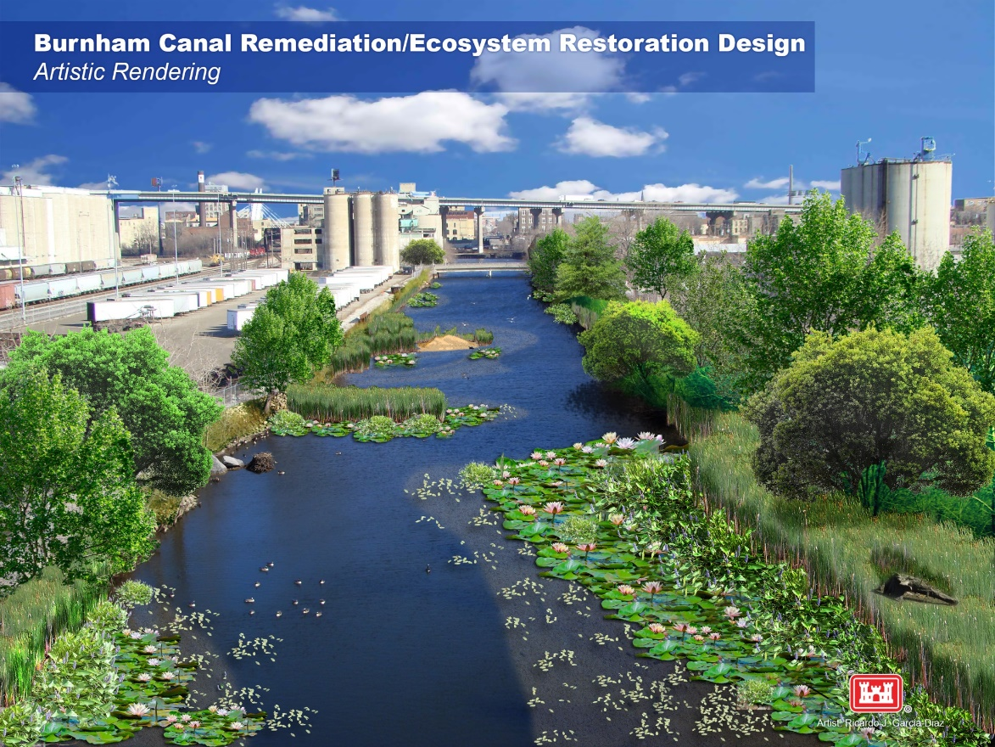

Figure 4 – Milwaukee Estuary Area of Concern
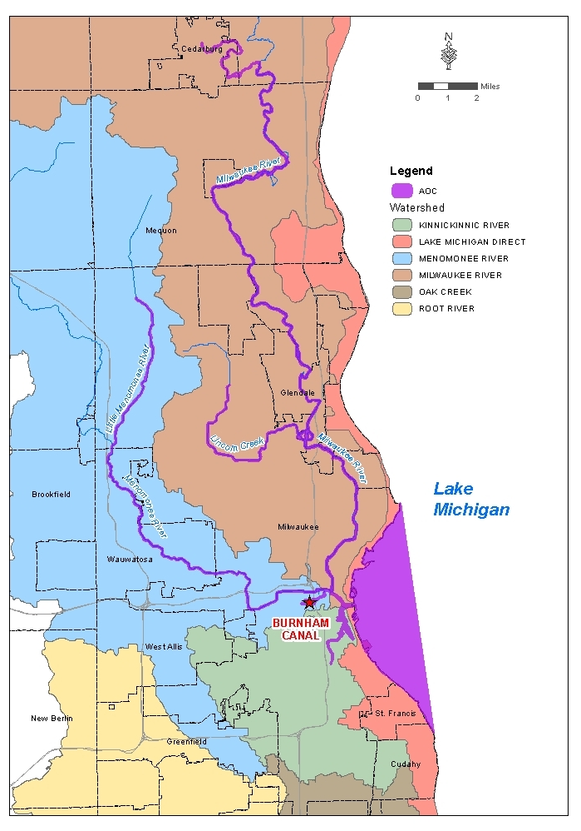

Figure 5 – Wetland Base Construction Contracts
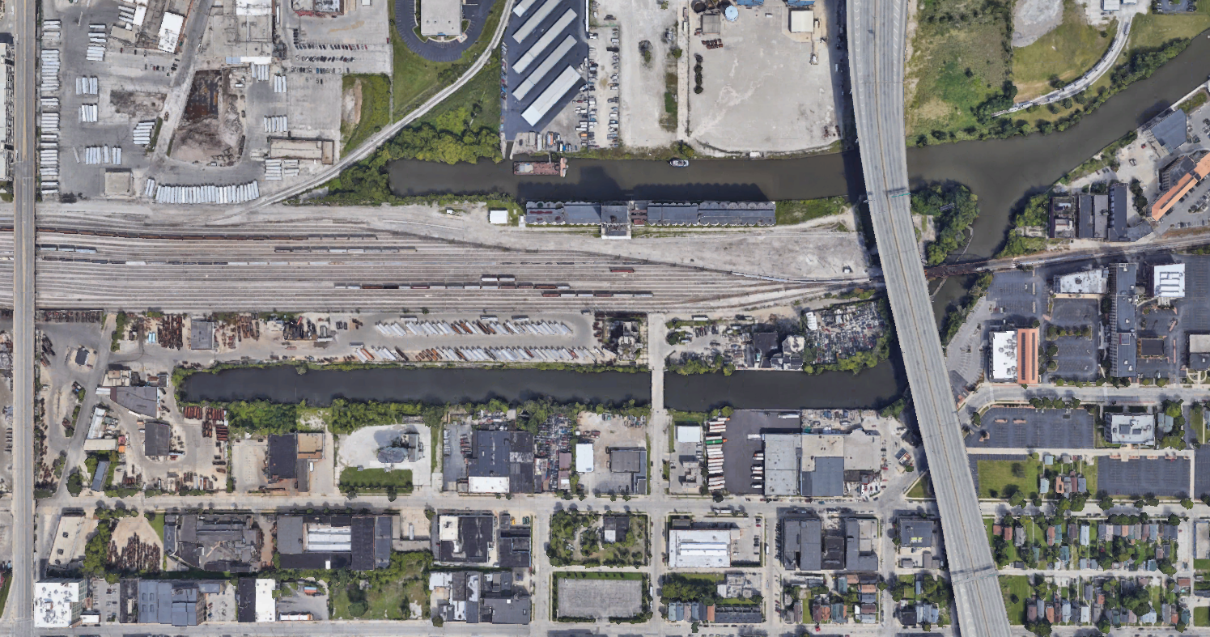
MMSD
Miller Compressing Corp

