Comparison Analysis of Drone Aerial Imagery with Field Sampling Data to Map Cattail Invasions in Allouez Bay
EDRR II Drone Analysis Addendum: Scope of Work Item #8

Final Report
December 15th, 2021
note Western side of Allouez Bay Coastal Wetland Complex.
Prepared by

Reed Schwarting, Researcher I
Kelly Beaster, Researcher I
With Assistance from: Amy Eliot, Assistant Director/Associate Scientist
University of Wisconsin-Superior
Lake Superior Research Institute
PO Box 2000
Superior, WI 54880

Prepared for
Cherie Hagen
Wisconsin Department of Natural Resources
810 W Maple St.
Spooner, WI 54801

Table of Contents

Executive Summary: 1
Introduction: 2
Objectives: 2
Methods: 3
Results: 7
Discussion 10
Non-native Cattail Impact on Wetland Health 11
Cattail Cover Effects on Average Mean C 11
Invasive Species Detected in Ground Truthing Surveys in Allouez Bay 12
Future Recommendations 12
Future Recommendations for Drone Use and Analysis 13
Future Recommendations for Allouez Bay 13
Future Recommendations for Management in Allouez Bay 13
References: 13
Appendix: 14

Executive Summary:
Freshwater coastal wetlands represent approximately 55,035 acres of Lake Superior’s shoreline. These wetlands provide water storage and filtration, nesting and hunting habitat for fish, birds, mammals, amphibians, and macroinvertebrates, and maintain an efficient storage of carbon. Due to the vast acreages and difficult terrain within Great Lakes coastal wetlands, vegetation sampling is both time consuming and costly. Allouez Bay was selected as a pilot location for testing new drone technology to determine if the technology was suitable for detecting invasive species, specifically invasive cattail. This project is focusing on sampling 250 acres of Allouez Bay Wisconsin’s south shore of Lake Superior.
Historically, aerial imagery has been used to inform the analysis of large and complex geographical areas that are cumbersome or sometimes not feasible to thoroughly survey on foot. The ability to observe and interpret finer details has drastically improved over recent decades. However, due to this rapid growth in technology, methods have not been standardized and in some cases, possibilities are still being realized. Due to this lack of standardization and testing of the reliability of the results, field observations still provide useful comparison data and still create a more accurate picture of the ecological communities within a targeted landscape. The focus of this report is to determine if drone aerial imagery can be utilized accurately as a rapid monitoring technique within large coastal wetland complexes. During this analysis, additional data was collected representing the extent of cattail invasion and overall health of Allouez Bay, which will be summarized along with the methods and results of these efforts in this report.

Introduction:
Specialized vegetation in coastal wetlands drives the dynamic nature in these systems and provides resiliency to short-term and long-term water fluctuations within the Great Lakes. The presence of monotypic stands of aquatic invasive species alters the functionality of these communities by removing that ability to change species composition when necessary. The presences of two species, Narrow-leaf (Typha angustifolia), and hybrid (Typha X glauca) cattail found in the emergent and wet meadow zones of Allouez Bay were identified as a possible threat to this natural, dynamic process. These two species have been shown to greatly alter and decrease the floristic quality of the wetland communities they establish in (Bansal et al., 2019). To better understand the extent of these species within Allouez Bay, a mosaic aerial image was created, collected by unmanned drones flown over the wetland complex. This mosaic was then visually interpreted in Geographic Information System (GIS) software to create graphical referenced polygons that included estimated percent of the foliage cover of cattail within the community (LSRI, 2021).

Objectives:
The objective of this project following the visual interpretation of the WDNR supplied aerial imagery was to develop and conduct field sampling surveys based on those results. The surveys would answer whether the drone imagery and analysis could accurately identify populations of cattail and to what degree of detail. Discrepancies between visual interpretation of imagery and on the ground field results would be reconciled on new maps. The field surveys would also provide the opportunity to assess the overall wetland floristic quality within Allouez Bay. Sampling methods would also be developed to capture both those metrics. Surveys would take place during the growing season (June 15 – September 15) and would focus on a mix of presumed high and low floristic quality areas. Once the surveys were completed, field data would be digitized, cataloged, and quality checks performed on all collected data. Project deliverables listed below:
- Develop a simplified sampling plan and identify a method for ground-truthing
- Conduct transect surveys in Allouez Bay
- Conduct timed meander surveys in Allouez Bay
- Interpret findings and revise original shapefile as needed
- Submit revised shapefile electronically to WDNR
- Submit a report (2-page) describing the objectives, methods, results and brief discussion
- Attend coordination meetings (2) and communicate with project lead from WDNR as needed

Methods:
Data collecting in the field can be split into two different methodologies. The first method is the Coastal Wetland Monitoring Protocols (IGLR, 2018) adapted to capture differences in cattail cover class rather than specific communities. The second is a Timed-Meander Sampling (WDNR, 2021). In order to meet the requirements defined by our objective it was deemed necessary to include both types of sampling. Since the primary focus of the project was cattail, the wetland East of the road was considered unnecessary for analysis given the small amount of cattail estimated and the limited resources to include additional surveys.
The main body of the complex was divided into three distinct lobes, using the two main creeks entering the bay from the South as boundaries. Each lobe was assigned two transects for a total of six. Transects were placed pre-survey and required to meet the following criteria: a transect needed to run through three distinct cover class polygons; a transect needed to run through a community type of high interest¹; a transect needed to run the length of the wetland communities, from the open water edge to the unclassified tree canopy or similar boundary with an angle that is perpendicular to the general boundary. ¹The community of high interested is in refinance to the estimated land cover field “type” (Appendix A. Table 1.). Of the three wetlands categorized in the “type” field (appendix, table 4); Marsh, Meadow, and Shrub Scrub, meadow was assumed to include the best indicators of high quality extrapolate by the estimated vegetation indicators and earlier experience within the complex. Transects were drawn in GIS software ArcGIS Pro to meet the criteria and exported to handheld GPS devices for use in the field.
Two handheld GPS devices were used during field sampling for quality assurance. The endpoints of the transects were accessed from the open water side (Allouez Bay) of the wetland via watercraft. Once an endpoint was reached a point was collected using both devices. Additional points were collected with both devices whenever possible. From the start point, a targeted end point was established at the far end of the complex using a combination of GPS and compass direction. A bearing tree was selected that best represented the targeted transect route. The field team would walk toward the selected bearing while making observations of the surrounding wetland. If a consensus between all members of the team was reached that a new dominance class of cattail foliage cover was reached, a waypoint was taken with the GPS’s. These points would be used later to divide the transect into smaller units for the quadrate potion of the survey.
This is the first modification to the Coastal wetland sampling protocols, which selects breaks in the transect based on dominate wetland type, not foliage cover of a specific species. The second modification is establishing “inland” endpoint for the transects. Our modification allowed for the continuation of the transect through dominate shrub/scrub habitat which would normally halt further expansion in the Coastal Wetland Monitoring Protocols. Instead, this modified version allowed the continuation of the transect until tree canopy became the dominate cover. Reaching an upland community or an area of open water (Creek edge, transect 4) was still used as criteria for ending a transect. Upon reaching the “inland” endpoint teams would begin the quadrat sampling part of the survey.
The transect was divided up using the points taken at the boundaries between observed changes in cattail foliage cover. A distance measuring tool on the GPS was used to find the length between one point and the next along the transect. This length was divided by six to create five equal distance breaks for sampling plots within the cover class area with a buffer zone on either end. A minimum of five meters is required as a buffer between the edge and each of the sampling points for a total of 30 meters. If the minimum of 30 meters can’t be reached along the length of a part of the divided transect, a sub-transect may be placed 90⁰ to the main transect and placed halfway between the two boundary points within a given foliage cover class. This requires that at least 30 meters of a given cover class be present to sample either by length or width along the main transect.
Using the profession experience of team members, a community could be selected for further sampling using the Timed-Meander protocols. Timed-Meanders capture a more wholistic picture of the species present within the targeted community. One of these surveys was required to accompany each transect, while additional Timed-Meander surveys could be performed if multiply communities within the transect are selected by team members.
Data sheets were scanned for digital archival. The transect data was entered into a Microsoft Access database. The Timed-meander sampling data was entered into a WDNR created Excel table specifically designed for analysis of that sampling method. All database and excel entries were quality checked against the physical datasheets after entry.
The main data analysis utilized for the floristic quality analysis was the averaged species’ coefficient of conservatism or C weighted against the observed foliage cover. This is referred to as a weighted meanC. This can be further analyzed using species richness (n) to supply a weighted Floristic Quality Index (FQI). These two calculations along with meanC make up a Floristic Quality Assessment (FQA) metrics. For additional information see below:
- Mean C is the arithmetic average of the C values across the total number of plant species (n) observed in a wetland.
$$\overline{C}=\left(C_{1}+C_{2}+C_{3}+…+C_{n}\right)÷n$$
- Weighted mean C is an arithmetic mean where the C-value for each species (i) is multiplied by its proportional abundance (p) and divided by the sum of the proportional abundances:
$$w\overline{C}= \frac{\sum{p_{i}C_{i}}}{\sum{p_{i}}}$$
- Weighted Floristic Quality Index is weighted mean C divided by the square root of the total number of species (n).
$$FQI=\frac{w\overline{C}}{\sqrt{n}}$$
In addition to FQA metrics, specific species were pulled from the collected data for mapping. Those being the targeted species: Typha X glauca (hybrid cattail) and Typha angustifolia (narrow-leaf cattail) with their associated observed foliage cover. The weighted meanC and targeted species were plotted at a per sample point level. They were georeferenced using the collected waypoints. FQA metrics of the Timed-meander sampling was also calculated (appendix, table 3).
As with the original analysis of aerial imagery (LSRI, 2021), ArcGIS Pro was used for geographical analysis. The georeferenced points included from analytics above along with the collected boundary points were overlaid on the original cover class polygon layer. Similar to the original analysis methods, visional interpretation using the collected field data was applied for correcting the cover class polygons.
Corrections began by looking at the breakdown of boundary points taken in the field and those from the original cover class polygons. If the field collected pointed didn’t correspond with similar breaks, new boundary between polygons were drawn using the cut/merge geoprocessing tools. Boundary points could not be used 1 to 1 as error within the GPS units satellite reception and the original georeferencing of the drone imaging didn’t allow for exacted overlay. Instead, measurements between boundary points and the number of divides within the transects were preferred. This allowed for a new interpretation of the underlying image and could be expanded to polygons outside of the six transects based on matching similarities in observed habitat.
Next a new breakdown of cover classes was applied. Field observations and data showed that cattail was more ubiquitous throughout the complex. Areas that contained higher abundance of high-quality¹ species still contained cattail, but the native broadleaf cattail (Typha latifolia). ¹High-quality referring to species with larger coefficient of conservatism, usually within values between 6 and 10. Within these areas the quadrate reflected a foliage cover of the native broadleaf cattail between 1 and 5%. While in quadrates of the targeted species of non-native cattail, foliage cover made up a larger portion of the vegetative canopy usually exceeding 5%.
To conform with these observations the original cover classes were consolidated into four new classes and one unclassified identifier. The unclassified identifier was added to better represent areas where there was no analysis, usually due to tree canopy cover, or in areas that are not normally affected by cattail population like upland habitats. To rectify differences and still measure alteration from the original analysis each class were given numerical values that represented the range of foliage cover (in % cover).
Table 1. Breakdown of new foliage cover classes used based on collected field data.
New Cover Class Identifier | Represented Range in % Cover | Assigned Identifier to Original Class | Original Identifier | Original Represented Range in % Cover
0 | Unclassified | - | - | -
1 | 0% | 1 | 0 | 0%
2 | > 0% to <= 5% | 2 | 25 | > 0% to <= 25%
3 | > 5% to <= 25% | 3 | 50 | > 25% to <= 50%
4 | > 25% to <= 100% | 4 | 75 | > 50% to <= 75%
 |  | 5 | 100 | > 75% to <= 100%

Using the quadrat cover data, polygons along the tracks were reclassified using the new classes. An average of foliage within the quadrats was used to assign a new class identifier. If a Timed-meander survey was completed within a given polygon, those cover values were given priority for classification and the average quadrate values served as a check. Once the polygons overlapping with a given transect were reclassified, this process could be expanded to polygons without an associating transect using the underlying imagery from the classified polygons as reference. If no underlying imagery could be referenced as similar habitat, proximity to adjacent polygons of either high or low value classes was considered, along with the original identifier class.
Finally, the calculated values of weighted meanC were applied as a metric for floristic quality of a given polygon. The georeferenced quadrates with weighted meanC values were used to determine the estimated meanC of their associated polygons. Whenever possible, weighted meanC values from Timed-meander surveys within the polygon were used in conjunction with the averaged quadrat values to estimate the best possible likelihood of a polygons possible meanC. Only whole number values were assigned to a given polygon to limit categories and emphasize generalization made to polygons not associated with transects or Timed-meander surveys. Once the estimated meanC value was assigned to polygons with associated transects a process similar to that of estimating cattail cover classes was used to estimate the rest of the wetland complex. A combination of estimated cattail foliage cover, proximity to other polygons, and similarities in the underlying imagery was used to estimate the meanC of the majority of wetland polygons within the layer.

Results:
A total of 474.18 acres were analyzed from the WDNR provided drone imagery. Of that, 222.73 acres (47%) were estimated to contain cattail. Between September 1-3, 2021, six transects were walked perpendicular to the shore and distributed throughout the Allouez Bay complex. These six transects collected quadrat data within 29 observed cattail cover classes. A total of 143 quadrats were sampled, five quadrats spaced evenly among each cattail cover class and/or unique plant community crossed. This deviates from the sampling protocol of five quadrats within each cattail cover class and/or plant community. Methods in the CWMP require a plant community of 30m length or greater to include in the sampling of that site (Uzarski, et al. 2016). One polygon defined by aerial imagery was found to have a notable change in cattail cover, and the populations, though adjacent, were easy to delineate from one another. Since this break in cover included a dense population of cattail, the decision was made to sample it as two separate cattail cover classes, which identified one cover class with only 20m of length, resulting in only 3 quadrats.
After reviewing the field sampling data, the cover classes were redefined to accurately map the cattail populations. The acreages within the various cattail cover classes also shifted as those cover classes were redefined. The total number of acres in the original estimated cover of cattail within the three densest classes (50/75/100) dropped considerably from a total of 95.78 acres (LSRI, 2021) to 9.86 acres (Table 2) in the comparable class 4, 26% to 100% cover range. The remaining two new cover classes that range between 1% and 25% make up a total 218.51 acres when comparing to the original cover class that makes up a similar range (25) at 126.95 acres (LSRI, 2021). The original class categories didn’t include an unclassified identifier but instead lumped assumed foliage cover of 0%. Due to this change, an added 4.9 acres were included to the original 256.35 acres in the 0% class (1) making a total of 251.45 acres.
Figure 1. Transect and Timed Meander Locations within Allouez Bay 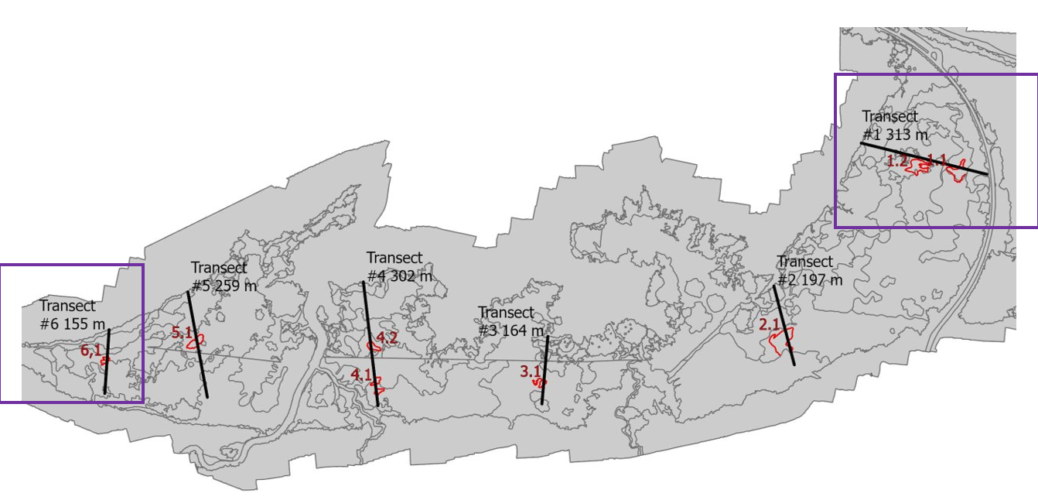
This map details the six quadrats that were sampled and their accompanying timed meander surveys (in red). The transects on the far east and far west were highlighted to demonstrate the difference in cattail between the aerial image and the ground truthing efforts (outlined with purple boxes).
Figure 2. Oligotrophic Coastal Fen on East Side of Allouez Bay Complex
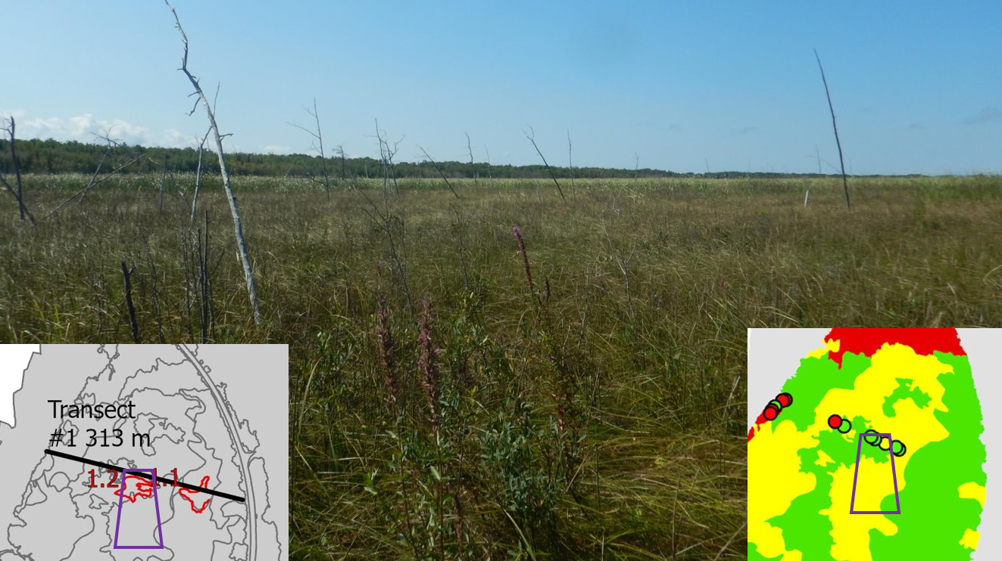
A photo of the intact plant community within the far eastern transect (#1). Looking to the south at a zone of 6-25% cattail cover (in yellow polygon). This cattail appears as a wall in the distance adjacent to the high-quality coastal fen community.
Figure 3. Cattail Density and Standing Dead Vegetation
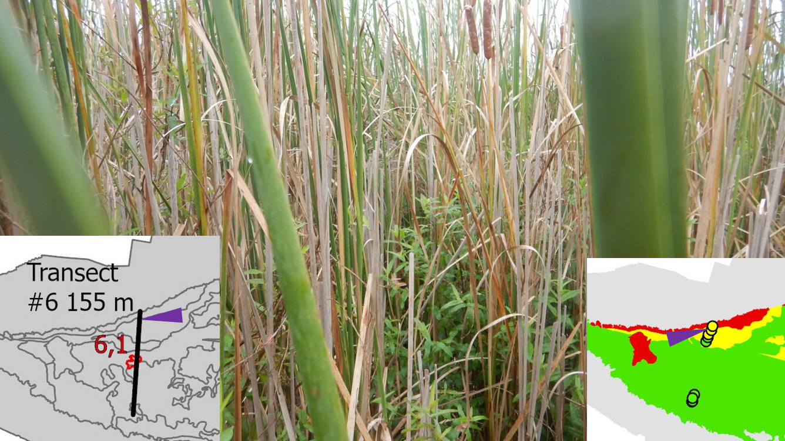
A photo of cattail within the far western transect (#6). This cattail was found to the north of the transect (purple arrow indicating approximate location). From the ground, this cattail was given a cover in the range of 6-25% (identified as yellow circle), but from the drone aerial image, it had been labeled 75-100%. Standing dead cattail stalks nearly outnumber the living, and the only other species found in this photo is non-flowering purple loosestrife (Lythrum salicaria).
Table 2. Invasive Species in Allouez Bay
Invasives Present Throughout Allouez Bay Survey
Species | Typha x glauca | Typha angustifolia | Lythrum salicaria | Iris pseudacorus | Typha latifolia | Phragmites australis ssp americanus
Occurrence | 34 | 8 | 43 | 2 | 34 | 5
Total Quadrats | 143 | 143 | 143 | 143 | 143 | 143
AVG % Cover | 22.2 | 19.6 | 7.4 | 3.5 | 7.3 | 2.8

Of 143 quadrats sampled along six separate transects, 65 quadrats (or 49%) contained one or more invasive species. Only four invasive species, Typha angustifolia (narrow-leaf cattail), Typha x glauca (hybrid cattail), Lythrum salicaria (purple loosestrife), and Iris pseudacorus (yellow iris), were detected along the six transects and within the eight meanders. Two native species that have been known to exhibit invasive habits, Typha latifolia (broadleaf cattail) and Phragmites australis ssp americanus (giant reed grass), were observed along transects and during meanders as well. Hybrid cattail occurred in the highest densities with 34 quadrats noting its presence, and among those 34 quadrats, hybrid cattail occupied an average of 22.2%. Purple loosestrife occurred with the most frequency, being noted 43 times, including within all eight timed meander surveys, but its average density was only 7.4% throughout those detections.
Figure 4. Composition of Cattail, Vegetation, and Standing Dead Cover in Average Quadrats
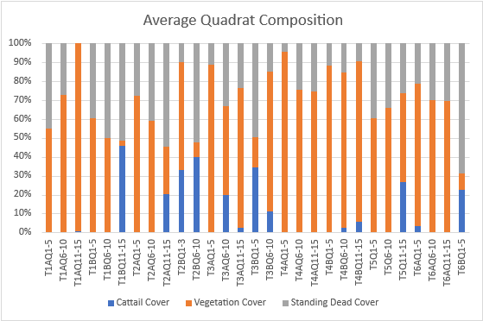
When cattail cover increased, as seen in blue, standing dead vegetation material, seen in grey, increased as a result. When cattail was present in quadrat, it often occupied close to 50% of the total vegetation observed. Total vegetation within quadrats ranged from a low of 22%, meaning 78% of quadrat was unvegetated, standing water, or plant debris, to a high of 96%, meaning only 4% of the quadrat did not contain vegetation. The average total percent cover for vegetation was 54% throughout the complex, meaning just over half of the floating mat was vegetated, the remaining unvegetated consisting of standing water, standing dead or plant debris.

Discussion
Allouez Bay is actively used by duck hunters, boaters, and fishermen while remaining a part of the Duluth/Superior shipping harbor. The bay’s importance extends to migratory birds as well as resident waterfowl and geese, the latter of which are reported to have increased in recent decades. Considered to be in relatively healthy condition when compared to other industrialized freshwater shores, Allouez Bay has experienced pollution and is included in Wisconsin’s St. Louis River Area of Concern. Past and recent surveys have shown that invasive plant species are reducing habitat quality in the bay. This drone project is LSRI’s first attempt to determine if cattail can be detected using high resolution aerial imagery obtained from drone composite photography.

Non-native Cattail Impact on Wetland Health
Non-native and hybrid cattail (Typha angustifolia and Typha x glauca) establish dense mats quickly, shading out shorter plants and eventually shading out the cattail itself, as observed during Coastal Wetland Monitoring Program surveys by the same survey team. A study by Boers et al stated that cattail populations could grow as much as 4 meters in diameter a year (Boers et al, 2008). Standing dead vegetation in coastal wetlands often plays an important role in bird habitat, but it can have detrimental impacts on the species composition when it outcompetes high-quality native plants (Bansal et al, 2019). In addition, emergent vegetation with narrower stems like bur-reed, bulrush, and arrowhead all provide for easier movement and escape for waterbirds, supply nesting cover, and produce high densities of protein rich seed which are all lacking from monotypic cattail stands (Bansal et al, 2019). High volumes of standing dead material also build up over time, weighing down the floating mat and can fill in the space beneath with that debris down to the sediment below, eliminating fish access and impacting the fish nursery (Mitchell et al, 2011).
Ground truthing efforts influenced the reclassification of the breakdown between cover values. Discerning living from dead stalks proved inaccurate during the drone imagery analysis process. Though the cover classes were not as easily classified via drone, the polygons themselves had very little to no change in area or location. This suggests that drone imagery would work well as a tool for monitoring long-term rate of spread of monotypic cattail stands.

Cattail Cover Effects on Average Mean C
In the delineated polygons, when the average cattail cover increased, the amount of standing dead vegetation, vegetation that is still discernable as having come from an identifiable plant but is no longer living, increases (Figure 4). This occurred notably in T1BQ11-15, T2BQ6-10, T3BQ1-5, and T6BQ1-5. Rarely did high average cattail cover not include a high estimation of standing dead plant material. Those delineated polygons with no cattail present often had little standing dead material.
In a similar way, as the average cattail cover increased, the average MeanC for that delineated polygon decreased (Figure 5). Eight high-quality plant communities with FQI MeanC values ranging from 5.8-6.9 and Weighted MeanC values ranging from 5.8-7.6 were observed along the six transects sampled. Five of the eight timed meander surveys identified oligotrophic coastal fens with higher Weighted MeanC values of 6.4-7.6. A small percent of cattail within a polygon had little to no effect on the average MeanC, however, as non-native cattail increased, the overall trend in average MeanC was a decline, as observed in the quadrat data along each transect (Table X). Native cattail was not included in this metric as it does not grow as aggressively as non-native cattail nor does it produce as much standing dead vegetation and shade out other plant associates, as observed by this team in this survey, EDRR surveys, and CWMP surveys.

Figure 5. Cattail Cover Effects on Average MeanC
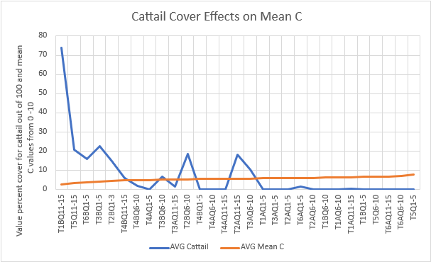
The lowest average Mean C values recorded occurred in the highest density stands of cattail.

Invasive Species Detected in Ground Truthing Surveys in Allouez Bay
Both species of non-native cattail were found in the highest densities and at nearly the same occurrence as purple loostrife (Lythrum salicaria) compared with other non-native species present. The non-native cattail species were found in 42 of the 143 quadrats or 29% of the quadrats sampled contained hybrid or narrow-leaf cattail. Purple loosestrife was found in 43 of the 143 quadrats or 30% of the quadrats sampled. When hybrid cattail was observed, its average cover was 23.7%, which is often considered the dominant species within a quadrat. Narrowleaf cattail had a slightly lower average cover when observed at 19.6%. These two cattail species were most often found on the edges of the mat, working their way inland, but occasionally would be found near Moccasin Mike Road or within the mat. A similar trend was observed with both yellow iris (Iris pseudacorus) and the native variety of giant reed grass (Phragmites australis ssp americanus), recorded on the deeper water emergent zones and spreading into the wet meadow zones. In North American wetlands, non-native cattail mats had the ability to invade open water but were found to be even more adept at progressing inland and replacing the native sedges, rushes, and grass species (Bansal et al, 2019). Dense monotypic stands replace open water and hemi-marsh systems that otherwise provided foraging and pollinating opportunities (Bansal et al, 2019). Contradicting that trend, purple loosestrife was ubiquitous throughout the complex in generally low densities, occurring at an average 3.5 percent cover. This species has been controlled with Gallerucella sp. Beetles in the past, which may be contributing to the lower density observations.

Future Recommendations

Future Recommendations for Drone Use and Analysis
This project produced a fairly accurate depiction of the total cattail invasion, as observed in 2020 via drone imagery and 2021 via field surveys. Though the field surveys were highly intensive and the initial imagery analysis was time consuming, that baseline data can now be applied to future drone efforts in Allouez Bay, using these images to train an algorithm to reduce the analysis cost. This can track cattail invasion trends over time within this complex. This same set of techniques can be applied to other wetlands and other species. As technology improves, the possibilities for using drones for future monitoring efforts will likely increase in capability.

Future Recommendations for Allouez Bay
The results of these surveys and analysis depict Allouez Bay as a high-quality oligotrophic coastal fen with heavily impacted emergent zone vegetation that is encroaching into the floating fen mat at a perceived rapid rate. The actual acreage converted each year is yet to be determined. Due to this unknown, it is recommended that drone flights continue to capture the spread of cattail. Ideally, this continuation of monitoring will develop methods for creating a suitable algorithm to classify polygons within the complex based on field survey plots obtained in 2021. Additional plots may be necessary to classify species compositions unknown to the algorithm and not visited in 2021 data collection.

Future Recommendations for Management in Allouez Bay
The field observations and floristic quality assessment data collection identified cattail as a concern for the health and preservation of high-quality plant communities with FQI MeanC values ranging from 5.8-6.9 and Weighted MeanC values ranging from 5.8-7.6. It is recommended that both hybrid and narrow-leaf cattail be controlled within the complex. The presence of cattail can be the result of an introduction of seed or root stock, but it is often an indicator or symptom of some other alteration in the environment, such as nutrient loading, presence of heavy metals, salt runoff or changes in dissolved oxygen (Bansal et al, 2019). An increase in sedimentation has been found when Typha invades a wetland, which allows for that sediment to release increased nitrogen and phosphorus that cattail is more efficient at using than native species, which eventually results in a more hospitable environment for the further success and spread of Typha (Bansal et al, 2019). Added monitoring and research into what other impacts might be contributing to the rapid spread of cattail should be conducted.

References:
Bansal, S., Lishawa, S., Newman, S., Tangen, B., Wilcox, D., & Albert, D. et al. (2019). Typha (Cattail) Invasion in North American Wetlands: Biology, Regional Problems, Impacts, Ecosystem Services, and Management. Wetlands, 39(4), 645-684. doi: 10.1007/s13157-019-01174-7
Boers AM, Veltman RLD, Zedler JB (2007) Typha x glauca dominance and extended hyrdoperiod constrain restoration of wetland diversity. Ecological Engineering 29: 232-244
Boers AM, Zedler JB (2008) Stabilized water levels and Typha invasiveness. Wetlands 28: 676-685
Institute for Great Lakes Research (IGLR). (2018) Standard Operating Procedure: Vegetation Sampling, Technical Manual. Accessed 2021, https://www.greatlakeswetlands.org/docs/QAPPs_SOPs/GLCWMP_Vegetation_SOP_2021.pdf
Lake Superior Research Institute (LSRI), Schwarting, R., Beaster, K., Eliot, A. (2021) Implementing Invasive Species Management in Coastal Wetlands Along Lake Superior: EDRR II Drone Analysis Addendum: Task #1, Summary Report
Mitchell ME, Lishawa SC, Geddes P, Larkin DJ, Treering D, Tuchman NC (2011) Time-dependent impacts of cattail invasion in a Great Lake coastal wetland complex. Wetlands 31: 1143-1149
Wisconsin Department of Natural Resources (WDNR). Timed-Meander Sampling Protocol for Wetland Floristic Quality Assessment, Accessed 2021, https://dnr.wi.gov/topic/Wetlands/documents/TimedMeanderSamplingProtocol.pdf
Uzarski, D., Brady, B., Cooper, M., & Wilcox, D. et al. (2016). Standardized Measures of Coastal Wetland Condition: Implementation of Laurentian Great Lakes Basin-Wide Scale. Wetlands, 37, 15-32. Doi: 10.1007/s13157-016-0835-7

Appendix:
Table 3. Summary of cattail (Typha sp.) cover classes by total number of acres and polygon count per cover class.
Typha Cover Class (%) | Number of Polygons | Acres
Unclassified | 155 | 235.14
0 | 91 | 21.21
≥ 0 to ≤ 5 | 123 | 160.83
≥ 5 to ≤ 25 | 166 | 57.68
≥ 25 to ≤ 100 | 38 | 9.86

Table 4. Summary of Time Meander Surveys conducted with Transects. Refer to Figure 3 for geographical location.
Time Meander  (Transect).(Set Number) | Species Richness (n) | Mean C | Weighted Mean C | Weighted Floristic Quality Index (FQI) | Observed Cattail (Typha sp.) abundance  Non-native/Native
1.1 | 36 | 6.2 | 6.4 | 38.3 | 0% / 1%
1.2 | 17 | 6.1 | 7.6 | 31.3 | 1% / 1%
2.1 | 30 | 6.8 | 6.0 | 33.1 | 0% / 12%
3.1 | 30 | 6.8 | 7.3 | 40.0 | 0% / 3%
4.1 | 29 | 5.8 | 5.8 | 31.2 | 1% / 3%
4.2 | 21 | 6.2 | 6.0 | 27.3 | 0% / 20%
5.1 | 33 | 6.9 | 7.1 | 40.5 | 0% / 1%
6.1 | 22 | 6.4 | 7.3 | 34.3 | 0% / 1%

Table 5. Metadata table for Cattail Cover Shape File (AllouezBayCattail_LSRI2021).
Field Name | Description | Unique Identifiers | Unique Identifier Descriptions
FID | Standard unique value | None | -
type | Estimated land cover | Aquatic/  Emergent | Open water and aquatic macrophyte communities.
 |  | Back Dune | Upland community progressing way from the lake behind the dune
 |  | Canopy | Tree canopy
 |  | Developed | Permanent man-made structures
 |  | Dune | Sand dune and beach
 |  | Upland Field | None forested upland.
 |  | Meadow | Wet meadow dominated by grasses or sedges
 |  | Marsh | Wetland community not dominated by woody vegetation
 |  | Shrub Scrub | Wetland community composed mainly of short woody vegetation
catail_cover | Original cover classes of estimated cattail (Typha sp.) foliage coverage based on source imagery | 0 | Percent cover of cattail (Typha sp.) foliage. 0%
 |  | 25 | Percent cover of cattail (Typha sp.) foliage.  > 0 to 25%
 |  | 50 | Percent cover of cattail (Typha sp.) foliage.  > 25 to 50%
 |  | 75 | Percent cover of cattail (Typha sp.) foliage.  > 50 to 75%
 |  | 100 | Percent cover of cattail (Typha sp.) foliage.  > 75 to 100%
area_acre | Area of polygon, unit US acres | None | -
 | New cover class classes of estimated cattail (Typha sp.) foliage coverage based on ground truthing (GT) efforts through field surveys. | 0 | Uncategorized polygon, no cover class was assigned to polygon either due to irrelevance habitat type or tree canopy cover.
 |  | 1 | Percent cover of cattail (Typha sp.) foliage. 0%
GT_cattail |  | 2 | Percent cover of cattail (Typha sp.) foliage.  > 0 to 5%
 |  | 3 | Percent cover of cattail (Typha sp.) foliage.  > 5 to 25%
 |  | 4 | Percent cover of cattail (Typha sp.) foliage.  > 25 to 100%
fqa | Estimated Floristic Quality Assessment (FQA) | 0 to 10 | Range of values between 0 and 10 using the coefficient of conservativism scale to estimate average coefficient of conservativism (meanC) within a given polygon.

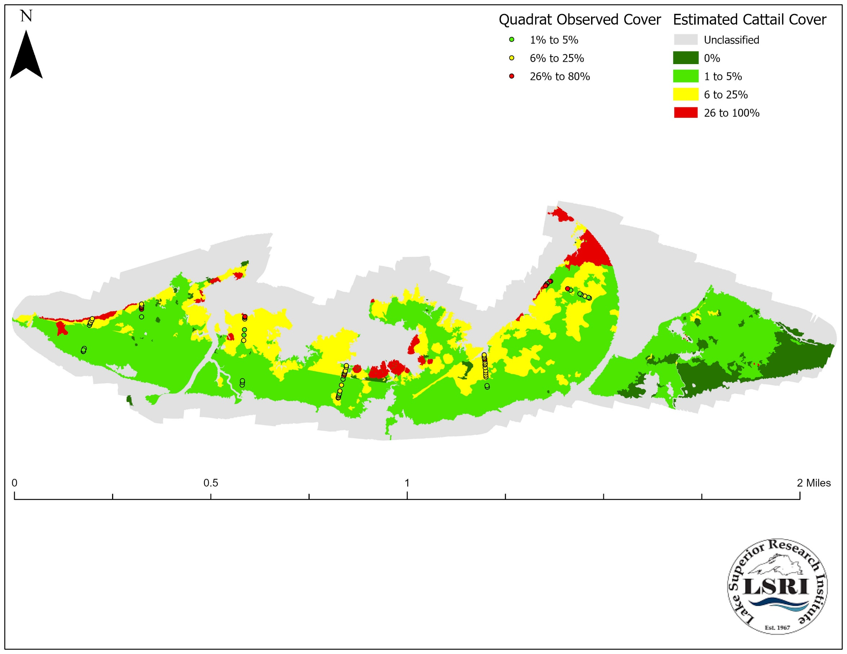

Figure 1. Estimated foliar cover of cattail (Typha sp.) in the coastal wetland at the south side of Allouez Bay.

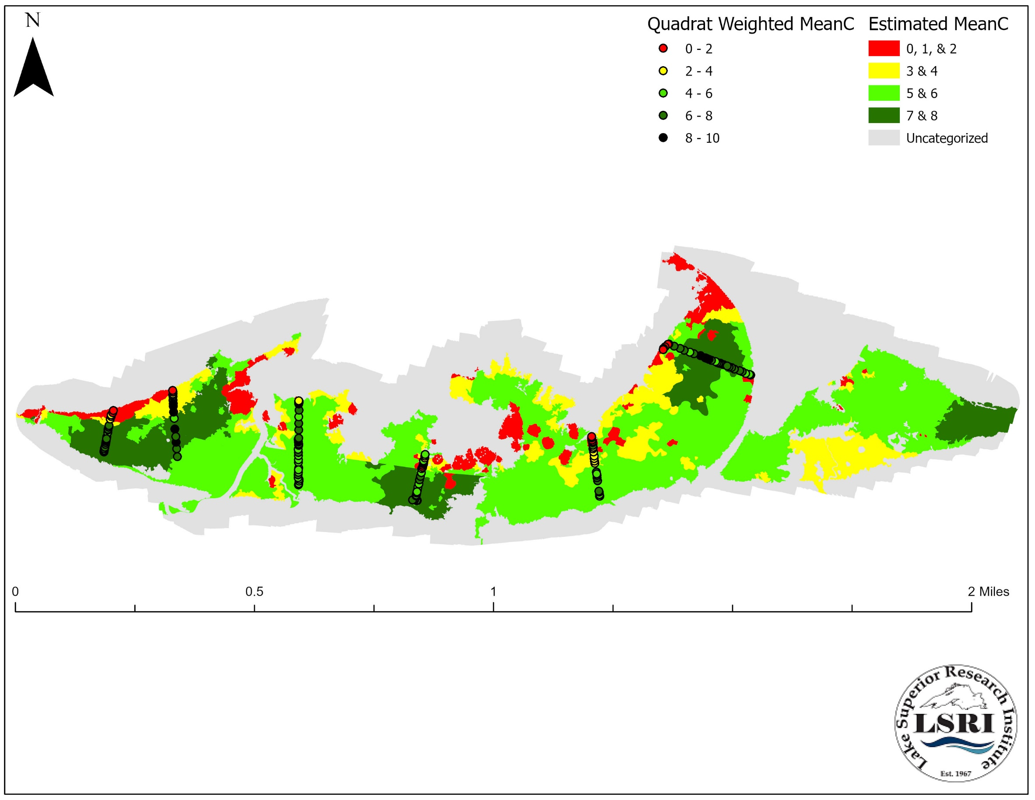

Figure 2. Estimated average coefficient of conservativism (meanC) of polygons within the wetland complex found at the south side of Allouez Bay within the St. Louis River Estuary.
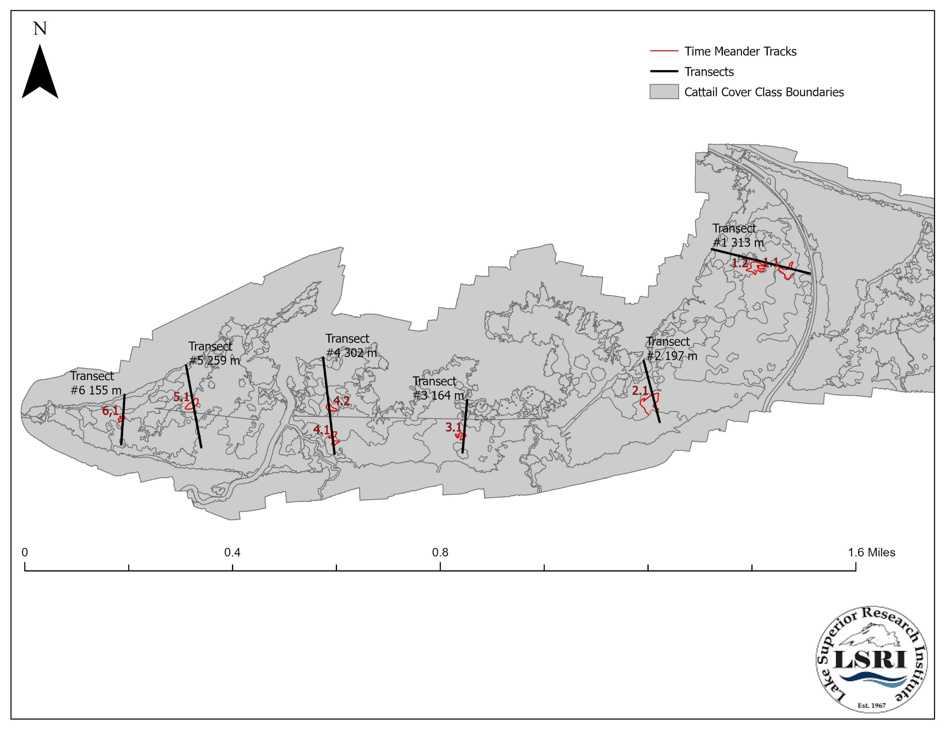
Figure 3. Sampling Location within the main wetland complex located in at the Southern edge of Allouez Bay.

