Sheboygan River AOC Mink Monitoring Summary
Compiled by Brie Kupsky – Brianna.kupsky@wisconsin.gov
Excerpts from the 2011 Sheboygan AOC REA Pathway to Delisting Project QAPP
Small mammal trapping
Small mammals will be collected from six sites in floodplain riparian areas of the Upper and Middle River segments (as delineated by the U.S. EPA for the Superfund project) of the Sheboygan River AOC and from one control location upstream of the areas of known contamination (see Figure 6). These sites will be the original three sites from the 1993 Seeley study plus three of the areas designated by the U.S. EPA FIELDS group as “hotspots” for PCB contamination. At each individual location, four traps will be set. Three of the traps will be large Sherman live traps, while the fourth trap will be a small-sized Tomahawk live trap. Trapping efforts will continue at each location until the required number of specimens is collected. For the six test sampling sites, the target will be two white-footed mice, two meadow voles, and two masked shrews per station, and for the control location, the target will be four individuals of each species. Some flexibility in these numbers is allowed in order to address the possibility of capturing mink and/or weasels. Mink and weasel are not the main targets of the study and trapping efforts for those species will only continue as long as mouse and shrew traps are still open and the researcher has not met the predetermined sample collection limit.
Mink trapping
The WDNR will contract with a local mink trapper to collect mink carcasses from two stretches of the Sheboygan River. The first location will be the Upper River and the upper half of the Middle River segments of the Sheboygan River AOC. The second location will be an area upstream and outside of the AOC. As many mink as possible will be collected during the time frame. Carcasses will be labeled and properly stored in a freezer indefinitely until sent for contaminant analysis (not included in current study). Labels will include GPS location, trap type, and date.

After trapping and analyses are completed, the data will be used to compare the contaminant levels of the mammals collected from the different AOC floodplain sites to each other and to those collected from the upstream control site. The numbers of mink trapped in the AOC will be compared to those trapped at the upstream site. A final report will be submitted, and the data will be included in the overall Ecological Assessment which is the final report for the Sheboygan AOC Pathway to Delisting habitat BUI’s—Survey and Assessment Project.

Project Timeline:
June 1st to July 31st, 2011 — Small mammal collection performed.
October 29th to December 9th, 2011 – Mink trapping performed.
August-October, 2011 – Lab analysis performed.
January 1, 2012 — Initial findings available.
June 30, 2012 — Final report (Ecological Assessment) completed for entire AOC project.

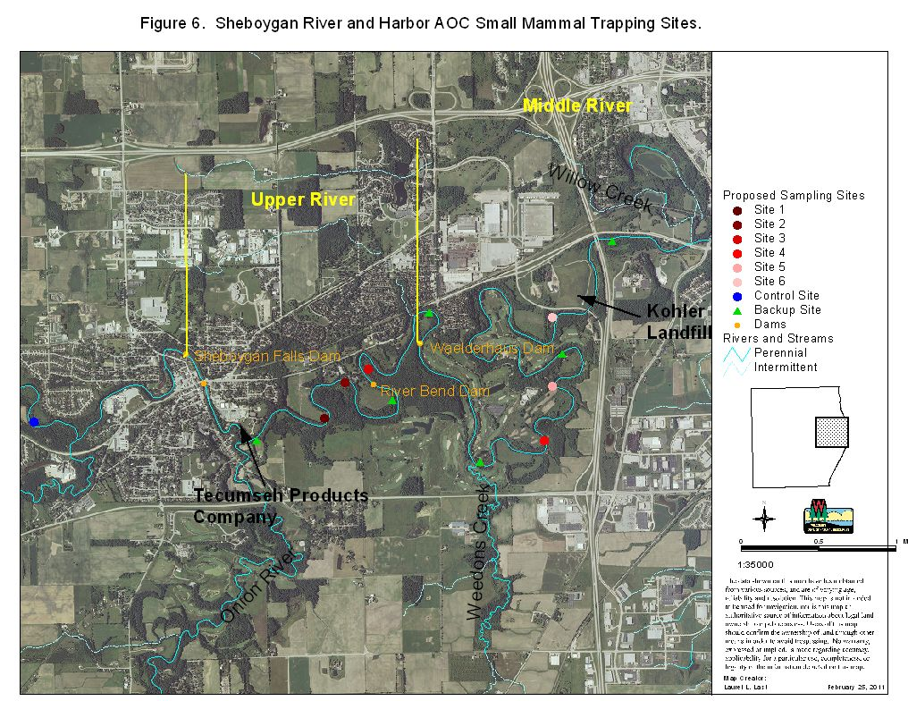
This document has concentrations from 2011 small mammal sampling with included mink from control and AOC site. Can compare to 2014-2018 results in a table.
Excerpts from the 2014 Sheboygan River AOC Verification Monitoring Project sub 5 QAPP
In 1993, a small mammal community study incidentally discovered measurable levels of PCBs in small mammals collected from three floodplain areas along the Sheboygan River AOC (Seeley, 1993). This was significant because it was the first study that showed that the PCB contamination in the Sheboygan River had found its way into the terrestrial food chain. Floodplain samples collected by Tecumseh in 1990 and 1992 for the Sheboygan River and Harbor Superfund project had already revealed high PCB levels in some floodplain areas. EPA issued a Record of Decision (ROD) for the Site on May 12, 2000. The remedy outlined specific actions to address PCB-contaminated sediment, PCB-contaminated floodplain soil, and groundwater contamination. The selected remedy included removal of floodplain soils containing PCB concentrations above 10 ppm.
In the Sheboygan AOC, there have been several attempts to quantify population dynamics and contaminant concentrations in small mammals both by academic institutions and the WDNR. These attempts have been completed with a varying degree of success. There is a prevalence of suitable habitat in the area, which suggests that is not the limiting factor for mink populations in the AOC (Seeley, 1993). It is important to note that the state of Wisconsin is one of the largest producers of mink pelts in the United states. Additionally, there are several large mink farms within 15 miles of the Sheboygan AOC including the largest individual minkery in North America.
In laboratory settings, mink have shown an extreme sensitivity to PCB contamination. Even at low levels of exposure, mink reproduction can be impaired. Mink also sit high on the food chain in riparian areas, consuming a wide variety of prey, including fish, amphibians, and small mammals. Much of this prey has tested positive in the past for contamination, especially PCB contamination. The wide variety of prey consumed, and the sensitivity to low levels of contamination make mink extremely useful as a bio-indicator of the health of an ecosystem. It has long been suspected that mink populations in the AOC are limited due to the PCB contamination. Previous efforts to locate mink in the area have been unsuccessful, despite the apparent prevalence of suitable habitat (Seeley, 1993).
2014-2016 Surveying and Trapping Methods
To determine the relative abundance of mink in the AOC and a reference site mink tracking rafts will be utilized. Tracking rafts will determine relative mink abundance. Approximately 20 rafts in the AOC and 20 rafts at the reference site will be check once a week for the duration of the trapping period for a period of 12 weeks.
Mink surveying/trapping will occur in two stretches of the Sheboygan River. The first location will be the Sheboygan River AOC between Rochester Park in Sheboygan Falls and Kiwanis Park in the City of Sheboygan. The second will be an area upstream of the AOC between Garton Rd. and County Hwy TT. The surveyor will use their own judgement as far as specific locations for raft placement.
Project Timeline:
July 7th-September 26th 2014 – Mink trapping performed.
September-December 2014– Lab analysis performed.
January 1, 2015 — Initial findings available.
June 30, 2015 — Final report completed for entire AOC project.
Mink raft sampling locations in the Sheboygan River reference and AOC 2014-2017.
2014-2016 Trapping Effort Summary
- 2014
  - Control
    - Effort lasted 78 nights from 07/14/2014 to 09/30/2014
    - 20 rafts deployed
    - 4 mink observations
      - 3 through tracks
      - 1 live on shore
    - Catch per Effort
      - 78 nights x 20 rafts = 1560 trap nights
      - 1560 trap nights / 4 mink observations
      - Total catch per effort = 1 mink every 390 trap nights
  - Within AOC Boundaries
    - Effort lasted 73 nights from 07/18/2014 to 09/29/2014
    - 19 rafts deployed
    - 2 mink observed (tracks only)
    - Catch per Effort
      - 73 nights x 19 rafts = 1387 trap nights
      - 1387 trap nights / 2 mink tracks = 1 mink every 693.5 trap nights
- 2015
  - Control
    - Effort lasted 71 nights from 07/20/2015 to 09/29/2015
    - 20 rafts deployed
    - 17 mink observations (tracks only)
    - Catch per Effort
      - 71 nights x 20 rafts = 1420 trap nights
      - 1420 trap nights / 17 mink tracks = 1 mink every 83.5 trap nights
  - Within AOC Boundaries
    - Effort lasted 71 nights from 07/22/2015 to 10/01/2015
    - 19 rafts deployed
    - 16 mink observations (tracks only)
    - Catch per Effort
      - 71 nights x 19 rafts = 1349 trap nights
      - 1349 trap nights / 16 mink tracks = 1 mink every 84.3 trap nights
- 2016
  - Control
    - Effort lasted 75 nights from 07/14/2016 to 09/27/2016
    - 20 rafts deployed
    - 8 mink observations (tracks only)
    - Catch per Effort
      - 75 nights x 20 rafts = 1500 trap nights
      - 1500 trap nights / 8 mink tracks = 1 mink every 187.5 trap nights
  - Within AOC Boundaries
    - Effort lasted 88 nights (total) from 07/14/2016 to 10/11/2016
      - Some rafts set late due to issues with Kohler Company access
      - Rafts 1-4 and 13-19 set from 07/14/2016 to 10/11/2016 (88 nights)
      - Rafts 5-12 set from 07/25/2016 to 10/11/2016 (77 nights)
    - 19 rafts deployed
    - 2 mink observations (tracks only)
    - Catch per Effort
      - 11 nights x 11 rafts = 121 trap nights
      - 77 nights x 19 rafts = 1462 trap nights
      - 1462 = 121 = 1584 total trap nights
      - 1584 total trap nights / 2 mink tracks = 1 mink every 792 trap nights
This message has an excel spreadsheet with results from 2014-2016, 2014-2016 summary, 3 year overall summary, and USGS water flow data.

This has correspondence between Julia Robson and I about mink in urban areas – they are present throughout the Milwaukee Estuary AOC, so the urbanization of Sheboygan is likely not the issue for low mink abundance.
2018 Surveying and Trapping Methods from 2018 QAPP Addendum
Trail camera will be used to collect data regarding species specific presence and total detections of species per area. Cameras will also be utilized to monitor activity in the area of body-grip traps. Each camera trap will be visited on a bi-weekly basis to check the cameras effectiveness and that it is still running correctly. Tracking surveys will collect data on animal tracks along areas of body-grip trap placement to determine presence of animals not detected by trail cameras. Tracking surveys will also assist in determining the optimal placement of body-grip traps and trail cameras in heavily used animal corridors and in areas of target animal activity.
The use and placement of body-grip traps within the AOC will be based on all Wisconsin DNR 2017-Trapping Regulations. Traps will be checked based on Wisconsin DNR 2017-Trapping Regulations. If a mink is harvested within the AOC the specimen will be submitted for contaminant analysis by the Wisconsin State Lab of Hygiene.
After trapping and contaminant analyses are completed, the data will be analyzed to compare relative abundance and contaminant levels of the mink collected from the AOC to those collected form the upstream reference site. A final report will be submitted and the results will be evaluated to assess the “Degradation of fish and Wildlife Populations” and “Bird or Animal Deformities or Reproductive Problems” BUIs.
Mink Tracking and Trapping
Mink surveying and trapping will occur along sections of the Sheboygan River within the AOC and an upstream reference area. Sites will be determined based on initial tracking surveys, past survey results, and camera trap detections. Locations of camera traps and body-grip traps will be based on availability of suitable locations and the surveyor’s best judgement.

Between January 22nd and March 30th, 2018, we will survey mink and small mammal populations within the Sheboygan River AOC. The initial portion of the study will be focused on winter tracking surveys and camera trapping in the AOC and an upstream reference area outside of the AOC. The location of AOC surveys will focus on the upper 10 miles of Sheboygan River AOC from approximately Rochester Park in Sheboygan Falls downstream to Roy Sebald Sheboygan River Natural Area in the city of Sheboygan. The upstream reference area will be bound by Sheboygan Marsh dam and Main Street in Sheboygan Falls. The small mammal tracking survey will be completed over 400 meter transects along the length of the Sheboygan River. Locations of 400 meter transects will be pre-determined from past survey results and habitat availability. Private land owner permissions will be determined before any tracking or trapping is completed on private property. Tracking surveys will be dependent on weather conditions when identifiable animal tracks are visible in the snow cover. Initial tracking surveys will determine the preferred locations of camera traps. Approximately 6 camera traps and 1-3
small mammal surveys a week will be utilized to determine presence of mink.

Camera traps will be set for an initial period of two week. Camera movement will be based on
detections made by cameras over the initial two-week period. Camera trap locations will be based on available woody vegetation to accommodate cameras and locks. The surveyors will make final in field decisions on specific camera trap locations. If presence of mink is determined within the AOC or the upstream reference area body-grip traps will then be deployed in areas of mink detection.

Body-Grip traps will be set following detections through tracking surveys or camera traps at locations determined by the surveyors. Body-grip traps will also be set in areas of special interest based on open water, habitat types, and prey availability. Diverse types of trap sets will be utilized to cover a wide range of habitats and animal behaviors. If a specimen is collected from within the AOC, trapping effort will be made to take a specimen from the upstream reference section.

2018 Budget

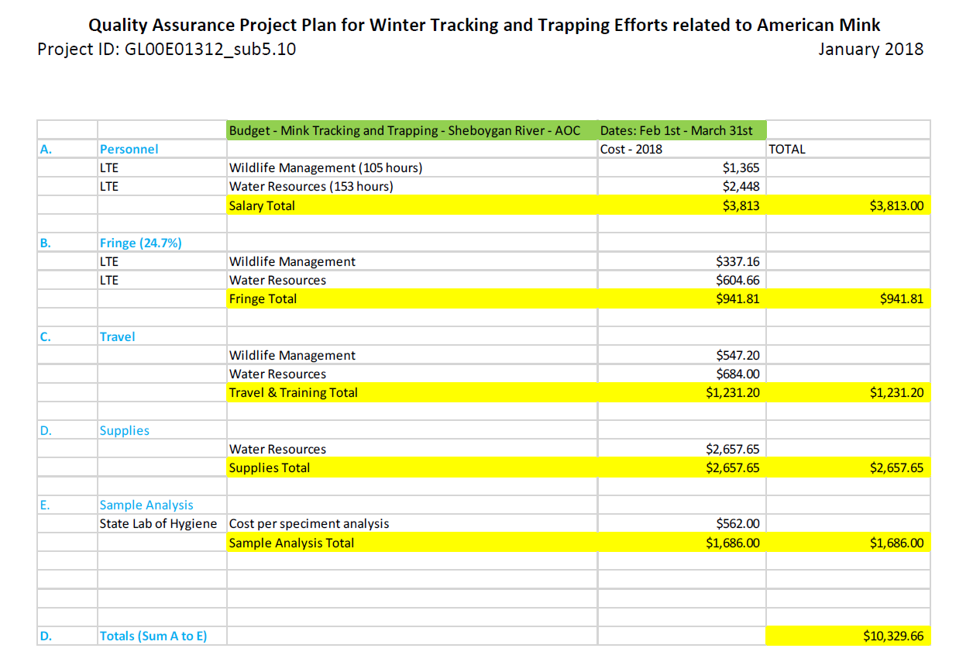
Budget Codes for Mink Project

2018 Results

The results appear to indicate that the mink within the AOC boundaries are higher than the mink from the control site. However, both AOC mink were below the toxic threshold concentration for PCBs in mink liver which is 2.0 ug/g. Sample size is an issue though.

https://prodoasint.dnr.wi.gov/prod1/pk_eq508_samp$samphdr.actionquery?P_PROCESSED_BATCH_SEQ_NO=321075&P_REPORT_TO_NAME_TEXT=SELLEAJ&P_SAMPLE_STATUS_CODE=COMPLETE&P_SAMPLE_STATUS_CODE=CORRECTED&P_SAMPLE_STATUS_CODE=DUPLICATE&Z_CHK=0

2013

- Only 2 mink and a short tailed weasel were collected within the AOC and only 3 mink were collected from the control area. Liver PCB levels from mink collected within the AOC were significantly greater than levels from mink collected outside the AOC. No mink were collected within the AOC during the initial small mammal assessment conducted in 1993, therefore a historic comparison was not possible.
  - 1 mink collected within AOC boundaries and one road-kill mink collected within the AOC, though origin of animal unknown.
  - AOC mink under the 2.0 ug/g threshold but approaching.

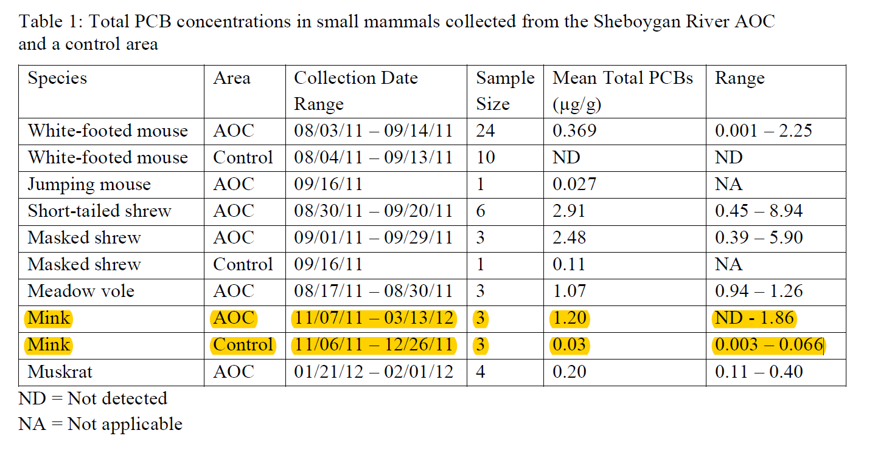

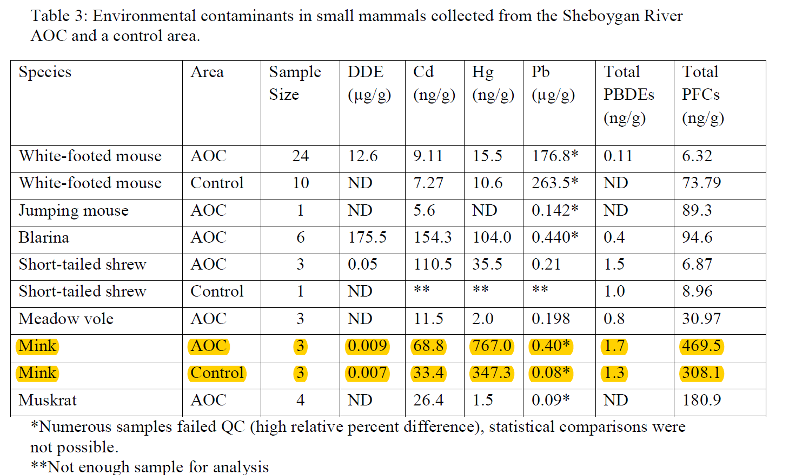

2018

- Trapped one mink at Esslingen
- Trapped one at Kohler Cnty Rd A
- One road kill mink in the control

MIN_ESS_1 = 956.2 ng/g
MIN_CORDA_2 = 1464.3 ng/g
MINK_CONTROL_PLYMOUTH = 30.7 ng/g

