SCOPE OF WORK

Project Title: W40011D01 - Kinnickinnic (KK) River Habitat Rehabilitation

DNR Project Manager: Stacy Hron, Milwaukee Estuary Area of Concern (AOC) Coordinator

Contact Information: 2300 N. Dr. Martin Luther King Jr. Dr., Milwaukee, WI 53212; 414.263.8625, stacy.hron@wisconsin.gov

Partner Project Manager: Courtney Allen, Senior Project Manager

Contact Information: Milwaukee Metropolitan Sewerage District (MMSD), 260 W. Seeboth Street, Milwaukee, WI 53204; 414-225-2069, callen@mmsd.com

DUNS #: 094361409

Milwaukee Estuary Area of Concern (AOC) Project Location: KK River between I-94 and Becher St., Milwaukee, WI

Project Landowners: MMSD, Milwaukee County, City of Milwaukee and other private riparian landowners (i.e., Cianciola LLP, United Migrant Opportunity (UMO’s) and Tall Tree Foods Inc formerly Klement Company)

Background
MMSD completed the KK River I-94 to Becher St. Feasibility Study that describes the characteristics and performance of several alternatives developed to improve the habitat and water conditions. Several meetings with stakeholder groups, notably the Milwaukee Estuary Area of Concern (AOC) committee, were conducted to obtain final alternatives. Habitat rehabilitation within the KK has been identified as a necessary fish and wildlife habitat restoration project in the Milwaukee Estuary AOC (Figure 1). The final alternatives include both habitat improvement and the additional hydraulic improvements required to offset any potential floodplain elevation increase (Figure 2). Under this scope of work MMSD proposes to design and implement habitat improvements that would address degraded aquatic habitat conditions in the upper portion of the Milwaukee Estuary AOC on the KK River. This is one of the few stretches of the KK River that has natural bed and native banks remaining. The KK River Flushing Station Improvements Feasibility Study determined this section of the KK River does not sustain a viable aquatic habitat due to low dissolved oxygen levels, lack of flow and limited diversity of channel morphology. In addition, there are contaminated sediments within this stream reach. The design and implementation will follow the KK River I-94 to Becher St. Feasibility Study, which was partially funded by a National Oceanic and Atmospheric Administration (NOAA) Great Lakes Restoration Initiative (GLRI) grant.

The KK River Habitat Rehabilitation project is located on the KK River immediately upstream from where a Great Lakes Legacy Act cleanup occurred in 2009 (see Figures 1 and 3). The KK River is the most urban and developed of the three AOC rivers/watersheds (Milwaukee, Menomonee and KK). The watershed is approximately 25 square miles on the south side of Milwaukee. Approximately 93% of the watershed is classified as urban land use (SEWRPC, 2010). In addition, of the 31 miles of stream length of the KK River and its tributaries, approximately 9 miles are lined with concrete and an additional 8 miles are contained within enclosed channel culverts (SEWRPC, 2010). In 2007, the KK River was named one of the most endangered rivers in the United States by American Rivers. Since that time, MMSD, along with other partners, have developed several plans and have implemented flood management projects on the KK River. In addition to reducing flood risks, these projects also removed concrete and restored the watercourse to a more natural state. This project would continue that progress and was identified as a management action in the DNR 2016 Remedial Action Plan Update for the Milwaukee Estuary AOC.

Under existing conditions, poor water quality due to sediment and lack of flow within the project reach has impaired both macroinvertebrate and fish communities in the lower KK River and the adjoining sections of the Milwaukee Estuary AOC. Existing conditions also reduce the potential for future fish passage to future stream restoration projects on the KK River. Improvements to these conditions will improve fish passage to the upper reaches and tributaries of the KK River Watershed as well as improve the water quality of the Milwaukee Estuary AOC.

MMSD performed a feasibility study (KK River I-94 to Becher Street Feasibility Study, December 2016), whose objective was to recommend a feasible alternative to modify the river channel to restore natural hydraulic function and to improve aquatic habitat by restoring the natural river system. The recommended alternative includes:
- Provide significant habitat improvements in the reach between S. Chase Avenue and W. Lincoln Avenue, by constructing a variety of bottom and side-channel features and connected and off-channel wetlands;
- Improve the quality of the forested corridor and floodplain forest by removing invasive species and enacting additional management measures;
- Enhance channel areas downstream of Lincoln Avenue by providing adequate substrate, improving bank vegetation and providing waterfowl resting areas;
- Provide supplemental oxygen to maintain in-stream dissolved oxygen levels adequate to support healthy riverine and benthic communities; and
- Increase hydraulic capacity at several street crossings to mitigate floodplain impacts.

The recommended alternative could proceed in phases. Initial work (Phase I) includes implementing the KK River I-94 to Becher Street Feasibility Study features identified in each alternative that do not adversely affect baseline floodplain conditions. The initial phase could be performed concurrently with a flood management study which would further evaluate floodplain mitigation options for each alternative. The remaining work (Phases II and III) would be performed following the completion of the flood management study.
Features identified in each phase include:
- Phase I – Habitat improvements
  - Riparian forest management throughout the reach
  - Placement of wood structures along bank for aquatic habitat improvement
  - Floating wetland downstream of Lincoln Avenue
  - Supplemental aeration downstream of Chase Avenue (limited to engineering and/or pilot study)
- Phase II – Channel improvements between Chase Avenue and Lincoln Avenue
  - Conveyance improvements
  - Channel reconstruction
  - Supplemental aeration downstream of Chase Avenue (full implementation)
- Phase III Channel improvements downstream of Lincoln Avenue
- Channel bottom substrate improvements
- Channel reconstruction
Implementing these proposed features would improve the aquatic habitat, improve water quality and reduce sediment accumulation and retention within the project reach and the AOC while not increasing the flood stages for the 1% annual probability flood event.

Project Rationale
Habitat rehabilitation in the KK River has been identified as a management action for the Loss of Fish and Wildlife Habitat beneficial use impairment in the Milwaukee Estuary AOC Remedial Action Plan Update for 2016. The KK River Habitat Rehabilitation project will contribute one management action. The management action projects were selected by DNR in consultation with the Fish and Wildlife Technical Advisory Committee (Tech Team). The Tech Team identified the following necessary project elements, fish and wildlife goals addressed by the project, and metrics for evaluating the project. These elements, goals and metrics will be included in the final design and implementation of the project (see Appendix C, 2015 Milwaukee Estuary AOC Remedial Action Plan Update).

Necessary KK River Habitat Rehabilitation Project Elements
- Identify feasible alternatives that will meet the project objectives defined below.
- Identify guidelines for an invasive species and vegetation management plan (aquatic and terrestrial) that will be developed in a future design phase.
- Permanent protections will be secured for any areas where habitat improvements are planned.

Fish and Wildlife Goals Addressed by this Project
- Enhance/improve aquatic habitat by…
A. Identifying and enhancing fish spawning sites from Lake Michigan to the tributaries and headwaters where opportunities exist (e.g., inner and outer harbors, Milwaukee River downstream of the North Ave. Dam pedestrian bridge), and/or
B. Improving lateral connectivity by connecting aquatic habitat to floodplain wetland with suitable hydroperiod from Lake Michigan to the tributaries and headwaters where opportunities exist.
- Improve aquatic habitat connectivity by…
  - Improving linear connectivity by restoring or enhancing fish and aquatic organism passage from Lake Michigan to the tributaries and headwaters.

Criteria/Metric for Evaluating Goals and Objectives are Met for this project:
- Improving linear connectivity of the KK River within the AOC and to the estuary.
- Increase in suitable habitat patch size resulting from new connectivity.
- Creation or enhancement of upland buffer habitat surrounding along the riparian corridor to improve connectivity.

Responsibilities of Partners, Collaboration & Decision Making
It is the intent of all partners (DNR, MMSD and AOC) to complete a project that benefits the fish and wildlife of the river and in turn the community, while fitting into the site and regulatory constraints. It is recognized that the project must meet the funding goals and criteria. It is DNR’s responsibility through the funding to ensure satisfaction of these goals and criteria for meeting the delisting of the Beneficial Use Impairments (BUIs).

A project team made up of representatives from the DNR and MMSD will ensure coordination and continuous interaction between parties. At a minimum, the project team will include the respective project managers for both agencies. The project team will utilize collaborative decision making. It is recognized that project outputs must meet GLRI and AOC goals and criteria. It is DNR’s responsibility to ensure satisfaction of these goals and criteria.

MMSD shall:
- Hold access agreement between DNR and riparian landowner (Milwaukee County) to gain access to properties where this scope of work is to be conducted.
- Seek public input including public education information meetings.
- Administer the funding according to the aid agreement and this scope of work.
- Hire qualified consultants and contractors and carry out this scope of work.
- Execute necessary permitting and obtain necessary approval from local entities.
- Work with the DNR to ensure the project meets the AOC fish and wildlife habitat goals to the DNR’s satisfaction.
- Review all consultant’s and contractor’s invoices to assure that all work included is complete before submitting an invoice to DNR for reimbursement.
- Provide a project manager.
- Work with project team to assure the scope of work has been completed by September 30, 2018.

DNR shall:
- Provide funding for the execution of this scope of work for the total tasks and deliverables in the amount specified in section Project Funding & Invoicing.
- Provide oversight of this funding agreement.
- Provide any available information collected as part of other AOC and wildlife and fisheries related projects.
- Review and approve drafts, work products, invoices and deliverables in a timely manner.
- Provide access agreement with riparian landowner (Milwaukee County) to gain access and property rights; ensure temporary and permanent protections are secured for areas where habitat improvements are planned and implemented.
- Work with riparian landowner (Milwaukee County) to provide maintenance where scope of work has been completed.
- Provide a project manager.

Project Goal and Scope

The goal of KK River Habitat Rehabilitation project is to provide design and implementation of the recommended alternative from the KK River I-94 to Becher Street Feasibility Study for habitat improvements from I-94 to Chase Avenue, evaluate the options for supplemental aeration upstream of W. Lincoln Avenue, and pilot test the preferred option (Figure 3).

The project scope includes:
- Develop and implement an invasive species removal plan along banks and the adjoining riparian areas and valley slopes;
- Investigate suitability and implement a sturgeon or greater redhorse spawning reef. The spawning reef consists of placement of stable, appropriately sized well-graded rock along the bank and bottom of the channel;
- Develop and implement a wood structures plan along banks for habitat. Wood structures are assumed to consist of anchored logs and root wads;
- Evaluate the options and conduct a pilot study for supplemental aeration system between W. Chase Ave and W. Lincoln Avenue to further address the severe oxygen deficit (hypoxia) that forms a barrier to transit of aquatic species through the reach. The proposed aeration system would be located near the vicinity of the MMSD flushing Station and be designed to supply 6 kg/hr of oxygen into the river during intermittent periods of low in-stream oxygen levels.

To accomplish the proposed work, the MMSD would hire a qualified consultant to perform design services.

Tasks and Deliverables

The following is a list of tasks that must be completed for the project along with the deliverables associated with each task. All work products must be approved by Wisconsin Department of Natural Resources (DNR) and will be retained as property of DNR. All work deliverables should be submitted to the DNR Project Manager.

Task 1: Hire a Qualified Consulting Firm
MMSD previously utilized a competitive bid process to award the contract with Montgomery Associates Resource Solutions, LLC (MARS) in June 2015 for the KK River 1-94 to Becher St. Feasibility Study funded by the GLRI through NOAA (NOAA/GLRI). MMSD will amend the MARS contract to perform the scope of work outlined in this document.
Deliverables:
- Amended scope for MARS.
a)
Task 2: Regulatory Analysis and Permitting
Identify all local, state and federal regulatory requirements and permits for the habitat rehabilitation and supplementary aeration pilot study in the KK River. Coordinate reviews for endangered and archeological resources. Prepare and submit applications and obtain the applicable permits. In-water and land-based construction activities will follow DNR practices and permit requirements for preventing the spread of aquatic invasive species (AIS). Prepare and gain approval for a Quality Assurance Project Plan (QAPP) or appropriate quality documentation for the activities within this scope of work from DNR and the US Environmental Protection Agency (EPA).
Deliverables:
- Copies of all permit applications, regulatory correspondence and approved permits.
- Completed QAPP in electronic format

Task 3: Pilot Study for Supplementation Aeration System
Develop a pilot study for a supplementary aeration system to be installed between W. Chase Avenue and W. Lincoln Avenue.. The conceptual plan should include 1) an analysis of the available technologies with recommendation to achieve the optimal results, 2) aeration system design and implementation, 3) installation, operation, and maintenance requirements of any necessary interim/pilot aeration and monitoring equipment included in the pilot study, 4) data gathering and analysis. The conceptual plan will be submitted for review and approval by the DNR.
Deliverables:
- Conceptual pilot study plan.
- Aeration system installation, operation and maintenance.
- Data collection, analysis and draft and final design report.

Task 4: KK River Habitat Rehabilitation
Develop concept through final design documents for habitat restoration in the project area. This will focus on the improvements that can be made without increasing the flood elevation, which are mostly within the upper reaches of the project area and AOC. Conceptual plans will be developed that will identify features to be included in the habitat rehabilitation as defined in the project scope and AOC fish and wildlife habitat restoration goals that will provide significant habitat improvements in the reach and remove invasive species. The plan will identify best suited materials and maintenance needs. Following an approved concept plan, draft design report, preliminary plans, specifications and cost estimates for District and DNR review and comment will be prepared. The design report will be updated at in the final design phase. Finalize the design and prepare detailed essentially complete construction drawings for review in consultation with DNR. Prepare a final design report and a detailed construction schedule. Develop camera-ready contract documents and cost estimate for habitat rehabilitation in the KK River suitable for bidding.
Deliverables:
- Conceptual plan
- Design report (draft, preliminary and final versions)
- Preliminary plans, specifications and cost estimates (electronic formats)
- Final design plans, specifications and cost estimates (paper and electronic formats)

Task 5: Coordination with Stakeholders
MMSD will collaborate with the DNR via the DNR project manager and other appropriate staff throughout the project. The County will be included in all phases of the project appropriate public input processes and notices in addition to soliciting input from the Tech Team during the design phase of the project. The DNR Project Manager will facilitate input via the Tech Team.
Deliverables:
- Summary of public feedback, public meeting minutes and stakeholder (DNR, County and Tech Team) meeting minutes.

Task 6: Complete Implementation Bid and Award
Advertise the contract documents, conduct pre-bid meeting, respond to contractor’s questions, issue addenda (if required).
Deliverables:
- Copy of all bidding documents
- Copy of bid tabulation

Task 7: Construct habitat improvements.
Deliverables:
    - Copy of all construction contractor’s submittals.

Task 10: Engineering Services During Construction (ESDC)
MMSD will provide resident engineering and inspection services during construction. The Consultant will perform the following ESDC services: Manage and coordinate Design Team engineering support during construction; coordinate, prepare for, and attend pre-construction and all monthly construction progress meetings; review, approve or reject construction contract submittals including:, shop drawings, work plans and O&M manuals; prepare drawings/sketches, specifications and cost estimates for contract modifications and submit draft and final record drawings.
Deliverables:
- Request for proposal or another instrument to hire qualified contractor.
- Copy of all contractor’s submittals.

Task 11: Prepare and Submit Quarterly Reports and Final Report
Prepare and submit quarterly grant reports, quarterly invoices and a final report. Reports will be submitted January 1, March 1, July 1, and September 1. Reports will identify amount expended per quarter, activities conducted, and planned activities for the following quarter. Reports will also include identification of any issues encountered and their resolution plan (i.e. delays or deviations from the original schedule.)
Deliverables:
- Quarterly project reports from receipt of fully executed funding agreement or pre-award cost eligibility through project close out.

Project Schedule
The following project schedule is subject to change based on receipt of funding, design, permitting and timing of construction. Any changes to timing below will be through written notification from the MMSD Project Manager to the DNR Project Manager.

May 2017 – August 2018 Aeration system pilot study plan, design, implementation and analysis.
July 2017 – February 2018 Design of habitat improvements from I-94 to Chase Ave.
February 2018 – August 2018 Bid, award, and construction of habitat improvements from I-94 to Chase Ave.
August 2018 Substantial completion of all design and construction work
September 2018 Project close-out

Project Funding & Invoicing
Total Tasks and Deliverables Cost $850,000

 | Total
Personnel | $ 61,796
Fringe Benefits (99.6%)* | $ 61,549
Travel
Equipment
Supplies
Contractual: Design & Engineering Services | $ 295,000
Construction Contractor | $ 431,655
Other Costs
Total Direct Charges | $ 850,000
Indirect Charges (%) | **
Total Cost | $ 850,000
*USEPA Cognizant Agency 2017 approved negotiation rate
**MMSD elects not to claim any Indirect Costs for this project

The method of payment is reimbursement for expenses incurred by MMSD. Those expenses include Consultant and Contractor expenses and District labor and other misc. expenses. Invoices will be submitted to DNR on a quarterly basis, but can be submitted monthly if desired. Documentation of allocation of project costs to this and any other funding sources must be included in each invoice. Invoices must also include details/description of work invoiced and copies of MMSD and MMSD consulting firm and contractor’s invoices.

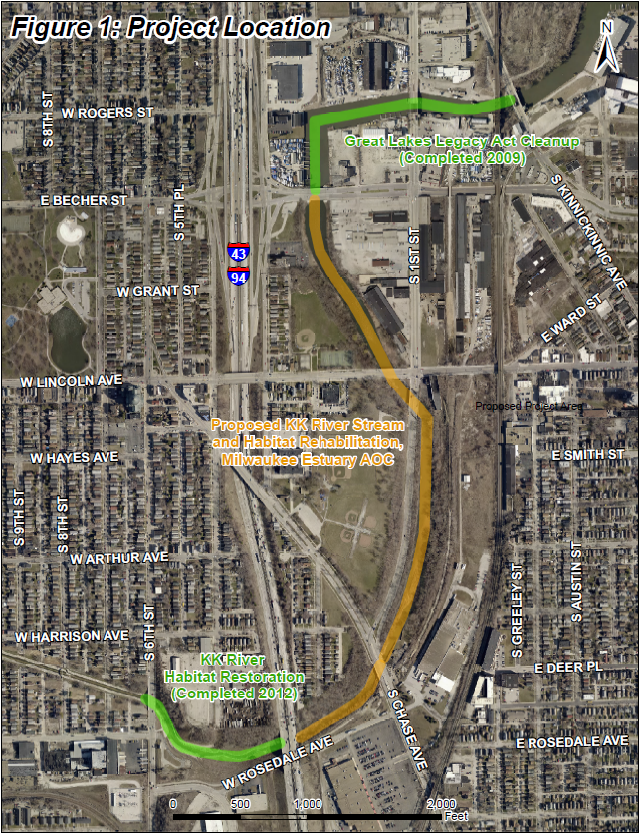

Figure 1 – Milwaukee Estuary (AOC) Project Location

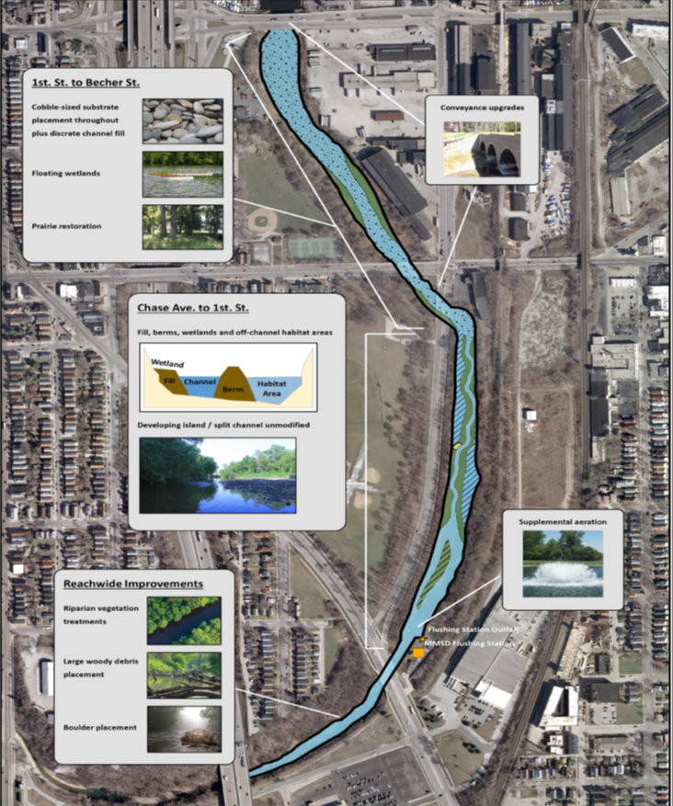

Figure 2 – Proposed Features
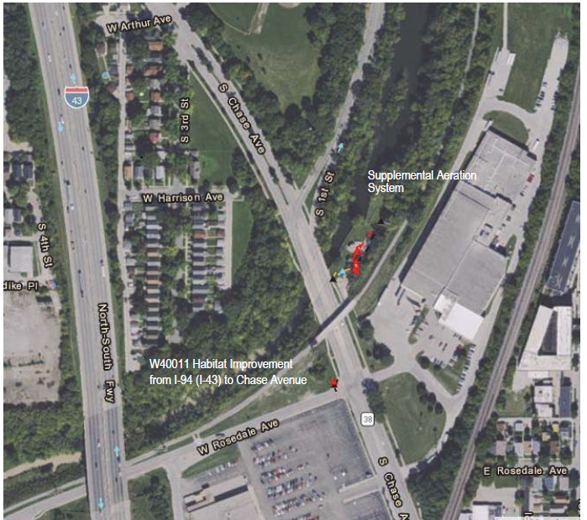

Figure 3 – Habitat Improvement and Aeration System Project Location

