Lost Creek Fish and Habitat Surveys

Date: March 30, 2022

Survey Dates: August 19 and 25/2020 Collectors: Jim Klosiewski, Jon Kleist, Al Wirt

Stream: Lost Creek (WBIC 2315800)

Location: Upstream from Pier Lake Rd. and Sandy Beach Rd., Vilas and Iron Counties

Purpose: Fish IBI and general fisheries survey, Qualitative habitat survey

Authors: Jim Klosiewski and Jon Kleist

Purpose: A sheet pile and stoplog dam is permitted to be constructed at the outlet of Dead Pike Lake across Lost Creek. The permit was issued October 30, 2020. The purpose of this study was to assess the current fish community and describe stream habitat of Lost Creek to assist with the permit review process. Because the permit has been issued, these data may provide baseline conditions prior to dam construction.

Lost Creek is an 8.58-mile river in the Bear River Watershed located within Iron and Vilas Counties. It is managed for fishing and swimming and is currently not considered impaired. Lost Creek is ultimately connected to the Turtle Flambeau Flowage via Little Bear Creek, the Bear and the Flambeau Rivers. Dams are known to be barriers to the movement of aquatic organisms, and it is anticipated that once constructed, movement of fish between the lake and its’ outlet, Lost Creek, will be limited. In addition, the fluctuations in water levels associated with dams can impact downstream habitats channel morphology, streambed composition, and alter the hydroperiods. There is the possibility that under the right conditions fish species including lake sturgeon and northern pike migrate the waterways upstream into Dead Pike Lake seeking out spawning habitat. This project identified the fish assemblage present during the surveys, which were then used to determine the natural community of Lost Creek, during the spring and summer seasons. A quantitative habitat survey was conducted to describe the current stream habitat conditions. Dam operation plans are currently unknown as are any potential impacts to the instream habitat.

We intended to conduct a survey during late March to early April (which is the northern pike spawning period) to look for northern pike. Additionally, if pike spawned within the creek itself, we expected to find evidence of young of the year (YOY) fish during a summer survey. Agency restrictions put in place due to the Covid-19 pandemic eliminated springtime fieldwork. Ultimately, only two surveys were conducted during August, one each upstream from Pier Lake and Sandy Beach Lake Roads. Future surveys conducted at both sites during the northern pike spawning period is warranted but may be difficult due to limited access and spring flooding conditions.

Methods:
Wadable Fish Surveys were conducted using a standard towed barge stream shocker following protocols established in Guidelines for Assessing Fish Communities of Wadable Streams in Wisconsin v2.0 at two locations on Lost Creek US of Pier Lake Road, station 10054546 and US of Sandy Beach Lake Road, station 10034285 in Vilas and Iron Counties, Wisconsin; (Figures 1 and 2). The surveys were conducted on August 19 and 25, 2020 respectively. A three-person crew consisting of a tower and two staff conducting shocking and collection was used to capture and record fish species utilizing Lost Creek at each station reach. A Fish Index of Biotic Integrity (FIBI) was calculated for both stations.

Quantitative Habitat Surveys were also conducted at the fish stations following protocols established in State of Wisconsin Department of Natural Resources, Guidelines for Evaluating Habitat of Wadable Streams, 2002.

Results:
Lost Creek, upstream from Pier Lake Road, Station 10054546
From the outlet of Dead Pike Lake to approximately 2.5 miles downstream the Natural Community of Lost Creek is modeled as a cool transition headwater stream. A 245-meter fish and habitat station was established and surveyed upstream from Pier Lake Road, on August 19, 2020 (Figure 1).

Figure 1. Lost Creek, Pier Lake Rd., Station: 10054546, upstream from Pier Lake Rd., downstream from Dead Pike Lake outlet

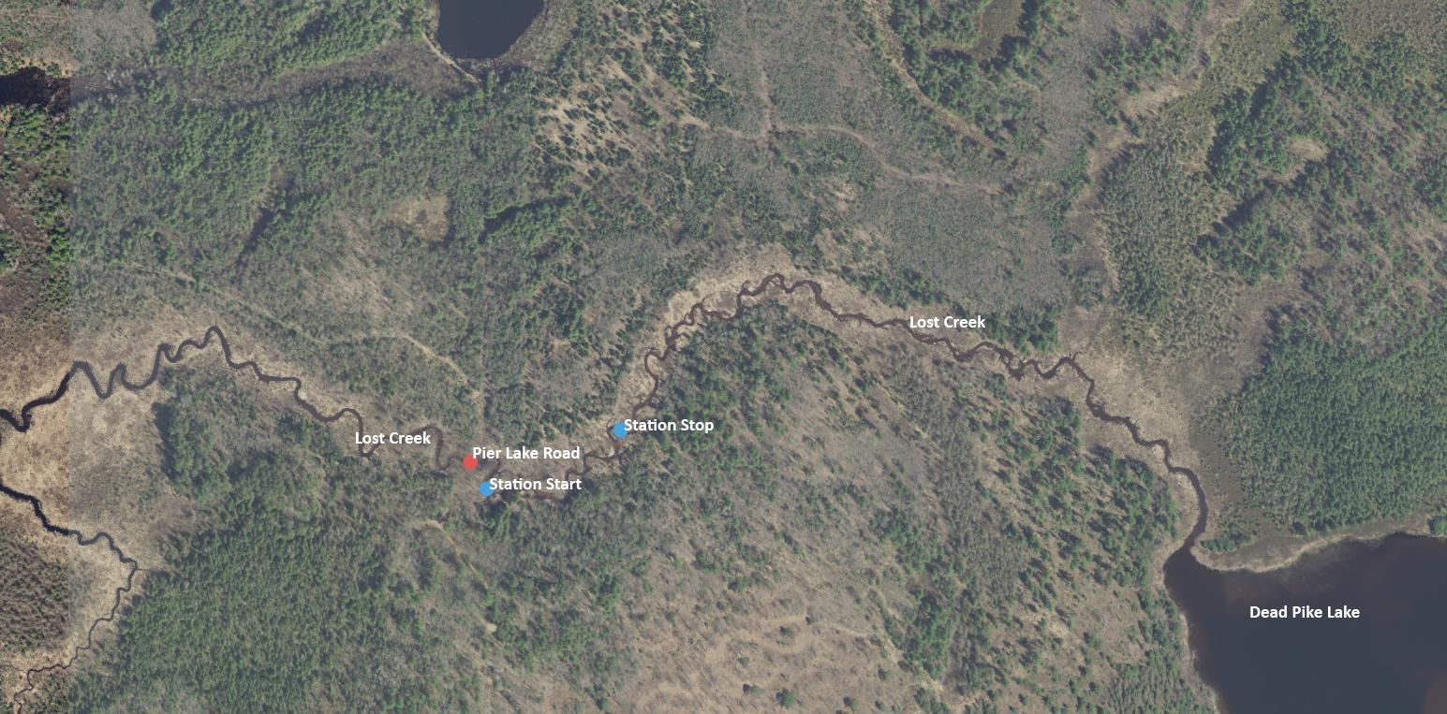

Fish:
A total of 151 individuals and 11 different fish species were captured during the survey, (Table 1). Yellow perch was the most abundant species, with 118 individuals captured, with YOY individuals dominating the count. Rock bass was the second most abundant species captured with 11 individuals. Only one individual of the pike family, a grass pickerel was captured in the survey. Two additional unidentified pike species fish were observed but not captured during the survey. The survey verified the natural community as a cool transition headwater stream consistent with the model. The small stream (intermittent) FIBI score was calculated at 60 and rated fair.

Table 1. Fish survey result, Lost Creek, Station 10054546, August 19, 2020.
Species | Count
Yellow Perch | 118
Rock Bass | 11
Largemouth Bass | 8
Black Bullhead | 4
Central Mudminnow | 3
Bluegill | 2
Smallmouth Bass | 1
Golden Shiner | 1
Johnny Darter | 1
Grass Pickerel | 1
Pumpkinseed | 1

Habitat:
The habitat rating for this station is Excellent with an overall score of 78, (Table 2). The creek at this reach is a low gradient, sand dominated stream flowing through a high-quality, intact, well protected scrub/shrub and forested wetland offering a well buffered riparian zone. Approximately two-thirds of the upper end of the station flows through a unique speckled alder and Canada bluejoint grass complex. Erosion is insignificant lending to a firm streambed without much deposition. Although it lacks the riffle, run, pool characteristics found in higher gradient streams, it offers excellent fish habitat through an overall deep channel for its width, well meandered stream course with deep bends, and has an abundance of macrophyte beds and woody cover scattered throughout.

Table 2. Wadable Stream Quantitative Fish Habitat Rating for Streams < 10 m wide.
Mean Buf Width Score | Mean Bank Eros Score | Perc Pool Score | Width Depth Ratio Score | Riff Riff Ratio Ss Score | Bend Bend Ratio Ss Score | Perc Fine Sed Score | Perc Fish Cover Ss Score | Total score
15 | 15 | 3 | 10 | 0 | 15 | 5 | 15 | 78

Lost Creek, Sandy Beach Road, Station 10034285
Lost Creek upstream from Sandy Beach Road is modeled as a warm transition mainstem natural community stream. A 245-meter fish and habitat station was established and surveyed upstream from Sandy Beach Lake Road on August 26, 2020, (Figure 2).

Fish:
We had difficulty shocking this station due to low water conductivity in combination with dense macrophyte growth. Maximum shocker output settings were employed but shocking efficiency and fish capture remained poor. The survey was terminated at 161 meters due to generator failure. Even though the entire station was not shocked which likely reduced the total number of fish captured, it is believed the fish captured were representative of the reach as all habitat types present in the station were surveyed. The survey verified the natural community as a warm transition mainstem consistent with the model. The warm transition mainstem FIBI score was calculated at 30 and rated fair.

Figure 2: Lost Creek, Sandy Beach Road, Station 10034285, upstream from Sandy Beach Lake Road
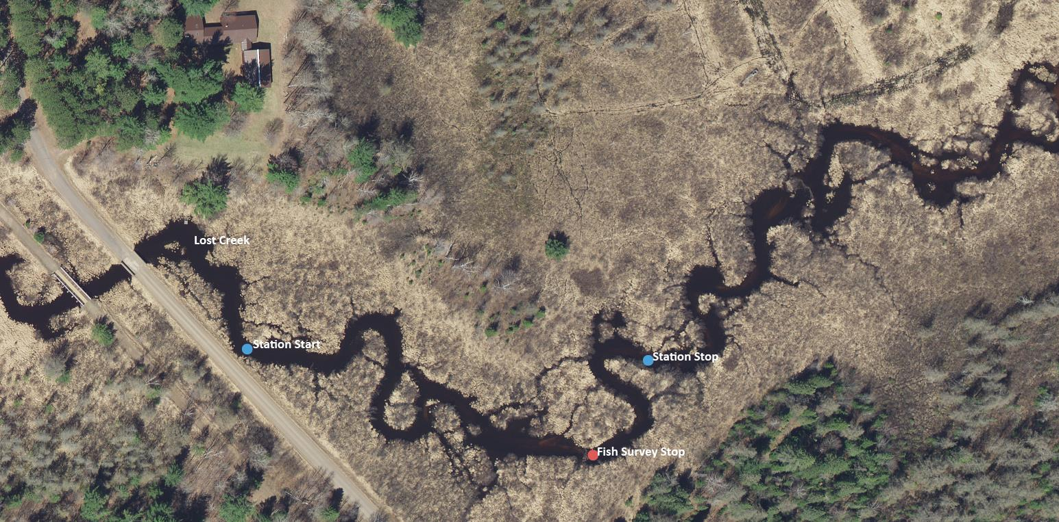

A total of 42 individuals and 7 different fish species were captured during the sampling effort, (Table 3). Yellow perch again made up the majority of total fish captured but were less abundant than the upstream survey with 20 individuals captured. Whereas rock bass were the second most abundant species in the upstream survey, they were absent in this station. Golden shiner was second most abundant with 9 individuals and common shiner with 7 individuals. One northern pike was captured.

Table 3. Fish survey result, Lost Creek, Station 10034285, August 26, 2020.
Species | Count
Yellow Perch | 20
Golden Shiner | 9
Common Shiner | 7
White Sucker | 2
Black Bullhead | 2
Largemouth Bass | 1
Northern Pike | 1

Habitat:
The overall quantitative habitat rating for this station is Good, with an overall score of 73, (Table 4). In this reach Lost Creek is a low gradient, sand dominated stream flowing through a scrub/shrub wetland complex with a couple larger areas of sediment deposition associated with beaver dams. If not for Sandy Beach Road running parallel to the start of the station, the riparian buffer zone would be fully intact, thereby increasing the buffer score from 10-15. This 5-point difference kept the overall habitat rating from being Excellent. Stream bank erosion is insignificant and like the upstream station the stream in this reach does not have riffle, run, pool physical characteristics but overall stream depth is good for its width. There is plenty of fish cover found throughout the station not only in the form of good depth but also dense macrophyte beds and large wood debris from present and past beaver activity. There are two active low-head beaver dams within the station. Additionally, there are remnant breached beaver dams and areas of deep holes created by beaver streambed manipulation where lodges once existed.

Table 4. Wadable Stream Quantitative Fish Habitat Rating for Streams < 10 m wide.
Mean Buf Width Score | Mean Bank Eros Score | Perc Pool Score | Width Depth Ratio Score | Riff Riff Ratio Ss Score | Bend Bend Ratio Ss Score | Perc Fine Sed Score | Perc Fish Cover Ss Score | Total score
10 | 15 | 3 | 10 | 0 | 15 | 5 | 15 | 73

Conclusion:
Lost Creek is a well buffered, presently unimpacted, cool transitioning to warm stream with flows dominated by a natural discharge out of Dead Pike Lake. The stream and its tributaries connect Dead Pike Lake to Mud, Sandy Beach, and Little Bear Lakes. Overall instream habitat is excellent, providing abundant fish cover in the form of a good depth to width ratio, deep bends, large woody debris and macrophyte beds. Erosion is insignificant throughout.

The total number of fish captured, and fish assemblage observed at both stations are typical for small, low velocity, low gradient lake driven streams. Surveys conducted in these systems tend to produce fewer individuals captured compared to other non-lake driven streams and they are typically dominated by lake species fish. The IBI scores are what is to be expected for these systems and show healthy fish communities. The Fair score at the Sandy Beach Lake Road station may have been affected by a shortened survey producing fewer fish captured due to equipment failure.

The surveys captured only 1 adult northern pike individual even though Lost Creek has plenty of adult fish cover habitat, and nursery areas for young fish, especially in the downstream station. It is suspected that there are compounding factors affecting the outcome encountered during the surveys. These types of river systems typically have fish in lower numbers, shocking efficiency was diminished due to low stream conductivity and large/dense beds of macrophytes further reduced shocking efficiency. Conductivity is the measure of water’s ability to carry an electric current. Measured values during the surveys were 57 and 46 µS/cm at Pier Lake and Sandy Beach Lake Roads, respectively. Dense macrophyte beds encountered, especially at the downstream station, further reduced shocker efficiency by reducing the size of the electrical current field. Northern pike in general are difficult to shock and capture even when using mini-boom shockers while conducting larger river surveys and they are even more difficult to effectively shock and capture with smaller towed barge shockers. Due to their body shape, they have the ability to detect the electrical field readily ahead of the effective range of equipment, are strong swimmers and often escape before being seen. Also, the downstream station had active beaver dams and it is reasonable that there may be more dams both up and downstream, possibly restricting northern pike movement within Lost Creek and restricting movement from other waterbodies.

