Little Balsam Creek Fish Passage Phase 1
Quarterly Report

Date: 1/14/2019

Project Title: Little Balsam Creek Fish Passage Phase 1

Grant Recipient: Town of Summit

Report Prepared by: Matt Steiger WDNR

Time period covered for this report: Q4 2018

Activities completed/work accomplished this quarter:

Douglas County advertised construction of the project and ordered materials (culverts) in September and October 2018. The Town of Summit signed the contract and associated documents to construct Phase 1 (3 crossings) of the project with Northern Interstate Construction in November 2018. A pre-construction meeting was held on Dec 5. Northern began work on Severson Road crossing Dec 10 and worked through early January 2019. General permits from DNR were issued for all three crossings.

Budget:

Funds expended this Quarter: $134,212.30

Amount of the funds expended to date: $134,212.30

Subcontracts or subgrants awarded this reporting period: Northern interstate was contracted to complete construction of Phase 1 (three crossings) by September 15, 2019.

QAPP (project plan) Status: N/A

Local services and/or products purchased this reporting period: None

Number of jobs created this reporting period: None

Schedule:
Is the project on track for completion by end date?

Yes, substantial completion date was amended to September 15, 2019.

Grant End Date: December 31, 2019

Problems / Issues:
The contractor was only able to work on one crossing in 2018. Substantial completion has been changed to September 15, 2019 and at this time the project is on track to be completed by that date.

Activities and work goals planned for next quarter:
Initial construction, including erosion control, will continue into January 2019 on Severson Road crossing. No new work is anticipated next quarter (Jan-March). Construction on the remaining crossings will begin when spring conditions allow. In water construction on Cth B may not begin until May 15.

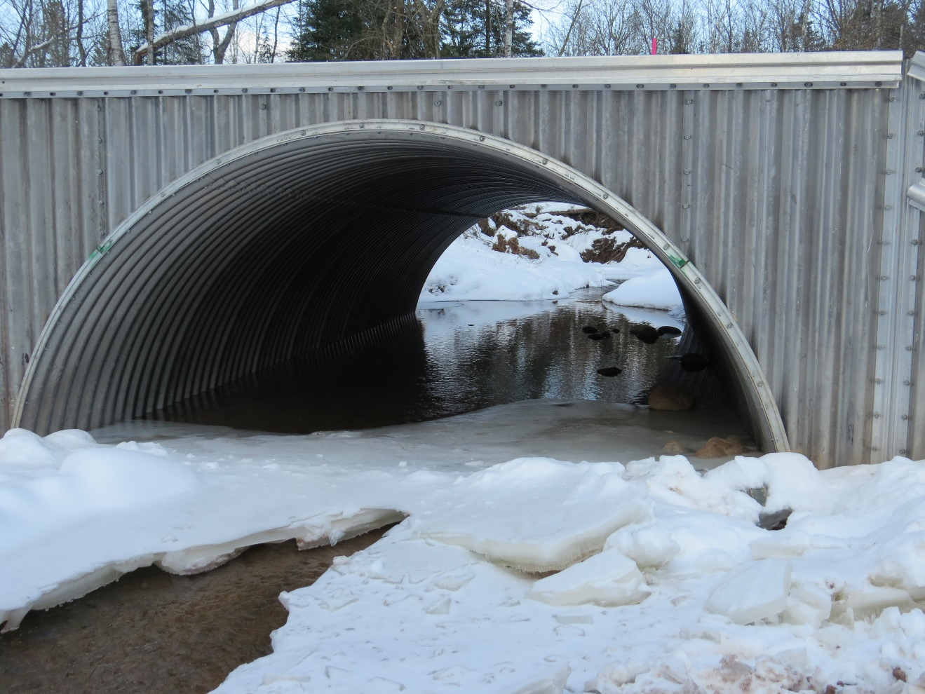
New structure installed at Severson road. (1/8/19)

