FY2022 WDNR Non-Competitive Grant Workplan for Great Lakes Restoration Initiative Focus Area 1 Toxic Substances and Areas of Concern
Project x of x

Project Title: St. Louis River AOC Wild Rice Restoration 2022-2024

Project Funding Request: $625,000

AOC(s): St. Louis River

BUI(s) Addressed: Loss of Fish and Wildlife Habitat

WDNR Project Lead(s):
David Grandmaison, St. Louis River Wild Rice Restoration & Habitat Project Coordinator
1701 N 4th Street, Superior, WI 54880
715-817-8510
david.grandmaison@wisconsin.gov

Partner Agency Lead(s):
Tom Howes, Natural Resources Program Manager
Fond du Lac Band of Lake Superior Chippewa
1720 Big Lake Road, Cloquet, MN 55720
218-878-7163
thomashowes@fdlrez.com

Darren Vogt, Resource Management Division Director
1854 Treaty Authority
4428 Haines Road, Duluth, MN 55811
218-722-8907
dvogt@1854treatyauthority.org

Kris Eilers, Executive Director
St. Louis River Alliance
394 S. Lake Avenue, Suite 208
Duluth, MN 55802
218-733-9520
kris@stlouisriver.org

Project Start/End Date: April 1, 2022- March 31, 2025

Place of Performance: Superior, Douglas County, 54880, 7th Congressional District

Project Location:
The project is a continuation of the St. Louis River Area of Concern (SLRAOC) wild rice restoration project with work taking place in both Minnesota and Wisconsin (Figure 1).

Brief Project Description:
The project is a continuation of the St. Louis River Area of Concern (SLRAOC) Loss of Fish and Wildlife Habitat Beneficial Use Impairment (BUI) Management actions 9.11 and 9.21. Management action 9.21 of the SLRAOC Remedial Action Plan (RAP) is focused on restoring wild rice in the SLRE with Management Action 9.11 focused specifically on vegetation management and wild rice restoration in Allouez Bay. Successful completion of both management actions will contribute to the removal of the Loss of Fish and Wildlife Habitat BUI. This project is a continuation and advancement of ongoing restoration work in Minnesota and Wisconsin portions of the AOC in partnership with the Fond du Lac Band of Lake Superior Chippewa, 1854 Treaty Authority, St. Louis River Alliance, Douglas County, UW Superior Lake Superior Research Institute (LSRI), City of Superior, St. Croix Chippewa Indians of Wisconsin, and other partners.

This project scope includes continued coordinator funding, wild rice seeding, restoration site treatments to promote rice growth and reduce herbivory by Canada geese, effectiveness monitoring of management actions, and a review and update of the Wild Rice Restoration Implementation Plan for the SLRE (“Wild Rice Plan”; Minnesota DNR 2014). This request is for three seasons: 2022, 2023 and 2024.

Project Background/Purpose:
Partners in both Minnesota and Wisconsin are committed to restoring self-sustaining, harvestable wild rice beds to the SLRE. An AOC-funded St. Louis River Wild Rice Habitat Restoration Project Coordinator (“WDNR Coordinator”) began in FY2021 to direct and lead AOC wild rice restoration efforts. The WDNR Coordinator implements, evaluates, and reports management actions and leads a multi-stakeholder restoration team. WDNR Coordinator will oversee implementation of this GLRI-funded project as part of the broader SLRAOC wild rice restoration effort.

The Wild Rice Plan was developed in 2014 to initiate an estuary-wide wild rice restoration program that considered the dynamic nature and broad spatial extent of the SLRE. The plan outlined goals for wild rice restoration, restoration strategies and techniques, partner roles, and potential challenges for a wild rice restoration program in the St. Louis River. The plan also included a spatial model based on existing data that prioritized specific locations for wild rice restoration in the estuary (Minnesota DNR 2014).

Much has been learned since restoration efforts in the SLRE began in 2015 (and earlier restoration efforts in the 1990s; Schwarzkopf 1999). Effective wild rice restoration requires an ongoing effort with wild rice distribution and density fluctuating annually in response to a suite of biotic and abiotic variables (e.g., water level, temperature, precipitation, disturbance, and herbivory). Herbivory has proven to be a major impediment to restoration success in the SLRE. Research and monitoring efforts have identified Canada geese as the primary source of herbivory and management actions are now in place to reduce their impact to wild rice growth and productivity, allowing more seed to fall naturally in restoration sites. In addition, Manoomin seed availability is constrained by growing conditions, climate change, and socio-economic factors influencing harvest rates. Seed acquisition will continue to be a challenge to restoration success and efforts are underway to expand sources, recruit harvesters, and educate the public about the importance of wild rice seed for restoration.

This project builds on current efforts and maximizes previous investments in wild rice restoration throughout the estuary. The SLRAOC RAP includes management action 9.21 in the Loss of Fish and Wildlife Habitat BUI to restore wild rice habitat in the AOC. Monitoring data indicate that increased seed rates and management actions to reduce Canada goose herbivory on standing rice have resulted in increased germination rates and seed production in subsequent years. Continued management of wild rice restoration sites (Figure 1) in the SLRE will be needed to maintain established restoration sites and accomplish restoration goals.

The SLRAOC is a bi-state AOC. The project will fulfill AOC-wide restoration goals and work will be performed in Minnesota and Wisconsin.

Proposed Work:
The project spans five seasons and has been divided into two separate funding requests with the first request having been submitted in FY2019. This FY2022 proposal includes restoration work across three seasons: 2022, 2023, and 2024. This project is part of a broader Manoomin restoration project in the SLRE and as the Wild Rice Plan is updated, this project will follow guidance therein. Each year the WDNR will coordinate annual restoration planning, wild rice seed acquisition, seed distribution, restoration site treatments to promote rice growth, and monitoring to quantify restoration progress.

Wild rice restoration efforts in the SLRE are hampered by Canada goose (Branta canadensis) herbivory. The WDNR project coordinator will lead partner collaboration to implement proven techniques that reduce Canada goose herbivory within restoration sites (e.g., goose exclosures and goose roundups). Goose exclosure installation and removal at upriver sites will be subcontracted to the Fond du Lac Band of Lake Superior Chippewa and exclosures in Allouez Bay will be installed and removed by WDNR personnel. Annual goose roundup efforts will be subcontracted to the USDA Animal and Plant Health Inspection Service. These efforts will help maximize wild rice seed production and enhance seed recruitment for germination in future years. Permits for certain aspects of the restoration plan (e.g., exclosure fencing, aquatic plant management, etc.) will be obtained from the appropriate agency.

For the 2022-2024 growing seasons, WDNR will complete all restoration tasks for the Allouez Bay site under guidance of the rice restoration partnership and plan. WDNR will collaborate with partners to continue the restoration work that has been ongoing since 2014. WDNR full time and limited term staff time has been budgeted to complete exclosures, seed acquisition, and distribution and monitoring.

For upriver sites, WDNR will subcontract site treatments, wild rice seeding, and monitoring as follows:
- The Fond du Lac Band of Lake Superior Chippewa will conduct seed acquisition and seed distribution at upriver wild rice restoration sites in the SLRE with site prioritization and seeding rates developed using best practices, historical knowledge, and input from restoration site team members. In collaboration with Tribal partners, the WDNR Coordinator will expand wild rice seed acquisition networks and build partnerships to enhance seed availability for restoration sites in the SLRE.
- The St. Louis River Alliance will coordinate and implement a volunteer outreach event to educate citizens on the wild rice restoration projects, BUI’s, and SLRAOC progress. This event includes seeding up to 10 acres and an educational program highlighting the cultural importance of wild rice for Ojibwe peoples in the region.
- The 1854 Treaty Authority will continue standardized Manoomin monitoring efforts in the SLRE to quantify progress towards wild rice targets for recovery. The WDNR Coordinator will lead monitoring implementation in Allouez Bay and ensure data sharing between monitoring efforts. WDNR will develop a QAPP and implement a plan to collect aerial image data for each of the wild rice restoration sites on an annual basis and analyze these data to delineate the extent of wild rice acreage restored within the SLRE.

A long-term monitoring and maintenance plan for continued wild rice restoration work beyond AOC goals will be developed and added to the Wild Rice Plan as an appendix. When a given site meets AOC restoration goals, treatments will be modified, and priority may shift to new sites until acreage goals are met. The total number of acres seeded each year will vary with wild rice seed production, timing of seed availability, harvest rates, and individual site prescriptions.

The WDNR Coordinator will serve as the restoration site team lead and will organize team meetings twice each year – once in the spring/summer to plan restoration work and once in the fall/winter to evaluate restoration success and review the monitoring report.

The WDNR Coordinator will work to expand seed acquisition opportunities that alleviate challenges associated with purchasing seed for restoration in the SLRE. Outreach efforts will focus on recruiting experienced harvesters and connecting them with seed purchasing programs that support our efforts to restore wild rice on the SLRE. This will include tabling at existing events and making presentations to suitable audiences.

Status and grant reporting will be developed by the WDNR project coordinator to document the progress made in management actions 9.11 and 9.21.

Collaboration with Partners:
Wild rice restoration in the SLRE is a collaboration among many partners and this project will continue these relationships. This includes a WDNR-led Wild Rice Restoration Team consisting of the Fond du Lac Band of Lake Superior Chippewa, GLIFWC, 1854 Treaty Authority, Minnesota DNR, Minnesota Land Trust, St. Croix Chippewa Indians of Wisconsin, Wisconsin DNR, UW Superior LSRI, Lake Superior National Estuarine Research Reserve, St. Louis River Alliance and other partners. An enhanced level of coordination with Minnesota DNR, including finalizing an interstate agreement/MOU, will be the responsibility of the WDNR project coordinator.

Subawards for seeding, monitoring and site treatments may include the Fond du Lac Band of Lake Superior Chippewa, St. Croix Chippewa Indians of Wisconsin, 1854 Treaty Authority and the St. Louis River Alliance. These partners have expertise in wild rice restoration and monitoring in many areas, including the SLR estuary.

Environmental Justice Considerations (Beneficiary):
Wild rice has profound cultural significance for the Anishinaabe community, and the depth of traditional ecological knowledge and expertise that our Indigenous partners bring to the table is critical to the program’s success. The SLRE has taken care of the Ojibwe people for thousands of years. In fact, our colleagues at the Fond du Lac Band of Lake Superior Chippewa derive the name of their people from the “Head of the Lake”. The Treaty of 1854 ensured that the Ojibwe people would retain rights to hunt, fish, trap, harvest, and manage the natural resources that have sustained their families for generations, and continue to do so, within the Arrowhead Region of northern Minnesota.

The industrialization of the SLRE – guided and facilitated by the Federal and State governments – resulted in substantial ecological impairments that we are now, collectively, working to fix. In the view of Tom and other Tribal community members, State and Federal partners are making good on their promise to honor treaty rights by funding and implementing the restoration of resources upon which those rights are founded – not the least of which is Manoomin (i.e., wild rice).

Paraphrasing Tom’s words, there is environmental and tribal justice in the act of working to fix the mistakes that we have made in the St. Louis River Estuary.

Outputs/Deliverables:
- Complete three years of rice restoration for management actions 9.11 and 9.21 in the SLRAOC RAP.
- Obtain local, state, and federal permits required for project implementation.
- Develop QAPP for geospatial analysis of aerial imagery to define wild rice acreage.
- Coordinate two restoration site team meetings each year.
- Annual SLRA volunteer outreach seeding event.
- Develop a long-term monitoring and maintenance plan for post-AOC management.
- Provide documentation for the Loss of Fish and Wildlife Habitat BUI removal package.
- Prepare semi-annual status and final reports detailing work performed.
- Geo-spatial data layers (i.e., ArcGIS shapefiles) of restoration treatment areas.

Outcomes:
- Complete management actions 9.11 and 9.21 in the SLRAOC RAP.
- Coordinate the SLRAOC wild rice restoration effort. This includes a WDNR-led Wild Rice Restoration Team that consists of Fond du Lac Band of Lake Superior Chippewa, Great Lakes Indian Fish & Wildlife Commission (GLIFWC), 1854 Treaty Authority, Minnesota DNR, Minnesota Land Trust, St. Croix Chippewa Indians of Wisconsin, Wisconsin DNR, UW Superior Lake Superior Research Institute (LSRI), Lake Superior National Estuarine Research Reserve, St. Louis River Alliance, and other partners.
- Provide documentation to be included in the Loss of Fish and Wildlife Habitat BUI removal package.
- Enhance and/or restore wild rice habitat in the SLRAOC, including Allouez Bay, to meet BUI targets.

Timetable: Project duration: April 1, 2022- March 31, 2025

Restoration work completed under previous grant funded in FY2019:
Task | Timeframe
WDNR Project Coordinator Hired | 2020 – 2021
Year 1 and 2 Restoration Implementation | 2020 – 2021
Year 3 Restoration Planning | January 2022 – March 2022
Wild Rice Plan Revision | December 2021 – April 2022

Restoration work to be completed under this award:
Task | Timeframe
Restoration Planning (annually) | December – April 2023-2024
Permitting (annually, if needed) | December – April 2023-2024
Updated Monitoring QAPP (annually, if needed) | April – August 2022-2024
Goose Exclosure Installation (annually) | May 2022-2024
Goose Roundup (annually) | June/July 2022-2024
Seeding (annually) | August/September 2022-2024
Monitoring (annually) | August/September 2022-2024
Goose Exclosure Removal (annually) | August/September (after Manoomin seed drops) 2022-2024
Monitoring Report Due (annually) | December 2022-2024
Long-Term Monitoring & Maintenance Plan | December 31, 2024
Final Status Report | December 31, 2024
Final Grant Reporting and Project Close out | March 31, 2025

WDNR Project Budget:
The project is for a total of five seasons and was divided into two separate funding requests (request one FY2019 and request two FY2022). This proposal includes restoration and project management for three seasons 2022, 2023, 2024.

Personnel funding for 2022 is covered with remaining funds under the FY2019 grant (GL-00E02456) due to COVID-19 related delays in hiring the WDNR Coordinator. Personnel costs include project management by WDNR 0.65 FTE. Three hundred (300) hours per year for limited-term employees (LTE) are included for goose exclosure installation/removal, wild rice seed acquisition and distribution, monitoring, and other wild rice fieldwork throughout the growing season for the Allouez Bay site. Travel and per diem are calculated from an estimated 30 field days and roundtrip travel of approximately 30 miles at rate $0.51/mile for each day for 3 staff and $10 lunch per staff per day.

Supplies include materials for exclosure construction in Allouez Bay, pneumatic post pounder to aid field crews in the installation of goose exclosures, boat gas, project signage and outreach materials, office supplies, PC support and other miscellaneous costs.

Sub-awards will be established as follows:
- Fond du Lac Band of Lake Superior Chippewa: Annual wild rice seed acquisition for restoration sites, wild rice seed distribution, and installation/removal of goose exclosures ($97,000/year)
- 1854 Treaty Authority: Annual wild rice restoration monitoring ($11,500/year)
- USDA Animal and Plant Health Inspection Service: Annual Canada goose roundup ($6,500/year)
- St. Louis River Alliance: Annual volunteer wild rice seeding and education event at the Clough Island restoration site ($6,000/year)
- St. Croix Chippewa Indians of Wisconsin or other organization (depending on availability) for wild rice seed ($15,000)

Budget Detail | Year 1: (April 2022- March 2023)* | Year 2: (April 2023 - March 2024) | Year 3: (April 2024 - March 2025) | Project Total
Personnel (FTE – 1,526 hours; LTE – 300 hours) | $0 | $53,524 | $53,524 | $107,048
Fringe (FTE - 47.66%; LTE – 31.76%) | $0 | $24,641 | $24,641 | $49,282
Travel | $0 | $2,500 | $2,500 | $5,000
Equipment | $0 | $0 | $0 | $0
Supplies | $15,220 | $6,000 | $6,000 | $23,500
Contractual | $0 | $0 | $0 | $0
Other (includes sub-awards) | $136,000 | $138,275 | $138,275 | $412,550
Total Direct | $147,500 | $224,939 | $224,939 | $597,378
Indirect (15.29%) | $0 | $11,951 | $11,951 | $23,902
Total | $147,500 | $236,890 | $236,890 | $625,000
*Due to the COVID-19 pandemic, a WDNR project coordinator was not hired under the previous grant until April 2021. Therefore, no salary is requested for 2022 as salary funds remaining from previous grant will cover this year. Seed acquisition in 2021 was significantly reduced relative to previous years due to poor harvest conditions and low harvest rates. This resulted in an additional roll-over of funding from the previous grant cycle.

Pre-award Costs:
No pre-award costs are requested for this project.

References:
Minnesota Department of Natural Resources. 2014. St. Louis River Estuary Wild Rice Restoration
Implementation Plan. Division of Ecological and Water Resources. Duluth, Minnesota.

Schwarzkopf, L. 1999. St. Louis River – Wild Rice Restoration Project. Prepared for Richard Greenwood,
Great Lakes National Program Office, U.S. EPA/Region V, Chicago, IL.

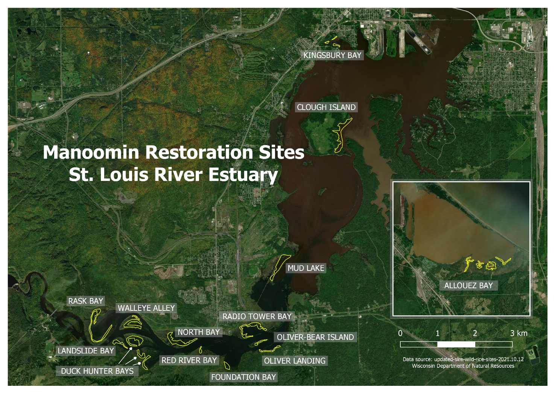
Figure 1: Manoomin (i.e., wild rice) restoration sites in the St. Louis River Estuary Area of Concern.

