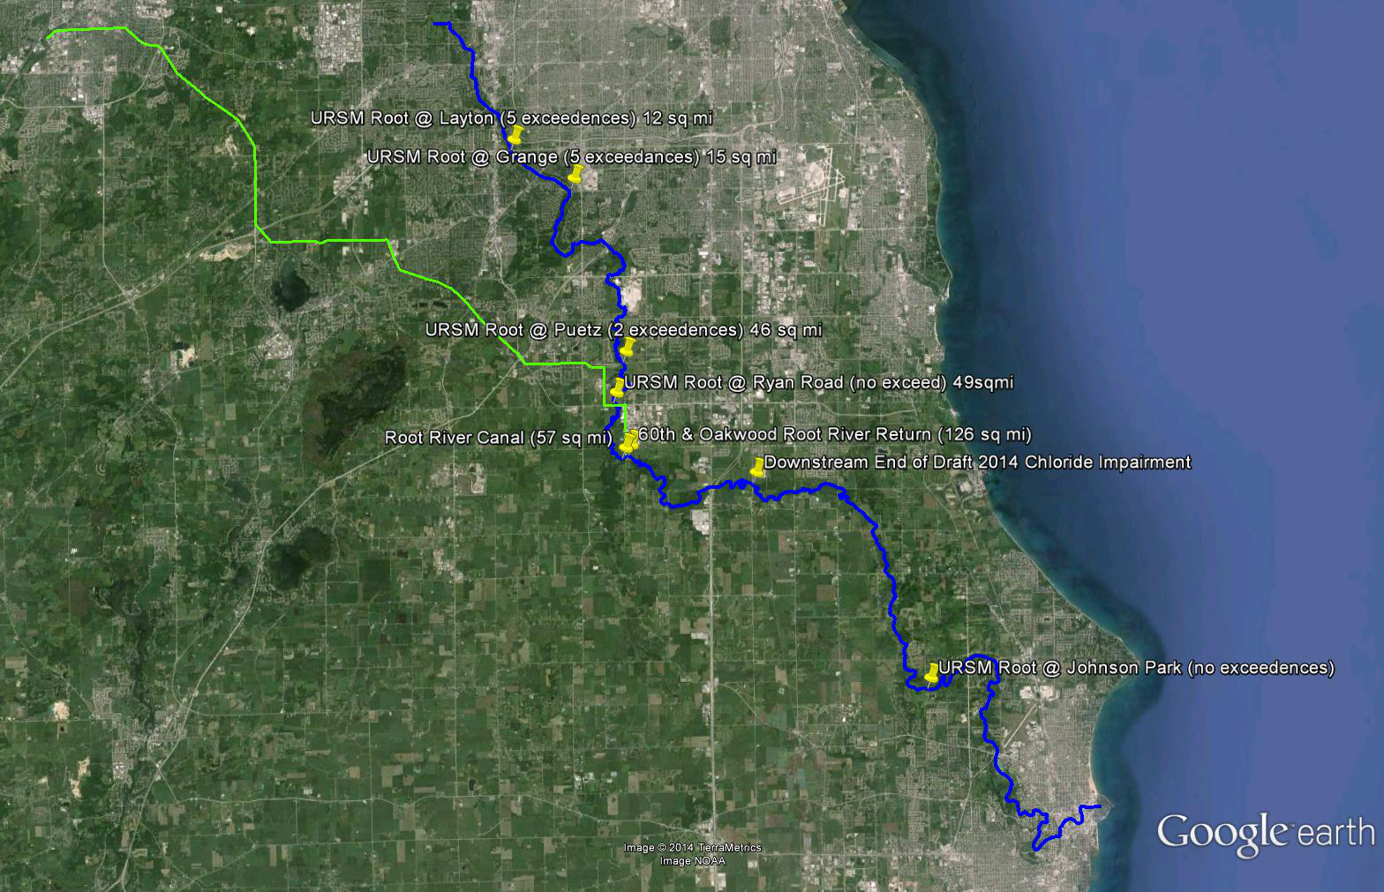

Chloride Data from DNR SWIMs database (samples from Urban Road Salt Study).

 | (Upstream) | Root River Location |  |  |  |  |  | (Downstream)
 | @ Layton | @ Grange |  | @ Puetz | @ Ryan |  | @ Root River Canal | @ 60th St Bridge  (Return Flow)
% Urban | 86% | 85% |  | 70% | 68% |  | 34% | 34%
Watershed Area (sq mi) | 12 | 15 |  | 46 | 49 |  | 69 | 126
Sample Date  (All from Urban Road Salt Study) | Chloride  (mg/L) | Chloride  (mg/L) | USGS Flow  (cfs) | Chloride  (mg/L) | Chloride  (mg/L) | USGS Flow  (cfs) | Chloride  (mg/L) | Chloride  (mg/L)
2/13/2011 | 1360 | 1220 | 2.4 | - | 670 | 6.3 | - | -
2/27/2011 | 2360 | 4130 | 3.6 | 763 | - | 42 | - | -
3/1/2011 | 2290 | 2240 | 4.9 | 1100 | - | 41 | - | -
3/25/2011 | 401 | 442 | 27 | 238 | - | 169 | - | -
6/20/2011 | 129 | 112 | 25 | 144 | - | 72 | - | -
9/28/2011 | 73.8 | 78.1 | 36 | 111 | - | 67 | - | -
1/23/2012 | 2930 | 2130 | 20 | 417 | - | 26 | - | -
2/16/2012 | 921 | 1100 | 4.2 | 465 | - | 15 | - | -
5/31/2012 | 315 | 240 | 7.6 | 168 | - | 9.6 | - | -
Bold and Red Values exceed the WisCALM 2012 Chloride Acute Toxicity Threshold = 757 mg/L
% Urban calculated from SEWRPC land use data. Draft Root River Restoration Plan, Table IV-3.

Data from SEWRPC’s Root River Restoration Plan (Draft Report Figure IV-23)

Picture 1
Near Ryan Road
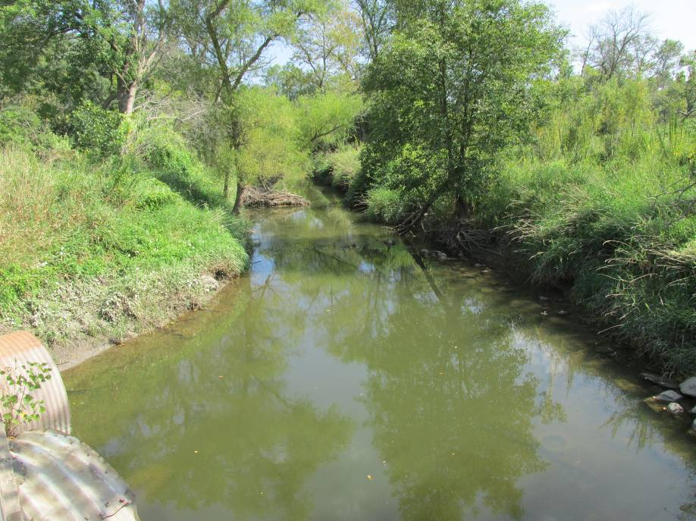 | 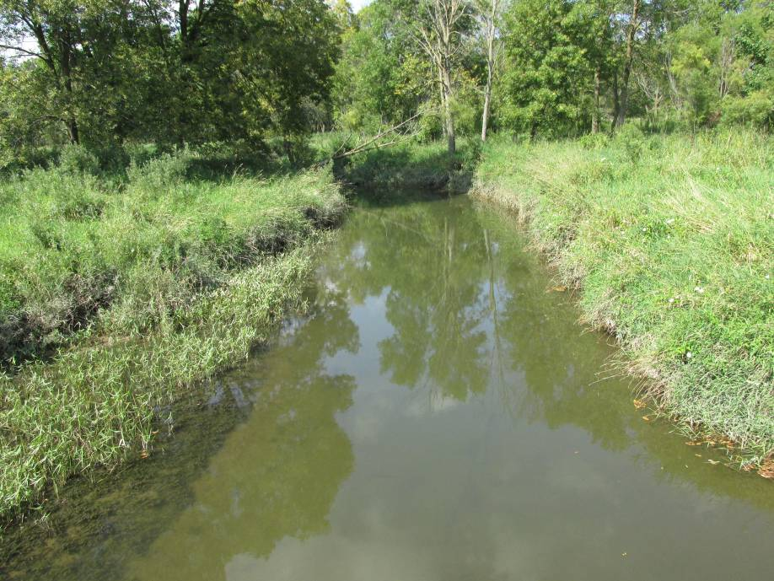

Picture 2
At Proposed Return Flow Location (60th Street Bridge)
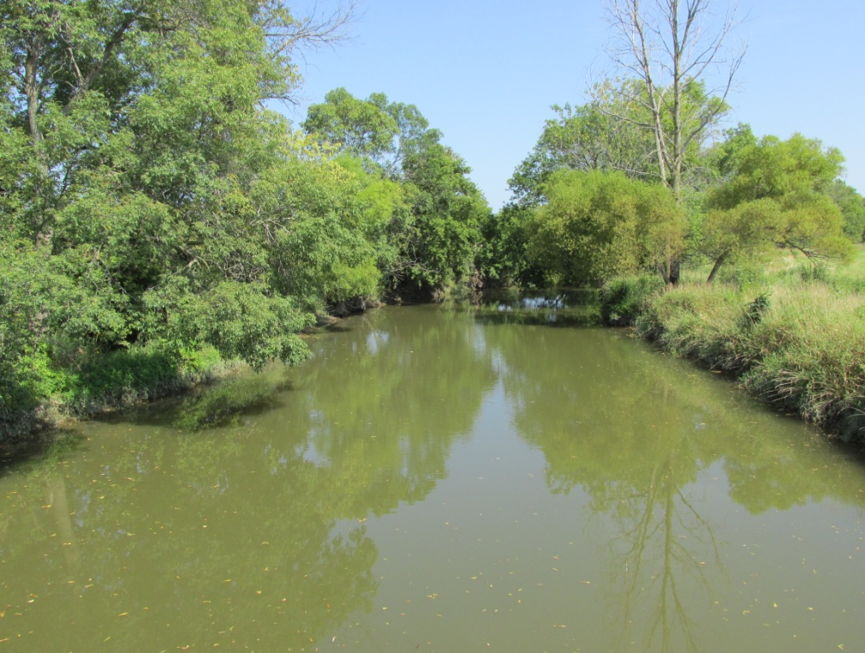 | 