Jeanne 7/28/2022: Pat’s release form is at the office and was pre-written to release which is fine because they were rearing in a large cage on site. In my answer to his email below, I asked him to remind me about how many beetles they started with that Chris Hameral provided. From that, we can estimate the release number. It is possible that there were some naturally occurring beetles on site, also. I did the data entry and added this report to the project, added the FW to the ROI https://dnrx.wisconsin.gov/swims/viewRoi.html?id=54534

Report from Pat Hayes July 28, 2022

Thought I would give you an update on our on-site Loosestrife cage. Two of the attached photo’s are from within the cage, with the third being a shot just outside the cage. As you will note, all show beetle activity. The two inside the cage are obvious, but thought the outside shot was of interest, as it also showed some munching going on. I think this may have come from either beetles surviving from past years, OR, some escaped from the cage, as we had a significant water drop in the lake and the fabric might of gapped at the bottom.

In any case, I took the side fabric off this week. My intention now is to leave the plants be within the surrounding area for a week or two.

As for our overall infestation, the main body of plants stay within the confines of the north shore of the Gunlock Channel but extends to the point of land west of the channel (until the water makes a turn to the right into the main body of the lake).

We are heading out on Saturday to remove four or five small areas that we can easily get to beyond the main infestation. We will deflower and pull entire plants. That will leave the one big area for a work team to attack in the coming weeks.

Any comments or suggestions on our activities are always welcome.

Let me know if there is any further paperwork that you would need from me. I ask this, as other than bringing in the beetles from Medford, we didn’t move any plants, etc.

Best Regards,
Pat Hayes
SGLA
phayes@hayesrtd.com
847 682 7777
Inside cage photo 1
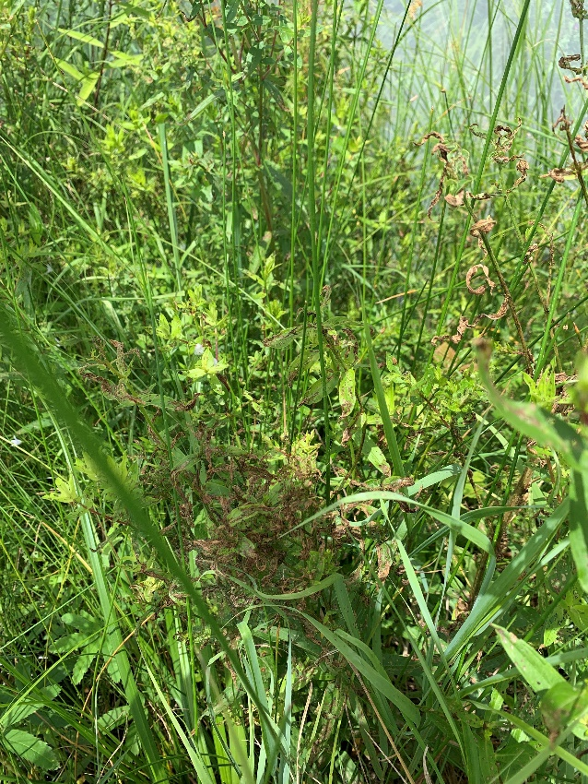
Inside cage photo 2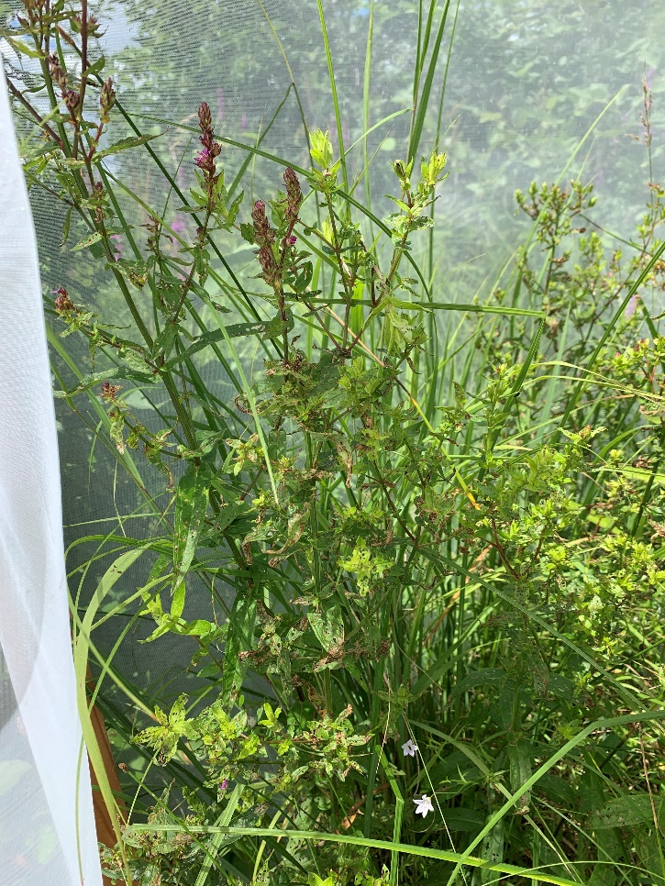
Just outside of cage 