Lilly Lake Management Report
(WBIC = 82900)
12/20/17

Andrew Ransom – University of Wisconsin, Green Bay

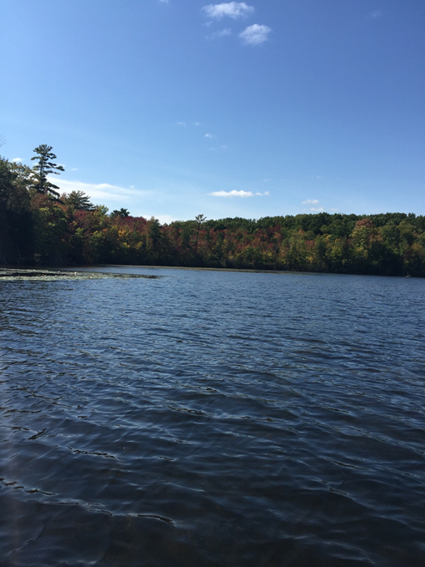
Introduction
Lilly Lake is a 42 acre seepage formed waterbody located in Southeastern Brown County, Wisconsin. The lake is in close proximity to the city of Green Bay and is south of US Highway 29. Due to its location near a highly populated area and small size, the lake is designated as an electric motor only location. Max depth in Lilly Lake is 19 feet, and average depth is 10 feet. Lilly Lake is classified as mesotrophic, with substrates consisting of 90% muck and 10% rock.
The geomorphology of the lake results in frequent winter kills during years with prolonged ice cover, and the Brown County Parks Department now operates an aerator during winter months to increase dissolved oxygen levels. The most recent winter kill was in 2014, and the lake has been restocked with Northern Pike, Largemouth Bass, and assorted Panfish Species. Fishing regulations were also revised in 2012, and a lake-wide survey has not been conducted since May of 2013.
In Fall of 2017, the Limnology class at University of Wisconsin – Green Bay (UWGB) conducted water quality monitoring, aquatic invertebrate surveys, vertical plankton trawls, vegetation surveys, and an exploratory fish sample with a boat electrofishing unit in order to assess the limnological aspects of Lilly Lake.
Water Quality
Water quality monitoring began on September 18, and continued until November 13 on a weekly or bi-weekly basis resulting in a total of 6 sample days. Water temperature and Dissolved Oxygen (DO) profiles were taken from the surface to the bottom of the lake using a YSI ProODO probe at three different locations each sample day, with the closest sample location to the boat launch designated as the “Master Point” (Figure 1). The lake was stratified and exhibiting a clinograde DO curve when sampling started on 9/18. Thermal turnover had occurred the week of 10/9/17 and DO turnover had occurred a week later on 10/16/17 (Figures 2-7). On the last sample day, 11/13/17, the parks department had turned on the aeration system and DO levels on the lake were significantly higher than all previous days, reaching complete saturation levels at 12 mg/l. On this sample day the lake was also 70 percent frozen over, and the closest point possible to the standard sample locations were used. Secci readings were taken on four sample days from 9/18 – 10/23, and measurements were between 3 and 4 meters throughout the sample period (Figure 8).
Aquatic Macrophytes
Aquatic macrophytes were sampled on 9/18/17 at 26 points throughout Lilly Lake (Figure 11). Samples were gathered via rake sampling and identified to species in-situ. Depths were also recorded at each sample point to assess species distribution at depth. Average depths of species ranged from 1 to 2 meters, with a max depth of 3.3m (Figure 10). Macrophyte sampling resulted in 15 different species distributed throughout the lake. Species composition and relative abundances are shown in detail in Figure 9. Emergent, submergent, and floating leaf style macrophytes were present, with only free floating macrophytes absent during the sample. The invasive species Eurasian Water Milfoil was present during previous lake assessments, and was confirmed in this study at one sample location.
Aquatic Invertebrates
Aquatic invertebrates were sampled on 9/25/17 in 5 locations (Figure 13). The four samples near shore were taken using two D-frame micromesh nets for a total of one minute at each sample site. Sweeps were made vertically and horizontally on the aquatic vegetation in order to sample invertebrates residing on the macrophytes. The fifth sample, located towards the center of the lake, was sampled using a ponar grab. Samples were sorted and all invertebrates were taken back to UWGB in a 95% ethanol solution. All preserved specimens were identified to order in lab on 11/20/17 using the Merritt et al. (2002) method, and samples were returned to the 95% ethanol solution for long term storage. Samples were taken to show students diversity of species, and to use as indicators of water quality. Invertebrate samples resulted in a total of 162 individuals and 10 different orders collected across the 5 sample sites (Figure 12). Aquatic invertebrates can be used as indicators of water quality, with sensitive species representing high levels of DO, neutral pH, and low pollution levels. Three orders of invertebrates classified as “sensitive” were observed in the lake; Trichoptera (caddisflies), Ephemeroptera (mayflies), and Plecoptera (stoneflies). Presence of these species indicates that water quality is high despite close proximity to agricultural and urban areas.
Plankton
Vertical plankton tows were conducted on between 10/9 and 11/13 using a micromesh plankton sampling net. Samples were taken at each of the water quality monitoring points. All zooplankton were stored in a 95% ethanol solution, and kept for references for students in the future. Copepods, cladocerans, cilia, daphnia, dinoflagellates, and green algae were all present, suggesting a complete planktonic food web in the lake.
Electrofishing
An exploratory boat electrofishing sample was conducted on Lilly Lake on 11/6/17 with the Green Bay Department of Natural Resource Inland Fisheries Division. While the sample was not quantitative and was conducted primarily to show students the methodology of electrofishing, a species list was gathered. Northern Pike, Largemouth Bass, Black Crappie, Green Sunfish, Black Bullhead, and Yellow Perch were all sampled during the event.
Discussion
Despite close proximity to an urbanized area, Lilly Lake shows high levels of water quality and species diversity throughout the food web. DO levels were consistent and high enough to support a fishery when the aeration system was in operation, and should be operated annually overwinter to reduce chances of further fish kills. In order to assess effects from the 2012 regulation changes, a standard electrofishing sample should be conducted in the future.

Tables and Figures
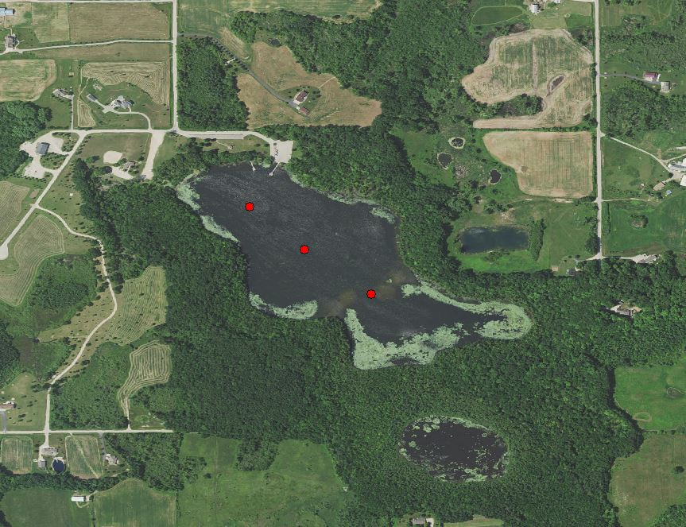
Figure 1. Water monitoring sample points on Lilly Lake.

Figure 2. Temperature and Dissolved Oxygen readings at depth for Lilly Lake on 9/18/17.

Figure 3. Temperature and Dissolved Oxygen readings at depth for Lilly Lake on 9/25/17.

Figure 4. Temperature and Dissolved Oxygen readings at depth for Lilly Lake on 10/9/17.

Figure 5. Temperature and Dissolved Oxygen readings at depth for Lilly Lake on 10/16/17.

Figure 6. Temperature and Dissolved Oxygen readings at depth for Lilly Lake on 10/23/17.

Figure 7. Temperature and Dissolved Oxygen readings at depth for Lilly Lake on 11/13/17. Note that bottom and vertical axis change.

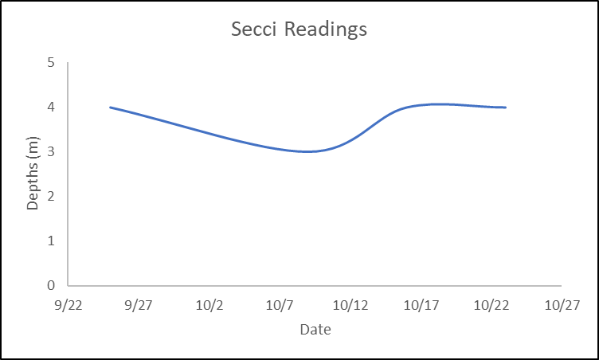
Figure 8. Secci readings for Lilly Lake at the Master Point throughout the sample season.

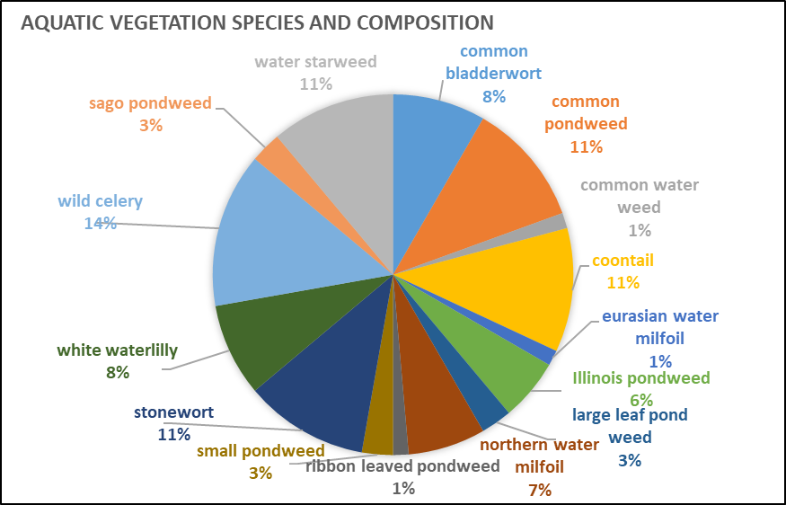
Figure 9. Aquatic macrophyte species composition during sampling event on 9/18/17.
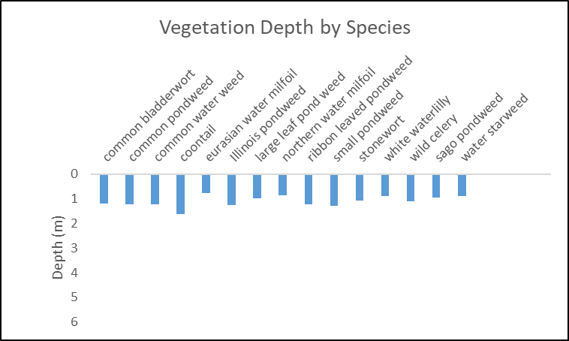
Figure 10. Average depths of individual aquatic macrophyte species during sampling event on 9/18/17.
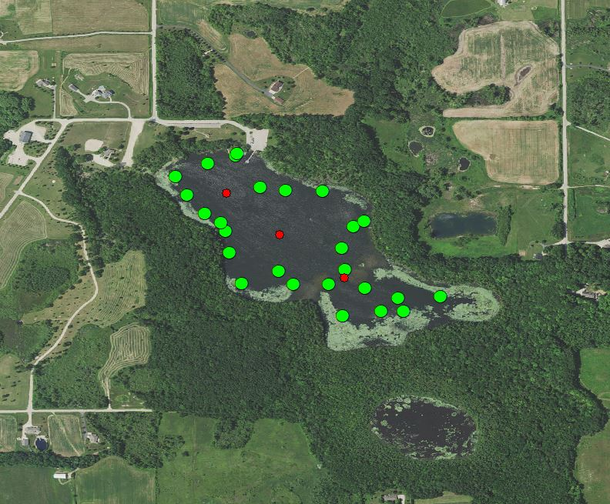
Figure 11. Sample locations for aquatic macrophyte surveys on Lilly Lake.
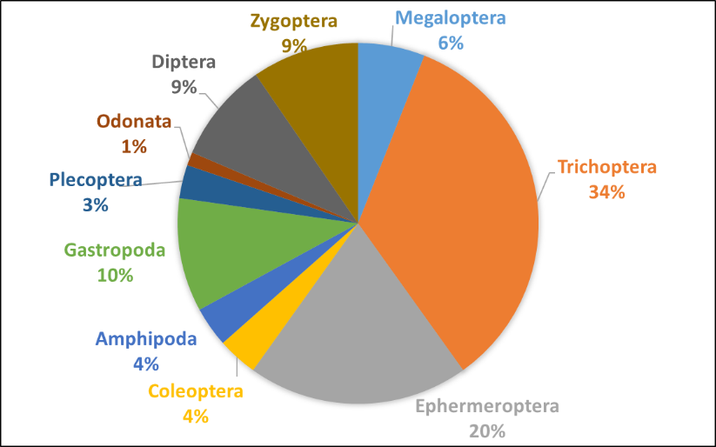
Figure 12. Aquatic invertebrate species composition on Lilly Lake.
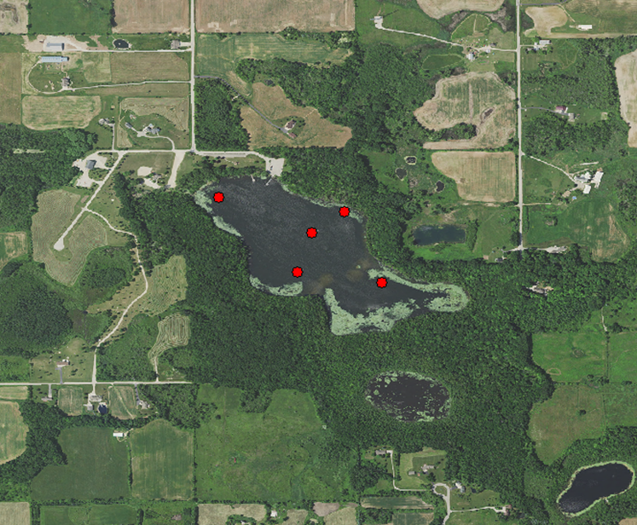
Figure 13. Sample locations for aquatic invertebrate sampling on Lilly Lake.
Acknowledgements
Special thanks to Sarah Gundrum, Briana Smiley, Ryan Miller, Jacob Pantzlaff, and Spencer VanderBluomen for all their help in the field, Steve Hogler and the Green Bay Inland Fisheries staff for the electrofishing demonstration, and Patrick Forsythe for guidance throughout the season.

References
FFG sorting approach/order keys from Merritt, R. W., Cummins, K. W., Berg, M. B., Novak, J. A., Higgins, M. J., Wessell, K. J., June, N. (2002). Development and application of a macroinvertebrate functional-group approach in the bioassessment of remnant river oxbows in southwest Florida. Journal of the North American Benthological Society, 21(2), 290–310.

