Scope of Work
Wisconsin DNR Office of the Great Waters

Project Title: Lower Fox River Tributary Volunteer Monitoring

AOC(s): Lower Fox River/Green Bay

Project Applicant: Erin DeMuynck, Professor of Geography
University of Wisconsin – Fox Valley
1478 Midway Rd, Menasha, WI 54952
920-832-2600
Erin.Demuynck@uwc.edu

Terri Gonya, Professor of Biological Sciences
University of Wisconsin – Fox Valley
1478 Midway Rd, Menasha, WI 54952
920-832-2693
Teresa.Gonya@uwc.edu

WDNR Project Manager: Megan O’Shea, Lower Fox River Green Bay AOC Coordinator
Wisconsin Department of Natural Resources
2984 Shawano Avenue, Green Bay, WI 54313
920-662-5465
Megan.OShea@Wisconsin.gov

Keith Marquardt, Fox Wolf TMDL Project Manager
Wisconsin Department of Natural Resources
625 E. County Rd. Y, Suite 700, Oshkosh, WI 54901
920-303-5435
KeithA.Marquardt@Wisconsin.gov

Project Location:
The project location consists of the 14 streams (13 tributary streams plus a reference stream) within the Lower Fox River Basin in Northeast Wisconsin. These streams contribute nutrients and sediment directly and via the Fox River to the Lower Fox River Green Bay Area of Concern. The basin comprises approximately 640 sq. miles, and in general, extends from the outlet of Lake Winnebago to Green Bay. Monitoring locations were previously established in the first year of the Lower Fox River Tributary Monitoring (map attached).

Problem Statement:
Currently, the Lower Green Bay and Fox River Area of Concern (AOC) has a total of 13 Beneficial Use Impairments (BUIs), of which 8 BUIs are linked to excessive nutrient and sediment loads. Twelve of the 13 streams located within the Lower Fox basin are impaired for total phosphorus (TP) and/or total suspended solids (TSS). In addition, their downstream receiving waters (the Lower Green Bay and Fox River AOC) are also impaired for TP and TSS. The EPA-approved Total Maximum Daily Load (TMDL) for the Lower Fox River Basin identifies the substantial reductions needed to meet water quality goals. The goals of the AOC and TMDL (removal of the BUIs and meeting the TMDL reductions, respectively) are closely tied together, and implementation of the TMDL is critical to the restoration of the AOC.
An analysis of phosphorus often includes both total phosphorus and dissolved reactive phosphorus. Total phosphorus includes particulate phosphorus—which is attached to sediments and contained in plant and animal fragments suspended in water—and soluble phosphorus. Dissolved reactive phosphorus (DRP) dissolves in water and its concentration varies widely over short periods of time as it readily aids plant growth. Another analysis of phosphorus is the diatom phosphorus index (DPI), this analysis is designed to show the impacts of eutrophication.
The goal of the project is to characterize the total phosphorus, dissolved reactive phosphorus, diatom phosphorus index, and total suspended solids concentrations, and associated chemical, physical, and biological characteristics in the Lower Fox tributary streams during the primary algae and aquatic plant “growing season” of May through October. Currently Wisconsin Consolidated Assessment and Listing Methodology (WisCALM) provides criteria for listing waters as impaired because they do not meet Wisconsin’s water quality standards. A stream could be listed as impaired because of elevated concentrations of total phosphorus which lead to biological impairments. This criterion helps to focus best management practices to reduce total phosphorus concentrations in streams and improve biological conditions. It is important to note however that investigations are currently ongoing into the relationship between the reduction of total phosphorus, dissolved reactive phosphorus, and biological responses. The collection of both total phosphorus and dissolved reactive phosphorus will help strengthen the understanding of these relationships and effects they may have on biological responses in the Lower Fox River Tributaries.

Proposed Work:
Water quality monitoring for total phosphorus, dissolved reactive phosphorus, total suspended solids, stream flow, and stream transparency will continue at the 14 monitoring stations. These parameters will be collected once a month May through October using a combination of volunteers and DNR staff time and will be analyzed by the State Lab of Hygiene. This year, an additional parameter, diatom phosphorus index, will be collected from each of the 14 tributaries once in August. Also, this year the project will start a new partnership with the University of Wisconsin – Fox Valley (UW Fox), who will be responsible for coordinating the monitoring activities. DNR staff will also assist in training volunteers and collecting samples as appropriate, so that the desired number of samples can be obtained. It is important that this work continues in the future so that changes in water quality over time can be assessed with the implementation of the Lower Fox River TMDL.

Collaboration with Partners:
This project will start a new partnership with UW Fox Valley and continued partnership with existing and new volunteers within the Fox River Basin.

Timetable:
QAPP development was completed and trained volunteers were recruited as part of the 2015 and 2016 AOC Lower Fox tributary volunteer monitoring project. For this project, volunteers would be deployed at the beginning of the monitoring season (May) and would continue through October of 2017.

Project duration: March 13, 2017 through December 31, 2017

Timeframe | Proposed Work | Deliverables
March 2017  (Q1) | · March hire and train project coordinators | NA
April – June 2017  (Q2) | · April volunteer training  · May sample collection  · June sample collection | · Quarterly report and invoice (Q1) due April 15th, 2017
July – September 2017  (Q3) | · July sample collection  · August sample collection  · September sample collection | · Quarterly report and invoice (Q2) due July 15th, 2017
October – December 2017  (Q4) | · October sample collection | · Quarterly report and invoice (Q3) due October 15th, 2017  · Final report due December 31st, 2017

Budget Details
The contract with UWFV will employ student interns to coordinate, advise, and train the volunteer monitors. Travel is for transportation to monitoring sites, which are distributed throughout the Lower Fox River watershed. Costs for sampling supplies and shipping are also included.

Deliverables:
Monthly samples collected at the 14 stations (13 tributary streams plus a reference stream). Parameters will include: TSS, TP, DRP, DPI, transparency, and flow. Quarterly reports along with a final report summarizing project outcomes will be completed to provide DNR with details of the volunteer monitoring program effectiveness, budget updates and details of the water quality.

Project Budget:

Total
March 13, 2017 to December 31, 2017
Personnel/Salaries: 2 Students @ 300 hrs each @ 10/hr | $6,000.00
Fringe Benefits (4%) | $240.00
Travel: 1000 miles @ $0.55/mile | $550.00
Equipment | -
Supplies:  - Glutaraldehyde = $175  - 2 pairs of Waders @ $90 = $180  - 2 Safety glasses @ $4.50 = $9  - 4 transparency tube @ $60 = $240  - 14 Staff Gauges @ $36 = $504  - 11 Folding Meter Sticks @ $11 = $121  - 6 100’ Measuring Tape @ $13 = $78  - 24 Tennis Balls = $24  - Ziploc Bags (quart/gallon) = $15  - Permanent Markers = $11  - Nitrile Gloves = $22  - Dish tub = $7  - 2 Squirt bottles = $12  - Disposable eye droppers = $2  - Petri dishes = $9  - Spatulas = $7  - 2 Nalgene (quart) = $34  - 60 mL sample container = $18  - Mini wire brush = $7 | $1,475.00
Contractual: | -
Other: Shipping: 6 events @ 602/event | $3,612.00
Total Direct Charges | $11,877
Indirect Charges | Not Eligible
Total Cost | $11,877

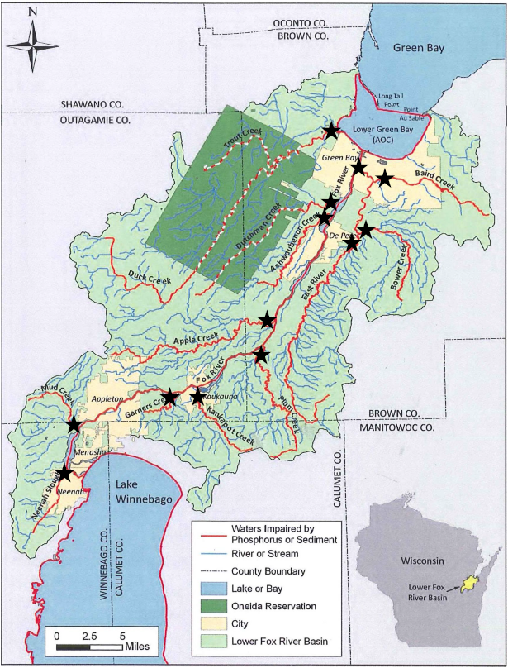
Figure 1. Approximate sample locations for the Lower Fox River Monitoring.
Monitoring Locations

