Tony Evers, Governor
Preston D. Cole, Secretary
Telephone 608-266-2621
Toll Free 1-888-936-7463
TTY Access via relay - 711

State of Wisconsin
DEPARTMENT OF NATURAL RESOURCES
101 S. Webster Street
Box 7921
Madison WI 53707-7921
March 1, 2019

To whom it may concern:

Shea Lake in Kewaunee County was part of the DNR Directed Lakes Monitoring Program. The purpose of this monitoring was to assess overall lake health. 2018 was the second year of a two-year assessment for this lake. In 2017, water chemistry, an aquatic plant survey and an aquatic invasive species survey were completed. A report of the 2017 results are available on the DNR website at: https://dnr.wi.gov/water/waterDetail.aspx?wbic=85400.

During the 2018 field season, water chemistry samples were collected three times on Shea Lake. This report summarizes the 2018 monitoring results.

A link to the DNR Directed Lake Monitoring protocols are available on our website at:
https://dnrx.wisconsin.gov/swims/downloadDocument.do?id=163086662.

Water Chemistry
The following information is taken from the Shea Lake webpage provided by the DNR.
http://dnr.wi.gov/lakes/lakepages/LakeDetail.aspx?wbic=85400

Shea Lake - Deepest Area was sampled 3 different days during the 2018 season. Parameters sampled included:
- water clarity (SD)
- temperature
- dissolved oxygen (D.O.)
- total phosphorus (TP)
- chlorophyll (CHL)

The average summer (July-Aug) secchi disk reading for Shea Lake - Deepest Area (Kewaunee County, WBIC: 85400) was 3 feet. The average for the Southeast Georegion was 7.4 feet. Typically, the summer (July-Aug) water was reported as clear and brown. This suggests that the Secchi depth may have been mostly impacted by tannins, stain from decaying matter. Tannins are natural and not a result of pollution. Tannins can be distinguished from suspended sediment because the water, even though it's brown, it looks clear, like tea. Though tannins are not harmful per se, they are often not perceived as aesthetically pleasing as clear water. Tannins can also be important for decreasing light penetration into the water and decreasing algal growth. Chemistry data was collected on Shea Lake - Deepest Area. The average summer Chlorophyll was 34.7 µg/l (compared to a Southeast Georegion summer average of 31.6 µg/l). The summer Total Phosphorus average was 44.9 µg/l. Lakes that have more than 20 µg/l and impoundments that have more than 30 µg/l of total phosphorus may experience noticeable algae blooms.

The overall Trophic State Index (based on chlorophyll) for Shea Lake - Deepest Area was 62. The TSI suggests that Shea Lake - Deepest Area was eutrophic. This TSI usually suggests decreased clarity, fewer algal species, oxygen-depleted bottom waters during the summer, plant overgrowth evident, warm-water fisheries (pike, perch, bass, etc.) only.

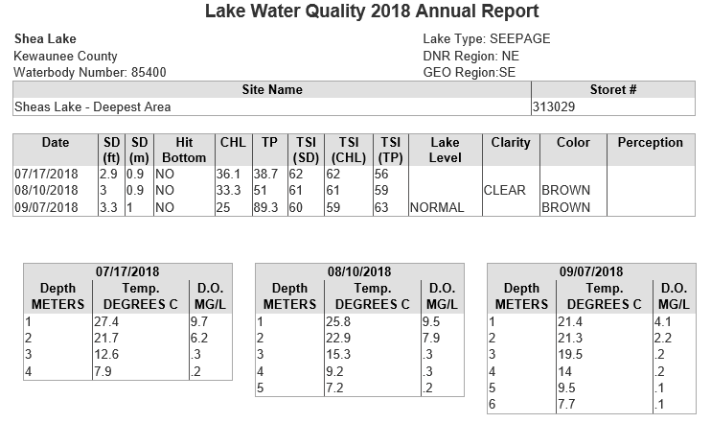

SD = Secchi depth measured in feet converted to meters; Chl = Chlorophyll a in micrograms per liter(ug/l); TP = Total phosphorus in ug/l, surface sample only; TSI(SD), TSI(CHL), TSI(TP) = Trophic state index based on SD, CHL, TP respectively; Depth measured in feet.

This report summarizes the 2018 monitoring results. If you have any questions regarding the survey results from Shea Lake, please feel free to contact me at 920-662-5497 or at holly.stegemann@wisconsin.gov.

Sincerely,

Holly Stegemann
Water Resources Management Specialist
Wisconsin Department of Natural Resources

