Scope of Work – Amendment 1

Project Title: Milwaukee Estuary Area of Concern Baseline Wildlife Population Assessment
Applicant name: Gary S. Casper, Ph.D.
NOTE: Send project agreement to Field Station, Attn: Cindy Boettcher, with Thomas Marcussen, Director Office of Sponsored Programs, as signatory
Organization name: UWM Field Station
Street/Mailing address: 3095 Blue Goose Rd., Saukville, WI 53080
Phone number: (262) 689-4095 (cell phone)
Email address: gscasper@uwm.edu
DUNS Number: 627906399
Project Manager’s name and contact info: Gary S. Casper, Ph.D., (262) 689-4095 (cell phone)

Proposed Work
This is an expansion of a current three year project to conduct wildlife surveys to support setting habitat restoration priorities within the Milwaukee Estuary Area of Concern (AOC). Work will build upon data mining activities conducted during the target refinement study and baseline wildlife assessments completed during 2014, 2015, and 2016. The year 1 baseline surveys targeted areas with known data gaps, while years 2 and 3 targeted areas with data gaps found through the data mining component. In 2017, wildlife surveys will be conducted in additional AOC target areas outside of the 2014-2016 AOC focus areas. Additional surveys within the 2014-2016 focus areas will also be conducted for Species Of Local Conservation Interest (SLCI) that have been identified as having low detection probabilities within the AOC. The new survey areas are, 1) Lakeshore Zone - the Lake Michigan lakeshore area from the Linwood Avenue water intake plant south to Sheridan Park; and 2) Ozaukee County - the Milwaukee River from the county line north to the confluence with Cedar Creek, and Cedar Creek north to Bridge Road, in Ozaukee County. As for prior survey work, the study area may include contiguous habitat within a half mile buffer of these shorelines.

Work and reporting will again be coordinated with the Milwaukee County Park Natural Areas program, whose surveys will be limited to Milwaukee County owned lands. We will again supplement their surveys on county lands, and continue surveys on other public and private lands where access is available. Surveys will utilize protocols in the Quality Assurance Project Plan. Data management will include merging and vetting data from both parties for final reporting products such as maps and databases.

UWM Field Station staff and contractors will conduct specific surveys using standardized protocols as described below in addition to those already included in 2014, 2015 and 2016 scopes of work:
- Data Acquisition: All available species occurrence data will be collected, vetted, and georeferenced for the two new study areas to include in our assessment, per standards applied in the original study area (see QAPP), and added to databases.
- Lakeshore Zone Wildlife Surveys: This area includes existing habitat potentially suitable for a variety of surveys at several county parks, Lakeshore State Park, and some municipal or private parcels with additional suitable habitat (e.g., Lake Express Ferry terminal, Seminary Woods). The following surveys are proposed:
  - Wintering Waterfowl Surveys: Visual surveys will utilize nine locations: a) offshore from Just south of the Linnwood Water Treatment Plant; b) offshore from Bradford Beach/ “North Point”; c) offshore from east and south of Veteran’s Park, from a location just southeast of the Milwaukee Sailing Center parking lot; d) Milwaukee River/Kinnickinnic River confluence just west of Hoan Bridge; e) Inner Harbor from Lakeshore State Park; f) offshore from the Lake Express Ferry parking lot; g) offshore from the Texas Avenue overlook; h) offshore from Bayview Park; i) offshore from Sheridan Park. These nine locations cover Milwaukee Bay geographically from north to south, and will be surveyed once each week (weather permitting) from December 15 to February 15. This time period covers late fall/early winter migrants arriving in the Bay, winter residents, and late winter/early spring migrants. Surveys will consist of visual surveys with binoculars and spotting scopes recording species counts.
  - Breeding Bird Surveys: We will conduct June point counts per our existing SOP at Seminary Woods and Lakeshore State Park (pending landowner permissions).
  - Acoustic Surveys for Frogs and Breeding Birds: We will conduct acoustic sampling per our existing SOP at Seminary Woods using an Automated Recording System (pending landowner permission).
  - Frog/Salamander Surveys: We will conduct Visual Encounter Searches (Shoreline and Egg searches) and Frog Call Surveys per our existing SOPs at Seminary Woods (pending landowner permission), targeting frogs and salamanders.
  - Aquatic Funnel Traps: We will conduct Aquatic Funnel Trapping targeting burrowing crayfish and amphibians per our existing SOP at Seminary Woods (pending landowner permission), if reconnaissance determines that equipment can be secured in suitable habitat.
  - Cover Object Surveys: We will conduct these surveys targeting snakes per our existing SOP at Seminary Woods (pending landowner permission) if reconnaissance finds suitable habitat where equipment will be secure.
  - Acoustic Bat Surveys: We will conduct stationary acoustic surveys using automated recorders at a minimum of 3 sites (probably Seminary Woods, Lakeshore State Park, and one or more county parks). We will conduct traveling acoustic surveys on a minimum of 3 evenings along the lakefront bike paths. All surveys will be in June-July to target resident bats. A new SOP will be written covering both survey types and data analyses. These protocols have evolved over the course of this study, mainly as a result of ongoing USGS, F&WS, and NPS research into methodology. Currently data analysis remains a problem but using two or more software programs with conservative settings, followed by manual expert vetting, is recommended to summarize species detected and produce a metric of overall bat activity. Archived data may be re-analyzed in future if methods improve.
  - Camera Surveys: Additional camera surveys targeting mammals will be considered at any locations that are deemed safe from vandalism, and with landowner permissions. Sites to be investigated are the extreme north end of Lake Park (near the Water Treatment Plant), Lakeshore State Park, and Seminary Woods.
  - Mammal Tracking Surveys: If snow conditions permit, mammal tracking surveys will be conducted along the lakeshore and at Seminary Woods.
  - Flying Squirrel Surveys: A feeder camera trap will be set up at Seminary Woods pending landowner permission and an equipment safety assessment.
  - Odonate Surveys: 3 weeks of surveys will be contracted and split among the new Lakeshore and Ozaukee County areas, following our existing methods. In the Lakeshore area, suitable habitat may be present at Sheridan Park, Bayview Park, Seminary Woods, Lakeshore State Park, Veterans Park (Juneau Lagoon), and Lake Park.
- Ozaukee County Wildlife Surveys: This area includes existing habitat potentially suitable for a variety of surveys along the designated portions of the Milwaukee River and Cedar Creek. Final survey site selections will be guided by a gap analysis from the results of Step 1 above (Data Acquisition), habitat suitability as evaluated by reconnaissance visits, and landowner permissions. The following surveys are proposed:
  - Breeding Bird Surveys: We will conduct June point counts per our existing SOP, at a minimum of 3 habitat areas (to be selected).
  - Acoustic Surveys for Frogs and Breeding Birds: We will conduct acoustic sampling per our existing SOP using Automated Recording Systems at a minimum of 3 habitat areas (to be selected).
  - Frog/Salamander Surveys: We will conduct Visual Encounter Searches (Shoreline and Egg searches) and Frog Call Surveys per our existing SOPs at as many suitable habitat areas as possible in the study area (pending landowner permissions), targeting frogs and salamanders.
  - Aquatic Funnel Traps: We will conduct Aquatic Funnel Trapping per our existing SOP at a minimum of 3 habitat areas (to be selected), targeting burrowing crayfish and amphibians.
  - Cover Object Surveys: We may conduct these surveys targeting snakes per our existing SOP if reconnaissance finds suitable habitat areas where equipment will be secure and landowners permit.
  - Acoustic Bat Surveys: We will conduct stationary acoustic surveys using automated recorders at a minimum of 3 sites. We will conduct traveling acoustic surveys on a minimum of 3 evenings along the streams at drive-up accessible points. All surveys will be in June-July to target resident bats and follow the SOP mentioned above.
  - Camera Surveys: Camera surveys targeting mammals will be conducted at a minimum of 3 sites that are deemed safe from vandalism, and with landowner permissions.
  - Mammal Tracking Surveys: If snow conditions permit, mammal tracking surveys will be conducted along the streams in the study area at drive-up accessible points.
  - Flying Squirrel Surveys: A feeder camera trap will be set up at a suitable site with landowner permission. If successful in detecting squirrel presence and time allows, it will be moved to additional sites.
  - Odonate Surveys: 3 weeks of surveys will be contracted and split among the new Lakeshore and Ozaukee County areas. In the Ozaukee County area, suitable habitat will be surveyed along the streams at drive-up accessible points.
  - Mussel Surveys: Surveys will be conducted at 3 points, 2 on the Milwaukee River and 1 on Cedar Creek, following our existing SOP. Locations will be determined by reconnaissance for suitable habitat and accessibility.
  - Turtle Basking and Trapping Surveys: Turtle basking surveys will be conducted at as many locations as possible, and turtle trapping surveys may be conducted if suitable and safe sites are found, per our existing SOP.
- Non-Lakeshore zone Surveys: We will conduct some follow up gap surveys in the stream portions of the original study area.
  - Frogs: We noticed markedly different results among years in call surveys, particularly Green Frogs and Treefrogs increasing in 2016, and additional Chorus Frogs detected, indicating that populations are variable across years and possibly ephemeral. Therefore, we will obtain another year of call survey data visiting suitable habitat areas. These consist of casual surveys stopping for 5-minute point counts at mostly roadside locations, and slow driving surveys stopping to document frogs heard. We may also repeat some automated recording surveys at additional or repeat locations if recorders are available after priority is given to deployments in the new survey areas. The rarest species will be the primary targets: Wood Frog, Chorus Frog, Spring Peeper, Treefrogs.
  - Salamanders: We will repeat egg surveys at Havenwoods State Forest, the Schlitz Cleaver property, and a few other locations. When these species are very rare eggs can be more easily overlooked, so these repeat surveys will provide greater confidence in the absence of salamanders that our surveys have so far indicated.
  - Mussel Surveys: 3 additional survey surveys will be conducted to increase coverage - 1 point on the Kinnickinnic River just downstream of Chase Avenue, and 2 points on the Menominee River between Three Bridges Park and the confluence with the Little Menomonee River.
  - Acoustic Bat Surveys: We will conduct additional stationary acoustic surveys using automated recorders at a minimum of 3 sites. Stationary surveys collect higher quality data than do traveling surveys, given the new data analysis recommendations. Most surveys to date in the original study area have been traveling surveys, therefore, supplementing these with additional stationary surveys will provide an improved baseline record better reflecting bat diversity and activity.
  - Turtle Basking Surveys: Turtle basking surveys will be conducted at additional locations and at prior surveyed locations, per our existing SOP, during the course of other field work when suitable weather conditions prevail.
- Project and data management and oversight, data analyses, meetings, and reporting: These tasks are ongoing through project completion.

The number and location of survey sites are subject to change based on the results of the historical literature and data review and availability of suitable habitat for surveys. Additionally, the UWM Field Station researchers will focus heavily on data analysis and final report preparation during 2017.

Project Location
In 2017, UWM Field Station researcher’s survey efforts will focus on 1) Lakeshore Zone - the Lake Michigan lakeshore area from the Linwood Avenue water intake plant south to Sheridan Park; and 2) Ozaukee County - the Milwaukee River from the county line north to the confluence with Cedar Creek, and Cedar Creek north to Bridge Road, in Ozaukee County. Additional data capture efforts for SLCIs will occur within suitable habitat on land owned by Milwaukee County Parks along portions of the Little Menomonee River, Menomonee River, Milwaukee River and their tributaries. A half-mile buffer surrounding these waterways defines the general lateral extent of the survey area, (see Figure 1).

Budget
Amendment 1- Year 4
 | Total cost
Personnel  Gary Casper (Principal Investigator) 6.6 months | 27586
Fringe Benefits | 10952
Equipment | 0
Supplies | 0
Contractual (proposed pending contractor negotiation)  Green Roots LLC (Herps, crayfish, mammals, project management and data analyses): $3,000  EARTH Ltd. (Herps, crayfish, mammals, project management and data analyses): $5,000  Bat Experts (acoustic analyses): $1,500  Howard Aprill (Herps, mammals): $1,725  Jason Dare (Mussels): $6,000  Bill Mueller/WGLBBO (Winter Waterfowl, Breeding Birds): $6,300  Biophilia LLC (Odonates, Breeding Birds): $7,500 | 31025
Other | 0
Total Direct Cost | 69563
Indirect cost (%) | 10434
Total Cost | 79997

For reference the following is a total budget for the project, including the original agreement:
Original Agreement Year 1 $ 75,000*
Agreement Year 2 & 3 $125,000
First Amendment (Year 4) $ 79,997
Project Total $279,997

* Year 1 funds were awarded in a separate agreement. This updated SOW is an amendment to the Year 2 & 3 agreement.

Timetable
Survey start times are weather dependent. The general timetable listed below is subject to change depending on weather and other environmental conditions. Any changes will be in concordance with survey protocols for maximizing species detection probabilities. The UWM Field Station principal investigator will provide written notification to WDNR Project manager of any changes to the timetable below.

October – December 2016
- Retain contractors, dedicate equipment and supplies, begin landowner contacts for access permissions, begin survey site selections
- Begin data acquisition, new data vetting, and GIS base layer revisions
- Perform gap analysis for Species of Local Conservation Interest in the Ozaukee County study area, to guide survey site selection
- Begin camera surveys for mammals
- Begin tracking surveys for mammals
- Complete new mussel surveys
- Setup Flying Squirrel surveys
- Begin wintering waterfowl surveys
- Begin voucher specimen preparation and deposits
- First quarterly report (for period October through December 2016)
January – March 2017
- Continue landowner contacts as needed, finalize remaining survey site selections
- Complete data acquisition, continue new data vetting, and GIS base layer revisions
- Continue camera surveys for mammals
- Complete tracking surveys for mammals
- Continue Flying Squirrel surveys
- Complete wintering waterfowl surveys
- Continue voucher specimen preparation and deposits
- Begin amphibian and crayfish surveys: visual searches and aquatic funnel trapping
- Begin frog call surveys
- Begin Automated Recording System surveys for frogs
- Second quarterly report (for period January through March, 2017)
April – June, 2017
- Complete turtle basking and trapping surveys
- Complete camera surveys for mammals
- Complete Flying Squirrel surveys
- Continue voucher specimen preparation and deposits
- Complete amphibian and crayfish surveys: visual searches and aquatic funnel trapping
- Complete frog call surveys
- Complete Automated Recording System surveys for frogs and birds
- Begin bat surveys
- Complete breeding bird point count surveys
- Begin Odonate surveys
- Third quarterly report (for period April through June, 2017)
July – August, 2017
- Complete Odonate surveys
- Complete bat surveys
- Complete acoustic data analyses
- Complete data vetting and GIS base layer revisions
- Complete reporting and deliverables by September 1, 2017
September 30, 2017
- Complete invoicing
- Complete voucher specimen preparation and deposits
- Final quarterly report (for period July - September, 2017)

Deliverables
The following are the deliverables for the entire project. The status of each is given in the column on the right.
Deliverable | Status
- Quarterly Reports – Reports will be submitted by April 1, July 1, October 1 and January 1. Reports will identify amount expended per quarter, activities conducted, and planned activities for the following quarter, along with identification of any issues encountered (including delays or deviations from the original schedule or other setbacks) during the time and how they were addressed. Reports should be submitted to WDNR. | Quarterly reports complete through July 2016
- Surveys & Survey Data – UWM Field Station staff and contractors shall perform all surveys described above in the Proposed Work section at the sites listed in Table 1 and shown on Figure 1. Survey data will be submitted in electronic format, which includes location information (i.e. lat/long, decimal degrees, etc.). The species occurrence databases will incorporate the original and expanded survey areas in tabular and GIS formats. Acceptable formats include, Microsoft Access, Microsoft Excel, or ArcGIS geo-database. | Incomplete/ Progress to Date in Table 1. Expected Completion March 31, 2017 and September 30, 2017
- Project Documentation - Completed data sheets, photographs, recordings and other documentation will be submitted in the appropriate format, with electronic format preferred. Species identification verification through voucher specimens, recordings or photographs. Recordings and photographs should be of the highest available resolution and provide needed information for species identification purposes. Documentation requirements:  - For all field work, accurate location information for survey sites, boundaries, species occurrence, etc. must be provided so data can be used in geographic information systems, including ArcGIS 10.3.1. The referencing system and datum (i.e. WGS84, WTM 83/91) must be documented for all data collected.  - Species identification (with the exception of birds) must be verified through collections of voucher specimens, recordings, or photographs to the extent allowable by local, state, and federal regulations. The recordings and photographs must provide the needed information for species identification purposes (i.e. identifying marks, size, etc). This verification must be linked to collection date, time and specific location. | Incomplete/ Expected Completion March 31, 2017 and September 30, 2017
- Presentations to Fish and Wildlife Tech Team - Prepare a presentation and report interim findings after the 2015 and 2016 field seasons, and final findings upon completion of the report in person at a minimum of two meetings to the Wildlife Subcommittee or the Milwaukee AOC Fish and Wildlife Technical Team. | One of four presentations complete (Sept. 2015)
- An interim report shall be prepared with the following elements which shall incorporate data/findings collected through 2016 by March 31, 2017. A final report shall be prepared with the following elements to incorporate all data/findings by September 30, 2017, working in conjunction with UWM Field Station and Fish and Wildlife Tech Team:  - Provide wildlife survey results with survey points/transects/areas mapped. Completed Table 1 covering all years.  - Provide updated tabular and GIS species occurrence data with the interim and final reports. Per the approval of the grantor in the “Final Report: Wildlife Population Target Refinement for the Milwaukee Estuary AOC”, this deliverable was agreed to be a work in progress, with development continuing into Phase 2 funding, in order to avoid the production of multiple versions and potential use of preliminary data by other partners which could result in confusion and errors.  - Provide updated Species Checklists for each taxonomic group covering the original and expanded study area, with Species of Local Conservation Interest (SLCI) identified.  - Evaluate how SLCI distributions concord with other species conservation rankings and habitat mapping efforts (e.g., from Natureserve, SEWRPC, Milwaukee County Parks, DNR).  - Compare historic vs. existing species richness in the study area.  - Identify broad biological constraints limiting species richness and restoration opportunities; develop a decision support chart to determine feasible restorations.  - Determine recommended Focal Species with stakeholder input and list their critical habitat requirements (biological constraints) for guiding habitat restorations and decision support. Consider Focal Species that represent species guilds with similar habitat requirements. Consider a wide array of species ranging from very tolerant to very intolerant as restoration targets, and include Umbrella, Keystone, and Flagship species concepts.  - Provide maps of Focal Species distribution covering the new expanded study area.  - Provide recommendations for goals for habitat restoration and connectivity, addressing:  - AOC Beneficial Use Impairments and measures of success.  - Social constraints on restoration feasibility (i.e., land ownership, existing development extents, funding levels, etc.)  - Identify and prioritize specific projects that will address the BUIs of impaired wildlife habitat and populations. Projects will have a direct connection to the stream. Projects will be prioritized for maximum benefit for increasing wildlife biodiversity and/or restoring or sustaining SCLIs (especially Endangered or Threatened Species). Projects will have measures of success identified.  - Provide proposed metrics for achieving delisting of the “Degraded of Fish and Wildlife Populations” beneficial use impairment. | Incomplete/ Expected Completion March 31, 2017 and September 30, 2017

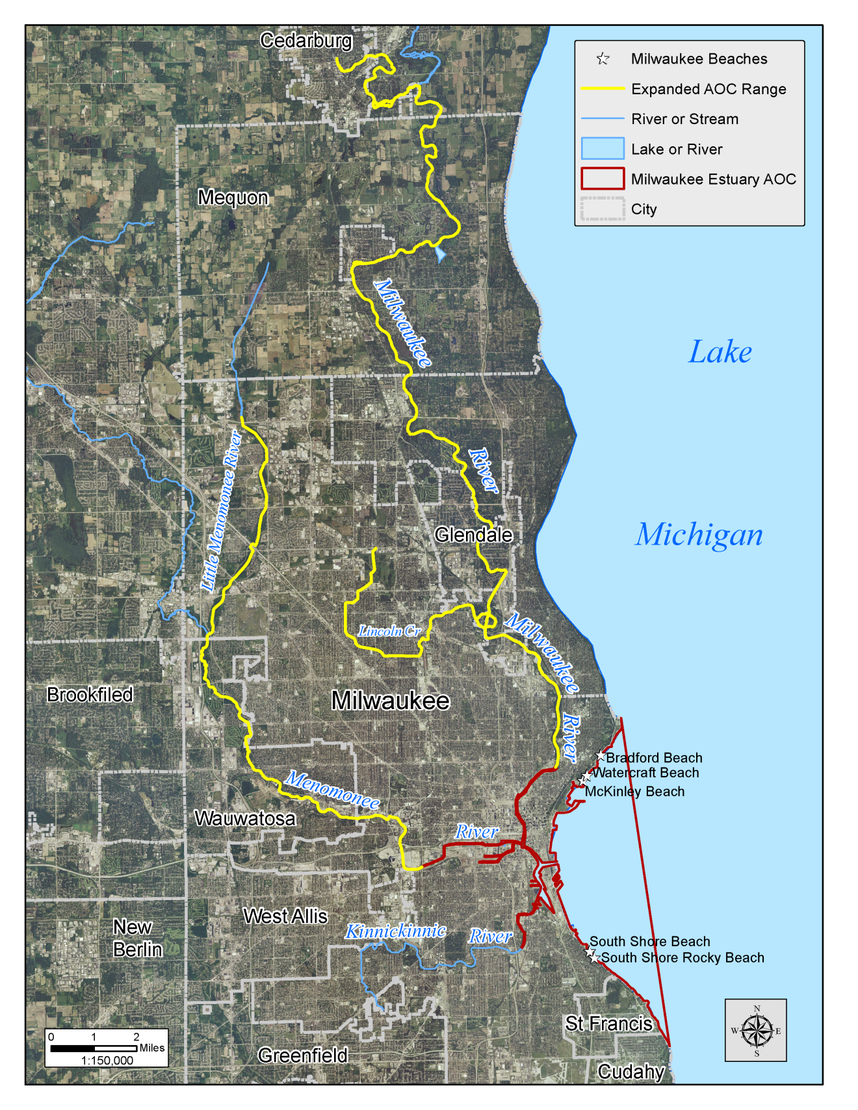
Figure 1: Study Area

