South Branch Manitowoc River Downstream of Hayton Dam Sediment Assessment Results

October 26, 2017

Cheryl A. Bougie
Office of Great Waters Sediment Management Section
Wisconsin Department of Natural Resources (WDNR) - Green Bay

Introduction and Background:
The South Branch of the Manitowoc River flows 37 miles through three counties: Fond du Lac, Calumet and Manitowoc. It drains 189 square miles located within the Manitowoc River Basin and the South Branch of the Manitowoc River Watershed (MAO5) (refer to Figure 1 on Page 3) (WDNR, 1997) and (WDNR, 2017). The sediment assessment study area is located downstream of Chilton and below the Hayton Millpond in Hayton Wisconsin, Calumet County (refer to Figure 2 on Page 4).

The Hayton Area Remediation Project (HARP) is a Polychlorinated Biphenyl (PCB) spill site that was discovered in the early 1990s as a result of routine fish tissue monitoring that identified high levels of PCB in fish in the South Branch Manitowoc River. An investigation of the water, sediment, and fish tissue conducted between 1992 and 1994 identified contamination in eight miles of stream and approximately 2 miles of drainage ditches stretching from New Holstein downstream to the Hayton Millpond on the South Branch of the Manitowoc River and includes Pine Creek, which discharges into the pond, and Jordan Creek, a tributary of Pine Creek. All areas impacted are located north of the city of New Holstein in Calumet County (WDNR, 1997 and TRC, 2011). PCBs were discharged from a Tecumseh Products Company (Tecumseh) manufacturing facility in New Holstein to drainage ditches in New Holstein which drained to Jordan Creek, Pine Creek and to the South Branch of the Manitowoc River. HARP is the subject of Consent Order No. 2004-COEE-010 requiring cleanup of the PCBs and restoration of the streams. The site has been divided into four Operable Units (OU), based largely on contaminant distribution and stream morphology. In Figure 3, Page 5 one can see the spill site location the drainage ditches and stream channels of the HARP project area (TRC, 2011).

Fish sampled in the HARP area showed PCB concentrations that exceeded US Food and Drug Administration (USFDA) and Wisconsin Department of Health Services human health fish consumption guidelines. The fish consumption advice for the HARP area (South Branch of the Manitowoc River from Chilton to Hayton, Jordan and Pine Creeks) is “do not eat any fish” (refer to Figure 4 on Page 6 and Table 1 on Page 7. Choose Wisely: A Health Guide for Eating Fish in Wisconsin).

A remedial investigation and feasibility study began in 1995 by Foth and Van Dyke and Asci Corporation and was overseen by the Wisconsin Department of Natural Resources (WDNR) and Wisconsin Department of Administration (WDOA). The WDNR is working with key partners and the responsible parties (Tecumseh and TRC Consultants, which assumed the liability for the PCB spill and is responsible for the cleanup) to address contaminated sediment in the river and bank areas. As of 2016 approximately 87,000 cubic yards of PCB sediment and over bank materials have been excavated and disposed from the HARP site.

HARP is entering its 17th year of design and sediment remediation including bank restoration, with work continuing in a downstream direction towards the Hayton Millpond/Dam. Work began on Operational Unit 4 in 2017. While water-column testing has shown that PCBs were being transported over the dam (USGS, 1999), there had been no sediment testing performed immediately downstream of the dam to determine if PCBs exist within the stream bed material. The Choose Wisely: A Health Guide for Eating Fish in Wisconsin contains PCB consumption advisories for black crappie, bullhead, carp, northern pike, redhorse, rock bass, and white sucker in the Manitowoc River from Hayton Dam to Clarks Mills Dam, also indicating a potential PCB sediment issue downstream of the HARP area and within the proposed sediment study area (WDNR, 2016). It should be noted that the advice for carp, northern pike and rock bass is “do not eat.” At the time of this study the extent of the HARP project included only areas above the millpond dam. The downstream sediment chemistry information was necessary to determine if the site boundaries need to be expanded before respondents (Tecumseh and TRC) begin design on the final phases of the project.

Figure 1. South Branch Manitowoc River Watershed
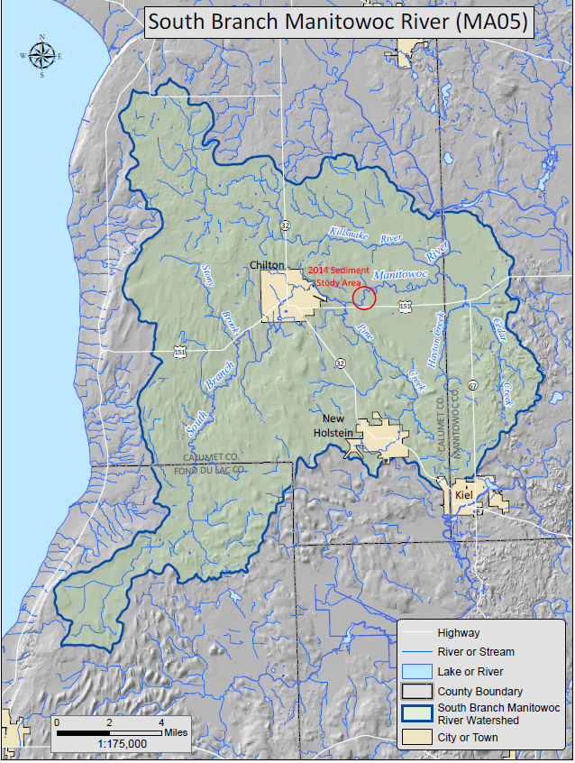
(WDNR, 2017)
Figure 2. South Branch Manitowoc River Sediment Assessment Study Area
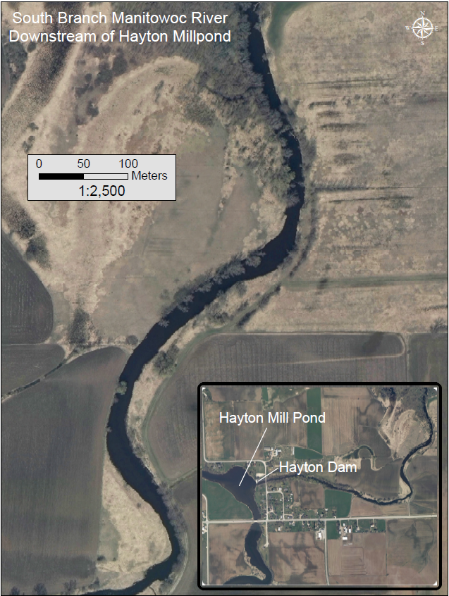
(WDNR, 2017)
Figure 3. Hayton Remediation Area Project – Operable Units
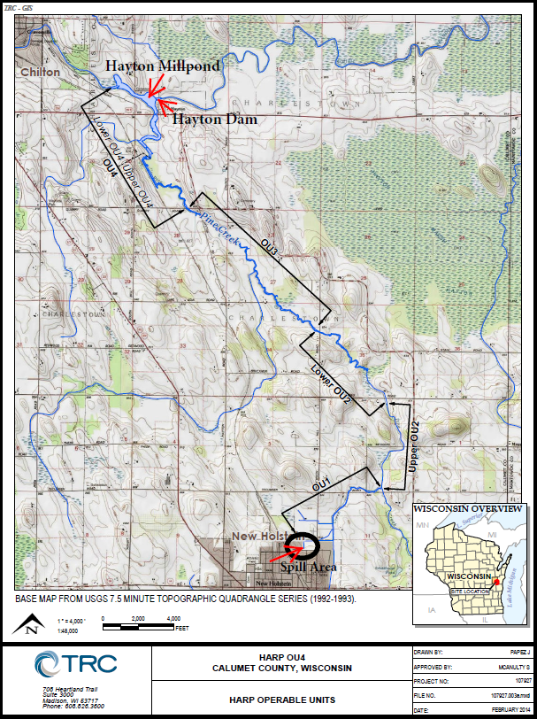
(TRC, 2011)

Figure 4. Choose Wisely: A Health Guide for Eating Fish in Wisconsin.
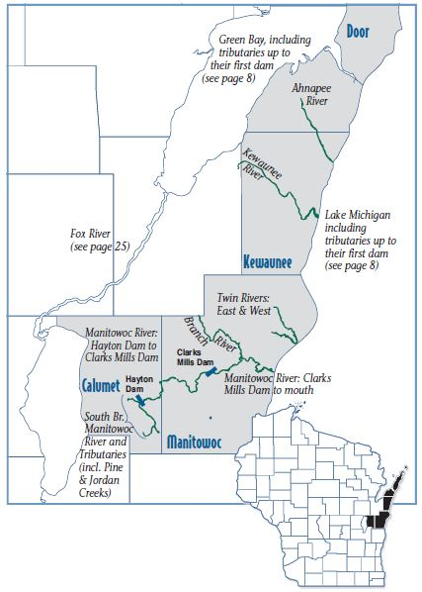
(WDNR, 2016)

Table 1. Choose Wisely: A Health Guide for Eating Fish in Wisconsin
(WDNR, 2016)

Project Objectives:
The project objective was to obtain representative samples of the soft anthropogenic sediment for laboratory analysis to determine presence or absence of total particle-bound PCB with Aroclor identification in the South Branch of the Manitowoc River below Hayton Millpond. The intent was to assess sediment quality downstream of the Hayton Dam to determine if there are impacts from upstream historic operations from the former Tecumseh facility in New Holstein, i.e., presence or absence of PCBs.

Sediment Sample Collection and Field Notes:

Field staff (Bougie and Killian), WDNR, Office of Great Lakes Sediment Management Section collected surficial river bed (soft) sediment from six distinct locations on the South Branch of the Manitowoc River within the 1.5-mile section downstream of the Hayton Dam (refer to Figure 5 on Page 12) on July 31, 2014. Weather on Tuesday, July 31, 2014: partly cloudy day, 73.9 $°$F, no precipitation (US Climate Data, 2014).

The sample locations were selected based on areas of the river that were wide and expected to have increased rates of sedimentation and were verified by earlier reconnaissance sediment poling performed by William Fitzpatrick and Scott Inman, Engineers from the Office of Great Lakes, Sediment Management Section. Coordinates were pre-entered into the Global Positioning System (GPS) Trimble Pro-XRS- RTD© and used to locate sediment deposits that were initially identified by Fitzpatrick and Inman. Sample locations were moved in some instances due to poor recovery in the sediment cores; in these instances, new GPS coordinates were recorded. A metal sounding pole was advanced through the sediment and used to determine substrate type along with water depths.

Polycarbonate core tubes with two-inch inner diameter were advanced manually (by hand) into the sediment and a rubber stopper was installed at the bottom of the core tube to capture the sediment sample. Multiple core samples were collected to ensure sufficient volume of material for analysis. Sample locations were moved if core recovery was poor, if the site lacked adequate sediment thickness, or if the substrate was not suitable (rock/stone). In addition, a Petite Ponar© grab sampler was used where there were shallow or sand sediment deposits at the sample location. Sample location S-1 was collected with a Ponar due to the sandy nature of the sediment and lack of core sample recovery.

A Global Positioning System (GPS) Trimble Pro-XRS-RTD© with real-time sub-meter accuracy was used to record the sediment sample locations. The GPS accuracy characteristics were:
Accuracy (RMS) (Note A):
MCORR400 differential correction: Submeter + 1 ppm on a second-by-second basis (horizontal)
Submeter + 2 ppm on a second-by-second basis (vertical)
Carrier phase processing: 30 cm + 5 ppm with 5 minutes tracking satellites
20 cm + 5 ppm with 10 minutes tracking satellites
10 cm + 5 ppm with 20 minutes tracking satellites
1 cm + 5 ppm with 45 minutes tracking satellites (with Centimeter Processing option)
RTCM satellite differential correction: Better than 1 meter

Core tubes were kept in a vertical position while the sample was measured and described. Distinct strata, color, odor, presence of debris, and any other distinguishing characteristics along with water depth, distance from bank, sediment depth and sample core thickness were also recorded.

Samples were processed at each site with a canoe as the platform for mixing and samples were homogenized in new, single-use disposable aluminum trays using a stainless-steel spoon. Upon completion of mixing, samples were placed in glass wide-mouth sample containers provided by the Wisconsin State Laboratory of Hygiene (WSLH), and immediately placed in a cooler with ice until delivery to the WSLH under their chain of custody protocol. A second sub-sample from each sample composite was placed in Ziploc© bags for physical analysis.

Decontamination of equipment was performed before the sampling and between each sampling location. All solid particles were removed from the equipment by brushing and then rinsing with tap water, then washed with a phosphate free detergent solution (Alconox©), and finally rinsed with distilled water to remove all detergent residue.

Sample ID nomenclature followed standard Department naming convention for sediment sampling: Project Name, Year, Sample Type (S=sediment), and Sample number (example: HAYT14-S1). The samples were labeled HAYT14-S1, S2, S2A, S3, S4 and S5, then placed in a cooler with ice and personally delivered to the WSLH for analysis the day after collection (August 1, 2014). The samples were analyzed for PCB Aroclor identification and concentration, Total PCBs, and Total Organic Carbon (TOC). The WSLH forwarded the plastic bags containing sub-samples to the University of Wisconsin Madison Soils Laboratory (UWMSL) for particle size analysis.

The laboratory supplied electronic data deliverables appropriate for upload into the Department’s Surface Water Integrated Monitoring System (SWIMS) Database.

All field staff were 40-hour HAZWOPER certified and WDNR Standard Operating Procedures (SOP) trained due to potential hazards with sampling contaminated sediment and working in wadable streams.

Laboratory analytical parameters, United States Environmental Protection Agency (USEPA) Methods, Level of Detection (LOD) and laboratory name are listed below in Table 2:

Table 2. Laboratory Analytical Parameter Information Summary
Parameter | USEPA Method | Level of Detection (ppm) | Laboratory
PCB – 1016 | Modified 8082A | 0.024 | WSLH
PCB – 1221 | Modified 8082A | 0.024 | WSLH
PCB – 1232 | Modified 8082A | 0.024 | WSLH
PCB – 1242 | Modified 8082A | 0.024 | WSLH
PCB – 1248 | Modified 8082A | 0.024 | WSLH
PCB – 1254 | Modified 8082A | 0.024 | WSLH
PCB – 1260 | Modified 8082A | 0.024 | WSLH
PCB – 1268 | Modified 8082A | 0.024 | WSLH
TOC | 9060A & Standard Method 5310C | 1,500 | WSLH
Particle Size | Hydrometer Method | 1 % | UWMSL
Notes: WSLH = Wisconsin State Laboratory of Hygiene (certified #113133790)
UWMSL = University of Wisconsin Madison Soils Lab (non-certified)

Important identification numbers for this sampling effort include the following: SWIMS Station ID Numbers 10041404 through 100041407, Waterbody Identification Code (WBIC) 77900.

Sediment Results:
The State Laboratory of Hygiene reported the sediment data via e-mail to James Killian on September 18, 2014 from Ron Arneson, Laboratory Liaison WDNR. Concentrations of PCBs analyzed were reported both above and below the Threshold Effect Concentration (TEC), as defined in the Department’s Consensus-Based Sediment Quality Guidelines (CBSQG) (WDNR, 2003).

The CBSQG was developed to determine effect levels at which toxicity to benthic dwelling organisms may be predicted. The TEC concentration is the point when the benthos (macroinvertebrates) begins to have negative impacts (reductions in survival, reproduction and growth) due to toxic effects. All 6 samples exceeded the TEC concentration for PCBs indicating induced stress on the benthos.

The cleanup goal for the HARP project is the removal of all contaminated sediment greater than 1 ppm PCB. Four of the six sample locations exceeded the 1 ppm remediation goal: S2, S2A, S3 and S5. Total PCB concentrations for these four locations were reported as 11ppm, 15 ppm, 6.2 ppm and 1.8 ppm, respectively. Sample sites S2 and S2A had noticeable oil sheen and distinctive petroleum odor to the sample. Coincidently, S2 and S2A also had the highest concentration of total PCBs at 11 ppm and 15 ppm, respectively.

The sediment samples were comprised mainly of silty sand, with particle size fractions ranging proportionately: sand (56%-85%), silt (8%-33%) and clay (6%-11%). Sample results showed that locations S2, S2A, S3 and S5 contained a higher percentage of silt than locations S1 and S4, the two locations with lower concentrations of total PCBs (0.28 ppm and 0.31 ppm, respectively). Site S1 was collected with a Ponar due to the sand material and lack of core recovery. Generally, PCBs are found in smaller grained silt material rather than coarser sand, the same is true on the Lower Fox River, Wisconsin.

A battery of PCB Aroclors were analyzed for each sediment sample. (PCBs generally occur as mixtures of congeners; the most common commercial mixtures are called Arochlors—their names reflect the percent chlorine by weight of the mixture {e.g., Aroclor 1248 is 48% chlorine by weight}, with the more chlorinated mixtures generally being the most persistent and toxic). Many were reported as No Detect: PCB 1016, 1221, 1232, 1242, 1260, and 1268. The laboratory PCB level of detection was 0.024 ppm. In addition, two Aroclors were detected with validated non-numeric results: PCB 1248 and 1254. Both PCB 1248 and 1254 were detected in samples S2 and S2A, the locations containing the highest concentrations of Total PCBs (11 ppm and 15 ppm, respectively). To clarify the lab reports total PCBs and does not quantitate each individual Aroclor, therefore, the numeric value of Aroclors (11 ppm) reported is the total of all the “validated non-numeric result” when Arochlors are “Detected”. The remaining Aroclors are either not present or are below ½ the LOD. In this case, there are a total of 11 ppm of PCBs containing a mixture of 1248 and 1254 Aroclors. There could be any combination of these two Aroclors adding up to 11 ppm. The Quantitation method involves making a custom standard mix of Arochlors (in this case 1248 and 1254) that as closely as possible matches the Aroclor mix/pattern in the sample to quantitate against. The total PCB concentration of the quantitation standard mixture will be above the LOD. Refer to Table 3 on Page 13 for analytical results.

Figure 5. South Branch Manitowoc River Sediment Sample PCB Concentrations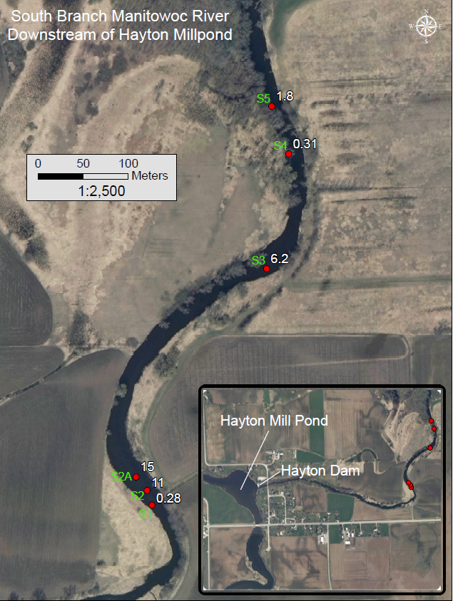
(WDNR, 2017)

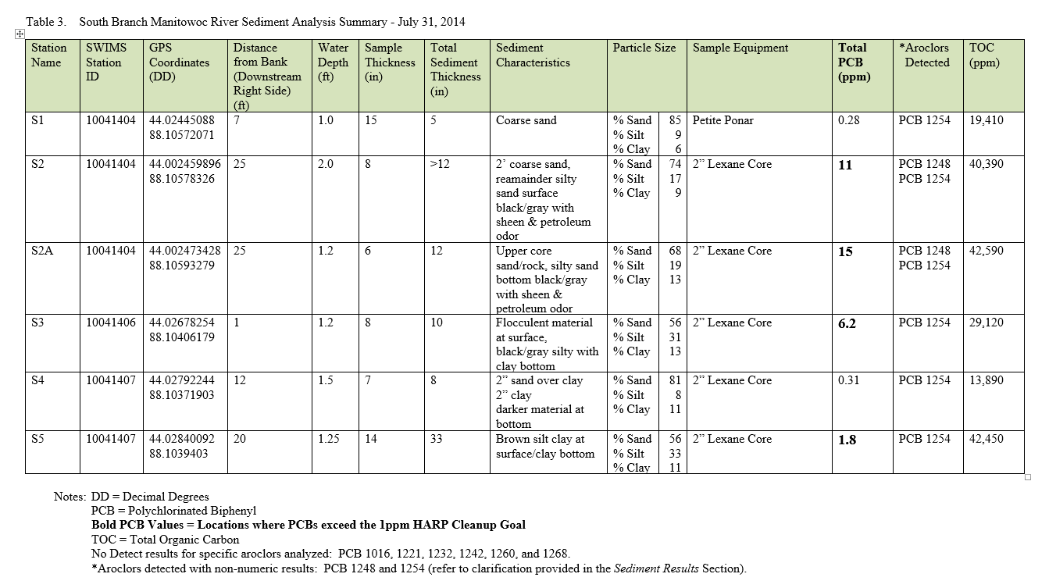
Conclusion:
Sediment samples collected in the South Branch of the Manitowoc River below the Hayton Millpond all show detectable levels of PCBs. At the time of the sampling, the dam was the downstream boundary of the HARP remediation area. PCBs were above the HARP cleanup action level of 1 ppm of Total PCBs at 4 of 6 locations and above the CBSQG TEC value (0.06 ppm) at all of the sampling locations. Data are consistent with the data from the HARP site and indicate ecological and human health risk. The sediment data correlates with the existing Fish Consumption Advisory and supports the need for continued routine fish tissue monitoring from Hayton Millpond to Clarks Mills Dam. Because PCBs are slow to degrade, bioaccumulate, and biomagnify in upper trophic levels it is important that this portion of river be further evaluated by Tecumseh and TRC.

The sampling team recommend that Tecumseh and TRC be informed of this data and requested they perform additional sediment investigations on the South Branch of the Manitowoc River below the Hayton Millpond. Including streambank and terrace areas, to further define the degree and extent of contamination. Routine fish tissue monitoring should also continue from Hayton Millpond to Clarks Mills Dam.

Based on the data gathered in this study the Department expanded the downstream boundary of the HARP site. Tecumseh and TRC were instructed to define the degree and extent of PCBs in the river below the dam.

In addition to Tecumseh and TRC, any private landowner wishing to dredge or perform stream alterations in this reach of river (Hayton Millpond to Clarks Mills Dam) under Wisconsin State Statues Chapter 30 Navigable Waters, Harbors and Navigation will also need to follow the Wisconsin Administrative Code Natural Resources Chapter (NR) 347 Sediment Sampling and Analysis, Monitoring Protocol and Disposal Criteria for Dredging Projects for sediment characterization, dewatering and placement of material with special attention given to PCB contaminated media.

List of Acronyms:

CBSQG Consensus-Based Sediment Quality Guidelines
DD Decimal Degrees
GIS Geographic Information System
GPS Global Positioning System
HARP Hayton Area Remediation Project
HAZWOPER Hazardous Waste Operations and Emergency Response
LOD Level of Detection
NR Natural Resources
OU Operable Unit
PCB Polychlorinated Biphenyl
PPM Parts Per Million
SWIMS Surface Water Integrated Monitoring System
TEC Threshold Effect Concentration
TOC Total Organic Carbon
USEPA United States Environmental Protection Agency
USFDA United States Food and Drug Administration
USGS United States Geological Service
UWMSL University of Wisconsin Madison Soil Laboratory
WBIC Waterbody Identification Code
WDNR Wisconsin Department of Natural Resources
WDOA Wisconsin Department of Administration
WSLH Wisconsin State Laboratory of Hygiene

References:

TRC Environmental Corporation, 2011. OU1 & OU2 Remedial Documentation Report and Partial Closure Request Hayton Area Remediation Project, Calumet County, Wisconsin, Project 107927.

US Climate Data, 2014. Chilton Weather Data via US Climate Data website:
http://www.usclimatedata.com/climate/chilton/wisconsin/united-states/uswi0133/2014/7

USGS, 1999. Distribution and Transport of Polychlorinated Biphenyls and Associated Particulates in the Hayton Millpond, South Branch Manitowoc River, 1993-95. Water-Resources Investigations Report 99-4101.

University of Wisconsin Soil and Forage Laboratory website:
https://uwlab.soils.wisc.edu/fees/

Wisconsin Department of Natural Resources (WDNR), 2016. Choose Wisely: A Health Guide for Eating Fish in Wisconsin. PUB-FH-824 2016
http://dnr.wi.gov/FCSExternalAdvQry/FishAdvisorySrch.aspx

WDNR, 2003. Consensus-Based Sediment Quality Guidance, Recommendations for use and Application, WT-732-2003.
http://dnr.wi.gov/topic/brownfields/documents/cbsqg_interim_final.pdf

WDNR, 1997. Manitowoc River Basin Water Quality Management Plan. PUB-WT-282-97 REV

WDNR, 2017. Manitowoc River Basin – South Branch Manitowoc River Watershed Map. GIS File

WDNR, 2017. South Branch Manitowoc River Basin – Down Stream of Hayton Millpond Map. GIS File

WDNR, 2017. South Branch Manitowoc River 2014 PCB Concentrations & Sediment Sampling Locations Map. GIS File

WDNR, 1989. Wisconsin Administrative Code Natural Resources NR 347 Sediment Sampling & Analysis, Monitoring Protocol and Disposal Criteria for Dredging Projects.
http://docs.legis.wisconsin.gov/code/admin_code/nr/300/347.pdf

WDNR, 2017. Wisconsin State Statutes Chapter 30 Navigable Waters, Harbors and Navigation.
http://docs.legis.wisconsin.gov/statutes/statutes/30.pdf

Wisconsin State Laboratory of Hygiene website:
http://www.slh.wisc.edu/environmental/organic/analytical-tests/

