Scope of Work
Wisconsin DNR Office of the Great Waters

Project Title: Big-I Development Restoration Project-Chiwaukee Prairie Preserve

Project Manager: Stephanie Judge, Land Protection Specialist, The Nature Conservancy, 633 West Main Street, Madison, WI 53703, 608-316-6445, sjudge@tnc.org. Ricki Disdier, Senior Grant Specialist, 1101 West River Parkway, Suite 200, Minneapolis, MN 55415, 612-331-0713, Ricki_disdier@tnc.org.

WDNR Project Manager: Sharon Fandel, Conservation Biologist, 608-275-3207, Sharon.fandel@wisconsin.gov.

Project Location:

The Big-I Development restoration project is located along the east side of Sheridan Road (STH 32), north of 128th Street in the Village of Pleasant Prairie, Kenosha County, Wisconsin. It lies just north of the Wisconsin-Illinois border. T1N, R23E, Section 31 (SE Quarter). Lat/Long: -87.82 and 42.5. Pike-Root Watershed - HUC 04040002.
Problem Statement:

The Big-I Development restoration project will result in the restoration and enhancement of approximately 33.33 acres of coastal wetlands and 25.35 acres of native prairie and other upland habitat. The project’s primary goal is protecting the highly sensitive hydrology of the Chiwaukee Prairie wetland complex to the east that is part of the Lake Plain coastal shore of Lake Michigan and hosts globally-rare wet-mesic lake plain prairie. Wetland and grassland habitat improvements at the site will also provide critical habitat for migratory birds, support nesting of Blanding’s turtles documented on site, and expand public recreational opportunities across the Preserve.
Proposed Work:

Site preparation for the proposed wetland restoration and enhancement project is expected to be intensive and will include clearing of undesirable tree and brush species and control of invasive plants. The primary invasive species found on the property include buckthorn, honeysuckle, oriental bittersweet, garlic mustard, dame’s rocket, and reed canary grass. These populations are largely occurring within the existing wetland areas or along the railroad grade and other wooded portions of the property covering about a 21-acre area. The remainder of the property (approximately 38 acres) is currently being used for agriculture and all crops planted on the site will be harvested prior to initiation of the project.

Wetland restoration activities will primarily include ditch fills, tile breaks, and shallow scrapes to restore wetland hydrology, as well as planting of native prairie species. Construction methods will consist of the use of heavy equipment to strip the material off adjacent croplands to fill ditches and achieve the desired elevations to restore hydrology on the site. Wide track, low pressure equipment will be used to construct the site to avoid or reduce soil compaction.

Planting will occur immediately after construction. The plantings will include native species common to the area which are suitable for growth in the saturated conditions for the target wetland community. Native mesic prairie vegetation will be established as a functional vegetated buffer adjacent to the re-established wetland communities to protect wetland functions and services, maintain water quality, provide habitat, and reduce impacts from invasive species. The site will be monitored to ensure that the desired hydrology and plant communities have been achieved and that buffers areas are dominated by a diversity of native, non-invasive plant species. The prairie plantings will be mowed for at least two growing seasons as part of the post-construction maintenance of the site and a treatment plan will be implemented to control the spread of invasive plant species.

Wetland enhancement activities within the existing wooded wetlands on the property will primarily include extensive tree and brush removal and invasive species control. Inter-seeding may be necessary to restore groundcover once the canopy is opened to prevent encroachment of invasive species while native plants are becoming re-established. All undesirable species will be cut and/or chemically treated using methods that will not result in soil disturbances. In order to control the spread of invasive plant species, a treatment plan will be implemented to ensure the success of the wetland enhancement work.

Collaboration with Partners:

TNC will oversee the restoration of this site in partnership with the U.S. Fish and Wildlife Service (USFWS) Private Lands Program. TNC will contract with USFWS to provide technical assistance in the design and construction of the project. Other contracts for work needed to complete the planned restoration activities will be secured through a competitive bidding process.

Timetable:
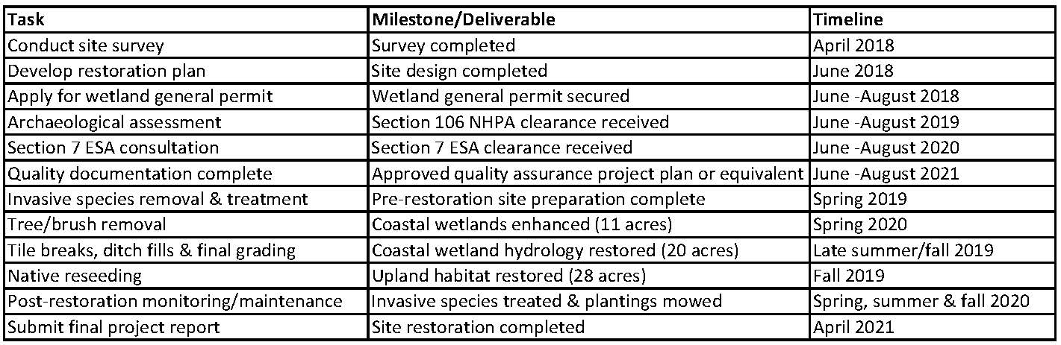

Deliverables:

Deliverables are identified in the table above and will include quarterly reports in addition to a final report. Quarterly reports will be submitted January 10, April 10, July 10, and October 10 of each year until project close out. Reports will identify amount expended per quarter (this can be approximate if an invoice is not yet available), activities conducted, and planned activities for the following quarter, along with identification of any issues encountered during the time and how they were addressed.

Project Budget:

 | Year 1 [4/2018-4/2019] | Year 2 [4/2019-4/2020] | Year 3  [4/2020-4/2021] | Total
Personnel/Salaries | $8,400 | $8,400 | $4,200 | $21,000
Fringe Benefits (40 %) | $3,360 | $3,360 | $1,680 | $8,400
Travel (0.535/mile x 1120 miles/year) | $599 | $599 | $599 | $1,797
Equipment
Supplies
Contractual: | $45,000 | $54,033 | $24,740 | $123,773
Other Costs | $100 |  |  | $100
Total Direct Charges | $57,459 | $66,393 | $31,219 | $155,071
Indirect Charges (23.31%) | $13,394 | $15,476 | $7,277 | $36,147
Total Cost | $70,853 | $81,869 | $38,496 | 191,218

Note that only Year 1 funds are provided as part of this grant agreement. Year 2 funds will be awarded at a later time in an addendum to this grant, pending successful completion of Year 1 deliverables. Year 2 is included in this Scope of Work for project planning purposes only

Budget Detail:

WDNR is partnering with TNC on this project. Funding will be provided to TNC in an agreement to complete project work. TNC will apply a majority of these funds to the direct costs of restoring and enhancing the Big-I parcel, including any permit fees and contracts for construction work, invasive plant control, tree/brush removal, planting, and post-construction monitoring of the site. Grant funds will also be used to cover salary, benefits, and travel costs for TNC staff to oversee project implementation at the site and manage the contracts. Since this property was purchased with federal funds, there will also be costs associated with an archaeological assessment and on-site consultation that is likely to be needed prior to beginning any restoration/enhancement work on the property, especially in the existing wetland areas. The remainder of the budget accounts for TNC’s negotiated and approved indirect cost rate, currently 23.31%, with their cognizant agency. TNC estimates that once restoration work commences, about 80% of the total budget will be spent in Year 1 and Year 2 of the project and the other 20% in Year 3 for post-construction monitoring and maintenance to ensure project success. See Project Budget above for itemized costs.

