LNRP Newsletter: Winter 2016
Lakeshore Natural Resource Partnership (LNRP) Adopt-A-Park Program
The LNRP Adopt-a-Park program was created to give citizens of all ages an opportunity to volunteer in our region’s village, city, and county parks. Time spent assisting with park upkeep, cleaning, maintenance, beautification, and preservation helps to provide a safer, more beautiful park experience for the entire community. Volunteers get to experience seeing the results of their efforts immediately and feel the satisfaction from helping improve their community.
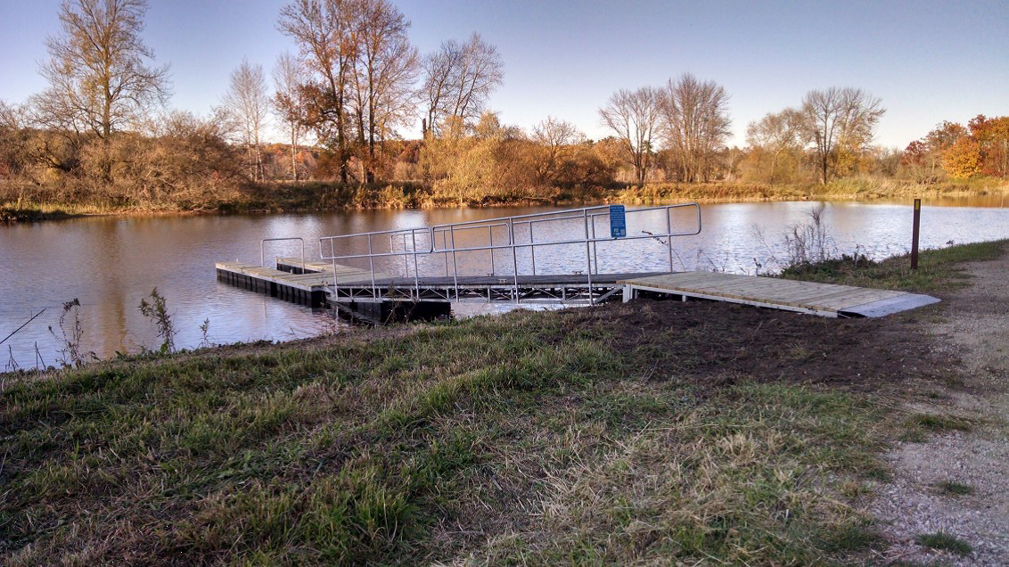
We welcome and encourage everyone to participate in this win-win program; individuals, families, church congregations and businesses can all do their part to help maintain and improve our parks. This effort can accommodate large groups or even one person to maintain.
The Adopt-a-Park program creates a powerful partnership between the managing government agencies and their citizens, friend groups, and LNRP. This alliance allows valuable communication and feedback between these groups that result in cleaner, safer and more user-friendly parks in their community.
Kayak launch at Lower Schuette Park installed with the help of the Friends of the Manitowoc River Watershed
Adopt-a-Park encourages civic engagement: By providing an opportunity for volunteers to give back to the community, and making noticeable improvements to our parks which are appreciated by the volunteers as well as the rest of the community. Environmental improvements: Not only does the program improve the environment aesthetically by picking up trash, planting flowers and trees, it also raises awareness of the importance and need to protect our natural spaces. As citizens observe the positive changes occurring in their neighborhood parks, they may be less likely to litter and instead show respect and care for their parks.
Safer, more beautiful parks: Program volunteers provide services that go beyond what the park management can handle time- or budget-wise. While the Parks Department takes care of regular maintenance like grass cutting, Adopt-a-Park volunteers add special touches to the park, such as mulch, flower beds, and trash removal. An adopted park is a safer park because it is free of waste and other potentially hazardous items. These volunteers save our municipalities money while continuing to improve and service our parks.
LNRP currently has friend groups who have adopted four parks in the Lakeshore: Friends of Crescent Beach for Crescent Beach in Algoma; Friends of the Manitowoc River Watershed for Lower Schuette Park in Manitowoc; Friends of Hika Bay for Fischer Creek Park in southern Manitowoc County and Hika Park in the Village of Cleveland. If you are interested in joining other volunteers in any of these parks, please contact Jenn Hansmann at jenn@LNRP.org. Come join the fun!

