Wisconsin Department of Natural Resources
Prepared in cooperation with the U.S. Geological Survey

Milwaukee Estuary Area of Concern Fish Population Assessment: Summary of Historic Densities and Life History
Daniel J. Sullivan
U.S. Geological Survey
Wisconsin Water Science Center
8505 Research Way
Middleton, WI 53562

And

Andrew H. Fayram
Wisconsin Department of Natural Resources
Office of the Great Lakes
101 South Webster Street
Madison, WI 53707

DNR PUB-WY-015-2014 Wisconsin Department of Natural Resources
Equal Opportunity Employer Statement
The Wisconsin Department of Natural Resources provides equal opportunity in its employment, programs, services, and functions under an Affirmative Action Plan. If you have any questions, please write to Equal Opportunity Office, Department of Interior, Washington, D.C. 20240.
Americans with Disabilities Act Statement
This publication is available in alternative format (large print, Braille, audio tape. etc.) upon request. Please call (608) 267-7694 for more information.
Program Guidance or Technical Guidance Disclaimer
This document is intended solely as guidance and does not include any mandatory requirements except where requirements found in statute or administrative rule are referenced. This guidance does not establish or affect legal rights or obligations and is not finally determinative of any of the issues addressed. This guidance does not create any rights enforceable by any party in litigation with the State of Wisconsin or the Department of Natural Resources. Any regulatory decisions made by the Department of Natural Resources in any manner addressed by this guidance will be made by applying the governing statutes and administrative rules to the relevant facts.
Suggested citation:
Sullivan, D.J. and Fayram, A.H., 2014. Milwaukee Estuary Area of Concern Fish Population Assessment: Summary of Historic Densities and Life Histories. Wisconsin Department of Natural Resources, 101 South Webster Street, Madison, WI 53707

Contents
Abstract 8
Introduction 8
Description of Milwaukee Estuary Area of Concern 9
Quantitative Target Metrics for Recovery of the Fish Population 10
History of Fish Assessments in the Milwaukee Estuary 13
Life Histories of Fish Captured in Milwaukee Estuary AOC 16
Indicator Species 16
Northern pike (Esox lucius) 16
General Species Information 16
Abundance in Milwaukee Estuary AOC 17
Expectation of recovered AOC population 17
Walleye (Sander vitreus) 20
General Species Information 20
Abundance in Milwaukee Estuary AOC 20
Expectation of recovered AOC population 21
Greater redhorse (Moxostoma valenciennesi) 23
General Species Information 23
Abundance in Milwaukee Estuary AOC: 23
Expectation of recovered AOC population 24
Lake Sturgeon (Acipenser fulvescens) 26
General Species Information 26
Abundance in Milwaukee Estuary AOC 26
Expectation of recovered AOC population 26
Other Fish Species in the Milwaukee Estuary Area of Concern 29
Amiidae (Bowfin) 29
Bowfin (Amia calva) 29
Clupeidae (Herring) 29
Alewife (Alosa pseudoharengus) [Non-Native] 29
Gizzard Shad (Dorosoma cepedianum) [Non-native] 32
Salmonidae 32
Brook trout (Salvelinus fontinalis) 32
Rainbow trout (Oncorhynchus mykiss) [Non-native] 32
Brown trout (Salmo trutta) [Non-native] 32
Coho Salmon (Oncorhynchus kisutch) [Non-native] 33
Chinook Salmon (Oncorhynchus tshawytscha ) [Non-native] 33
Lake trout (Salvelinus namaycush namaycush) 33
Lake whitefish (Coregonus clupeaformis) 35
Round whitefish (Prosopium cylindraceum) 37
Bloater chub (Coregonus hoyi) 38
Cyprinidae (Minnows) 38
Common Carp (Cyprinus carpio) [Non-native] 38
Catastomidae 41
White Sucker (Catastomus commersoni) 41
Longnose Sucker (Catostomus catostomus) 42
Ictaluridae 44
Gasterosteidae 44
Ninespine stickleback (Pungitius pungitius) 44
Percopsidae (Trout-perch) 44
Centrarchidae 44
Various sunfish species 45
Smallmouth bass (Micropterus dolomieui) 45
Largemouth bass (Micropterus salmoides) 46
Percidae 47
Yellow Perch (Perca flavescens) 47
Cottidae 49
Sculpin (spp.) 49
References Cited 53
Appendix 1. 55

Figures
Figure 1. Map of the Milwaukee Estuary Area of Concern. 12
Figure 2. Map showing location of all sampling areas of 1983 fish population assessment of the Milwaukee Estuary Area of Concern. 14
Figure 3. Location of sites sampled by electrofishing in 1983. 15
Figure 4. Northern pike abundance and distribution in Milwaukee Estuary and tributary streams in 1983 (data from Holey, 1984). Image: http://www.maine.gov. 19
Figure 5. Walleye abundance and distribution in Milwaukee Estuary and tributary streams in 1983 (data from Holey, 1984). (Walleye image courtesy State of Oregon, http://www.dfw.state.or.us). 22
Figure 6. Redhorse sp. abundance and distribution in Milwaukee Estuary and tributary streams in 1983 (data from Holey, 1984). (Greater redhorse image courtesy of NOAA) 25
Figure 7. Lake sturgeon abundance and distribution in Milwaukee Estuary and tributary streams in 1983 (data from Holey, 1985). (Lake sturgeon image courtesy TVA) 28
Figure 8. Alewife abundance and distribution in Milwaukee Estuary and tributary streams in 1983 (data from Holey, 1984). Image: www.dec.ny.gov 31
Figure 9. Lake trout abundance and distribution in Milwaukee Estuary and tributary streams in 1983 (data from Holey, 1984). Lake trout image: http://www.fish.state.pa.us/pafish/fishhtms/chap15trout.htm 35
Figure 10. Lake whitefish abundance and distribution in Milwaukee Estuary and tributary streams in 1983 (data from Holey, 1984). Image: http://www.michigan.gov/ 37
Figure 11. Common carp abundance and distribution in Milwaukee Estuary and tributary streams in 1983 (data from Holey, 1984). Image: maine.gov 40
Figure 12. White sucker abundance and distribution in Milwaukee Estuary and tributary streams in 1983 (data from Holey, 1984). (Image courtesy Michigan DNR) 42
Figure 13. Longnose sucker abundance and distribution in Milwaukee Estuary and tributary streams in 1983 (data from Holey, 1984). Image: John Lyons, Wisconsin Department of Natural Resources 43
Figure 14. Smallmouth bass abundance and distribution in Milwaukee Estuary and tributary streams in 1983 (data from Holey, 1984). 46
Figure 15. Yellow perch abundance and distribution in Milwaukee Estuary and tributary streams in 1983 (data from Holey, 1984). 49
Tables
Table 1. Fish population assessment sites in the Milwaukee Estuary Area of Concern, 1983
Table 2. List of species captured in 1983 and 1997-2001 surveys of Milwaukee Estuary AOC

Abstract
A key impairment of the Milwaukee Estuary is the degraded condition of the fish community. It is not known whether investments in infrastructure meant to enhance water quality and aquatic habitat since designation of the Milwaukee Estuary as an “Area of Concern” (AOC) have led to an improvement of the condition of the fish community. A 1983 survey of the fish abundance and distribution in the area is a baseline for determining if the fisheries have recovered enough to remove the “impaired” designation so that aspect of the AOC can be removed. To determine whether the fish community has recovered, annual fish abundance and distribution surveys in 2014, 2015 and 2016 are providing new data allowing three metrics to be evaluated: 1) the populations of four indicator species for 2014-16 must show increases compared to 1983 populations, with a 100 percent increase as the standard for improvement; 2) the overall health of the fish community must show improvement by garnering a “fair” or better score on the Index of Biotic Integrity for large rivers; and 3) the populations of all native fish species with the exception of indicator species in 2014-16 must show increases compared to the 1983 populations, with a 95 percent increase as the standard for improvement.

Introduction
The designation of “Area of Concern” (AOC) is given by the U.S.-Canada Great Lakes Water Quality Agreement to a location that has experienced environmental degradation (http://www.epa.gov/greatlakes/aoc/; accessed June 24, 2014). Each AOC in the Great Lakes is officially “listed” due to one or more beneficial use impairments (BUIs), for example, degraded fish and wildlife populations, degradation of benthos (bottom-dwelling or benthic invertebrates), or degradation of plankton populations (free-floating algae and invertebrates, or phytoplankton and zooplankton, respectively). An AOC cannot be “delisted” until remediation has resulted in improvements meeting certain criteria, allowing removal of all BUI designations for the AOC except in cases where a beneficial use cannot be fully restored (U.S. Policy Committee, 2001). A BUI may be removed without a full recovery only in cases where a) the BUI is due to natural rather than human causes; b) the BUI is not limited to the AOC but is instead typical of lake-wide, region-wide, or area-wide conditions; or c) the impairment was caused by stressors outside of the AOC (Grapentine, 2009).
Historically, the primary causative agent of these impairments has been contamination. While is it unclear from the scientific literature the degree to which contamination contributes to the decline of fish and wildlife populations, cleanup of contaminated sites in the AOC remains a key management action. The lack of suitable physical habitat in order to support populations of desired fish and wildlife species is also a key feature that will need to be addressed to make progress on these impairments.

Description of Milwaukee Estuary Area of Concern
The study area includes the area identified as the Milwaukee Estuary AOC in 1987 by the International Joint Commission (fig. 1). The AOC designation was given to the area because of historical modifications and pollutant loads that contributed toxic contaminants to the AOC and Lake Michigan (http://dnr.wi.gov/topic/greatlakes/milwaukee.html, accessed March 11, 2014). Sediments contaminated with PCBs, PAHs and heavy metals contribute to nearly all of the eleven beneficial use impairments within the original boundaries of the AOC. The rivers within the AOC were also historically modified (straightened and dredged) to accommodate large vessel commercial shipping. While Milwaukee still maintains a viable commercial port, some of the river reaches within the estuary are no longer maintained through dredging.
The original boundaries of the AOC included the lower 5 km of the Milwaukee River downstream of North Avenue Dam; the lower 4.8 km of the Menomonee River downstream of 35th Street; the lower 4 km of the Kinnickinnic River downstream of Chase Avenue; the inner and outer harbors; and the nearshore waters of Lake Michigan, bounded by a line extending north from Sheridan Park to the city of Milwaukee’s Linnwood water intake. In 2008, the boundaries of the AOC were expanded to include areas of contaminated sediments in upstream reaches of the rivers (Figure 1).
The Milwaukee Estuary AOC is very large and many partners are working to reduce pollution to AOC waterways (O’Shea, 2012). The main priorities for the Milwaukee Estuary AOC include remediation of contaminated sediments in tributaries and nearshore waters of Lake Michigan; nonpoint source pollution control; improving water quality for recreation; and enhancing fish and wildlife habitat and populations (http://dnr.wi.gov/topic/greatlakes/milwaukee.html, accessed Dec. 24, 2013).
Through the Remedial Action Planning (RAP) process, the Wisconsin Department of Natural Resources (WDNR) along with the help of citizens Groups, have identified 11 of the 14 beneficial uses as impaired. Beneficial use impairments (BUIs) in the AOC include but are not limited to: restrictions on fish and wildlife consumption, eutrophication or undesirable algae, beach closings, degraded fish populations, degradation of aesthetics, loss of fish and wildlife habitat, and restrictions on dredging activities.

Quantitative Target Metrics for Recovery of the Fish Population
The goal of this report is to aid in the development of quantitative target metrics for fish population recovery of the Milwaukee Estuary AOC. For the purposes of removal of the BUI for fish, both an increase of 100% of four native indicator species and 95% of all other native species relative to the 1983 totals, and an overall mean value from all IBI sampling efforts of “Fair” or better (i.e. 40-69) will be considered adequate for removal of this BUI (O’Shea 2012).
The specific native indicator species include northern pike, greater redhorse, lake sturgeon, and walleye. Because fish populations present in the 1980s (when the BUI was designated) were unacceptable, we consider a 100% increase of relative density (as measured by survey wide catch per effort in Holey 1984) of these four species from those estimated in a 1983 survey (Holey, 1984) as central to consideration of BUI removal except in the case of lake sturgeon.
Although these four species (northern pike, greater redhorse, lake sturgeon, and walleye) are thought to be broadly representative of fish life histories and morphometry of the various fish species throughout the estuary, the direct relation between their population success and those of other fish populations is not defined. As such, two other measures of relative fish population abundance are to be evaluated in considering removal of this BUI. As a very conservative baseline, an increase in relative density of 95% of the other native species captured in the original 1985 study is required, regardless of magnitude. In 2014-15, based on the information found in this summary, the WDNR is to evaluate the list of originally captured native fish species to refine the list of species density based on life history, ecology, and utilization of the AOC proper. Based on the results of this evaluation, the WDNR is to develop less conservative but more precise targets with regard to species and relative densities.
While these two measures (four indicator species and all relevant native species) provide an opportunity to examine relative population density in a temporal context, a spatial comparison to reference sites is also necessary. To compare the Milwaukee AOC fish populations of native indicator species to reference sites, we rely on large river IBI scores. Large river IBI scores (Lyons et al. 2001) are constructed, by definition, to represent the range of values present in similar communities (i.e. reference sites). The WDNR is to characterize IBI scores within the AOC in a given year (11 sites) and also between years (3 years). An overall mean value from all IBI sampling efforts of “Fair” or better (i.e. 40-69) will be considered adequate for removal of this BUI.
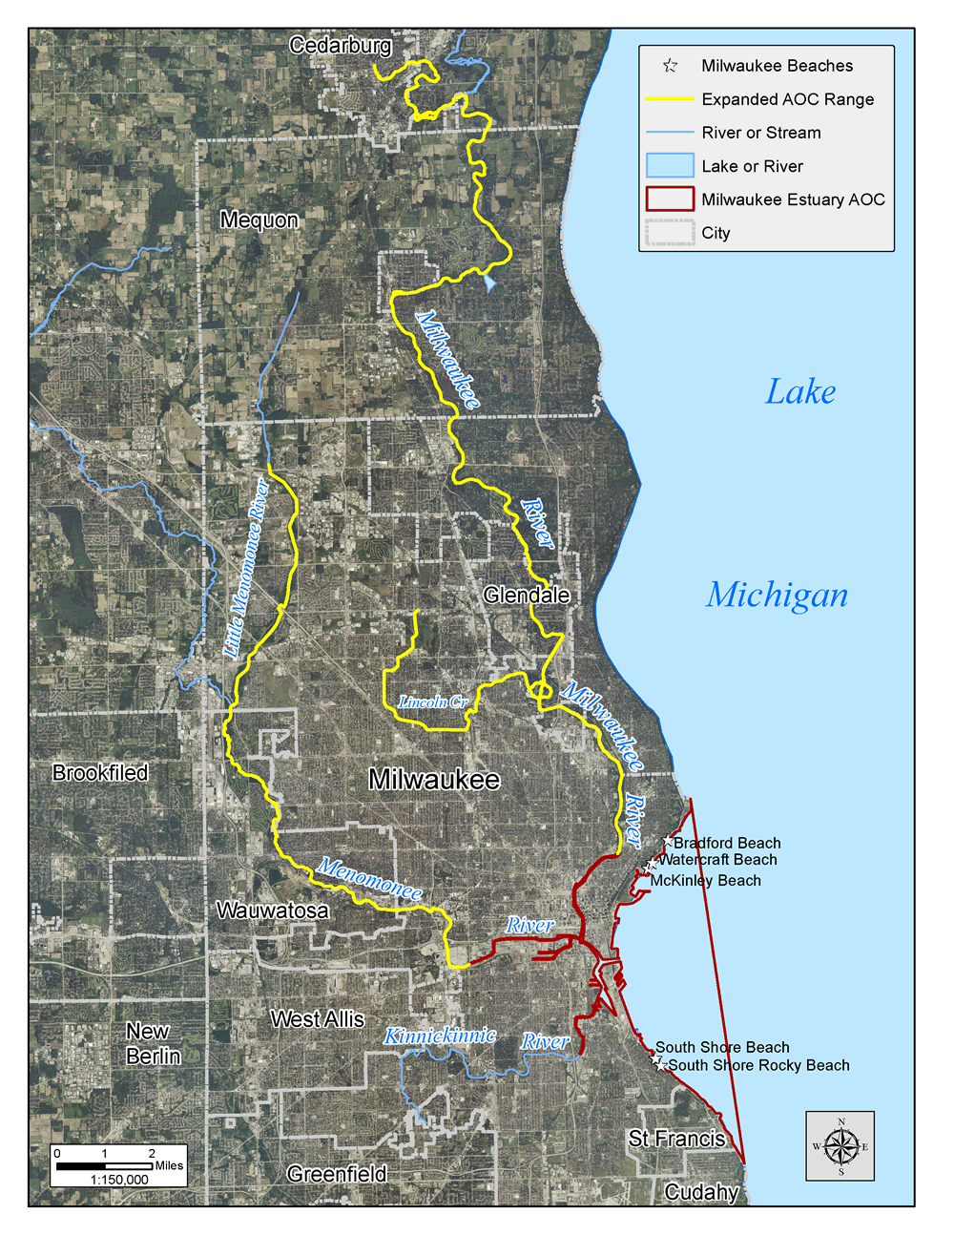
- Map of the Milwaukee Estuary Area of Concern.

History of Fish Assessments in the Milwaukee Estuary
An intensive survey of fish populations in the Milwaukee Estuary and its major tributaries was conducted in 1983 by the Wisconsin DNR in cooperation with the Southeastern Wisconsin Regional Planning Commission. The work was done to characterize the fish community and to determine the concentrations of toxic substances in the body tissues of selected fish. The sampling was done over the open-water season, with some sites sampled as early as March and some as late as October. The most intensive sampling occurred in May through July at most sites.
The 1983 survey area included the Milwaukee, Menomonee, and Kinnickinnic Rivers and the Outer Harbor and South Shore Harbor (Figure 2). Some sampling also occurred near the Lakeside Power Plant and the Oak Creek Power Plant. For the purpose of determining movements of fish, the harbor areas were divided into 18 arbitrary locations (Figure 2, Table 1). The locations and corresponding map abbreviations are listed in Table 1.
Table 1. Fish population assessment sites in the Milwaukee Estuary Area of Concern, 1983
Waterbody | Station description | Station abbreviation
Milwaukee River | Downstream (d.s.) of North Avenue dam | MILR
Menomonee River | d.s. of S. Layton Blvd. | MENR
Kinnickinnic River | d.s. of S. Chase Ave. | KKKR
Outer Harbor Shore | North of art museum | OHS1
 | Summerfest lagoon and surrounding breakwalls | OHS2
 | Southern portion of outer harbor | OHS3
Outer Harbor Breakwall | Northern segment | OHW1
 | Southern segment | OHW2
 | Southwest-Northeast running breakwall | OHW3
South Shore Shore | Northern segment | SSS1
 | Southern segment | SSS2
South Shore Breakwater | Northern segment | SSW1
 | Southern segment | SSW2
Outer Harbor Lake | Northern segment | OHL1
 | Southern segment | OHL2
 | Southwest-Northeast running breakwall | OHL3
South Shore Lake | Lake side of South shore breakwater, northern segment | SSL1
 | Lake side of South shore breakwater, southern segment | SSL2
McKinley Marina | Shoreline area of marina | MCKY
Lakeside Power Plant | Shoreline near LSPP | LSPP
Oak Creek Power Plant | Shoreline near OCPP | OCPP

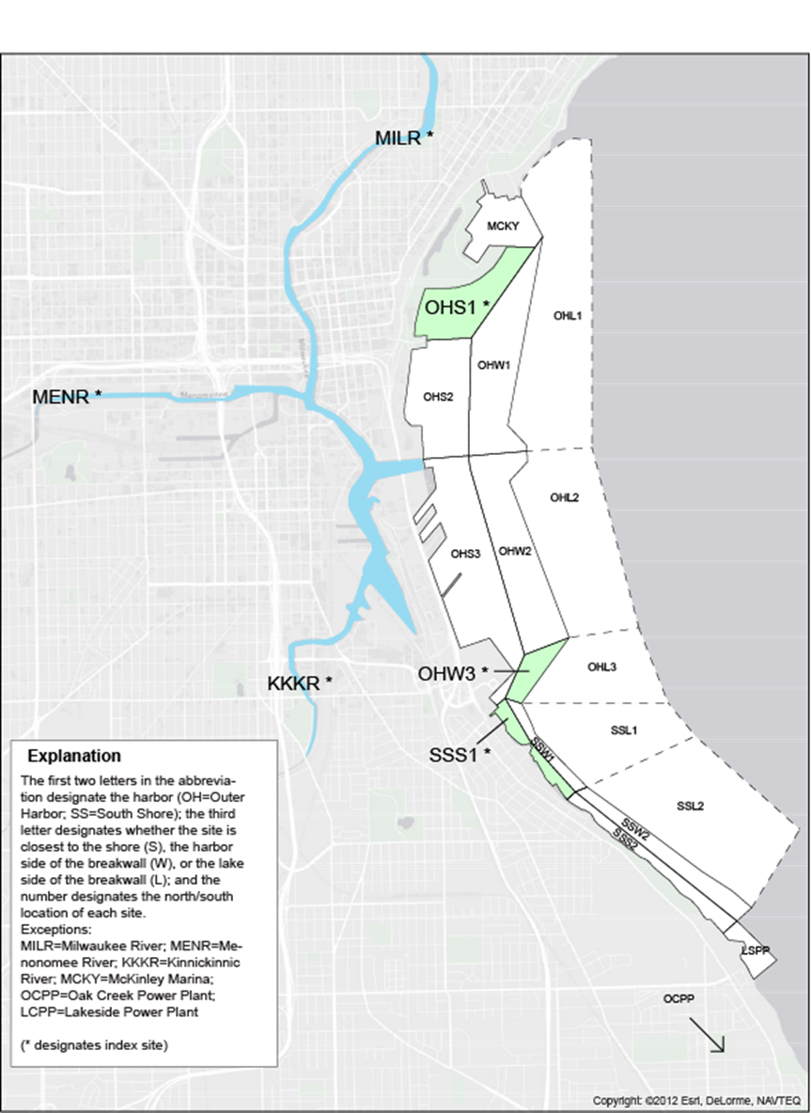
- Map showing location of all sampling areas of 1983 fish population assessment of the Milwaukee Estuary Area of Concern.
Sampling was done using three techniques: electrofishing, fyke nets, and gill nets. The river sites that were sampled by electrofishing in 1983 included the Milwaukee River downstream from below the North Avenue dam to the Humboldt Street bridge; the Menonomee River from the 25th Street bridge upstream to the first railroad bridge; and the Kinnickinnic River Becher Street bridge upstream to the Chase Avenue bridge. Additional sites were sampled by electrofishing in the harbor area on an approximately monthly interval (Figure 2).
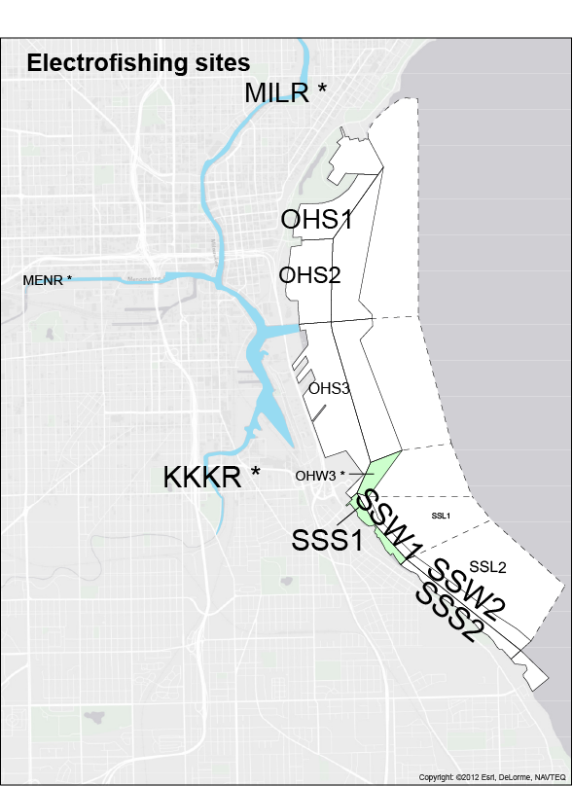
- Location of sites sampled by electrofishing in 1983.
In the years 1997-2001, the WDNR conducted an intensive fish survey that targeted a subset of the sites sampled by the 1983 survey (Hirethota and Burzynski, 2007). Species counts from that survey are included in Table 2 as information only; these results will not be discussed or used as a basis for comparison to the sampling planned for 2014-16.

Life Histories of Fish Captured in Milwaukee Estuary AOC
Each of the species captured in sampling activities that occurred in 1983 (Holey, 1985) and the period 1996-2001 (Hirethota and others, 2005) (Table 2) are described in this section. The four indicator species are described in detail, and each subsequent species is denoted as to whether it is native or non-native to the study area.
Table 2. List of species captured in river and harbor sites in 1983 and 1997-2001 surveys of Milwaukee Estuary Area of Concern

Indicator Species
Four species were selected as the main comparison species as they represent varying life histories and habitat preferences. These indicator species include northern pike, walleye, greater redhorse, and lake sturgeon. Each of these species fills a unique niche, and recovery of one or more of them may signify significant progress in at least some of the goals of ecosystem restoration within the Milwaukee Estuary AOC. A description of each species follows along with expectations for recovery. Species information is from Becker (1983) unless otherwise noted.

Northern pike (Esox lucius)

General Species Information
The northern pike inhabits cool to moderately warm weedy lakes, ponds, and sluggish rivers. It is a common resident of most medium- to large-sized lakes with inlet streams. In streams it is generally found in quiet pools to fast currents. It is present in areas of light to dense aquatic vegetation, and in areas with a wide range of turbidity, although it is much more common in clear and only slightly turbid water.
Spawning may occur from late March to early April, as soon as the ice begins to break up in the spring. Spawning sites are located in shallow, flooded marshes associated with lakes or with inlet streams to those lakes. Spawning runs occur at water temperatures between 1.1 and 4.4°C (34 and 40'F), but 2.2-2.8°C (36-37°F) is the preferred temperature range.
Northern pike congregate in spawning areas a few days before spawning actually occurs. The spawning habitat generally consists of flooded areas with emergent vegetation. Grasses, sedges, or rushes with fine leaves appear to make the best substrate for egg deposition.
In Wisconsin, the northern pike is generally common except in the southeastern quarter of the state, where populations are substantially depressed. Northern pike are found in the Mississippi River, Lake Michigan, and Lake Superior drainage basins. It is widely distributed throughout the state except in the unglaciated area, where it is sparsely dispersed except in large river systems and impounded areas. It occurs in the shallow waters of Lakes Superior and Michigan, particularly Green Bay.

Abundance in Milwaukee Estuary AOC
Northern pike were relatively rare in the 1983 survey; a total of only 50 individuals were collected from 9 sites, including all three river sites (Figure 1). As noted in Becker (1983), populations of this fish were depressed in southeastern Wisconsin in the early 1980s. Of the 50 northern pike collected, 18 were from the Milwaukee River sampling site (MILR), and Holey noted a range of sizes, indicating multiple year classes. In the WDNR’s 1996-2001 sampling, fewer northern pike were captured but they comprised a slightly higher percentage of the total catch compared to the 1983 survey (Table 2).

Expectation of recovered AOC population
Northern pike are wetland spawners, and restoration of these critical habitats has been a key component of AOC activities. However, impediments to reaching these habitats can limit their usefulness to northern pike, which are not strong swimmers. Therefore, habitat connectedness is critical, particularly within and among headwater tributaries and wetlands. Thus, a recovered northern pike population in the AOC is expected to be a good indicator the ecosystem function of wetlands has improved. On the other hand, a population that is holding steady or decreasing may indicate that wetland function in the AOC is not sufficient.

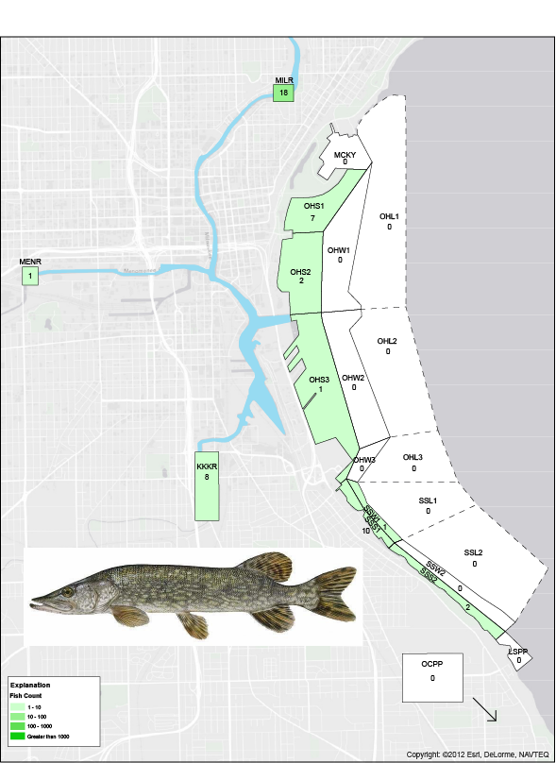
- Northern pike abundance and distribution in Milwaukee Estuary and tributary streams in 1983 (data from Holey, 1984). Image: http://www.maine.gov.

Walleye (Sander vitreus)

General Species Information
The walleye is generally associated with large rivers and drainage lakes (Becker, 1983). Many large impoundments also contain substantial walleye populations even in drainages where the species is not native. Walleyes prefer moderately fertile waters, but they occur in all types of lakes, especially the eutrophic, or fertile, hardwater lakes that combine the necessary spawning grounds and feeding areas. It is believed that the walleye was originally confined to the larger lakes and waterways in Wisconsin. The extensive stocking of walleye fry and fingerlings that expanded the original range of the walleye in Wisconsin occurred early in many Wisconsin waters partly obscured the original distribution of the species. Today the walleye is present throughout Wisconsin. Reproduction is often sporadic in the more fertile waters.
The spawning migration of the walleye begins soon after the ice goes out, at water temperatures of 3.3-6.7°C (38-44°F). Walleyes have specific spawning habitat requirements, although no nests are built and the eggs are broadcast over a suitable substrate. In lakes with rocky shorelines, the rocky, wave-washed shallows are the primary spawning grounds. On lakes with inlet waterways, spawning generally occurs in inlet streams on gravel bottoms. In some places walleyes spawn on flooded wetland vegetation. Spawning in Wisconsin generally occurs between mid-April and early May, although it may extend from the beginning of April to the middle of May. Walleye spawning ordinarily reaches a peak when water temperatures are 5.6-10°C (42-50'F); it has been observed, however, at temperatures as high as 17.2°C (63°F).

Abundance in Milwaukee Estuary AOC
In 1983, walleye were only found at 2 sites, with one fish collected in the harbor (OHS1) and 11 individuals collected at the Milwaukee River site (fig. 2). Few individuals were also collected in 1996-2001 WDNR sampling, but nearly the reverse results, with a single fish collected at the Milwaukee River site and 13 in the harbor (table 2).

Expectation of recovered AOC population
Historically, populations of walleye and many other species native to the Milwaukee River declined dramatically due to the effects of dams and other losses of habitat. Since the complete removal of the North Avenue Dam in 1996, the water quality and the habitat have greatly improved in the Lower Milwaukee River. In an attempt to restore a native walleye population, WDNR initiated limited stocking of extended growth walleye fingerlings in the Lower Milwaukee River in 1995. About 10,000 extended growth walleye fingerlings were stocked annually until the program was suspended in 2007 (Hirethota and Burzynski, 2007).
To date, there has been no evidence of spawning success in the Milwaukee River estuary. Cessation of stocking was initially due to concerns of Viral hemorrhagic septicemia (VHS) being spread by introduced fish even though a "Great Lakes or Lake Michigan strain" has been stocked continuously since 2007 throughout the Lake Michigan drainage including inland lakes, rivers and even Green Bay (Wawrzyn, William, Wis. DNR, written communication, 2013).

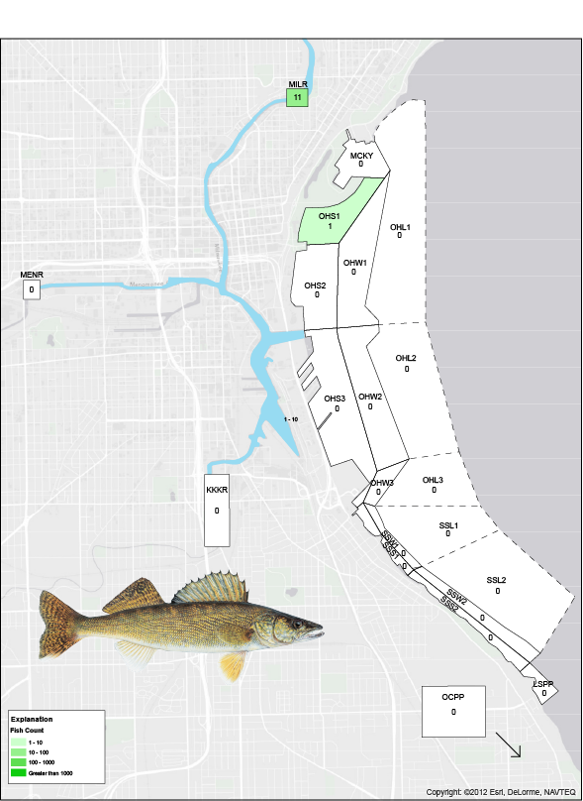
- Walleye abundance and distribution in Milwaukee Estuary and tributary streams in 1983 (data from Holey, 1984). (Walleye image courtesy State of Oregon, http://www.dfw.state.or.us).

Greater redhorse (Moxostoma valenciennesi)

General Species Information
The greater redhorse inhabits mainly medium-sized to large rivers, reservoirs, and large lakes. They prefer clear water over substrates of sand, gravel, or boulders, and may occur in limited numbers in the Great Lakes themselves, near the mouths of tributary streams. They are the largest of the redhorse species (Moxostoma spp.) and primarily eat midge larvae, mollusks, crustaceans and plant material.
In Wisconsin, the greater redhorse occurs in widely scattered localities within the Mississippi River and Lake Michigan drainage basins. It has not been reported in the Lake Superior basin. The greater redhorse spawns in May or June in the moderately rapid water of streams.
Formerly listed as a threatened species in Wisconsin, greater redhorses are now known to be more common than previously thought. Continued monitoring of population levels are needed and may result in the animal being removed from the threatened list (http://dnr.wi.gov/topic/EndangeredResources/Animals.asp?mode=detail&SpecCode=AFCJC10170, accessed 11/1/2013).

Abundance in Milwaukee Estuary AOC:
In the 1983 study (Holey, 1984), 430 individuals classified as “redhorse” were captured from 6 sampling sites, with the majority coming from the Milwaukee River proper, MILR (342), and from two of the Outer Harbor sites, OHS1 (57 individuals) and OHS2 (20 individuals). Unfortunately, there are several species of redhorse known to exist in the Milwaukee River and its estuary, so it is impossible to determine how many of these fish were greater redhorse or one of the other species, such as golden or shorthead. In the 1996-2001 WDNR sampling, 28 greater redhorse were captured at the three river sites (out of a total of 157 “redhorse spp.” captured) and 31 from the harbor (of a total of 50 “redhorse spp.”) (Table 2).
The greater redhorse is classified as a species of special concern in Wisconsin, although proposed, as sampling has shown its distribution is greater than previously thought.

Expectation of recovered AOC population
Dam removal and general improvement of water quality in the Milwaukee River is expected to benefit this species as well as projects undertaken specifically for the AOC improvements such as habitat restoration. Greater redhorse are intolerant to low dissolved oxygen so the removal of dams and improved water quality would benefit the species. They are benthic feeders so sediment toxicity remediation would offer improved conditions for the species to thrive. Finally, they are mainstem spawners and susceptible to impediments such as dams so removal of these obstacles opens up additional high quality spawning areas.
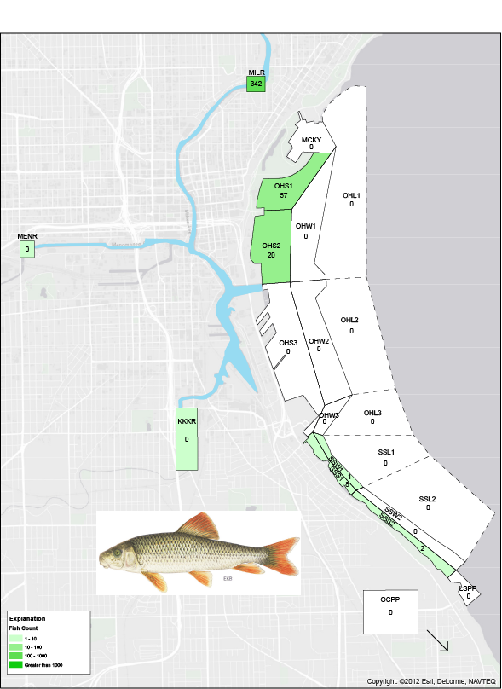
- Redhorse sp. abundance and distribution in Milwaukee Estuary and tributary streams in 1983 (data from Holey, 1984). (Greater redhorse image courtesy of NOAA)

Lake Sturgeon (Acipenser fulvescens)

General Species Information
The lake sturgeon is a typical inhabitant of large rivers and lakes. It lives in shoal water in the Great Lakes. Inland it shows a preference for the deepest midriver areas and pools. The lake sturgeon occurs in the Mississippi, Lake Michigan, and Lake Superior drainage basins. Lake sturgeon historically made spawning runs up the Milwaukee River. However, this fish disappeared from local waters due to overfishing and habitat destruction in the 1800s and early 1900s. Spawning takes place during late April and early May.
The waters of Wisconsin collectively possess one of the largest self-sustaining populations of lake sturgeon in the world. The biological characteristics of lake sturgeon (e.g., slow growing, late-to-mature) combined with the ease in which a population may be negatively altered in an exploited fishery, has led the state of Wisconsin to create a statewide lake sturgeon management plan (http://dnr.wi.gov/topic/fishing/documents/sturgeon/lsturmplan_eversion.pdf, accessed 12/3/2013).
The lake sturgeon is listed as a rare species in the United States by the Committee on Rare and Endangered Wildlife Species (1966). Over most of its range in the United States it appears to be threatened.

Abundance in Milwaukee Estuary AOC
Lake sturgeon were extirpated in the Milwaukee AOC and there was not a single specimen captured in the 1983 study. Lake sturgeon were also absent from the WDNR 1996-2001 sampling. Currently the species is undergoing re-establishment efforts.

Expectation of recovered AOC population
Lake sturgeon are a good long-term goal species representing connection between Lake Michigan and upstream mainstem of the Milwaukee River. The species are benthic feeders, and as such, are a good candidate to assess achievement of sediment toxicity remediation. Finally, they spawn in the mainstem of the river, and thus are a good candidate to assess access to high quality main stem habitat.
The lake sturgeon stocking effort begun in 2003 appears to be a success; in 2013 a pair of lake sturgeons about 48-inches long were captured in the Milwaukee River by DNR fisheries personnel. The fish, which were likely stocked prior to the current program, were tagged and released (http://wtaq.com/news/articles/2013/apr/23/dnr-survey-crew-captures-releases-two-lake-sturgeons-from-milwaukee-river/; accessed 12/30/2013). A self-sustaining population is the goal of current restoration efforts. Lake sturgeon is an extremely long-lived species and females do not begin spawning until they are 25-30 years old, thus indications of breeding may not be observed for many years. Because no fish were captured in 1983 or 1996-2001, any fish caught would represent an improvement in the population.
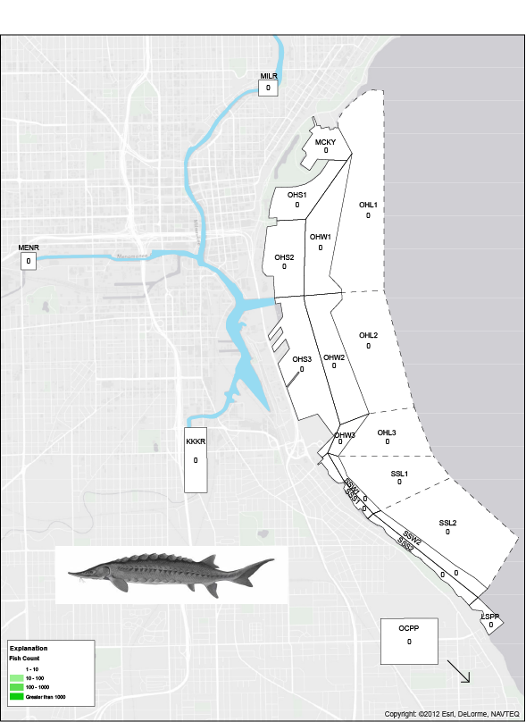
- Lake sturgeon abundance and distribution in Milwaukee Estuary and tributary streams in 1983 (data from Holey, 1985). (Lake sturgeon image courtesy TVA)

Other Fish Species in the Milwaukee Estuary Area of Concern
Other species collected in 1983 (Holey, 1984) and during 1996-2001 (Hirethota and others, 2005) are described briefly in this section. Species that are important because of a variety of possible reasons, and may include nuisance (exotic) species, or species of historical abundance or economic importance, either as sportfish or potential commercial fishery, are described in more detail.

Amiidae (Bowfin)

Bowfin (Amia calva)
A single bowfin was collected at the MILR site (table 2). One species of bowfin is known from Wisconsin and North America. This species was apparently never common in the Milwaukee River AOC; Becker cites a single report of the bowfin captured there.

Clupeidae (Herring)
Two species of herring are found in the study area, although neither is native. Both species arrived as a result of hydrologic modifications made to ease shipping through the waterways. The alewife arrived via saltwater while the gizzard shad, which is native to adjacent watersheds in Wisconsin and Illinois, had considerably less distance to travel.

Alewife (Alosa pseudoharengus) [Non-Native]
The alewife was the second-most abundant fish in the AOC behind yellow perch in 1983 (Figure 18). The alewife reached the upper Great Lakes via the Welland Canal (bypass of Niagara Falls). It was first recorded in Lake Erie in 1931 and in Lake Huron in 1933. It appeared in Lake Michigan in 1949, had dispersed throughout most of the lake by 1953, and had become common throughout the lake by 1957. In the late 1950s and early 1960s, the population increase was explosive. In Lake Superior it was first reported in 1953.
In the 1980s in Lake Michigan, the alewife dominated the fishery of the lake: they constituted 70-90% of the fish weight, and dominated the numbers at that time. Recent surveys have found a much lower abundance of alewife in the lake. Baitfish trawl surveys in 2011 and 2012 found the lowest biomass in 17 years of surveys (from interview of USGS Great Lakes Science Center scientist, accessed 12/6/2013 at http://howardmeyerson.com/2013/02/28/bottoming-out-lake-michigan-forage-still-at-all-time-low/). The physical condition of alewives has also declined. One of the alewife’s food staples is diporeia, a tiny, energy-rich shrimp-like creature. Diporeia have virtually disappeared from the lake, and that is thought to be related to the presence of zebra and quagga mussels in Lake Michigan that filter out important phytoplankton that diporeia feed upon, although the exact reason for their disappearance is unknown.

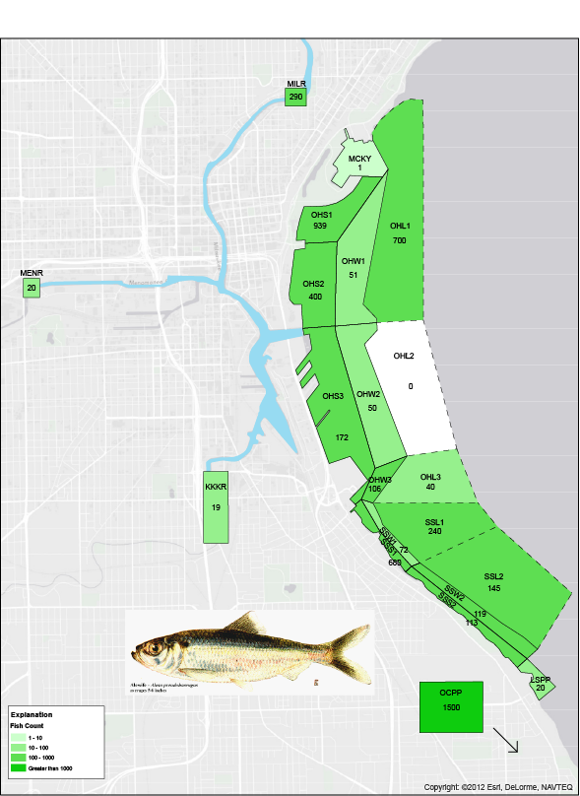
- Alewife abundance and distribution in Milwaukee Estuary and tributary streams in 1983 (data from Holey, 1984). Image: www.dec.ny.gov

Gizzard Shad (Dorosoma cepedianum) [Non-native]
Gizzard shad were collected at numerous locations in 1982 (Table 2). Native to the Mississippi River basin, the gizzard shad's entry into Lake Michigan may have been through the Chicago River canal. It is also possible that the Fox-Wisconsin canal at Portage, WI (Columbia County) may have been another dispersal route.

Salmonidae
A total of 9 species from this family were captured in 1983, but only two in 1996-2001. The differences may be related to sampling intensity and/or timing for many species, but may be indicative of decline in several species as well.

Brook trout (Salvelinus fontinalis)
Brook trout were captured at many sites during the 1983 survey of the area (Table 3), in rivers, the harbor, and lake. However, none were captured during the 1996-2001 sampling effort; this is likely due to the discontinuation of stocking in the AOC in the late 1980’s (Wawrzyn, William, Wis. DNR, personal communication, 2014).

Rainbow trout (Oncorhynchus mykiss) [Non-native]
Rainbow trout accounted for over 9 percent of fish caught in the rivers of the Milwaukee Estuary AOC in the 1983 study, but less than one percent in the later survey (Table 2). In the harbor sites, it represented 3.4 percent of the fish in the 1983 survey but was not captured in the later survey. Rainbow trout were introduced to Lake Michigan and its tributaries to provide a sport fishing opportunity and continue to be stocked in Lake Michigan.

Brown trout (Salmo trutta) [Non-native]
Brown trout were captured in low numbers in rivers in both studies (Table 2) and in slightly higher proportions in the harbor sites in both studies. This species was introduced into the United States from Central Europe in 1883 and is currently stocked in Lake Michigan to provide sportfishing opportunities.

Coho Salmon (Oncorhynchus kisutch) [Non-native]
Coho were captured in the 1983 study in both river and harbor sites, and were not captured in the 1996-2001 survey (Table 2). Coho salmon inhabit Lakes Michigan and Superior and a number of their tributary streams. A large-scale program for the introduction of coho salmon into Lake Michigan began in 1966 when 660,000 yearlings were released; a total of 10.3 million (mostly from the state of Michigan) were stocked through 1970. Coho continue to be stocked into Lake Michigan to provide sportfishing opportunities.

Chinook Salmon (Oncorhynchus tshawytscha ) [Non-native]
Like the coho, chinook were captured at both river and harbor sites in 1983 and were not captured in the 1996-2001 surveys (Table 2).The chinook salmon, a Pacific Ocean salmon, was introduced into the Lake Michigan and Lake Superior drainage basins. From 1967 through 1970, 4.1 million fingerlings were released in Lake Michigan. Chinook continue to be stocked into Lake Michigan to provide sportfishing opportunities.

Lake trout (Salvelinus namaycush namaycush)
Lake trout and burbot are the two top native coldwater piscivores in the main basin of Lake Michigan. The lake trout population in Lake Michigan was extirpated during the 1950s due to the combined effects of sea lamprey predation and overfishing. Since the early 1960s, state and federal fish management agencies have conducted an active fisheries program to rehabilitate lake trout. The goal of the program has been to re-establish a self-sustaining lake trout population capable of supporting harvest. The principal tools utilized in the restoration program have been a large-scale sea lamprey control program and the massive stocking of hatchery-reared lake trout. Lakewide plants of lake trout (mainly yearlings) averaged between 2 and 3 million fish annually between 1965 and 1994 (Madenjian, http://www.glsc.usgs.gov/restoration-ecology/restoration-ecology-population-restoration/lake-michigan-trout-restoration; accessed 12/30/2013).
In 1983, lake trout were found at all harbor sites, but only at one river site, where a single individual was collected at the MILR site (Figure 7; Table 2). In general, lake trout were collected throughout the sampling period, with most individuals being collected in the early fall (September) sampling run. A total of 443 individuals were collected over the entire sampling period. No lake trout were captured during the 1996-2001 sampling efforts.
Because of the history of stocking and the lake trout’s reliance on deepwater habitat, as well as further efforts (or lack thereof) to restore native, reproducing stocks of this species, the future success of reintroducing large populations to southern Lake Michigan and specifically the Milwaukee River Estuary, is unknown.

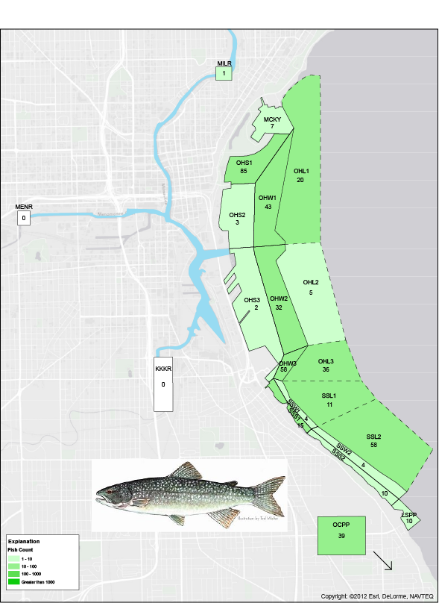
- Lake trout abundance and distribution in Milwaukee Estuary and tributary streams in 1983 (data from Holey, 1984). Lake trout image: http://www.fish.state.pa.us/pafish/fishhtms/chap15trout.htm

Lake whitefish (Coregonus clupeaformis)
It is generally accepted that in large lakes like Superior and Michigan there are discrete populations of lake whitefish with quite different growth characteristics within the same lake, even though these populations may be separated by relatively short distances. In Wisconsin, the lake whitefish occurs in the Mississippi River, Lake Michigan, and Lake Superior drainage basins. It occurs in the littoral waters of Lakes Michigan and Superior.
Lake whitefish were found in low numbers at 10 of 21 sites sampled in 1983 (Figure 11). 44 of 54 individuals were collected from 4 northern estuary and lake sampling sites (OHS1, OHS2, OHS3, OHW1). Lake whitefish were not found during the 1996-2001 effort.
Reports of lake whitefish recovery in waters around Green Bay may be an indication that this species is staging a comeback in Lake Michigan waters (Green Bay Press Gazette, Nov. 27, 2013, accessed Jan. 12, 2014; see Appendix 1), including the Fox River, home to the nation’s largest toxic cleanup project. It is unknown whether this recovery is likely to happen in waters farther south near Milwaukee.
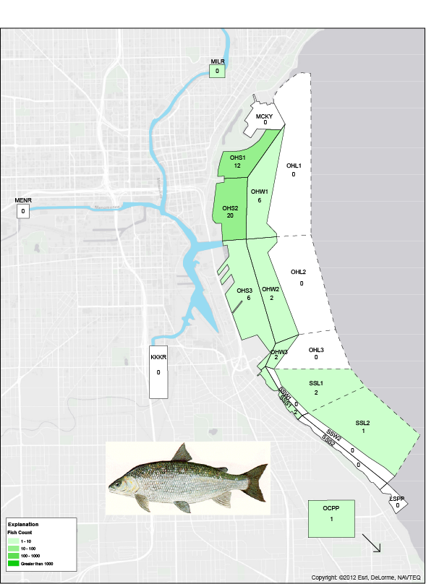
- Lake whitefish abundance and distribution in Milwaukee Estuary and tributary streams in 1983 (data from Holey, 1984). Image: http://www.michigan.gov/

Round whitefish (Prosopium cylindraceum)
Only a single round whitefish was collected in 1983 study, from the lake side of the harbor (OHL1; table 2). None were collected during 1996-2001 study. Once a commercial species, the round whitefish has rarely been seen in Lake Michigan since the late 1940s.

Bloater chub (Coregonus hoyi)
A total of 11 bloater chubs were captured at three sites (OHW1, OHL1, and MILR) during the 1983 study; none were captured in 1996-2001 (Table 2). The bloater chub’s preference for deep, cold waters means it is unlikely to be found in great numbers in the estuary or rivers of the Milwaukee Estuary AOC.
In Lake Michigan, as the lake trout declined in the late 1940s and early 1950s – a result of commercial fishing pressure and sea lamprey depredations – the bloater benefited by losing a key predator. At the same time the larger species of chubs were removed by the same pressures. By the early 1960s, the largest deepwater ciscoes apparently had been exterminated and the intermediate-sized species were uncommon. The smallest species, the bloater, exploded in numbers, beginning probably in the early or mid-1950s. However, since then a variety of factors has led to the overall population of the bloater chub to decline significantly.

Cyprinidae (Minnows)
A dozen species of minnows were captured in the 1983 survey (Table 2). Fewer minnow species were captured in the 1996-2001 surveys, although a single individual of a new species, the exotic grass carp, was captured in the Milwaukee River. The sampling techniques used in earlier surveys were probably biased toward capturing larger species. Only one species, the non-native common carp, will be discussed in detail here; others are listed in Table 2.

Common Carp (Cyprinus carpio) [Non-native]
The common carp occurs in all three drainage basins in Wisconsin, and has been steadily extending its range in the state. Although the carp is known to survive under a wide range of conditions, it prefers warm streams, lakes, and shallows containing an abundance of aquatic vegetation. The carp is tolerant of all bottom types and of clear or turbid waters, but is not normally found in clear, cold waters or streams of high gradient.
The common carp was found throughout the AOC in 1983, although it was more prominent in the rivers than from the lake and harbor sites (fig. 10). Carp were less common in rivers in the later survey but slightly more abundant proportionally at the estuary sites (table 2).

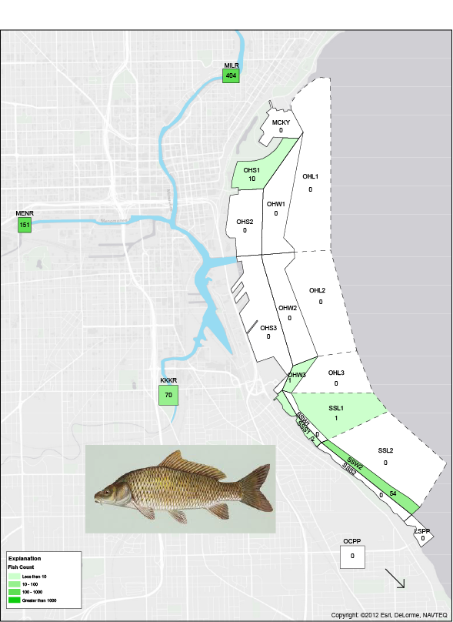
- Common carp abundance and distribution in Milwaukee Estuary and tributary streams in 1983 (data from Holey, 1984). Image: maine.gov

Catastomidae
The species of Catastomidae (redhorse and suckers) that occur in the AOC are described here to differentiate them from the indicator species of greater redhorse. A total of six species, including the greater redhorse, were collected in the 1996-2001 survey; only white sucker and longnose sucker were differentiated from other Catasomids in 1983 (Table 2).

White Sucker (Catastomus commersoni)
White sucker are more tolerant of a wide range of environmental conditions and are a common inhabitant of the most highly polluted waters of southeastern Wisconsin. As such, their presence is not considered an indicator of ecosystem health, as they can be present in both polluted and pristine waters. The white sucker is probably the most widespread of all fishes in Wisconsin, where it is common to abundant in most streams and in large lakes.
White sucker were abundant throughout the Milwaukee Estuary AOC in the 1983 survey (Holey, 1984). They were the only species found at every sampling site. In terms of total fish caught (5,572), white suckers were roughly equal to alewife as the second-most abundant species, and only yellow perch were caught in significantly higher numbers. In 1996-2001 sampling, white sucker were captured at nearly identical proportions as in the 1983 sampling (Table 2).
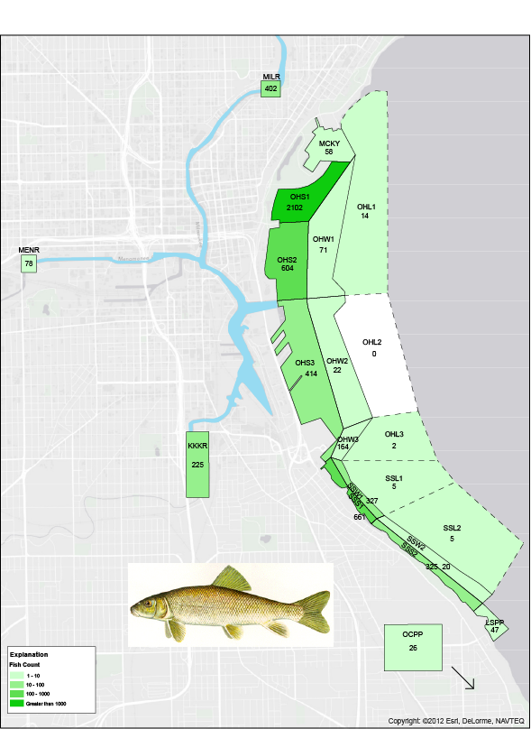
- White sucker abundance and distribution in Milwaukee Estuary and tributary streams in 1983 (data from Holey, 1984). (Image courtesy Michigan DNR)

Longnose Sucker (Catostomus catostomus)
The longnose sucker is common in northern Lake Michigan but it is rarer to the south, and has probably been extirpated at the southern tip of the lake.
The longnose sucker was found at 8 sites in the 1983 study in the Outer Harbor and South Shore areas (fig. 12, table 2). A total of 15 individuals were collected, so it was not a common species despite being collected at a variety of sites. This species was not captured during the 1996-2001 sampling effort.
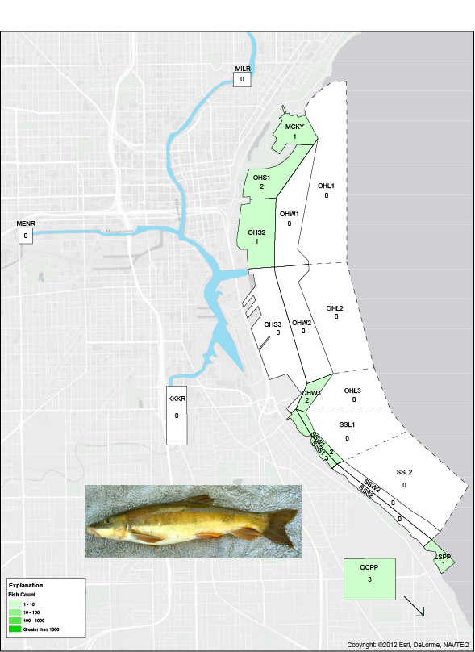
- Longnose sucker abundance and distribution in Milwaukee Estuary and tributary streams in 1983 (data from Holey, 1984). Image: John Lyons, Wisconsin Department of Natural Resources

Ictaluridae
Several species of catfishes have been captured in the AOC. The black bullhead was by far the most common of the five bullhead-catfish species, with 266 individuals collected from 4 sites (MILR, MENR, KKKR, and SSS1). Only 4 brown bullhead were collected at two sites (MILR and MENR) and only 1 yellow bullhead, from MILR. Ten channel catfish were collected a single site (MILR). A single flathead catfish was also collected at the Milwaukee River site (MILR). Given these low capture numbers, it may be difficult to ascertain what collection numbers of Ictalurids can potentially mean for the restoration of the AOC.

Gasterosteidae

Ninespine stickleback (Pungitius pungitius)
Only one species of stickleback, the Ninespine stickleback (Pungitius pungitius)) was collected in 1983, with thirteen individuals collected at one site (SSS1); none were collected in the later survey. The threespine stickleback (Gasterosteus aculeatus), a non-native species, was not found in 1983 but was found in the 1996-2001 survey, which may indicate that it is a relatively recent arrival in the study area.

Percopsidae (Trout-perch)
The trout-perch (Percopsis omiscomaycus) is the only species of this family in the AOC. Trout-perch prefer the shallow and intermediate depths of Lakes Superior and Michigan and large inland lakes; it avoids shallow, mud-filled bays. It is present in tributary streams, particularly during spawning. It was found throughout the AOC in 1983 but was not noted in the later study (Table 2).

Centrarchidae
Many species of Centrarchidae exist in the AOC. Commonly known as sunfish, these species are popular with anglers and fill a variety of habitat niches. A brief overview of the species found in the AOC is included here.

Various sunfish species
The rock bass (Ambloplites rupestris) is common in medium to large streams and in lakes throughout Wisconsin. Although the rock bass is found in many kinds of water, it shows a distinct preference for clear, cool to warming waters over a gravel or rocky bottom, with some vegetation present. In the AOC, rock bass were common, comprising over 3 percent of the total catch (Table 2). Expectations are that rock bass will continue to thrive in the AOC with improved conditions.
Green sunfish (Lepomis cyanellus) are a tolerant species and were found in the rivers of the AOC as well as two estuary sites (table 2). It is a possibility that improved water quality would lead to lower relative numbers of tolerant fishes such as the green sunfish, as they are outcompeted by less tolerant fishes that are able to thrive as water quality improves.
Two species of crappie were present in the 1983 survey, although the black crappie (Pomoxis nigromaculatus) was more common than the white crappie (Pomoxis annularis) (Table 2). The white crappie is near the northern limit of its distribution in Lake Michigan.
The bluegill (Lepomis macrochirus) is the most abundant sunfish and centrarchid in Wisconsin and comprised over 6 percent of the total catch in 1983 (table 2). It was especially common in the Milwaukee River, where it is more suited to the warmer waters than in the harbor.
The pumpkinseed (Lepomis gibbosus) was taken in lower numbers than the bluegill in the 1983 sampling effort, although it was most common in the rivers as well.

Smallmouth bass (Micropterus dolomieui)
Smallmouth bass were captured exclusively from the Milwaukee River (MILR) site (Figure 13) in 1983, where 24 individuals were collected. Smallmouth bass were more common in the 1996-2001 surveys, where they comprised 2.4 percent of the total catch in the rivers, up from 0.7 percent, a threefold increase (Table 2). They also comprised over 30 percent of the total catch from the harbor sites in the latter survey.
Smallmouth bass are relatively sensitive to certain types of environmental degradation, particularly sedimentation and organic pollution, and its abundance is a useful indicator of river and lake quality in Wisconsin (Lyons et al. 1988). It is considered an intolerant species, and thus increased populations may be an indication of improving water quality and other environmental factors.
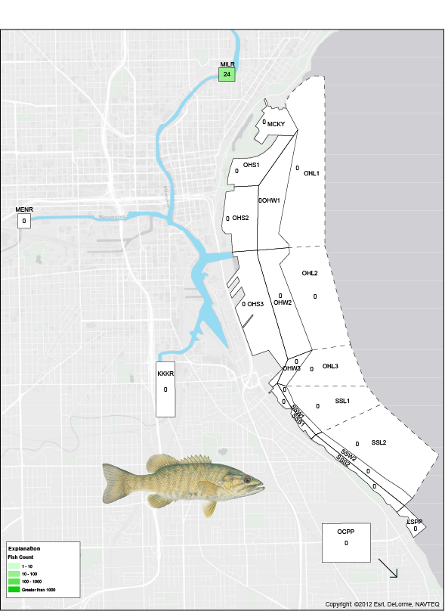
- Smallmouth bass abundance and distribution in Milwaukee Estuary and tributary streams in 1983 (data from Holey, 1984). Image courtesy Oregon Department of Fish and Wildlife

Largemouth bass (Micropterus salmoides)
Largemouth bass were rarely collected in the 1983 survey; a total of 3 individuals were captured from the MILR (2 fish) and KKKR (1 fish) stream sites. Like the smallmouth bass, they were more common in the later surveys (table 2). Largemouth bass are more likely to be found in slack water and warmer waters than smallmouth, therefore it is expected that they are less likely than smallmouth bass to be a dominant species in the area regardless of AOC recovery status.

Percidae
Two species of the family Percidae were found in the AOC, the johnny darter (Etheostoma nigrum) and yellow perch (Perca flavescens). Although the johnny darter is the most successful member of the family Percidae in Wisconsin and is common to abundant in most waters, johnny darter were rarely collected (Table 2). By contrast, yellow perch were the most common species collected in 1983 and will be discussed in detail.

Yellow Perch (Perca flavescens)
The yellow perch was a critical commercial resource for the communities along Lake Michigan. The commercial production of perch averaged 2.4 million pounds a year from 1889 (when records began) to 1970, according to Becker (1983). In the mid-to-late 1990s, the perch population collapsed in southwestern Lake Michigan.
One reason yellow perch are so prevalent in state waters is that they are generally a tolerant species. While they prefer clear, fertile water (water supporting moderate to large amounts of plant growth), yellow perch are renowned for their ability to survive low oxygen levels. That trait allows yellow perch to inhabit deep water that often has reduced oxygen levels and helps it survive winterkill conditions (mortality in fish associated with lack of oxygen under frozen lakes) that suffocate other species like bluegill, bass and walleye. Perch are also tolerant of eutrophic (nutrient rich) and turbid (containing suspended solids) water and a wide temperature range.
Yellow perch are an important link in the aquatic food chain. When feeding, small yellow perch swim along the bottom picking off small aquatic insects or straining zooplankton (minute aquatic organisms) from the water with their gill rakers (comblike structures inside the gills). Minnows and small fish become the preferred prey and make up a large portion of their diet as yellow perch grow in size.
With a short life span, lasting about seven years, yellow perch reach maturity and begin reproducing at age 2 or 3. Yellow perch spawn early in the spring shortly after the ice goes out. Spawning lasts approximately from April to early May, when the water temperature ranges between 44 and 52 ºF. In the Great Lakes, perch spawn primarily on sandy bottoms.
Yellow perch comprised almost 60 percent of the total catch in the 1983 effort, and were especially abundant in the Outer Harbor (OHS1) and South Shore Shore (SSS1 and SSS2) and South Shore Breakwater 2 (SSW2) sampling sites (Figure. 23). In 1996-2001 sampling, only three individuals were collected from river sites and none from the harbor (Table 2). This is by far the biggest disruption of a species’ status in the study area.
The extreme decline of the yellow perch in southwestern Lake Michigan is recognized as an issue that is unique to this species and is not a reflection of the overall ecological health of the Milwaukee River Estuary and tributaries. Various theories exist to explain the decline, but it is likely related to food web disruption resulting from exotic species introductions.

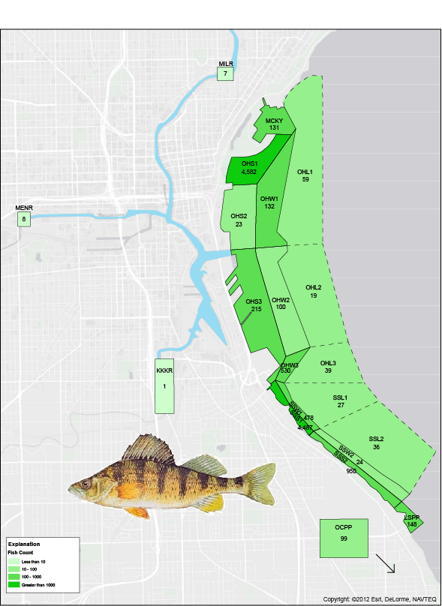
- Yellow perch abundance and distribution in Milwaukee Estuary and tributary streams in 1983 (data from Holey, 1984). Image courtesy Michigan Department of Natural Resources.

Cottidae

Sculpin (spp.)
Sculpin were captured in the 1996-2001 surveys but not identified to species. Four species from two genera are known to exist in Wisconsin (Becker, 1983).

Discussion and Recommendations
Our compilation of life history and occurrence of species present in the Milwaukee AOC in sampling efforts in both 1983 and 2001 are meant to be reasonably comprehensive. However, we have included a discussion both of non-native species and those that were either extremely rare in initial sampling efforts or are likely to be affected primarily by factors external to activities within the Milwaukee AOC. We recommend including native species, which are not considered rare, and have not experienced lakewide increases or decreases based on conditions primarily outside of the AOC environment to be included in the evaluation of the “degraded fish and wildlife populations” BUI. We have included other species for reference and to aid in determining if interspecific interactions may be helpful in explaining any future increases or decreases in relative density. Given the tremendous amount of sampling effort which occurred in the 1983 effort, we contend that species occurrences with 10 or fewer individuals could be considered as incidental and difficult to measure with regard to increases or declines in population levels (Table 2). There are also two species captured in the 1983 effort that have likely experienced general lakewide increases or declines that would imply that they would be less likely to reflect conditions within the AOC. Specifically, yellow perch have experienced a lakewide decline since the 1990’s presumably caused by physical and ecological changes to the nearshore environment as a result of the invasion of dressenid mussels. Lake trout, while still far short of the restoration goal of a self-sustaining and harvestable population, are heavily stocked. In addition, lake trout primarily utilize primarily offshore and deeper environments within the lake. As a result, population densities may simply reflect stocking intensity and more closely reflect the offshore environment.
A stated criterion of the BUI removal within the Milwaukee AOC is a 100% increase in relative population density in the four indicator species and an increase of any magnitude in 95% of other native species to be considered. Although we report absolute capture numbers in Table 2, a direct comparison between future sampling efforts and the 1983 effort should be adjusted for the gear specific effort to facilitate direct comparison. We have recommended that 21 species be included for consideration, of which four are indicator species. As such, an increase of any magnitude in relative density of 16 of the remaining 17 would merit consideration of a removal of the BUI.
Table 2 List of species captured in river and harbor sites in 1983 and 1997-2001 surveys of Milwaukee Estuary Area of Concern
Species designated as "rare" are considered incidental occurrence in the estuary (fewer than 10 inidividuals in the 1883 effort).
"Rare" also is used to designate populations are not expected to have recovered or conversely have recovered for reasons external to
restoration of the estuary. Light blue shading indicates an indicator species.
Total no.
captured
Percent of
total
Total no.
captured
Percent of
total
OHS1,
OHW3,
SSS1
Percent of
Total
Summerfest
Lagoons
Percent of
total
Include in
BUI
evaluation
Acipenseridae
Lake sturgeon
Acipenser fulvescens
x
--
--
--
--
--
--
--
--
x
Amiidae
Bowfin
Amia calva
x
x
1
<0.1%
1
0.10%
--
--
--
--
Clupeidae
Alewife
Alosa pseudohrengus
329
9
90
5
1,725
10.60%
12
3.30%
Gizzard shad
Dorosoma cepedanium
64
1.8
971
54
33
0.2
3
0.8
Salmonidae
Brook trout
Salvelinus fontinalis
x
12
0.3
--
--
69
0.4
--
--
x
Rainbow trout
Oncorhynchus mykiss
337
9.2
4
0.2
554
3.4
--
--
Brown trout
Salmo trutta
11
0.3
4
0.2
275
1.7
17
4.6
Coho salmon
Oncorhynchus kisutch
12
0.3
--
--
20
0.1
--
--
Chinook salmon
Oncorhynchus tshawytscha
22
0.6
--
--
51
0.3
--
--
Lake trout
Salvelinus namaycush namaycush
x
x
1
<.1
--
--
158
1
--
--
Lake whitefish
Coregonus clupeaformis
x
--
--
--
--
16
0.1
--
--
x
Round whitefish
Prosopium cylindraceum
x
x
--
--
--
--
1
--
--
--
Bloater
Coregonus hoyi
x
x
1
<.1
--
--
9
--
--
--
Esocidae
Northern pike
Esox lucius
x
27
0.7
20
1.1
17
0.1
6
1.6
x
Cyprinidae
Creek Chub
Semotilus atromaculatus
x
--
--
23
1.3
1
<.1
--
--
Common shiner
Notropis cornutus
x
x
2
0.1
--
--
--
--
--
--
Spottail shiner
Notropis hudsonius
x
19
0.5
1
0.1
23
0.1
--
--
x
Fathead minnow
Pimephales promelas
x
--
--
21
1.2
6
<.1
--
--
x
Emerald shiner
Notropis atherinoides
x
x
1
<.1
1
0.1
--
--
--
--
Goldfish
Carassius auratus
112
3.1
3
0.2
2
<.1
--
--
Grass carp
Ctenopharyngodon idella
1
<.1
1
0.1
--
--
--
--
Spotfin shiner
Cyprinella spilotera
x
x
--
--
1
0.1
--
--
--
--
Common carp
Cyprinus carpio
625
17.2
83
4.6
13
0.1
8
2.2
Golden shiner
Notemigonus crysoleucas
x
5
0.1
4
0.2
6
<.1
--
--
x
Lake chub
Couesius plumbeus
x
--
--
--
--
11
--
--
--
x
Catastomidae
White sucker
Catastomus commersoni
x
705
19
203
11
2,927
18
64
18
x
Longnose sucker
Catastomus catastomus
x
x
--
--
--
--
7
<.1
--
--
Redhorse spp.
Moxostoma spp.
x
342
9.4
157***
8.7
65
0.4
50***
14
x
Silver redhorse
Moxostoma anisurum
x
x
n/a
n/a
9
--
n/a
n/a
1
--
Golden redhorse
Moxostoma erythrurum
x
x
n/a
n/a
68
--
n/a
n/a
14
--
x
Shorthead redhorse
Moxostoma macrolepidotum
x
x
n/a
n/a
5
--
n/a
n/a
4
--
Greater redhorse
Moxostoma valenciennesi
x
n/a
n/a
28
--
n/a
n/a
31
--
x
Ictaluridae
Black bullhead
Ameiurus melas
x
264
7.2
8
0.4
2
<.1
2
0.5
x
Brown bullhead
x
x
4
0.1
--
--
--
--
--
--
Yellow bullhead
x
x
1
<.1
--
--
--
--
--
--
Channel catfish
x
x
10
0.3
--
--
--
--
--
--
Flathead catfish
x
x
1
<.1
--
--
--
--
--
--
Gasterosteidae
Threespine stickleback
Gasterosteus aculeatus
x
x
--
--
2
0.1
--
--
4
1.1
Ninespine stickleback
Pungitius pungitius
x
x
--
--
--
--
3
<.1
--
--
Percopsidae
Trout-perch
Percopsis omiscomaycus
x
6
0.2
--
--
56
0.3
--
--
Centrarchidae
Rock bass
Ambloplites rupestris
x
121
3.3
5
0.3
4
<.1
1
0.3
x
Green sunfish
Lepomis cyanellus
x
57
1.6
43
2.4
2
<.1
4
1.1
x
Black crappie (
Pomoxis nigromaculatus
)
x
183
5
7
<.1
x
White crappie (
Pomoxis annularis
)
x
20
0.5
1
<.1
x
Pumpkinseed
Lepomis gibbosus
x
42
1.2
5
0.3
2
<.1
26
7.1
x
Bluegill
Lepomis macrochirus
x
239
6.6
24
2
4
<.1
13
3.6
x
Smallmouth bass
Micropterus dolomieu
x
24
0.7
42
2.3
--
--
112
31
x
Largemouth bass
Micropterus salmoides
x
3
0.1
25
1.4
--
--
27
7.4
Percidae
Johnny darter
Etheostoma nigrum
x
x
--
--
1
0.1
--
--
--
--
Yellow perch
Perca flavescens
x
x
16
0.4
3
0.2
9,599
59
--
--
Walleye
Sander vitreus
x
11
0.3
1
<.1
1
<.1
13
3.6
x
Cottidae
Sculpin spp.
x
x
--
--
--
--
325
2
1
0.3
Total no. native species
Total no. non-"Rare" native species
Total no. species
21
Family and species
Native
Rare
1983

24

River sites
1983
1996-2001
2001
Harbor sites
32
35
33
21
25
22
17

Acknowledgements
We thank the US Environmental Protection Agency Great Lakes National Program Office and the Great Lakes Restoration Initiative for support of this project. We also thank Megan O’Shea (Wisconsin DNR Milwaukee Area of Concern Coordinator) and the Milwaukee AOC Technical Advisory Committee for their guidance and suggestions related to this project. Finally, we thank the WDNR Office of the Great Lakes Staff for assisting the prioritization and implementation of monitoring projects of central importance to the evaluation of Beneficial Use Impairments within Wisconsin Areas of Concern.

References Cited
Grapentine, L.C., 2009, Determining degradation and restoration of benthic conditions for Great Lakes Areas of Concern, Journal of Great Lakes Research 35:36-44.
Hirethota, P.S., and Burzynski, T.E., 2007, Movement of walleye in the Lower Milwaukee River and estuary: Wisconsin Dept. of Natural Resources PUB-FH-513-2007, (http://dnr.wi.gov/topic/fishing/Documents/LakeMichigan/WalleyeTelemetryReport.pdf, accessed 11/1/2013)
Hirethota, P.S., Burzynski, T.E., and Eggold, B.T., 2005, Changing Habitat and Biodiversity of the Lower Milwaukee River and Estuary: Wisconsin Dept. of Natural Resources PUB-FH-511-2005, 50 p.
Holey, M.E., 1984, Milwaukee Harbor Estuary Fish Survey and Toxic Substance Evaluation, 1983: Wisconsin Department of Natural Resources, 70 p.
O’Shea, Megan (compiled by), 2012, 2012 Remedial Action Plan Update for the Milwaukee Estuary Area of Concern: Wisconsin Department of Resources, Office of the Great Lakes (http://dnr.wi.gov/topic/greatlakes/documents/RAP-UpdateMKE2012final.pdf, accessed 12/10/2013)
Wilberg, M.J., Bence, J.R., Eggold, B.T., Makauskas, Daniel, and Clapp, D.F., Yellow Perch Dynamics in Southwestern Lake Michigan during 1986–2002: North American Journal of Fisheries Management 25:1130-1152; http://dnr.wi.gov/topic/fishing/documents/species/yellowperch.pdf
United States Policy Committee, 2001, Restoring United States Areas of Concern: Delisting Principles and Guidelines, 27 pp. Available at: http://www.epa.gov/glnpo/aoc/rapdelistingfinal02.PDF
Wisconsin DNR, 2008, http://dnr.wi.gov/topic/fishing/documents/species/brooktrout.pdf, accessed 12/9/2013.
U.S. Environmental Protection Agency Great Lakes Areas of Concern website: http://www.epa.gov/greatlakes/aoc/; accessed June 24, 2014.
Wisconsin Department of Natural Resources Milwaukee Estuary website: http://dnr.wi.gov/topic/greatlakes/milwaukee.html, accessed Dec. 24, 2013.

Appendix 1.
Green Bay Press Gazette, Nov. 27, 2013: MARINETTE — Lake Michigan whitefish have been spawning in Northeastern Wisconsin rivers where they haven’t been seen in more than a century.
The fish’s return has created a welcome mystery for scientists, who aren’t sure why they are migrating from Green Bay into rivers. It could be a sign of improving water quality. Or, the population in Green Bay may have grown enough that young fish are being pushed out of traditional spawning areas.
The fish do not appear to be leaving Lake Michigan to spawn in tributaries of Wisconsin rivers, the Milwaukee Journal Sentinel reported. The migration seems to be coming only from Green Bay.
Whitefish rebounded on Lake Michigan and Green Bay in the 1980s. They were discovered on the Menominee River in 1993, but until this fall had not been seen on other inland waterways.
The fish have now been found on at least four rivers in northeastern Wisconsin, according to the state Department of Natural Resources. The most surprising location may be the Fox River in Green Bay, home to the nation’s largest toxic cleanup project.
Many scientists believe the fish’s appearance is a sign of improving water quality.
“It’s a feel-good thing about the ecology of the rivers that they can actually support spawning whitefish,” said Scott Hansen, a fisheries biologist with the DNR.
He was out in a boat on Nov. 18 with Solomon David, a postdoctoral research associate at the John G. Shedd Aquarium in Chicago.
The whitefish’s return shows “something has changed,” David said. “We don’t know exactly what, but fish tend to be really good indicators of what is going on in the environment.
“If the habitat stinks, they aren’t going to be there.”
The river migration is even more perplexing because invasive species have eaten all the shrimp-like creatures that were the whitefish’s main food source. The fish are now eating such invaders as alewives, gobies and mussels, which is causing them to change as well.
A 7-year-old whitefish in 1985 would have weighed about 5 pounds. Today, a similar fish weighs just 1 pound, according to the DNR.

