The Lakeshore Natural Resource Partnership, Inc.

Cultivating Community and Stewardship from the Ledge to the Lakeshore

Wisconsin Department of Natural Resources
River Planning Grant RP-274-15

LNRP Lower Manitowoc Watershed Plan

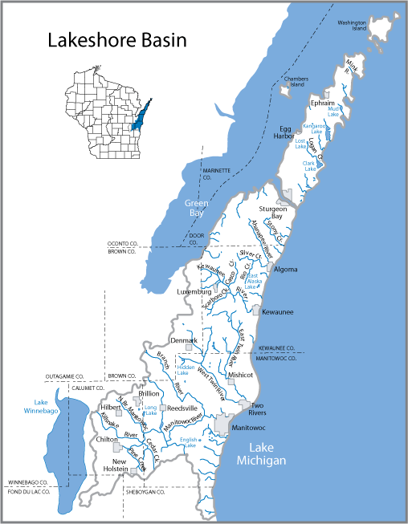

Report Materials

February 15, 2015 to June 30, 2016

Jim Kettler,
Executive Director

