Appendix A. Trout Stream Classification Checklist (revised 2/2016)

(This completed checklist should accompany any trout stream classification changes. Check the items as appropriate and attach comments if desired.)

Stream name: ___Kittleson Valley Creek_________________________________________
(if stream is known by another name please list both names with the more common name first)

County: __Dane ___ WBIC: _907900 __

Define the portion of the stream to be classified. Please provide both a written description and the coordinate locations of the upstream and downstream beginning and end points.

The portion of stream to consider for reclassification runs from CTH H in Dane County to the Iowa County/Dane County line.

This written description should reference permanent, unambiguous landmarks that would allow a person unfamiliar with the area to locate the points (e.g., dams, road crossings, stream confluences, county lines, section lines, township lines)

Please provide coordinate locations in one of three formats:
Longitude/Latitude (Degrees, Minutes, Seconds): 89° 41' 28.7" W , 44° 55' 14.0" N
Longitude/Latitude (Decimal Degrees): -89.691332, 44.920576
WTM91 (easting and northing in meters): 544361, 494173

Upstream point coordinates: _42.8749___-89.7991_____________________
Downstream point coordinates: __42.8765 -89.8379_______________

Classification proposed ____Class II____________________

____ Fish survey (including relative abundance, length distribution, and age structure) and habitat survey completed on water to be classified. Survey on file at _Fitchburg_ (office location)

____ Fish team supervisor and district fisheries supervisor have approved the classification.
Date___________

____ Fish Biologist has consulted with the following staff in their office or district
____ Permit Drafter Name__________________ Date____________ Concerns Yes No
____ Water Resource Specialist ____________________ Date_________Concerns Yes No
____ Water Management Specialist ________________ Date________ Concerns Yes No
____ Drinking and Groundwater staff ________________ Date_______ Concerns Yes No

____ Public notice published in local newspaper or other media. Date___________

____ Notice sent to all clerks of the county, town, city, or village in which the stream is located. Date____________

____ Notice sent to legislators in the affected districts. Date__________

____ Notice sent to chairpersons of legislative committees with jurisdiction for natural resources issues. Date__________

____ No hearing requested 30 days after public notice.

____ Hearing requested, held, and classification recommended. Date__________

Signed: ___________________________________ Date: ______________
Fisheries Biologist

Approved: ___________________________________ Date: ______________
Fish Team Supervisor

___________________________________ Date: ______________
District Fisheries Supervisor

Appendix B. Trout Stream Classification Public Notice Template

Pursuant to NR 1.02(7)(c), Wis. Adm. Code, the Department of Natural Resources gives public notice of the classification of 3.9 miles of Kittleson Valley Creek, in Dane County as a Class 2 Trout water. The portion of stream to consider for reclassification runs from CTH H in Dane County to the Iowa County/Dane County line.

This classification is based upon a survey which indicates this portion of stream has some natural reproduction, multiple year classes of trout present and there is sufficient overwinter survival.

“A Class II Trout Stream is a stream or portion thereof that contains a population of trout made up of one or more age groups, above the age one year, in sufficient numbers to indicate substantial survival from one year to the next, and may or may not have natural reproduction of trout occurring; however, stocking is necessary to fully utilize the available trout habitat or sustain the fishery.”

The Department shall waive any hearing requirement on this classification unless a written request for hearing is received before (insert date 30 days from mailing date). Requests should be sent to David Rowe, WDNR, 3911 Fish Hatchery Rd, Fitchburg WI, 53711.

Length frequency distributions from 2016 surveys.

Recent Stocking History
Year | Species | Age class | Number stocked | Average Length
2015 | BROWN TROUT | LARGE FINGERLING | 877 | 3.3
2014 | BROWN TROUT | LARGE FINGERLING | 296 | 2.8
2013 | BROWN TROUT | ADULT (BROODSTOCK) | 210 | 11.5
2013 | BROWN TROUT | LARGE FINGERLING | 844 | 3.05
2012 | BROWN TROUT | LARGE FINGERLING | 1,900 | 2.7
2011 | BROWN TROUT | LARGE FINGERLING | 1,000 | 2.8

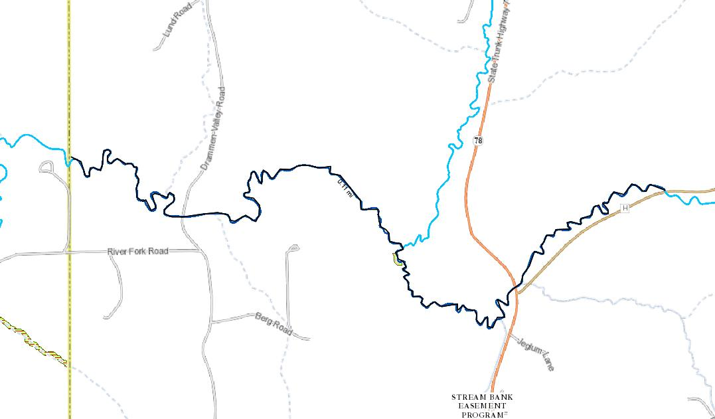
Map of proposed changes. The portion of stream to consider for reclassification runs from CTH H in Dane County to the Iowa County/Dane County line.

