Manley Creek 2015 Interim Report

Jean Unmuth, DNR - Water Quality Section

Caleigh Dickson & Emma Lee – UW-Platteville

Manley Creek (WBIC: 1261200) in Sauk County is monitored by Wisconsin DNR water quality staff, fisheries staff and interns from UW-Platteville. The site is located upstream of STH.-113 at SWIMS station: 10010989 (Figure 1). It has been monitored by water quality staff yearly for fish, macroinvertebrates and quantitative habitat since 2008, and water quality and chemistry have been monitored since 2010. A calibrated YSI multimeter is used to collect water quality, while water chemistry is collected, iced and and sent to the State Lab of Hygiene for analysis. A backpack electrofishing unit is used to collect fish in a 100-120 meter stream stretch and evaluate stream health using the Fish Index of Biotic Integrity (FIBI). Macroinvertebrates are also sampled using a kick net, and stream health evaluated using the Macroinvertebrate Index of Biotic Integrity(MIBI). Standard DNR field protocols and methodologies are used during monitoring.



Figure 1. Location of Monitoring Site in Manley Creek.

Water Quality Results

Manley Creek has good water quality. Total suspended solids and nitrates are low, at less than 12 mg/l, and 0.6 mg/l, respectively (Figures 2 & 3). Stream transparency is high, indicating the stream has clear water and minimal over land runoff during rain events (Figure 4). Total Phosphorus results indicate that the stream is meeting the criteria for phosphorus in small streams (Figure 5).

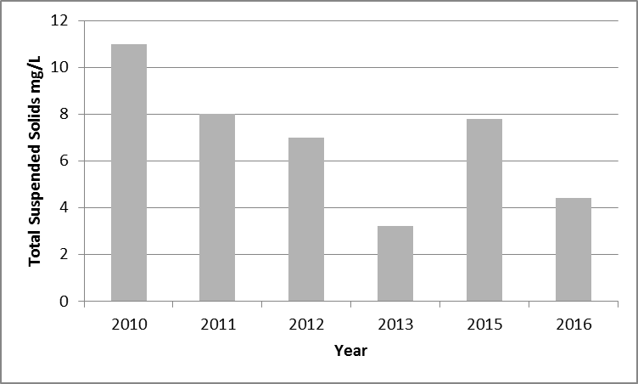

Figure 2. Total Suspended Solids from 2010-2016.

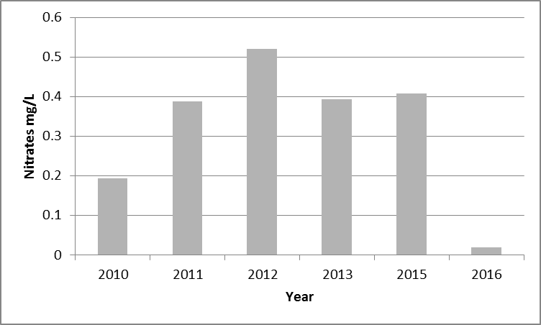

Figure 3. Total Nitrates from 2010-2016.

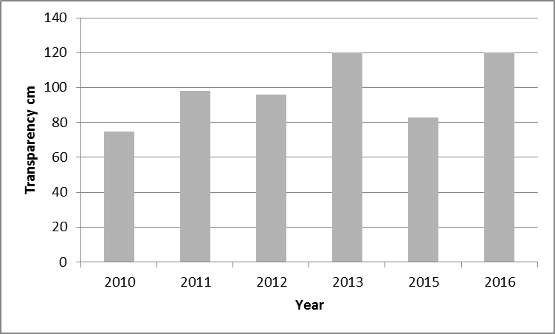

Figure 4. Stream Transparency from 2010-2016.

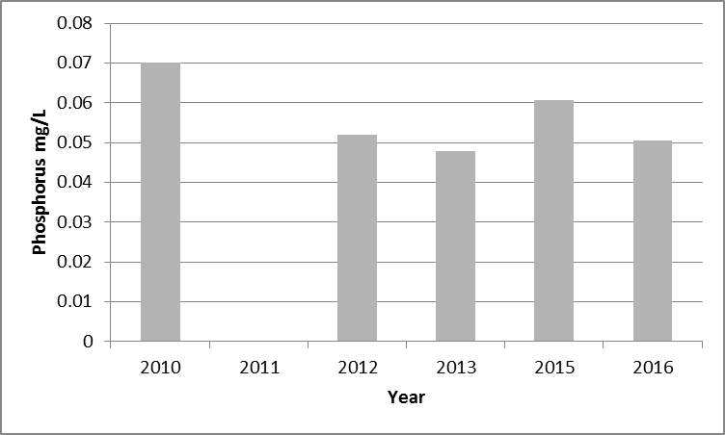

Figure 5. Total Phosphorus from 2010-2016.

Stream Habitat Results

Habitat has been collected yearly at the site since 2008. Habitat scores ranged from 68 up to 78, and ratings ranged from good to excellent (Figure 6). The stream has an excellent wetland vegetation buffer, and banks are stable. However, five of the in-stream weir structures been migrating downstream or are pushed off to the side of the stream. Boulders that were placed above the weirs have also migrated downstream. This has resulted in a loss of some pool habitat, where previously scour pools existed below the structures. For some of the weir structures repair would simply require re-staking, and moving rocks back up above the weirs.

Figure 6. Manley Creek Habitat Scores.

Fish IBI

Electrofishing surveys in years 2012 through 2015 were done seperately by Fish Management and Water Resources staff, hence the double reporting of Fish IBI’s for those years. Fish IBI results over the years scored a 90 and above, and ratings were excellent (Figure 7). Brook trout (*Salvelinus fontinalis)* dominated the catch, followed by much lesser numbers of mottled sculpins (*Cottus bairdii*), central mudminnows (*Umbra limi*) and brook stickleback (*Culaea inconstans*). The general trend of brook trout caught during monitoring has increased over time (Figure 8). The exception was in year 2013 where brook trout numbers declined . The 2013 decline in trout likely is due to the drought of 2012, when stream temperatures were abnormally high, and recruitment of fish from year 2012 into year 2013 was lower. Lower fish recruitment was also documented in other coldwater streams in this part of the state in 2013. However, from year 2013 to year 2014 the number of fish caught more than doubled, indicating increased recruitment.

Figure 7. Coldwater fish IBI Scores from 2008-2016.

Figure 8. Number of Brook Trout Captured In Yearly Surveys.

Macroinvertebrates (Aquatic Insects)

The macroinvertebrate IBI (MIBI) score in most years ranged from 6.6 – 7.0, indicating stream health according to this index rated good (Figure 9). The exception was in 2014 when the MIBI score was low at 4.1, and rated only fair. It appears that the number of insects in the EPT Orders Ephemeroptera (mayflies), Plecoptera (stoneflies), and trichoptera (caddisflies), which are intolerant to pollution, has declined over time (Figure 9). Macroinvertebrate declines are often associated with increased water pollution, declines in stream habitat or loss of high quality riparian buffers. However since water quality has not declined, and the in-stream habitat and riparian areas have not really changed over time, we ruled those out as a possible causes of macroinvertebrate decline. Upon further investigation, we looked at numbers of brook trout captured in the surveys over time, and compared that to the number of EPT genera, and found an inverse relationship between increasing brook trout and declining EPT (Figure 9). In other words, EPT genera have declined as brook trout numbers increased. Since our surveys indicate that prey fish for trout are low in numbers in Manley Creek, it makes sense that aquatic insects are the primary prey food for trout, and thus an increase in predators may be responsible for the decline in EPT genera. To confirm this, a more in depth analysis of fish and insect size distribution, and modeling of bioenergetics over time would have to be completed.

Figure 9. Macroinvertebrate IBI, and Abundance of Ephemeroptera, Plecoptera and Trichoptera.

Figure 10. Brook Trout Numbers vs. Ephemeroptera, Plecoptera, and Trichoptera Numbers.