An Assessment of

Water Quality

In

The Lower Sugar River Watershed

HUC 10 = 0709000407

2014

Green and Rock Co, Wisconsin

Projects: Lower Sugar River HUC 12 TWAs and Local Needs: SCR_07_CMP14

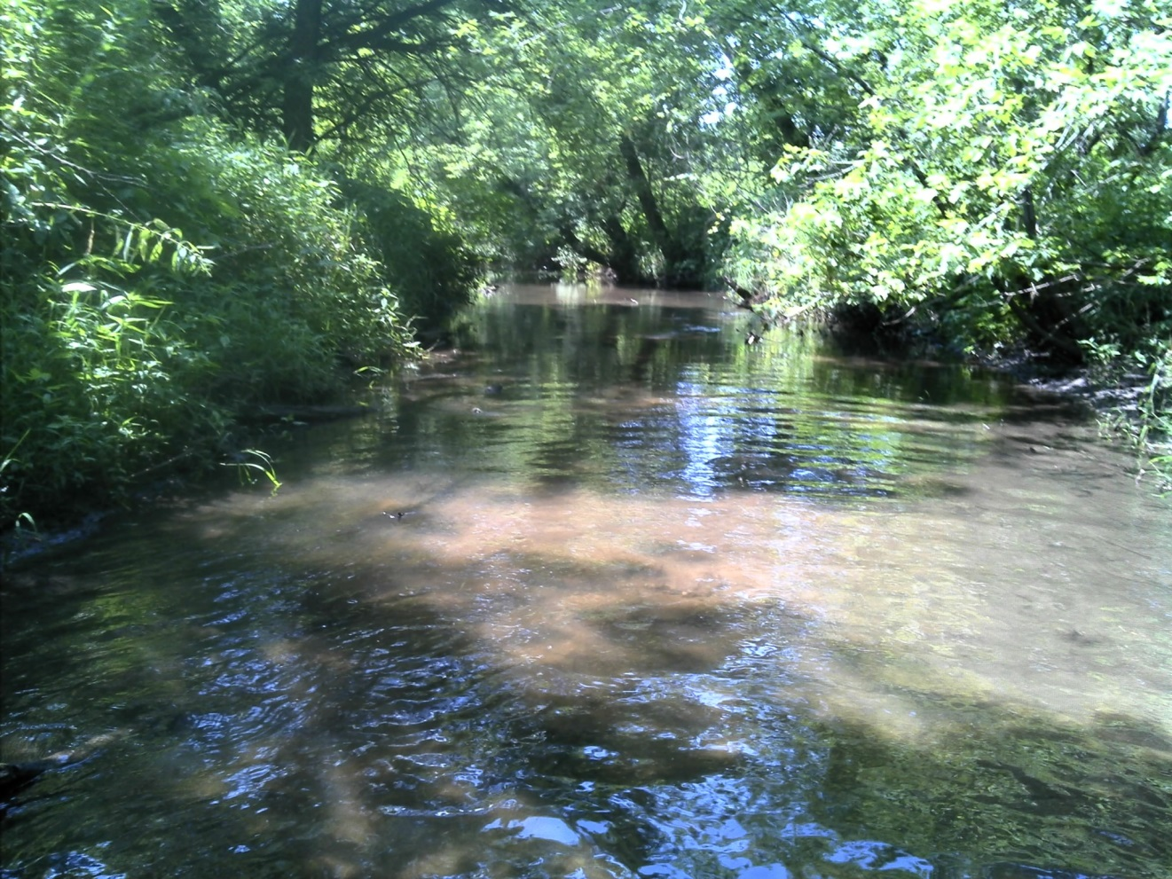

Willow Creek at Lee Road

By James Amrhein

Water Quality Biologist – Water District South

December, 2015

The “Lower Sugar River” Watershed HUC 10 (0709000407) is a subset of the larger “Lower Sugar River Watershed” and includes a portion of the Sugar River and its’ tributaries from the confluence with Sylvester Creek downstream to the Illinois border. As Figure 1 shows, it encompasses a 110 square mile drainage area and is part of the larger, 214 square mile watershed that includes the HUC 10 0709000315 (Raccoon and East Fork Raccoon) watershed and HUC 10 0709000406 (Juda and Sylvester Creek). The latter was sampled in 2013.

The watershed is intensively farmed with scattered grasslands and woodlots. Agriculture makes up 73% of the land use, with grasslands and woodland making up 12% and 9% respectively. The municipality of Orfordville discharges to Swan Creek. Spring Creek is on the state’s 303(d) list of impaired waters due to habitat impairment caused by excessive sediment deposition (WDNR, 2003).



One of the features which is fairly unique to this watershed are large, floodplain wetland complexes that exist along the lower portion of the Sugar River. These wetland complexes have high value as wildlife habitat and help maintain good water quality. Unfortunately, a number of streams through this wetland area have historically been ditched and straightened to enhance drainage. The streams in this watershed that have been straightened to enhance movement of water from fields are now entrenched with steep banks. The bank stability varies, depending on whether the riparian corridor is grassland, wet meadow, or wooded. Tree growth, primarily box elder, along the banks has exacerbated erosion of the steep banks in certain areas.

*Methods*

The 2014 watershed survey was conducted by water resources biologists on 22 sites in the watershed. Sites were selected to cover named streams or major unnamed tributaries in the HUC 10. The fisheries assemblage was determined by electroshocking a section of stream with a minimum station length of 35 times the mean stream width (Lyons, 1992). A stream tow barge with a generator and two probes was used at most sites. A backpack shocker with a single probe was used at sites generally less than 2 meters wide. All fish were collected, identified, and counted. All gamefish were measured for length. At each site, qualitative notes on average stream width and depth, riparian buffers and land use, evidence of sedimentation, fish cover and potential management options were also recorded. A qualitative habitat survey (Simonson, et. al., 1994) was also performed at each site. Macroinvertebrate samples were obtained by kick sampling and collecting using a D-frame net at these same sites in the watershed in fall, 2014 and sent to the University of Wisconsin-Stevens Point for analysis.

Additionally, water samples were collected once per month throughout the growing season (May through October) by volunteer monitors in 2013 and/or 2014 and 2015 at 6 sites in the watershed. Three of these sites (Spring Creek, Taylor Creek at Smith Road and Willow Creek) are at the pour point of the HUC 12’s which make up the HUC 10 because it was practical to do so. Two sites – on Swan and O.K. creeks - were near the pour point of these major tributaries. An additional site was collected in 2014 on Taylor Creek at W. Keesey Road for comparison with upstream/downstream of the confluence with Swan Creek. These samples were analyzed for total phosphorus.

Continuous water temperature loggers were also placed at sites on Swan, Taylor, and Willow creeks and programmed to take hourly water temperatures throughout the “summer” (June – August) period.

*Results*

The results of the fisheries surveys are summarized in Table 1. Because the natural communities model (Lyons, 2008) predicted most of the waters in the watershed to be cool transitional waters, the coolwater index of biotic integrity (IBI) developed by Lyons (2012) was applied to all streams. A total of 38 species were found throughout the watershed. White sucker, creek chub, brook stickleback and johnny darters, all of which are coolwater transitional species, were the most widely distributed. Central stonerollers were also quite prevalent. Most species found were either coolwater transitional or warmwater species (Ibid). A total of 8 intolerant species were found during the surveys with Iowa darter being the most widely distributed of these species.

Qualitative habitat surveys (Table 2) showed overall habitat rating at 13 of the 22 sites to be “fair” while 9 sites were “good”. Riparian buffer scores and bank erosion scores were

**Table 1**: Fisheries Assemblage, IBI, and Natural Community Analysis for sites in the Lower Sugar River Watershed (HUC 0709000407) - 2014



**Table 2**: Qualitative Habitat Surveys of the Lower Sugar River Watershed – 2014



generally “good” to “excellent”. Width-to-depth ratios were generally “good”. Pools were mostly scarce as were riffles and bends. Fine sediments and fish cover scores varied widely from site to site, but most were in the “fair” to “good” range.

Total phosphorus data is summarized in Table 3. At several sites, 3 years of data exist as samples were collected during the growing season 2013 through 2015. Average phosphorus concentrations range from 0.04 mg/l to 0.17 mg/l. The median concentration varied from 0.04 to 0.19 mg/l. The median growing season concentration is compared with the department’s phosphorus criteria of 0.075 mg/l for streams and 0.1 mg/l for rivers (WDNR, 2013). The median concentration exceeded the criteria at 3 out of 6 sites. The full phosphorus dataset is attached in Appendix B.

**Table 3**: Mean and Median Total Phosphorus Data

|  |  |  |
| --- | --- | --- |
| Site (Years of data) | Total Phosphorus (mg/l) | |
| Median | Mean |
| OK Creek - Mt. Hope Road (3) | 0.160 | 0.172 |
| Spring Creek - Mt. Hope Road (3) | 0.075 | 0.079 |
| Swan Creek - W. Keesey Road (1) | 0.186 | 0.168 |
| Taylor Creek - W. Keesey Road (1) | 0.045 | 0.042 |
| Taylor Creek - Smith Road (3) | 0.089 | 0.096 |
| Willow Creek - STH 81 (2) | 0.068 | 0.072 |

Temperature data, collected hourly from May to October at 4 sites, showed maximum water temperatures to be below 25oC at all sites with the exception of 1 day on Taylor Creek at W. Smith Road (Appendix A). Both Swan Creek at W. Keesey Road and Taylor Creek at W. Keesey Road had daily mean water temperatures below 20.7oC, the coldwater threshold (Lyons, et. al., 2009). Willow Creek at STH 81 and Taylor Creek at W. Smith Road had daily mean temperatures above 20.7oC, but below 22oC, putting them in the cold-cool thermal range (Ibid). With the exception of a 1 week period between July 28th and August 4th, air temperature data for the summer 2014 was not considered “extreme” in that the average air temperature 30 days prior to any given sampling date was between the lower 10th and upper 90th percentiles (WDNR, 2013). During that 1 week period, temperatures were considered to be “cool” for that period, meaning the average temperature in the 30 days prior to those sampling dates were lower than the 10th percentile.

Macroinvertebrate data can be found in Table 4. The macroinvertebrate IBI (MIBI) (Weigel, 2003) and the Hilsenhoff Biotic Index (HBI) (Hilsenhoff, 1987) were calculated for all samples. The IBI’s ranged from “poor” to “good” with most sites throughout the watershed consistently in the 3.5 to 4.5 or “fair” range. Likewise the HBI was also consistent with most sites in the “good” to “very “good” range indicating slight to some organic pollution.

*Discussion*

Most of the streams in this HUC 10 are modelled to be cool-cold transitional headwaters or mainstems (Lyons, 2008). The department has recently developed a draft method to determine whether or not the modeled natural community is accurate based on the fishery assemblage and climate conditions (Lyons, 2013). In most cases, the thermal composition of species (cold, warm, or transitional) indicated these streams resemble cool-warm systems rather than cool-cold systems. There is a fair amount of diversity of nongame species in most of the streams and coldwater species are absent for all intents and purposes.

Environmental degradation can sometimes explain the discrepancy between the modelled and actual community where there is a lack of intolerant species and a dominance of tolerant ones (Ibid). For most systems in this HUC 10, the percentage of tolerant fish fall with expected ranges for cool-cold transitional systems, and therefore a degraded community is not the principle reason for the discrepancy.

**Table 4**: Macroinvertebrate data for the Lower Sugar River Watershed Survey



Actual water temperature data collected in the watershed shows summer temperatures to be within the realm of cold to cool-cold transitional systems (Lyons et. al., 2009). The discrepancy between the temperature data and the fishery community can happen for several reasons: either the year of the thermal measurement wasn’t representative of the long-term average, the modeled thermal values were inaccurate, or both (Lyons, personal communication). In this case, air temperatures during the 2014 “summer” season over which the thermisters were deployed were not considered abnormal save for a one week period at the end of July and beginning of August when temperatures were considered abnormally cool. However, it is unlikely this weather affected the fish assemblage because the species found favored transitional and warm water systems despite the cool temperatures. The fishery assemblage encountered in 2014 is similar to that found in other years dating back to 2001 (WDNR, unpublished data), and therefore can also be considered representative of the stream. The fishery is a long-term gauge of conditions in the stream and is therefore most important for bioassessment. That’s not to say measured water temperatures aren’t useful, but for natural community determination and IBI purposes, and in the absence of moderate to severe environmental perturbation, the fishery assemblage trumps water temperature data (Lyons, personal communication).

Compared to streams in the northwest portion of the Lower Sugar watershed and the Lower Middle Sugar watershed which were sampled in 2013 (WDNR, 2015), these streams had a greater diversity of darters, and in particular Iowa and rainbow darters. There were also a greater number of intolerant species, but the percentage of tolerant species was similar.

The great majority of the transitional species (brook stickleback, creek chubs, and white sucker) found in these streams are tolerant to low dissolved oxygen and/or disturbed habitat. These particular species tend to be more widespread throughout the state, including south central Wisconsin, as opposed to other more intermediate or low tolerance species which are not found in this area (Becker, 1983).

One interesting occurrence from this study was the discovery that Iowa darters, an intolerant warmwater species, were quite prevalent in the 2014 sampling and found at 13 of the 23 sites. When looking back at historic fisheries data back to 1875, there are scant reports of an individual or two being found in Willow Creek and O.K. Creek. They have historically been reported in this area of the Sugar River (Ibid). Iowa darters do well in sandy bottomed streams. They prefer submerged fibrous roots or filamentous algae for spawning and will only occasionally spawn on gravel. Their population size tends to be dependent the territorial society in that males can fertilize and care for only a limited number of eggs. Under crowded conditions, territories are not maintained and spawning is usually not successful (Ibid). The reason for the increase in incidence of Iowa darters in the 2014 surveys is unknown. Southern Wisconsin is near the southern edge of the species range. It is likely the Sugar River always harbors small populations of them. It can be surmised that weather conditions over the past several years just happened to be favorable for increased populations and expansion of their range into the Taylor Creek system.

Iowa Darter Photo by John Lyons

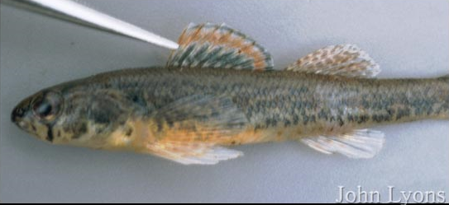

Gamefish and/or panfish were virtually absent despite the proximity of several of the sites to the Sugar River. One could hypothesize the cool water temperatures limit the number of these species which generally inhabit the warmer waters of the Sugar River. However, there was a number of other (nongame) warmwater species present in these systems. The size of the streams may have been a limiting factor, but it is likely the general lack of fish cover and deeper pools that these species prefer plays a greater role.

The coolwater IBIs (Lyons, 2012), when applied to the natural community indicated by the fishery assemblage, rates the fishery of most of these systems to be “good” to “excellent”, despite the prevalence of species that are tolerant to habitat disturbance and lower water quality. This prevalence of transitional tolerant species may be a factor of water temperature and/or environmental disturbance, but likely influenced by both. The fishery is only one environmental indicator and for this reason, the quality of the resources should be looked at in the context of overall conditions including habitat and macroinvertebrates.

Given the land use, hydrologic modifications, and biologists’ observations of conditions in this watershed, there are suggestions of environmental disturbance. Overall habitat scores were fair to good, but were buoyed by several metrics that were favorable in this watershed. The buffer width was favorable at many sites although it must be acknowledged that some of this is coincidental with the streams being deeply entrenched with steep banks, making farming up to the stream edge impractical if not impossible. There is also very limited grazing along the banks of the streams. There are sites with a riparian wooded corridor, which acts as a buffer, but also exacerbates bank erosion. The width-to-depth ratio of these channelized systems was also generally good. Conversely, many of the stream sites contained a predominance of silt and sand on the bottom which inhibited the percent fines metric. This was very dependent on the gradient at a particular site. Fish cover was variable, but 70% of sites had only “poor” to “fair” fish cover. Because of the straightening and dredging of the stream channels to augment drainage from agricultural fields, the pool area and riffle/bend ratio were depressed. OK Creek and Spring Creek had the lowest overall scores, followed by Swan Creek and Taylor Creek. Willow Creek was good save for the site at Lee Road. The overall scores for the unnamed tributaries ranged from 35 (fair) to 50 (good).

For streams that feed into the Sugar River from the west (Spring and OK Creeks), their gradients are good on the western (headwaters) areas and tend to have more gradual slopes as they near the Sugar River. These lower gradient areas are also most likely to be channelized to promote drainage from fields. These streams tend to be wider and shallower than a natural condition. However, numerous blowdowns have created small holes, narrowing, and scouring to create some habitat for non-game fish. In spring, 2014, several severe storms hit the area and created fresh blowdowns across some of the streams. This decreased sampling efficiency at several sites and even forced biologists to truncate station length at a few of the sites. While blowdowns can create habitat for fish, they also exacerbate bank erosion, and cause further widening of the stream channel. Not surprisingly, species diversity increased at sites closer to the Sugar River.

Streams that lie to the east of Sugar River (Swan, Taylor, and Willow) have fairly low gradients. Many sections have been channelized to augment drainage of the wet meadows which they flow through. In contrast to streams on the west side of the Sugar River, these streams tend to have more channelization in the mid to upper portion of their thread, with more meandering occurring closer to the Sugar River. Sand dominates the bottom composition with a few areas of gravel, particularly toward the headwaters. Similarly to other streams in the area, species diversity gradually increases as one goes from the headwaters downstream toward the Sugar River.

The macroinvertebrate data was very consistent throughout the watershed, with macroinvertebrate IBIs generally in the “fair” range. The macroinvertebrate IBI has shown the combination of watershed land cover and local riparian and instream conditions strongly influence one another (Weigel, 2003). While watershed and local variables explain a significant portion of variance among sites, Weigel found that in the driftless region, localized stressors were of greater importance to explain the IBI than in other parts of the state. The similarity amongst scores in this watershed as well as the adjacent watershed (WDNR, 2015) reflects the overall condition of the watershed in that these streams are highly modified systems flowing through an intensive agricultural landscape. The HBIs indicate there is little organic loading to these streams.

Growing season phosphorus concentrations varied amongst the streams and the sites. The department’s listing methodology for impaired waters (WDNR, 2013) recommends listing sites where the median phosphorus concentration exceeds 0.075 mg/l on wadable streams and 0.1 mg/l on rivers. The impairment listing protocol uses a 95% confidence interval about the median for listing streams and rivers. This guidance was exceeded on Swan Creek at Keesey Road and OK Creek at Mt. Hope Road. For all intents and purposes, the criteria was also exceeded at Taylor Creek at Smith Road, but was not exceeded upstream at W. Keesey Road. It is likely the phosphorus concentrations on Swan Creek and Taylor Creek at Smith Road are influenced by the wastewater discharge from Orfordville. OK Creek had a median concentration which was over double the criteria and all but 1 of the 18 samples taken over 3 years exceeded 0.075 mg/l. These concentrations are similar to Swan Creek, which receives a wastewater discharge. It is unknown why the phosphorus concentrations of OK Creek are almost double that of other streams in the area. A review of land use and nutrient management plans is warranted. The median concentration did not exceed the criteria nor data exceed the 95% confidence interval on Spring Creek and Willow Creek, but each of these systems had individual samples which exceeded the criteria and bare further monitoring.

It is interesting to note that the yearly median concentration increased at most sites in successive years from 2013 to 2015 at those sites where multiple years of data were available. The exception was on Taylor Creek at Smith Road, where it decreased in successive years (Figure 2). When compared to the long-term trend site on the Sugar River, the 3 year median also increased, indicating a more basin-wide phenomenon.

It is unknown what caused this trend. The precipitation was not considered extreme - below 10th percentile or above 90th percentile – for the sample dates over this period (WDNR, 2013). This 3 year trend may be short-term as the 10 year median growing season phosphorus concentration on the Sugar River decreased (WDNR, unpublished data).

*Summary and Conclusions*

Streams of the Lower Sugar River watershed tend to contain fish resembling a cool-warm thermal regime. The streams typically have 10 to 15 species, many of them transitional or warmwater species. And while there are multiple intolerant species found in certain locations, the majority of the total numbers of fish are tolerant to environmental degradation. The streams themselves have many sections that have been straightened to enhance drainage from agricultural fields. This lends itself to degraded habitat within the individual streams and advanced sediment delivery to larger systems like the Sugar River. Individual stream narratives can be found in Appendix C.

As one attempts to think of ways to improve these streams, it is unrealistic to think that re-meandering of the stream channels is cost-effective or practical, especially in the contemporary agricultural economy. Therefore it is imperative to work with landowners in the watershed to encourage management of woody vegetation to prevent overgrowth along banks, to control regrowth and use management practices that avoid destabilization

**Figure 2**: Trends in Median Total Phosphorus Concentration

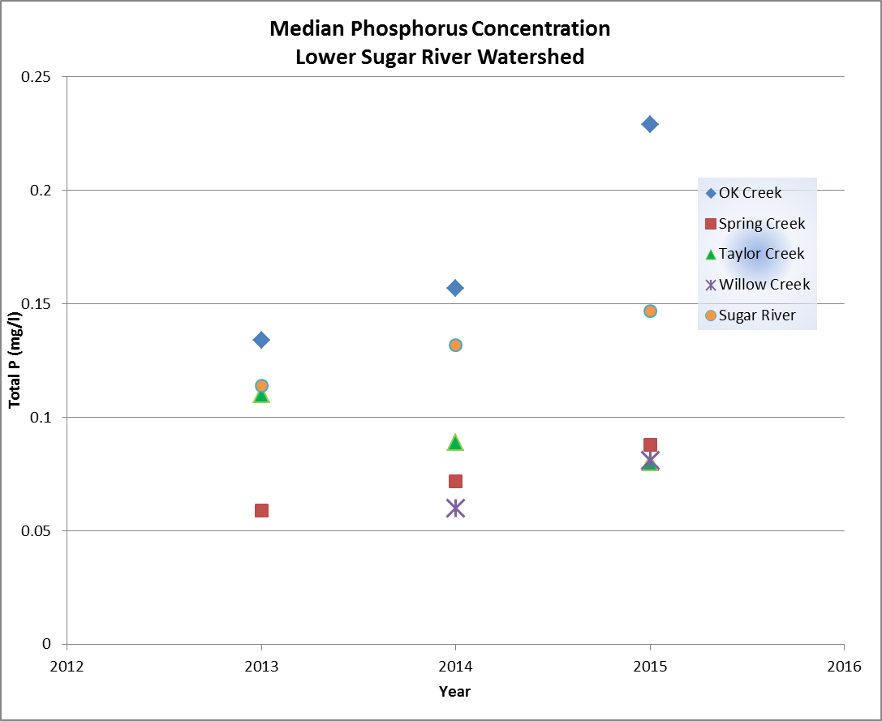

of banks (i.e. cutting and grubbing of the shoreline with no shaping, sloping or mulching).

This would allow for stabilization in grasses, embrace natural “re-meandering” within the channel footprint, strive to keep some buffers in place. Where possible, encourage landowners to slope banks 3:1 to prevent erosion. It is also important to leave some in-stream woody debris in place to act as natural cover for fish. Control nutrient loading through development and implementation of nutrient management plans and proper manure management.

The department should work with watershed organizations such as the Lower Sugar River Watershed Association on outreach efforts with landowners in the watershed, environmental programs in the Juda and Brodhead school districts, and research opportunities for harvestable buffers to provide economic incentives for maintaining buffers along streams.

It is recommended that the entire length of OK Creek be added to the state’s 303(d) list of impaired waters due to habitat degradation caused by excessive sediment deposition and channel straightening. While the appropriately applied fish IBIs are fair to good, it is difficult to ignore the fact that the lower half of OK Creek is straight, unnaturally wide, shallow, and deeply entrenched with steep eroding banks and a high amount of soft sediment. It should also be added for total phosphorus as concentrations exceed the WisCALM (WDNR, 2013) guidance. The department should review land use and nutrient management efforts in this sub-watershed to determine if any improvements can be made to reduce phosphorus delivery to the stream.

Swan Creek should be added to the 303(d) list of impaired waters for phosphorus that exceeds the criteria.

Taylor Creek, from Swan Creek downstream to the Sugar River and Willow Creek should be added as a watch waters as total phosphorus concentrations are near the criteria for listing.

Monitoring of phosphorus and nitrate concentrations in the streams of the Lower Sugar River should continue as funding and volunteer efforts allow.

References

Becker, George C. 1983. Fishes of Wisconsin. The University of Wisconsin Press. 1051 pp.

Hilsenhoff, William L. 1987. An Improved Biotic Index of Organic Stream Pollution. The Great Lakes Entomologist. 20: 31-39.

Lyons, John. 1992. Using the Index of Biotic Integrity (IBI) to Measure Environmental Quality in Warmwater Streams of Wisconsin. United States Department of Agriculture. General Technical Report NC-149.

Lyons, John. 2006. A Fish-based Index of Biotic Integrity to Assess Intermittent Headwater Streams in Wisconsin, USA. Environmental Monitoring and Assessment 122: 239-258.

Lyons, John. 2008. Using the Wisconsin Stream Model to Estimate the Potential Natural Community of Wisconsin Streams (DRAFT). Wisconsin Department of Natural Resources Fish and Aquatic Life Research Section. November, 2008.

Lyons, John. T. Zorn, J. Stewart, P Seelbach, K Wehrly, and L. Wang. 2009. Defining and Characterizing Coolwater Streams and Their Fish Assemblages in Michigan and Wisconsin, USA. North American Journal of Fisheries Management. 29:1130-1151.

Lyons, John. 2012. Development and Validation of Two Fish-based Indices of Biotic Integrity for Assessing Perennial Coolwater Streams In Wisconsin, USA. Ecological Indicators 23 (2012) 402-412.

Lyons, John. 2013. Methodology for Using Field Data to Identify and Correct Wisconsin Stream “Natural Community” Misclassifications. Version 4. May 16, 2013. IN DRAFT.

Simonson, Timothy D., J. Lyons, and P.D. Kanehl. 1994. Guidelines for Evaluating Fish Habitat in Wisconsin Streams. U.S. Department of Agriculture. Forest Service. General Technical Report NC-164.

WDNR. 1980. Surface Water Resources of Green County. By D. Bush, R. Cornelius, D. Engel, C. Brynildson. Wisconsin Department of Natural Resources. Madison, WI.

WDNR. 2003. The State of the Sugar and Pecatonica River Basins. Wisconsin Department of Natural Resources.

WDNR. 2013. Wisconsin 2014 Consolidated Assessment and Listing Methodology (WisCALM). Clean Water Act Section 305(b), 314, and 303(d) Integrated Reporting. Wisconsin Department of Natural Resources. Bureau of Water Quality Program Guidance. September, 2013.

References: continued

WDNR. 2015. An Assessment of Water Quality in the Lower Middle and Lower Sugar River Watershed (HUC 0709000406). 2013. Project SCR_20_CMP13. February, 2015. By James Amrhein, Water Quality Biologist – South District. http://prodoasint.dnr.wi.gov/wadrs/viewWatershedDetail.do?id=924722

Weigel, Brian. 2003. Development of Stream Macroinvertebrate Models That Predict Watershed and Local Stressors in Wisconsin. Journal of the North American Benthological Society. 22(1): 123-142.

**Appendix A**: Water Temperature Data for Streams of the Lower Sugar River Watershed

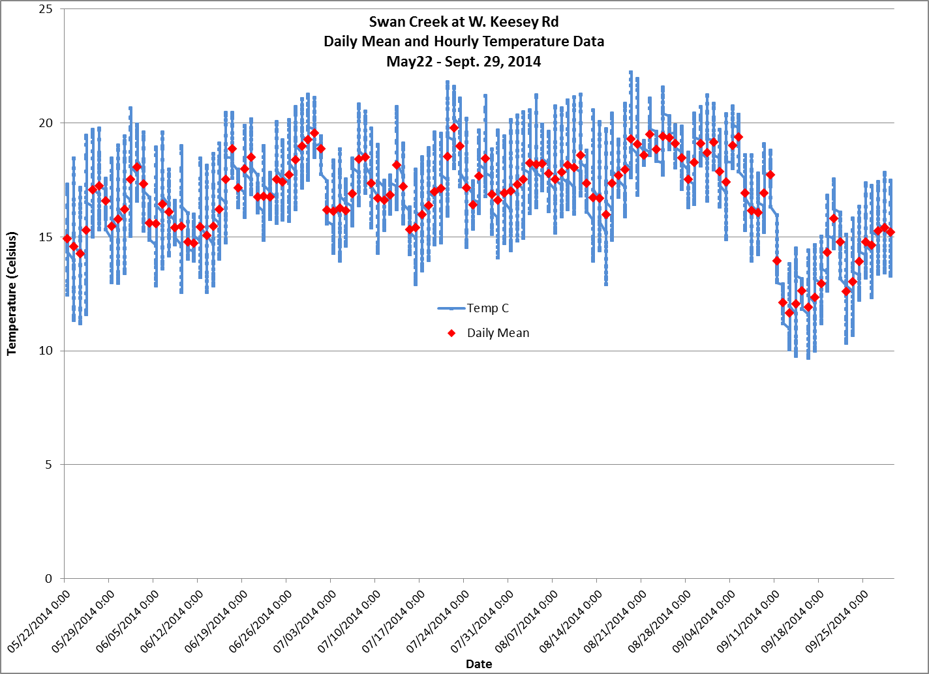

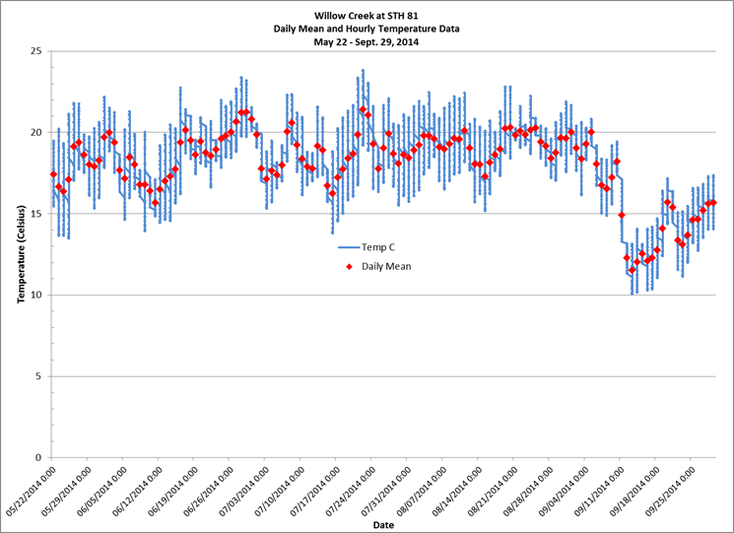

**Appendix A**: continued

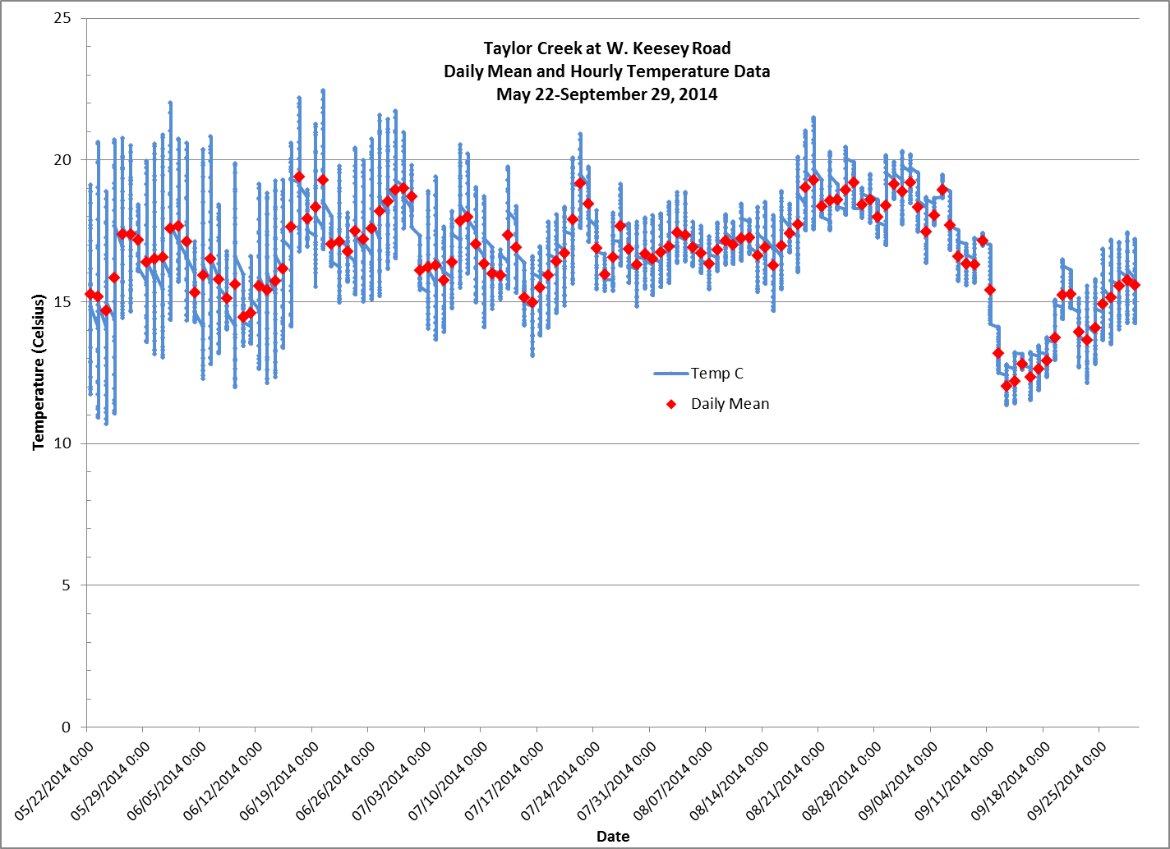

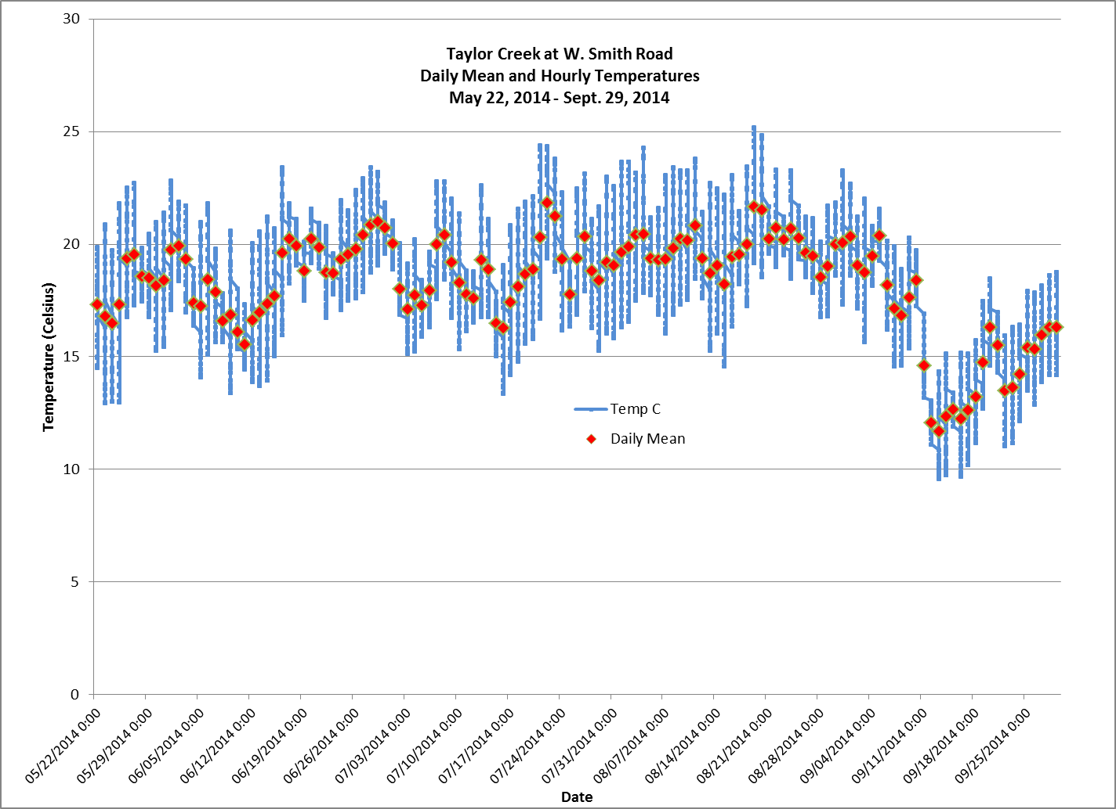

**Appendix B**: Total Phosphorus Concentrations in Streams of the Lower Sugar Watershed



**Appendix B**: (Continued)



**Appendix C**: Stream Narratives

***Oakley Branch***

This small, 2 mile long stream has its source near the Illinois border and flows northward and converges with Spring Creek near the unincorporated community of Oakley. It historically flowed entirely through pasture and experienced the severe bank erosion associated with heavy grazing (WDNR, 1980). Near Oakley, a 0.5 acre spring pond discharges a small flow to the stream.

Very little monitoring data exists for this stream. It harbors about a dozen non-game species, predominately creek chubs and white sucker. In the 2014 survey, 1 Iowa darter, an intolerant warmwater species was found along with 1 largemouth bass – most likely a stray from the spring pond – were also found. The stream has good gradient which scours down to the gravel and rubble cobble bottom. However, there is 6-8 inches of silt in the small pools. The moderate bank erosion is testament to its flashy nature. Much of the upper half of the stream runs through fields, while the middle portion is now more wooded. The stream is adjacent to several barnyards and feed lots which may contribute sediment and nutrients to the stream. Despite this, the fishery community represents a good, cold-cool transitional community.

***OK Creek***

Several springs in a small upland area form the headwaters of OK Creek. It flows 5 miles easterly until it joins the Sugar River. Like many streams in the area, the western headwaters area has higher gradient, but then gives way to lower gradient as it nears the Sugar River. Most of the lower half of OK Creek has been ditched to drain the large wetland complexes of the lower Sugar River (WDNR, 1980).

Three sites were sampled in 2014. At Preston Road, near the headwaters, only brook stickleback and fathead minnows were found. Historic sampling showed a more diverse fishery with creek chubs, stoneroller, johnny darters, and white sucker present. This site scored “poor” from a fishery IBI standpoint even though the habitat was good.

Further down at CTH G, diversity increased with creek chubs being most prevalent, followed by johnny darter, stoneroller, bluntnose minnow, and fathead minnow also common. Here the stream flows through a wooded corridor which exacerbates bank erosion, contributing to a shallow, wide stream with a silty bottom. Habitat scores were modest. Tree blowdowns from recent storms in the area made shocking difficult.

At Mount Hope Road, the stream is channelized and highly entrenched. Several tile lines drain the fields and add cold water to the stream. The monotypic habitat of this site is typical of the channelized sections of this stream. Still, species diversity was good with 15 species being represented. This may be due in part to the closer proximity with the Sugar River. Creek chubs and bluntnose minnows, both species tolerant of habitat disturbance were the most prevalent. This section is modelled to be a cold-cool mainstem, but the fishery assemblage more closely resembles a cool-warm mainstem that is excellent. Habitat was considered “fair” at this site, although the metrics of pool area, riffle/bend ratio and fine sediments were “poor”. Water samples were also collected from 2013 through 2015 and analyzed for phosphorus. The median concentration was 0.17 mg/l, which exceeds the state’s water quality criteria of 0.075 mg/l.

O.K Creek should be added to the state’s list of impaired waters for phosphorus as well as habitat degradation due to sedimentation and channelization. The department should review land use and nutrient management efforts (plans) in this sub-watershed to determine if any improvements can be made to reduce phosphorus delivery to the stream.

***Spring Creek***

Spring Creek flows 10 miles in southeastern Green County and drains into the Sugar River. Much of its length has been ditched to drain cropland. The lower ten miles of the stream are on the state’s 303(d) list of impaired waters for degraded habitat due to sedimentation (WDNR, 2003).

It is modelled to be a cold-cool transitional stream, but the fishery assemblage more closely resembles that of a cool-warm system. Species diversity increases as one moves from the headwaters downstream toward the Sugar River. The variety of species found at Mt. Hope Road may be in part due to its proximity to the river. Creek chubs and white suckers are the predominant species at all sites sampled in 2014. Historic fishery surveys have shown similar species presence. The balance of the fishery is made up of a variety of species ranging from spotfin shiners to shorthead redhorse, suckermouth minnows to rock bass and northern pike and present in modest amounts. Most of these are warmwater species. Cool-warm IBI’s range from 60 to 90 and are considered excellent. However, the habitat surveys showed a system that is only of moderate habitat quality, with qualitative habitat ratings of 35 to 43 or “fair”. The stream suffers from severe bank erosion, lack of pools and lack of fish cover.

More specifically, the site at Town Center Road was unique in that it flowed through pastureland. It had many trampled banks, but the good gradient helped scour the bottom and create nice riffle/run complexes. Biologists noted that this portion of the stream, “reminded them a lot of the pastured streams of Lafayette and Grant counties”. The other two stations sampled, at CTH OK, near the headwaters, and at Mt. Hope Road near the bottom end, were both in wooded corridors. As such, they both had raw eroding banks. Flow and temperature at the CTH OK site was influenced by springs in the area and the good gradient allowed the stream to scour to a rubble/cobble bottom in riffle areas. However, many areas also had silt over hard the hard substrate, likely from bank erosion. The lower site at Mt. Hope Road more silt, sand and clay. However species diversity was greater, with 5 darter species being found during the survey. Biologists noted lots of blowdowns at both sites. While providing habitat for fish, these blowdowns also enhance bank erosion and increase the width- to-depth ratio.

In fall and winter of 2014/2015, a project was conducted on the stream at Mt. Hope Road that removed all the trees along the stream and sloped and stabilized the banks. Unfortunately, all the woody debris that was the only habitat in the stream was removed.  However, the stream was narrowed this improved (lowered) the width/depth ratio.  This type of project will also reduce the amount of bank erosion (and sediment delivery to the Sugar River) that had occurred in the past.

Phosphorus concentrations from 2013 through 2015 showed the median concentration to be 0.0749. This is just below the 0.075 mg/l criteria, however there were several samples that exceeded the criteria and therefore qualify Spring Creek as a “watch water” in the future.

Spring Creek should remain on the impaired waters list as certain aspects of the habitat measure are still poor. The stream would benefit from harvest of nuisance species like box elder along the shoreline and then bank stabilization. Landowners should be encouraged to leave some woody debris in the stream as habitat for fish. While species diversity is good, enhanced stream management to improve the corridor could result in the lower portion of Spring Creek to be a refuge for some species like northern pike and smallmouth bass at certain times of the year. The department should monitor the stream at Mt. Hope Road to determine the effect of the recent management actions on the fishery and habitat indices.

***Swan Creek***

This stream originates near Orfordville and flows west, then south a total of 9 miles where it empties into Taylor Creek. The stream receives effluent from the Orfordville sewerage treatment plant through a ditch that parallels Potter Road and joins the creek just upstream of the bridge. The stream is modelled to be a coldwater system from its headwaters downstream 2.5 miles to just upstream of Dickey Road. From there, down to its confluence with Taylor Creek, it is purported to be a cold-cool headwater. Much of the stream has been channelized.

The stream is small, with limited flow upstream of Potter Road. This section contains the typical pioneer species you’d expect from a headwaters system, including creek chubs, brook stickleback, and johnny darter. Between Potter Road and Dickey Road, the stream picks up considerable flow as it meanders through spring-fed wetlands in this section. The Dickey Road site contains a higher diversity and number of fish and probably the best habitat of the system owing to the fact it is one of the few areas not channelized. While this portion is dominated by white sucker and creek chubs, central stonerollers, were also prevalent and a healthy number of the intolerant species, Iowa darter were reported. The fishery assemblage at W. Keesey Road is very similar, picking up several more species present in low numbers.

While the stream is modelled to be cold or cold-cool, and several brown trout have occasionally been reported in surveys conducted on the creek, there are no other stenothermal coldwater species present and the fishery assemblage more closely resembles a cold-cool to cool-warm system. Cool IBI’s range from 60-70, or good to excellent.

Phosphorus sampling conducted at W. Keesey Road in 2014 showed an exceedance of the criteria. The median phosphorus concentration was 0.186 mg/l and all samples exceeded the 0.075 mg/l criteria. This is not unexpected given that the stream receives effluent from the Orfordville wastewater treatment plant.

Swan Creek should be added to the state’s 303(d) list of impaired waters for phosphorus concentrations that exceed the listing criteria.

**Taylor Creek**

Taylor Creek is a 13 mile stream that drains southward in western Rock County and empties into the Sugar River. The lower ¾ mile flows through the Avon Bottoms Wildlife Area. At its headwaters, the upper mile of Taylor Creek is modelled to be a warm headwater. It then transitions into a cold-cool headwater until its confluence with Swan Creek where it becomes a cold-cool mainstem. It remains that way until it is joined by Willow Creek where it then is modelled to be a cool-warm mainstem. The fishery community has been monitored at the various road crossings over the past 10 years. The fishery community suggests the stream more closely resembles a cool-warm system for most of its length. Several species of gamefish are typically found in the lower 1/3 of the stream, likely owing to the proximity with the Sugar River. Four sites were surveyed in 2014.

As expected, the uppermost site at W. Gempler Road contained typical pioneer species such as brook stickleback creek chubs, and johnny darter. Species diversity increases as one moves downstream. The site at W. Keesey Road was difficult to sample because of shrub overgrowth. At W. Smith Road, 22 species were found, including a couple of gamefish species and 4 intolerant species, but tolerant species made up 74% of the assemblage.

In a survey conducted in 2007, biologists noted that the bridge at STH 11 seemed to be backing up water, and as a result, silt upstream of the bridge. The species diversity “is skewed towards the tolerant species”. Indeed, the sites sampled upstream and downstream of STH 11 (W. Keesey Road and W. Smith Road) likewise contained a great majority of tolerant species, particularly bluntnose minnow, creek chub, and white sucker.

The bottom substrate of Taylor Creek has some gravel, but sand becomes more predominant as one moves downstream. The lower ½ of the stream is buffered to some extent by the wet shrub meadows that it meanders through. Fish cover is generally limited to overhanging vegetation along the banks. Overall habitat scores are around 50, or good.

Phosphorus was sampled at 2 locations: W. Keesey Road in 2014 and at W. Smith Road in 2013 through 2015. The median phosphorus concentration at W. Keesey Road was 0.04 mg/l and ranged from 0.01 to 0.07 mg/l. At W. Smith Road, the median phosphorus concentration was 0.09 mg/l. Thirteen of the eightteen samples collected from 2013 to 2015 exceeded the 0.075 mg/l criteria. The input from Swan Creek likely has some effect on the concentrations seen at W. Smith Road.

Taylor Creek should be added to the list of watch waters from Swan Creek downstream to the confluence with the Sugar River for phosphorus concentrations that may exceed the listing criteria.

***Willow Creek***

Willow Creek is a seepage fed stream originating south of Orfordville and flowing generally southwest to enter Taylor Creek. The upper three-fourths of the stream has been ditched. The stream is generally home to a variety of non-game species although a few game species (northern pike, large and smallmouth bass and rock bass) may occur in the lower portions near Taylor Creek. The lower portion of Willow Creek – downstream of Lee Road - adjoins fresh meadow and shallow marsh wetland.

Species diversity is as good as any stream in the watershed, with 20+ species found in the creek. In the 2014 surveys, good numbers of Iowa darter, an intolerant warm water species, were found. Previous investigations yielded only 1 or 2 individuals whereas the contemporary surveys showed a couple dozen specimens.

Habitat scores ranged from 25 (fair) at Lee Road to 63 (good) at STH 81. The overall score was buoyed by the wetland corridor which provides a good de facto buffer as well as low bank erosion. The site at Lee Road was different than the other two sites in that it flowed through a wooded corridor which enhanced bank erosion, was wide and shallow, and had little fish cover, save for woody debris. Despite this, there were a variety for species present in good numbers, and the cool-warm IBI for the stream was 90, or excellent.

Phosphorus sampling was conducted 6 times during the growing season in 2014 and 2015 by volunteers at STH 81. While the median concentration was 0.068 mg/l – below the 0.075 mg/l phosphorus criteria, nearly half the samples exceed the criteria, therefore Willow Creek should be added to the list of watch waters.

The macroinvertebrate assemblage in Willow Creek was typical for the watershed with IBIs ranging from 4.6 (fair) to 5.7 (good). An unnamed tributary (WBIC = 876500) to Willow Creek had a good and poor IBI and very poor and fair HBI. At the lower crossing, overhanging vegetation was the only available cover sampled and was dominated by hemipteran species (water striders, giant water bugs, water boatman, and water scorpions) which depressed the IBI. Conversely, the upper portion was dominated by chironomids, which depressed the HBI. This tributary is a low gradient, channelized system that runs through a large wetland complex. The macroinvertebrate community appears to reflect these aspects.