Scope of Work

Sediment Toxicity Tests

Solvay Coke and Manitowoc MGP sites

Revised – July 11, 2014

OBJECTIVES AND GOALS

The primary objectives of the proposed sediment toxicity tests for both the Solvay Coke and Manitowoc MGP sites are to build a database to better understand sediment toxicity test results and to support resolving issues related to establishing contaminated sediment remedial action target levels (RATL) for MGP sites, specifically based on concentrations of polycyclic aromatic hydrocarbons (PAHs). The goal of the project is to provide information to either support or modify the current PAH sediment quality guidelines.

BACKGROUND

Contamination of sediment related to previous manufactured gas plant (MGP) operations is a statewide concern. A total of twenty eight MGP sites have been identified and under different stages of assessment and remediation.

Similar to other contaminated sediment sites, managing the MGP related sites faces challenges in assessment and remediation due to factors such as heterogeneity of sediment and complex migration pathways of contaminants associated with sediment. Based on the information obtained from sites that have been either remediated or assessed, WDNR sediment management team observed inconsistences in cleanup criteria or RATL from one site to another. At some sites, RATL was based on site specific risk assessment, primarily sediment toxicity test results, in conjunction with chemical concentrations of contaminants of concern. The others used the WDNR consensus based sediment quality guidelines. Proposed or implemented RATL varied from 3.8 ppm at one site to more than 400 ppm of PAHs at another. In addition, depending on the circumstances, the RATL was sometimes normalized by total organic carbons in sediment.

SCOPE OF WORK

Sediment and surface water sampling

Sediment samples will be collected from Manitowoc River close to Wisconsin Public Service Corp MGP site and from the Kinnickinnic (KK) River close to Solvay Coke MGP site. Figure 1 shows the general location of the sites. It is proposed that four investigative sediment samples and one reference sample will be collected from each site.

*Manitowoc River*

Sediment samples will be collected from places representative of concentrations of PAHs ranging from low to high. There is a possibility of encountering free tar products so that how to clean sampling equipment between sampling locations needs to be planned out. Also the investigative waste will need to be properly disposed of. Samples will be collected in late July by either WDNR.

A single surface water sample will be collected from the Manitowoc River at the reference site for conducting elutriate toxicity tests. The reference site will be located upstream of the MGP site on the Manitowoc River.

*KK River*

At this point, the USEPA GLNPO will provide assistance to collect samples from the KK River in September. One grab sample and two sediment core samples are planned to be collected. Sediment cores will be segment into two layers, surface sediment sample (0-1ft) and subsurface sample (1ft to the end of the core) for toxicity tests. Selection of a reference site is difficult given that the investigative site is an urban estuary. The most upstream site will be considered as a reference but it might not be treated as a true reference because of constant seiche effect in the project area.

A single surface water site on the KK river will be selected to collect ambient water for use in elutriate toxicity tests.

Toxicity tests

This study will use two species, *Hyalella azteca* and *Chironomus dilutus*, for the sediment toxicity tests and two species, *Daphnia magna* and *Pimephales promelas* (fathead minnow), for the elutriate water toxicity tests. The water test will be done using elutriate prepared using sediment from each site mixed with the ambient surface water in a 1:4 ratio and then allowed to settle at least 4 hours or overnight at 4˚C . This water will then be poured off and stored at 4˚C for use. Elutriate for each site will be prepared once for acute tests and weekly as needed for chronic toxicity tests. In addition, if it is found to be feasible (i.e. control performance is acceptable) the tests will be conducted with a small layer of sediment in the test container and elutriate used as overlying water and for renewals. Disposable plastic beakers will be used for toxicity testing. Table 1 summarizes the proposed test duration and endpoints based on the previous tests conducted by the USEPA on the KK River sediment and the US Army Corps testing manual. Methods are also based on ASTM methods with modification. A testing SOP will be developed for the project. Additional discussion will be carried out between WDNR and SLH to finalize testing objectives and procedures as project QA/QC plans are developed.

Table 1 Toxicity tests and endpoints

|  |  |  |
| --- | --- | --- |
| **Sediment** | | |
| Species | Test 1 | Test 2* |
| *H. azteca* | 28 day-survival and dry weight  (may run 2-4 replicates for 10 days and 4-6 replicates will continue for 28 days) | Use the sediment demonstrating the most toxicity to conduct a dilution series 10-day test. The purpose is to establish an LC50 or equivalent.  Use lab control sediment prepared in lab to dilute the sediment samples with a series of 25%, 50%, 75%, and 100% of contaminated sediment with lab water as overlying water. |
| *C. dilutus* | 10 day-survival and dry weight (using ~2nd to 3rd instar – 7-10-day old organisms) | Use the sediment demonstrating the most toxicity to conduct a dilution series 10-day test. The purpose is to establish LC50 or equivalent.  Use clean sand materials prepared in lab to dilute the sediment samples with a series of 25%, 50%, 75% and 100% of contaminated sediment with lab water as overlying water. |

|  |  |  |
| --- | --- | --- |
| **Water\*\*** | | |
| **Species** | **Test 1** | **Test 2** |
| *D. magna* | 48-hr acute tests:  Three parallel tests:   1. Elutriate with Sediment on bottom   sediment:elutriate water ratio of 1:4v/v in beaker, , at 25oC   1. Ambient water with sediment on bottom of beaker   Sediment:water ratio of 1:4v/v  Site ambient water, at 25oC   1. Elutriate with no sediment in beaker   Run appropriate controls using lab water and lab sediment, , at 25oC.  Prepare elutriate in a large container, add ambient water and pre-mixed sediment at 1:4v/v ratio, mix the sediment and water with a blender and then place on shaker table for 60 minutes and then let it settle for four hours or overnight as needed. 48 Hour tests will be static non-renewal tests to assess mortality. | After Test 1 results are done – determine which samples should have chronic tests completed and with which species (D.magna or P.promelas). Use method determined to be most effective based on Test 1 for D.magna. Daphnia magna and fathead minnow will be <24 hours old at chronic test initiation – will assess mortality and reproduction for Daphnia and mortality and growth for fathead minnows. |
| *P. promelas* | 96-hr acute test  Three parallel tests:   1. Elutriate with Sediment on bottom ( sediment on the bottom may not be possible with renewal method but with non-renewable method)   sediment:elutriate water ratio of 1:4v/v in beaker   1. Ambient water with sediment on bottom ( sediment on the bottom may not be possible with renewal method but with non-renewable method)   sediment:water ratio of 1:4v/v  Site ambient water, at 25oC   1. Elutriate with no sediment   -Run appropriate controls using ambient water, lab water and lab sediment.  Prepare elutriate in a large container, add ambient water and pre-mixed sediment at 1:4v/v ratio, mix the sediment and water with a blender and then place on shaker table for 60 minutes and then let it settle for 4 hours or overnight as needed.  96 Hour FHM tests will be static renewal – with partial renewal of elutriate or ambient water daily and feeding of FHM after 48 hours. Test will assess mortality. | After Test 1 results are done – determine which samples should have chronic tests completed and with which species (D.magna or P.promelas). Use method determined to be most effective based on Test 1 for D.magna . Daphnia magna and fathead minnow will be <24 hours old at chronic test initiation – will assess mortality and reproduction for Daphnia and mortality and growth for fathead minnows. Fathead minnow test is a 7 day chronic test. |

* Whether or not to conduct the dilution series tests will be determined after Test 1 is completed

** Water phase test needs additional discussion with SLH

Chemical Analyses

*Sediment*

A total of five sediment samples will be collected from each site for chemical analyses. The actual sampling location will be developed later. Tentatively sediment samples will be collected in July 2014 from Manitowoc River and in September 2014. A sampling QAPP will be developed to detail the sampling methods, analytical methods, and data objectives. Table 2 provides a summary of analysis parameters and associated cost. A final decision on parameters will be made two weeks before sampling starts.

*Water*

Ambient water samples will be collected in the quantity needed to conduct the elutriate water toxicity tests. The samples will analyzed for the parameters of interest as listed in Table 2. One ambient sample will be collected from each study site at the reference site upstream of the contaminated areas.

Elutriate samples will also need chemical analyses for interpretation of the toxicity test results. Elutriate is prepared by mixing sediment and ambient water for each site and allowing settling for a time period that will be determined after further literature review. The supernatant from the sediment slurry should be tested for chemistry with suspended sediment in the aqueous phase. A possible total of 8 elutriate samples for each project (16 total) will be analyzed including the reference site. If a lab control elutriate is also tested that and lab control . The first batch of elutriate at each site will be assessed for 5 samples plus an additional 3 samples for follow-up preparation of elutriate for one site for Phase 2 testing. The number of elutriate samples will depend upon how many sites will have chronic toxicity tests conducted with elutriate water. For chronic tests an initial elutriate sample will be made and used for the first 7 days and then two more elutriate samples will be made for Test days 7-14 and 14-21.

Coordination between WDNR and SLH will further clarify the sampling containers, parameters and analytical cost.

Table 2. Chemical analyses of sediment, ambient water and elutriate water samples

|  |
| --- |
| **Chemical Parameter** |
| **Water Column** | **Sediment** |
| PAHs | X | X |
| Oil and Grease | X | X |
| Ammonia | X | X |
| Arsenic | X | X |
| Cadmium | X | X |
| Chromium | X | X |
| Copper | X | X |
| Nickel | X | X |
| Lead | X | X |
| Zinc | X | X |
| Cyanide | X | X |
| Mercury | * | X |
| TOC | X | X |
| Suspended solids | X |  |
| Particle size distribution |  | X |
| Lipid Content |  |  |

* May not analyses due to sampling requirement

Table 3. Elutriate Chemistry requirements for Manitowoc Project (potentially X2 if done for KK project as well)

|  |  |  |  |  |  |
| --- | --- | --- | --- | --- | --- |
| Sample | Acute Test Elutriate sample | Chronic test Elutriate sample Day 0-6 | Chronic test Elutriate sample Day 7-13 | Chronic test Elutriate sample Day 13-21 | Total |
| 1 | 1 | 1 | 1 | 1 | 4 |
| 2 | 1 |  |  |  | 1 |
| 3 | 1 |  |  |  | 1 |
| 4 | 1 |  |  |  | 1 |
| Reference | 1 |  |  |  | 1 |
| Lab Control | 1 |  |  |  | 1 |
| Total | 6 | 1 | 1 | 1 | **9** |

Figure 1. Site locations

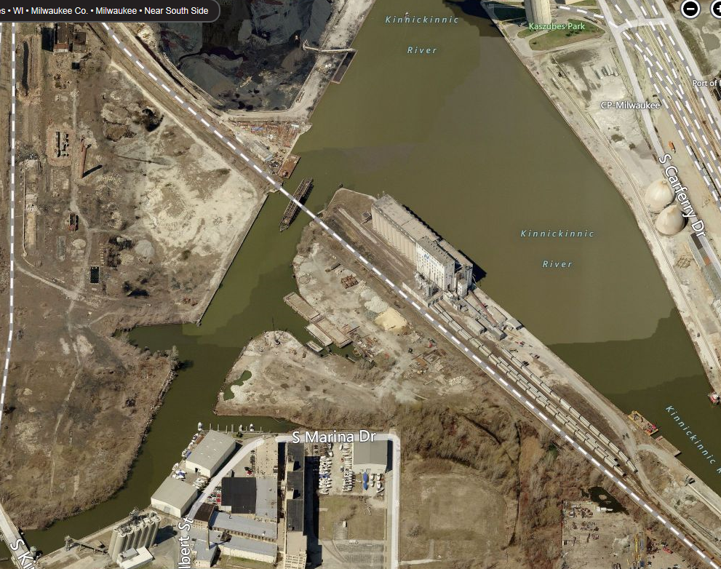

Kinnickinnic River site

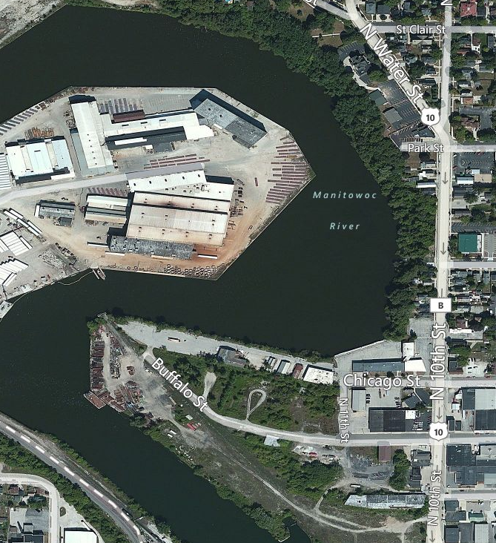

Manitowoc River site