**A 2017 Assessment**

**of the**

**West Branch Sugar River**

The Contemporary Condition of the West Branch Sugar River

15 Years After Stream Rehabilitation

Dane County, WI

WBIC =886100

Project: South_3_CMP17

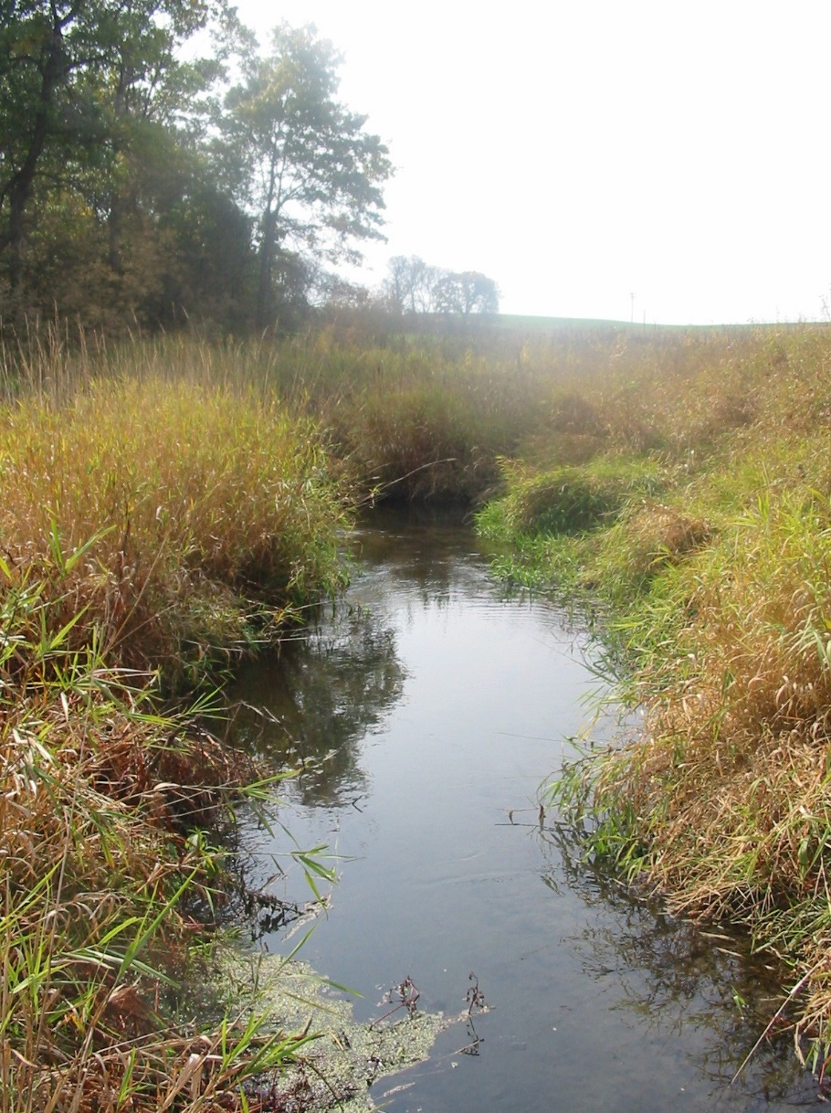

West Branch Sugar River downstream of CTH G

By James Amrhein

Southern District Water Quality Biologist

May, 2018

Background

The West Branch of the Sugar River rises near the southwest limits of the Village of Mount Horeb and proceeds southeast for 21 miles where it flows into the Sugar River just upstream from Lake Belleview. It drains 66.6 square miles of southwest Dane County and has a gradient of 7.5 feet per mile (WDNR, 1985). The Mount Horeb wastewater treatment plant is the only permitted facility and discharges effluent to the headwaters of the West Branch Sugar River. While the upper watershed is receiving development pressure, most of the stream flows through agricultural lands.

The stream is currently classified as a limited forage fishery from its headwaters downstream 2 miles. The next 11 miles, from Barton Road to State Highway 92, are a default warm water forage fishery. The next 5.5 miles from Mount Vernon Creek to County Highway PB are classified as a cold-water Class II trout fishery. The final 2.5 miles from Highway PB to the mouth is considered a default warm water sport fishery. In 1998, three segments of the river were put on the state’s list of impaired waters due to severe nonpoint source pollution causing a failure to meet its potential. The stream was impacted by streambank erosion, overgrazed pastures, unrestricted cattle access, barnyard runoff, gully erosion, and sediment deposition from uplands, all of which resulted in the destruction of in-stream habitat.

However, the department recognized that, except for the lower 2.5 miles, the rest of the stream had the potential to be a cold water, trout fishery (WDNR, 2004a). Historical fisheries surveys showed that the lower reaches of the West Branch were inhabited by warm water species such as carp, black crappie, white sucker and a variety of eurythermal minnows. From 3 to 8 miles above the mouth, brown trout became more predominant, and other cool and cold-water indicator species such as brook lamprey and mottled sculpin were found. Above mile 10.3 (County Highway U), only forage fish were found and most of those were eurythermal, tolerant species such as white sucker, creek chubs and fathead minnows (WDNR, 2004b).

The Dane County Land Conservation Department started working with landowners in the 1970s to change cropping practices to reduce erosion and prevent animal waste from entering streams. This project was successful at putting a number of conservation practices on the landscape. In 1997, a watershed assessment showed that the numbers of intolerant coldwater species had increased over the past 20 years. This was likely an indication that the best management practices placed on surrounding lands improved groundwater flows to the river and further indicated the its potential as a coldwater fishery (Ibid).

Despite the improvement in overall water quality of the West Branch Sugar River, in-stream habitat surveys indicated that the habitat above State Highway 92 still suffered from environmental degradation. The main problems were steep, highly eroded banks, shallow depth, and heavy deposits of silt. So, while intolerant coldwater species had increased, eurythermal tolerant species such as white suckers and creek chubs were still predominant at most segments and habitat was lacking to sustain many top-level carnivores such as brown trout (Appendix 1).

#### Stream Rehabilitation and Environmental Response

In 1999, work began to improve the riparian corridor and habitat of the stretch of the West Branch Sugar River above State Highway 92. From 1999 to 2002, the Dane County Land Conservation Department worked with landowners along 12 miles of the stream to install riprap and fencing as well as shaping, seeding, and stabilizing the banks of the river. The rehabilitation project removed most of the undesirable trees. The banks were sloped back at a 3:1 ratio to allow the river to over-top onto its floodplain during high water events. The banks were riprapped at the toe (edge) and seeded, thus establishing grasses with good root structure to preserve bank integrity. This also provides a buffer to help mitigate runoff from the surrounding agricultural fields. The river was narrowed in appropriate places to increase flow, flushing the soft sediment out of the channel and reestablishing a gravel bottom which is essential to trout reproduction. Habitat structures such as Little Underwater Neighborhood Keepers Encompassing Rheotactic Salmonids (LUNKERS) were placed in bends on the stream and rock weirs were used on straight sections to create plunge pools for generating deeper water areas.

Before

After

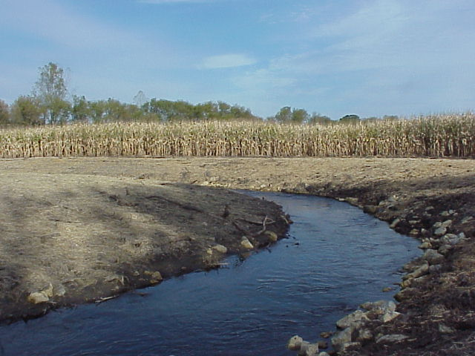

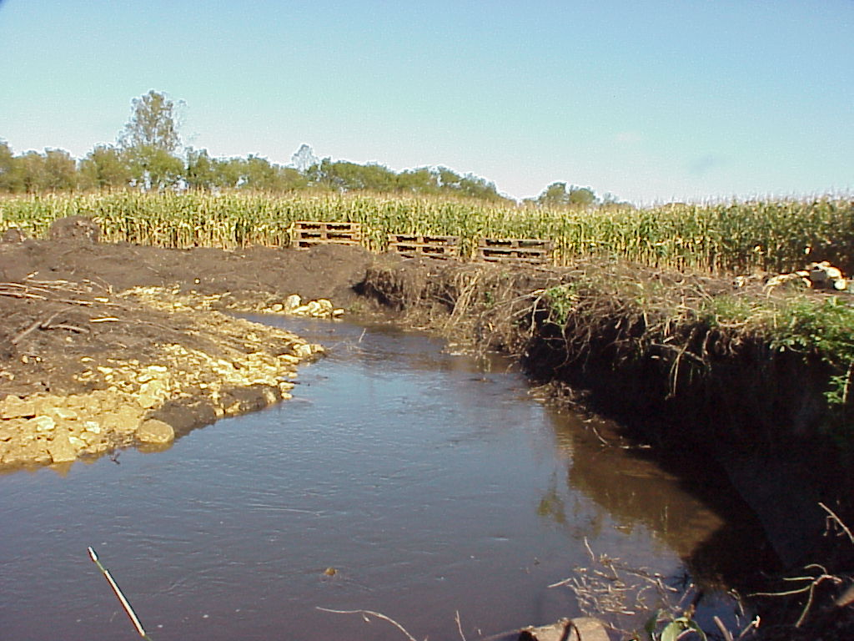

Post-rehabilitation monitoring of the fishery and habitat was conducted in 2002 and 2003. The monitoring showed a dramatic increase in overall habitat scores and an improvement in the fish assemblage (WDNR, 2004b). Overall, the stream improved to the point it was meeting its attainable use. In 2004, the Department was granted approval from EPA to remove the West Branch Sugar River from the impaired waters list. In February 2005, the stream suffered a fish kill due to runoff of manure. While hundreds of trout died, it was not a complete kill and the stream was able to recover. In 2008, fisheries management extended the Class II trout water designation from STH 92 up to the headwaters.

**2017 Fish and Habitat Survey**

In response to anecdotal reports from anglers and trend surveys showing a decrease in the number of trout in the West Branch Sugar River, Southern District water resources personnel conducted a survey of the stream to determine contemporary conditions from both a habitat and fish population standpoint. Biologists attempted to repeat the stations (locations and survey lengths) from previous studies conducted in the early 2000’s as much as possible. This would provide an opportunity to compare information from 15 years ago to determine what, if any, changes have occurred, to determine if the stream was no longer meeting its attainable use, and possible causes if this condition should exist.

Methods

The 2017 survey was conducted on 12 sites along the stream (Figure 1). Sites were selected based on previous studies. Biologists were unable to conduct sampling at STH 92 due to high water levels that existed throughout the field season. The fisheries assemblage was determined by electroshocking a section of stream with a minimum station length of 35 times the mean stream width (Lyons, 1992) or based on previous station lengths. A stream tow barge with a generator and two probes was used at most sites. A backpack shocker with a single probe was used at sites generally less than 2 meters wide. All fish were collected, identified, and counted. All gamefish were measured for length. At each site, qualitative notes on average stream width and depth, riparian buffers and land use, evidence of sedimentation, fish cover and potential management options were also recorded. A qualitative habitat survey (Simonson, et. al., 1994) was also performed at each site. Four sites were chosen to conduct a quantitative habitat analysis (Ibid) for comparison with previous studies.

**Figure 1**: West Branch Sugar River 2017 Survey Sites



Fisheries management also has 2 stations on the West Branch River where they conduct annual trend monitoring surveys to look at trout populations, size distribution, and condition. They have also deployed continuous temperature monitors to record hourly water temperatures at those same 2 sites. Macroinvertebrate samples were obtained by kick sampling and collecting using a D-frame net at 4 sites on the stream in fall, 2017 and sent to the University of Wisconsin-Stevens Point for analysis.

Results

The results of the fisheries surveys are summarized in Table 1. Because the Wisconsin Streams model (Lyons, 2008) predicted most of the waters for the stream to be cold or cold transitional, the cold water IBI (Lyons, et. al., 1996) and coolwater IBI (Lyons, 2012) were applied where appropriate.

Brown trout were found at all sites in the survey. Brown trout found exclusively at Docken Road. Brown trout and mottled sculpin, both coldwater indicator species, were predominant species found at Barton Road and all sites downstream from there. As one proceeded below CTH JG, white suckers also became more predominant. Brook trout were found at 7 sites, albeit in low numbers save for the two Haag properties. Several other species appear at Primrose Center Road and County Highway U, but in very low numbers.

Qualitative habitat surveys (Table 2) were conducted at all sites and ranged from 43 (fair) to 78 (excellent). Overall the riparian buffer, width-to-depth ratio and fish cover scores were consistently good to excellent. There was a general lack of pools, and the riffle/bend scores were fair (5) to good (10). Bank erosion and fine sediment scores were the most variable and not necessarily correlated with each other. Quantitative habitat surveys (Table 3) were conducted at CTH JG (where no rehabilitation was performed) and at CTH G and CTH U. The overall quantitative habitat scores correlated fairly well with the qualitative ones for these sites. The quantitative scores ranged from 55 to 70 for a “good” rating.

Continuous temperature monitoring data collected at CTH G in 2016 and 2017 and at STH 92 in 2016 are shown in Appendix 2

Macroinvertebrates collected in fall were analyzed and the macroinvertebrate IBI (MIBI) developed by Weigel (2003) and the Hilsenhoff Biotic Index (HBI) (Hilsenhoff, 1987) were applied to the data. As shown in Table 4, the MIBI ranged from 1.8 (poor) to 4.3 (fair) on the West Branch Sugar, in comparison to the 6.7 (good) value taken from an unnamed tributary (887300). The HBI scores ranged from 4.5 (very good) to 5.8 (fair) on West Branch Sugar in comparison to 3.5 (excellent) on the unnamed tributary.

Discussion

The 2017 study was conducted to look at the fishery and habitat of the West Branch Sugar River some 15 years after completion of a major stream rehabilitation project. There had been anecdotal reports that the fishery was in decline and data from fisheries management indicated a reduction in numbers of trout based on annual surveys conducted from 2013 through 2015 at their trend monitoring site. There were also anecdotal reports that the habitat was also in decline.

As Table 1 showed, the 2017 survey indicates the stream generally reflects the cold-water resource it’s purported to be. The species assemblage reflects a cold to cold transitional one with several coldwater indicator species (brook trout, brown trout and mottled sculpin) that are present in good numbers. Brook trout and mottled sculpin are also considered intolerant species (Lyons, et. al., 1996). The coldwater IBI indicates a fishery in good health from Lewis Road and sites upstream. The presence of numbers of white suckers at sites downstream from that point depresses the score somewhat. It should be

**Table 1**: Fisheries Assemblage, Natural Community Analysis, and IBI for sites on the West Branch Sugar River - 2017



**Table 2**: Qualitative Habitat Surveys of the West Branch Sugar River - 2017



**Table 3**: Quantitative Habitat Analysis for Select Sites on West Branch Sugar River: Pre- and Post-rehabilitation



**Table 4**: Macroinvertebrate Data for Sites in the West Branch Sugar River Watershed



noted that even the presence of large numbers of mottled sculpin will limit the overall IBI score because they lower the metric associated with percentage of top level predators. Compared to pre-rehabilitation, the coldwater IBI shows improvement (Appendix 3). Natural community verification (Lyons, 2015) shows these downstream sites to transition back and forth between cold and cold transitional (cool-cold). However, the resource still majorly reflects a coldwater community in that it is very limited in numbers of species and the most prevalent ones are coldwater indicators (Lyons, et. al., 1996). The brook trout, Wisconsin’s only native trout, have been stocked since 2015. They were present in limited numbers in this survey and considered to be more sensitive to water quality issues than brown trout.

A comparison of numbers of brown trout from this survey compared to the post-rehabilitation monitoring conducted in 2002 and 2003 shows the total numbers and catch per unit effort (normalized to trout/mile) to be greater in 2017 than from previous surveys at the same sites in the early 2000’s (Table 5).

**Table 5**: Catch Per Unit Effort (Trout per Mile) Brown Trout



Weather conditions, angler harvest, and stocking rates can all play a role in determining fish populations and size structure. The trend site at CTH G shows that brown trout numbers as normalized for catch per unit effort (trout/mile) for most size classes fluctuate annually. Beginning in 2013, trout numbers dropped substantially and remained lower through 2015 (Figure 2). This trend may have resulted in the anecdotal reports of lower trout numbers in the stream. The reduction in population was likely due to drought conditions in 2012 followed by unusually cold winters in 2012/13 and 2013/14 and was noted in other trout streams throughout the region (David Rowe, fisheries supervisor, personal communication). In the past 2 years, numbers have rebounded to pre-2013 levels.

Length/Frequency data for the surveys conducted in 2017 show multiple year classes present at most sites (Appendix 4). As is typical for most waters, there are more 2-3-year-old fish than others. The size distribution then gradually declines as older fish are taken out of the system either by angling or natural mortality. The West Branch Sugar River has been stocked periodically with brown trout, but has not received browns since 2015. This survey showed the presence of 2-4-inch specimens, which are typically sizes of young-of-the-year fish. This would indicate that some natural reproduction is occurring in the stream, primarily at upstream sites and presumably because habitat favorable for brown trout spawning is more prevalent at these sites. Fisheries management believes the West Branch Sugar River is now functioning as a Class 1 brown trout stream (David Rowe, personal communication).

**Figure 2**: Brown Trout at CTH G - Catch per Unit Effort Based on Size Class

Qualitative habitat assessments were done on all sites and quantitative habitat assessments conducted on a subset of sites in 2017. Qualitative habitat assessments showed a range of “fair” to “excellent” sites, with most falling in the “good” range. Overall, the riparian buffer is excellent, some due to a natural condition of woods or grassland along the stream corridor. Some is also due to the easements secured when the rehabilitation took place. The width-to-depth ratio was also good to excellent. Again, this was a natural phenomenon upstream of Lewis Road, but some stream narrowing took place during the rehabilitation downstream from there. Pools are lacking and riffles are generally scarce throughout the length of the stream, save for the headwaters at Docken Road; however, bends are quite prevalent in some stretches as the stream meanders back and forth through its floodplain. The rehabilitation project followed the natural meandering of the stream and did not attempt to augment it in any way.

Fish cover varied by segment. Docken Road had the least cover as the stream was wide and shallow. This site’s water depth generally varied from a few inches to a foot deep in places. However, the bottom is all rock owing to the number of high velocity events that scour out this high gradient area. There is a perched culvert at Docken Road. Fish cover improves downstream from this point, except at Lewis Road. Biologists noted the segment upstream of CTH JG is a nice, natural looking section of stream, with nice riffle/run complexes, overhanging vegetation, and deep corners. From the Haag properties on downstream, habitat structures (LUNKERS, vortex weirs, and rock) were placed in the stream to enhance fish cover.

Bank erosion was fair to good along most section of stream. However, biologists noted the erosion score didn’t always reflect the amount of lateral recession that has occurred in some portions of the stream, particularly on outside bends. They noted that many of the habitat structures were 30 – 40 cm deeper (under the water’s surface) than when they were originally installed. This may be due to slumping of the structures over time, having to endure the floods of 2007 and 2008, or the possibility that baseflows are higher now than when rehabilitation took place. For whatever reason, some LUNKER structures have sunken or collapsed, and lateral recession of the banks – 1 to 1.5 meters in some places - have occurred to the point where some structures are now in danger of being cut behind by the stream. The department should work with the Dane County Land and Water Resources Department to address this issue.

When the department first added the West Branch Sugar River to the state’s 303(d) list of impaired waters in 1998, it was because of habitat loss due to excessive sedimentation. The quantitative habitat surveys conducted post-rehabilitation showed some improvement in amount of sediment. As shown in Table 3, while the actual percent fine sediment score may not reflect it, a look at the actual amount of fine sediment present is dramatically lower. For instance, prior to the project, fine sediment made up 86% of the stream bottom at the downstream CTH U site in the year 2000. The year after the project, that amount had been reduced to 70%. In 2017, biologists found fine sediment only made up 21% of the stream bottom. The same held true for the station at STH 92 where fine sediment dropped from 90% to 56% in the year after the project was completed. Qualitative habitat surveys showed fine sediments to be fairly low at most sites, and biologists noted bottom substrate primarily contained gravel, with some boulders and rubble cobble, with areas of sand and silt. This observation would be consistent with the score of “good” for most sites.

Temperature data was collected hourly at CTH G in 2016 and 2017 and at STH 92 in 2016 by fisheries management. Table 5 shows water temperatures at CTH G fall into the cold range as defined by the maximum daily mean, summer (June-August) mean, and the July mean (Lyons, et. al., 2009). The site at STH 92 shows temperatures to be in the low end of the cold transitional range. This is similar to the natural communities found at these 2 sites (note: STH 92 was not surveyed for this study due to high water levels, but past data has confirmed this site as cool-cold).

The macroinvertebrate community as defined by the MIBI was depressed, a possible indication that there are stressors in the watershed which are affecting water quality and habitat quality. The upper portions of the West Branch, as indicated by the site at Docken Road, are impacted by nonpoint issues related to increased urbanization by the Village of Mount Horeb. This aspect, combined with the limited flows and flashy nature of this headwater area may contribute to lower macroinvertebrate quality. The stream also receives wastewater between Docken Road and Barton Road. Downstream from there, most of the additional inputs of nutrients, as well as sediment, are in the form of nonpoint source pollution from agricultural operations. Compared to historical macroinvertebrate data (WDNR, unpublished data), the 2017 data shows little difference between historic MIBIs, which generally ranged from 2 to 5 (poor to fair). Even though direct comparison of sites is limited, overall there did not appear to be the positive response by the macroinvertebrate community to the riparian habitat improvement work that there was with the fishery community. This is somewhat interesting because Weigel (2003) found localized stressors were of greater importance to explain the IBI in the driftless area than in other parts of the state. It can by hypothesized that the riparian stream work, and corresponding scouring of sediments, creation of a riparian buffer, and reduction in sediment load due to bank stabilization would lend themselves to improved habitat for macroinvertebrates just as they did for fish. In comparison to a smaller tributary (887300) which has a smaller watershed and no point source inputs, but similar hydrology and land use, the macroinvertebrate community of the West Branch is certainly more impacted. The reason for this cannot be explained by this study. The HBI, however, indicates only slight organic inputs.

**Table 5**: Comparison of Temperature Data, Modeled Community and Verified Community



Conclusions and Recommendations

Based on the 2017 survey, the West Branch Sugar River continues to meet its attainable use as a cold water system. Although the Wisconsin Streams model shows the system to transition back and forth from a cold to a cold-transitional system, it could easily be argued that the entire stream is a cold water resource based on the community and actual water temperature data collected on various sites along the stream. The concern over degradation of the fishery does not appear to be founded. Trout populations appear to be well above pre- and post-rehabilitation numbers from the early 2000’s surveys. It is reasonable to assume the reported lower numbers of trout were due to extreme weather phenomena that occurred between 2012 and 2014. While brown trout stocking was ceased in 2015, populations are not declining and there is evidence of natural reproduction. In fact, fisheries management believes the West Branch is functioning as a Class I brown trout stream. Now that brook trout are being stocked in the system, it will be interesting to see if their populations continue to increase in the stream.

While the overall habitat continues to be good, there are causes for concern with the status of some areas of the rehabilitation project – most notably erosion of outside bends and degradation of LUNKER structures. These may be due to higher baseflows than what existed during installation. *The DNR should work with the Dane County Land and Water Resources Department to address these issues.*

*The Department should also work with land owners, the county and other interested groups to see if there are opportunities to conduct stream rehabilitation upstream of the Haag properties and the segment upstream of Lewis Road.*

*The department should update its water resources designation to match the fisheries designation for the creek. The West Branch Sugar River should be considered a cold water resource from CTH PB upstream to its headwaters*.

References:

Hilsenhoff, William L. 1987. An Improved Biotic Index of Organic Stream Pollution. The Great Lakes Entomologist. 20: 31-39.

Lyons, John. 1992. Using the Index of Biotic Integrity (IBI) to Measure Environmental Quality in Warmwater Streams of Wisconsin. United States Department of Agriculture. General Technical Report NC-149.

Lyons, John, L.Wang, and T. Simonson. 1996. Development and Validation of an Index of Biotic Integrity for Coldwater Streams in Wisconsin. North American Journal of Fisheries Management 16:241-256.

Lyons, John. 2008. Using the Wisconsin Stream Model to Estimate the Potential Natural Community of Wisconsin Streams (DRAFT). Wisconsin Department of Natural Resources Fish and Aquatic Life Research Section. November, 2008.

Lyons, John. T. Zorn, J. Stewart, P Seelbach, K Wehrly, and L. Wang. 2009. Defining and Characterizing Coolwater Streams and Their Fish Assemblages in Michigan and Wisconsin, USA. North American Journal of Fisheries Management. 29:1130-1151.

Lyons, John. 2012. Development and Validation of Two Fish-based Indices of Biotic Integrity for Assessing Perennial Coolwater Streams In Wisconsin, USA. Ecological Indicators 23 (2012) 402-412.

Lyons, John. 2015. Methodology for Using Field Data to Identify and Correct Wisconsin Stream “Natural Community” Misclassifications. Version 5. May 29, 2015.

Simonson, Timothy D., J. Lyons, and P.D. Kanehl. 1994. Guidelines for Evaluating Fish Habitat in Wisconsin Streams. U.S. Department of Agriculture. Forest Service. General Technical Report NC-164.

WDNR. 1985. Surface Water Resources of Dane County. Elizabeth Day, Gayle Grzebieniak, Kurt Osterby, Clifford Brynildson. Wisconsin Department of Natural Resources Lake and Stream Classification Project. Madison, WI.

WDNR. 2004a. State of the Basin Report: Sugar and Pecatonica Rivers Basin. March 2004. James Amrhein. Wisconsin Department of Natural Resources. South Central Region Headquarters.

References (continued):

WDNR. 2004b. Rehabilitation of the West Branch Sugar River – A Documentation for Removal from the State of Wisconsin List of Impaired Waters. Wisconsin Department of Natural Resources. South Central Region. April, 2004.

Weigel, Brian. 2003. Development of Stream Macroinvertebrate Models That Predict Watershed and Local Stressors in Wisconsin. Journal of the North American Benthological Society. 22(1): 123-142.

**Appendix 1**: Species List and Coldwater IBI – West Branch Sugar River - 1997

|  |  |  |  |  |  |
| --- | --- | --- | --- | --- | --- |
| Species | Fritz Road | STH 92 | CTY U | Primrose Ctr | CTY G |
| Brown Trout | 17 | 35 | 23 | 7 | 11 |
| Mottled Sculpin | 21 | 11 | 135 | 186 | 988 |
| White Sucker | 51 | 64 | 100 | 53 | 405 |
| Creek Chub | 21 |  |  | 6 | 11 |
| Rainbow Trout |  |  | 1 |  |  |
| Bluntnose Minnow | 6 |  |  |  |  |
| Central Mudminnow | 2 |  |  |  | 6 |
| Common Carp | 23 | 11 |  |  |  |
| Northern Hogsucker | 1 |  |  |  |  |
| Shorthead Redhorse | 1 |  |  |  |  |
| Green Sunfish | 2 |  | 1 |  |  |
| Bluegill |  |  |  | 1 |  |
| Brook Stickleback |  |  |  |  | 2 |
| Coldwater IBI | 10 (Poor) | 20 (Poor) | 20 (Poor) | 20 (Poor) | 20 (Poor) |

**Appendix 2**: Temperature Data for West Branch Sugar River

Appendix 2: (continued)

**Appendix** **3**: Species Assemblage and Coldwater IBI at Various Sites on the

West Branch Sugar River Pre- and Post-rehabilitation

|  |  |  |  |  |  |
| --- | --- | --- | --- | --- | --- |
|  | 2000 | 2001 | 2002 | 2003 | 2017 |
| 1) State Highway 92 | | | | |  |
| Brown Trout | 40 | 7 | 20 | 35 | N/A |
| Rainbow Trout |  |  | 3 | 0 |  |
| Mottled Sculpin | 6 | N/A | 96 | 145 |  |
| American Brook Lamprey | 0 | 0 | 2 | 2 |  |
| White Sucker | 180 | N/A | 96 | 147 |  |
| Bluntnose Minnow | 0 | N/A | 0 | 133 |  |
| Coldwater IBI | 20 (Poor) | N/A | 30 (Fair) | 20 (Poor) |  |
|  |  |  |  |  |  |
| 2) Ralston’s #2 | | | | |  |
| Brown Trout | 49 | 27 | 33 | 26 | N/A |
| Rainbow Trout | 1 | 1 | 6 | 0 |  |
|  |  |  |  |  |  |
|  |  |  |  |  |  |
| 5) Downstream CTH U | | | | |  |
| Brown Trout | N/A | 6 | 48 | 19 | 32 |
| Brook Trout | N/A | 0 | 4 | 1 | 0 |
| Rainbow Trout | N/A | 2 | 7 | 0 | 0 |
| Mottled Sculpin | N/A | 52 | 205 | 356 | 125 |
| American Brook Lamprey | N/A | 0 | 0 | 2 | 0 |
| White Sucker | N/A | 191 | 177 | 101 | 43 |
| Coldwater IBI | N/A | 30 (Fair) | 40 (Fair) | 40 (Fair) | 40 (Fair) |
|  |  |  |  |  |  |
| 6) Upstream CTH U | | | | |  |
| Brown Trout | N/A | N/A | 40 | 14 | 46 |
| Brook Trout | N/A | N/A | 3 | 1 | 1 |
| Rainbow Trout | N/A | N/A | 2 | 0 | 0 |
| Common Carp | N/A | N/A | 0 | 0 | 1 |
| Common Shiner | N/A | N/A | 0 | 0 | 1 |
| Creek Chub | N/A | N/A | 0 | 0 | 2 |
| Mottled Sculpin | N/A | N/A | 30 | 122 | 28 |
| White Sucker | N/A | N/A | 60 | 74 | 24 |
| Coldwater IBI | N/A | N/A | 50 (Fair) | 40 (Fair) | 50 (Fair) |

Shaded areas indicate pre-rehabilitation monitoring Appendix 3 (continued):

|  |  |  |  |  |  |
| --- | --- | --- | --- | --- | --- |
|  | 2000 | 2001 | 2002 | 2003 | 2017 |
| 7) Upstream Primrose Center Road | | | | |  |
| Brown Trout | N/A | N/A | 10 | 9 | 41 |
| Brook Trout | N/A | N/A | 0 | 0 | 2 |
| Rainbow Trout | N/A | N/A | 2 | 0 | 0 |
| Mottled Sculpin | N/A | N/A | 87 | 346 | 364 |
| Shorthead Redhorse | N/A | N/A | 0 | 0 | 1 |
| Black Bullhead | N/A | N/A | 0 | 0 | 1 |
| White Sucker | N/A | N/A | 85 | 127 | 127 |
| Creek Chub | N/A | N/A | 0 | 0 | 1 |
| Coldwater IBI | N/A | N/A | 10 (Poor) | 20 (Poor) | 40 (Fair) |
|  |  |  |  |  |  |
|  |  |  |  |  |  |
| 8) Upstream County Highway G | | | | |  |
| Brown Trout | N/A | 15 | 23 | 14 | 35 |
| Brook Trout |  | 0 | 0 | 0 | 2 |
| Mottled Sculpin | N/A | 256 | 253 | 199 | 33 |
| Fathead Minnow |  | 0 | 0 | 0 | 1 |
| White Sucker | N/A | 265 | 173 | 138 | 62 |
| Bluntnose Minnow | N/A | 27 | 0 | 213 | 0 |
| Coldwater IBI | N/A | 20 (Poor) | 20 (Poor) | 10 (Poor) | 50 (Fair) |
|  |  |  |  |  |  |
|  |  |  |  |  |  |
| 10) Upstream L. Haag Bridge |  |  |  |  |  |
| Brown Trout | N/A | 4 | 27 | 13 | 88 |
| Brook Trout | N/A | 0 | N/A | 0 | 10 |
| Mottled Sculpin | N/A | 126 | N/A | 92 | 104 |
| White Sucker | N/A | 98 | N/A | 131 | 173 |
| *Coldwater IBI* | N/A | 20 (Poor) | N/A | 20 (Poor) | 50 (Fair) |

Shaded areas indicate pre-rehabilitation monitoring

**Appendix 4**: West Branch Sugar River 2017 Brown Trout Frequency by Site



Appendix 4: Continued

