# SCOPE OF WORK

***Project Title:*** Milwaukee Estuary Area of Concern Baseline Wildlife Population Assessment

***Project Manager:***

Julia Robson – Assistant Natural Areas Coordinator

Milwaukee County Department of Parks, Recreation and Culture

9480 Watertown Plank Road

Wauwatosa, WI 53226

Office Phone: (414).257.8081

Cell Phone: (414).659.4229

Email: [Julia.Robson@milwcnty.com](mailto:Julia.Robson@milwcnty.com)

***Project Signatory Name:***

John Dargle, Director

Milwaukee County Department of Parks, Recreation and Culture

**NOTE: Send project agreement to Project Manager (Julia Robson), but John Dargle as signatory**

**DUNS #:** 172896383

***Project Description and Background:***

This is the third, and final, year of a three year project to conduct wildlife surveys to support setting habitat restoration priorities within the Milwaukee Estuary Area of Concern (AOC). The project area (Figure 1) is home to a wide variety of wildlife occupying a densely urban setting, with more than 50 species listed by the State of Wisconsin as endangered, threatened or special concern.

Work will build upon data mining activities conducted during the target refinement study completed by Dr. Gary S. Casper (UWM Field Station) and baseline wildlife assessments implemented during 2014 and 2015. The year 1 baseline surveys targeted areas with known data gaps, while years 2 and 3 will target areas with data gaps found through the data mining component. This project will lead to identification of specific projects that, once implemented, will lead to the eventual removal of the wildlife component of the Degraded Fish and Wildlife Populations impairment for the AOC.

Baseline data collection is essential for first understanding existing conditions in order to plan for restoration of appropriate species richness. Inadequate biotic inventories can and do result in real harm, as sensitive species existing on parcels can be overlooked, populations impacted during restoration activities and species fail to recolonize restored habitats. Therefore it is of utmost importance that the baseline surveys be conducted in a statistically rigorous fashion to reduce the possibility of false negatives.

The baseline data collection effort, combined with the historical data review will allow the Milwaukee Estuary AOC Fish and Wildlife Tech Team to identify focal species for habitat restoration planning and spatial analysis of how wildlife populations can best be recovered and persist through restoration work and/or recolonization.

***Project Location:***

The project area for this three-year effort is defined as suitable habitat on land owned by Milwaukee County Parks along portions of the Little Menomonee River, Menomonee River, Milwaukee River and their tributaries. A half-mile buffer surrounding these waterways defines the general lateral extent of the survey area, (see Figure 1).

***Proposed Work***

The Milwaukee County Park Natural Areas Program will conduct specific surveys using standardized protocols as described below and in Table 1:

1. Ephemeral ponds – revisit select 2014 ponds for hydroperiod data;
2. Aquatic funnel trapping for salamanders at 2 sites;
3. Visual encounter surveys for salamanders and other amphibians at 5 sites;
4. Aquatic egg mass surveys at 5 sites;
5. Aquatic funnel trapping for crayfish at 2 sites;
6. Cover object surveys for snakes at 1 site;
7. Migratory bird surveys at 1 site;
8. Camera surveys for mammals at approximately 3 sites.

The number and location of survey sites are subject to change based on the results of the historical literature and data review and availability of suitable habitat for surveys. Additionally, the DPRC will focus heavily on data analysis and final report preparation during 2016.

***Documentation Requirements***

* For all field work, accurate location information for survey sites, boundaries, species occurrence, etc. must be collected using GPS with 95% accuracy, so data can be used in geographic information systems, including ArcGIS 10.0. The referencing system and datum (i.e. WGS84, WTM 83/91) must be documented for all data collected.
* Species identification (with the exception of birds) must be verified through collections of voucher specimens, recordings, or photographs with minimum of 2 mega pixel resolution to the extent allowable by local, state, and federal regulations. The recordings and photographs must provide the needed information for species identification purposes (i.e. identifying marks, size, etc). This verification must be linked to collection date, time and specific location.

***Tasks and Required Deliverables***:

1. Quarterly Reports – Reports will be submitted by March 1, July 1, September 1 and January 1. Reports will identify amount expended per quarter, activities conducted, and planned activities for the following quarter, along with identification of any issues encountered (including delays or deviations from the original schedule or other setbacks) during the time and how they were addressed. Reports should be submitted to WDNR and the Milwaukee County Department of Parks, Recreation and Culture.
2. Survey Data – Survey data will be submitted in electronic format, which includes location information (i.e. lat/long, decimal degrees, etc.). Acceptable formats include, Microsoft Access or ArcGIS geo-database.
3. Project Documentation - Completed data sheets, photographs, recordings and other documentation will be submitted in the appropriate format, with electronic format preferred. Species identification verification through voucher specimens, recordings or photographs. Recordings and photographs should be of the highest available resolution and provide needed information for species identification purposes.
4. Reporting to Natural Heritage Inventory - Documentation showing that rare, threatened or endangered species observed have been reported to the WDNR Natural Heritage Inventory Program.
5. Presentations to Fish and Wildlife Tech Team - Prepare a presentation and report interim and final findings in person at a minimum of two meetings to the Wildlife Subcommittee or the Milwaukee AOC Fish and Wildlife Technical Team.
6. Prepare a final report including the following elements, working in conjunction with UWM Field Station and Fish and Wildlife Tech Team
   * + - 1. Wildlife survey results
         2. Maps of existing plant and animal communities with survey points/transects and survey areas shown. Include existing habitat mapping efforts in evaluation (i.e., SEWRPC, Milwaukee County Parks, DNR). (Per the approval of the grantor in the “Final Report: Wildlife Population Target Refinement for the Milwaukee Estuary AOC”, this deliverable was agreed to be a work in progress with development continuing into Phase 2 funding. In order to avoid the production of multiple versions, and potential use of preliminary data by other partners which could result in confusion and errors, metadata are delivered here describing the databases. Final tabular and GIS data will be made available at the end of 2016.).
         3. Comparison of historic vs. existing species richness
         4. Identify broad biological constraints limiting species richness and restoration opportunities; develop a decision support chart to determine feasible restorations
         5. Determine focal species with stakeholder input; include umbrella, keystone, and flagship species concepts
         6. Identify short list of Species of Local Conservation Interest (SLCIs) and other target species with stakeholders and list their critical habitat requirements (biological constraints) for guiding habitat restorations and decision support. Consider a wide array of species ranging from very tolerant to very intolerant as restoration targets
         7. Recommendations for goals for habitat restoration and connectivity, addressing:

AOC Beneficial Use Impairments and measures of success.

Social constraints on restoration feasibility (i.e., land ownership, existing development extents, funding levels, etc.)

Identify and prioritize specific projects that will address the BUIs of impaired wildlife habitat and populations. Projects will have a direct connection to the stream. Projects will be prioritized for maximum benefit for increasing wildlife biodiversity and/or restoring or sustaining SCLIs (such as Endangered or Threatened Species). Projects will have measures of success identified.

***Timetable:***

March 1, 2016 – February 28, 2017

Survey start times are weather dependent. General timetable listed below is subject to change depending on weather and other environmental conditions. Any changes to timing below will be through written notification from County Parks Project Manager to WDNR Project manager (email acceptable).

March 2016 – May 2016

* Aquatic funnel trapping for amphibians and crayfish
* Visual encounter and egg mass surveys for salamanders and other amphibians
* Spring migratory bird transects (April – May)
* Camera surveys for mammals

July 10, 2016 – first quarterly report due (for period March through June 30, 2016)

May 2016 – July 2016

* Snake cover object surveys
* Continue aquatic funnel trapping for crayfish
* Camera surveys for mammals

September 2016 – October 2016

* Camera surveys for mammals

October 10, 2016 – Second quarterly report due (for July-September 2016)

November 2016-January 2017

* Prepare draft report for review

January 10, 2017 – Third quarterly report due (for October-December 2016)

March 2017 – Submit final report including final tabular and GIS data in conjunction with the UWMFS.

***Project Budget***

|  |  |  |  |
| --- | --- | --- | --- |
|  | **Milwaukee County DPRC AOC Wildlife Assessment Project Budget** |  |  |
|  | **Item** |  | **Cost** |
|  |  |  |  |
|  | **County Staff Labor** |  | **$15,000** |
|  |  |  |  |
|  | **Project Total:** |  | **$15,000** |

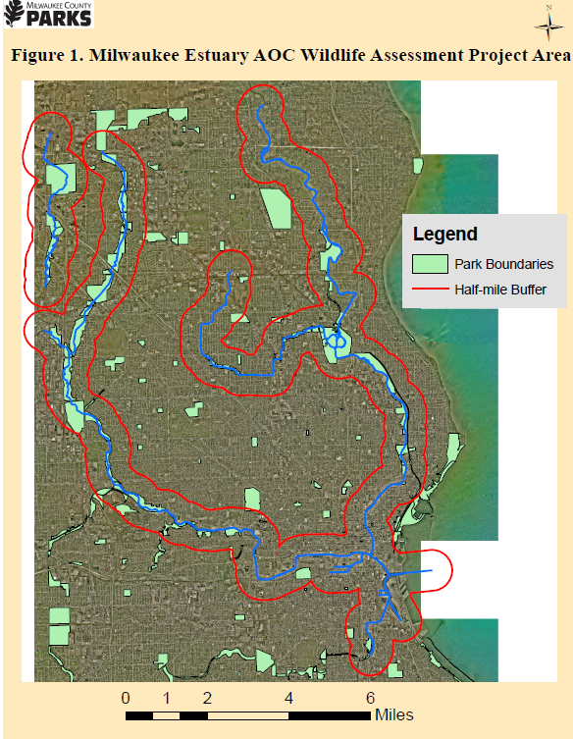

**Table 1. DPRC AOC Assessment Deliverables**

