Parkman Project part of the Desair Lake Restoration DNR Grant LPT 66920
Aug 30-Sept 19,2020
During the end of August, a permit was issued, and preparations made for construction of catchment basins at Steve and Lorie Parkman ravine. Putting small weirs (catchment basins) at the bottom of a deep ravine required a slide for materials to get to the worksite without disrupting the forest floor. At the polebarn, I found two sixteen-foot 2x6s and eight-foot corrugated steel roofing. Old plywood held it all together and several layers of plastic roadside sign material was used to make the surface slippery. It is nice to have had repurposed materials available for such a unique project. Clunky as it was, the 16’ slide could be moved around with the tractor and trailer and served its purpose well. A load of 6”x18” cobble was brought to Site #1 at the top of the ravine. After a discussion with Steve Parkman on the details of our project, we were ready to begin. Steve and his two sons, Colan and Cody were great help, but Colan got a job in Los Angeles and Cody went off to college at UMD. When he could after work, Steve’s weightlifting ability and dedicated work ethic, made the labor of placing rock much easier and faster.
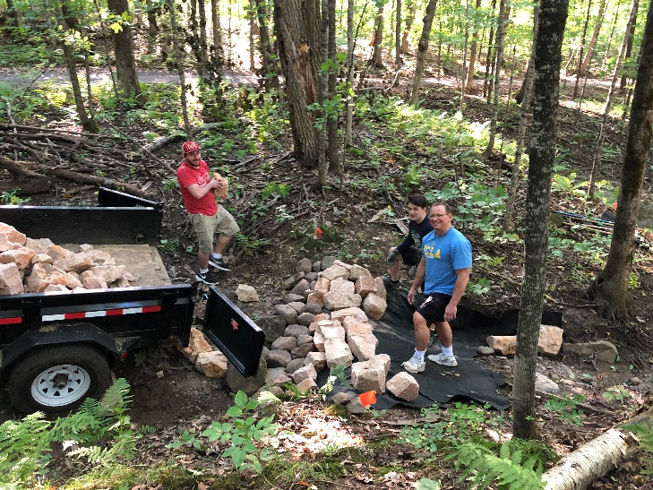
The first two basins were set just beyond their driveway culvert. With easy access and the four of us working, we put basin #1 and most of #2 in place. The ravine is largely raw clayish ground under a dense canopy of hardwood trees. Scattered fern and a few flowering plants along with woody plant debris covered the forest floor. The streambed was cutting deeper into the glacial till that made up this large hill on the south side of Desair Lake. Branches and sticks washed down by stormwater were cleared before a swale of compaction gravel was placed in the streambed and tamped solid. An 8oz ground fabric was laid over the swale and tucked into the upstream side of the bed. It was then covered with quarry rock weighing between 20-70 pounds, puzzled in with smaller rock to hold it all together under the force of rushing water.
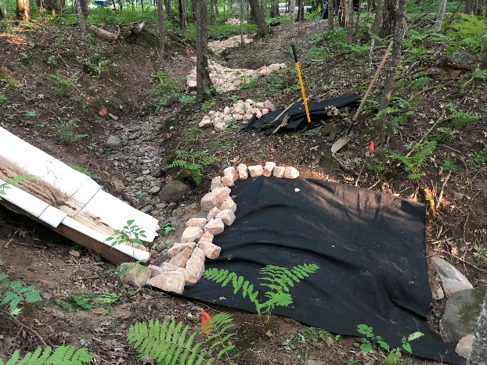
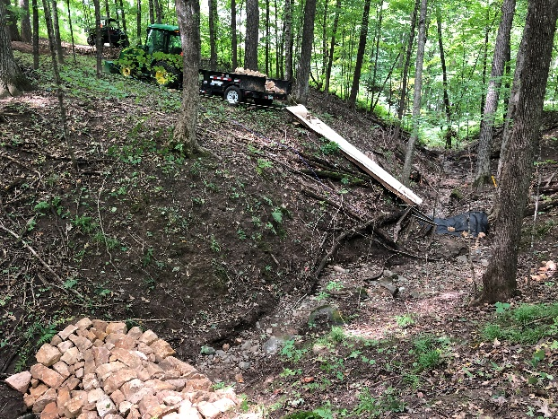
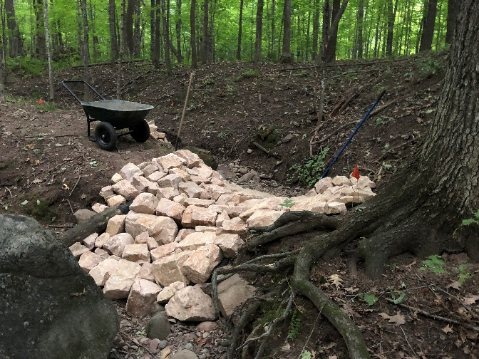
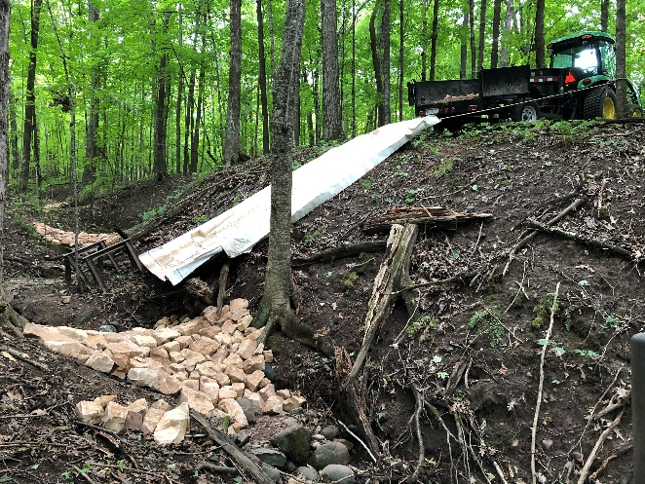
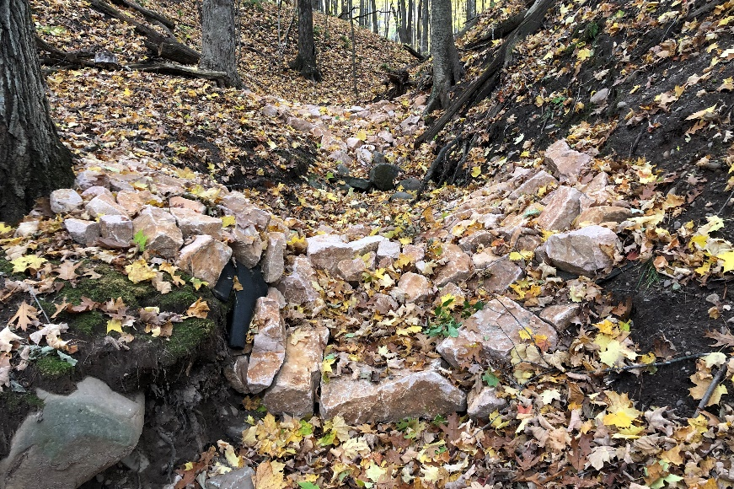
The following day, the second basin was finished with all four of us working. I hauled approximately 2 ½ tons of rock from Uchytil Flats to the bottom of 23rd Ave for each of the fourteen catchment basins. This was a 4-mile round trip with the tractor and dump trailer. Fabric had to be cut to size of each basin and gravel brought in from a nearby stockpile in preparation for construction. By the fourth basin, Site #4, the slide was put to use. I built this basin alone. A route through the woods off Linder’s driveway was chosen and the slide moved. I worked my way to the ravine’s edge using the utility tractor with turf tires having minimal impact on the topsoil. It was never disturbed except by compaction. The slide was set on sawhorses and secured to trees with rope. Gravel and rock were shoveled off the trailer or loader bucket and pushed down the slide right to the worksite. Site #5, Steve, and Cody helped as it needed to be built wider at this junction of the ravine. Nicole, our engineer, came to see the project. From her hydrology perspective we were building appropriate basins with the right design and only 2-3-foot-high spillways. Site #6 and #7 were gently sloped down from #5 but had difficult direct access. Materials for them were sent down the slide at Site #5 and transferred by wheelbarrow to #6 and #7 for placement. I built them mostly alone. To build Site #8 and #9, Steve helped me move the slide across the ravine as I could access them downhill from the Parkman driveway. This section was the steepest, just to get to the slide itself, I had to be especially careful with the equipment to keep it from rolling. The material placement and construction for Site #8 I did alone. Steve helped me redirect the slide for Site #9 and helped build the swale. I rocked it the next day. After work, Steve again helped me move the slide to Site #10. We took a few days off to let the ground dry after a slight rain. Steve and I then finished laying the rock and moved the slide to Site #11. There were more logs and debris on the lower ravine as it leveled off for a distance. Steve cleared the area where we would be working. As he was getting better and better at puzzling in the rock to interlock and prevent dislodgement, I turned over the rock laying to him while I brought materials and built the foundation of each subsequent basin, Sites #11-14. When done, I removed all our tools, examined each site to be sure there was no disturbance to the soils and thanked Steve for his very capable and powerful help placing rock. We were done with fourteen basins in twenty days and I packed for a Montana trip. The job was a challenge with special attention to minimizing disturbance to the ravine environment. It will easily recover, and we wait to see how the basins handles the next flush of stormwater.
Total cost was $7319. Engineering and permit applications was $1462, $2575 for materials, equipment and operator cost was $1604 and the rest donated work valued at $1011. I am proud of the work and know we will take some of the speed and power from rushing water, capture the sediment and protect the streambanks (and Desair Lake) from further erosion. We will see if Mother Nature agrees with this!

Rod Olson, DLR President and Project Manager

