**2011 Sheboygan River AOC Herptile Survey and Habitat Assessment**

**Conducted for the WI DNR Bureau of Endangered Resources**

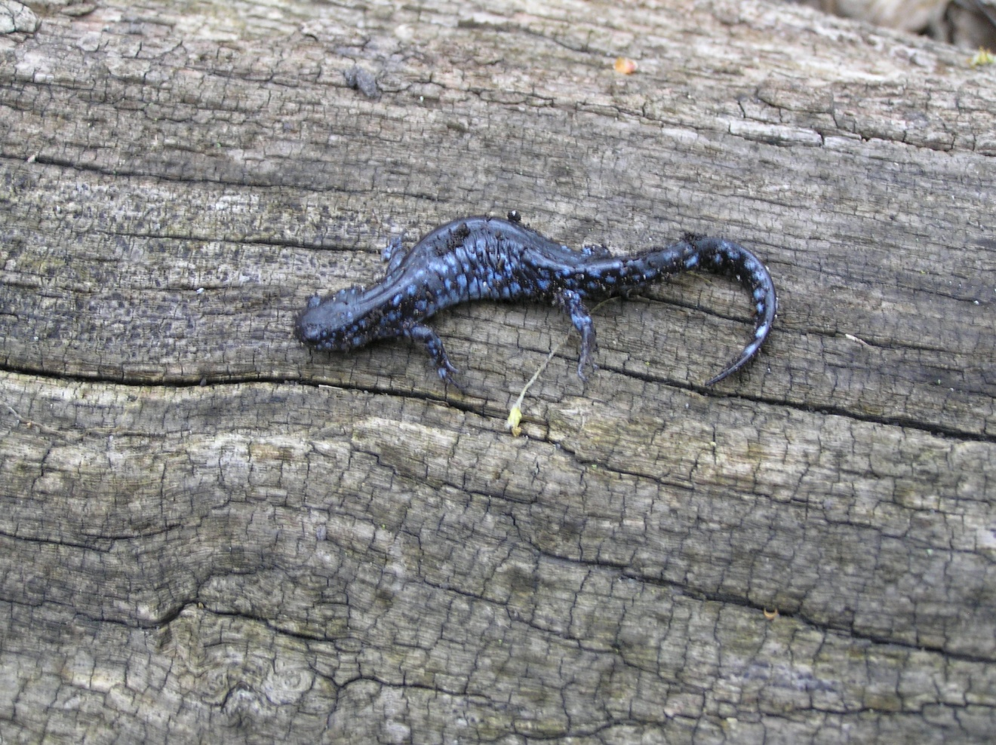

By Jason Dare

Dare Ecosystem Management, LLC

N3935 Liberty St, Sullivan, WI 53717

# Sheboygan AOC Herptile Assessment

## Introduction

A cursory inventory and habitat assessment was conducted to evaluate habitat conditions and make herptile observations on Sheboygan Area of Concern (AOC) in Sheboygan County, Wisconsin during the spring and summer of 2011. The primary purposes for conducting this work were to:

1) Evaluate existing habitat conditions, focusing on essential habitats such as nesting opportunities for rare turtles and essential breeding habitat (including Ephemeral Ponds, Springs and Seeps) for rare amphibians known or having the potential to occur along the Sheboygan River or in surrounding habitats.

2) Make management recommendations that would benefit these species. The information generated will be used to help guide the property’s recovery and restoration plan. While conducting the habitat assessment, we also surveyed the available macro and micro habitats to detect rare species, but also noted any common herps.

## Methods

2005 color aerial photos and topographic maps were reviewed to pre-determine the most likely microhabitats to assess for the rare herptiles suspected of historically or currently occurring in the vicinity of the Sheboygan AOC. A probable rare target species list for the area was generated to guide the habitat assessment and surveys (see below). The species list was generated by reviewing previous rare species records for the area, by considering the general habitat types in the area, and by overlaying species range maps that encompass the area and by including any prior knowledge of the area and site. The list was further refined by the actual field assessment and surveys. These steps allowed us to focus our attention on areas that were most likely to support the rare target species habitats. A driving survey was first conducted to determine the best access points to the various areas to be surveyed and to get a feel for the existing habitat conditions on and adjacent to the properties. The assessment and species surveys involved both wading and walking survey that were guided in part by the aerial photos and on the micro level by the observations we made. We assessed a wide variety of upland, riparian and riverine habitats. We conducted our assessments and surveys primarily on warm and sunny days with light winds but also did some surveys on rainy days, which are often best for turtle nesting. Locations of all herptile observations were recorded using a Garmin 450 GPS unit. This is a recreational grade GPS with manufacturer specs on accuracy at 5-15 meters. Visual Encounter Surveys took place at all times while doing habitat assessments. A very limited effort was put into nighttime frog calling surveys, targeting bullfrogs.

***Historical records of Herptile occurrences within Sheboygan AOC:***

Mudpuppy

Leopard Frog

Green Frog

Blue Spotted salamander

Northern Watersnake

Queen Snake: Data is questionable

Common Garter Snake

American Toad

Bullfrog  
Painted turtle

Snapping turtle

*\*\*Historical data was obtained from the following sources*:

WI Natural Heritage Inventory

WI Herp Atlas

***Target Species For Surveys and Potential Habitats within Sheboygan AOC:***

*Blandings turtle:*

*Northern Watersnake*:

*Pickerel frog*

*Bullfrog*

*Northern Cricket frog*

M*udpuppy*

*Four toed salamander*

*Spotted salamander*

*Red-backed salamander*

***Targeted Conservation Areas for Assessement:***

River wildlife (A): River wildlife lodge.

River wildlife (B): Forested area near river. Floodplain Forest and Northern Mesic Forest

River wildlife( C): Hedgerow trail system semi open cool season grassland area with isolated woodlands

River Wildlife (D): Weedens creek

River Wildlife (E): Gate 1 Wooded area and hunting reserve

River Wildlife (F): Entire property

Sheboygan Falls River Park (G):

Sheboygan Falls Settlers park (H):

Sheboygan Falls Falls Park (I):

Sheboygan Falls Rochester Park (J):

Esslinger Park (K):

Lutheran School Ponds (L):

UW- Sheboygan Lands( M):

Schugardt (N):

Island Park Industrial lands 19th st (O)

Kiwanis Park (P)

***GPS/Waypoints/ Pictures (see also excel spreadsheet)***

GPS1: Lutheran school ponds.

GPS2: Esslinger Park

GPS3: UW- Sheboygan woods.

GPS4: Riparian area of Sheboygan River within UW-Sheboygan Land. Possible area to look for cricket frogs.

GPS5: UW-Sheboygan seepage areas and ephemeral wetlands.

GPS6: Island Park 19th st. Industrial lands

GPS7: Kiwanis Park

GPS8: Schuchardt

GPS9: Schuchardt

GPS10: Schuchardt

GPS11: Rochester Park

GPS12: River Park

GPS13: Settlers Park

GPS14: River Wildlife unit C. Isolated woods and seepage area.

GPS15: River Wildlife Unit C

GPS16: River wildlife Unit B

GPS17: River wildlife Unit B. Ephemeral wetlands.

GPS18: River wildlife Unit B. Blue spotted salamander

GPS19: River Wildlife Unit B. Nice CWD. Decent amount of paper birch CWD.

GPS20: River Wildlife Unit E. Typical wooded area in (E) to south. To the east recreated prairie.

GPS21: River Wildlife Unit E. Decent mesic forest. Not as much CWD as in most of Unit B.

GPS22: River Wildlife Lodge.

GPS23: River Wildlife Lodge.

GPS24: River Wildlife Unit B. River area. Some flat rocks.

Pic 1: Settlers Park

Pic 2: Rochester Park

Pic 3: Ephemeral wetland River Wildlife Lodge

Pic 4: Blue spotted salamander River Wildlife Lodge

Pic 5: Leopard frog Kiwanis Park

Pic 6: Seepage area UW- Sheboygan

Pic 7: Snapping turtle Schuchardt land

Pic 8: Potential snake hibernacula Schuchardt land railroad track bridge.

Pic 9: Schuchardt land ephemeral wetland

Pic 10: Seepage area Schuchardt

Pic 11: Painted turtle Sheboygan falls river park

Pic 12: Blue spotted salamander River Wildlife Unit B

Pic 13: Wood frog River wildlife Unit B

## Results

***Herp Species present in 2011 Inventory: (Sites)***

*Green frogs*: F, G, H, J, K, L, M, N, O, P

*Snapping turtle*: F, G, J, L, N, P

*Toad*: F, G, I, J, K, L, M, N, O

*Eastern Common gartersnake*: F, L, N

*Blue spotted salamander*: F,

*Eastern Grey tree frog*. F, G, J, K, L, M, O, P

*Leopard Frog*. F, G, J, K, L, M, P

*Spring Peeper*. F, J, L

*Chorus frog*. F, J, L

*Painted turtles*. F, G, I, J, L, P

*Wood Frog* : F,

***Potential for species through habitat assessment and survey***

Species will be ranked based on the possibility of presence.

1Present (Field season, 2011)

2High probability

3Moderate probability

4Low probability but possible

5Possible but highly unlikely

*Blandings turtle:* F (2/3) possible moderate to high probability population will exist most likely within the Kohler lands of Black Wolf Run River Wildlife area. This entire unit has suitable habitat for this species. N(4). See report.

*Northern Watersnake*: A (2) B(2) C (4) D (2) E (2) G(4) H (4) I (3) J(2) K(2) L(3) M(2) N (2) see report. O (4) P (4).

This species has a variable probability to be present within the riparian areas of these units within the AOC.

*Pickerel frog:* A (4) B (3/4) Many seeps and seepage areas in unit. C (5) there are seeps in this area. D (5) water is cool but not cold. E (4) N (4) coming off the wooded slopes to the east are multiple seeps. I could possibly see the associated wetlands being able to harbor this species. If a search on the site was completed for this species this is where efforts should be prioritized (in the wetland seeps at the base of the wooded slope).

*Bullfrog:* (no bullfrogs were heard within the AOC in 2011. Although decent habitat for this species is present and historical data is available). A (2) oxbow, stagnant water. B (2) stagnant water. C (4) ponds. D (5). E (2). G(3) lily pad area near fishing pond. H (5) I (5) J (4) K (4) L (3) M (4) N (4) cattail ephemeral pond on parcel. O (5) P (5)

*Northern Cricket frog:* (Some spots along the Sheboygan River have suitable habitat and would be worth looking at if a focused study was done on this species. F (5) gravel beds and cobble beds on the shore and riparian area of the Sheboygan River. K (5) M (5) GPS 4 if survey was done this would be one point to check.

*Mudpuppy:* A (3) B (3) GPS 24 . D(5) where it enters Sheboygan river E (4) I (4) J (4) K (4) N (5) possibly where the stream reaches the Sheboygan river.

*Four toed salamander:* A (3) B(3) best place to look in AOC. E (3) CWD is typically smaller in diameter here than in unit B of River Wildlife area. M (5) N( 4) There are some shrubby areas with hummocks that are a possibility for this species adjacent to the Northern Mesic forest.

*Spotted salamander:* A (2/3) B (2/3) best spot to look in AOC for this species. C(5) E (2/3) M (3/4) N (3) Decent wetland with some associated upland woods. If stickleback and mud minnows are in the ephermeral wetlands I would drop this down.

*Red-backed salamander:* A (4) B(4) best spot to look for this species in the AOC. Good size and amount of CWD. E (4) M (5) N (4) There is a moderate quality Northern Mesic Forest on this property. See Schuchardt report.

## Summary

***Management Recommendations, Threats Observed, and Restoration Oppurtunities by Conservation Area:***

River wildlife (A): River wildlife lodge.

High quality Northern/Southern mesic forest (tension zone), Floodplain forest riparian area.

There is a decent amount of CWD in this unit but the maintenance crew should work to leave more in the future. They really have done a pretty good job leaving some of the larger CWD they cut up on site in place. Nevertheless they should be reminded how important these logs are while keeping the lodge area aesthetically pleasing to visitors. The staff should monitor the potential poaching and harvesting of native vegetation by visitors. On two separate occasions I saw individuals digging up plants (wild leek, and wild geranium). This activity will only promote invasive species to increase and possibly change the floristic makeup of the woods.

River wildlife (B): Forested area near river.

Floodplain forest and Northern Mesic forest (tension zone).

The unit has more spots with an adequate to great amount of CWD than spots that are lacking. In general educate the maintenance crew of the importance of fallen snags and the area should then naturally provide more fallen CWD in the future. No management actions should be taken to create more CWD in this unit. The area has a few ephemeral ponds and these should be maintained, mapped and monitored if a monitoring program is set up in the future. Within this unit and the whole Kohler River Wildlife site in general the in-stream snag density is great; no dropping of trees is needed for structure.

River wildlife( C): Hedgerow trail system semi open cool season grassland area with isolated woodlands.

GPS# 14. This area could hold some water in spring and has white cedar and yellow birch present. This little wooded refugia in an open unit will have to be protected from excessive cutting of trees. The area should be maintained as a forested refugia for herptiles. GPS # 15. The windmill pond could use some structure within the pond. The unit is a monoculture of reed canary grass with few trees to drop into the pond for structure. However, one lone black locust tree is near the pond and should be dropped and hauled into the pond in winter for structure. The tree should be poisoned as black locust can be very aggressive and undesirable.

River Wildlife (D): Weedens creek.

Try to get the golf course to leave live brush and fallen brush within the riparian area and in stream for watersnakes to bask. Obviously a better buffer would be ideal n spots but since this is a golf course that may be impossible.

River Wildlife (E): Gate 1 Wooded area and hunting reserve

The wooded portions of this unit have far less downed CWD and have been manicured a bit more than most of the wooded areas of the site. It would be worthwhile to notify the maintenance crew to leave fallen trees in this unit. It may be desirable to hire an ecologist to assess the unit for CWD density and drop a few undesirable trees. The recreated prairies that exist in the unit were probably planted for pheasant and other game species with very little thought put into what herptiles may use this. Nevertheless, the burn managers should take herps into consideration when making and executing their burn plans to minimize mortality. A good source of information is provided here. PARC ( http://mwparc.org/products/fire/) .

River Wildlife (F): entire property.

One focus for the entire parcel will be to conduct an inventory for Blandings turtles to obtain a confirmed presence within the AOC.

Sheboygan Falls River Park (G):

The lagoon/pond could use some structure within the pond. One possibility is adding some basking logs in the pond which go a long way to providing structure within the cities pond. The park is mowed up to the river and pond edge. Any buffering that can be done will provide habitat for common herp species. By simply not mowing up to the water’s edge habitat for common species will be created. If this cannot be conducted throughout most of the site, a compromise could be leaving an unmowed buffer by the white bridge near the pond and the dense lily pad area.

Sheboygan Falls Settlers park (H):

Only green frogs were heard here and the park was void of herpetofauna in general. The wooded slopes on the east side of the river should harbor more herps than the west. It’s hard to conduct calling frog surveys at the park due to car traffic and the dam. The riparian area could use more buffer, but since it is a city park it’s understandable that the area is mowed to the edge. It might be a good option or project to create rain gardens where the road outlet pipes enter the river (pic 1). Or simply leave these areas unmowed. This could provide some minor habitat for leopard frogs and other common herps while also providing a little filtration from the outlet pipes. The city park managers have left some snags in the water and that is a practice that should be maintained and encouraged.

Sheboygan Falls Falls Park (I): No management recommendations at this time.

Sheboygan Falls Rochester Park (J):

The stretch of river through this park could use more in stream snags in the river. Try to focus on box elders and cut them into the river. Behind the baseball field towards the river something has been planned to be built. This should be checked on by the coordinator because of its proximity to the river. The detention swales (pic 2) that enter the river are mowed and this could be one area that is left unmowed. This action could help water quality/ clarity and provide some habitat for common herp species. The peninsula of habitat where the Onion river meets the Sheboygan river should be a focus for future herp inventories.

Esslinger Park (K):

This is a site were mowing up to the river’s edge can be reduced and should be recommended to the municipality. The design found in (appendix 1) is a simple example of how this mowing could be done to provide more habitat for herps, reduce the amount of canadian geese, cut down on erosion, and filter surface water entering the river. The simplest action would be to provide 4-7 access points for park users to access the river. Simply have the lawn crew mower make two passes within the access point and leave the areas in-between the access points unmowed. There is not a real need to spend a ton of money on planting a riparian buffer. Just leave the area unmowed at least 8 feet or hopefully more from the river’s edge.

Lutheran School Ponds (L):

Both ponds could use more of a buffer around them. Of the two, Myrtles pond needs four to five more feet of unmowed buffer towards the ball fields. The larger pond (north side of University dr) needs more structure within the water for basking turtles and as refugia for herp species. To do this have the maintainance workers at UW –Sheboygan take tree limbs they have to cut up on campus and place them over the ice in the winter months near the shore but in the water. The other possible option would be to drop a few aspen into the pond as structure for various herp species to use. The Aspen will quickly regenerate as the individual tree and clone will not die.

UW- Sheboygan Lands (M):

There are many opportunities within this unit of land the UW system owns to maintain herptile populations. The floodplain forest near the river has different ranges of quality. In general, the western half of the woods closer to the freeway is of higher ecological quality. Over all, the woods uplands of lowlands are plagued by invasive species such as garlic mustard, dame’s rocket and canada thistle among others. In the river there are spots with decent sized and density of snags. In some spots some box elders could be dropped into the stream to provide some temporary habitat for herps. This action should be developed and conducted by an ecologist. There are some seepage areas and spots within the upland woods that may hold water in the spring for herp breeding. These areas should be fishless and may be breeding areas for species like wood frogs , blue spotted salamanders and other common herps. There is a slight possibility these wetlands could provide habitat for the spotted salamander (GPS#5). These types of wetland areas could be monitored and inventoried by an ecology club or by the ecology professors at UW-Sheboygan. They are prime spots for citizen monitoring and basic education about the importance of ephemeral wetlands to take place. In general working with the universities maintainance crew will be a key action to undertake so that the uplands and wetlands can be managed accordingly and not disturbed by activities such as driving ATVs, removing downed wood, and burning coarse woody debris.

Schugardt (N): In separate report sent to Rich Staffen WI DNR BER.

Island park-Industrial lands 19th st(O)

Near Judson ct and 19th st.

Cut and drop box elders along this stretch of riparian area into the Sheboygan River to create snags for thermoregulation and refugia in-stream.

Kiwanis Park (P)

This park is mowed to the river so anywhere you can promote leaving areas unmowed will be huge improvement. Possibly develop a spot designated for the construction of a rain garden or riparian buffer demonstration plot.

***Management Recommendations for Herptiles - General to Sheboygan AOC:***

1. Monitor, manage, and preserve areas with crayfish and burrowing mammal evidence and populations: If managers see this, maintain these areas. Crayfish are often times prey for many snake species and their burrows create summer refuges and winter hibernacula for snakes and frogs. Burrowing mammals can create habitat for herps to utilize as well.

2. Focused inventories for target species: Conduct more species inventories for spotted salamander, four-toed salamander, watersnake and pickerel frog.

3. Monitoring programs for target species: Monitor populations of known species like spotted salamander, when and if presence data is obtained.

5. Forest management: Conduct timber harvest in winter when the soil in frozen. Minimize forest harvest 300 m from ephemeral ponds to minimize soil compaction. Leave downed coarse woody debris during forest restoration activities. Manage and create coarse woody debris snags that will eventually be downed CWD.

6. Recreation: Control off road vehicle use in wildlife areas. Take herps into consideration even if deer or game management is the main objective.

7. Identify, protect and maintain all hibernacula: Bridges can be hibernacula within the AOC area. An inventory should be done describing the state of these spots and potential sites. Once identified they should be monitored as bridge repair may occur. Identify and locate spots with good crayfish populations and burrowing.

8: Machinery: Operate heavy machinery in winter after frost if possible.

9. Invasive species: Limit soil compaction by using heavy machinery in winter for restoration activities like tree harvesting or brush removal. When foliar spraying, be aware of how surfactants and the potential active ingredients may impact herps. Great caution should be taken during the spring and fall migrations and during metamorphosis when individuals can be exposed to the chemicals. Read the label and do not directly spray individuals. Foliar spraying with a backpack versus an ATV or boom can cut down the potential exposure to animals. Mowing is problematic for herps. Mow when species are either underground during cold or very hot temperatures or create patchiness while mowing to create refugia.

11. Active creation of structure: Research herp species needs and create habitat for them. This can be done by cutting trees into an aquatic community for basking. Creating coarse woody debris that is 8 inches in diameter or greater. PARC puts out a great guide for managers to follow to conduct some of these activities. (<http://parcplace.org/midwest.html>). Or contact experts for guidance.

12. Restoration: Not all shrubs are bad. Along stream corridors restoration should leave native shrubs when managing so that snakes can bask. Only exotic species should be prioritized. When removing shrubs; if an area is going to be cleared at the very least leave some native shrubs for basking even if it is determined that native and non native shrubs will be removed for a particular project

13: Siltation of stream. Sections of the stream had a high level of turbidity in 2011. Look for areas where buffers can be developed and help landowners develop and maintain buffers on park and private sites.