New kayak launch installed
HTR Media5:09 p.m. CDT October 22, 2015
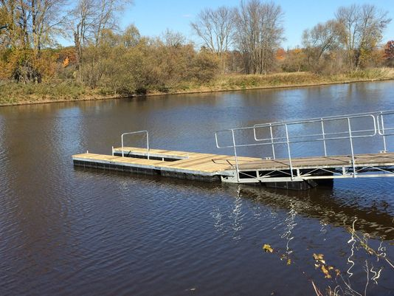
(Photo: Marcus Nesemann/HTR Media)
437CONNECT 2TWEETLINKEDIN 1COMMENTEMAILMORE
The Manitowoc Parks Department installed a new kayak launch at Lower Schuette Park Thursday, Oct. 22.
The launch will be open for use for a couple of weeks before being taken back down for the winter, said Chad Scheinoha, operations division manager of the Parks Department.
"We'll watch the weather and leave it in as long as we can before taking it out for the winter," Scheinoha said. "It'll be back in again once spring hits next year."
The launch was funded, in part, by grant money received through the Wisconsin Department of Natural Resources Knowles-Nelson Stewardship Program. Donations from the Lakeshore Natural Resources Partnership and the Friends of the Manitowoc River Watershed funded the rest of the project.
The launch is handicapped accessible.

