Vermont Creek Pre-Post BMP Evaluation Final Report
Jean Unmuth – DNR Water Quality Section
In Cooperation with Pete Jopke, Dane County Land Conservation
Assisted by UW-Platteville Students: Elliot Momchilovich, Andrew Meiborg

Overview and Methods
Vermont Creek (WBIC: 1249200) in Dane County is listed as a 303 d impaired stream for a four mile stretch from the mouth upstream and general condition is listed as poor. The stream impairments are degraded biological community and habitat and elevated stream temperatures. Pollutants listed are sediment and total suspended solids.. In 2015 we monitored to evaluate recent agricultural best management practices (BMP’s) implemented by Dane County Land and Water Resources Department between years 2008 and 2013. BMP’s practices implemented were stream bank stabilization, bank sloping and shaping, in stream habitat structures to provide cover for fish and scour holes, and culvert retrofits to allow for better passage of stream biota. The project goals were to restore biological habitat, control sediment, and reduce nonpoint source pollution, which would enhance water quality and fish habitat.
Four sites were chosen to monitor fish using towboat stream electrofishing equipment and the cool-cold water calculator used to evaluate fish for indices of biotic integrity (FIBI). Qualitative habitat assessments were completed, and scores and ratings output to determine quality of habitat. Stream flows were collected using a Marsh-Mcburney meter, and instantaneous temperature, dissolved oxygen, pH and conductivity were collected using a YSI multi-meter. Continuous instream water temperature was collected using Onset PRO V2 meters, between June 1 and October 12 at a reference site in the non-impaired stream segment, and in the impaired segment at a BMP site. Macroinvertebrates were collected at the DNR lot near Windy Acres Way and at Michaelis Road, and analyzed by the biomonitoring lab at UWSP. Macroinvertebrate Indices of Biotic integrity (MIBI’s) were calculated and evaluated to determine stream health. Dane County staff collected six total phosphorus samples and 5 total suspended solids samples at CTH-KP near the stream mouth, and samples wereanalyzed by the State Lab of Hygiene.
Fish, habitat and macroinvertebrates collected from years 2006 to 2015 at additional sites are also included in this report to evaluate stream health as a whole, and data collected over the past 5 years is used to evaluate whether the stream should be removed from the impaired list. Monitoring site locations are listed in Table 1, and shown in Figures 1 and 2. Three reference (non-BMP) sites are compared to five BMP sites, and BMP sites are compared between Pre- and- Post implementation years.

Table 1. Vermont Creek monitoring sites from downstream to upstream.
Site # | Site Name | SWIMS ID | Survey Dates | BMP or Reference Site
1 | CTY. RD. KP | 10011931 | 20-Jun-2006  7-Sep-2006 | Non-BMP
2 | PARRELL’S | 10034044 | 12-Jul-2011  21-Jul-2015 | BMP
3 | DANZ CULVERT | 10009346 | 14-Jul-2006 | BMP
4 | MICHAELIS ROAD | 10015267 | 12-Jul-2011 | BMP
4 | MICHAELIS ROAD | 10012507 | 12-Jul-2011  21-Jul-2015 | BMP
5 | CTH JJ. | 10016009 | 20-Jul-2015 | BMP
6 | COWAN PICNIC AREA | 10014195 | 20-Jun-2006 | BMP
7 | VERMONT CHURCH ROAD | 10012508 | 13-Jun-2006 | Reference
8 | DNR PARKING LOT WINDY ACRES WAY | 10009749 | 20-Jun-2006  20-Jul-2015 | Reference

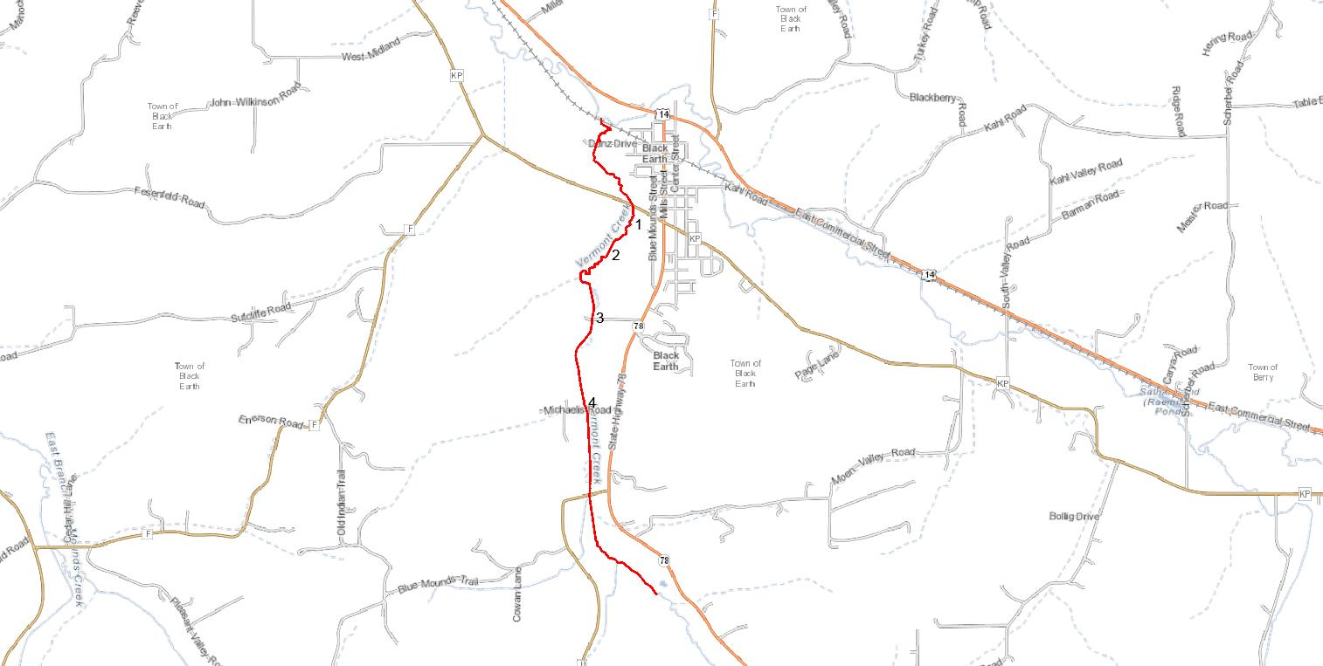
Figure 1. Vermont Creek Downstream Sites Map (red line indicates impaired segment).
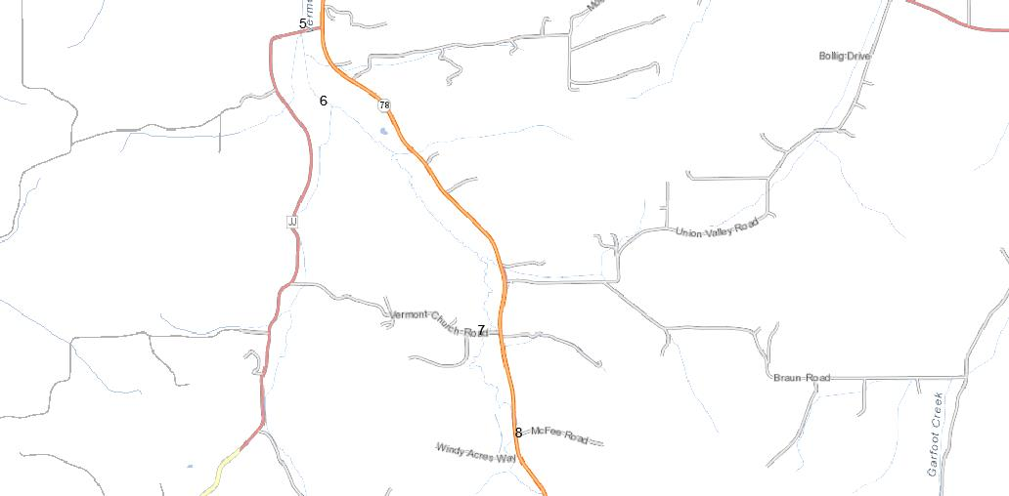
Figure 2. Vermont Creek Upstream Sites Map
FIBI Results
Nine species of fish were found at the four sites sampled in 2015 (Table 2). FIBI ratings were good to excellent at all locations, regardless of whether they were BMP, non-BMP or reference sites (Tables 3 & 4). The single rating of “Good” during year 2011 was at the Michaelis Road site. While brown trout (Salmo trutta) were captured at all four sites sampled during 2015, young of the year trout were chiefly found higher up in the watershed at the DNR lot near Windy Acres Way. Trout throughout the stream ranged from 2.7” to 17.2” and the largest trout was captured at the Parrell site. Vermont Creek has been stocked with Brown trout every year since 1991, and in the past five years nearly 5,000 fingerlings and 331 adult brood stock were stocked in the stream. Other fish species dominating the catch were white sucker (Catostomus commersonii), and mottled sculpin (Cottus bairdii), with hundreds of yearlings caught at most sites. For cold water fish species at all the four sites combined, 92% were sculpin.
Table 2. List of fish species captured during 2015 Vermont Creek monitoring.
Brown Trout | Salmo trutta
Blacknose Dace | Rhinichthys atratulus
Brook Stickleback | Culaea inconstens
Common Shiner | Luxilus cornutus
Creek Chub | Semotilus atromaculatus
Fathead Minnow | Pimphales promelus
Green Sunfish | Lepomis cyanellus
Mottled Sculpin | Cottus bairdii
White Sucker | Catostomus commersonii

Table 3. Vermont Creek FIBI scores and ratings in BMP areas in pre- and post- implementation years.
 | Location | Date | Cool-cold IBI Score |  | Rating
Non-BMP Sites | CTH-KP | 20-Jun-06 | 70 |  | Excellent
 | CTH-KP | 7-Sep-06 | 90 |  | Excellent
Pre- BMP Sites | DANZ Culvert | 14-Jul-06 | 90 |  | Excellent
 | Cowan Picnic Area | 20-Jun-06 | 70 |  | Excellent
 | Michaelis Rd | 14-Jul-06 | 90 |  | Excellent
Post- BMP Sites | Michaelis Rd | 12-Jul-11 | 60 |  | Good
 | Michaelis Rd | 21-Jul-15 | 80 |  | Excellent
 | CTH-JJ | 20-Jul-15 | 80 |  | Excellent
 | Parrell's | 12-Jul-11 | 80 |  | Excellent
 | Parrell's | 21-Jul-15 | 80 |  | Excellent

Table 4. Vermont Creek FIBI scores and ratings at reference sites.
Location | Date | Cool-cold IBI Score |  | Rating
DNR Lot Windy Acres Way | 20-Jun-06 | 90 |  | Excellent
DNR Lot Windy Acres Way | 20-Jul-15 | 70 |  | Excellent
Vermont Church Rd | 13-Jun-06 | 80 |  | Excellent

Habitat Results
Habitat improved after BMP’s were installed. Reference and Non-BMP sites had habitat ratings of fair to good in the downstream most and upstream most stream segments (Table 5). The fair ratings at CTH-KP and at the DNR lot were mainly due to moderate stream bank erosion, a lack of pools and riffle habitat, and fine sediments common in the stream channel. All BMP sites had ratings of good to excellent, with the exception of the Michaelis Road site which had a fair rating in 2006, yet the site showed improvement after BMP’s were installed and the rating increased to excellent by 2015. Of the aquatic plant species found in Vermont Creek, white water crowfoot (Ranunculus aquatilus) and water starwort (Calltriche palustris) were most abundant, followed by common waterweed (Elodea Canadensis), sago pondweed (Stuckenia pectinate), leafy pondweed (Potomageton foliosus), and a single non-native invasive plant species, curly-leaf pondweed (Potamogeton crispus), was present but not abundant.

Table 5. Vermont Creek Habitat Scores and Ratings in Reference and BMP sites Pre – and Post –Implementation from downstream to upstream.
Location | BMP or Reference Site | Date | Habitat Score | Habitat Rating
CTH-KP | Non-BMP | 7-Sep-06 | 45 | Fair
Parrell's | BMP | 12-Jul-11 | 67 | Good
Parrell's | BMP | 21-Jul-15 | 67 | Good
Danz Culvert | BMP | 14-Jul-06 | 50 | Good
Michaelis Rd. | BMP | 14-Jul-06 | 30 | Fair
Michaelis Rd. | BMP | 12-Jul-11 | 72 | Good
Michaelis Rd. | BMP | 21-Jul-15 | 83 | Excellent
CTH-JJ | BMP | 20-Jul-15 | 83 | Excellent
Vermont Church Rd | Reference/Non-BMP | 13-Jun-06 | 68 | Good
DNR lot near Windy Acres Way | Reference/Non-BMP | 20-Jul-15 | 48 | Fair

Macroinvertebrates
All samples collected from 2006 through 2015 were compiled and used in this analysis, and it appears that the MIB ratings show some improvement in stream health. All samples collected after BMP implementation rated fair to good (Figure 3). Two BMP sites (Danz Culvert and CTH-JJ) showed improvement in Macroinvertebrates, from pre- post BMP implementation, as ratings went from poor to fair and from fair to fair-good transition, respectively (Figure 3). A third BMP site showed an increase in MIBI score of 3.1 (fair) in year 2006 to a score of 4.6 (good) in year 2012 but then declined in year 2015 to a score of 2.9 (fair). The MIBI rating from the DNR lot site (A reference/Non-BMP site) in the upper stream segment that is not listed as impaired had the highest rating and was close to the good-excellent transition line. The non-BMP site at CTH-KP showed a slight improvement in ratings from poor to fair.

Figure 3. Vermont Creek Macroinvertebrate Scores.

Water Temperatures
Continuous temperatures were collected during the summer 2015 near the mouth at a non-BMP site at CTH-KP in a cool–cold main stream segment, and in a cool–cold headwater segment at the DNR public access lot near Windy Acres Way. The expected maximum daily mean temperature for a cool–coldwater stream should fall between 20.7 – 22.0 degrees celcius. Temperatures falling below 22.0 celcius indicate the stream should be able to support a cold water fish community. Both sites had temperatures cold enough to support a cold water fish community. During the warmest month, the mean of the maximum daily temperature at CTH-KP and at the DNR public access near Windy Acres Way was 20.7 and 20.3 degrees C, respectively. In early August the highest temperature recorded at CTH-KP for a single reading was 24.3 degrees celcius, and at The DNR public access lot the highest single temperature reading was 23.8 degrees.
Phosphorus, Total Suspended Solids, and Transparency
Six monthly total phosphorus (TP) samples were collected, and five monthly total suspended solids were collected at the CTH-KP site. The median TP was 106.4 ug/L. Based on the lower 90% confidence interval results of 95.69 ug/L, phosphorus in Vermont creek exceeds the phosphorus criteria of 75 ug/L. But since all FIBI and recent MIBI (2012) data scores were not in the “poor” category, biological evidence does not corroborate the fish and aquatic life use impairment. Therefore, it should be listed as impaired under subcategory 5P only for the pollutant TP. The median of five samples of suspended solids (TSS) collected near the stream mouth were relatively low at 15.6 mg/L. The highest value occurred in October when TSS was 20 mg/L, but the TP was relatively low on the same date (Figure 4).

Figure 4. Vermont Creek total suspended solids and total phosphorus value.
Vermont Creek has good water clarity as evidenced by the low suspended solids (TSS) collected at the CTH-KP site and low turbidity values of <10 NTU’s during 2015 at all sites.
Dissolved Oxygen, pH, Conductivity
These parameters were collected instantaneously only once during habitat assessment. Dissolved oxygen was adequate, and similar between sites, ranging from 9.6 – 12.0 mg/L. pH was within an acceptable range, and similar between sites, ranging from 7.8 – 8.1 SU. Conductivity was similar between sites, ranging from 625-637 mg/L.

Summary and Recommendations
The fish index of biotic integrity (FIBI) and habitat assessment information collected after year 2006, and after agricultural BMP’s were installed in the impaired stream segment, indicates that the stream is in good condition. FIBI at all sites rated good or excellent. Habitat ratings ranged from fair to excellent, and in all recent agricultural BMP implementation sites rated good or excellent. Using historic macroinvertebrate data collected at four sites within the impaired stream segment in 2006 and comparing them to 2012 and 2015 data, it appears that the macroinvertebrate index of biotic integrity (MIBI) scores have improved with all sites rating fair, and three of the four sites approaching the fair to good transition line. Based on biological evidence and habitat assessments from pre – to Post BMP’s, it appears that BMP’s were effective.
The fish and aquatic life condition of Vermont Creek, is currently listed as poor, but that status should be changed by the Department as biological evidence indicates the fish and aquatic life condition is good. Water temperature data, FIBI and MIBI information indicate that the stream is meeting the fish and aquatic life designated use. The stream natural community classification is cool-cold headwater and mainstem, and the fish data indicates it is meeting the classification, and temperature data shows the stream can support cool-cold water fish communities.
The impaired listing for degraded biological community, degraded habitat, elevated stream temperatures, and suspended solids should be removed from the list. However, phosphorus results indicate the stream exceeds the criteria, likely due to excessive sediment, and an abundance of plants which tend to trap and hold sediment in the lower stream segments where velocities are reduced. Since the biology meets the designated use for fish and aquatic life, but the phosphorus exceeds the criteria, the stream should be listed as impaired only for sediment and phosphorus according to Wiscalm guidance.
To help reduce instream phosphorus and sedimentation, stream segments historically ditched and having high vertical eroding banks combined with poor riparian vegetated buffer habitat, would have to be stabilized. However, this means landowners, who were previously approached by Dane County during the BMP installation period, but were not willing to install BMP measures would have to be willing to cooperate. In those stream segments a lack of cooperation means ongoing erosion, in stream sedimentation and continued elevated phosphorus levels.

