Bluff and Bear Creek Water Quality Assessment
and 303d Listing Determination

Craig Roesler – DNR, Spooner (2/12/14)

Introduction

Bluff and Bear Creeks are fairly small streams located in Douglas County, southeast of the City of Superior (figure 1 and 2) in the red clay plain area. Both streams flow into Allouez Bay. Monitoring of these streams was conducted during 2006 to 2010 by DNR Superior office staff to assess water quality conditions, and to determine if these streams should be placed on Wisconsin’s 303d list of impaired waters. (303d listing discussion is found on p. 15-16. It was concluded that 303d listing is not supported by the data collected.)

Bluff Creek’s stream length is 18.2 miles. Its watershed area is 18.3 mi2. Watershed land use (L-THIA) distribution is:
- Forested – 73% (some forested areas are wetlands)
- Grassland/pasture – 16%
- Wetland – 6%
- Residential – 4%
- Agricultural – 1.4%
- Commercial and industrial – 0.4%

Bear Creek’s stream length is 11 miles. Its watershed area is 7.2 mi2. Watershed land use distribution is:
- Forested – 66% (some forested areas are wetlands)
- Grassland/pasture – 18%
- Wetland – 10%
- Residential – 5%
- Agricultural 1%
- Commercial and industrial – 0.4%

Erodible clay soils interspersed with sands and silts are present throughout the two watersheds. This results in “flashy” hydrology, with high peak flows during runoff events, and low base flows between runoff events. Flows in much of Bear Creek are intermittent. Flows in most of the tributaries and the upper reaches of Bluff Creek are also intermittent.

Erosion of clay, sand, and silt from stream banks and from drainageways to streams is typically the largest source of sediment to streams in this area. Clay erosion results in frequently turbid water with high suspended solids concentrations. Erosion of sand and silt results in large bed loads of these materials.

Other non-point sources of pollutants include barnyards, livestock wastes, streambank pasturing, cropland erosion, and septic systems (Epstein 1997).

There is one point source discharging to Bear Creek. The Chicago Northwestern Transport Co.’s Itasca Yard has a discharge from a switching yard that enters Bear Creek just upstream of highway 2/53. There are no point sources discharging to Bluff Creek.

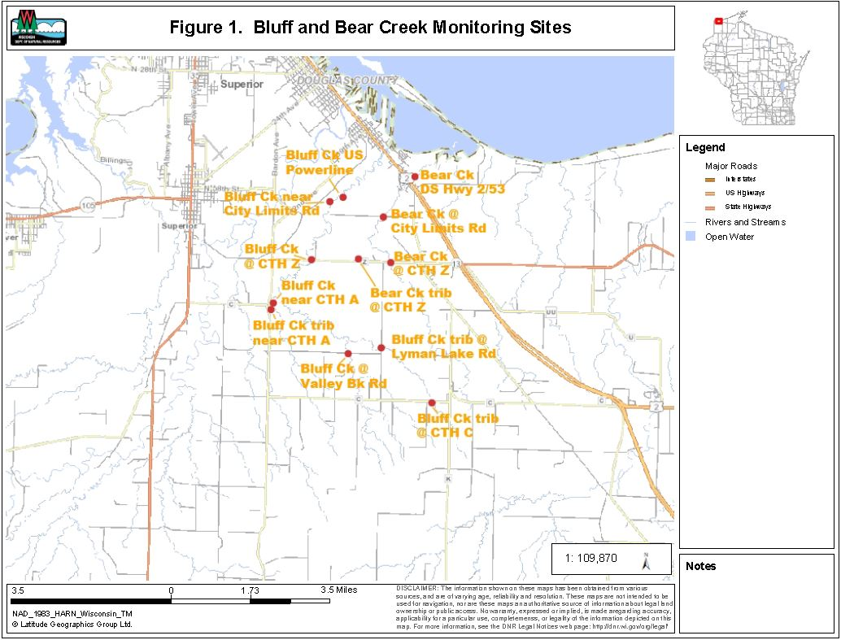

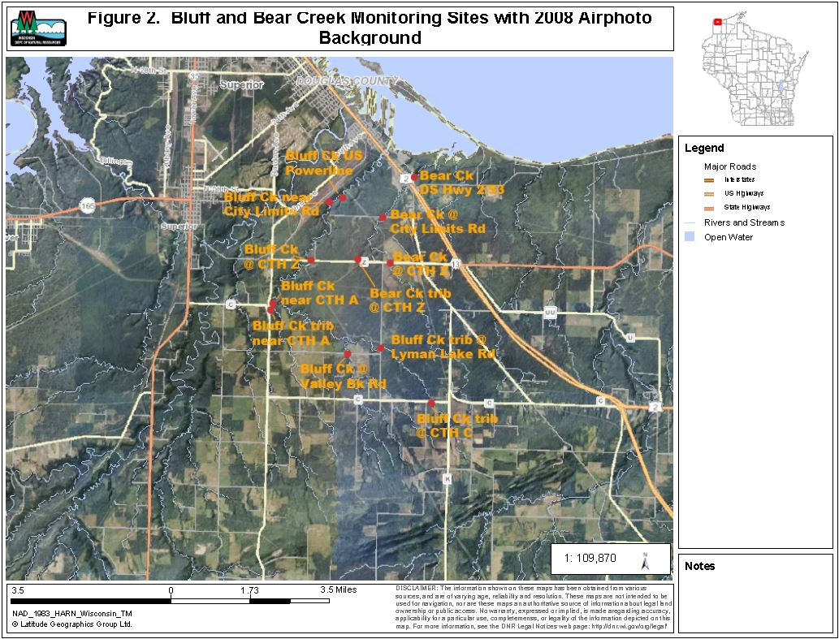

Methods

Five sites on Bluff Creek and three Bluff Creek tributary sites were monitored (table 1and figures 1 and 2). Three sites on Bear Creek and one Bear Creek tributary site were monitored. Monitoring was done for fish and macroinvertebrate communities, water chemistry, and stream habitat. The range of monitoring at each site varied (table 1).

Fish communities were assessed by electrofishing with a single anode backpack shocker. As many fish as possible were captured with a single upstream pass. Station lengths were 35 times the mean stream width, with a minimum length of 100 meters. Fish captured were counted and identified to species. Fish community data was used to determine the natural community of the stream, and to calculate potentially appropriate biotic indices.

Macroinvertebrate communities were assessed by collecting kick samples from riffles, using a 500 um mesh D-frame net. Samples were preserved in 85% ethanol and were processed by UW – Stevens Point’s Aquatic Biomonitoring Lab. Macroinvertebrates were counted and identified to the lowest possible taxa. Biotic indices and other statistics were generated.

Water samples were collected and field parameters were measured following standard DNR protocols. Water samples were preserved, as needed, and shipped on ice to the Wisconsin State Lab of Hygiene for analysis. Field parameters measured were:
- Temperature
- pH
- Dissolved Oxygen
- Conductivity
- Transparency (using a transparency tube)
Lab parameters were:
- Total Phosphorus
- Ammonia – N
- Total Kjeldahl N
- Nitrate plus Nitrite – N
- Total Suspended Solids
- Turbidity
- Chlorophyll a
- Dissolved phosphorus

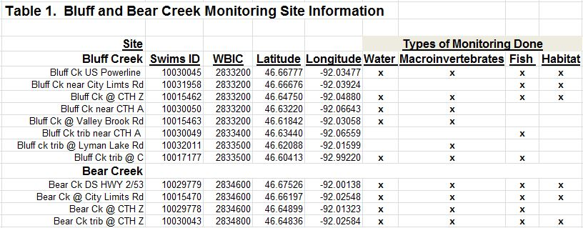

Findings and Discussion

Fish Communities

Complete fish survey results are contained in appendix A. Fish survey IBI’s (index of biotic integrity) are summarized in table 2.

A total of 18 fish species were found. The species found and their tolerances to disturbance are listed below:

- Black bullhead – tolerant
- Black crappie – intermediate
- Bluegill – intermediate
- Brassy minnow – intermediate
- Brook stickleback – tolerant
- Central mudminnow – tolerant
- Common shiner – intermediate
- Creek chub – tolerant
- Fathead minnow – tolerant
- Hornyhead chub – intermediate
- Johnny darter – intermediate
- Lake chub – intermediate
- Logperch – intermediate
- Northern pike – intermediate
- Pumpkinseed – intermediate
- Walleye – intermediate
- White sucker – tolerant
- Yellow perch - intermediate

Sites in the lower reaches of the streams had more species and more species with intermediate tolerance ratings. Sites in the upper reaches of the streams had fewer species and a higher percent of tolerant species. The majority of fish collected at all sites were tolerant species. There were no intolerant species found.

The majority of fish collected at all sites were transitional (coolwater) species. The model-predicted natural stream community for all sites is Cool-Warm Headwater. The sampled fish populations at all but one site indicated this is the correct natural stream community. The lower site on Bluff Creek (upstream of powerline) had a sampled population indicating a Cool-Warm mainstem community, due to an abundance of white suckers. However, stream flows for the site indicate a Cool-Warm Headwater community is probably appropriate.

Seven of the nine sites had tolerant species comprising over 75% of the sampled fish populations (table 2). This exceeds the normally expected range for Cool-Warm Headwater community streams. The influence of red clay watershed soils probably accounts for this (flashy runoff events, low base flows, turbidity, and sand/silt bedloads).

Past fisheries work in the area has shown that the mouths of Bluff and Bear Creeks are important spawning areas for northern pike and other warmwater fish (Pratt 1996). White sucker collection in May 2013 found white suckers and lake chubs in spawning condition at multiple sites in Bluff Creek, and in the lower reach of Bear Creek. Bear Creek passes through a perched culvert just upstream of highway 2/53 that probably prevents spawning fish from moving further upstream.

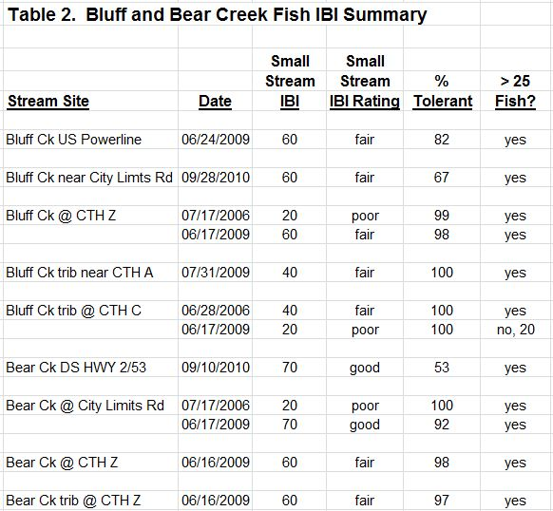

Macroinvertebrate Communities

Macroinvertebrate IBI (MIBI) ratings ranged from fair to excellent, and all but one were good or excellent (table 3). MIBI ratings were generally better than the small stream IBI’s for the fish communities. Hilsenhoff biotic index (HBI) ratings ranged from fairly poor to good. HBI’s are mostly influenced by organic matter loading and the resultant dissolved oxygen concentrations. The HBI’s suggest dissolved oxygen stress to macroinvertebrates is moderate.

Macroinvertebrate communities are probably limited by the limited availability of coarse substrate. Habitat surveys for all sites found that fine sediment was extensive in all habitats and covered more than 60% of the stream bed. Limited periphyton growth due to high stream turbidity may also limit macroinvertebrate communities.

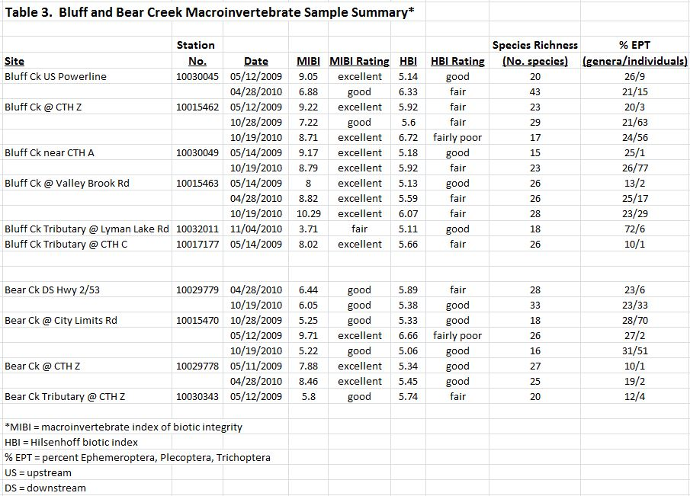

Water Chemistry

Water chemistry data for Bluff and Bear Creeks is shown in table 4. Sampling frequency and duration varied by site making comparisons between sites tentative. Only the mainstem sites had more than one date of sampling and are discussed below.

Bluff and Bear Creek sites had high and similar concentrations of total phosphorus (TP) and total nitrogen (TN)(total Kjeldahl nitrogen plus nitrate and nitrite nitrogen). TP concentration medians ranged from 99 – 151 ug/l. The percent of total phosphorus present in the dissolved form varied from 21 – 61%. TN concentration medians ranged from 1.3 – 1.8 mg/l. More than 95% of the total nitrogen was present in an organic form.

Bluff and Bear Creek sites had low and similar concentrations of ammonia and nitrate plus nitrite. Ammonia concentration medians ranged from 0.024 – 0.058 mg/l. Nitrate plus nitrite concentration medians ranged from < 0.015 – 0.069 mg/l.

Bluff and Bear Creek sites had high total suspended solids (TSS) concentrations, high turbidity, and low transparency. The Bear Creek sites tended to be somewhat better than the Bluff Creek sites for these parameters. TSS median concentrations ranged from 17 – 37 mg/l. Turbidity medians ranged from 77 to 138 ntu’s. Transparency medians ranged from 11 – 13 cm.

Daytime dissolved oxygen (D.O.) concentrations were generally good. Bluff Creek at CTH Z had a D.O. concentration of 3.7 mg/l on one date, and two other dates with D.O. concentrations less than 5 mg/l. Bear Creek at CTH Z also had a D.O. concentration of 3.7 mg/l on one date.
The occasionally low D.O. concentrations at Bluff Creek at CTH Z may have contributed to obtaining a poor fish IBI and a fairly poor HBI at the site.

Conductivities varied widely from 83 – 939 umhos/cm. Conductivity is typically low when surface runoff is dominating stream flow and high when groundwater discharge is dominating stream flow. pH values ranged from 6.8 to 7.8.

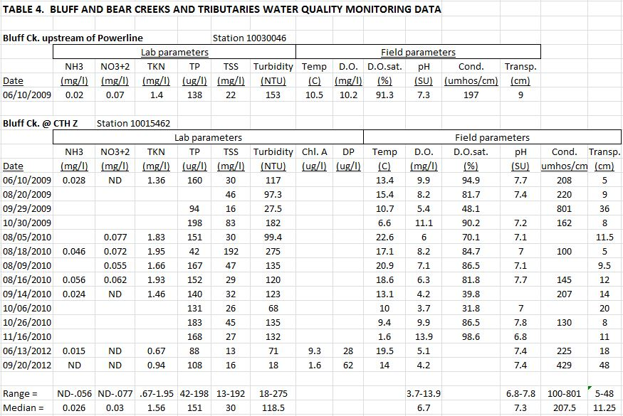

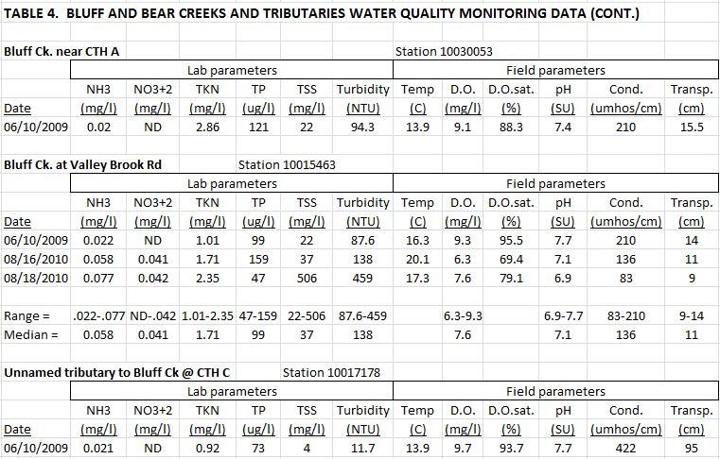

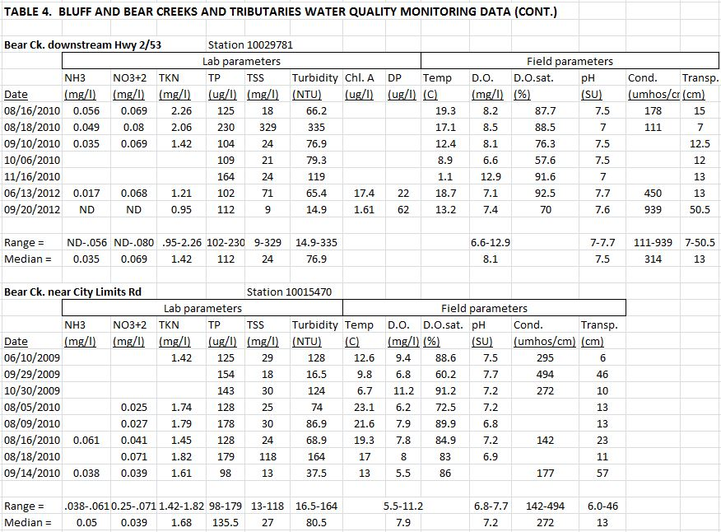

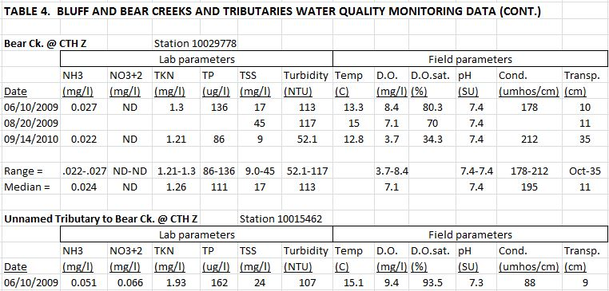

Conclusions

Bluff and Bear Creeks are located in the red clay plain adjacent to Lake Superior. The watersheds are mostly undeveloped land, with 76 -79% of the area consisting of forests and wetlands. Grassland and pasture is the most common developed land use making up 16 - 18% of the watersheds. Only 6% of the watersheds are more intensively developed as residential, commercial, or industrial areas, and agricultural fields.

The erodible clay soils along with the moderate development in the watershed result in water quality concerns including:

- High peak flows resulting from rapid runoff from clay soils.
- Low base flows resulting from limited groundwater discharge.
- Scouring of stream bed and bank erosion resulting from high peak flows. Habitat surveys rated bank erosion as moderate to extensive at all sites.
- High bed load of sand and silt, reducing the substrate quality for fish and macroinvertebrates. Habitat surveys found fine sediments were extensively present at all sites.
- High TSS and turbidity, and low transparency resulting from erosion of clay soils.
- High TP concentrations.
- Perched culvert for Bear Creek upstream of highway 2/53 preventing most fish passage.

A primary goal of this project was to determine if Bluff Creek or Bear Creek should be placed on Wisconsin’s 303d list of impaired waters. WISCALM guidance (2014) indicates at least two samples of one biological assemblage (fish or macroinvertebrates) collected in different calendar years and having “poor” ratings are required to list a stream as impaired.

None of the sites monitored on the two creeks or their tributaries met this threshold (table 5). Fish communities with a poor rating were found at two Bluff Creek sites and one Bear Creek site. However, all three sites also had second fish surveys that produced fish community ratings of fair or good. Macroinvertebrate IBI’s at these three sites had ratings of good to excellent. Sites with a poor fish community rating on one date were:

- Bluff Creek @ CTH Z poor in 2006 (fair in 2009)
- Bluff Creek tributary @ CTH C poor in 2009 (fair in 2006)
- Bear Creek @ City Limits Road poor in 2006 (good in 2009)

None of the sites for the two creeks had macroinvertebrate IBI’s with a poor rating. M-IBI ratings ranged from fair to excellent, and all but one were good or excellent.

Total phosphorus (TP) concentrations can also be used to list a stream as impaired. Six monthly samples collected from May to October are needed for this assessment. The lower bound of the 90% confidence interval of the mean must exceed 75 ug/l to list a stream as impaired.

None of the sites had an adequate distribution of TP samples collected (table 5). However, it appears likely that the TP listing threshold would be exceeded for sites on both streams if adequately distributed samples were collected. TP median concentrations for Bluff Creek at CTH Z and Valley Brook Road were 151 ug/l and 99 ug/l respectively. TP median concentrations for Bear Creek downstream of Hwy 2/53 and near City Limits Road were 112 ug/l and 136 ug/l respectively.

The available data is insufficient for placing Bluff and Bear Creeks on the 303d list. The high total phosphorus concentrations indicate a potential use impairment could exist. Bluff and Bear Creek should be designated as “Watch Waters”. Additional total phosphorus monitoring should be done in the near future.

