Horicon Marsh Watershed Improvement Project

Monitoring, Restoration and Evaluation Activities in the Watershed

Watersheds: West Branch Rock River HUC 10-0709000102
- Headwaters South Branch Rock River HUC 12-070900010201
- South Branch Rock River HUC 12-070900010202
- Headwaters West Branch Rock River HUC 12-070900010203
- Plum Creek HUC 12-070900010204
- Mill Creek HUC 12-070900010205
- West Branch Rock River Frontal Horicon Marsh HUC 12-070900010206
- Horicon Marsh HUC 12-070900010207

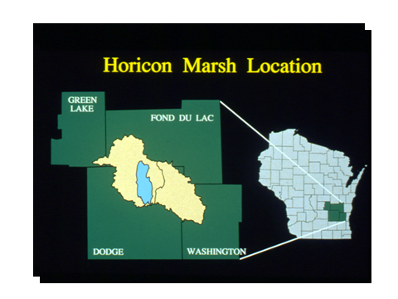

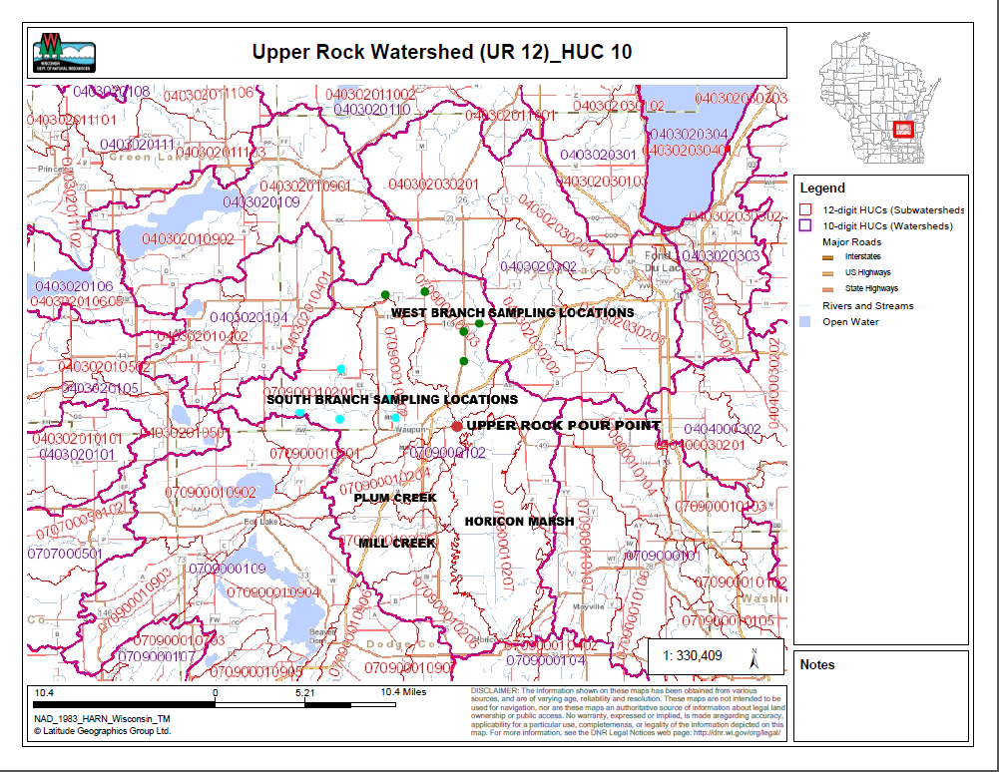

Table of Contents

Background……………………………………………………………….…….4

Upper Rock River Watershed (UR 12)……………………………………...…5

Project History……..…………………………………….…………………..…8

2013 Upper Rock Subwatershed Monitoring Project…..………………..……14

South Branch/West Branch Subwatershed Data Assessment ..……………….19

Recommendations.………………………………………………………….…22

Background

The project area includes the portion of the Upper Rock River Basin above the dam at Horicon. At the heart of the Upper Rock River Basin is the Horicon Marsh. On the north end of Horicon Marsh is the 21,000 acre Horicon National Wildlife Refuge. On the south end is the 10,000 acre Horicon Marsh State Wildlife Area. This wetland is of great importance, because of the significant wildlife habitat and other ecological functions provided by the Horicon Marsh ecosystem. In addition, there is a considerable economic impact to the community. The study area also includes the headwater areas of the West Branch and South Branch of the Rock River Rock River resulting in this being a critical area affecting the entire river basin.

Resources and Landscape Description:
Horicon National Wildlife Refuge (NWR) is located on the West Branch of the Rock River in southeastern Wisconsin. The U.S. Fish and Wildlife Service (USF&WS) manages the northern two thirds of the marsh (Horicon Marsh National Wildlife Refuge) and the Department of Natural Resources manages the southern one third of the marsh, the State Wildlife Area (SWA).

Horicon Marsh is a shallow, peat-filled lake bed gouged out by the Wisconsin Glacier thousands of years ago. Horicon marsh is located within the Rock River Basin, which encompasses 3,800 square miles in South Central Wisconsin. At 32,000 acres, Horicon Marsh is the largest freshwater cattail marsh in the United States. Horicon Marsh is bounded on the east by a sharply rising ridge of the Niagara escarpment which rises approximately 250 feet above the marsh to an elevation of 1,100 feet. The land to the west of the Marsh rises slowly and is dotted with many small potholes and several shallow lakes.

Horicon Marsh has been classified as a palustrine system dominated by persistent emergent vegetation and floating vascular aquatic beds. Major land types identified on the refuge include wetland, with the majority classified as deep, freshwater marshes; and uplands, including forestland/brushland habitat and sedge meadows and warm season grasses. In 1990, Horicon Marsh was designated a "Wetland of International Importance" by the Ramsar Convention. In 1997, Horicon March was determined to be a Globally Important Bird Area by the American Bird Conservancy due to its importance as a migratory stop-over site for Canada geese and other waterfowl species. Up to 300,000 Canada geese stage on the Refuge in the fall. The area is also a mecca for ducks, cranes, herons, and shorebirds. The State recognized Horicon Marsh as an Important Bird Area in 2004. Horicon Marsh has a number of important species that the refuge manages for.

Geographic Location:
The marsh is located 6 miles east of the city of Waupun and overlaps in two Wisconsin Counties, Dodge and Fond du Lac. On refuge land, the northern section of the Marsh, there is over 15,500 acres of marsh, 600 acres of upland habitat which includes 2,000 acres of woodlands and 3,600 acres of grassland. There are similar habitats on the state owned property.

Geological features and land use around Horicon Marsh will partially determine the various pathways that contaminants can enter the marsh. Cropland accounts for a large percent of the Upper Rock River watershed, which influences the input of phosphorous and other chemicals used in agriculture to the marsh (Table 1).

Table 1. Area (thousands of acres) of land by Land-use for Dodge and Fond du Lac Counties (Horicon Marsh National Wildlife Refuge, Comprehensive Conservation Plan Final, page 32).
County | Forest | Cropland | Pasture | Wetland | Total
Dodge | 27.8 | 438.6 | 25.2 | 111.2 | 581.3
Fond du Lac | 35.1 | 342.9 | 37.9 | 69.6 | 489.5

Upper Rock River Watershed (UR12)

The Upper Rock River Watershed consists of numerous headwater area rivers and streams, which flow southward through Fond du Lac County and enter the northern portion of the Horicon Marsh. This stream complex drains a portion of Fond du Lac County and Dodge County. The most significant rivers in the watershed include the South and West Branch of the Rock River, which totals 59 river miles. As in most other watersheds in the Upper Rock River Basin, the streams and rivers have low gradients

The South Branch was added to the 303d list in 1998 while the West Branch was added in 2006. Created by the Environmental Protection Agency (EPA), the 303(d) listed waters are those waters, which have impairments that prohibit them from meeting their potential use and meeting water quality standards. Environmental problems have impacted the level of flow, habitat, fish migration, turbidity, dissolved oxygen, and sedimentation. Efforts have been made over the past 20 years to reduce nonpoint and point source pollution. Despite these efforts, however, the majority of the Upper Rock River Basin continues to be on the 303(d) list of impaired waters.

Although there are some significant sources of point source pollution to the river, the greatest water quality problem in this stretch of the upper Rock River is from urban and rural nonpoint source pollution. Urban stormwater runoff carries sediment and pollutants to area surface waters.

Rural sources of nonpoint pollution come from cropland erosion and runoff from barnyards and cattle exercise lots. Runoff from agricultural lands carries nutrients and sediment into the River system, which adversely impacts the aquatic habitat and water quality in the watershed. Sedimentation of the river also increases the turbidity of the water and decreases the amount of dissolved oxygen in the water.

There are three municipal wastewater facilities discharging into the watershed: Brandon, Burnett and Waupun. There is also one industrial point source discharge, Saputo Cheese. The City of Waupun and the Saputo cheese factory are the largest of the point source contributors and are still major contributors of phosphorous to the Upper Rock River system.

Hydrologic modifications to surface waters also negatively impacts water quality. Many of the small tributaries in the Upper Rock River have undergone channelization projects. In addition, the River flow has been interrupted by a dam at Waupun. Dams, and other hydrologic modifications can impair water quality by slowing flow, acting as sediment and nutrient collection basins, impeding fish movement, warming waters in the impoundment and, consequently, warming waters downstream.

Groundwater flow as part of the system is little understood.. It is likely that groundwater inputs are reduced and flows decline during dry periods due to the impact of urbanization on groundwater recharge although this has not been studied. These impacts are only beginning to be locally recognized. A severe drought in 2012 led to extremely low flows in the River and caused a significant fish kill.

The Upper Rock River is used for a variety of water related recreational purposes. Several parks along the river provide easy public access for fishing, canoeing, hunting and other recreation. In addition to its use for human activities, significant tracts of wetlands are productive for waterfowl.

The Upper Rock River supports a diverse warmwater fishery, including walleye, northern pike, largemouth bass, yellow perch, bluegill, white and black crappie, pumpkinseed, green sunfish, white sucker, channel catfish, yellow, black and brown bullhead, stonecat, common carp, bluntnose and fathead minnow, cheek chub, river and golden shiner, pearl dace, central stoneroller, central mudminnow, Johnny, fantail, and banded darter and brook stickleback. The high population of common carp and other rough fish does increase turbidity in the system leading to a reduction in submergent vegetation.

Tributaries in the Upper Rock River Watershed

Alto Tributary
Alto Tributary is a small stream that feeds into the South Branch of the Rock River. It is a shallow, narrow stream with average depth less than 3 feet. Factors contributing to poor water quality in this stream are high phosphorus loading from an industrial wastewater plant. There may also be chloride and temperature issues related to this point source discharge. Nonpoint runoff and drain tile discharge are also problems with this stream.

South Branch Rock River
This river flows east for 17 miles through Fond du lac and Dodge Counties and joins with the West Branch of the Rock River just southeast of Waupun, where it enters the Horicon National Wildlife Refuge. The stream has been classified as Warm Water Sport Fish (WWSF). Factors limiting this stream from reaching its full biological potential are: cropland erosion, wetland loss, streambank and riparian zone erosion and livestock access to streambanks.

West Branch Rock River
This river is only partially supporting its potential as a WWSF. Observations and monitoring of the river reveal extensive sedimentation (WDNR, 1994). The West Branch, after it has joined the south Branch, is the principle source of runoff, nutrient and sediment loading to the Horicon National Wildlife Refuge (Rock River Partnership Monitoring Study, 1999).

In 2000, DNR conducted baseline monitoring of the West Branch of the Rock River, at Oak Center Drive that included fishery and habitat assessments. Fish species collected included: creek chub, white sucker, central stoneroller, pearl dace, fathead minnow, brook stickleback, Johnny darter, fantail darter, green sunfish, bluntnose minnow, stonecat, golden shiner, banded darter, pumpkinseed, yellow perch, and northern pike. The Index of Biotic Integrity (IBI) score for the fisheries survey was categorized as very poor, with a numerical score of 15 (using Warmwater IBI calculator). The qualitative habitat rating was fair with a numerical score of 40. No macroinvertebrate samples were collected from the West Branch of the Rock River as part of the monitoring conducted in 2000.

Plum Creek
A main tributary to the Horicon National Wildlife Refuge, Plum Creek drains a watershed of 16 square miles. In 2003 and 2004, DNR conducted baseline monitoring on Plum Creek, at Highway I, that included fishery, habitat and macroinvertebrate assessments. Fish species collected in2004 included: brook stickleback, central mudminnow, creek chub, white sucker, and blacknose dace. The IBI score for the fisheries survey was categorized as very poor, with a numerical score of 10 (using Warmwater IBI calculator). The qualitative habitat rating was good with a habitat score of 58. Macroinvertebrate samples were collected from Plum Creek at 2 locations. One location was ranked fairly poor and the other fair.

Mill Creek
A 12-mile tributary to the Horicon National Refuge, Mill Creek drains a 22-square mile watershed. The creek is classified as a Limited Forage Fish (LFF) and intermittent, seasonal low flows have historically been documented.

Libby Creek
A small tributary to the West Branch of the Rock River originating southeast of Waupun, Libby Creek is classified as LFF for its entire 2 miles and is intermittent in nature.

Ladoga Creek
A 3 mile creek that flows into the West Branch of the Rock River in southern Fond du lac county. Ladoga Creek is not classified so it defaults to WWSF. Data has recently been collected and has shown to have low phosphorous and suspended solids concentrations. The stream has consistently met the water quality standard of .075 mg/l phosphorous. A fish survey was completed in July of 2013 and showed an IBI of good.

Willow Creek
A 6 mile creek that flows into the West Branch of the Rock River in southern Fond du lac county. The stream has been adversely impacted from agricultural runoff and livestock having access to the stream. A recent fish survey showed the stream to have a Fish IBI of poor.

Project History

The origin of the watershed improvement project actually began in 1993 when a forum was held in the City of Horicon to identify area resident concerns. One of the concerns that surfaced during the forum was water quality and the protection of Horicon Marsh. A group was formed, the Horicon marsh Area Coalition to look at the various concerns raised by community residents. A Water Quality work group was formed to look into the issue of water quality. Being that there was very limited water quality data as to pollutant loading into Horicon marsh, a project was developed to measure phosphorous and suspended sediment loadings coming in and leaving Horicon marsh. Partnerships were formed and grants obtained that led to a comprehensive monitoring project designed to measure inputs to Horicon marsh from the two main tributaries (East and West Branches) and outputs from the rock river in the City of Horicon. From fall of 1997 and into year 2000, the USGS installed sample stations at 3 locations. Phosphorus, suspended solids, some nitrogen and flow were monitored.

The data showed some extremely high loadings to Horicon Marsh, both phosphorous and suspended solids. As time went on, several actions/events occurred that helped reduce the inputs to the Refuge. One of the first things to happen was the implementation of Wisconsin Administrative Code NR 216, the phosphorous rule. This rule went into effect in 2002 and required all discharges from wastewater treatment plants to meet a 1 mg/l limit. The 2 main point sources (City of Waupun, Saputo Cheese – formerly Alto Dairy) in the Upper Rock basins significantly reduced their phosphorous discharge.

On the nonpoint side of things, the city of Waupun worked to reduce their stormwater discharges. A stormwater reduction plan was developed and implemented by the City. There were numerous meetings and forums held by Horicon Marsh Area Coalition and various other organizations to address the agricultural nonpoint source loadings. Presentations were given showing the amount of nonpoint pollution that was entering and leaving Horicon Marsh with the goal of getting cooperation from the agricultural community to implement best management practices. There was little success.

Then, in 2006, an innovative watershed project was initiated and a staff person was hired with monies from the US fish and Wildlife Service to identify critical source areas, improve relationships with landowners, and increase awareness of various conservation programs. All with the goal of implementation of best management practices such as nutrient management planning and buffer strips. In addition, dollars were included to be used as incentive payments to add to other programs such as EQIP and CREP to further entice landowner cooperation. This approach proved to be successful as much of the watershed did get under some planning or buffer (Figure 1). According to a 2012 update of the project, over 67,000 acres of the approximately 90,000 cropped acres in the Fond du lac portion of the watershed are either under a nutrient management plan or conservation plan. There have also been about 25 miles of stream bank buffer installed (Table 2).

Figure 1.

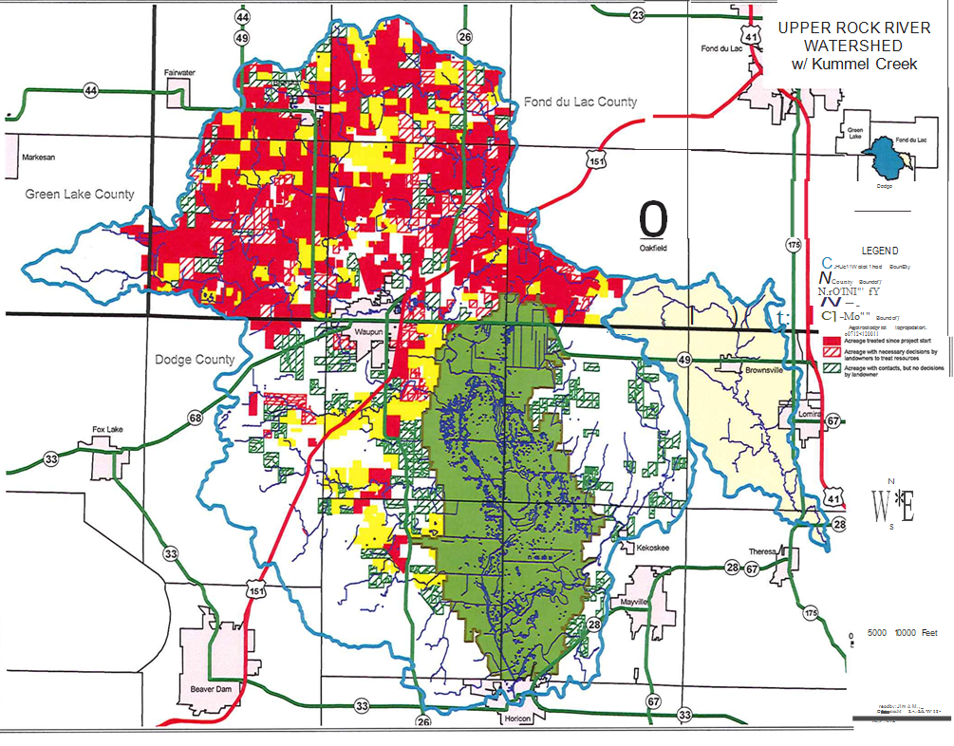

Table 2.
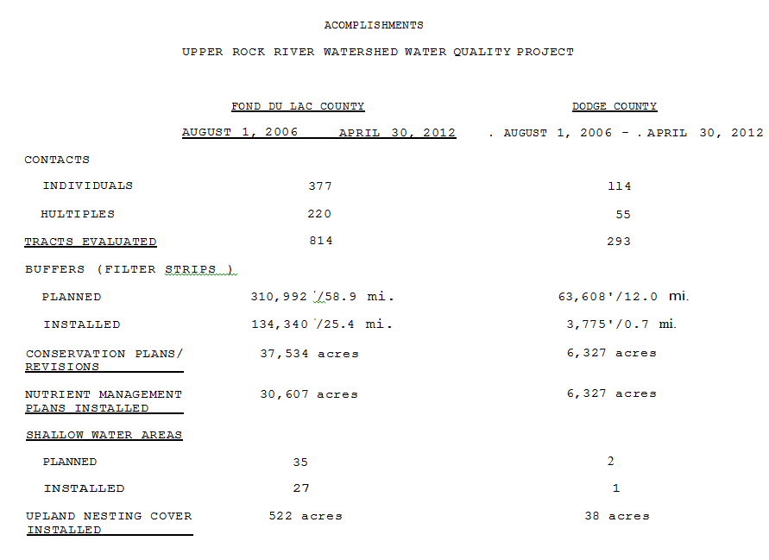

To determine if there had been any measureable reductions in pollutants entering Horicon Marsh Wildlife Refuge, a repeat monitoring project was initiated in 2009. The study concluded in 2011. To date, there has not been a thorough data analyses to compare the 1997 data to the 2009 data. Some limited analyses did show a reduction in phosphorous concentration and mass but a more detailed analysis is needed (Figure 2). The data does clearly show that the water quality standard of .075 mg/l phosphorous is not being met ( Table 3).

Table 3.

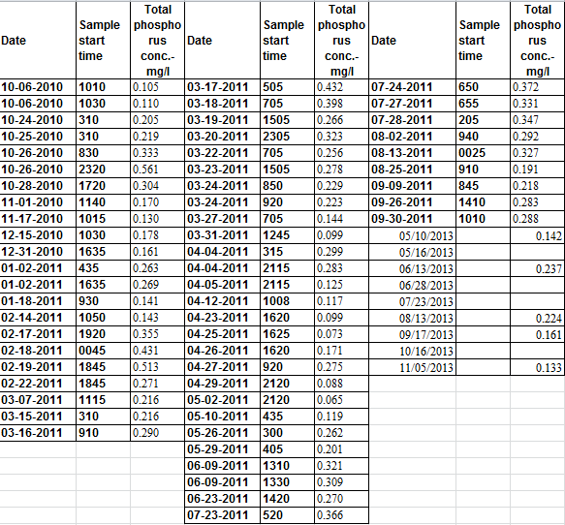

It should be noted that there are many variables involved that can affect the data comparison below. Rainfall intensity, volume, snow cover, temperature and other events can differ considerably from year to year which can skew the data. However, the large decrease in pounds of phosphorous would indicate that phosphorous has been removed from the system Figure 2). Whether the reduction is indicative of what has been removed from the point source discharges, the nonpoint reductions or a combination of both is impossible to tell based on this limited data comparison. The point source phosphorous reductions are measureable (Table 4). The relative small changes in TSS seen in this limited comparison could also be skewed by weather events or by in stream sediments (Figure 3).

Table 4.

Year | Saputo Cheese Annual Phosphorus (lbs.) | City of Waupun Annual Phosphorous (lbs.)
1999 | 53,064 | 30,801
2000 | 53,027 | 17,119
2001 | 48,687 | 28,495
2002 | 31,175 | 37,842
2003 | 18,878 | 22,002
2004 | 10,749 | 3,955
2005 | 6,475 | 2,066
2006 | 4,508 | 2.872
2007 | 4,661 | 3,432
2008 | 5,263 | 3,327
2009 | 6,656 | 4,554

Figure 2.

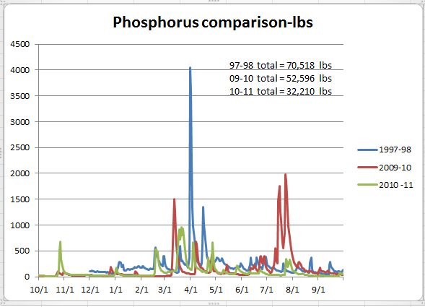
Figure 3.

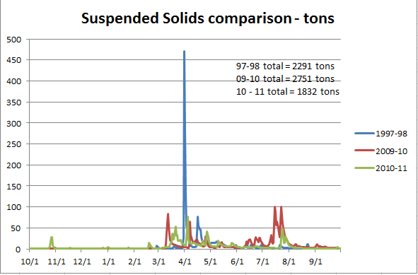

2013 Upper Rock Subwatershed Monitoring Project

To further investigate where in the Upper Rock watershed the highest amounts of phosphorous are coming from, a subwatershed investigation was initiated in 2013. There were 10 sites located in the watershed to sample. There were 5 sites located in the West Branch Rock River HUC 12 (070900010203) and 5 sites in the South Branches Rock River HUC 12’s (070900010201 & 070900010202). Samples were taken from May through October and during several rain events.

South Branch sampling locations

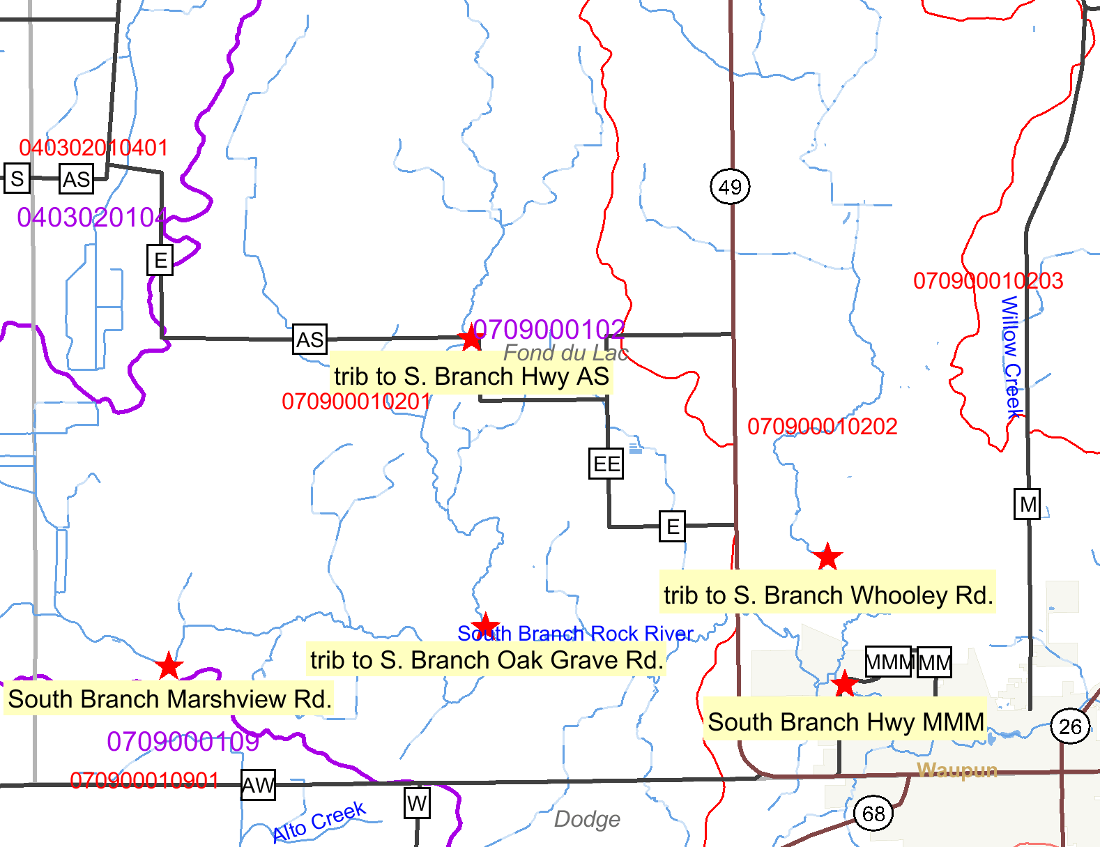
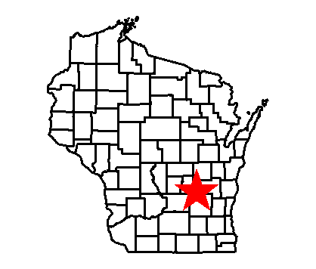
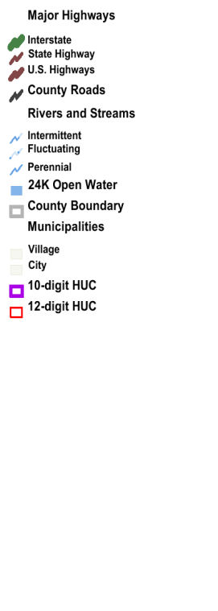


South Branch

Trib. to South Branch, Hwy AS – FIBI = 30 (poor); MIBI = ?

South Branch, Mielke (Marshview) Rd.- FIBI=70 (good); MIBI=?

Trib. to South Branch, Oak Grove Rd.- FIBI = 0 (poor); MIBI = ?

Trib. to South Branch, Whooley Rd- FIBI = 40 (fair); MIBI = ?

South Branch, Hwy MMM- FIBI=40 (fair); MIBI=?

Table 5

Phosphorus conc.  Mg/l | Trib. to South Branch @ Hwy AS | South Branch @ Mielke Rd. | Trib. to South Branch @ Oak Grove Rd. | Trib. to South Branch @Whooley Rd. | South Branch @ Hwy MMM
05/10/2013 | 0.22 | 0.22 | 0.275 | 0.079 | 0.299
05/16/2013 | 0.165 | 0.103 | 0.14 | 0.072 | 0.112
06/13/2013 | 0.228 | 0.213 | 0.302 | 0.182 | 0.242
06/28/2013 | 0.243 | 0.327 | 0.573 | 0.328 | 0.446
07/23/2013 | 0.21 | 0.19 | 0.322 | 0.198 | 0.276
08/13/2013 | 0.131 | 0.122 | 0.167 | 0.123 | 0.201
09/17/2013 | 0.12 | 0.115 | 0.26 | 0.139 | 0.347
10/16/2013 | 0.088 | 0.157 | 0.196 | 0.104 | 0.265
Average | 0.175625 | 0.180875 | 0.279375 | 0.153125 | 0.2735

Table 6

SS mg/l | Trib. to South Branch @ Hwy AS | South Branch @ Mielke Rd. | Trib. to South Branch @ Oak Grove Rd. | Trib. to South Branch @Whooley Rd. | South Branch @ Hwy MMM
05/10/2013 | 10.2 | 3.8 | 6 | 5.2 | 18.8
05/16/2013 | 4.6 | 2 | 0 | 4 | 5
06/13/2013 | 14 | 4.8 | 2.8 | 8.7 | 11.4
06/28/2013 | 4 | 0 | 2.2 | 8 | 14.7
07/23/2013 | 8.2 | 0 | 6.4 | 4.4 | 5.4
08/13/2013 | 7.8 | 0 | 4.6 | 0 | 3
09/17/2013 | 0 | 0 | 29.3 | 3.25 | 2.8
10/16/2013 | 0 | 0 | 4.6 | 0 | 0
 | 6.1 | 1.325 | 6.9875 | 4.19375 | 7.6375

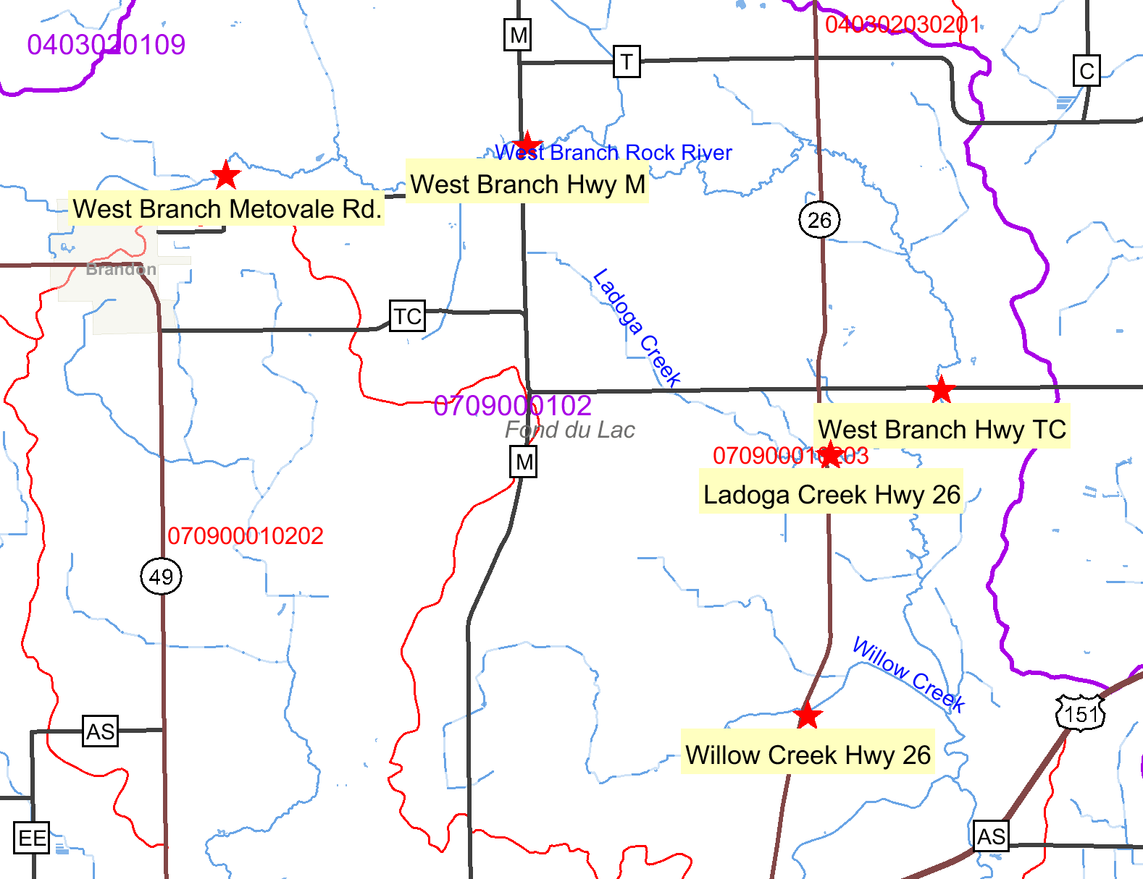
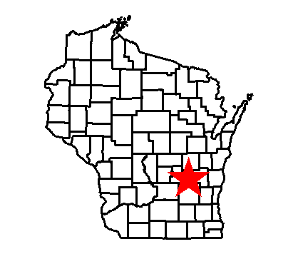
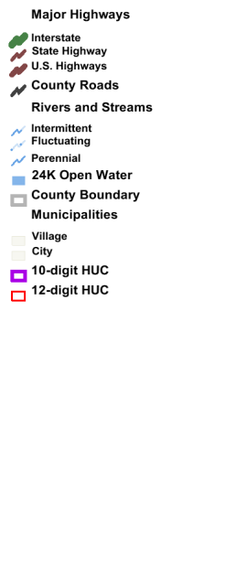

West Branch sampling locations

West Branch

West Branch, Metovale Rd.- FIBI = 10 (poor); MIBI=?

West Branch, Hwy M – FIBI = 32 (fair); MIBI = ?

West Branch, Hwy TC – FIBI = 47 (fair); MIBI = ?

Ladoga Creek, Hwy 26- FIBI = 80 (good), MIBI = ?

Willow Creek, Hwy 26 – FIBI = 25 (poor); MIBI = ?

Table 7

Phosphorous conc.  Mg/l | Willow Creek | Ladoga Creek | West Branch@Hwy TC | West Branch @ Hwy M | West Branch @ Metovale Rd.
05/10/2013 | 0.104 | 0.073 | 0.113 | 0.061 | 0.062
05/16/2013 | 0.058 | 0.027 | 0.043 | 0.045 | 0.062
06/13/2013 | 0.101 | 0.052 | 0.188 | 0.119 | 0.186
06/28/2013 | 0.143 | 0.078 | 0.177 | 0.362 | 0.567
07/23/2013 | 0.116 | 0.038 | 0.187 | 0.133 | 0.447
08/13/2013 | 0.077 | 0.03 | 0.104 | 0.115 | 0.228
09/17/2013 | 0.091 | 0.035 | 0.201 | 0.027
10/16/2013 | 0.049 | 0.037 | 0.288 | 0.033
Average | 0.092375 | 0.04625 | 0.162625 | 0.111875 | 0.10328125

Table 8

SS mg/l | Willow Creek | Ladoga Creek | West Branch@Hwy TC | West Branch @ Hwy M | West Branch @ Metovale Rd.
05/10/2013 | 13.2 | 4.8 | 3 | 0 | 17.4
05/16/2013 | 0 | 3.4 | 2 | 0 | 0
06/13/2013 | 21 | 11 | 9.2 | 2 | 5.6
06/28/2013 | 2.4 | 50.8 | 6 | 10.5 | 8.5
07/23/2013 | 6.3 | 9.8 | 3.2 | 0 | 6.8
08/13/2013 | 4.2 | 4.6 | 2.4 | 13 | 5.2
09/17/2013 | 34.6 | 2.6 | 5.2 | 0
10/16/2013 | 0 | 2.2 | 0 | 0
 | 10.2125 | 11.15 | 3.875 | 3.1875 | 7.10625

South Branch/West Branch Data Assessment

General Summary

Most of the samples collected during the May-October sampling season were baseline samples taken near the middle of each month. Flow was not taken at any of the stations so no mass loading numbers are available. Also, due to an error by the sampling coordinator none of the samples were analyzed for the nitrogen series.

There were only 2 significant rain events where runoff created high flow in the streams. One on May 10th and one on June 28th. In both instances, there was an increase in concentrations as compared to baseline conditions. The suspended solids data showed relatively low concentrations throughout the sampling period. This could have been due to the timing of the samples as most were taken after there was vegetative growth.

There is some data available for the Plum and Mill Creek watersheds which are located west of the Horicon Marsh Wildlife Refuge (table 9). Sampling was done by US fish and Wildlife staff. Phosphorous data is similar to what was collected at the 10 sites that this project focused on. There is also extensive data available at the pour point of the West and South Branch watersheds combined. This report is only discussing the data collected of the West and South Branches of the Rock river Watershed.

Table 9
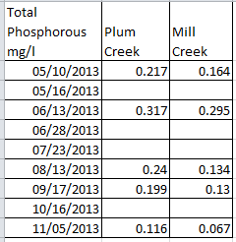

South Branch Watershed Summary (Tables 5& 6)

The South Branch watershed seemed to have consistently higher levels of phosphorous than the West Branch watershed. The average phosphorus concentration for all the samples for the South Branch was .21 mg/l while the West branch average was .1 mg/l. The tributary with the highest overall average phosphorous concentration (.279 mg/l) was the tributary to the South Branch at Oak Grove Rd. The main stem of the South Branch at Hwy MMM was also high at .273 mg/l total phosphorous. It should be noted that the site at Hwy MMM is directly downstream of a golf course.

There are 2 permitted farms in the watershed along with numerous other small to medium sized farms (see map).

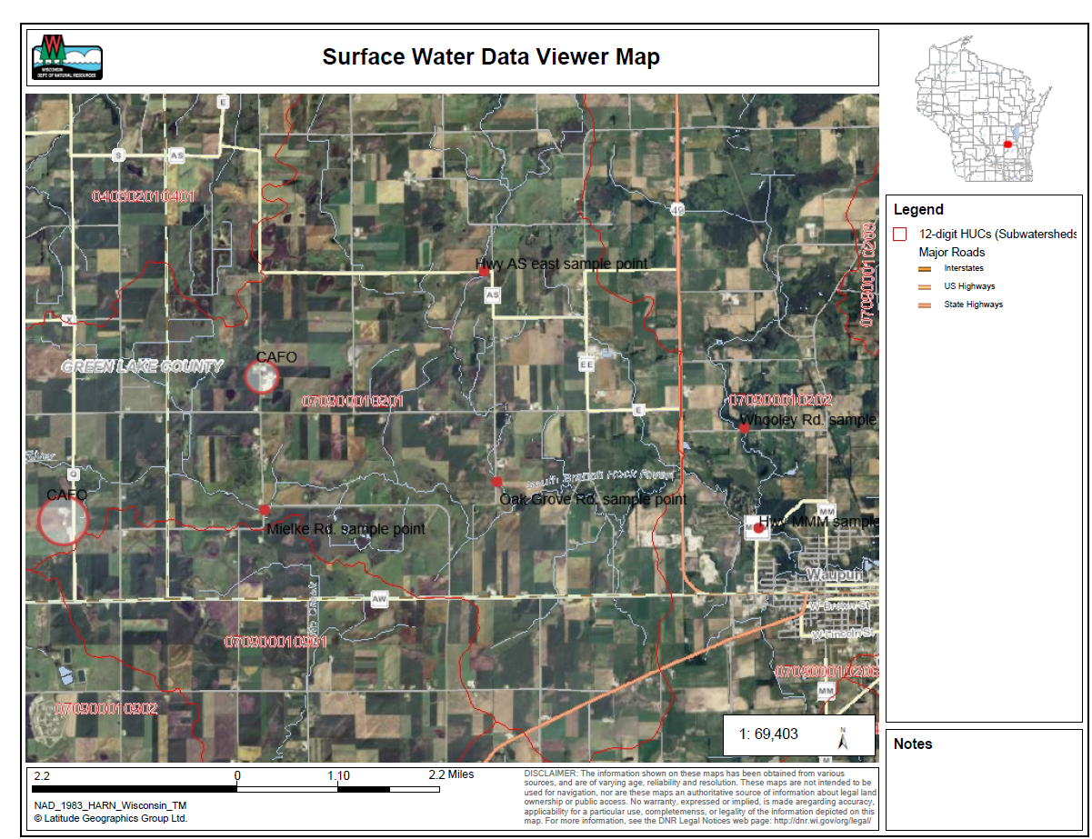

The fish IBI at the Oak Grove site was poor along with the habitat assessment. There was also considerable siltation in the stream.

The tributary at Hwy AS also had a poor fish IBI although the habitat at this stream was better than the Oak Grove Rd. site.

The Whooley Rd. and the Hwy MMM site did have fish IBI’s of fair although both sites were very close to being poor.

The Mielke Rd. site did have a fish IBI of good however the site also was straightened and did go into a wetland complex. All the sites did have excessive siltation which could account for some of the phosphorus numbers.

The results of the macroinvertebrate samples were not available at the time of this report.

West Branch Watershed Summary (Tables 7 &8)

Of the 5 sampling sites, 3 of them are located on the main stem of the West Branch of the Rock river. Phosphorus concentrations did get higher as the samples were taken downstream. The main stem of the West Branch at Hwy TC did have the highest concentration of total phosphorous.

Ladoga Creek did consistently have the lowest concentrations of phosphorous of all the sites and was consistently below the water quality standard of .075 mg/l. In addition, Ladoga Creek also had cool water temperatures even during the hottest days of summer. The habitat for Ladoga was also very good and there was little siltation.

Willow Creek did have some relatively low phosphorus numbers but there was some heavy siltation in the stream. There is a farm located just upstream of the Hwy 26 crossing that did allow animals (sheep and cattle) to graze into the stream.

The Hwy M site was heavily ditched and straightened and did appear to go directly through a wetland complex. The site also had excessive sedimentation and was very difficult to walk through.

The Metovale Rd. site did have adequate flow early in the spring but did dry up as the summer went along. There was no flow for the last 2 sampling events.

Recommendations

- Sampling should continue throughout the year, especially in the late winter to assess the runoff problems. Given the intensity of animal agriculture in the area, there are likely manure runoff issues from winter landspreading.
- Both watersheds do show impacts from excessive phosphorus loading; however if it is necessary to prioritize, the South Branch Watershed does appear to consistently have higher phosphorous concentrations and should be a higher priority
- This is only one year of data, another year or 2 should be collected for a more accurate assessment
- The Ladoga Creek watershed consistently is meeting water quality standards. A detailed assessment of land use in the watershed should be done to determine why this watershed is doing so well despite it being similar to the other areas in the watershed.
- Animal feedlots that are significant sources of phosphorous or nitrogen should be identified and corrected.
- The 2 large permitted farms should be monitored closely to ensure proper manure handling is being done.
- All farms in the watershed should have nutrient management plans and should be monitored to ensure those plans are being followed.
- Drain tile discharges should be identified and monitored to assess that contribution of phosphorous and nitrogen
- Although not included in this study, Alto Creek data does show elevated levels of phosphorus. The source of that phosphorus needs to be identified and corrected

