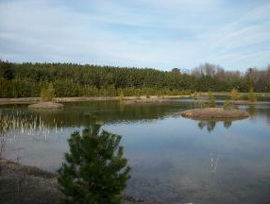
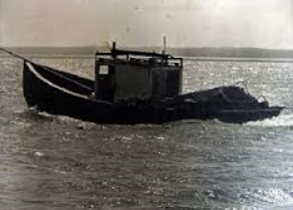
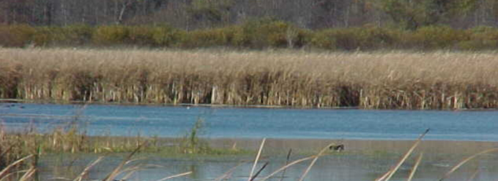

Milwaukee River South Watershed

[Type the abstract of the document here. The abstract is typically a short summary of the contents of the document. Type the abstract of the document here. The abstract is typically a short summary of the contents of the document.]
  - A Watershed Report created by the Bureau of Water Quality in support of the Clean Water Act.

Contents
Watershed Details 3
About the Watershed 3
Population and Land Use 3
Hydrology 4
Ecological Landscapes 4
Historical Note 5
Watershed Condition 5
Overall Condition 5
River and Stream Condition 5
Lake Health 5
Wetland Health 5
Groundwater 6
Point and Nonpoint Pollution 6
Waters of Note 6
Trout Waters 6
Outstanding and Exceptional Resource Waters 7
Impaired Waters 7
Fish Consumption 7
Aquatic Invasive Species 8
Species of Special Concern 8
State Natural and Wildlife Areas 8
The Green Bay West Shores Wildlife Area 8
Watershed Actions 8
Grants and Projects 8
Monitoring 8
Volunteer Monitoring 8
Basin/Watershed Partners 8
Priority Issues 8
Recommendations 8
Contributors 9

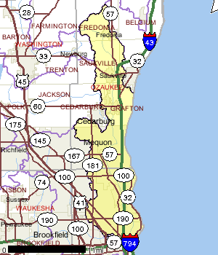
Watershed Details

About the Watershed
The Milwaukee River South Watershed covers about 168 square miles and is located in portions of Ozaukee and Milwaukee Counties. The Milwaukee River main stem enters the watershed west of the Village of Fredonia and flows for about 48 miles before entering the Milwaukee Harbor. There are three small named lakes, several unnamed lakes and many park ponds within the Milwaukee River South Watershed.
Most of the tributary streams in the Milwaukee County portion of this watershed are only capable of supporting populations of more tolerant fish species like common carp. Although not officially listed as a cold water stream, Mole Creek in Ozaukee County is the only river in the Milwaukee South Watershed with the ability to sustain cool and cold water fish species.
Figure 1 Watershed Location
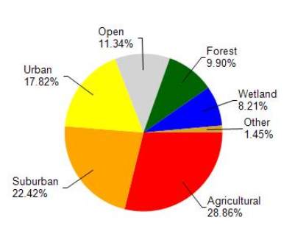

Population and Land Use
Land cover in the watershed is a mix of rural and urban uses. Land use in the watershed is primarily agricultural (28.86%), suburban (22.42%) and a mix of urban (17.82%) and other uses (30.90%). This watershed has 203.63 stream miles, 13,038.94 lake acres and 5,996.03 wetland acres.

Figure 2 Land Use 2006 NAIP Land Cover

Table 1 Milwaukee South Watershed
Land Use | % of Area
Agriculture | 28.86%
Forest | 9.9%
Wetlands | 8.21%
Open Land and Water | 11.34%
Suburban | 22.42%
Urban | 17.82%
Open | 11.34%
Total Acres in Watershed

Hydrology
Nearly 15 percent of all perennial stream miles in this watershed are significantly modified to the extent they have limited ability to sustain diverse biological communities. Many of these streams were straightened, enclosed or lined with concrete to facilitate water movement downstream to alleviate flooding concerns. This method to control flooding, while popular 35 years ago, is now considered somewhat ineffective.
From a water quality and biological standpoint this type of river modification causes wide fluctuations in water levels over short periods of time, increases channel scour, and provides little to no habitat for aquatic life. Establishing a meandering stream helps create more diverse habitat for biological activities. The Milwaukee Metropolitan Sewerage District (MMSD) is implementing major flood water storage and where possible, river restoration activities in Lincoln Creek, South branch Creek and Indian Creek and other area watersheds.
For more information on the Lincoln Creek flood control project and other MMSD watercourse activities, please visit the mmsd web site at: http://www.mmsd.com/lcreek/news_lcreek.html.

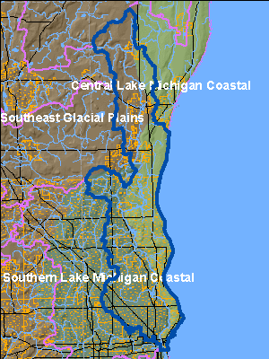
Ecological Landscapes
The Milwaukee River South Watershed is located in two ecological landscapes: the Southern Lake Michigan Coastal Ecological Landscape and the Central Lake Michigan Coast Ecological Landscape.
The Southern Lake Michigan Coastal Ecological Landscape is located in the southeastern corner of Wisconsin along Lake Michigan. The landforms in this Ecological Landscape are characteristic of glacial lake influence, with ridge and swale topography, clay bluffs, and lake plain along Lake Michigan. Further inland, ground moraine is the dominant landform. Soils typically have a silt-loam surface overlying loamy and clayey tills.
The historic vegetation in the northern part of this Ecological Landscape was dominated by sugar maple-basswood-beech forests with some oak while the southern part was dominated by oak forest, oak savanna and prairies. Wet, wet-mesic, and lake plain prairies were common in this area. Black ash and relict cedar and tamarack swamps were found in this Ecological Landscape. Today, most of the area is dominated by dairy and cash grain agriculture and intense urban development. Only about 8% of the Ecological Landscape is forested. Maple-beech forests are about half of the remaining forest types with the remainder split equally between oak-hickory and lowland hardwood forest types. There are some areas of wet-mesic and wet prairie but only small preserves remain since the landscape is heavily disturbed and fragmented. Because of this isolation, fragmentation, and high level of disturbance, non-native plants are abundant.
Figure 3 Ecological Landscapes of the Milwaukee South

Historical Note
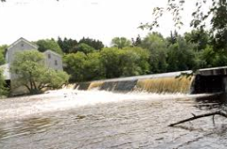
The hamlet of Waubeka, just outside of the Village of Fredonia in Ozaukee County, is located in the northern part of the Milwaukee River South Watershed. Waubeka is known as the birthplace of Flag Day. In 1885, Stony Hill School teacher Bernard John Cigrand displayed a 10-inch flag in an inkwell and had his students write essays on what the flag meant to them. He told the students that June 14th was the birthday of the flag. The school is now considered a historic site.
In 2001, a dam in Waubeka, built in 1925 was removed to release the free flowing river. The dam had been 10 ft. tall and 270 ft. long and created “Lake CiGrand”. Historically, residents would go to Lake CiGrand to slide down the dam to find relief from the heat.

Watershed Condition

Overall Condition
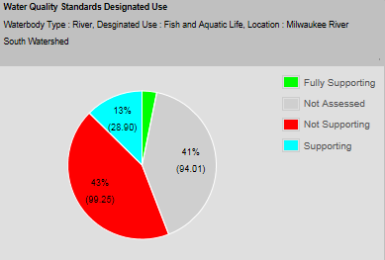
As with the other watersheds in the basin, the streams in the Milwaukee River South Watershed exhibit a wide range of quality. Over 35 stream miles within the Milwaukee South Watershed are listed on the 303(d) list), including the Milwaukee Estuary, a Great Lakes Area of Concern.
The Milwaukee Estuary area of concern encompasses the Milwaukee Harbor, the Milwaukee River downstream from the abandoned North Avenue Dam, the Menomonee River downstream from 25th street and the Kinnickinnic River downstream from Chase Avenue. The International Joint Commission (IJC) and U.S. EPA designated the Milwaukee Estuary in 1987 through the Great Lakes Water Quality Agreement as one of 43 Great Lakes Areas of Concern. These areas are usually industrial in nature, with a history of pollution.
In the Milwaukee Estuary, sediments contaminated with polycyclic aromatic hydrocarbons (PAHs), polychlorinated biphenyls (PCBs) and heavy metals are linked to degraded water quality, impaired fish and wildlife populations, and restrictions on dredging. A remedial action plan defining the problems with the estuary was published in 1989 by WDNR. A follow up plan further refining impairments and outlining a plan for restoring the estuary was published by WDNR in 1995. For more information about Great Lakes Areas of Concern, please visit the U.S. EPA web site at the following address: http://www.epa.gov/grtlakes/aoc/.

River and Stream Condition
In the past five years, over 21 streams in this watershed, covering 142 stream miles, have been monitored. A majority of the streams with monitoring data located in the Surface Water Integrated Monitoring System are indicated as “poor” for fish and aquatic life. The following streams are considered “poor”: Indian Creek, Kinnickinnic River, Lincoln Creek, Milwaukee Harbor, Milwaukee River, South Branch Creek, Beaver Creek, Un. Creek (Trinity Creek)(T09n R21e Se Ne 35), Fredonia Creek, Ulao Creek, and Fish Creek. These streams may be part of the 43% of the watershed stream miles that are considered “not supporting”.
The following streams are considered in “good “or better condition: Pigeon Creek, Unnamed Creek (Mole Creek)(T10n R21e Ne Ne 13), Cedar Creek, Unnamed Creek and Mole Creek.

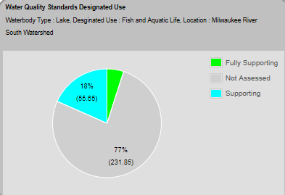
Lake Health
Twenty-three lakes and impoundments in this watershed have been monitored in the past five years. Of the lakes/impoundments monitored, only two have updated assessments for fish and aquatic life in the state’s assessment database.

Wetland Health
- Wetland Status
- Wetland Condition
- Wetland Restorability

Groundwater
- Private Wells
- Potential Sources of Contamination

Point and Nonpoint Pollution
From Viewer: Nearly all of the point source pollution in this watershed is coming from urban centers (see them listed below), namely Milwaukee. Permitted nonpoint source pollution in this watershed is largely coming from _____
Fredonia: Fredonia Municipal Sewer and Water Utility
Opitz Dairy Farm,
Saukville: Saukville Village Sewer Utility, Charter Steel Division of Charter MFG Co., Arkema Inc.,
Cedarburg/Grafton: Mid City Foundry United Division, Grafton High School Swimming Pool, Grafton Village Water and Wastewater Utility,
Fromm Family Pet Food,
Milwaukee and suburbs: Mequon Public Pool, JCC Family Park, Ozukee Country Club, North Shore Country Club, ITT Sanitaire, YMCA of Metro Milwaukee Schroeder YMCA, Badger Meter Inc., Milwaukee Country Club, Hydrite Chemical Company, Ritus Rubber Corporation, Western Products, Super Steel LLC Calumet, Kracor Inc., Hydro Platers Inc., Electron Beam Fusion, Corp, Hentzen Coatings Inc. Milwaukee, Amcor Flexibles, Inc., Chicago Faucets, Amcor Flexibles, Inc., Lallemaid Specialties Inc., Pereles Bros, Brady USA inc. Coated Products Div., Johnson Controls Inc., Pentair Residential Filtration LLC, Moore Oil Co Inc., Solenis LLC, Novozymes Bioag Inc., Stainless Foundry Engineering Inc., Milwaukee Gear Co Inc. Regal Beloit, Regal Beloit America Inc., Whitefish Bay High School Pool, Shea Kenny, Schulz Aquatic Center, Milwaukee Iron and Metal, DRS Power & Control Technologies, Inc., Wisconsin Thermoset Molding Inc., Johnson Controls Inc. Humboldt, C & D Technologies, Brewery Works Inc., Fred Usinger Inc., WE Engergies, Milwaukee Art Museum, Compass Properties, Milwaukee City, Discovery World at Pier Wisconsin, and Milwaukee Metro Sewer District Combined.

Waters of Note

Trout Waters
There are no trout waters in the Milwaukee River South Watershed.

Outstanding and Exceptional Resource Waters
There are no outstanding or exceptional resource waters located within the Milwaukee River South Watershed.

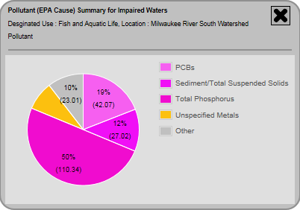
Impaired Waters

*Insert map of impaired waters
Table 2: Milwaukee River South Watershed Impaired Waters
Waters ID | Waterbody Name | WBIC | Acres/Miles Impaired | Impairment Status | Pollutants
1854856 | Milwaukee River | 15000 | 9.98 | 303d Listed, TMDL Approved | PCBs, E. coli
10005 | Indian Creek | 19600 | 2.63 | 303d Listed, TMDL Development | Unspecified Metals, Total Phosphorus, Sediment/Total Suspended Solids
10008 | Beaver Creek | 20000 | 2.69 | Addition, 303d Listed | Unknown Pollutant, Total Phosphorus
9999 | Lincoln Creek | 19400 | 9.7 | Addition, 303d Listed, TMDL Development | PCBs, PAHs, Unspecified Metals, Total Phosphorus, Chloride, Sediment/Total Suspended Solids
426381 | Milwaukee River | 15000 | 16.45 | Addition, TMDL Development, 303d Listed | PCBs, E. coli, Total Phosphorus
3991976 | Unnamed | 5032576 | 0.92 | Proposed for List | Chloride
3924909 | Fish Creek | 44700 | 3.38 | Proposed for List | Total Phosphorus
10014 | Fredonia Creek | 26600 | 4.2 | Proposed for List | Total Phosphorus
10012 | Ulao Creek | 21200 | 8.6 | Proposed for List | Total Phosphorus
10010 | Un. Creek (Trinity Creek)(T09n R21e Se Ne 35) | 20400 | 3.1 | Proposed for List | Total Phosphorus
10051 | Cedar Creek | 21300 | 5 | TMDL Approved | PCBs
426339 | Milwaukee River | 15000 | 2.9 | TMDL Development, 303d Listed | PCBs, E. coli, Total Phosphorus, Unspecified Metals
9973 | Kinnickinnic River | 15100 | 2.83 | TMDL Development, 303d Listed | PCBs, E. coli, Total Phosphorus, Unspecified Metals, Fecal Coliform
426424 | Milwaukee Harbor | 15010 | 0.32 | TMDL Development, 303d Listed | PCBs, E. coli, Unspecified Metals
3899370 | South Branch Creek | 3000073 | 2.36 | TMDL Development, 303d Listed | Total Phosphorus, Sediment/Total Suspended Solids
1452363 | Atwater Beach | 20 | 0.65 | Water Delisted | E. coli
481465 | Bradford Beach | 20 | 0.64 | Water Delisted | E. coli
481498 | Mckinley Beach | 20 | 0.59 | Water Delisted | E. coli
481532 | Tietjen Beach-Doctors Park | 20 | 0.81 | Water Delisted | E. coli
481566 | Milwaukee River | 15000 | 39.17 | Water Delisted, Proposed for List | PCBs, Total Phosphorus

Fish Consumption
Wisconsin’s fish consumption advisory is based on the work of public health, water quality, and fisheries experts from eight Great Lakes states. Based on the best available scientific evidence, these scientists determined how much fish is safe to eat over a lifetime based on the amount of contaminants found in the fish and how those contaminants affect human health. Advisories are based on concentrations of contaminants, along with angler habits, fishing regulations, and other factors.
In 2001, Wisconsin adopted a statewide general fish consumption advisory that applies to all (non-Great Lakes) waters of the state based on statewide distribution of mercury in fish and species differences in mercury concentrations. The statewide general advisory eliminated the need for many of the pre-2001 advisories because the equivalent of more stringent advice now applied through the general advisory. In addition to the statewide general advisory, some waters still require more stringent advice or exceptions to the general advisory. Exceptions to the general advice apply to some species of fish from specific waters where higher concentrations of mercury, PCBs, or other chemicals require advice more stringent than the general advisory.
Cedar Creek downstream from Bridge Road in Cedarburg, and the Milwaukee River Estuary and tributaries to Estabrook Falls, have a specific fish consumption advisory in addition to the general statewide advice. The specific advisory is for contaminated fish tissue from polychlorinated biphenyls (PCBs). More information about the specific consumption advisory can be found in the publication: Choose wisely: a health guide for eating fish in Wisconsin [PUB-FH-824]. It is available online at http://dnr.wi.gov/topic/fishing/consumption/index.html.

Aquatic Invasive Species

Species of Special Concern
Two threatened species of fish. The redfin shiner (Lythrurus umbratilis) and the longear sunfish (Lepomis megalotis) have been reported in the Suamico River. The threatened wood turtle (Clemmys insculpta) breeds and over-winters in portions of the river. A full list of special concern plants and animals for this watershed can be found on the state’s Natural Heritage Inventory (NHI) at http://dnr.wi.gov/topic/nhi/.

State Natural and Wildlife Areas

The Green Bay West Shores Wildlife Area
The Green Bay West Shores Wildlife Area is located allow the west shore Green Bay within Oconto County. The wildlife area contains deltas formed by the Oconto River and the Suamico river, which serve as an important habitat for water fowl and fish populations in the Green Bay region. The Green Bay West Shores Wildlife Area is contained within the larger ecological unit known as the Pensaukee River Wetlands Complex. The state wildlife area is used for many kinds of recreation including hunting, fishing, trapping, boating, snowmobiling, and cross-country skiing. For more information please visit the Wisconsin Coastal Wetlands Management program and the Wisconsin Wetlands Association.

Watershed Actions

Grants and Projects
Grant Details Habitat Date 10/1/2010
Waters Involved Lake Michigan Status
West Shore Green Bay Northern Pike Habitat Project: The northern pike (Esox lucius) is Wisconsin’s second largest predator fish and is an important part of the Green Bay ecosystem and fish community. Northern pike have become scarce in Green Bay due to wetland habitat losses of as high as 70% (Bosley, 1978) due to a combination of human and non-human factors (Rost, 1996). In addition, fish encounter passage obstacles when leaving Green Bay to find spawning marshes or when fry migrate back to Green Bay. Small perennial and intermittent streams (including roadside and agricultural ditches) on the western shore of Green Bay provide high quality fish spawning and rearing habitat for northern pike (Rost 1992, 1993, 1994, 1995, 1996). These streams and pooled wetlands provide very productive habitat for other fish species as well as aquatic organisms. Reproduction in these wetlands is likely a principle source of recruitment for fish populations in Green Bay.
In 1998-99, the Wisconsin Department of Natural Resources (WDNR) conducted a habitat assessment in the Suamico and Little Suamico Rivers watershed basins. Physical, chemical, and biological data were collected. Areas were identified for protection/restoration of northern pike spawning and rearing habitat. Study results revealed that the major impediments were excessive algae from eutrophication along with stream flashiness (extremely rapid increases and then decreases in stream discharge following rain events). In another study on lower Green Bay, the scarcity of top predator species, such as northern pike, was recognized as a significant problem in the Green Bay ecosystem . It is estimated that over 70% of the spawning habitat for northern pike has been lost. Since lost habitat also provided plankton to downstream communities, the Green Bay ecosystem continues to be out of balance.

Grant Details Targeted Runoff - Rural Construction Date 10/15/2008
Waters Involved Unnamed Status Complete
Outagamie County: Vandehei Farms Manure Storage: To cost-share landowner installation of additional manure management systems to increase storage capacity and address the Agricultural Performance Standards and Prohibitions in Subchapter II of NR 151 relating to manure storage facilities, nutrient management, prevention of overflow from manure storage facilities, prevention of unconfined manure piles in water quality management areas, and prevention of direct runoff from a feedlot or stored manure into waters of the state.

Grant Details Urban Nonpoint - Stormwater Planning Date 1/1/2007
Waters Involved Unnamed Status Complete
Village Of Suamico: Storm Water Plan: To cost-share creation of runoff management ordinances, establishment of a public education program, and development of a storm water management plan for the Village.
In addition to the projects above a number of pass through funding projects have been carried out in the watershed and nearby or affected county. See below for detail regarding these projects.
Project Name (Click for Details) | Year Awarded
Aquatic Invasives County Coordinator - Brown County | 2011
Aquatic Invasives County Coordinator - Oconto County | 2011
Aquatic Invasives County Coordinator - Outagamie County | 2011
Aquatic Invasives County Coordinator - Shawano County | 2011
Aquatic Invasives County Coordinator - Taylor County | 2011
BROWN COUNTY: Brown County Shoreland Ordinance Revision Project | 2010
Brown County Navigability | 2008
Cat Island Chain Restoration Project | 2010
Fish Propagation Actions | 2001
GLACIERLAND RC&D, INC.: Glacierland RCD Tri-County Clean Boats Project | 2010
LUMBERJACK RC&D COUNCIL: Oconto & Marinette Counties Motor Tour Guide of Shoreland Restoration Projects Development | 2005
OCONTO COUNTY: Gohr Farm Runoff Control | 2009
OCONTO COUNTY: Oconto County Clean Boats-Clean Waters Project | 2006
OCONTO COUNTY: Oconto County Lake Classification Ordinance Development | 2004
OCONTO COUNTY: Oconto County Lakes Classification Project | 2001
OUTAGAMIE COUNTY: Outagamie County Shoreland Ordinance Revision Project | 2010
OUTAGAMIE COUNTY: Vandehei Farms Manure Storage | 2008
Outagamie Navigability | 2008
SHAWANO COUNTY: Shawano County Lake Classification Study | 2000
SHAWANO COUNTY: Shawano County Lakes AIS Project | 2010
SHAWANO COUNTY: Shawano County Shoreland Ordinance Evaluation | 2001
SHAWANO COUNTY: Shawano County Shoreland Ordinance Revision Project | 2010
SHAWANO COUNTY: Shawano County leyogonimus Parasite Study Phase 2 | 1999
Suamico Little Suamico Rivers (GB01) Watershed Planning | 2012
VILLAGE OF SUAMICO: Storm Water Plan | 2007
West Shore Green Bay Northern Pike Habitat Project | 2010
West shore of Green Bay Northern Pike Habitat Project | 2010

Monitoring
Great Lakes Beaches - 2002 Pilot Project 1/1/1960 Complete Monitoring for pathogens at Great Lakes to help assessment beach quality under the state's Recreational Use Designation.
Lake Michigan Basin Wetland Intensification Study 8/1/2011 Active Monitoring data are needed to assess the health of existing wetlands and measure the success of restoration projects. It is clear that to report a more complete picture on the status of wetlands we will need to develop more measures of wetland quality. We have worked with EPA to develop methods to assess wetland health, known as “condition assessment,” and continue to work on additional methods. The EPA is planning a condition assessment survey of the nation’s wetlands to be carried out in 2011. The Department is part of the work group designing the national survey. This is an intensification of the national survey that to focus in on Wisconsin wetlands, most likely within a particular watershed or river basin.
NER NC Stream Stratified Sites 2010, 2011 5/24/2010 Complete Project for Natural Communities. This project selects sites from all wadeable streams (83,500 miles, which includes ephemeral and macroinvertebrate streams). The random sites stratified by natural community (nc) and Region by Weigel. Two-hundred sites are sampled per year (approximately 25 sites per natural community per basin). This is a five year study. The sites are mapped on SWDV. April-October sampling
NER NC Stream Stratified Sites 2012 7/1/2012 Active Project for Natural Communities. This project selects sites from all wadeable streams (83,500 miles, which includes ephemeral and macroinvertebrate streams). The random sites stratified by natural community (nc) and Region by Weigel. Two-hundred sites are sampled per year (approximately 25 sites per natural community per basin). This is a five year study. The sites are mapped on SWDV. April-October sampling
NER Watershed Rotation Sites (Non_LTT) 7/1/2005 Complete Stream water quality monitoring covering primarily biological, chemical, and habitat related monitoring to determine ambient conditions at "pour point" locations for each of state's 330 watersheds.
Severely Impacted Sites 2012 7/1/2012 Active 100 sites total per year in 2012 and 2013 Identify most-impacted stream sites in state
Severely Impacted Sites 2013 3/27/2013 Active 100 sites total per year in 2012 and 2013 Identify most-impacted stream sites in state

Volunteer Monitoring
There are no citizen monitors in the Suamico/Little Suamico River Watershed. For information on how to become a Water Action Volunteer Stream Monitor, visit- http://watermonitoring.uwex.edu/index.html.

Basin/Watershed Partners

Priority Issues

Recommendations
Restore Wetlands to prevent altered food webs, a loss of biodiversity, and a poorly functioning ecosystem.
District WRM should conduct basin assessment monitoring on streams in the Suamico and Little Suamico Rivers watershed so the watershed can be ranked for possible nonpoint source priority watershed selection.

Contributors
Ruth Person, Lisa Helmuth, Mark Binder, Burke Pinney, and Deanna Sell

