East Branch Rock River Watershed Monitoring Project

Monitoring, Restoration and Evaluation Activities in the Watershed

Watersheds: East Branch Rock River HUC 10-0709000101
- Village of Theresa East Branch Rock River HUC 12-070900010106

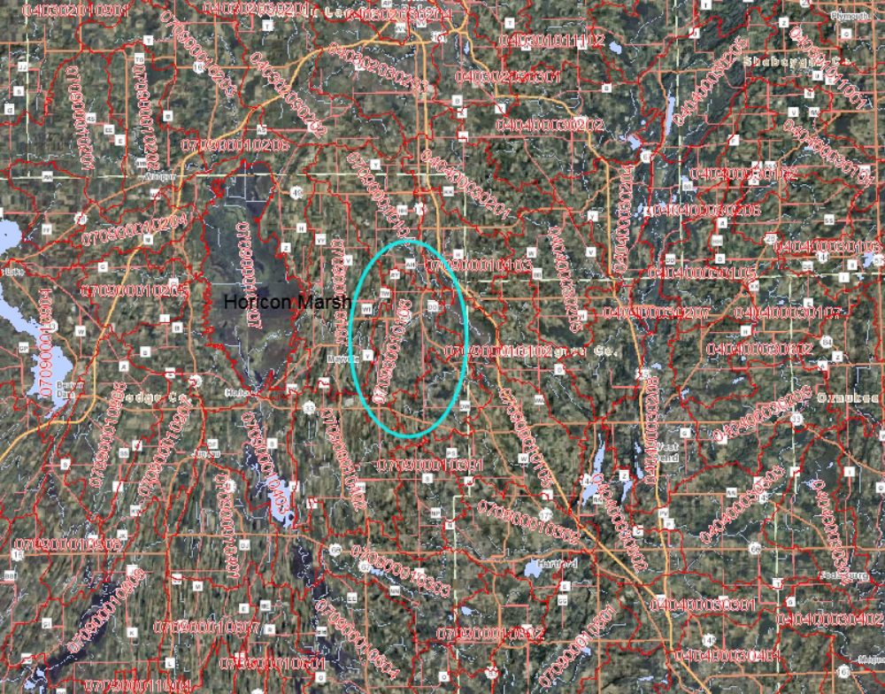

Table of Contents

Background………………………………………………………………….3

Watershed descriptions………………………………………………………5

Watershed improvements……………………………………………………7

Pour Point Monitoring Data…………………………………………………9

Sub-watershed Monitoring Data……………………………………………..10

Costs………………………………………………………………………….12

Background

The project area includes the portion of the East Branch Rock River Watershed between the City of Mayville and the Village of Theresa. The HUC 12 is about 15,770 acres. The watershed is predominately agriculture with the Village of Theresa covering a small portion.

Resources and Landscape Description:

The East Branch of the Rock River flows through the identified watershed. There are numerous small tributaries and drainage ditches connecting to the East Branch that drain the watershed. The landscape consists of numerous drumlins with wetland areas between. The drumlins are sloped but most are still farmed. There are approximately 30 farms with animals within the watershed boundaries ranging in size from a few to over 1000 animal units. The CAFO (confined animal feeding operation) is located in the eastern portion of the watershed with many of its manure spreading sites located within the watershed. The Village of Theresa does have a wastewater treatment plant with an outfall to the east Branch.

Geographic Location:

The watershed is located approximately 5 miles east of the Horicon Marsh and is in the counties of Dodge and Washington.

Pasture | Cropland | Wetland | Other
30% | 41% | 13% | 16%

Theresa/Mayville HUC 12-070900010106

The HUC 12 consists of numerous headwater area ditches and streams, which flow in various directions and empty into the main stem of the East Branch of the Rock River. A small portion of the watershed on the east edge is located in Washington County. The majority of the watershed is located in Dodge county. The most significant river in the watershed is the main stem of the East Branch of the Rock River. As in most other watersheds in the Rock River Basin, the streams and rivers have low gradients

This portion of the East Branch is not on the 303d list Only the most western part of the East Branch is currently on the list. Current data does suggest the possibility of more being added. Created by the Environmental Protection Agency (EPA), the 303(d) listed waters are those waters, which have impairments that prohibit them from meeting their potential use and meeting water quality standards. Environmental problems have impacted the level of flow, habitat, fish migration, turbidity, dissolved oxygen, and sedimentation. Efforts have been made over the past 20 years to reduce nonpoint and point source pollution. Despite these efforts, however, the majority of the Rock River Basin continues to be on the 303(d) list of impaired waters.

Although there is some significant sources of point source pollution to the river, the greatest water quality problem in this stretch of the East Branch Rock River is from rural nonpoint source pollution. There is some urban stormwater runoff which carries sediment and pollutants to area surface waters. In addition, areas of high development pressures in the area pose the threat of increasing construction site erosion. As the demand for waterfront property grows in the area, the East Branch Rock River could face increasing development pressure.

Rural sources of nonpoint pollution come from cropland erosion and runoff from barnyards and cattle exercise lots. Runoff from agricultural lands carries nutrients and sediment, which harm the aquatic habitat and water quality in the watershed. Sedimentation of the river also increases the turbidity of the water and decreases the amount of dissolved oxygen in the water.

There is only one municipal wastewater facilities discharging into the watershed, but there are several point sources upstream of this particular HUC 12 watershed. The Village of Theresa does discharge into the East Branch Rock river in this watershed but the villages of Brownsville, Allenton and Lomira discharge upstream. There is also one industrial point source discharge, Grande Cheese - Brownsville.

Hydrologic modifications to surface waters also negatively impacts water quality. The East Branch Rock River has undergone only limited channelization projects, but its flow has been interrupted by a several dams. Many of the smaller tributaries to the East Branch have undergone channelization.

Dams, and other hydrologic modifications, can impair water quality by slowing flow, acting as sediment and nutrient collection basins, impeding fish movement, warming waters in the impoundment and, consequently, warming waters downstream.

The East Branch Rock River is used for a variety of water related recreational purposes. The river provides opportunities for fishing, canoeing, hunting and other recreation. In addition to its use for human activities, significant tracts of wetlands are productive for waterfowl.

The East Branch Rock River and its tributaries in this HUC 12 watershed does support a somewhat diverse warmwater, including northern pike, largemouth bass, rock bass, bluegill, black crappie, pumpkinseed, green sunfish, white sucker, yellow and black bullhead, tadpole madtom, common carp, bluntnose and fathead minnow, Creek chub, blacknose dace,central mudminnow, Johnny darter, fantail darter, brook stickleback.

Tributaries in this HUC 12 Watershed

Trib to East Branch – North Pole Rd.
This tributary is a small stream that feeds into the East Branch of the Rock River. It is a shallow, narrow stream with average depth less than 3 feet. It enters the River just downstream of the Theresa Marsh wildlife Area. Factors contributing to poor water quality in this stream are high nutrient loading from an agricultural runoff. The may also be drain tile discharges which would also be a problem for this stream. The stream also flows very near to a CAFO and many of the manure spreading sites are likely located within the drainage of this watershed.

Trib to East Branch – Hwy 28
This small tributary flows into the East Branch of the Rock River just west of the Village of Theresa. The stream appeared to have been dredged within the last year or two as there was limited vegetation along the banks. The banks were also steep with a 20 -30% slope or more. Factors adversely affecting this stream are: cropland erosion, wetland loss, streambank and riparian zone erosion. There is little to no vegetative buffer in the area sampled as crops are within several feet of the stream. There are some wetlands still present in the upstream reaches but most have been drained and are now being farmed.

Trib to East Branch – Hwy Y
This tributary is a small stream that flows directly into the East Branch of the Rock River from the south just east of the City of Mayville. It is located between drumlins and would have an extensive network of wetlands. However most of the wetlands have been drained and are listed as potentialbly restoreable. Once again, the stream is severely impacted from agricultural runoff, tile drainage and hydrologic modification.

Trib to East Branch – Allen Rd.
This tributary is a small stream that flows directly into the East Branch east of the city of Mayville. The stream flows for about 4 miles from the south through an area of niagra escarpment with a relatively steep gradient. There may be some springs in the area that contribute to the flow. The higher nitrate-nitrite levels are indicative of this. The lower part of the stream does go through agriculture land so is affected by runoff during events. It also suffers from channelization in the lower stretch.

Trib to East Branch – McArthur Rd.

This is a low gradient stream that flows from the south about 3 miles before entering the East Branch. There are considerable wetlands associated with this streams drainage area although it does appear to be some channelization through the wetlands. It is unclear as to the impacts the channelization has had on water quality. The stream was heavily impacted by excessive vegetative growth. This stream did have the highest level of phosphorous of all the streams sampled. This was found during base flow conditions which may be linked to the wetlands.

2014 East Branch Rock River Subwatershed Monitoring Project

According to the Rock River TMDL this HUC 12 of the East Branch watershed has some of the highest amounts of phosphorous and sediments entering the River. The monitoring project began in May 2014 and included 7 different locations. There were 5 tributaries of the East Branch monitored and 2 locations on the main stem of the East Branch. Water quality samples were taken from each location a total of 3 times from May through October and analyzed for nitrogen, phosphorus and suspended solids. In addition, a fish survey was done at each location as well as an invertebrate sample taken.

HUC 12 sampling locations

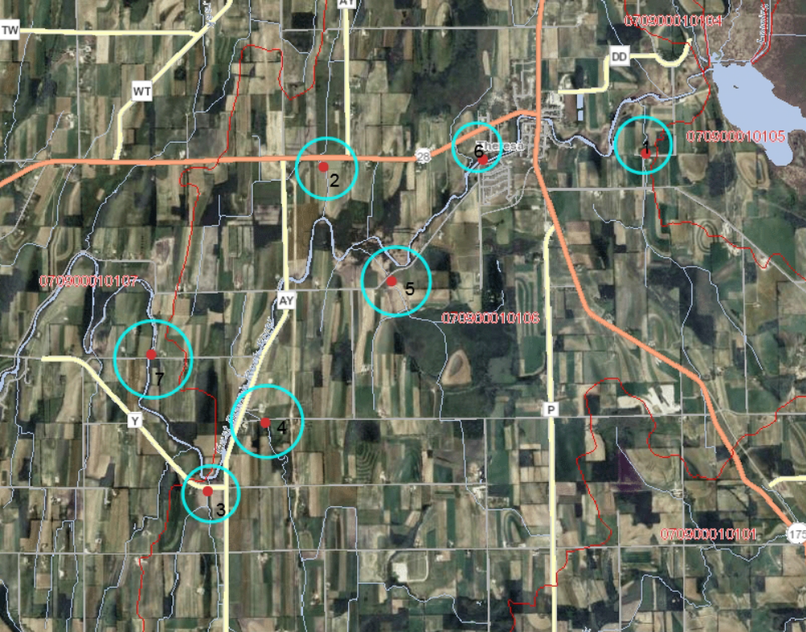

1) Trib to East Branch - North Pole Rd. – FIBI = 50 (fair); MIBI = ?
-note: too few fish to accurately calculate

2) Trib to East Branch – Hwy 28 - FIBI=0 (poor); MIBI=?

3) Trib. to East Branch – Hwy Y.- FIBI = 40 (fair); MIBI = ?

4) Trib. to East Branch – Allen Rd.- FIBI = 60 (fair); MIBI = ?

5) Trib to East Branch – McArthur Rd. FIBI=Equipment breakdown and were unable to finish survey, did get all mudminnows prior to breakdown; MIBI=?

6) East Branch Rock River – McArthur Rd. – FIBI – 52 (good); MIBI=?

7) East Branch Rock River – Gill Rd. – FIBI – 37 (fair)

Table 5 – Total phosphorous (mg/l)

Date | Trib to East Branch- N. Pole Rd. | Trib to East Branch-Hwy 28 | Trib to East Branch-Hwy Y | Trib to East Brranch- Allen Rd. | Trib to East Branch-McArthur Rd. | East Branch Rock River-McArthur Rd. | East Branch Rock River-Gill Rd.
06/25/2014 | .356 | .216 | .255 | .148 | .326 | .320 | .317
07/29/2014 | .264 | .137 | .101 | .070 | .473 | .174 | .182
09/22/2014 | .392 | .134 | .115 | .141 | .642 | .093 | .106

Table 6 – Total Kjeldahl Nitrogen

Date | Trib to East Branch- N. Pole Rd. | Trib to East Branch-Hwy 28 | Trib to East Branch-Hwy Y | Trib to East Branch- Allen Rd. | Trib to East Branch-McArthur Rd. | East Branch Rock River-McArthur Rd. | East Branch Rock River-Gill Rd.
06/25/2014 | 2.24 | 1.21 | 1.02 | .749 | 1.44 | 1.29 | 1.29
07/29/2014 | 1.08 | .907 | .42 | .334 | 1.37 | 1.33 | 1.09
09/22/2014 | 1.37 | 1.05 | .644 | .608 | 2.12 | .81 | .676

Table 7 – NO2 + NO3 nitrate

Date | Trib to East Branch- N. Pole Rd. | Trib to East Branch-Hwy 28 | Trib to East Branch-Hwy Y | Trib to East Brranch- Allen Rd. | Trib to East Branch-McArthur Rd. | East Branch Rock River-McArthur Rd. | East Branch Rock River-Gill Rd.
06/25/2014 | 6.13 | 2.03 | 4.25 | 6.97 | .547 | .575 | .736
07/29/2014 | 5.14 | 2.03 | 5.7 | 9.15 | .1 | 2.65 | 2.29
09/22/2014 | 3.55 | 2.51 | 5.75 | 9.67 | .115 | 7.16 | 6.83

East Branch Data Assessment

General Summary

Only 3 water quality samples were taken during the sampling season of May – October. Flow was not taken at any of the stations so no mass loading numbers are available.

There was only 1 significant rain event where runoff created somewhat higher flow in the streams. On June 23 there was about 1 inch of rain. As expected, there was an increase in concentrations of phosphorous and TKN as compared to the other 2 sampling events. Only one sample had a phosphorous level below the standard of .075 mg/l. Nearly all other samples were well above the phosphorous threshold.

It does appear that the inflow of these tributaries and other inflow is having a negative effect on the quality of the East Branch. The fish index of biotic integrity was considerably lower in the downstream section that was sampled. The invertebrate results are not in but it was very difficult to even get enough invertebrates in the downstream sample of the East Branch to be a valid sample.

Recommendations

- Sampling should continue throughout the year, especially in the late winter to assess the runoff problems. Given the intensity of animal agriculture in the area, there are likely manure runoff issues from winter landspreading.
- The data does show the watershed to be impacted from phosphorous loading. However, with the information collected I could not prioritize one subwatershed over another. Only the tributary at the Allen Rd. crossing had an acceptable phosphorus concentration but that was only during one sampling event.
- This is only one year of data, another year or 2 should be collected for a more accurate assessment.
- Animal feedlots that are significant sources of phosphorous or nitrogen should be identified and corrected.
- The 1 large permitted farms should be monitored closely to ensure proper manure handling is being done.
- All farms in the watershed should have nutrient management plans and should be monitored to ensure those plans are being followed.
- Drain tile discharges should be identified and monitored to assess that contribution of phosphorous and nitrogen

