Helen Lake, Portage County (WBIC 323700)
Herbicide Sample Plan, 2014
John Skogerboe

Helen Lake, Portage County is 89 acres with a maximum depth of 20 ft, and a mean depth of 8 ft. The lake is classified as an oligotrophic, seepage lake in the WI DNR lake finder web site. The herbicide 2,4-D is proposed to be applied to the lake in spring 2014 to control Eurasian watermilfoil.

Water samples will need to be collected at sites and depths listed below. A map of the herbicide sample site locations is attached and the coordinates are provided with the map. Data are in degrees and the datum is WGS84. The coordinates can also be emailed to you.

Helen Lake Herbicide Sample Sites
Site | Sample Depth
Hel1 | Integrated
Hel2 | Integrated
Hel3 | Integrated

Samples will need to be collected at different time intervals throughout the project and are listed below.

Helen Lake Herbicide Sample Intervals,
Interval | Samples/interval | Total Samples
1 DAT | 3 | 3
3 DAT | 3 | 6
5 DAT | 3 | 9
7 DAT | 3 | 12
14 DAT | 3 | 15
21 DAT | 4 | 18
28 DAT | 3 | 21
35 DAT | 3 | 24
42 DAT | 3 | 27
56 DAT | 3 | 30

- Water samples can be collected using an integrated water sampler. An example of how to construct an integrated sampling device using a sump pump check valve, a 2" to 1 1/2" coupler, and an 8 to 10 ft section of PVC pipe is provided below. I can provide one if necessary, but shipping the PVC is cumbersome. The materials can be purchased at a hardware store and are inexpensive. Water is collected by pushing the pipe straight down to within 1 ft of the bottom or as far as it will go in deep water. The pipe is brought to the surface and emptied into a bucket using a screw driver to push open the check valve. If you already have a water sampling device that you feel comfortable with, please use that instead of the integrated sample device.

- Samples should be collected at each point using a GPS at each interval listed above. If you cannot collect a sample at the interval listed above please collect the sample as soon as reasonably possible and record the change. Sample bottles and labels will be provided. If you need a GPS please let us know.

- Please print out a data sheet, included, for each sample interval and fill in the shaded boxes including:

Collector Name
Phone Number
Sample Interval, 1 DAT, 3 DAT, 5 DAT, etc.
Date (sample collected)
Time (sample collected)
Water Temp
Wind Direction and Speed (i.e. 5 to 10 mph, W SW

- Water sample bottle kits will be sent to the sample collection coordinator along with directions for sample handling from the State Laboratory of Hygiene (SLOH). When all of the sample intervals are completed, please return the samples along with the data sheets from each sample interval to the SLOH.

If you have and questions, please call or email one of us. We can be reached at the following:

John Skogerboe
jskogerboe@comcast.net
Cell Phone (651) 328-0769

Curtis Hedman, PhD
SLOH
curtis.hedman@slh.wisc.edu
Office (608) 224-6271
Scott Van Egeren
WI DNR
scott.vanegeren@dnr.state.wi.us
Office (608) 264-8895
Helen Lake Herbicide Sample Locations, 2014
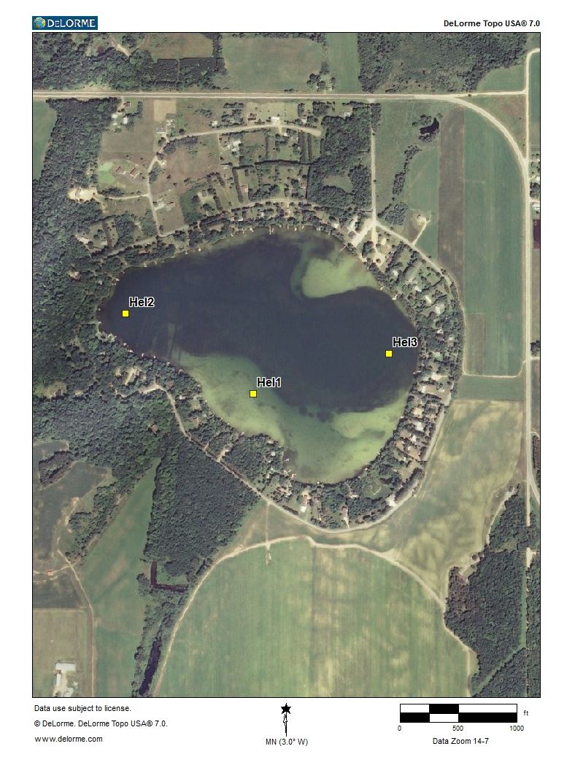

Helen Lake herbicide sample site coordinates

North West Sample Site
44.617099 -89.242601 Hel1
44.618981 -89.246807 Hel2
44.618032 -89.238125 Hel3
Integrated Water Sample Device
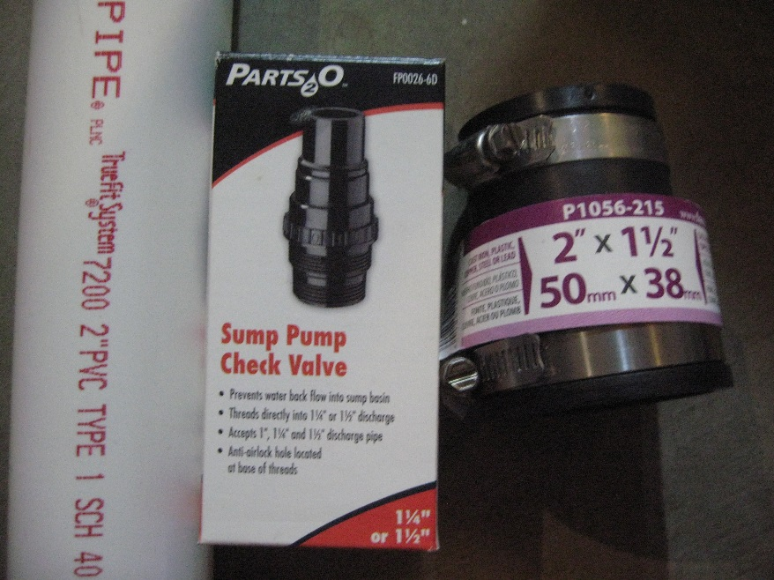
Integrated sampler requirements,
2"Pvc pipe, sump pump check valve, and 2"x 1 1/2"couping

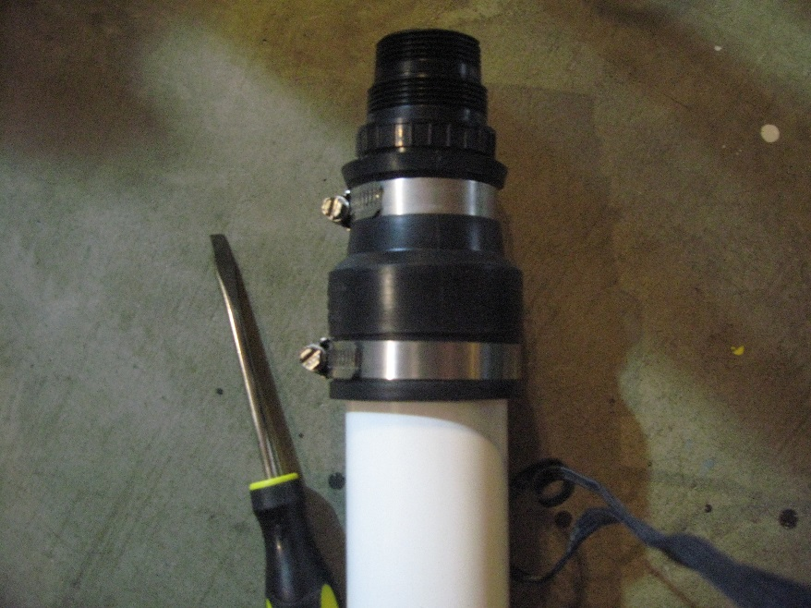
Assemble integrated sampler with a flathead screw driver.
