A 2014 Survey

of the

Sugar River Mainstem

(WBIC = 875300)

Green and Rock Counties.

Project SCR_13_CMP14

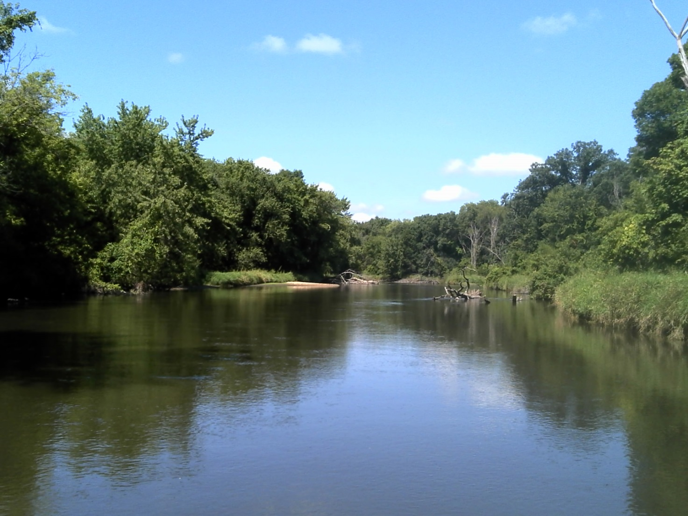
Sugar River upstream of Beloit-Newark Rd

By James Amrhein and Michael Sorge

Water Quality Biologists
Water District - South

March, 2015
The Sugar River has its origin in the groundwater fed springs in the rolling landscape east of the village of Mount Horeb, Wisconsin and flows 91 miles southeasterly until it crosses the Wisconsin-Illinois border and joins the Pecatonica River between Shirland and Harrison, Illinois.

The entire 81 mile length of the Sugar River within the state’s boundary is designated as an Exceptional Resource Water (ERW). The upper 20 miles of the river were recently designated as Class II trout waters by the fisheries management bureau. The water resources designation continues to be "warm water sport fish” for the entire length of stream.

The river has 3 low-head dams along its length – at Belleville, Albany, and Brodhead. These same municipalities also have waste water discharges directly to the river. While most of the stream flows through agricultural land, the lower 10 miles in Wisconsin flows through the Avon Bottoms State Wildlife Area. There is also a small 1 mile section that flows through the Albany State Wildlife Area. The flood zone of the Sugar River provides a de facto buffer along many sections of the river. This corridor is a mixture of floodplain forest and meadow and is home to many wildlife species, but also offers a source of woody debris as habitat when it falls into the river.

The department’s current monitoring of lotic systems generally focuses on wadable resources within smaller management units (HUC 10 or 12). As such, larger systems with non-wadable sections tend to be overlooked, but can be a major indicator of ecosystem health on a much larger scale - HUC 8 or “basins”. These larger systems also provide the habitat and forage for larger fish species, as well as serving as a source of species recruitment to tributaries, a conduit for fish movement, and a refuge for certain species during winter and/or low water years. Several rare species have also been reported in the Sugar River mainstem including the gravel chub, silver chub, pallid shiner, redfin shiner and river redhorse.

Methods
The Wisconsin Streams Model (Lyons, 2008) shows the Sugar River to be a cool-warm mainstem from Belleville to Albany, a warm mainstem from Albany to Brodhead, and a large river downstream of Brodhead (Figure 1). The 50 mile section of Sugar River below the dam at Belleville to the Illinois border contains a mixture of wadable and non-wadable sections. As such, it was decided the most efficient and consistent way to sample the river was to use the sampling protocol developed by Lyons, et. al. (2001) for sampling large, warmwater rivers.

To summarize, a pulsed-DC “miniboom” electrofishing unit was used to sample 1 mile (1600 meter) stations either upstream or downstream of 8 points along the Sugar River. There was no scientific reason behind these points other than they provided an access large enough to launch the shocker boat, but coincidentally, these access points provided a fairly uniform sampling distance along the river. The main gap in the survey points was between CTH EE and CTH F. This section contains the two impoundments along the river formed by the dams at Albany (Albany Lake) and Brodhead (Decatur Lake).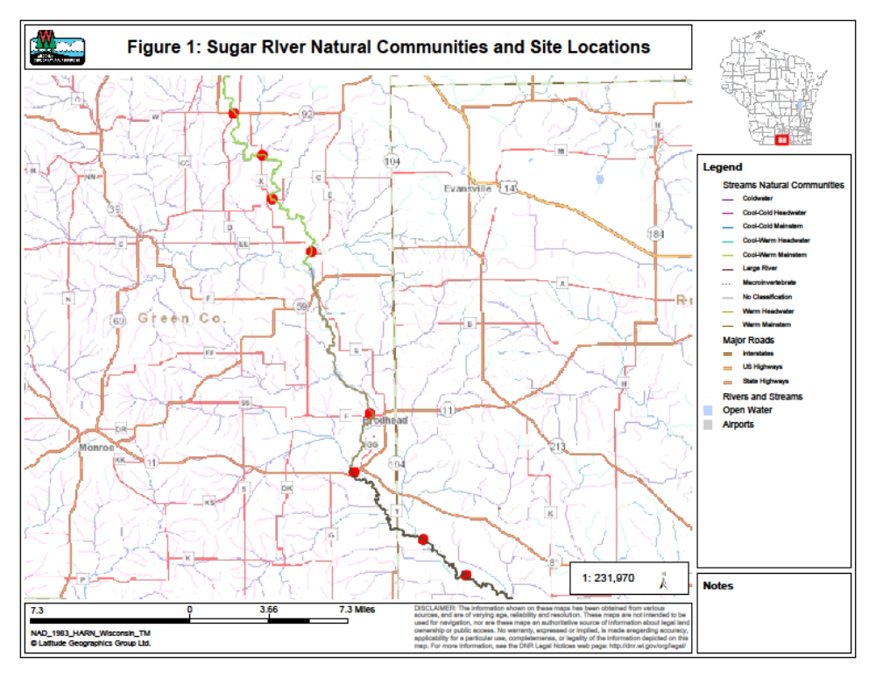
The individual surveys were always conducted in a downstream direction, with emphasis on sampling main channel border habitats in close proximity to the shoreline and generally consistent with the thalweg.

The surveys were conducted between August 18th and August 22nd, 2014. River flows were not considered unusually high or low during that time period when compared to USGS flow gauging stations located in the City of Verona at the upper end of the Sugar River and at the Village of Brodhead near the lower end of the river. Gauge data at Brodhead during the week of sampling showed the river to be between 300 and 350 ft³/second and approximately 100 to 150 ft³/second higher compared to the 100 year median statistic. The gauge height at Brodhead varied from 1.03ft to 1.29ft during the sampling period (USGS, 2014).

During sampling, 1 person stationed in the front of the boat used a 3/16 inch dip net in an attempt to capture all fish observed. All captured fish were identified. Game and panfish species were measured and weighed individually. Nongame fish were counted and weighed in aggregate by species.

At each site, qualitative notes on average stream width and depth, riparian buffers and land use, evidence of sedimentation, fish cover and potential management options were also recorded. A qualitative habitat survey (Simonson, et. al., 1994) for streams greater than 10 meters wide was also performed at each site. It should be noted this qualitative habitat assessment is more appropriate for wadable streams, but for the purposes of this study, was used for comparison of sites relative to one another.

Results
A total of 34 fish species were collected during the survey (Table 1), although almost half of them were captured in small numbers of 1-3 individuals. Many of these were minnow species which are not optimally sampled using this technique. Shorthead redhorse were the most frequently sampled species, followed by golden redhorse and then silver redhorse. These 3 species, along with common carp and quillback, were observed at all 8 sites. Northern hog suckers and bigmouth buffalo were found at most sites. Smallmouth bass were the most prevalent game species encountered, followed by channel catfish and walleye. Spotfin shiners were the most commonly found minnow species. Species diversity increased from the upper 4 sites above the Albany dam to the lower 4 sites downstream of the Brodhead dam. Smallmouth bass and northern pike were the only game species observed upstream of the Albany dam and downstream of the Brodhead dam, whereas all other game species were found only downstream of the Brodhead dam. Similarly, bowfin, emerald shiner, freshwater drum, gizzard shad, river redhorse, rock bass, slenderhead darter, suckermouth minnow, and white bass were only found downstream of the Brodhead dam.

The large river index of biotic integrity (IBI) developed in Lyons, et. al. (2001) was calculated for all sites (Table 2). Total biomass ranged from approximately 60 kg at CTH X to 137 kg at CTH F (See Appendix 1). The majority of the biomass was made up of the weight of the 3 redhorse species, plus bigmouth buffalo where that species was present. All sites had total scores and rating ranging from 80 to 100 or “excellent”. The number of intolerant species varied from 2 to 5, but smallmouth bass and northern hog suckers were the typical intolerant species found at most sites. The number of sucker species was consistent and represented by shorthead, silver, and golden redhorse, quillback, bigmouth buffalo, and white sucker, with additional species being noted where highfin carpsucker and/or river redhorse were found. The individual metrics of WPUE (weight per unit effort), number of sucker species, number of riverine species, percent riverine species, percent lithophils, percent insectivores, percent round suckers, and percent DELT (disease, erosions, lesions, and tumors) were “good” for all sites.

The qualitative habitat analysis (Table 3) showed the mean stream width increased from approximately 20 meters at the upper most stations to 32-34 meters at the lower stations. Bank stability varied from 4 (fair) to 12 (excellent). Most sites had a bank stability of 8 or “good” and indicating limited erosion with 70-80% of the bank protected. Maximum
Table 1: Summary of the Fisheries Data for 2014 Sugar River Mainstem Survey
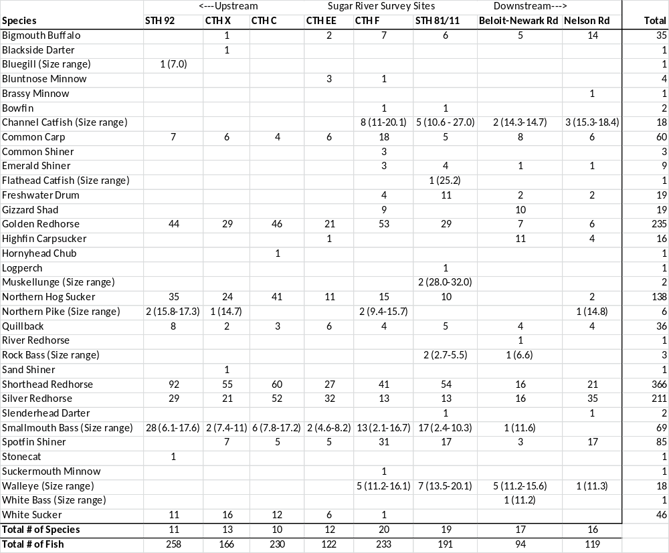
Table 2: Large River Index of Biotic Integrity for the 2014 Sugar River Sites
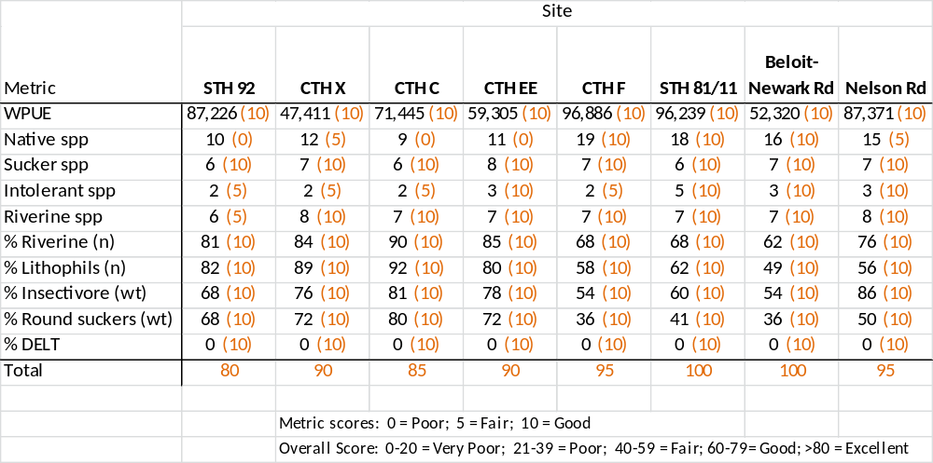

Table 3: Qualitative Habitat Assessment of the Sugar River Mainstem
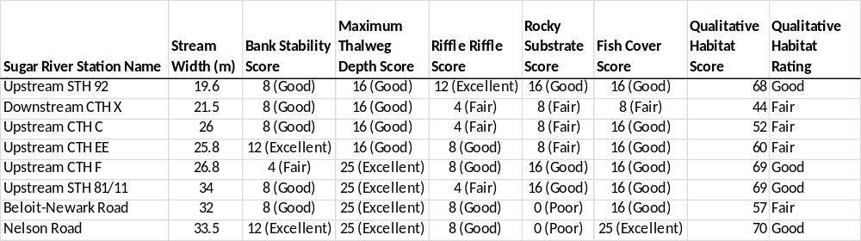

thalweg depth was fairly consistent between 16 (good) with depths 1-1.5 m and 25 (excellent) with thalweg depths over 1.5 m. Thalweg depths were greater for the lower 4 stations than for the upper ones. Riffle/bend scores ranged from 4 (fair) to 12 (excellent) with most scores varying from 4 to 8 (good). Rocky substrate (percent of substrate that is particle size of gravel or larger) ranged from 0 (poor) to 16 (good). The lower 2 stations were depauperate of coarse substrate except in areas scoured under fallen trees. The upper stations (STH 92 to CTH C) contained several substantial riffles (50-100 m long), while the lower stations had gravel bottom predominant throughout the thalweg. Fish cover ranged from 8 (fair) to 25 (excellent) but was consistently 16 (good) at most sites. Woody debris accounted for most of the fish cover, save for several locations where rock rip-rap was added for shoreline protection. Overall scores ranged from 44 (fair) to 70 (good).

Discussion
Monitoring of the biotic integrity of river systems in Wisconsin has been inconsistent for the most part over the past 20 years. The department’s bureau of research conducts trend monitoring on 13 stations on the lower Wisconsin River on an annual basis. The U.S. Environmental Protection Agency (EPA) also conducts river sampling on a 5 year basis as part of a national program to look at the quality of streams and rivers from a national perspective (U.S. EPA, 2013). The department’s fisheries program historically surveyed a series of river sites, but that monitoring was done inconsistently in both methodology and routine. More recently the department has made analysis of the macroinvertebrate community on river systems (Weigel, 2011) a part of the department’s monitoring strategy.

Monitoring of rivers which contain shallow (wadable) and deep (non-wadable) sections, swift currents and other natural or man-made obstacles can be challenging. It requires specialized equipment - a “mini-boom” shocker or similar device - as well as staff who are versed in operation of the equipment and navigation of river systems. Still, these systems are important in the diversity of fisheries assemblages that they contain as well as indicators of the health of the ecosystem on a larger scale (Lyons, et. al., 2001). The U.S. EPA (2013) reported that, within the temperate plains ecoregion – the region wherein the Sugar River lies - the fish multimetric index (MMI) was good at 52% of the river and stream miles, 8% was fair, and 35% was poor. There are several drawbacks to the EPA methods when conducting this assessment: 1) EPA combines stream and river data, 2) they use methods similar, but not the same as the department, and 3) the metrics used for evaluation are not specifically correlated to rivers in Wisconsin as those used by Lyons, et. al., (2001).

Because the Sugar River is not modelled to be a “river” according to Lyons (2008) until it is downstream of Brodhead, there was some question as to whether the use of the large warmwater river IBI was an appropriate tool to evaluate the data from sections that are modelled to be cool-warm or warm mainstem streams and in the absence of “...at least 3 km of contiguous river channel too deep to be sampled effectively by wading” (Lyons, et. al., 2001). In consultation with Dr. John Lyons it was decided that the sections of the Sugar River sampled in this study are functionally close-enough to a large river for the IBI to be used.

The fishery assemblage at all stations was very similar, made up of many round sucker species, simple lithophils and insectivores – all indicators of a healthy river environment. Not surprisingly, species diversity increased as one proceeded further downstream as the river became larger and in the absence of dams from Brodhead downstream to its confluence with the Pecatonica River.

The overall species assemblage is likely underrepresented for Cyprinids (minnows) and Percids (darters) because these species generally inhabit areas not effectively sampled by boom shocking and/or because the net mesh size is too large to retain these specimens.

Game species were present, but not abundant, with smallmouth bass making up the bulk of the gamefish numbers. There is likely a larger representation of Ictalurid species – both channel and flathead catfish - but boom shocking is not an effective way to sample these species. To that end, fisheries management coincidentally conducted a hoop net study at 10 sites on the lower Sugar River at Nelson Road (Appendix 2). This survey is designed to primarily target channel catfish. The survey found a good distribution of channel catfish from 7 to 26 inches, with the majority of fish less than 14 inches. In comparison to other hoop net surveys conducted on other Wisconsin waters over the past 25 years, the catch per unit of effort (CPUE) was similar to lotic systems throughout the state. However, the proportional stock density (PSD) and relative stock density (RSD), measures of “quality” fish and “preferred” fish respectively, were below the average for the Sugar River in comparison with other lotic systems. Possible reasons for this include the relatively small size of the Sugar River compared to other Wisconsin river systems as well as the apparent high recruitment rate of channel catfish in the Sugar River. As noted earlier, the majority of fish found in the 2014 survey were smaller than 14 inches. These smaller fish can depress the PSD and RSD metrics.

Overall, the IBI indicated the mainstem of the Sugar River has a healthy, valuable fishery, is not dominated by carp or other tolerant species, and offers a system that is unique to the highly agricultural landscape of southern Wisconsin. This study was by no means an all-encompassing look at the Sugar River ecosystem. There was no assessment of oxbow or backwater habitats, although such studies have been conducted by others such as Marshall (2012). There was no detailed assessment of riffles which probably contain additional species diversity and in particular may harbor the rare species historically found in the river. For comparison, a wadable assessment conducted over the past several years on the Sugar River just below the Belleville dam shows upwards of 30 species typically present (WDNR, unpublished data), compared to the 10 to 20 found in this study.

As was noted earlier, the wadable stream qualitative habitat rating for streams larger than 10 meters wide may not be the most appropriate tool to use for river systems as it is designed for large, wadable streams. However, in the absence of any other existing tool, it can serve to determine habitat characteristics relative to sites on the river.

The qualitative stream ratings were fairly consistent between the metrics and overall score. There were certain areas where particular scores were depressed or enhanced. For instance, the bank stability score at CTH F was particularly low relative to the other sites. This is consistent with biologist’s observations and suggestions that a potential management tool would be the addition of rock, wood, or other bank stabilization structures which would also enhance habitat for fish. Bank stability overall was generally good, owing to the flood plain environment which makes development or farming up to the river’s edge impractical, and subsequently leads to a de facto buffer along the river.

Much of Sugar River bottom is sand or a combination of sand and gravel. The prevalence of rocky substrate, defined as gravel, rubble/cobble, boulder or bedrock, varied by site between poor and good. In those sections where rocky substrate occurred, it was mostly in the form of gravel with some areas of rubble/cobble and boulder along shorelines that had been rip-rapped to protect the shoreline. While the upper section had some substantial riffles (50-100 m long) made up of gravel and rubble/cobble, the middle sections of the river contained mostly gravel in the thalweg, with sand and or sand/silt along the edges. The lower 2 sites were devoid of coarse substrate for the most part, save for small sections where scouring was enhanced by tree falls.

Fish cover was consistent. For most sites, woody debris made up the bulk of the habitat. In lower sections downstream of the Brodhead dam, holes with depths to greater than 2 meters also provide cover for fish. There were also sections which contained rock rip-rap along the shoreline. Most of these sections were from 50 to 200 m long.

The water quality of the Sugar River has been monitored for many decades. A long-term trend monitoring station exists at Ten Eyck Road downstream of Brodhead. Water samples are taken monthly and analyzed for nutrients, total suspended solids, chlorophyll a, alkalinity, and bacteria. Trend analysis has shown the flow-weighted annual geometric mean total phosphorus concentration has decreased from 0.356 mg/l in 1961 to 0.084 mg/l in 2010 (Matt Diebel, WDNR, pers. comm.). Still, the department has recently proposed the Sugar River downstream from Belleville to the Illinois state line be placed on the state’s 303(d) list of impaired waters because the mean concentrations of total phosphorus exceed the state’s water quality criteria during the growing season (WDNR, 2014).

Summary and recommendations
Quality of the Sugar River as represented by the fishery community is excellent. It confirms the status of the river as an ERW and deserving of protection. Nonpoint source inputs could potentially threaten the health of the stream and efforts to enact best management practices in the adjoining watersheds would be beneficial. The department should explore working with riparian landowners to stabilize eroding banks along the river to reduce sediment input and enhance fish habitat. Based on the species diversity upstream and downstream of the dams at Albany and Brodhead, it is likely the dams affect this diversity by limiting the upstream movement of certain species. The desire to mitigate the effects of dams on fish movement needs to be balanced with the need to prevent migration of exotic/nuisance species to other parts of the river. To that end, the department should continue periodic monitoring of sloughs and backwaters to monitor the status of the non-native western mosquitofish (Gambusia affinis), which were found downstream of the Brodhead dam in 2009.

The monitoring section of the Bureau of Water Quality should develop and incorporate a strategy to effectively and systematically assess large, non-wadable streams and rivers. This includes the use of the large river IBI (Lyons, et. al., 2001), the non-wadable macroinvertebrate IBI (Weigel and Dimick, 2011), use of long-term trend data at USGS gauging stations, the need to develop the diatom nutrient index to correlate phosphorus impacts, and the need to develop a habitat measurement for large, non-wadable river systems.

References

Lyons, John, R.R. Piette, and K.W. Niermeyer. 2001. Development, Validation, and Application of a Fish-Based Index of Biotic Integrity for Wisconsin’s Large Warmwater Rivers. Transactions of the American Fisheries Society. 130:1007-1094.

Lyons, John. 2008. Using the Wisconsin Stream Model to Estimate the Potential Natural Community of Wisconsin Streams (DRAFT). Wisconsin Department of Natural Resources Fish and Aquatic Life Research Section. November, 2008.

Marshall, David. 2012. Surveys of River Floodplain Habitats for Fish Species with Inventory Needs, SGCN and Associated Off-channel Fish Populations. In fulfillment of State Wildlife Grant (SWG-11). Final Report. Underwater Habitat Investigations LLC. November 2012.

Simonsen, Simonson, Timothy D. J. Lyons and P. Kanehl. 1994. Guidelines for Evaluating Fish Habitat in Wisconsin Streams. United States Department of Agriculture. Forest Service. General Technical Report NC-164.

U.S. EPA. 2013. National Rivers and Stream Assessment. http://water.epa.gov/type/rsl/monitoring/riverssurvey/

USGS. 2014. National Water Information System. Current Water Data for Wisconsin. United States Geologic Survey. http://waterdata.usgs.gov/wi/nwis/rt

WDNR. 2014. Wisconsin 2014 Consolidated Assessment and Listing Methodology (WisCALM). Clean Water Act Section 305(b), 314, and 303(d) Integrated Reporting. Wisconsin Department of Natural Resources. Bureau of Water Quality Program Guidance. September, 2013.

Weigel, Brian and Jeffery Dimick. 2011. Development, validation and application of a macroinvertebrate-based Index of Biotic Integrity for nonwadeable rivers of Wisconsin. Journal of the North American Benthological Society. 30(3):665-679.
Appendix 1: Species Assemblage and Large River IBI – Sugar River 2014

STH 92
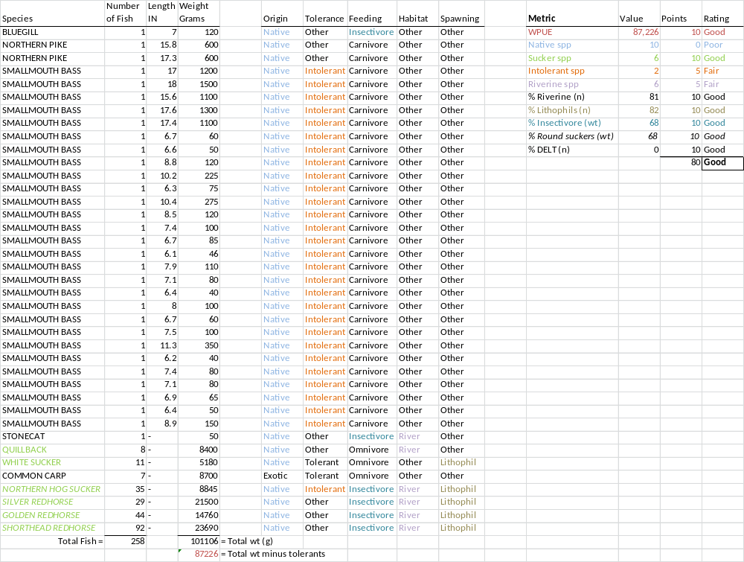
Appendix 1: continued

CTH X
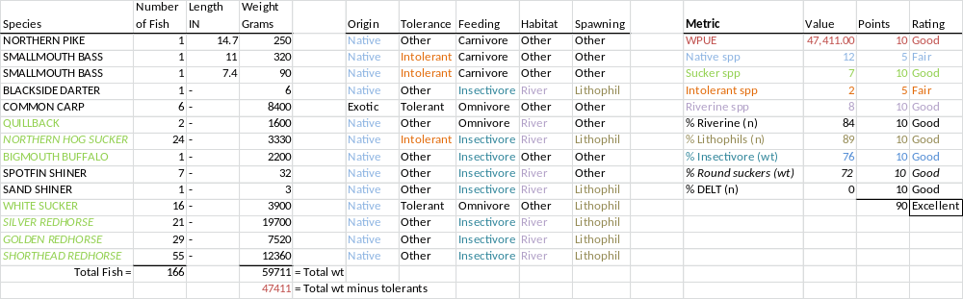
Appendix 1: continued

CTH C
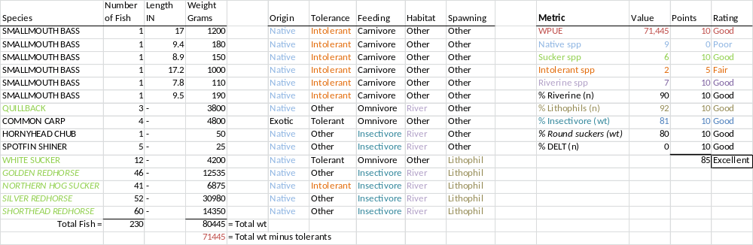

Appendix 1: continued

CTH EE
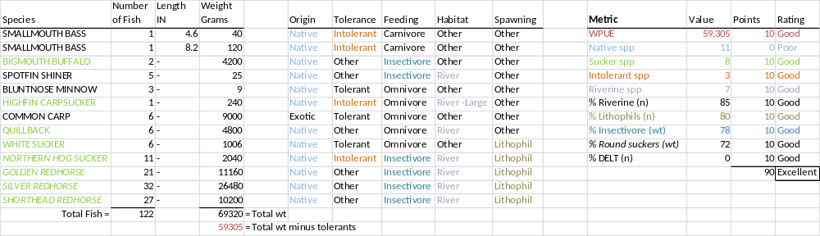

Appendix 1: continued

CTH F
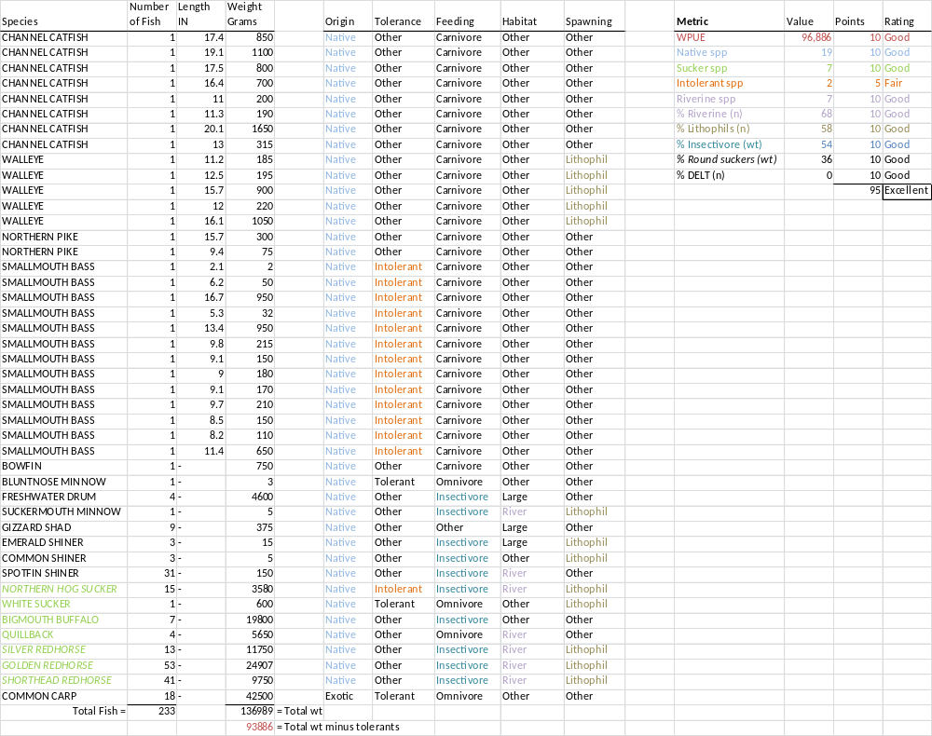
Appendix 1: continued

STH 81/11
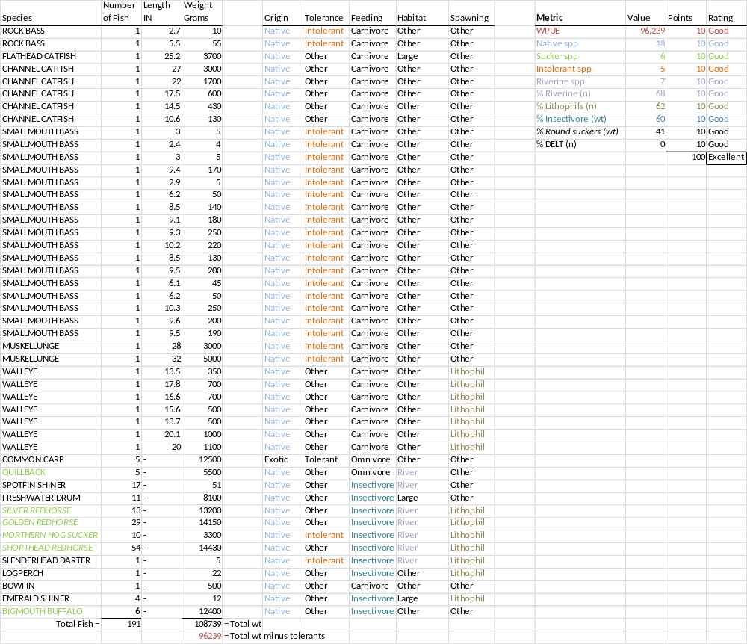
Appendix 1: continued

Beloit-Newark Road
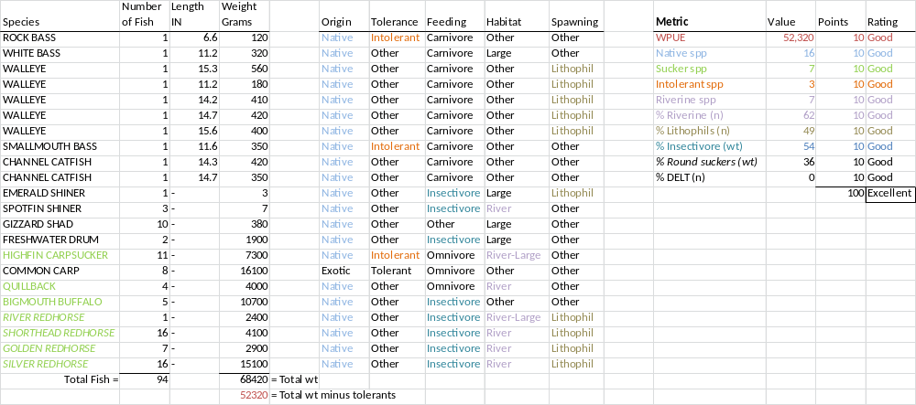

Appendix 1: continued

Nelson Road
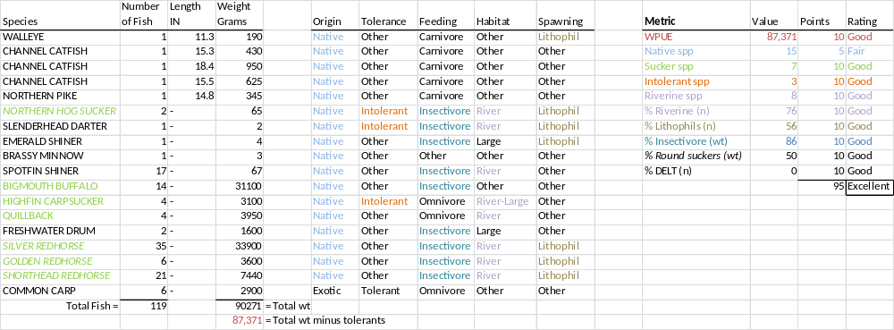
Appendix 2: Lower Sugar River Channel Catfish Survey – 2014
by Michael Rennicke, Fisheries - South District

Methods
Ten hoop nets were set in the Sugar River up to 2000 meters upstream and 1000 meters downstream of Nelson Road on September 2, 2014 and fished until September 12, 2014. Some nets were moved because of siltation and/or catch rates were low. Each net has nine fiberglass hoops tapering in size from 42 inches to 34 inches outside diameter with black standard mesh size of 1-inch bar. Nets were baited with approximately 3 pounds of presoaked soy cake inside laundry bags prior to deployment. Hoop nets are set with the mouth of the net facing downstream with an eight pound mushroom anchor attached at each end to keep the net upright and stationary. A standard DNR buoy is attached to locate and mark the nets for navigation.
Results/Discussion
Sampling protocol is advised from mid-June through August when water temps are greater than 70°F, and fish are sampled until either 250 fish are sampled or the nets are fished for 100 net nights (Simonson, 2013). However, staff time and other concurrent projects altered the protocol slightly in terms of effort and timing.
Nets were fished for a total of 90 net nights, yielding a total of 232 channel catfish. Sizes ranged from 6.6 – 29.2 inches, with an average of 14.63 (Figure 1). The length frequency shows a good distribution of fish from 7 – 26 inches, with the majority of fish less than 14 inches. The catch per unit of effort (CPUE) for all sizes was 2.58/net night. In comparison to other hoop net surveys completed in the last 25 years on other Wisconsin waters, CPUE is similar to the average for a lotic system (Figure 2). Proportional stock density (PSD) was 72.7 and relative stock density (RSD) at 24 inches was 10.3. PSD for the Sugar River is above the average for a lentic system, but well below the average for a lotic system (Figure 3). Similarly, the RSD₂₄ for the Sugar River was also below the average for a lotic system as well as a lentic system (Figure 4).
The slight timing and effort difference from what the protocol suggests probably had little effect on the results as water temperatures ranged from 68º – 73ºF during the sampling period.
A simple lentic/lotic break down does not go far enough to fairly compare PSD, RSD, and CPUE values. A further analysis should be done to compare the statistics of lotic systems to similar systems by average annual flow and also comparison of catch rate for a specific size fish (as well as the aging structures, if available) between systems.
Reference:

Simonson, Timothy. 2013. Fisheries management handbook (update). Chapter: Surveys and Investigations. Section: Inland Fisheries Surveys. Section 510. September, 2013.

Appendix 2: continued

Figure 1: Channel Catfish Length Frequency

Figure 2: CPUE of Channel Catfish in Wisconsin Waters (Lentic and Lotic Average of last 25 years)

Appendix 2: continued

Figure 3: PSD₁₆ of Channel Catfish in Wisconsin Waters (Lentic and Lotic Average of last 25 years)

Figure 4: RSD₂₄ of Channel Catfish in Wisconsin Waters (Lentic and Lotic Average of last 25 years)

Appendix 3: Pictures
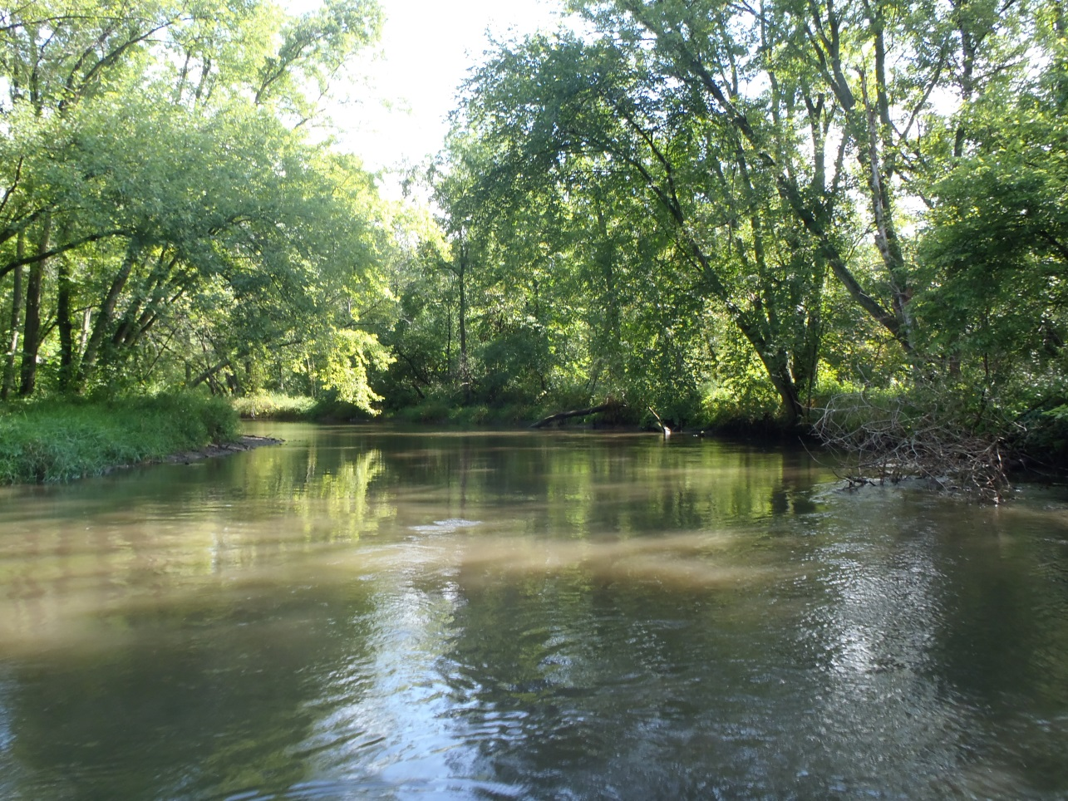
Typical floodplain forest of the Sugar River

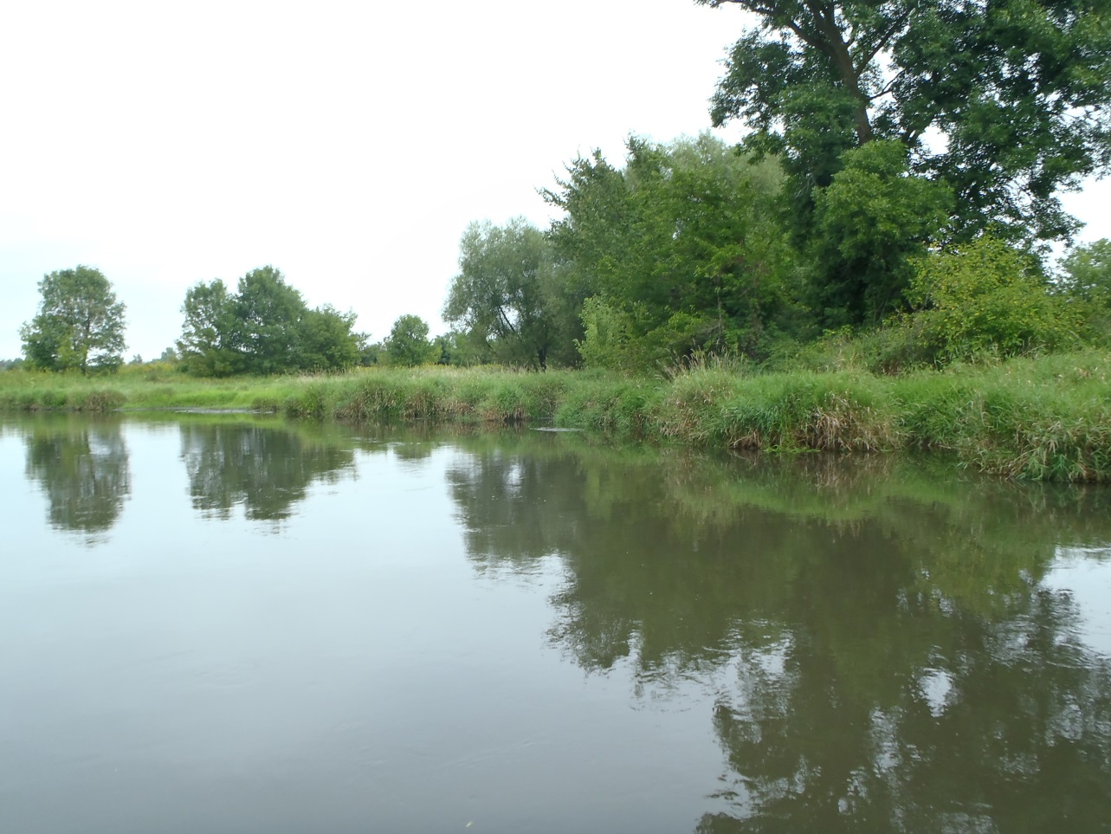
Typical floodplain meadow of the Sugar River

Appendix 3: continued
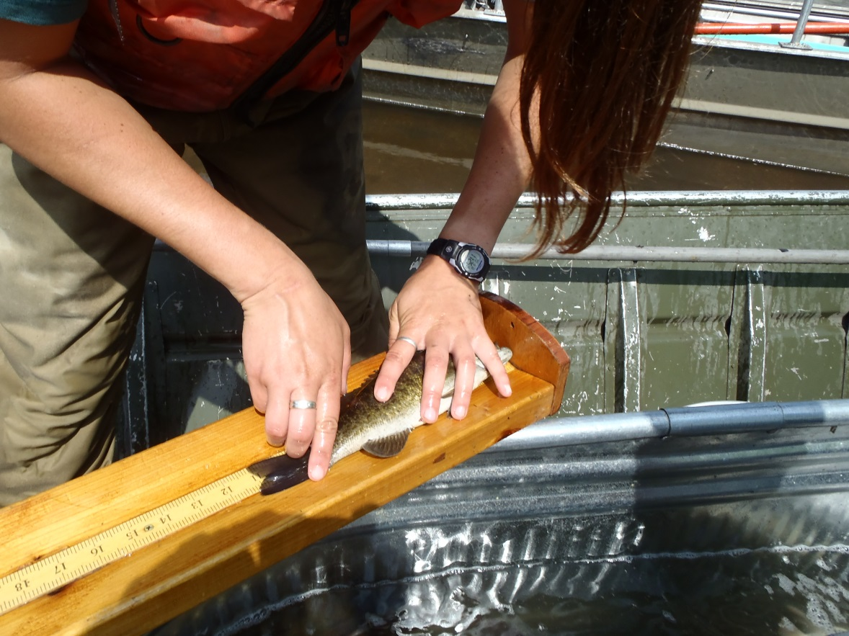
Measuring length of gamefish species

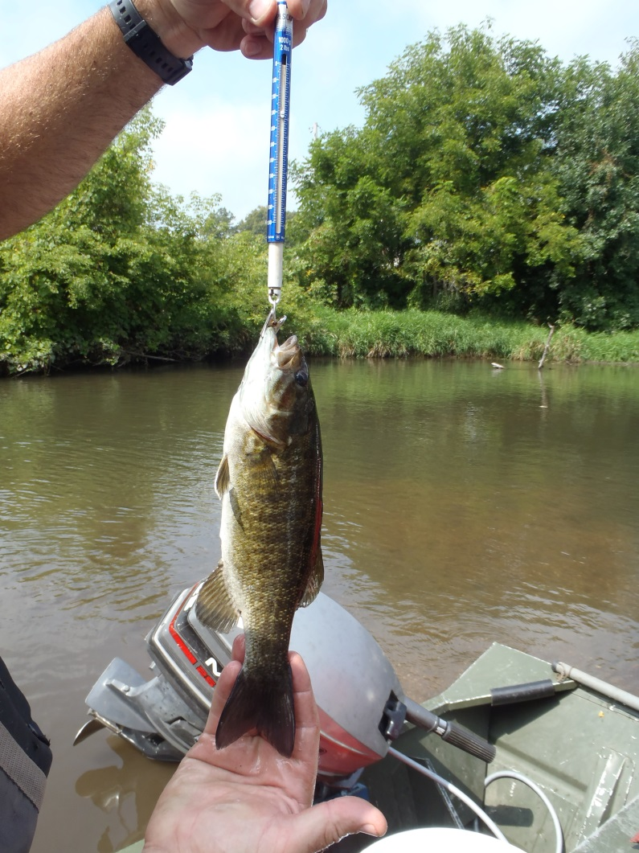
Measuring weight of gamefish species
Appendix 3: continued
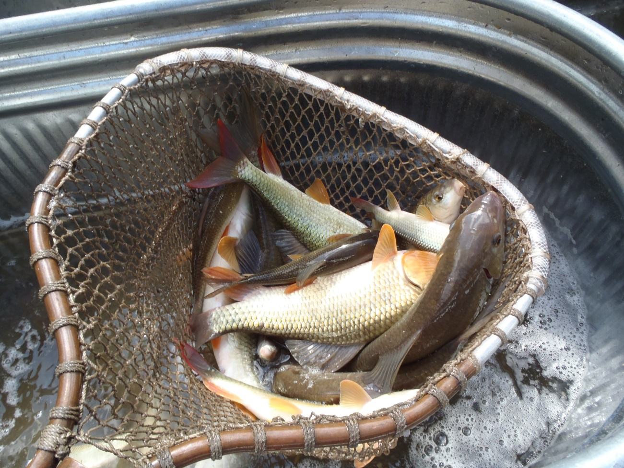
Net full of redhorse

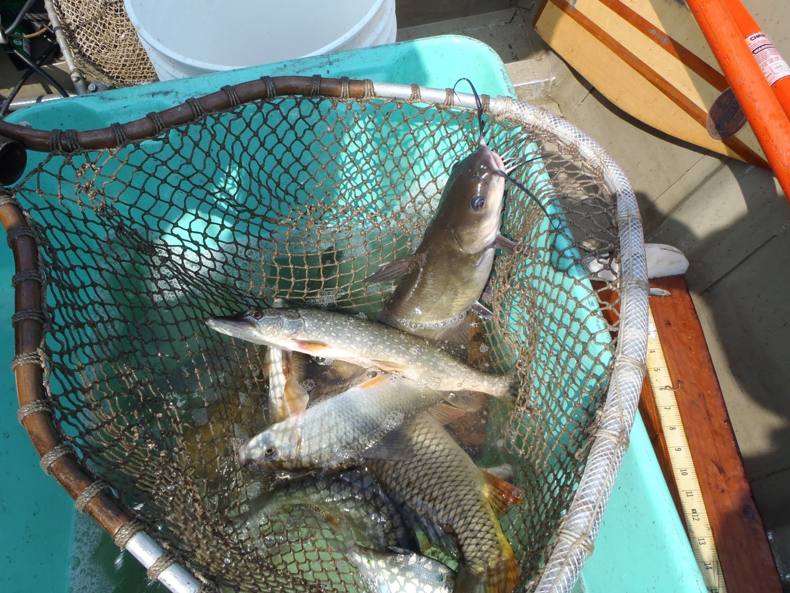
Mixed bag of fish (CTH F)
Appendix 3: continued
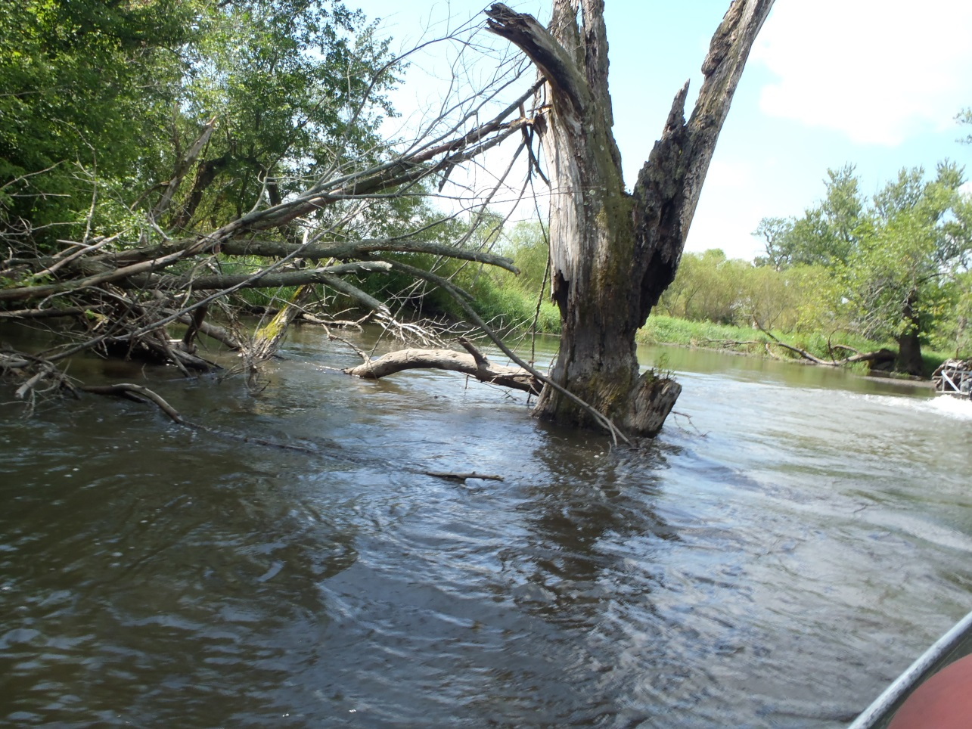
Woody debris on the Sugar River

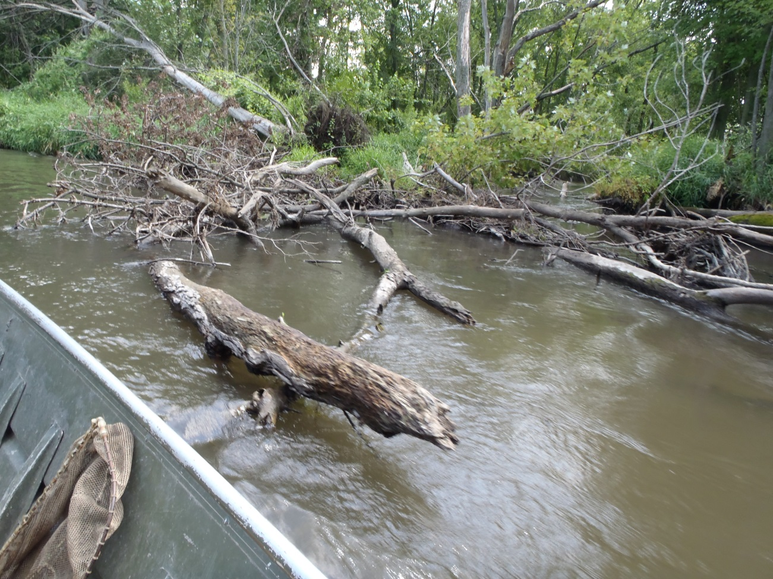
Woody debris on the Sugar River

Appendix 3: continued
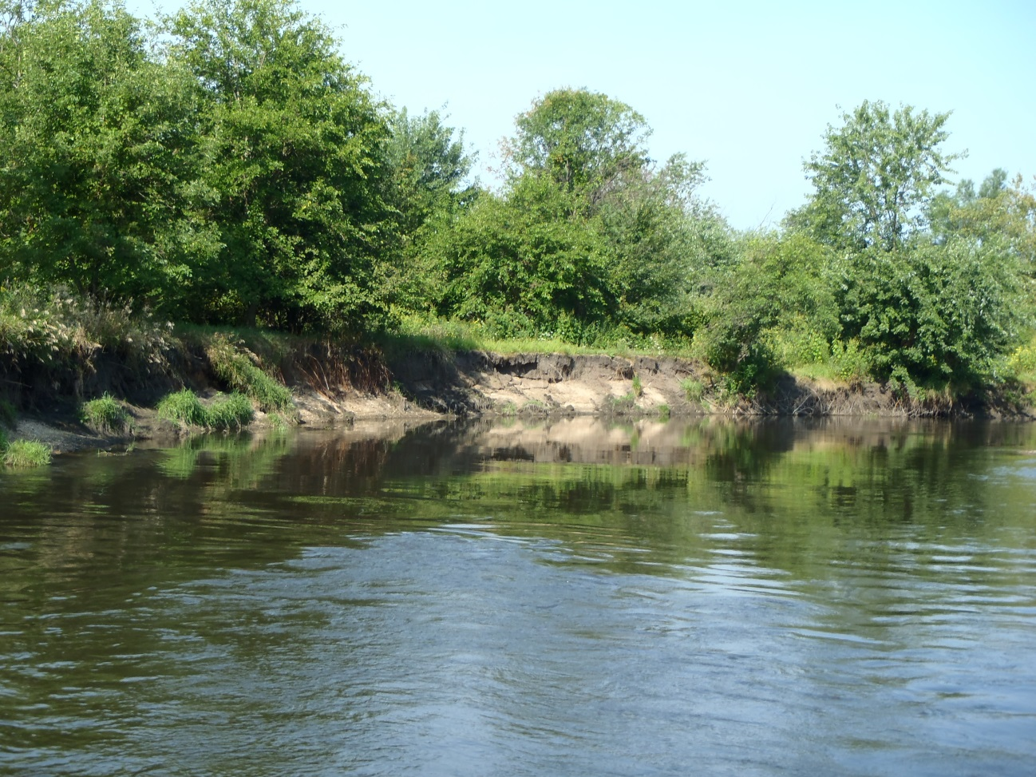
Eroding bank (upstream of CTH F)

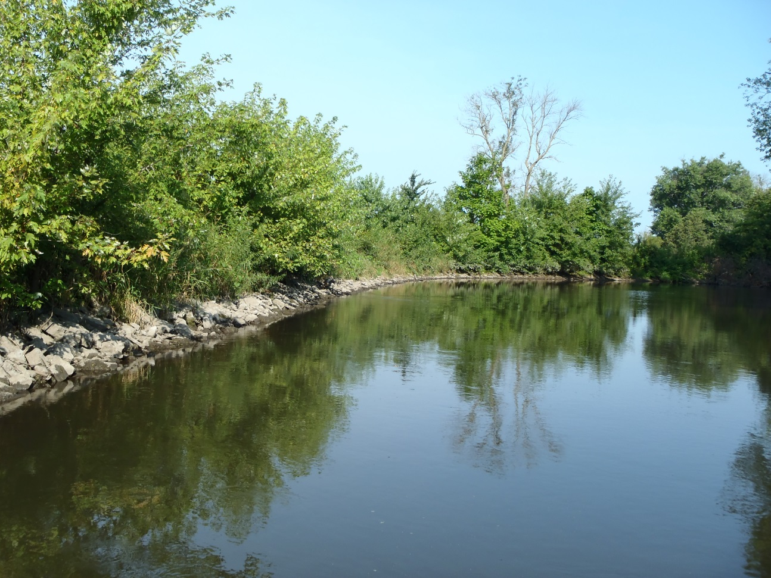
Rip-rap along bank (upstream CTH F)

Appendix 3: continued
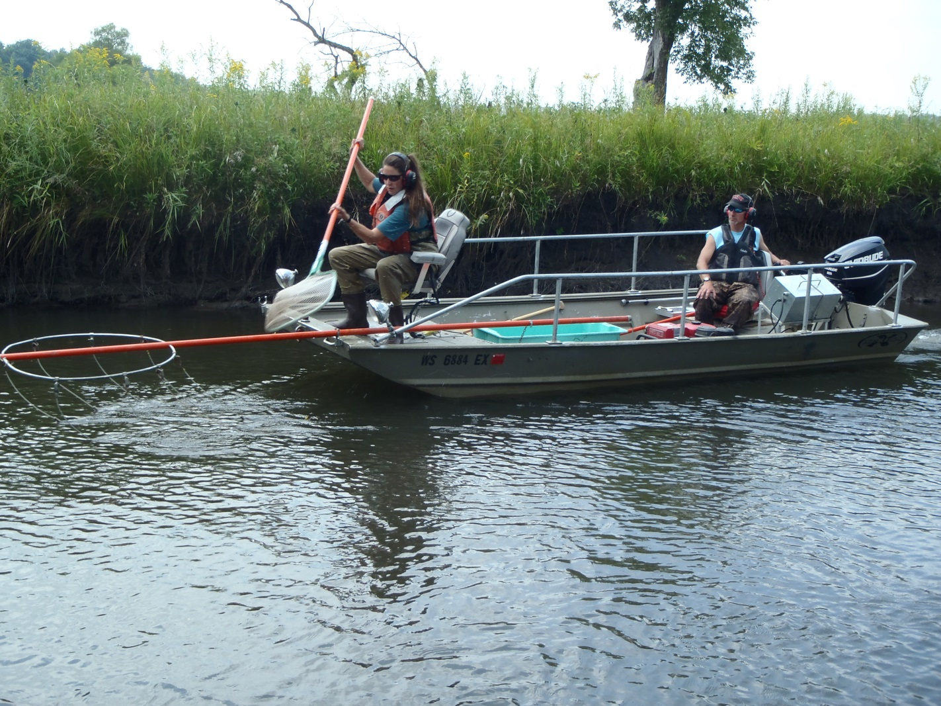
Using the mini-boom shocker on the Sugar River

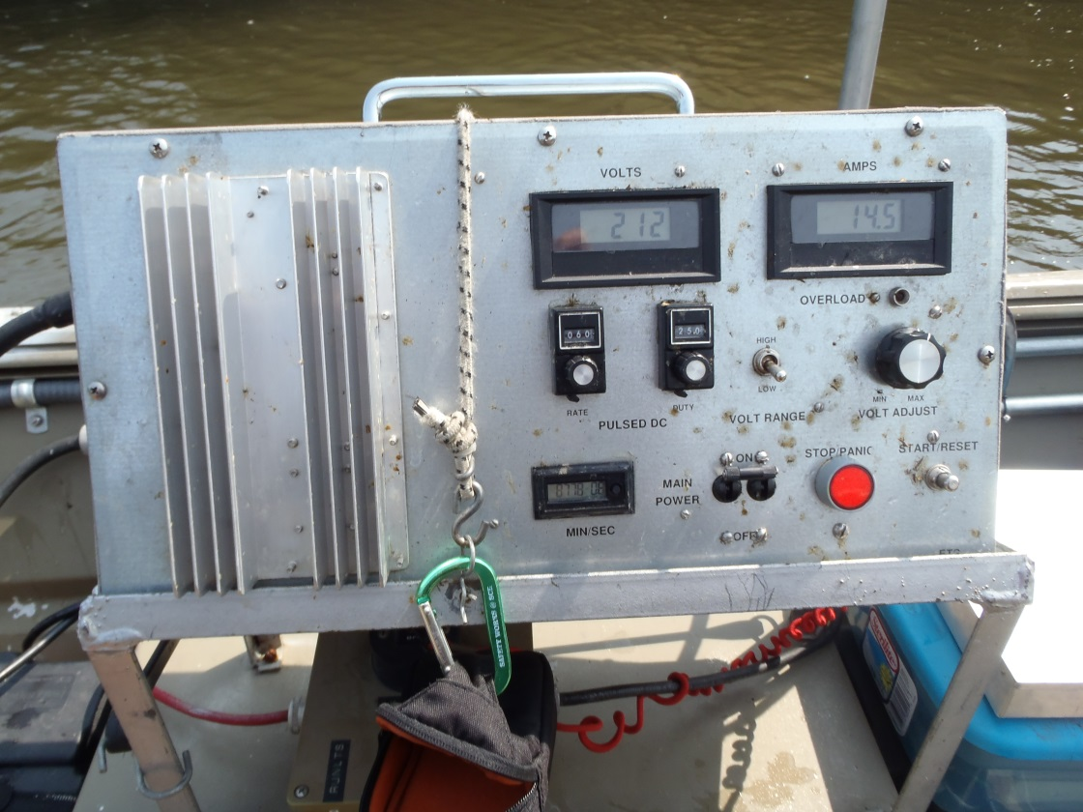
Electrofishing control box

