Straight Lake Water Quality Report for 2014

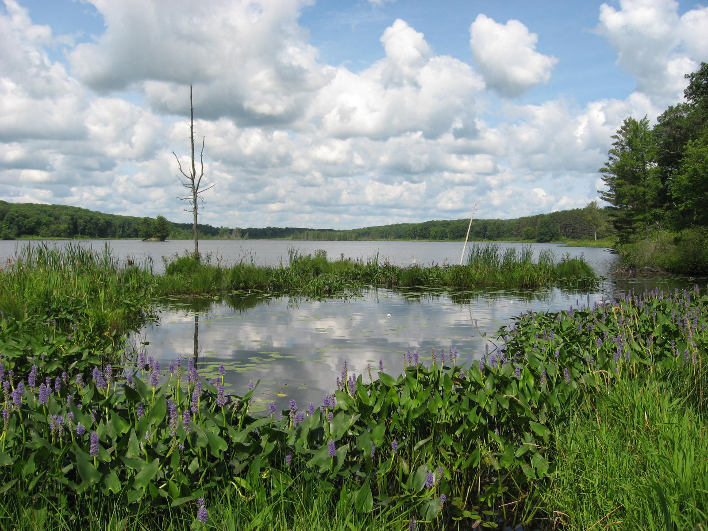

Data Collected by: Alex Smith and Mark Sundeen
Report prepared by: Rachel Peacher and Alex Smith

INTRODUCTION
Straight Lake (WBIC 2627800) is located in the north central part of Polk County approximately 4.5 miles southeast of Frederic, Wisconsin. The lake lies within Straight Lake State Park and Wildlife Area, contiguous properties owned and managed by the Wisconsin Department of Natural Resources (WDNR) (Figure 1). Current access to the lake is carry-in only via a trail to the dam from the parking area at 12th Street and 270th Avenue. Motors are not allowed on Straight Lake.
Straight Lake is a shallow lowland drainage lake with an area of 120 acres and a maximum depth of 12 feet. The bottom of the lake is composed of muck (50%), sand (20%), gravel (20%), and rock (10%) (WDNR Lake Pages, 2014).
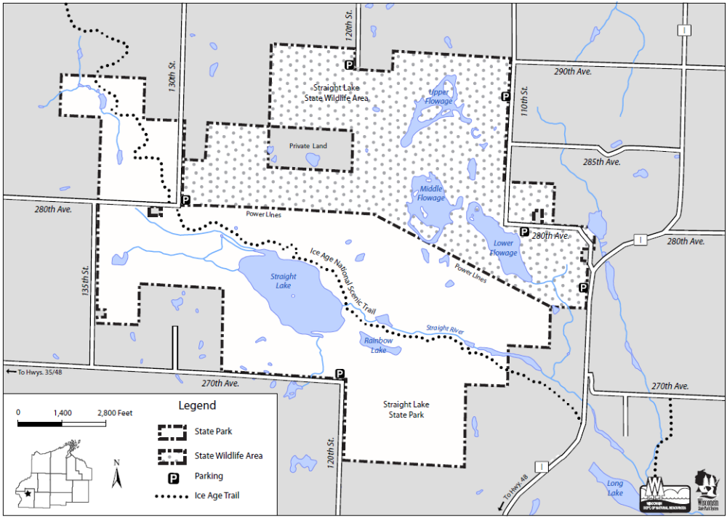
Figure 1. Straight Lake State Park and Wildlife Area (WDNR, 2009b).

A water quality project was conducted by WDNR employees to collect baseline data to be included in the next Straight Lake State Park Master Plan update.

METHODS
Water quality data was collected by WDNR employees on four dates during the spring and summer of 2014: May 5th, July 24th, August 20th, and September 15th. All data and samples were collected at the deepest point (SWIMS station 10041466) (Figure 3).
Data was collected during a time period with above normal precipitation. Precipitation during the time period of January – September 2014 was 8.3 inches above normal with 4 inches above normal precipitation occurring in June alone (PRISM, 2015).

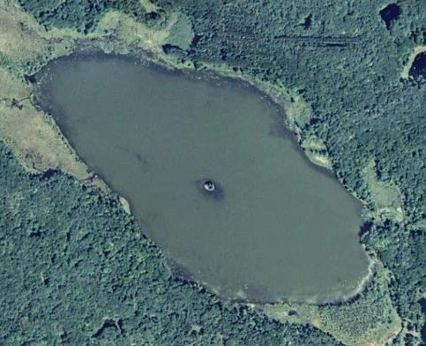
Figure 3. Straight Lake deep hole location. All water quality data was collected at this point.
Transparency (secchi depth), temperature, dissolved oxygen, and conductivity profiles, and general lake water appearance were recorded during all four sampling dates (Table 1). Nutrient samples were collected on all four sampling dates. Chlorophyll-a samples were collected on July 24th, August 20th, and September 19th. pH was measured on May 5th, August 20th, and September 19th. One metals sample was collected on May 5th. All water and chlorophyll-a samples were processed at the Wisconsin State Laboratory of Hygiene (WSLH). A trophic state index (TSI) was calculated on the WDNR Lakes page for Straight Lake 2014 data. The TSI is a score from 0 to 110 that takes into account Secchi depth, chlorophyll-a, and total phosphorus (TP). The TSI score indicates the degree of eutrophication of a lake. The index ranges from low scoring oligotrophic lakes to high scoring hypereutrophic lakes.

Table 1. Dates of water quality parameter dates of measurement and sample collection.
Sampling date | May 5th | July 24th | August 5th | September 19th
Secchi transparency | X | X | X | X
Visual assessment | X | X | X | X
Chlorophyll-a |  | X | X | X
Total phosphorus | X | X | X | X
Nitrogen series | X |  | X | X
Temp., D.O., conductivity profiles | X | X | X | X
pH | X |  | X | X
Metals sample | X

Total nitrogen (TN) was calculated by adding Kjedahl nitrogen to nitrate and nitrite concentrations. Inorganic nitrogen (IN) was calculated by summing nitrate, nitrite, and ammonia concentrations. A total nitrogen to total phosphorus ratio (TN:TP) was calculated for each date where sufficient data was available. This ratio is used to determine whether plant and algae growth is being limited by nitrogen or phosphorus. When TN:TP is less than 10:1, growth is being limited by nitrogen. When TN:TP is 10:1 to 15:1, the lake is considered transitional. A TN:TP of greater than 15:1 indicates that growth is limited by phosphorus (WDNR Lakes Pages, 2014).
TP and chlorophyll-a levels were compared with impairment threshold levels in the Wisconsin 2014 Consolidate Assessment and Listing Methodology (WisCALM) in order to determine whether listing the lake as impaired should be investigated.
Watershed area, watershed land use areas, and watershed soil group areas were calculated using WDNR’s Internal Surface Water Data Viewer “Delineate watershed” tool. This tool utilizes Purdue University’s Long Term Hydrologic Impact Analysis (L-THIA) model website, which offers many tools for watershed modelling (Purdue University, 2013). Tools utilized for this project produced areas for: total watershed, land use categories, hydrologic soil group categories, and total impervious surface.
Land use categories were assigned based on definitions from the National Land Characteristics Data 1992 Classification System (EPA, 2007). Descriptions of land use categories can be found in Appendix A. 1992 or 2001 Landsat satellite data were used as base maps for delineation. USDA Natural Resource Conservation Service (USDA NRCS) Hydrologic Soil Groups (USDA NRCS, 1986) were used to classify soils’ runoff and infiltration potential. Classifications are described in Table 2.

Table 2. USDA NRCS (1986) Hydrologic Soil Groups and descriptions
Hydrologic Soil Group | Description
A | Sand, loamy sand or sandy loam types of soils. It has low runoff potential and high infiltration rates even when thoroughly wetted. They consist chiefly of deep, well to excessively drained sands or gravels and have a high rate of water transmission.
B | Silt loam or loam. It has a moderate infiltration rate when thoroughly wetted and consists chiefly or moderately deep to deep, moderately well to well drained soils with moderately fine to moderately coarse textures.
C | Soils are sandy clay loam. They have low infiltration rates when thoroughly wetted and consist chiefly of soils with a layer that impedes downward movement of water and soils with moderately fine to fine structure.
D | Soils are clay loam, silty clay loam, sandy clay, silty clay or clay. This HSG has the highest runoff potential. They have very low infiltration rates when thoroughly wetted and consist chiefly of clay soils with a high swelling potential, soils with a permanent high water table, soils with a claypan or clay layer at or near the surface and shallow soils over nearly impervious material.

RESULTS AND DISCUSSION
Transparency ranged from 3.0 to 4.8 feet with an average of 3.8 feet and a standard error of 0.5 (Figure 4). These results indicate that Straight Lake water is much less clear than other lakes in the Northwest Georegion where the average July-August transparency is 8.4 feet (WDNR Lake Pages, 2014). Secchi disc readings of less than 5 feet indicate possible eutrophic conditions (UW Extension, 2004). The transparency data corresponds with the recorded visual assessment of the lake, which indicates that the appearance ranged from clear to murky, the color was consistently brown, and the perception ranged from a rating of 2 (very minor aesthetic problems) to 3 (enjoyment somewhat impaired (algae)) (Table 3). Color was analyzed in the May 5th water sample. It was found to have a value of 50 su which indicates a medium color level which are probably the result of tannins. Water transparency and appearance in this lake is probably influenced by both tannins and algae.

Figure 4. Straight Lake transparency.

Table 3. Water quality visual assessment for four dates in 2014.
Sampling date | May 5th | July 24th | August 20th | September 15th
Appearance | MURKY | CLEAR | MURKY | CLEAR
Color | BROWN | BROWN | BROWN | BROWN
Perception | 2-Very minor aesthetic problems | 2-Very minor aesthetic problems | 3-Enjoyment somewhat impaired (algae) | 3-Enjoyment somewhat impaired (algae)

Total phosphorus (TP) ranged from 38.9 to 57.4 µg/L with an average of 50.9 and a standard error of 4.2 (Figure 5). Lakes that have more than 20 µg/L of TP may experience noticeable algal blooms (WDNR Lake Pages, 2014). Wisconsin’s recreational impairment threshold for shallow lowland drainage lakes is ≥ 40 µg/L for samples collected between June 1st and September 15th (WDNR, 2013). Straight Lake exceeded this limit on 3 of the four sampling dates although the May 5th sample is outside the acceptable date range.

Figure 5. Straight Lake total phosphorus.

Chlorophyll-a ranged from 13.6 to 56.3 µg/L with an average of 37.3 µg/L and a standard error of 12.5 (Figure 6). The average July – August chlorophyll-a for the Northwest Georegion is 16.6 µg/L. The recreational impairment threshold for shallow lowland drainage lakes is >30% of days in sampling season have nuisance algal blooms (>20 µg/L) between July 15th and September 15th.

NO SAMPLE COLLECTED
Figure 6. Straight Lake chlorophyll-a.
WisCALM (2013) impairment levels were compared with 2014 levels where data was available. Total phosphorus and chlorophyll-a means both exceeded impairment threshold levels for recreational use (Table 4) while the pH mean was inside the range of a non-impaired waterbody for fish and aquatic life.

Table 4. Impairment thresholds of total phosphorus, chlorophyll-a, and pH (WDNR, 2013).
Parameter | Impairment threshold type | Impairment threshold level | Total number of samples | Total number of samples within data requirement time frame | Mean of samples within data requirement time frame
Total phosphorus | Recreational | ≥40µg/L | 4 | 3 | 49µg/L
Chlorophyll-a | Recreational | >30% of days in sampling season have nuisance algal blooms (>20µg/L) | 3 | 3 | 37µg/L

The overall Trophic State Index (TSI) for Straight Lake was 62 suggesting that Straight Lake is eutrophic (WDNR Lakes Pages, 2014).
Lab results for nitrogen indicated an average total nitrogen (TN) concentration of 1.46 mg/L with a standard error of 0.06 (Figure 7). TN levels ranged from 1.35 to 1.53 mg/L. The ratio of TN to TP indicates that Straight Lake algae growth was controlled by phosphorus – not nitrogen for all sampling dates where data is available (UW Extension, 2004) (Table 5).

NOT MEASURED
Figure 7. Straight Lake total nitrogen.

Table 5. Total nitrogen to total phosphorus ratios for each sampling date.
Sampling date | May 5th | July 24th | August 20th | September 15th
Total nitrogen (mg/L) | 1.35 | not analyzed | 1.53 | 1.50
Total phosphorus (mg/L) | 0.057 | 0.039 | 0.056 | 0.051
TN:TP ratio | 24:1 | -- | 27:1 | 29:1
N limited or P limited | P limited | -- | P limited | P limited

Lab results for inorganic nitrogen (IN) indicated a range from 0.06 to 0.39 mg/L (Figure 8). The August 20th sample returned results of <0.0610 mg/L of nitrate and nitrite and <0.0480 mg/L of ammonia. These values were added together for a value of <0.109 mg/L. Inorganic forms of nitrogen can be utilized by plants and algae to grow. When IN forms exceed 0.3 mg/L in spring, there is sufficient nitrogen to support summer algae blooms (UW Extension, 2004). These conditions were met this spring as indicated by the May 5th sample value.

NOT MEASURED
LESS THAN
0.109 mg/L
Figure 8. Straight Lake inorganic nitrogen.

Temperature, dissolved oxygen, and conductivity profile data indicate that the lake weakly stratifies periodically during the summer and is likely polymictic (Figure 9). The temperature and dissolved oxygen profile data for May 5th indicates that the lake was mixing during the spring turnover period. The profile data for July 24th and August 24th indicate that the lake is weakly stratified and that the bottom four feet of the lake is depleted of oxygen. The August 24th temperature profile shows the entire water column is over 20°C which suggests that the lake does mix occasionally during the summer. Shallow lowland lakes do not typically stratify during the summer months (WDNR, 2014). Straight Lake likely mixes during storm and wind events and weakly stratifies during calm weather conditions.
Precipitation during the time period of January – September 2014 was 8.3 inches above normal with 4 inches above normal precipitation occurring in June (PRISM, 2015).
Surface pH ranged from 7.1 to 7.9 with an average of 7.4 and a standard error of 0.2 making the lake slightly basic (Figure 10). These values are within the acceptable range (for fish and aquatic life) of 6.0-9.0 (WNDR, 2013).

Figure 9. Straight Lake temperature, dissolved oxygen, and conductivity profile data for four dates in 2014.
NOT MEASURED
Figure 10. Straight Lake pH.

Chloride lab results indicate that chloride levels (2.1 mg/L) are below normal for the Straight Lake area (Table 6). Typical chloride levels in the area range from 3-10 mg/L (UW Extension, 2004). Low chloride levels indicate that the water is not likely impacted by human activities. Sulfate levels were also low as no sulfate was detectable in the sample. Sodium and potassium levels were present in concentrations of 2.3 and 1.3 mg/L, respectively. Alkalinity levels were at 56.6 mg/L which signifies that Straight Lake is not susceptible to acid rain damage. A lake with 10-25 mg/L has low sensitivity to acid rain damage, 2-10 mg/L indicates moderate sensitivity, and 0-2 mg/L indicates a lake that is highly susceptible to acid rain damage (UW Extension, 2004). Lab results indicate calcium and iron levels in Straight Lake to be 12.3 and 0.31 mg/L, respectively. Magnesium was present at 5.2 mg/L, and conductivity was 115 µmhos/cm. Raw data for water quality monitoring can be found in Appendix B.

Table 6. Metals sample results. (ND – not detected)
Parameter | Value
Chloride (mg/L) | 2.12
Sulfate total (mg/L) | ND
Sodium total recoverable (mg/L) | 2.25
Potassium total recoverable (mg/L) | 1.22
Alkalinity total CaCO₃ (mg/L) | 56.6
Calcium total recoverable (mg/L) | 12.3
Iron total recoverable (mg/L) | 0.311
Magnesium total recoverable (mg/L) | 5.21
Conductivity (µmhos/cm @ 25° C) | 115

Watershed delineation results reveal a watershed area of 2,514 acres (Figure 11) (Table 7). The land use in this area is made up of forest (70%), grass/pasture (14%), water (12%), low density residential (3%), agriculture (1%), and high density residential (<1%) (Appendix C).
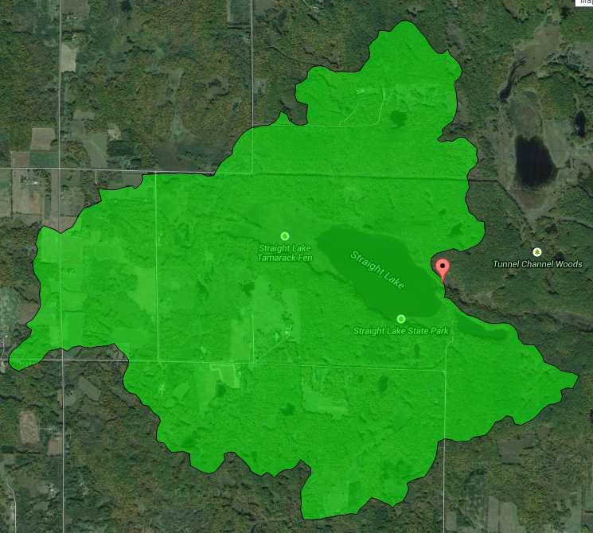
Figure 11. Straight Lake watershed (Purdue University, 2013).
Table 7. Watershed land use areas and percentages.
Land use | Area (acres) | Percent (%)
Forest | 1755 | 70
Grass/Pasture | 352 | 14
Water | 309 | 12
Low Density Residential | 72 | 3
Agriculture | 27 | 1
High Density Residential | 1 | <1
Total Area | 2514 | 100
These percentages indicate that the watershed is mostly under undeveloped non-agricultural conditions as 96% of the watershed is made up of forest, grass/pasture, or water. Although much of the grass/pasture designation may be used for pasture or haying, these land uses are usually not classified as impervious surfaces and so will probably have little impact on soil erosion. However, this is hard to determine without more information on where grazing is happening and its intensity.
Sixty-seven percent of the watershed has group B soils (silt loam or loam), which have a moderate infiltration rate (Table 8). Group D soils, which have high clay content and have the highest runoff potential, have the second highest percentage in the watershed with 20%. Group C soils (low infiltration, sandy clay loam) made up 11% of the watershed, and Group A soils (high infiltration, high sand) made up 2% of the watershed.

Table 8. Watershed hydrologic soil group (USDA NRCS, 1986) areas and percentages.
Soil group | Area (acres) | Percent (%)
A | 48 | 2
B | 1691 | 67
C | 280 | 11
D | 495 | 20

CONCLUSION
The purpose of this study was to provide baseline information on the current water quality of Straight Lake for the next Straight Lake State Park Master Plan update. Straight Lake is eutrophic and would likely exceed recreational impairment thresholds for TP and chlorophyll-a under WisCALM (2013). An investigation of the source of these nutrients is beyond the scope of this project, but they are likely coming from natural sources as the lake watershed is predominantly undeveloped. Management efforts should focus on minimizing negative impacts from current land use practices as well as the future development of the Straight Lake State Park and the surrounding watershed.

LITERATURE CITED
Environmental Protection Agency, 2007. National Land Cover Data Classification Schemes Definitions. Retrieved on February 26, 2015 from http://www.epa.gov/mrlc/ definitions.html#1992
Purdue University, 2013. Long Term Hydrologic Impact Analysis (L-THIA). Retrieved on February 26, 2015 from https://engineering.purdue.edu/~lthia/
PRISM Climate Group, Oregon State University, 2015. Prism Climate Data. Retrieved February 25, 2015 from http://prism.oregonstate.edu. Created February 2004.

United States Department of Agriculture Natural Resources Conservation Service, 1986. Urban Hydrology for Small Watersheds (TR-55). Retrieved on February 26, 2015 from ftp://ftp.wcc.nrcs.usda.gov/wntsc/H&H/other/TR55documentation.pdf
University of Wisconsin Extension, 2004. Understanding Lake Data (G3582). Cooperative Extension Publishing Operations. RP-03/2004.
Wisconsin Department of Natural Resources, 2009a. Citizen Lake Monitoring Training Manual (PUB SS 1010 2009). Retrieved February 24, 2015 from http://dnr.wi.gov/lakes/CLMN/manuals/ 0910LakeMonitoring.pdf
Wisconsin Department of Natural Resources, 2009b. Straight Lake State Park and Wildlife Area Master Plan. Retrieved February 6, 2015 from: http://dnr.wi.gov/topic/parks/name/ straightlake/
Wisconsin Department of Natural Resources, 2013. Wisconsin 2014 Consolidated Assessment and Listing Methodology (WisCALM). Retrieved February 24, 2015 from: http://dnr.wi.gov/topic/SurfaceWater/documents/2014/2014WisCALM.pdf

Wisconsin Department of Natural Resources, 2014. Lake Pages. Retrieved January 15, 2015 from: http://dnr.wi.gov/lakes/lakepages/

Appendix A:
National Land Characteristics Data 1992 Classification System (EPA, 2007)

10. Water - All areas of open water or permanent ice/snow cover.

11. Open Water - all areas of open water, generally with less than 25% cover of vegetation/land cover.

12. Perennial Ice/Snow - all areas characterized by year-long surface cover of ice and/or snow.

20. Developed - Areas characterized by a high percentage (30 percent or greater) of constructed materials (e.g. asphalt, concrete, buildings, etc).

21. Low Intensity Residential - Includes areas with a mixture of constructed materials and vegetation. Constructed materials account for 30-80 percent of the cover. Vegetation may account for 20 to 70 percent of the cover. These areas most commonly include single-family housing units. Population densities will be lower than in high intensity residential areas.

22. High Intensity Residential - Includes highly developed areas where people reside in high numbers. Examples include apartment complexes and row houses. Vegetation accounts for less than 20 percent of the cover. Constructed materials account for 80 to100 percent of the cover.

23. Commercial/Industrial/Transportation - Includes infrastructure (e.g. roads, railroads, etc.) and all highly developed areas not classified as High Intensity Residential.

30. Barren - Areas characterized by bare rock, gravel, sand, silt, clay, or other earthen material, with little or no "green" vegetation present regardless of its inherent ability to support life. Vegetation, if present, is more widely spaced and scrubby than that in the "green" vegetated categories; lichen cover may be extensive.

31. Bare Rock/Sand/Clay - Perennially barren areas of bedrock, desert pavement, scarps, talus, slides, volcanic material, glacial debris, beaches, and other accumulations of earthen material.

32. Quarries/Strip Mines/Gravel Pits - Areas of extractive mining activities with significant surface expression.

33. Transitional - Areas of sparse vegetative cover (less than 25 percent of cover) that are dynamically changing from one land cover to another, often because of land use activities. Examples include forest clearcuts, a transition phase between forest and agricultural land, the temporary clearing of vegetation, and changes due to natural causes (e.g. fire, flood, etc.)

40. Forested Upland - Areas characterized by tree cover (natural or semi-natural woody vegetation, generally greater than 6 meters tall); tree canopy accounts for 25-100 percent of the cover.

41. Deciduous Forest - Areas dominated by trees where 75 percent or more of the tree species shed foliage simultaneously in response to seasonal change.

42. Evergreen Forest - Areas dominated by trees where 75 percent or more of the tree species` maintain their leaves all year. Canopy is never without green foliage.

43. Mixed Forest - Areas dominated by trees where neither deciduous nor evergreen species represent more than 75 percent of the cover present.

50. Shrubland - Areas characterized by natural or semi-natural woody vegetation with aerial stems, generally less than 6 meters tall, with individuals or clumps not touching to interlocking. Both evergreen and deciduous species of true shrubs, young trees, and trees or shrubs that are small or stunted because of environmental conditions are included.

51. Shrubland - Areas dominated by shrubs; shrub canopy accounts for 25-100 percent of the cover. Shrub cover is generally greater than 25 percent when tree cover is less than 25 percent. Shrub cover may be less than 25 percent in cases when the cover of other life forms (e.g. herbaceous or tree) is less than 25 percent and shrubs cover exceeds the cover of the other life forms.

60. Non-Natural Woody - Areas dominated by non-natural woody vegetation; non-natural woody vegetative canopy accounts for 25-100 percent of the cover. The non-natural woody classification is subject to the availability of sufficient ancillary data to differentiate non-natural woody vegetation from natural woody vegetation.

61. Orchards/Vineyards/Other - Orchards, vineyards, and other areas planted or maintained for the production of fruits, nuts, berries, or ornamentals.

70. Herbaceous Upland - Upland areas characterized by natural or semi-natural herbaceous vegetation; herbaceous vegetation accounts for 75-100 percent of the cover.

71. Grasslands/Herbaceous - Areas dominated by upland grasses and forbs. In rare cases, herbaceous cover is less than 25 percent, but exceeds the combined cover of the woody species present. These areas are not subject to intensive management, but they are often utilized for grazing.

80. Planted/Cultivated - Areas characterized by herbaceous vegetation that has been planted or is intensively managed for the production of food, feed, or fiber; or is maintained in developed settings for specific purposes. Herbaceous vegetation accounts for 75-100 percent of the cover.

81. Pasture/Hay - Areas of grasses, legumes, or grass-legume mixtures planted for livestock grazing or the production of seed or hay crops.

82. Row Crops - Areas used for the production of crops, such as corn, soybeans, vegetables, tobacco, and cotton.

83. Small Grains - Areas used for the production of graminoid crops such as wheat, barley, oats, and rice.

84. Fallow - Areas used for the production of crops that do not exhibit visable vegetation as a result of being tilled in a management practice that incorporates prescribed alternation between cropping and tillage.

85. Urban/Recreational Grasses - Vegetation (primarily grasses) planted in developed settings for recreation, erosion control, or aesthetic purposes. Examples include parks, lawns, golf courses, airport grasses, and industrial site grasses.

90. Wetlands - Areas where the soil or substrate is periodically saturated with or covered with water.

91. Woody Wetlands - Areas where forest or shrubland vegetation accounts for 25-100 percent of the cover and the soil or substrate is periodically saturated with or covered with water.

92. Emergent Herbaceous Wetlands - Areas where perennial herbaceous vegetation accounts for 75-100 percent of the cover and the soil or substrate is periodically saturated with or covered with water.

Appendix B:
Straight Lake Raw Data
Table 1. Raw data. (ND - not detected)
Sampling date | May 5th | July 24th | August 20th | September 15th
Transparency (Secchi feet) | 4.8 | 4.5 | 3.0 | 3.0
Color (su) | 50 | not analyzed | not analyzed | not analyzed
Appearance | MURKY | CLEAR | MURKY | CLEAR
Color | BROWN | BROWN | BROWN | BROWN
Perception | 2-Very minor aesthetic problems | 2-Very minor aesthetic problems | 3-Enjoyment somewhat impaired (algae) | 3-Enjoyment somewhat impaired (algae)
Total phosphorus (mg/L) | 0.057 | 0.039 | 0.056 | 0.051
Chlorophyll-a (µg/L) | not analyzed | 13.6 | 56.3 | 41.9
Kjeldahl nitrogen total (mg/L) | 1.26 | not analyzed | 1.53 | 1.50
Nitrate and nitrite nitrogen (mg/L) | 0.0891 | not analyzed | <0.0610 | ND
Total nitrogen (mg/L) | 1.35 | not analyzed | 1.53 | 1.50
Ammonia (mg/L) | 0.304 | <0.0480 | <0.0480 | 0.0623
Inorganic nitrogen (mg/L) | 0.3931 | <0.0480 | <0.109 | 0.0623
pH | 7.85 | not analyzed | 7.1 | 7.21
Chloride (mg/L) | 2.12 | not analyzed | not analyzed | not analyzed
Sulfate total (mg/L) | ND | not analyzed | not analyzed | not analyzed
Sodium total recoverable (mg/L) | 2.25 | not analyzed | not analyzed | not analyzed
Potassium total recoverable (mg/L) | 1.22 | not analyzed | not analyzed | not analyzed
Alkalinity total CaCO₃ (mg/L) | 56.6 | not analyzed | not analyzed | not analyzed
Calcium total recoverable (mg/L) | 12.3 | not analyzed | not analyzed | not analyzed
Iron total recoverable (mg/L) | 0.311 | not analyzed | not analyzed | not analyzed
Magnesium total recoverable (mg/L) | 5.21 | not analyzed | not analyzed | not analyzed
Conductivity (µmhos/cm @ 25° C) | 115 | not analyzed | not analyzed | not analyzed
Table 2. May 5th, 2014 temperature, dissolved oxygen, and conductivity profile raw data.
Depth (feet) | Temperature (C) | Dissolved oxygen (mg/L) | Conductivity (µmhos/cm)
0 | 8.8 | 12.5 | 90
1 | 8.8 | 12.7 | 86.2
2 | 8.2 | 12.6 | 86.2
3 | 8 | 12.6 | 85
4 | 8 | 12.6 | 86
5 | 7.9 | 12.5 | 86.3
6 | 7.6 | 12.7 | 86.5
7 | 7.6 | 12.7 | 88.6
8 | 7.6 | 12.6 | 88.6
9 | 7 | 12.2 | 92.6
10 | 6.8 | 11.9 | 92.1
11 | 6.8 | 11.9 | 92
12 | 6.8 | 11.9 | 92.3
13 | 6.8 | 11.9 | 92.1
14 | 6.7 | 11.7 | 91.6
15 | 6.5 | 10.9 | 89.5

Table 3. July 24th, 2014 temperature, dissolved oxygen, and conductivity profile raw data.
Depth (feet) | Temperature (C) | Dissolved oxygen (mg/L) | Conductivity (µmhos/cm)
1 | 25.4 | 8.88 | 102.5
2 | 25.3 | 8.88 | 102.4
3 | 25.3 | 8.87 | 102.6
4 | 25.1 | 8.85 | 102.4
5 | 24.9 | 8.75 | 102.4
6 | 24.8 | 8.67 | 102.4
7 | 24.7 | 8.32 | 101.7
8 | 23.6 | 3.75 | 100.6
9 | 22.2 | 1.83 | 101.6
10 | 21.7 | 1.34 | 99.9
11 | 21.1 | 0.12 | 263
12 | 20.6 | 0.13 | 290
13 | 20.2 | 0.13 | 292
14 | 19.8 | 0.15 | 290
15 | 19.8 | 0.17 | 296
Table 4. August 20th, 2014 temperature, dissolved oxygen, and conductivity profile raw data.
Depth (feet) | Temperature (C) | Dissolved oxygen (mg/L) | Conductivity (µmhos/cm)
0 | 24.1 | 9.55 | 132.1
1 | 23.9 | 9.56 | 131.5
2 | 23.8 | 9.49 | 129.6
3 | 23.4 | 8.9 | 129.9
4 | 23.3 | 7.98 | 130.1
5 | 23.3 | 7.63 | 129.7
6 | 23.2 | 7.49 | 129.9
7 | 23.2 | 7.01 | 129.7
8 | 22.9 | 5.1 | 131.7
9 | 22.8 | 4.95 | 130.4
10 | 22.3 | 1.6 | 135.3
11 | 21.8 | 0.1 | 145.7
12 | 21.7 | 0.11 | 158.2
13 | 21.6 | 0.13 | 159.9
14 | 21.4 | 0.16 | 168.2
15 | 21.2 | 0.18 | 186.9

Table 5. September 15th, 2014 temperature, dissolved oxygen, and conductivity profile raw data.
Depth (feet) | Temperature (C) | Dissolved oxygen (mg/L) | Conductivity (µmhos/cm)
0 | 16.2 | 10.61 | 109.7
1 | 16.1 | 10.62 | 107.5
2 | 16.1 | 10.6 | 109.3
3 | 16.1 | 10.56 | 109.3
4 | 16.1 | 10.5 | 108.5
5 | 16.1 | 10.39 | 110.2
6 | 16.0 | 10.34 | 109.2
7 | 16.0 | 10.34 | 109.6
8 | 16.0 | 10.29 | 109.2
9 | 16.0 | 10.28 | 109.1
10 | 16.0 | 10.22 | 110
11 | 15.9 | 10.07 | 110
12 | 16.1 | 9.96 | 110.2
13 | 16.5 | 0.2 | 328
14 | 16.4 | 0.22 | 327
15 | 16.4 | 0.27 | 330

Appendix C: Watershed Land Use and Hydrologic Soil Group Maps

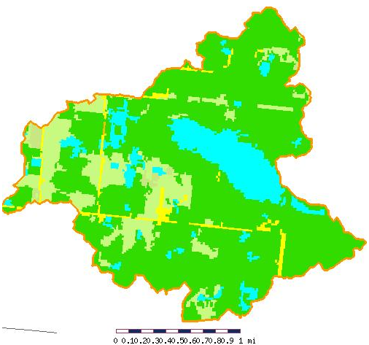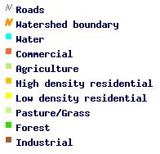
Figure 1. Straight lake watershed land use categories (EPA, 2007)

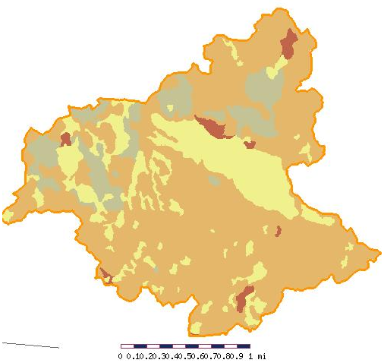

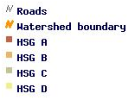

Figure 2. Straight Lake watershed Hydrologic soil groups (USDA NRCS, 1986)

