Water Quality Monitoring Report for the Silver Creek Watershed, Green Lake and Fond Du Lac County, Wisconsin

David Bolha-WDNR Water Quality Biologist-Oshkosh

December 2015

Purpose

The purpose of this project was to collect inorganic chemistry and aquatic macroinvertebrate samples, conduct qualitative habitat assessments and fish surveys to meet the requirements of USEPA Clean Water Act Section 208 (CWA 208) and Wisconsin Administrative Code ch. NR 121 (NR 121) and to write a watershed plan for the Silver Creek Watershed. A secondary goal of this project was to determine Wisconsin Administrative Code ch. NR 102 (NR 102) phosphorus water quality criteria exceedances and degraded biological community impairments for United States Environmental Protection Agency Clean Water Act Section 303d (CWA 303d) listing purposes for the Silver Creek Watershed. A tertiary goal of the this project was to collect baseline water quality data for comparison of future monitoring after watershed enhancements have been made to improve water quality in Silver Creek and reduce the nutrient and suspended solids load into Big Green Lake.

Methods

During the growing season of 2014, Total Phosphorus (TP) and Total Suspended Solids (TSS) samples were collected by volunteers at 11 locations once per month from May through October (Table 1, Map 1). All samples were collected using the standard Wisconsin Department of Natural Resources (WDNR) grab sampling method for a total of 65 samples (one sample was not collected due to low water in the creek) (WDNR 2014). All TP and TSS samples were shipped to Wisconsin State Laboratory of Hygiene (WISLOH) for analysis. The WISLOH entered all sample analysis data into the WDNR Surface Water Integrated Monitoring Systems (SWIMS) database.

SWIMS Station ID | Site Name | Surface Water WBIC | Map Location Number
10041510 | Silver Creek at County KK | 146800 | 16
10021299 | Silver Creek at Douglas St (Hwy 44) | 146800 | 11
10015911 | Silver Creek DS Scott Street Dam | 146800 | 10
203080 | Silver Creek at Koro Rd | 146800 | 17
10037918 | Dakin Creek E of FDL County Line | 146700 | 4
10041508 | Unnamed Trib to Silver Creek at Hwy 23 | 146900 | 5
10041507 | Unnamed Trib to Silver Creek at Murray Rd | 147000 | 6
10016330 | Unnamed Trib to Silver Creek at Trail (County FF) | 147400 | 7
10040834 | Unnamed Trib to Silver Creek US Arcade Rd | 5026964 | 8
10041506 | Unnamed Trib to Silver Creek at Hwy 23 | 5027015 | 12
10041509 | Unnamed Trib to Silver Creek at County KK | 147700 | 14
Table 1: Total Phosphorus and Total Suspended Solids Monitoring Sites Sampled in the Silver Creek Watershed May Through October 2014.

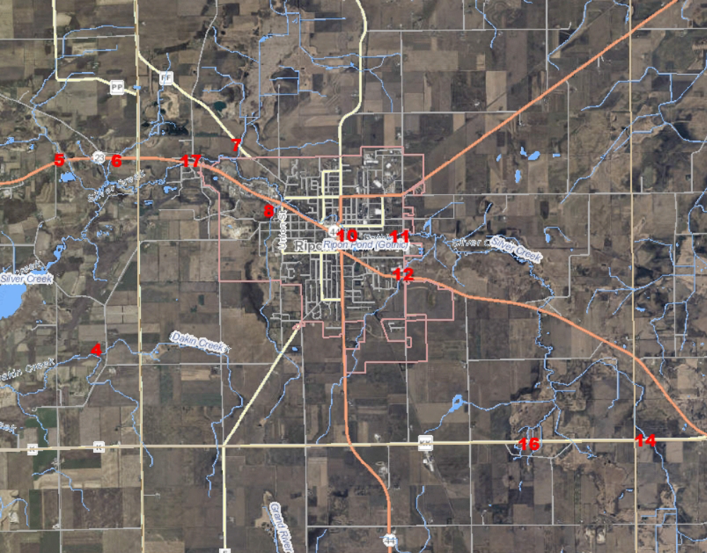
Map 1: Monitoring Locations in the Silver Creek Watershed Plan Project Area in 2014.

Each of the eleven sites listed in Table 1 were sampled for aquatic macroinvertebrates in October 2014 (Map 1). All sites were sampled using the WDNR Guidelines for Collecting Macroinvertebrate Samples from Wadable Streams (2000). A D-shaped kicknet with 600 micron mesh was used at all sites by standing upstream from the net and placing it firmly on the stream bed while digging into the substrate with the heel or toe to free the macroinvertebrates from the substrate. Riffles were targeted at each of the sites, but if none were present then overhanging vegetation, woody debris, or other vegetation would be sampled. This is done by jabbing the net into the vegetation to free the invertebrates. For a representative sample of the aquatic macroinvertebrate community, a minimum of 100 aquatic macroinvertebrates collected in each sample was targeted. The aquatic macroinvertebrates were preserved in a 70-80% ethanol solution inside quart “Mason” jars. If necessary, multiple “Mason” jars were used per sample depending upon how much sediment and organic material was collected with the aquatic macroinvertebrates. Within the next 24 hours, the samples were represerved with another 70-80% ethanol solution. Samples were taken to the University of Wisconsin-Stevens Point Aquatic Entomology Laboratory (UWSP AEL) for lowest possible taxonomic identification. Staff at the UWSP AEL entered the data into the SWIMS database in summer 2015.

Qualitative habitat surveys were conducted at 9 of the 11 sites listed above in Table 1 in July through September 2014 (Table 2, Map 1). Each qualitative habitat survey assessed a stream length of 35 times the mean stream width at that location. Qualitative habitat surveys rapidly assess characteristics such as bank erosion, width to depth ratio, % fine sediments, and cover for fish. WDNR staff entered the qualitative habitat data into the WDNR Fisheries and Habitat Management Database (FHMD).

SWIMS Station ID | Site Name | Surface Water WBIC | Map Location Number
10041510 | Silver Creek at County KK | 146800 | 16
10015911 | Silver Creek DS Scott Street Dam | 146800 | 10
203080 | Silver Creek at Koro Rd | 146800 | 17
10037918 | Dakin Creek E of FDL County Line | 146700 | 4
10041508 | Unnamed Trib to Silver Creek at Hwy 23 | 146900 | 5
10041507 | Unnamed Trib to Silver Creek at Murray Rd | 147000 | 6
10016330 | Unnamed Trib to Silver Creek at Trail (County FF) | 147400 | 7
10041506 | Unnamed Trib to Silver Creek at Hwy 23 | 5027015 | 12
10041509 | Unnamed Trib to Silver Creek at County KK | 147700 | 14
Table 2: Qualitative Habitat Survey Locations in the Silver Creek Watershed Conducted July through September 2014.

Between July and September 2014, wadable fish surveys were conducted at all 9 sites listed above in Table 2. A fish survey was not conducted in Silver Creek at Douglas Street/Hwy 44 as the survey station was not wadable. A fish survey was not conducted in the Unnamed Trib to Silver at Arcade Rd as a survey was completed in 2013. The 9 wadable fish surveys were conducted following the WDNR Guidelines for Assessing Fish Communities of Wadable Streams in Wisconsin (2001). All 9 wadable sites were surveyed in July through September 2014 during the guidance-recommended summer time survey period. Stream flow and water chemistry data was recorded at each wadable site prior to conducting the fish survey. The wadable fish survey stations were a minimum of 35 times the mean stream width (overall minimum of 100 meters, overall maximum of 400 meters). An otter sled stream shocker with a 4000 Peak Watt generator was used for 4 of the 9 wadable sites with appropriate stream width and/or depth. A 12 Volt, 18 Amp Hour battery-powered backpack shocker was used for 5 of 9 sites based upon the smaller stream width and depth. Catch per effort sampling procedures were used for this project (no particular species was targeted, all captured). A single upstream pass was made using 0.125 inch mesh nets to collect the fish. At the end of the station, captured fish were identified and counted and all game fish were measured for length. Once all data was collected, the fish were returned to the creek. Fish survey data was entered into the FHMD by WDNR Water Resources staff.

Continuous temperature data was collected at 9 sites in the Silver Creek Watershed in 2014 (Table 3, Map 1, Photo 1). Temperature measurements were collected once per hour at each location from May through mid-October. Temperature measurements were taken with an Onset Hobo Pendant thermistor attached to a fence post driven into the stream bed of the creek (Photo 1). The thermistor was attached to the fence post in such a manner as to suspend the thermistor in the water column low enough to stay under water in low flow conditions and high enough to not get buried in bottom substrate (~ 6 inches above the bottom). The thermistor was placed in a shaded location when possible.

SWIMS Station ID | Site Name | Surface Water WBIC | Map Location Number
10041510 | Silver Creek at County KK | 146800 | 16
10015911 | Silver Creek DS Scott Street Dam | 146800 | 10
10021299 | Silver Creek At Douglas St/Hwy 44 | 146800 | 11
203080 | Silver Creek at Koro Rd | 146800 | 17
10037918 | Dakin Creek E of FDL County Line | 146700 | 4
10041508 | Unnamed Trib to Silver Creek at Hwy 23 | 146900 | 5
10041507 | Unnamed Trib to Silver Creek at Murray Rd | 147000 | 6
10016330 | Unnamed Trib to Silver Creek at Trail (County FF) | 147400 | 7
10041509 | Unnamed Trib to Silver Creek at County KK | 147700 | 14
Table 3: Temperature Monitoring Sites Sampled in the Silver Creek Watershed May Through October 2014.

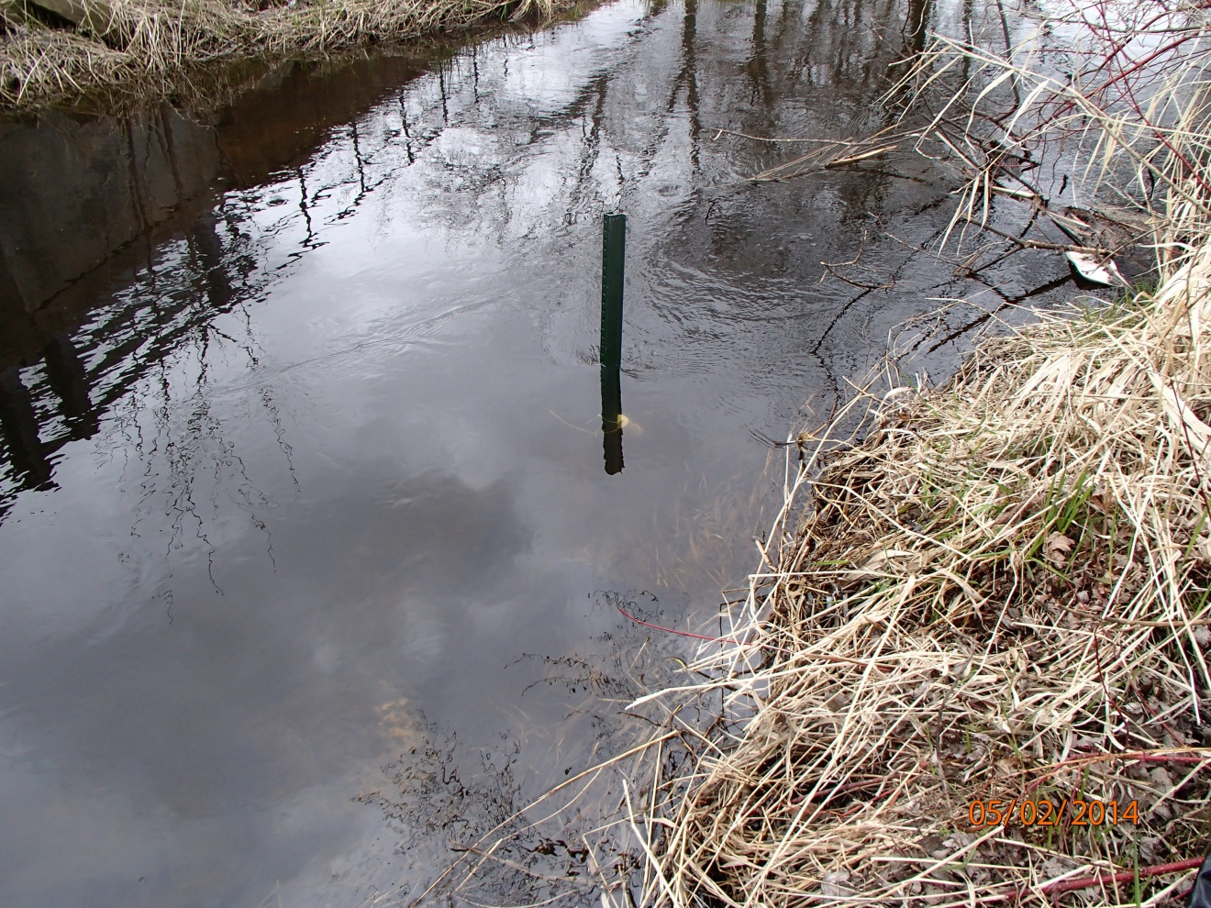
Photo 1: Hobo Pendant Thermistor Deployment in Silver Creek at Douglas Street/Hwy 44 in 2014. Photo taken by D. Bolha on May 2nd, 2014.

Results

All TP and TSS samples were sent to the WISLOH in Madison for analysis. Eight of the 11 sites in this project had an average TP concentration (mg/L) exceeding the NR 102 WQC for creeks at 0.075 mg/L (Table 4-5, Chart 1-2). Three of the 11 sites had average TP concentrations less than the WQC (Table 4-5, Chart 1-2). The average TP concentrations for the 11 sites in this project ranged from 0.0268 mg/L at Site 16 to 0.2057 mg/L at Site 7 (Map 1, Table 4-5, Chart 1-2).

Month of Sampling Event | Silver Creek at Hwy KK  Site 16  (mg/L) | Silver Creek Above Gothic Millpond  at Hwy 44  Site 11  (mg/L) | Silver Creek Below Gothic Mill Pond  Site 10  (mg/L) | Silver Creek  at Koro Rd  Site 17  (mg/L)
May | 0.0227 | 0.123 | 0.0533 | 0.0694
June | 0.0189 | 0.109 | 0.13 | 0.158
July | 0.0284 | 0.194 | 0.135 | 0.139
August | 0.0233 | 0.165 | 0.105 | 0.135
September | 0.028 | 0.0769 | 0.0338 | 0.0553
October | 0.0394 | 0.0664 | 0.0584 | 0.07
Average | 0.0268 | 0.1224 | 0.0859 | 0.1045
Table 4: Total Phosphorus Concentrations and Averages of Samples Collected in the Silver Creek Mainstem from Upstream to Downstream in 2014.

Sample Event  Month | Unnamed  Site 5  (mg/L) | Unnamed  Site 6  (mg/L) | Unnamed  Site 7  (mg/L) | Unnamed  Site 8  (mg/L) | Unnamed  Site 12  (mg/L) | Unnamed  Site 14  (mg/L) | Dakin Creek  Site 4  (mg/L)
May | 0.0418 | 0.0629 | 0.0742 | 0.112 | 0.0209 | 0.101 | 0.0743
Jun | 0.107 | 0.0838 | 0.333 | 0.0381 | 0.0614 | 0.0924 | 0.108
Jul | 0.124 | 0.0814 | 0.247 | 0.0687 | 0.0264 | 0.125 | 0.056
Aug | 0.132 | 0.171 | 0.163 | 0.195 | 0.0418 | 0.103 | 0.0353
Sep | 0.132 | 0.0656 | 0.303 | 0.175 | 0.023 | 0.129 | 0.037
Oct | 0.102 | 0.0439 | 0.114 | 0.131 | 0.0293 | 0.108 | 0.0351
Ave | 0.1065 | 0.0848 | 0.2057 | 0.1200 | 0.0338 | 0.1097 | 0.0576
Table 5: Total Phosphorus Concentrations and Averages of Samples Collected in the Tributaries of the Silver Creek Watershed in 2014.

Chart 1: Total Phosphorus Concentration Results and Averages in Silver Creek Mainstem (with 0.075 mg/L WQC red line) in 2014.

Chart 2: Total Phosphorus Concentration Results and Averages in the Tributaries to Silver Creek (with 0.075 mg/L WQC red line) in 2014.

Wisconsin Consolidated Assessment and Listing Methodology (WisCALM 2014) requires a parametric statistical approach to assess creek and river TP data against the applicable water quality criteria found in NR 102.06. This approach involves the calculation of a 90% confidence limit around the median of a TP sample dataset. If the lower 90% confidence limit (LCL) exceeds the criteria for TP, then that creek or river segment (assessment unit) is considered to be exceeding the criteria. If the LCL exceeds the criteria by more than twice the criteria (>0.15 mg/L), the assessment unit is considered to be overwhelmingly exceeding the criteria. The LCLs were calculated for each creek’s TP samples (Table 6-7, Chart 3-4). Two of the 4 Silver Creek sites’ TP LCLs exceeded the WQC (> 0.075 mg/L) while two met the WQC (< 0.075 mg/L) (Table 6, Chart 3). The headwaters of Silver Creek at County Hwy KK met the WQC. Just upstream of the Gothic Millpond at Hwy 44 the Silver Creek TP LCL exceeded the WQC. Below the Gothic Millpond, the Silver Creek TP samples met the WQC. At Koro Road, the WQC was exceeded by the Silver Creek TP samples. None of the Silver Creek TP LCLs overwhelmingly exceeded the WQC (>0.15 mg/L). The Silver Creek TP LCLs ranged from 0.0225 at County Hwy KK to 0.0925 mg/L above the Gothic Millpond (Table 6, Chart 3, Map 1).

 | Silver Creek at Hwy KK  Site 16 | Silver Creek Above Gothic Millpond  at Hwy 44  Site 11 | Silver Creek Below Gothic Mill Pond  Site 10 | Silver Creek  at Koro Rd  Site 17
LCL (90%)  mg/L | 0.0225 | 0.0925 | 0.0605 | 0.077
Exceedance Level | Meets | Exceeds | Meets | Exceeds
Table 6: Total Phosphorus Lower 90% Confidence Limit and Water Quality Criteria Exceedance Level of Samples Collected in the Silver Creek Mainstem from Upstream to Downstream in 2014.

Chart 3: Total Phosphorus Lower 90% Confidence Limit and Water Quality Criteria Exceedance Level of Samples Collected in the Silver Creek Mainstem from Upstream to Downstream in 2014 (with 0.075 mg/L WQC red line).

Four of the 7 tributary sites’ TP LCLs exceeded 0.075 mg/L while 3 met the WQC (Table 7, Chart 4). The tributary LCLs ranged from 0.0245 mg/L at Site 12 to 0.1426 mg/L at Site 7 (Map 1). None of the tributary TP LCLs overwhelmingly exceeded the WQC (>0.15 mg/L).

 | Unnamed  Site 5 | Unnamed  Site 6 | Unnamed  Site 7 | Unnamed  Site 8 | Unnamed  Site 12 | Unnamed  Site 14 | Dakin Creek  Site 4
LCL (90%) mg/L | 0.0859 | 0.0576 | 0.1426 | 0.0836 | 0.0245 | 0.1011 | 0.0401
Exceedance Level | Exceeds | Meets | Exceeds | Exceeds | Meets | Exceeds | Meets
Table 7: Total Phosphorus Lower 90% Confidence Limit and Water Quality Criteria Exceedance Level of Samples Collected in the Tributaries of the Silver Creek Watershed in 2014.

Chart 4: Total Phosphorus Lower 90% Confidence Limit and Water Quality Criteria Exceedance Level of Samples Collected in the Tributaries of the Silver Creek Watershed in 2014 (with 0.075 mg/L WQC red line).

TSS samples were collected at each of the 4 Silver Creek Mainstem project sites during the same sampling events as TP. TSS samples were collected once per month from May through October 2014 (Table 8). Wisconsin does not have a water quality standard for TSS; however, this data provides useful information about the watershed, background information for future comparison, and additional support for adding these systems to the CWA 303d list for habitat degradation. The average TSS concentration for the Silver Creek Mainstem ranged from 5.3 mg/L at County Hwy KK to 33.3 mg/L at Hwy 44 (Table 8, Chart 5, Map 1).

Month of Sampling Event | Silver Creek at County Hwy KK | Silver Creek Above Gothic Millpond at Hwy 44 | Silver Creek Below Gothic Millpond | Silver Creek at Koro Rd
May | 3.8 | 66 | 5.4 | 9
June | 2.2 | 12.5 | 8.67 | 14.7
July | 2.2 | 31.3 | 10.8 | 17
August | 2.6 | 47.7 | 10 | 10.2
September | 3.8 | N/A | N/A | N/A
October | 17 | 9 | 4.4 | 8.4
Average | 5.27 | 33.3 | 8.72 | 11.86
Table 8: Total Suspended Solids Concentrations and Averages (mg/L) of Samples Collected in the Silver Creek Mainstem from Upstream to Downstream in 2014.

Chart 5: Total Suspended Solids Concentrations and Averages (mg/L) of Samples Collected in the Silver Creek Mainstem from Upstream to Downstream in 2014.

TSS samples were collected at each of the 7 Silver Creek tributary sites during the same sampling events as TP. TSS samples were collected once per month from May through October 2014 (Table 9). The average TSS concentration for the Silver Creek tributaries ranged from 4.1 mg/L at Site 12 to 26.65 mg/L at Site 6 (Table 9, Chart 6, Map 1).

Sample Event  Month | Unnamed  Site 5 | Unnamed  Site 6 | Unnamed  Site 7 | Unnamed  Site 8 | Unnamed  Site 12 | Unnamed  Site 14 | Dakin Creek  Site 4
May | 3 | 13.4 | 2 | 2 | 2 | 3 | 35.2
June | 24 | 19.7 | 7 | 5.25 | 13 | 2 | 18.2
July | 20.6 | 19.7 | 6 | 9 | 3.4 | 2 | 10.4
August | 11.2 | 92.3 | 7 | 2 | 2 | 9.6 | 2
September | 10.4 | 2 | 5.6 | 3.8 | 2 | 52.5 | 2
October | 7.6 | 12.8 | 3.8 | N/A | 2 | 49 | 2
Average | 12.8 | 26.65 | 5.23 | 4.41 | 4.07 | 19.68 | 11.63
Table 9: Total Suspended Solids Concentrations and Averages (mg/L) of Samples Collected in Tributaries of Silver Creek in 2014 (2.0 mg/L = Limit of Detection).

Chart 6: Total Suspended Solids Concentrations and Averages (mg/L) of Samples Collected in Tributaries of Silver Creek in 2014 (2.0 mg/L = Limit of Detection).

In October 2014, 11 streams were sampled for aquatic macroinvertebrate communities in the Silver Creek Watershed. Some aquatic macroinvertebrate species are tolerant of environmental degradation, while some species are moderately tolerant, and some others are intolerant. Based upon the representative macroinvertebrate sample collected and their associated tolerance to environmental degradation, an Index of Biotic Integrity (MIBI) was calculated to indicate the water quality condition of the stream (Table 10, Chart 7). The MIBI scores ranged from 1.71 at the Unnamed Tributary to Silver Creek upstream of Arcade Road to 4.54 at Silver Creek at Douglas Street (Table 10, Chart 7). The condition categories for 10 sites were Fair (Table 7, Chart 3), while Site 8’s demonstrated a condition category of Poor. All 11 streams demonstrated a macroinvertebrate community significantly impacted by environmental degradation.

SWIMS Station ID | Stream Name and Location | Site # | Macroinvertebrate IBI Score | Condition Category
10041510 | Silver Creek at County KK | 16 | 3.57 | Fair
10021299 | Silver Creek at Douglas St (Hwy 44) | 11 | 4.54 | Fair
10015911 | Silver Creek DS Scott Street Dam | 10 | 3.77 | Fair
203080 | Silver Creek at Koro Rd | 17 | 4.07 | Fair
10037918 | Dakin Creek E of FDL County Line | 4 | 4.33 | Fair
10041508 | Unnamed Trib to Silver Creek at Hwy 23 | 5 | 3.85 | Fair
10041507 | Unnamed Trib to Silver Creek at Murray Rd | 6 | 3.05 | Fair
10016330 | Unnamed Trib to Silver Creek at Trail (County FF) | 7 | 4.34 | Fair
10040834 | Unnamed Trib to Silver Creek US Arcade Rd | 8 | 1.71 | Poor
10041506 | Unnamed Trib to Silver Creek at Hwy 23 | 12 | 3.52 | Fair
10041509 | Unnamed Trib to Silver Creek at County KK | 14 | 2.80 | Fair
Table 10: Aquatic Macroinvertebrate Index of Biotic Integrity Scores and Water Quality Condition Category in the Silver Creek Watershed in October 2014.

Chart 7: Aquatic Macroinvertebrate Index of Biotic Integrity Scores and Water Quality Condition Category in the Silver Creek Watershed in October 2014.

Between July and September 2014, qualitative habitat surveys were conducted at 9 locations in the Silver Creek watershed (Table 2). Based upon the assessment data collected during the 2014 surveys, a habitat rating was calculated for all sites. The habitat rating scores ranged from 35 at tributary Sites 7 and 12 to 73 at the headwaters site of Silver Creek at County Hwy KK (Table 11, Chart 8, Map 1). All 9 surveys demonstrated a Condition Category of Good (Table 11, Chart 8).

SWIMS Station ID | Stream Name and Site Location | Qualitative Habitat Score | Condition Category
10041510 | Silver Creek at County Hwy KK | 73 | Good
10015911 | Silver Creek Below Gothic Millpond | 63 | Good
203080 | Silver Creek at Koro Rd | 52 | Good
10037918 | Dakin Creek E of FDL County Line | 72 | Good
10041508 | Site 5 | 55 | Good
10041507 | Site 6 | 63 | Good
10016330 | Site 7 | 50 | Good
10041506 | Site 12 | 50 | Good
10041509 | Site 14 | 55 | Good
Table 11: Qualitative Habitat Survey Scores and Rating Conditions for 9 Sites in the Silver Creek Watershed in 2014.

Chart 8: Qualitative Habitat Survey Scores and Condition Categories for 9 Sites in the Silver Creek Watershed in 2014.

Between July and September 2014, the 9 sites in Table 2 were surveyed for representative fish communities. Some fish species are tolerant of environmental degradation, while some species are moderately tolerant, and some others are intolerant. Based upon the representative fish collected during the survey and their associated tolerance to environmental degradation, an Index of Biotic Integrity (FIBI) was calculated to indicate the water quality of each creek (Table 11, Chart 8). The FIBI scores ranged from 20 in the headwaters of Silver Creek to 100 in the Unnamed Creek at County Hwy FF (Table 12, Chart 9, Map 1). The condition category for the 9 sites ranged from Poor to Excellent. The fish survey in the Unnamed Creek at County Hwy FF had a condition category of Excellent, with the highest number of fish species (11) and total number of fish caught (1341) (Table 12, Chart 9). The Silver Creek fish survey below Gothic Millpond had a condition category of Good, with 10 species caught (Table 12, Chart 9). Three of the 9 fish surveys indicated creeks having a condition category of Fair. The remaining four sites had a condition category of Poor based upon the fish surveys (Table 12, Chart 9).

Each fish community surveyed was used to verify or update the modeled Natural Community for that stream segment. The modeled Natural Community for Silver Creek changes as you move from upstream to downstream. The headwater area of Silver Creek is modeled as a Cool-Warm Headwater Natural Community downstream to the west side of the City of Ripon. The modeled Natural Community changes to Cool-Warm Mainstem on the west side of Ripon until Silver Creek discharges into Big Green Lake. Each of the 6 tributary streams’ Natural Community was verified or changed based upon the fish caught in the survey (and any historical known surveys in that stream segment). Verifying or changing the modeled Natural Community was important since the Natural Community determines what FIBI was used to determine the water quality of that stream segment. The results of the calculated FIBI calculations displayed in Table 11 and Chart 8 are based upon the verified or changed Natural Community.

SWIMS Station ID | Site Name | FIBI Score | Condition Category | Verified or Updated Natural Community
10041510 | Silver Creek at County KK | 20 | Poor | Cool-Warm Headwater
10015911 | Silver Creek DS Scott Street Dam | 80 | Good | Cool-Warm Headwater
203080 | Silver Creek at Koro Rd | 30 | Fair | Cool-Warm Mainstem
10037918 | Dakin Creek E of FDL County Line | 50 | Fair | Cool-Cold Headwater
10041508 | Unnamed Trib to Silver Creek at Hwy 23 | 30 | Poor | Cool-Cold Headwater
10041507 | Unnamed Trib to Silver Creek at Murray Rd | 20 | Poor | Cool-Cold Headwater
10016330 | Unnamed Trib to Silver Creek at Trail (County FF) | 100 | Excellent | Cool-Warm Headwater
10041506 | Unnamed Trib to Silver Creek at Hwy 23 | 20 | Poor | Cool-Cold Headwater
10041509 | Unnamed Trib to Silver Creek at County KK | 60 | Fair | Cool-Warm Headwater
Table 12: Fish Survey Results in the Silver Creek Watershed Conducted in July through September 2014.

Chart 9: Fish Survey Results in the Silver Creek Watershed Conducted in July through September 2014.

Temperature data was collected from May through mid-October in 2014 at 9 locations in the Silver Creek Watershed (Table 13, Map 1). Four locations were monitored hourly in the Silver Creek mainstem. The temperatures in Silver Creek in general increased from upstream to downstream, except between the Gothic Millpond outlet and Koro Rd which showed a slight decrease in monthly average and maximum daily average temperatures. The decrease in temperature at Koro Rd is likely due to higher inputs of cooler groundwater into the creek as it flows through the City of Ripon. The upper portions of Silver Creek, in reference to the County Hwy KK location, are cold enough to support a Cool-Cold transitional fish community (Table 14, Chart 10). This section of Silver Creek upstream of Hwy 23 on the east side of Ripon is currently identified as Class 2 Trout Waters, which means some trout reproduction may occur but stocking is necessary to maintain a desirable fishery (WDNR 2002). The maximum daily average temperature of Silver Creek at County Hwy KK increased from 59.6F to 74.5F at Hwy 44 upstream of the Gothic Millpond (Table 14, Chart 10). The maximum daily average temperature of Silver Creek increased from 74.5F to 76F from upstream of the Gothic Millpond to downstream. The average monthly temperature increased on average 4F from upstream of the millpond to downstream between June and September 2014.
SWIMS Station ID | Site Name | Map Location Number
10041510 | Silver Creek at County KK | 16
10015911 | Silver Creek DS Scott Street Dam | 10
10021299 | Silver Creek At Douglas St/Hwy 44 | 11
203080 | Silver Creek at Koro Rd | 17
10037918 | Dakin Creek E of FDL County Line | 4
10041508 | Unnamed Trib to Silver Creek at Hwy 23 | 5
10041507 | Unnamed Trib to Silver Creek at Murray Rd | 6
10016330 | Unnamed Trib to Silver Creek at Trail (County FF) | 7
10041509 | Unnamed Trib to Silver Creek at County KK | 14
Table 13: Temperature Monitoring Locations in the Silver Creek Watershed in 2014.

Location | June Average Temperature | July Average Temperature | August Average Temperature | September Average Temperature | Maximum Daily Average Temperature
Silver Creek at County Hwy KK | 50.4 | 50.2 | 50.5 | 50.3 | 59.6
Silver Creek Above Gothic Millpond | 68.5 | 68 | 68.7 | 61.3 | 74.5
Silver Creek Below Gothic Millpond | 70.7 | 71.6 | 73.8 | 66.2 | 76
Silver Creek at Koro Rd | 68 | 68 | 69.3 | 63.1 | 73.1
Table 14: Average Monthly and Maximum Daily Average Temperatures in Silver Creek Mainstem in 2014 (Fahrenheit).

Chart 10: Average Monthly and Maximum Daily Average Temperatures in Silver Creek Mainstem in 2014.

Four Unnamed Creeks and Dakin Creek were monitored for temperature in the Silver Creek Watershed in 2014 (Table 13). Each location was monitored once per hour from early May through mid-October. Dakin Creek recorded the lowest temperatures of the tributaries to Silver Creek (Table 15, Chart 11), with a Maximum Daily Average (MDM) of 65.7F. Site 14 (Unnamed Creek at County KK) recorded the highest temperatures of the 5 tributaries in this project, with a MDM of 75F (Table 15, Chart 11).

Location | June Average Temperature | July Average Temperature | August Average Temperature | September Average Temperature | Maximum Daily Average Temperature
Site 5 | 62.2 | 61.2 | 61.7 | 56.5 | 66.6
Site 6 | 67.8 | 68.4 | 69.1 | 61.3 | 74.5
Site 7 | 68.7 | 66.6 | 66.9 | 60.1 | 74.7
Site 14 | 67.8 | 66.4 | 64.8 |  | 75
Dakin Creek | 57.2 | 55 | 56.5 | 54.3 | 65.7
Table 15: Average Monthly and Maximum Daily Average Temperatures in Silver Creek Tributaries in 2014 (Fahrenheit).

Chart 11: Average Monthly and Maximum Daily Average Temperatures in Silver Creek Tributaries in 2014.

Discussion

The purpose of this project was to collect TP and TSS data, collect biological community information and conduct qualitative habitat assessments to write a watershed plan for the Silver Creek Watershed required by NR 121 and CWA 208. A secondary goal of this project was to determine NR 102 phosphorus water quality criteria exceedances and degraded biological community impairments for CWA 303d listing purposes for the Silver Creek Watershed. The TP, aquatic macroinvertebrate, and fish monitoring in this project demonstrated that the water quality in the Silver Creek Watershed is between poor and excellent condition.

Silver Creek drains a 35,170 acre watershed before discharging into Big Green Lake. The Silver Creek Watershed is part of the larger Big Green Lake Watershed. The Silver Creek Watershed is located on the western edge of the Southeast Glacial Plains and the eastern edge of the Central Sand Hills Ecological Landscapes (WDNR 2014). The eastern Big Green Lake Watershed is more appropriately associated with the Southeast Glacial Plains. The Southeast Glacial Plains (WDNR 2014) correlates loosely with the Southeastern Wisconsin Till Plains (USGS 2006). The land use for the Southeast Wisconsin Till Plains (SWTP) is dominated by cropland (USGS 2006). The creek subwatersheds in this study have low to high clay soil content and are low to high in gradient, which is likely the driver behind cropland-dominated land use. The clay content of the soils in the SWTP has had a strong effect on the water quality of Midwestern streams (USGS 2006). Typically, as increases in agricultural land use occur, there is a correlating increase in TP concentration in creeks in the watershed. Water clarity (secchi depths) decreases and chlorophyll a concentration (which is an indication of algae populations) increases as TP and TDP increases. Water clarity and chlorophyll a concentration are indicators of water quality in Wisconsin lakes (WisCALM 2014).

Reference average creek conditions for the SWTP ranged from 0.080 mg/L (USEPA 2000-2001) to 0.042 mg/L TP (median) (USGS 2006). Eight of the 11 average TP concentrations in this project were above the modeled reference conditions (USEPA 2000-2001 & USGS 2006) (Table 4-5, Chart 1-2). Eight of the 11 TP LCL concentrations in this project were above the USGS modeled reference conditions for creeks in this “environmental phosphorus zone” (USGS 2006). Response thresholds of fish and aquatic macroinvertebrates to changes in nutrient concentrations for all wadable (not just SWTP) creeks are 0.055 mg/L and 0.088 mg/L for TP, respectively (USGS 2006). In general, that means a small increase in nutrient concentration before reaching that threshold concentration results in a relatively large change to the macroinvertebrate and fish communities. Eight of the 11 sites demonstrated TP LCL concentrations over response thresholds of fish (USGS 2006) (Table 6-7, Chart 3-4). Three of the 11 sites demonstrated TP LCL concentrations over response thresholds of macroinvertebrates (USGS 2006) (Table 6-7, Chart 3-4). Water quality has been impacted by the TP concentrations in the creeks of this project. Therefore, an impairment assessment was conducted to evaluate if Silver Creek and its tributaries should be placed on the CWA 303d list for biological community impairments due to the pollutant phosphorus.

The inorganic chemistry data collected during this project established that instream TP concentrations were above reference conditions; therefore, an impairment assessment was conducted to evaluate if NR 102 water quality criteria (WQC) were being met or if the creeks should be placed on the CWA 303d Impaired Waters List. The requirements to demonstrate if WQC for TP were being met, clearly exceeded, or overwhelmingly exceeded were accomplished through this project. WisCALM 2014 requires that a minimum of 6 monthly samples for TP from May through October occur within two years to have sufficient data to calculate the lower 90% confidence limits (LCL). The LCL determines if the creek was meeting, clearly exceeding, or overwhelmingly exceeding the water quality standard (Table 6-7). To conduct a CWA 303d impairment assessment, WisCALM 2014—Table 4 was referenced to determine impairment status and the associated pollutant (Table 16). Two of the 4 locations sampled from the Silver Creek Mainstem exceeded the TP WQC, but did not overwhelmingly exceed. According to impairment assessment protocol (WisCALM 2014), biological confirmation was needed to determine which CWA 303d listing was necessary (Table 16). Biological confirmation was considered a FIBI or MIBI condition category of Poor in the same section of Silver Creek as the WQC exceedances. None of the macroinvertebrate and fish surveys in Silver Creek Mainstem indicated a condition category of Poor (besides the FIBI at County KK). Therefore, the requirements for listing Silver Creek as Impaired due to degraded biological community from the pollutant phosphorus was not met (Table 16). None of the seven tributaries’ TP LCLs overwhelmingly exceeded the WQC (>0.15 mg/L TP). Four of the 7 TP LCLs exceeded the WQC but did not overwhelmingly exceed (>0.075<1.5 mg/L). Biological confirmation was needed to determine which CWA 303d listing was necessary for the 4 tributaries (Table 16). The 2013 fish survey and the 2014 macroinvertebrate survey at the Unnamed Tributary to Silver Creek (Site 8) scored in the Poor condition category (Table 10, Chart 7). The 2014 fish survey at the Unnamed Tributary to Silver Creek (Site 5) scored in the Poor condition category (Chart 12). The Poor IBI scores together with the TP LCLs exceeding the WQC indicate that the two Unnamed Tributaries to Silver Creek (WBIC 5026964 & 146900) should be CWA 303d listed for degraded biological community due to pollutant TP (Category 5A) (Table 16-17). The Unnamed Tributary to Silver Creek at County FF (Site 7) was recommended for the 2016 Impaired Waters List due to biological degradation due to the pollutant phosphorus (Table 17). The phosphorus levels in 2014 (Table 5 & 7, Chart 2 & 4) led to that recommendation for listing. The Unnamed Tributary to Silver Creek at County FF (WBIC 147700) should not be CWA 303d listed for TP.

 | Biological Response Indicators | Overall Assessment Result & EPA Listing Category | Pollutant
Meets TP Criteria | None indicate impairment | Not Impaired (Fully Supporting) Category 2 | NA
Meets TP Criteria | One or more indicate impairment | Impaired—Biology Only (Not Supporting) Category 5A | Unknown
Exceeds TP Criteria (not an overwhelming exceedance) | One or more indicate impairment | Impaired—TP & Bioconfirmation (Not Supporting) Category 5A | TP
Exceeds TP Criteria (not an overwhelming exceedance) | None indicate impairment | Impaired—Exceeds TP but has insufficient or conflicting biological data (Not Supporting) Category 5P | TP
Exceeds TP Criteria by an Overwhelming Amount | None needed | Impaired—TP Only (i.e. Overwhelming exceedance (Not Supporting) Category 5A | TP
Table 16: Assessment of Phosphorus and Biology in Combination to Determine Impairment Status and Pollutant (WisCALM 2014).

Habitat degradation by sedimentation is also a common driver of fish and aquatic life use impairments due to the nature of the land use in the SWTP. Fine sediment covers the creek substrate and fills in pools, reducing the suitable habitat for fish and macroinvertebrate communities. Filling-in of pools reduces the amount of available cover for juvenile and adult fish. Sedimentation of riffle areas reduces the reproductive success of fish by reducing the exposed gravel substrate necessary for appropriate spawning conditions. Suspended sediment also increases turbidity, reducing light penetration necessary for photosynthesis in aquatic plants. Increased turbidity also reduces the feeding efficiency of visual predators and filter feeders, and lowers the respiratory capacity of aquatic invertebrates by clogging their gill surfaces. Silver Creek Mainstem was CWA 303d listed for impaired fish and aquatic life use due elevated water temperatures and habitat degradation from pollutant TSS/Sedimentation in 1998. The TSS, biota, and habitat monitoring throughout the Silver Creek Watershed in this project provided the information needed to make an impairment assessment of the tributaries. An impairment assessment was conducted to evaluate if its tributaries should be placed on the CWA 303d Impaired Waters List for degraded habitat due to the pollutant TSS/Sedimentation.

To conduct an impairment assessment of each of these tributaries based upon habitat degradation by sedimentation, biological and qualitative habitat surveys were conducted in 2014. The FIBI calculation at two of the unnamed tributaries at Sites 5 & 6 indicated a Condition Category of Poor when compared to reference Wisconsin fish communities (Table 12, Chart 9). In 2013, a fish survey conducted in the Unnamed Tributary at Arcade Rd (Site 8) indicated a Condition Category of Poor. The qualitative habitat surveys conducted at each of the three locations indicated a Fair to Good fish habitat, ranging from 35 at Site 8 (in 2013) to 63 at Site 6 (in 2014). The habitat surveys indicated specific aspects of the three tributaries’ habitat which contributed to the Poor FIBI. The habitat score was brought down due to limited available fish cover, high percentage of fine sediment, and a lack of pool habitat. Based upon the Poor FIBI score, impacted instream habitat, and my best professional judgment, the three tributaries to Silver Creek should be listed as Impaired (Category 5A) with the impairment degraded habitat and the pollutant TSS (Table 17).

Creek | WBIC | Pollutant | Listing Category
Unnamed Tributary to Silver Creek | 146900 | TSS Degraded Habitat-Sedimentation | 5A
Unnamed Tributary to Silver Creek | 146900 | TP Exceeds-Bioconfirmation | 5A
Unnamed Tributary to Silver Creek | 5026964 | TSS Degraded Habitat-Sedimentation | 5A
Unnamed Tributary to Silver Creek | 5026964 | TP Exceeds-Bioconfirmation | 5A
Unnamed Tributary to Silver Creek | 147000 | TSS Degraded Habitat-Sedimentation | 5A
Unnamed Tributary to Silver Creek | 147400 | TP Exceeds-No Bioconfirmation | 5P
Table 17: Impaired Waters Listing 303d Pollutant and Listing Category Recommendations for Creeks in the Project Area.

Some of the sources of sedimentation, phosphorus, increased temperatures, and decreased biotic integrity in Silver Creek and the Unnamed Tributaries are streambank erosion, agriculture tile drainage, urban and construction site runoff, fish barriers, minimal buffer widths, and stream channelization (Photo 2-6). The poor to fair FIBI and MIBI scores reflect the effects of habitat degradation, sedimentation, and high nutrient loads from the subwatersheds.

There are many options available to reduce the pollutants phosphorus and sediment in Silver Creek and the Unnamed Tributaries. One option to reduce the sediment and nutrients is to conduct streambank restoration on eroding banks (Photo 2). Another option to reduce the cropland runoff is to increase flood storage capacity in the watersheds. Creating sedimentation ponds which capture runoff from cropland/uplands will provide flood storage, reduce sediment and nutrients reaching the creeks, and reduce high creek flow velocities which cause erosion. A third option to reduce nutrient and sediment loading while creating fish and aquatic life habitat is to re-meander channelized ditches which contain large amounts of organic material (Photo 3). Perched culverts and the Gothic Millpond Dam are partial or complete barriers to fish migration (Photo 4-6). Fish barriers, whether complete or partial, can limit the biotic integrity of a watershed. Replacing perched culverts with properly sized and designed culverts increases the available fish and aquatic life habitat and limits any risk to fish migration. Adding a fish passage component to the Gothic Millpond Dam would encourage fish migration by fish species such as brown trout and northern pike to spawning habitat upstream of the millpond. Increasing vegetative and forested buffer widths along the creeks in the Silver Creek Watershed can also have a positive impact on the sediment and nutrient load reaching the creeks (Photo 2 & 7). Recommended buffer widths vary significantly in published research (there is no one-size-fits all), but the majority of research recommends vegetative buffers >35’, with 35’ being on the lower end of recommended buffer widths. In general, as the land slope along a creek increases, the riparian buffer width recommendation increases. The type of vegetative buffer is also critical to reducing sediment and nutrients reaching the creeks of this project. A combination of forest and native grass buffers may have a better nutrient reduction than strictly grassed buffers.

Several partnering agencies and organizations including Green Lake County LCD, Fond Du Lac County LWCD, Green Lake Sanitary District, Green Lake Association, the City of Ripon, Ripon College, Ripon High School, NRCS, and USGS are working together to reduce the overall load of sediment and nutrients into Big Green Lake downstream of Silver Creek. Implementing BMPs (streambank restoration, sediment basins, vegetative buffers, stormwater management, ect.) will likely have a significant improvement of the water quality in Silver Creek, its tributaries, and Big Green Lake.

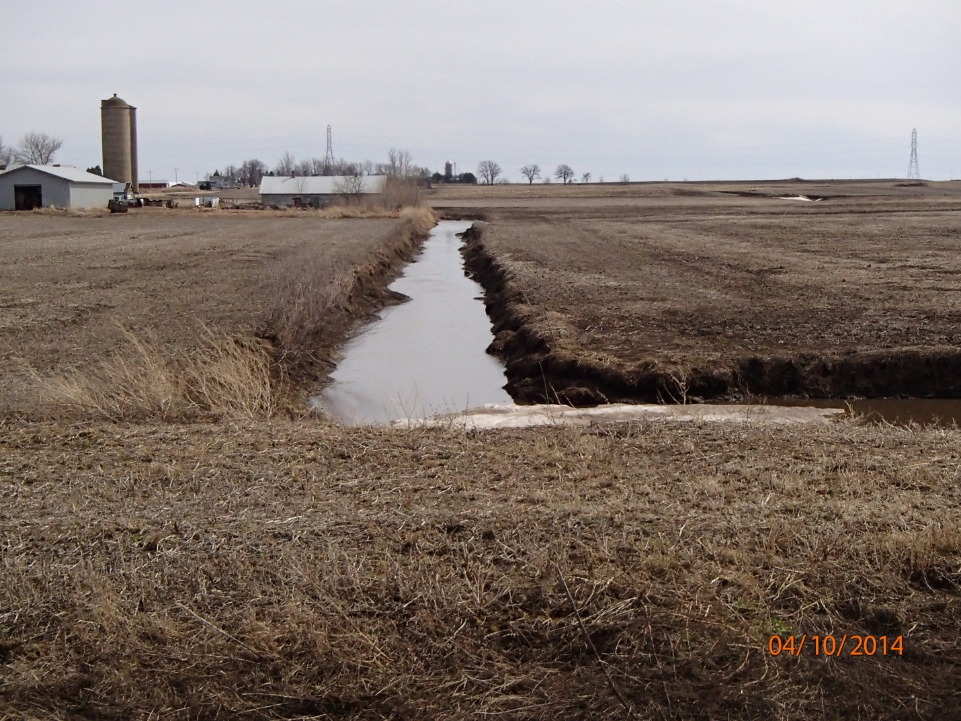
Photo 2: Dakin Creek Facing Upstream of County Hwy KK. Photo taken by D. Bolha on April 10th, 2014.
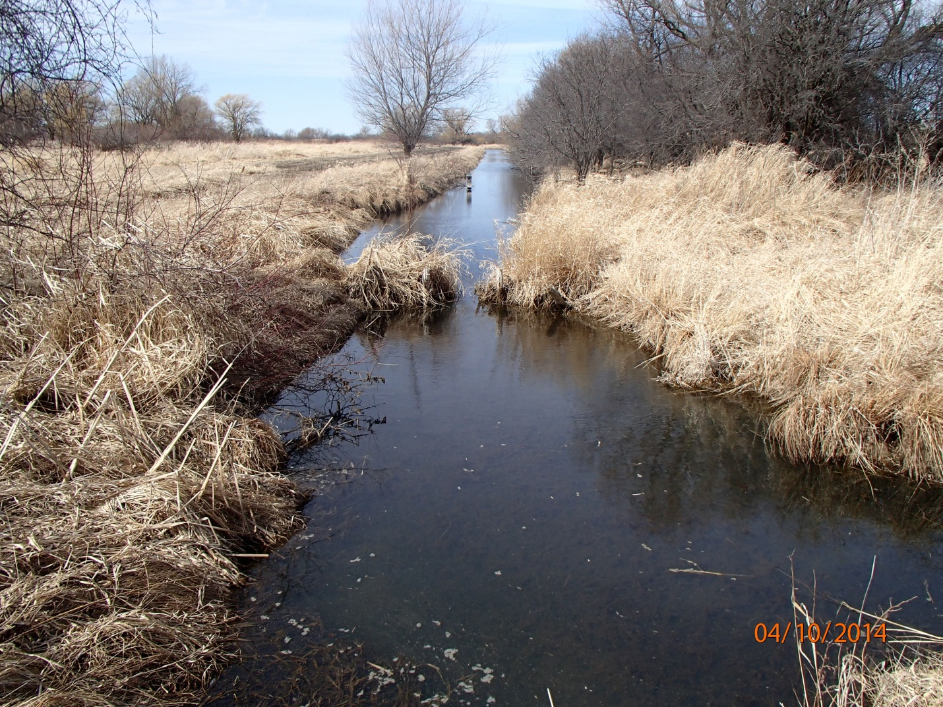
Photo 3: Unnamed Tributary to Silver Creek (WBIC 147900) Facing Downstream of County Hwy KK. Photo taken by D. Bolha on April 10th, 2014.

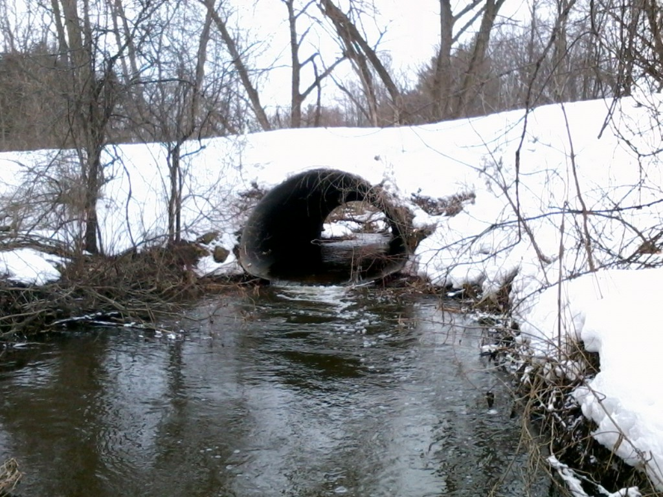
Photo 4: Dakin Creek Facing Upstream at the Perched Culvert Under Skunk Hollow Road. Photo taken by D. Bolha on March 14th, 2013.

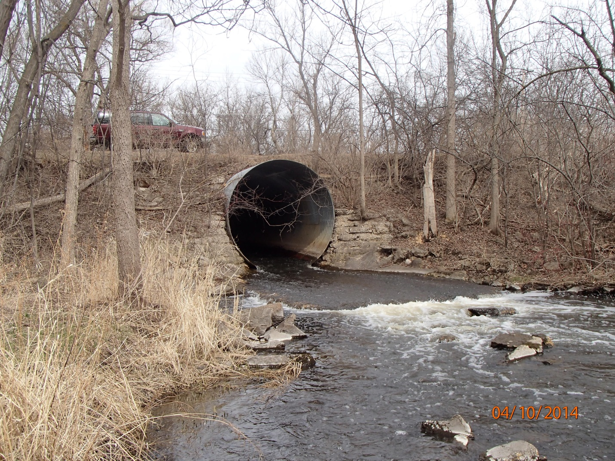
Photo 5: Silver Creek Facing Upstream at the Perched Culvert Under South Koro Road. Photo taken by D. Bolha on April 10th, 2014.

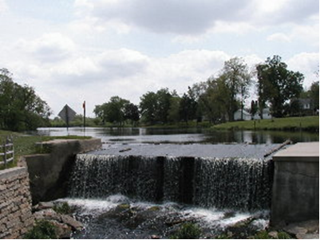
Photo 6: Silver Creek Facing Upstream at the Gothic Mill Dam and Gothic Millpond Upstream of Scott Street in Ripon. Photo taken by M. Rief in Summer 2000.
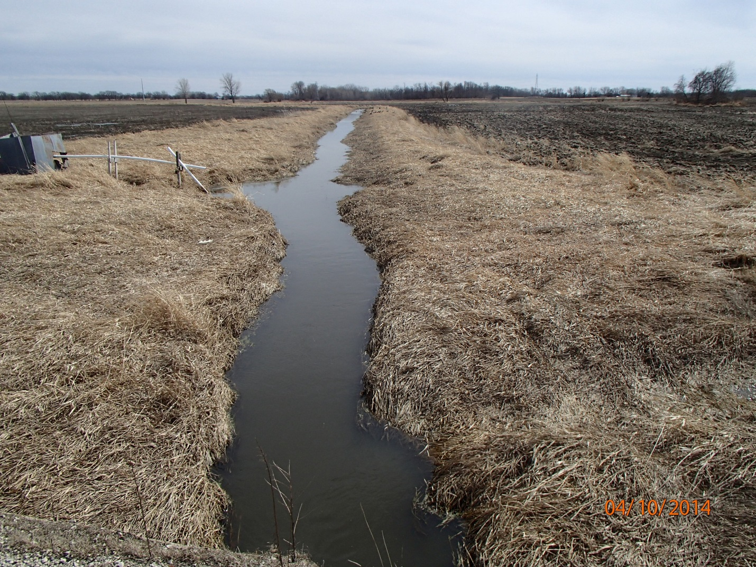
Photo 7: Unnamed Tributary to Silver Creek (WBIC 147700) Facing Upstream of County Hwy KK. Photo taken by D. Bolha on April 10th, 2014.

References

USGS (United States Geological Survey) (Robertson, D.M. et. al.). 2006. Nutrient Concentrations and Their Relations to the Biotic Integrity of Wadeable Streams in Wisconsin.

WDNR (Wisconsin Department of Natural Resources). 2000. Guidelines for Collecting Macroinvertebrate Samples from Wadable Streams.

WDNR (Wisconsin Department of Natural Resources). 2001. Guidelines for Assessing Fish Communities of Wadable Streams in Wisconsin.

WDNR (Wisconsin Department of Natural Resources). 2002. Guidelines for Evaluating Habitat of Wadable Streams.

WDNR (Wisconsin Department of Natural Resources). 2002. Wisconsin Trout Streams.

WDNR (Wisconsin Department of Natural Resources) (Rief). 2010. Silver Creek Stream Reclassification, Fond Du Lac County, Wisconsin.

WDNR (Wisconsin Department of Natural Resources) (Johnson et. al.). 2011. An Assessment of Hill, Roy, Silver, and Wuerches Creeks (303d Impaired Waters).

WDNR (Wisconsin Department of Natural Resources). 2014. Total Phosphorus Sampling Methods: Water Action Volunteers Manual 2014.

WDNR (Wisconsin Department of Natural Resources). 2014. Wisconsin Consolidated Assessment and Listing Methodology Guidance Document.

