Fish, Crystal and Mud Lakes Management Plan
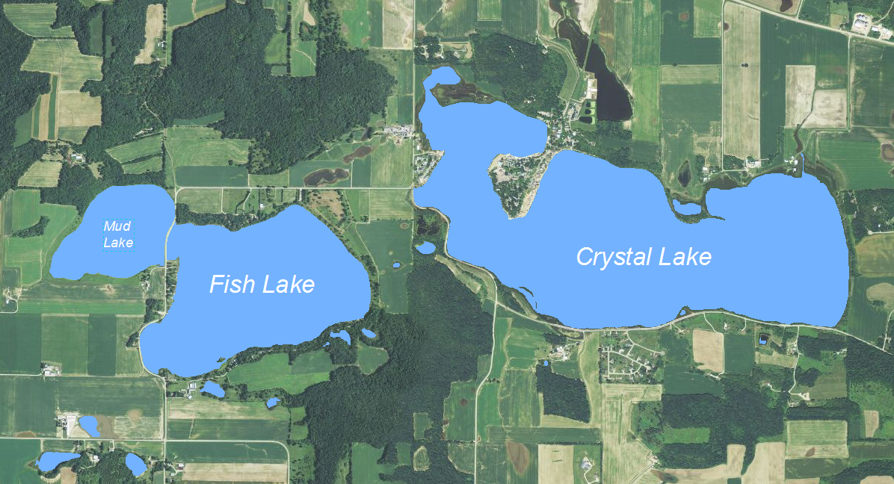

David W. Marshall¹, Pete L. Jopke² and Jean M. Unmuth³
¹ Underwater Habitat Investigations LLC
² Dane County Land and Water Resources Department
³ Wisconsin Department of Natural Resources

November 2014
Plan Funded by the Wisconsin Department of Natural Resources Lake Planning Grant

Summary
As part of a large-scale lake planning grant project, Fish Lake, Mud Lake and Crystal Lake were monitored spring through fall on a monthly basis in 2013 and 2014. Fish Lake is a rare southern Wisconsin deep water seepage lake that lies just east of the unglaciated Driftless Area. While the watershed area to lake area ratio is only 4.4:1, this deep water dimictic lake continues to display eutrophic conditions even though the relatively small drainage area would otherwise suggest more favorable water quality. Recent data indicates continued water quality decline in the lake (R² = 0.72) since monitoring began in the early 1970’s. The continued water quality decline may reflect the environmentally sensitive nature of seepage lakes like Fish Lake. However, the lake still supports a relatively diverse fishery that includes environmentally intolerant Iowa darters, blackchin shiners and State Special Concern banded killifish. The single individual of the latter species was collected in August 2014 and was last documented in the lake over two decades ago. In sharp contrast to the water quality in Fish Lake, adjoining Mud Lake is highly degraded and displays hypereutrophic conditions. The shallow former bay of Fish Lake had suffered decades of runoff pollution, particularly manure, and the degraded conditions are exacerbated by the aggressive foraging behaviors of common carp. Young of year carp were collected in August 2014 and revealed continued recruitment of the non-native fish. Strategies to reverse these conditions will require shifting the alternative stable turbid state to a clear water macrophyte dominated ecosystem. Crystal Lake continued to display highly eutrophic conditions. Poor water quality reflects the shallow polymictic basin that favors internal nutrient loading throughout the growing season and an intensive agriculturally dominated watershed with numerous row crop fields located in close proximity to the shorelines.
Recommendations

- Establish conservation buffers and/or fee title acquisition to reduce runoff pollution on the west and south sides of Fish Lake. These efforts are needed to reverse the long term trend of water quality decline in the lake and compliment existing public investments including Lussier County Park.
- Target Fish Lake TSI values should be less than 50.
- Block the migrations of common carp between Fish Lake and Mud Lake. This will require a migration screen or rocks that will sustain the connection between the two lakes. Following this effort, a rotenone treatment of Mud Lake is recommended to reduce carp and shift the lake from an alternative stable turbid state to a clear water state.
- Consider an alum treatment in Mud Lake after the carp eradication given the apparent internal loading.
- Target chlorophyll-a and secchi TSI values for Mud Lake should be 52 and phosphorus TSI should be 55.
- Reduce polluted runoff to Crystal Lake by 50% and achieve TSI values less than 60. Work with the Columbia County Land Conservation Department to help identify potential solutions.
- Expand floating-leaf plant beds in Crystal Lake to improve fish habitat.
- Promote the expansion of cattail beds in the SW bay of Fish Lake, and in Mud Lake, as a means to help filter pollutants from soil erosion and runoff, and increase northern pike spawning habitat.
- Encourage local stakeholders to engage in a Citizen Lake Monitoring effort.
- As part of master planning efforts, work with Dane County Parks to enhance recreational and water quality improvements. Dane County Parks only acquires land from willing land owners. Additional properties within the project boundary that provide shoreline access, water quality and habitat buffer zones, and/or connectivity to existing public lands should be considered short term goals. Land acquisition is more often based on an opportunity than identified priorities, therefore any lands available within the project area should be considered on a case by case basis. (See Fish Lake Master Plan: Existing Public Lands)

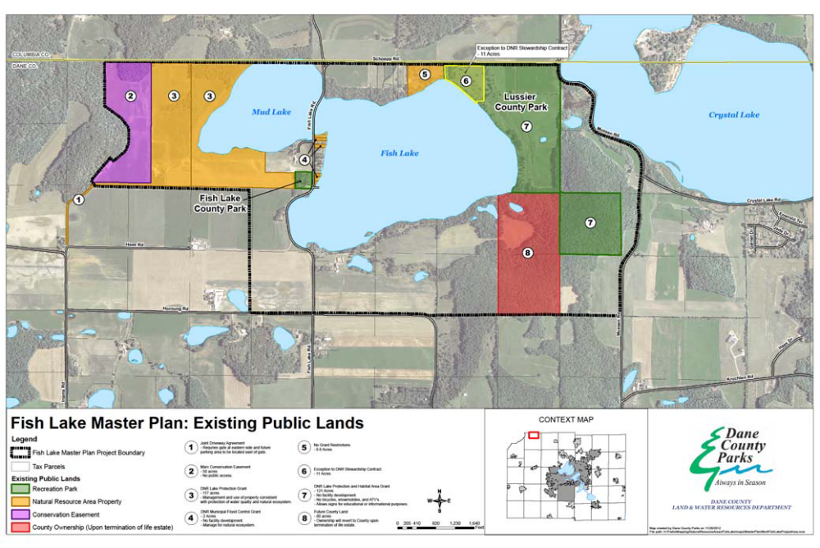

Background
Fish Lake and Mud Lake
Substantial water quality and fisheries databases have been established for Fish Lake beginning in the 1970’s as part of WDNR Research monitoring, Long Term Trends (1986-1995) monitoring, Littoral Zone Research Project, U.S.E.P.A Clean Lakes Diagnostic and Feasibility Study, LTER Project and most recently the large-scale lake planning grant study.
Fish Lake (252 acres) is a moderately eutrophic lake located in the Town of Roxbury. The lakeshore is relatively undeveloped with significant parklands adjoining the east and west shorelines. The public land acquisitions and the creation of Lussier County Park have been great additions to this unique deepwater seepage lake in southern Wisconsin. The acquisitions have also benefitted the water quality by reducing surface runoff pollution. Recreational uses include swimming, fishing and boating. There is a town ordinance prohibiting gasoline motors on the lake.
The Fish Lake watershed is approximately 1680 acres including the lake surface. The primary land use is agriculture. Top soils are fine silty loam and are nutrient rich from manure and fertilizer applications. Most of the watershed is rolling farmland with steep wooded hills. Just northwest of Fish Lake is Mud Lake (74 acres). Mud Lake was historically a northwest bay of Fish Lake that was mostly disconnected when Fish Lake Road was constructed. The bay is currently connected to Fish Lake via a culvert.
Major changes had occurred in Fish Lake over the last several decades including declining water quality and reduced native aquatic plant beds. Detailed information on Fish Lake can be found in a comprehensive lake management plan (Marshall et al. 1996) and in numerous research articles focusing on ecology of macrophytes and fish. The comprehensive lake management plan was based on a U.S. Environmental Protection Agency (USEPA) Clean Lakes Phase I Diagnostic and Feasibility Study and incorporated significant findings of the cooperative research effort known as the “Integrated Management of Macrophytes and Fish”.
Historically, Fish Lake had been classified mesotrophic based on chlorophyll-a, phosphorus, and Secchi (DCRPC 1979). During the 1970’s, the lake was considered to have the best water quality in the county however other indicators suggested gradual water quality decline. Hypolimnetic dissolved oxygen levels had been declining since the late 1950’s while poor survival of stocked rainbow trout (Oncorhynchus mykiss) ended any efforts to manage a two story fisheries by 1969 (DCRPC 1979). Cisco (Coregonus artedii) populations are native to the lake, and like trout, also require deep cool water habitat with sufficient dissolved oxygen. Over the past several decades, periodic cisco kills have been documented and coincided with low dissolved oxygen levels in the upper hypolimnion and thermocline. No cisco were captured during recent (2013) DNR Science Operations vertical gill net surveys of the lake (Lyons, personal communication).
Fish Lake historically supported diverse floating-leaf, submersed and emergent aquatic plant beds but significant declines in abundance had occurred. Native plant declines coincided with three long term changes in the lake: eutrophication, Eurasian water milfoil (EWM) invasion and rising water levels.
Approximately 60% of the Fish Lake watershed was agricultural, primarily in the forms of croplands and dairy farms. Even though the watershed to lake ratio is relatively low at 4.4:1, high phosphorus loading was documented during the 1990’s. The estimated annual phosphorus loading to the lake was 479 lbs/year. Winter manure spreading and feedlots were identified as principal watershed sources of phosphorus and nitrogen at that time. More recently, the predicted phosphorus loading to the lake has declined and reflects a feedlot closure near Mud Lake and expanded parkland around both Fish and Mud lakes.
Within the last few decades, rising Trophic State Index (TSI) values indicated that Fish Lake had shifted from mesotrophic to moderate eutrophic condition. The long term water quality decline in the lake had been linked to watershed nutrient sources (Marshall et al. 1996). Evidence of declining water quality included reduced Secchi measurements, higher chlorophyll and higher hypolimnetic phosphorus and ammonia levels. In addition to increasing (TSI) values, littoral zone sediments also reflected nutrient enrichment. Shallow water sediment core sampling revealed very high levels of both phosphorus (1142 mg/kg) and ammonia (128 mg/kg). Sediment testing indicated that polluted runoff was deposited within littoral areas of the lake, particularly along the west shorelines adjacent to most of the agricultural runoff. Sediment fertility has been linked with EWM growth and phosphorus transport from the littoral zone (Smith and Barko 1990). Deep water sediment core sampling was also conducted and revealed significant water quality decline in recent years. Analyzing sediment cores is a way of determining a history of nutrient input into a lake. Upper portions of sediments reflected recent deposition.
While detailed lake and watershed monitoring studies were initiated in 1988 to address the declining water quality, lake users were generally more aware of the “dense weed beds” in the lake. Eurasian watermilfoil was first identified in 1967 and rapidly expanded throughout the 1980s. By 1991 dense growths of EWM covered 99 acres of the lake bottom area (Lillie 1996). During the EWM expansion period, numerous native species declined substantially as EWM established monotypic stands beyond one meter depth - a typical pattern of EWM invasions (Madsen et al. 1991). With the exception of coontail, the remaining native macrophytes occupied near-shore areas (Lillie 1996). The near-shore native plant beds can be more vulnerable to shoreline development and rapid water level decline.
In 1994, EWM declined by approximately 40% across the lake. The decline coincided with weevil damage (Lillie 2000, Creed 1998). Native weevils can reduce the viability of EWM by boring into the stems (Mazzei et al. 1999). Boring into the stem results in loss of plant buoyancy and the plant basically sinks. This either kills the plant directly or severely weakens the plant due to reduced photosynthesis. Coinciding with reduced macrophyte density that year, Secchi depths declined and chlorophyll-a concentrations increased. Higher chlorophyll levels may have reflected nutrient release from decaying EWM, reduced alleopathy or both. These conditions were temporary since EWM rebounded in 1996. The temporary EWM decline did not expand the distribution or abundance of native plants and may reflect sediment nutrient effects. The EWM decline and resurgence suggested that a lake-wide chemical eradication may not expand native plants and could result in severe Cyanobacteria blooms.
In addition to eutrophication and EWM expansion in Fish Lake, long-term rising water levels (Krohelski et al. 2002) was likely a third factor contributing to redistribution of native plants. A 1937 aerial photo (Appendix C) demonstrates a significantly lower Fish Lake and when cattail beds dominated what is now called Mud Lake. As the water level rose, emergent and floating-leaf plants moved to newly submersed shorelines while EWM also migrated toward shore. The result had been a gradual shift of all plants, emergent, floating-leaf and submersed, toward the perimeter of the lake. In 2006, the management district began pumping water from the lake to reduce water levels. The lake pumping had become a controversial issue given the uncertainty of pumping effectiveness and negative impacts of pumping hypereutrophic water to the Lower Wisconsin State Riverway. Impacts of the pumping in 2009 had included shoreline erosion of State Riverway land, and water quality degradation. The intake pump was later moved to much cleaner Fish Lake to reduce some of these impacts.
The EWM invasion had altered the habitat chemically in Fish Lake (Unmuth et al. 2000). Very low dissolved oxygen levels were found near the bottom of the beds. The effects of dense plant beds on predator-prey interactions had been reported as well (Engel 1987, Savino et al. 1992). Local efforts to develop new methods for improving habitat within dense EWM beds began in 1989 (Marshall 1990). Scuba divers used manual cutting tools in Fish Lake to cut deeper growths of EWM at the sediment surface. The deep cutting technique held promise since the channels created by the SCUBA divers persisted for four years. Aerial photographs of the lake during this period clearly revealed where the channels were cut. Modest growths of curly-leaf pondweed and coontail had replaced EWM within the channels. Deep cutting to stress deeper EWM stands was ultimately tested by teams of researchers seeking management tools for improving EWM habitat and predator-prey interactions (Unmuth et al. 1999, Unmuth et al 1998, Olson et al. 1998, Trebitz et al 1997). The Dane County Public Works Department modified one of the county harvesters in order to conduct a series of deep cutting experiments in Fish Lake and in other lakes as well. While the mechanical channels did not persist as long as the manual cut channels, the results demonstrated increased growth rates for particular year classes of both bluegill and largemouth bass populations. “Cruising lanes” became available to largemouth bass. Predation on stunted bluegills occurred, followed with increased growth rates of specific year classes for both species.
Bluegill and largemouth bass comprise the dominant fisheries in the lake but numerous other species are found in the lake as well. Environmentally sensitive nongame species identified in Fish Lake include banded killifish (Fundulus diaphanous), blackchin shiner (Notropis heterodon) and blacknose shiner (Notropis heterolepis) and Iowa darter (Etheostoma exile). These species can typically be found in dense aquatic plant communities near shore (Becker 1983). The banded killifish is classified as State Special Concern and the other three species are classified as environmentally sensitive to degraded habitat (Lyons 1992). The blacknose shiner has not been found in the lake since the 1970’s and may be extinct in this waterbody. Abundant overhanging trees ring the lake and create another important habitat feature for fish populations and herptiles. In 2002, WDNR and Dane County Parks cooperated in a habitat improvement project along the Lussier Park shore. Large dead trees were pushed into the water and American lotus seed and nursery seedlings from Mud Lake were planted as well. The goal was to improve habitat for game fishes and intolerant nongame species that can be vulnerable to near-shore habitat loss.

Crystal Lake
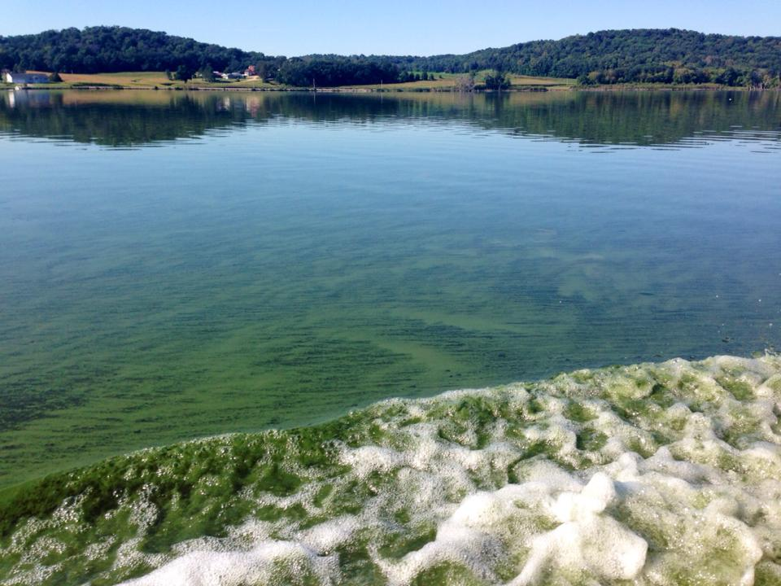
Crystal Lake is a 525 acre shallow seepage lake located just 1,950 feet east of Fish Lake. Recreational uses include gasoline motorized boating, fishing, water skiing and swimming. In recent years, Crystal Lake has been a popular attraction for anglers due to the fast growing bluegill, crappie and largemouth bass populations. Additional recreational opportunities are located at a large commercial park located on the Columbia County side of the lake.
Unlike the relatively deep Fish Lake, Crystal Lake is shallow and it does not thermally stratify. Crystal Lake is classified as hypereutrophic due to high concentrations of Cyanobacteria. The WDNR lake database indicated that Secchi depth measurements have ranged from 1.5 feet (TSI = 72) to 2.8 feet (TSI = 63). The surrounding watershed is very similar to the Fish Lake watershed with agriculture the dominant land use. Likely sources of phosphorus to Crystal Lake include feedlots, crop fields and internal loading as the lake mixes throughout the summer. During the 1980s, WDNR conducted animal waste management (NR 243) investigations on several shoreline feedlots that were located on the Columbia County side of the lake.
Blue-green alage bloom on Crystal Lake, October 2014
Crystal Lake and Fish Lake are connected to a common aquifer and rising water levels have been occurring in both lakes for decades (Krohelski et al. 2002). Maximum water depths were only 6 feet in the 1940s and increased to 9 feet by 1960. Frequent winter fish kills had been documented from the 1940s through the 1960s (DCRPC 1979). Aeration and frequent stocking were necessary to create recreational fishing during that period. When fish kills had occurred, bullheads were often the only survivors.
In recent years the trend of increasing water levels continued and the maximum water depth is now 14 feet. Consistent with the Fish Lake shoreline, trees had become inundated in past years and dead trees now line the perimeter of Crystal Lake. The dead trees are an important habitat feature for fish and herptile populations. Coinciding with the rising water levels, sustainable largemouth bass and panfish populations in the lake indicate that winterkills had diminished. In spite of continued hypereutrophic conditions, greater water volume has apparently increased the total oxygen mass within the lake. The lake management district began pumping water from Crystal Lake to Roxbury Creek in 2014.
Dense growths of macrophytes had been reported decades ago including common waterweed (Elodea canadensis), sago pondweed (Struckenia pectinatus), duckweed (Lemna) and white water lily (Nymphaea odorata) (DCRPC 1979). There are no historical quantitative records on Cyanobacteria blooms or how the blooms might have affected the maximum rooting depths and distribution of macrophytes in Crystal Lake.
EWM had become established in the lake during the 1990’s and the formation of dense monotypic stands in parts of the lake hindered motorboat use. Management had included private herbicides applications around the two commercial mobile home parks in Columbia County while Dane County operated mechanical harvesters to provide boating access from the public boat ramp and elsewhere. More recently, EWM and other macrophytes had declined due to Cyanobacteria blooms, turbid water, and fluctuating water levels (THIS WAS A NOTE FROM STANTEC WHO CONDUCTED THE MOST RECENT PLANT SURVEYS).
Fish populations had fluctuated over the years due to previous winterkills and also reflected restocking efforts. Bluegills (Lepomis macrochirus), largemouth bass (Micropterus salmoides) and black bullhead (Ameirus melas) had been the most common species reported (DCRPC 1979). Other species reported from the lake include golden shiner (Notemigonus crysoleucas), fathead minnow (Pimephales promelas), pumpkinseed (Lepomis gibbosus) and orangespotted sunfish (Lepomis humilis). No environmentally intolerant fish species have been reported from the lake. Since about 1980, higher water levels have coincided with sustainable populations of largemouth bass, bluegill, black crappie (Pomoxis nigromaculatus), and to a lesser extent yellow perch (Perca flavescens). Panfish growth rates had been exceptionally fast compared with most Wisconsin lakes (Unmuth and Larson 1999). Cyanobacteria blooms and outbreaks of Columnaris bacteria are factors that periodically have negative impacts on the fisheries.
Methods
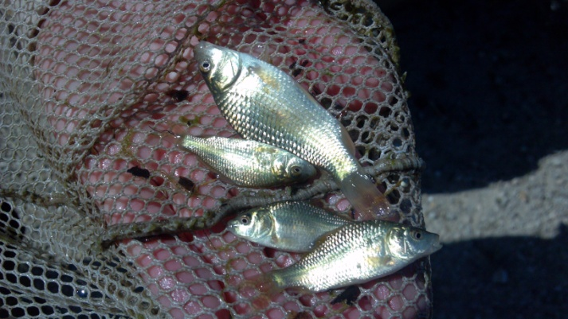
Nearshore fish population sampling was completed for Fish Lake and Mud Lake in 2013 and 2014 and Crystal Lake in 2013. All specimens were immediately released after field identification and enumeration. The fish surveys are designed to sample populations of nongame species, common carp recruitment and juvenile stages of sportfish. The survey results are indicators of ecological diversity and distribution of fishes that inhabit nearshore areas within floodplain habitats. This type of survey will not evaluate the growth rates, size distribution or population densities of sport fish populations. The fish sampling in Fish Lake was coordinated with LTER. An investigation was completed on the status of the culvert that adjoins Fish Lake with Mud Lake to determine if it is open or blocked. A submersible camera was used for this effort. A point intercept aquatic plant survey was conducted on Mud Lake in July 2013. Monthly secchi measurements were collected from Crystal, Mud Lake and Fish Lake from April through October each year. Additionally, chlorophyll-a and total phosphorus samples were collected from the lakes along with vertical dissolved oxygen, temperature, pH and specific conductance profiles. The chlorophyll a and phosphorus samples were collected monthly from June through September in 2013 and 2014. Secchi, chlorophyll and total phosphorus data were converted to TSI (WILMS). Additional water quality information was obtained at the SLOH including NO² + NO³, TKN and planktonic analysis. Dane County Department of Land and Water Resources will update the land use inventory and that information will be used to estimate total phosphorus loadings (WILMS) to Crystal Lake, Fish Lake and Mud Lake. For Fish Lake, limnological sampling results were also obtained from the University of Wisconsin Madison Limnology LTER project. Historical data was compared with current results and sources included WDNR Research (1970’s data), WDNR Lakes Program Long Term Trends (1986-1995 data), U.S.E.P.A. Clean Lakes Diagnostic and Feasibility Study (1994-1996), LTER (1999-) and recent WDNR baseline survey data.
Young of year carp from Mud Lake, August 2014
Results
Fish Lake and Mud Lake Water Quality
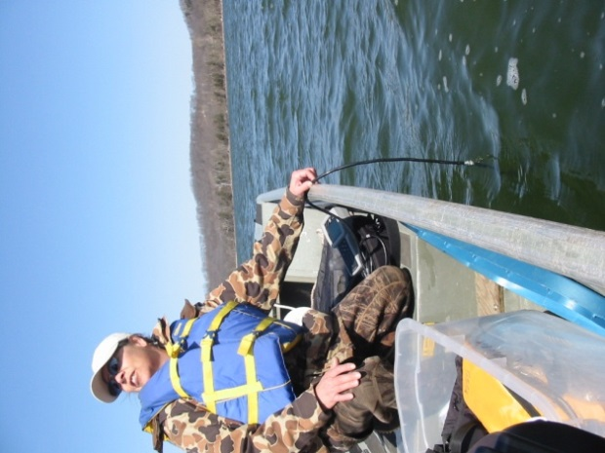
Previously a clear mesotrophic seepage lake, Fish Lake water clarity has continued to decline over the last several decades. In Figure 1 the long term annual growing season secchi TSI data demonstrates these changes with an R² value of 0.72. The water clarity decline has continued even though significant conservation efforts, including county land purchases, have reduced nutrient loading to the lake. The data suggest that further conservation efforts are needed to protect this rare southern Wisconsin seepage lake. In Figure 2, the secchi data for both 2013 and 2014 are displayed in both actual measurements (left Y axis) and corresponding TSI values (right Y axis). All (+) marks above the red line indicate eutrophic conditions. In Figures 3 and 4, both chlorophyll-a and phosphorus data also reflect eutrophic conditions in Fish Lake and are consistent with water clarity data. Total nitrogen to phosphorus (N : P) ratios typically exceeded 26:1, indicating that the lake was not nitrogen limited. However, microscopic analysis also indicated that nitrogen fixing Cyanobacteria species dominated the summer the phytoplankton and was another indication of eutrophication. In Figures 5 and 6, LTER data collected from 1999-2007 is also consistent with the recent lake planning grant data
DNR Water Quality Biologist Jean Unmuth taking dissolved oxygen profiles on Fish Lake, April 2014

profiles.
and reflect continued eutrophic conditions in Fish Lake.
Dissolved oxygen and temperature data also demonstrate that Fish Lake hypolimnetic anoxia begins in June each year and expands until habitat for the cisco (Coregonus artedii) population becomes significantly reduced and threatens their existence (Figures 7 and 8). The horizontal red line in Figure 8 highlights the 7 meters depth. The water temperatures at this depth can typically sustain the cisco population in late summer months but coinciding the favorable temperatures are very low dissolved oxygen levels. The anoxic hypolimnion also has potential for internal nutrient loading but so far fall turnover sampling data, particularly water clarity, do not indicate significant internal loading. The August 2013 temperature profile revealed unusually cold temperatures in Fish Lake, and the other lakes, that coincided with an unusually cool summer stretch that occurred during most of July and August 2013 (see graph Appendix 1).
Mud Lake (former Fish Lake west bay before the Fish Lake Road was constructed) represents a stark difference from Fish Lake by displaying hypereutrophic conditions. The very poor water clarity in the lake, along with common carp, eliminated aquatic vegetation except of robust American lotus beds along nearshore zones. Nitrogen and phosphorus analysis indicated that Mud Lake not only had much higher concentrations than Fish Lake, but the lake was nitrogen limited (<10:1 on July 10, 2013). This condition clearly influenced the dense Cyanobacteria blooms. Hypereutrophic conditions are evident in Figure 9 that presents secchi and TSI data, Figure 10 with chlorophyll-a results and Figure 11 with total phosphorus results. Figures 12 and 13 display Mud Lake temperature and dissolved oxygen profiles for July, August and September in 2013 and 2014. Periodic low bottom dissolved oxygen in Mud Lake will likely result in phosphorus loading from the anoxic sediments.
Figure 1: Long Term Annual Growing Season Secchi TSI Data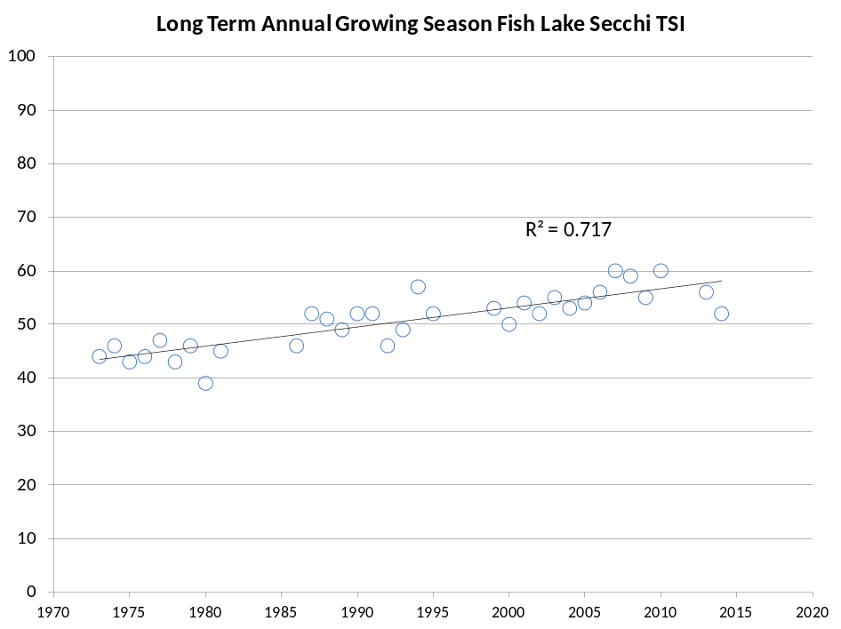

Figure 2: 2013-14 Fish Lake Secchi Data and TSI Values (TSI > 50 = eutrophic, red line)
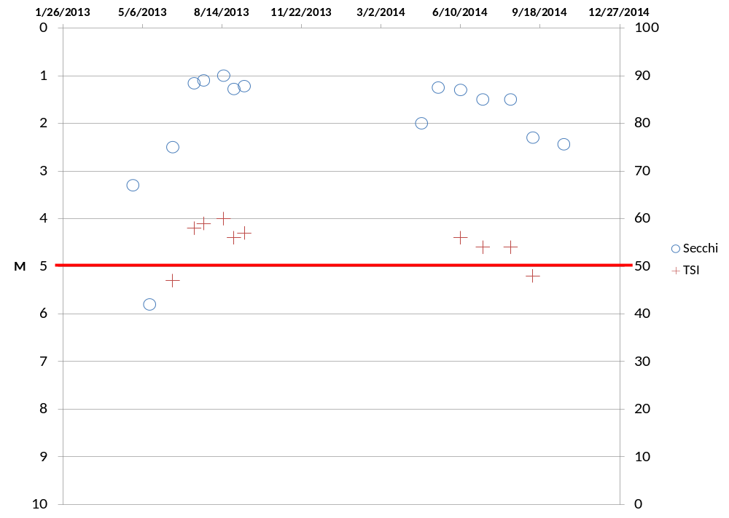
Figure 3: 2013-14 Fish Lake Chlorophyll-a Data and TSI (TSI > 50 = eutrophic, red line)
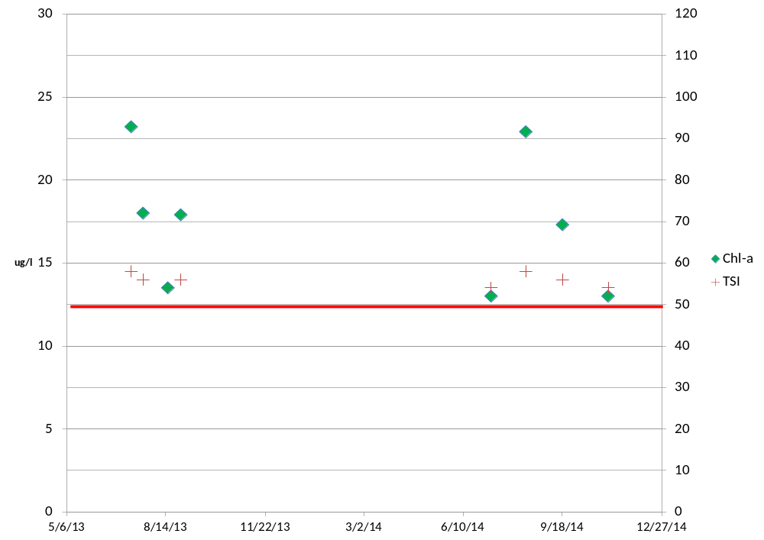

Figure 4: 2-13-14 Fish Lake Phosphorus Data and TSI (TSI > 50 = eutrophic, red line)
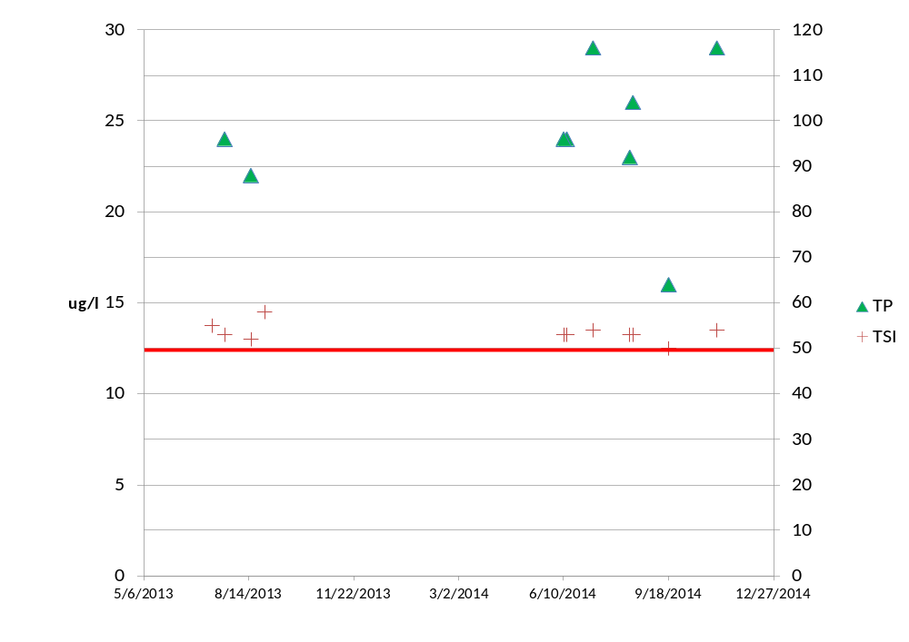
Figure 5: LTER Chlorophyll-a Data and TSI (TSI > 50 = eutrophic, red line)
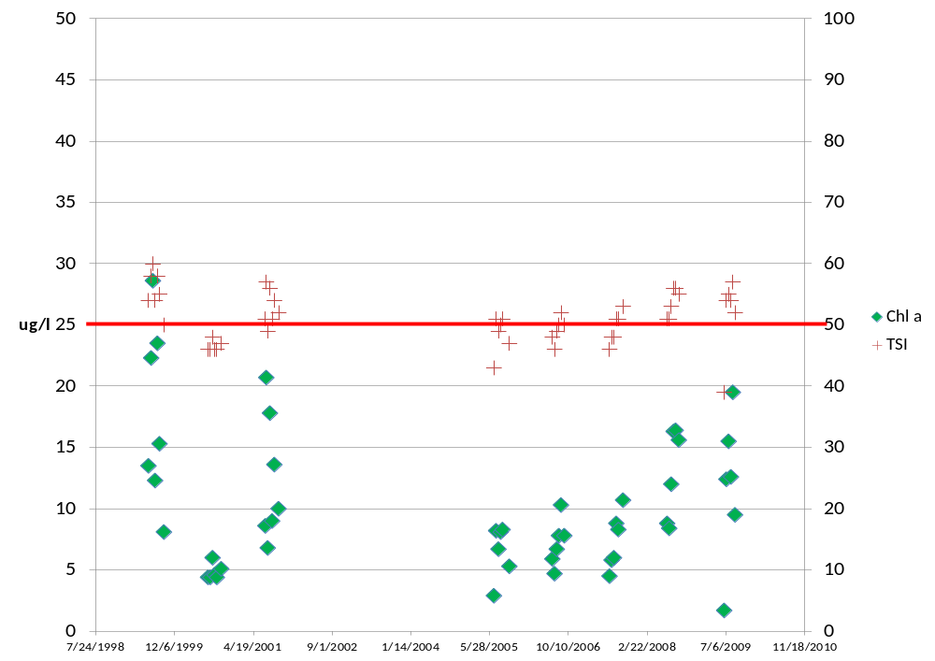
Figure 6: LTER Phosphorus Data and TSI (TSI > 50 = eutrophic, red line)
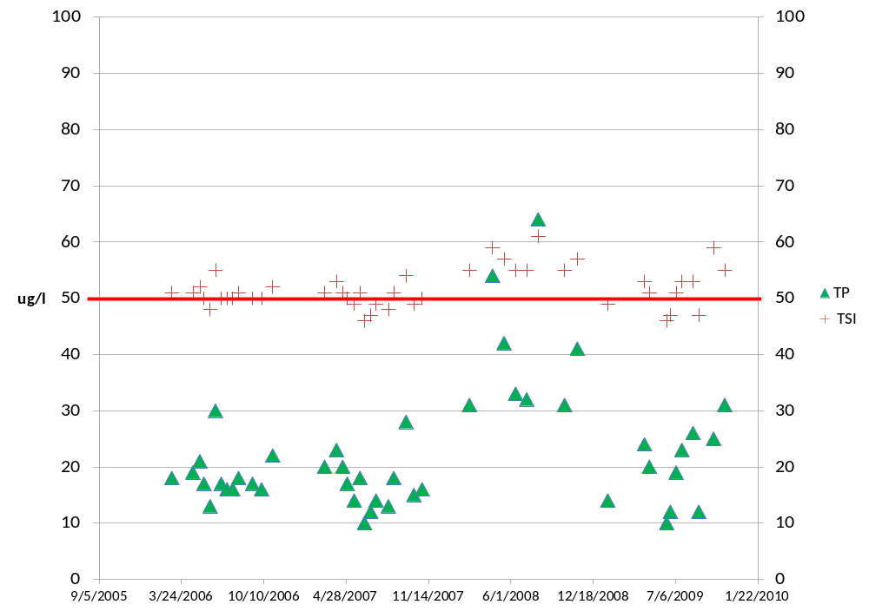
Figure 7: 2013 and 2014 Fish Lake Temperature Profiles for July, August and September
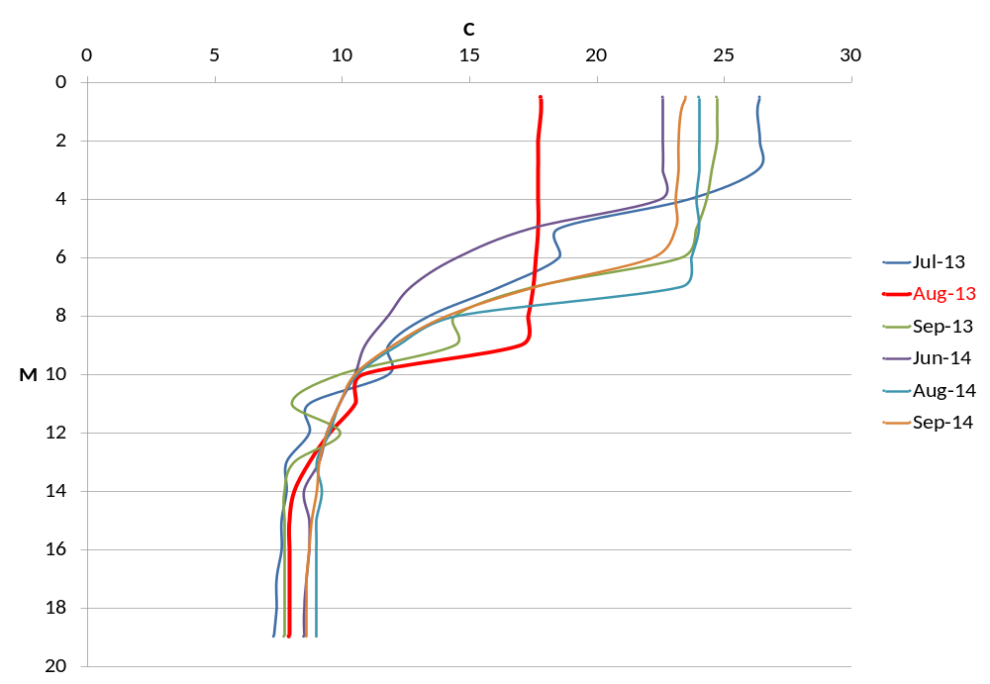
Figure 8: 2013-14 Fish Lake Dissolved Oxygen Profiles for July, August and September
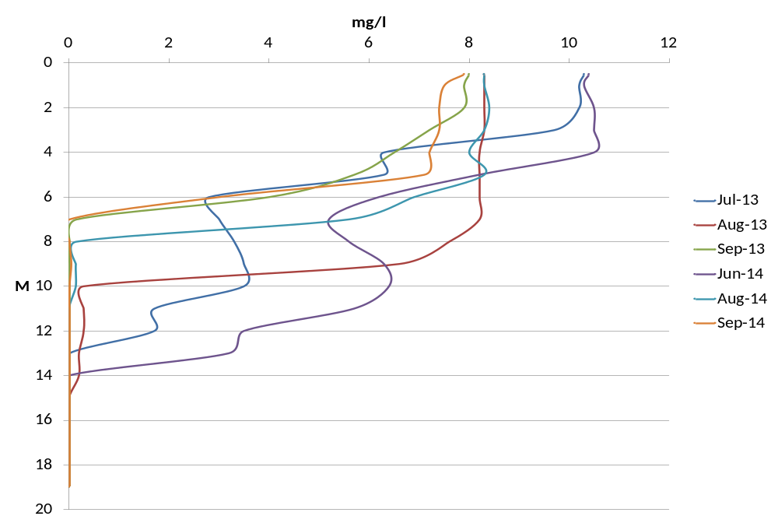
Figure 9: 2013-14 Mud Lake Secchi Data and TSI Values (TSI > 50 = eutrophic, red line)
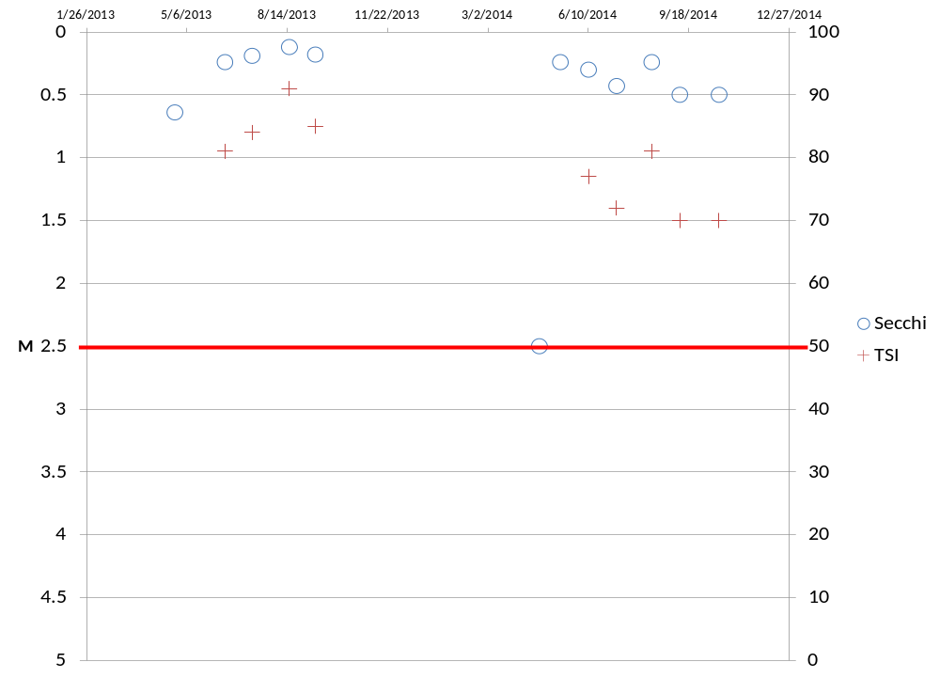
Figure 10: 2013-14 Mud Lake Chlorophyll-a Data and TSI Values (TSI > 50 = eutrophic, red line)
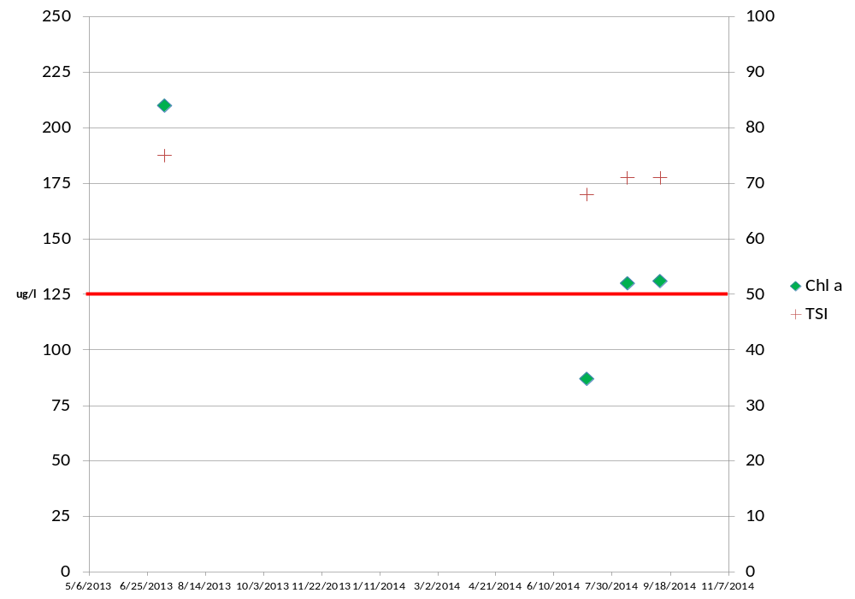
Figure 11: 2013 and 2014 Mud Lake Total Phosphorus Data and TSI Values (TSI > 50 = eutrophic, red line)
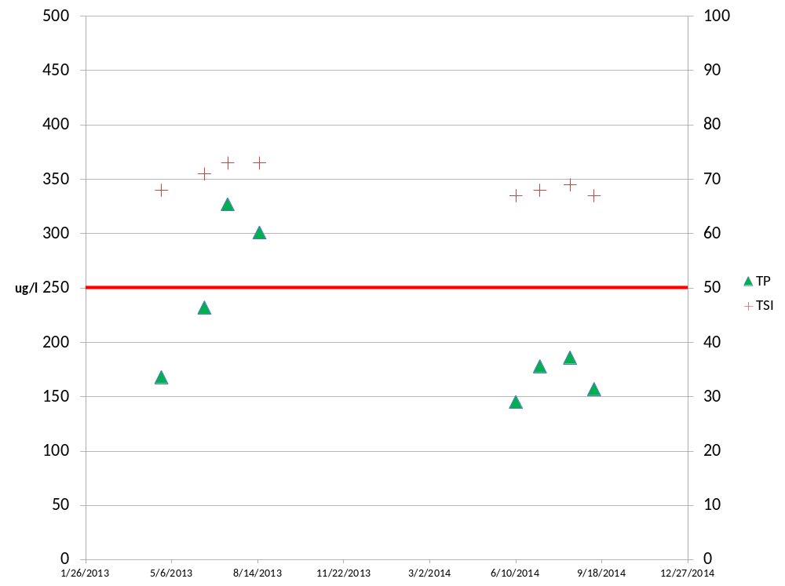
Figure 12: 2013 and 2014 Mud Lake Temperature Profiles
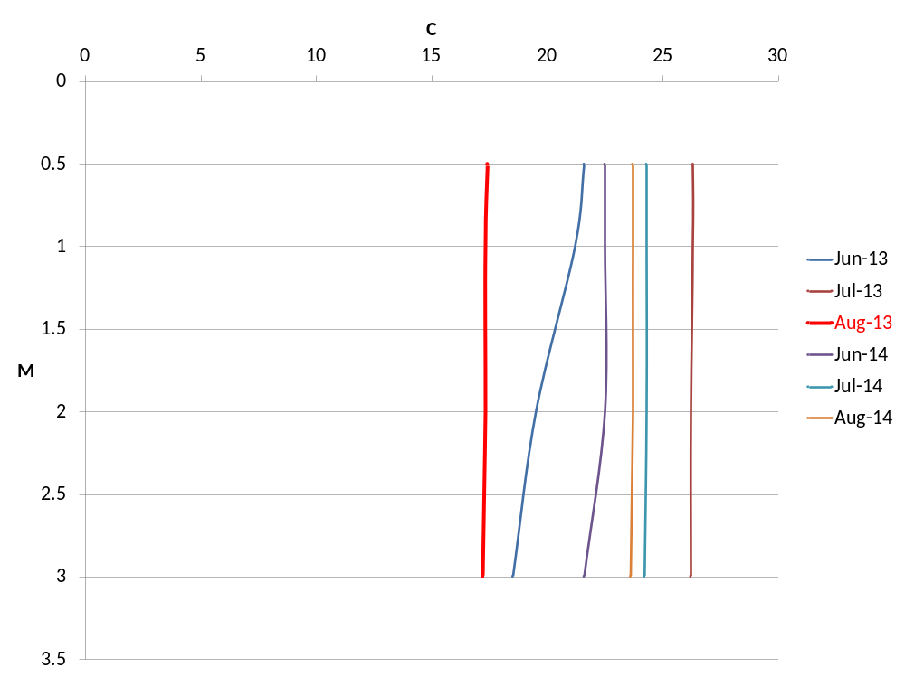
Figure 13: 2013 and 2014 Mud Lake Dissolved Oxygen Profiles
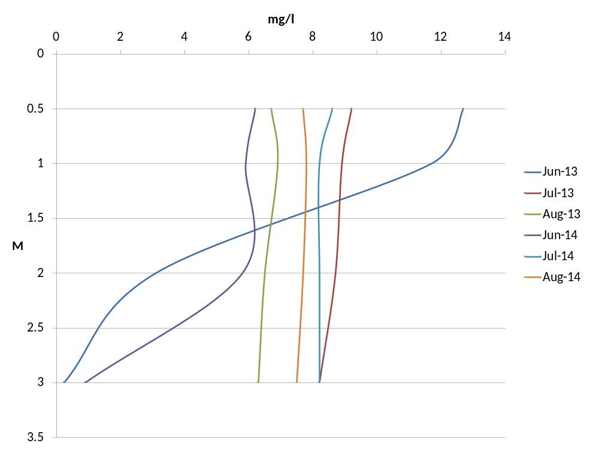
Fish Lake and Mud Lake Nearshore Electroshocking Results
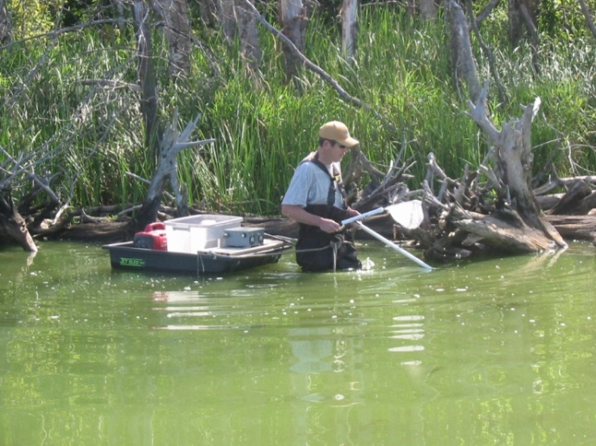
Only nine fish species (8 native) were found in Mud Lake (Figure 14) and none were environmentally sensitive species (intolerant). No darter species were found and Cyprinids were limited to one golden shiner (Notemigonus crysoleucas) and common carp (Cyprinus carpio). Centrarchid panfish dominated the fishery in Mud Lake. Low species diversity reflected very poor water quality. Favorable habitat was limited to the lake perimeter including American lotus stands, woody debris, emergent vegetation and limited rocky substrates. Submersed plants were absent as the Point Intercept survey demonstrated.
Dave Marshall of Underwater Habitat Investigations performing near shore electrofishing survey on Crystal Lake. August 2013

profiles.

Ten native fish species were found in Fish Lake including two environmentally sensitive species (Iowa darter – Etheostoma exile and blackchin shiner – Notropis heterodon). Both species have otherwise been declining throughout their ranges. We did not find blacknose shiners (Notropis heterolepis) but one State Special Concern banded killifish (Fundulus diaphanus) was collected during the August 2014 survey. The Iowa darters and banded killifish were collected along the west side of the lake and blackchin shiners were collected along the east northeast shorelines. On August 12, 2014, only the west shoreline of Fish Lake was electroshocked. Our data and LTER data suggest that blacknose shiners may be extinct in the lake and banded killifish are significantly reduced. Figure 15 displays the Fish Lake electroshocking results for Fish Lake. The Fish Lake fish community indicates significantly better environmental conditions than found in Mud Lake and is consistent with chemical water quality data.

Figure 14: Mud Lake Nearshore Electroshocking Results

Figure 15: Fish Lake Nearshore Electroshocking Results

Mud Lake Point Intercept Aquatic Plant Survey
The point intercept aquatic plant survey that was performed on July 1, 2013 and Figure 16 is a map of the sampling points. Only one rooted plant species was found in the lake; Nelumbo lutea (American lotus). American lotus was found at a frequency of 17%. The dearth of rooted plants in the lake reflected the very low water clarity and common carp disturbance. Information on the occurrence, distribution and management of aquatic plants in Fish Lake can be found in the Aquatic Plant Management Plan – Fish, Crystal and Indian Lakes (http://danewaters.com/management/AquaticPlantManagement.aspx) and 2013 amendment.
Figure 16: Mud Lake Point Intercept Aquatic Plant Survey Map
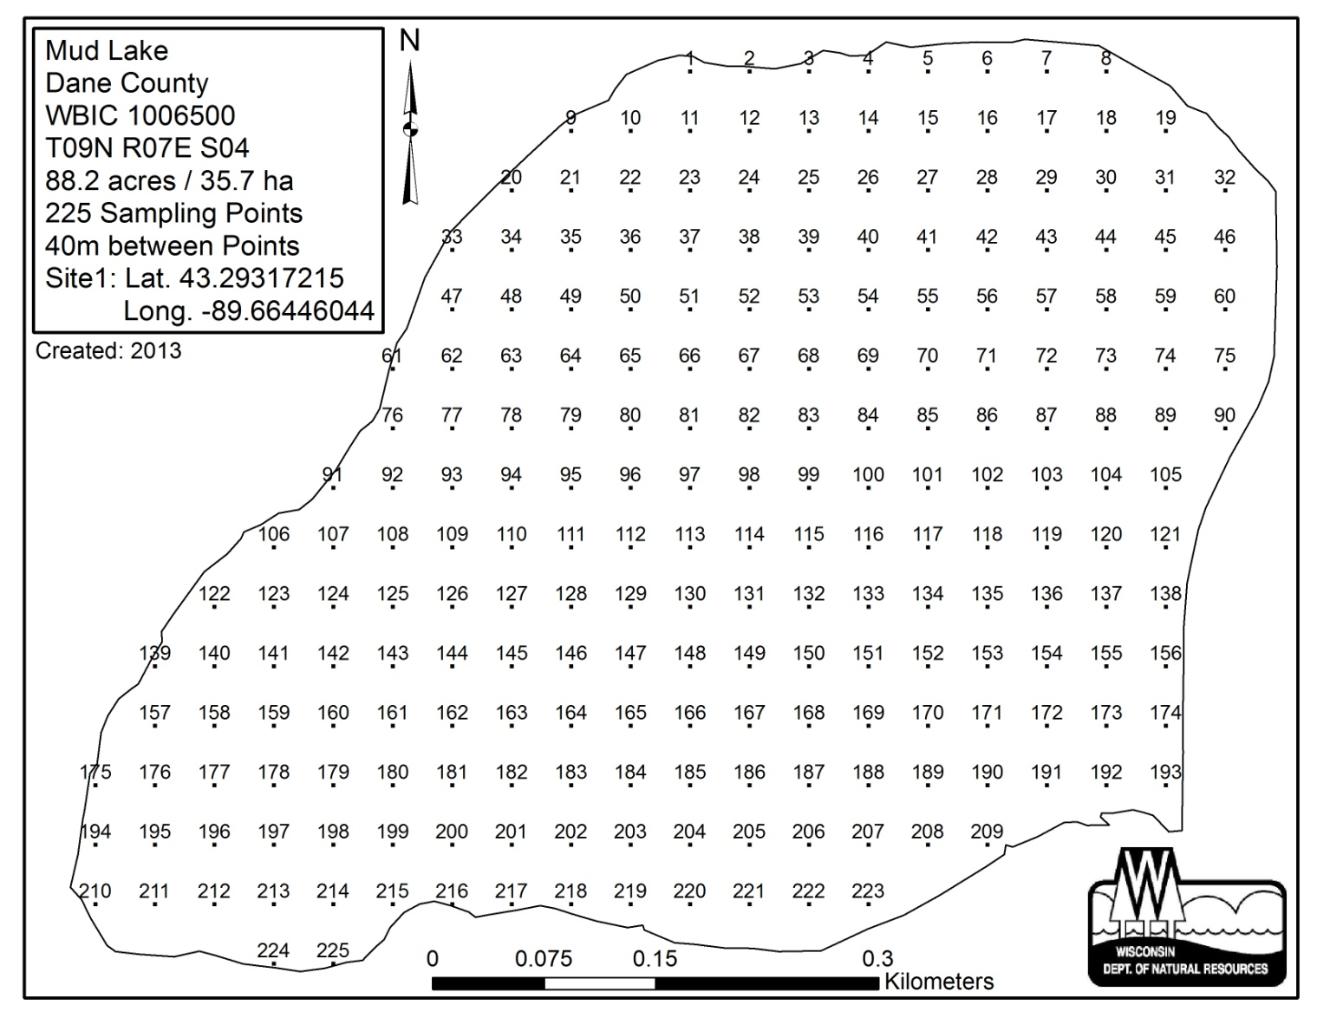
Fish Lake Aquatic Plant Management Recommendations (2013)
- Conduct mechanical harvesting as needed at important access points to improve navigation and fish habitat.
- Consider longer term efforts to sustain boating lanes and improved fish habitat using methods such as deep cutting - harvesting. Methods could include modified large scale harvesting or manual cutting involving SCUBA.
- Protect important habitat features including floating-leaf plant beds and coarse woody habitat. Residents should be discouraged from manually removing high value species such as watershield, floating-leaf pondweed and water lilies.
- Recommend Critical Habitat Areas Designations to WDNR based on criteria established in Wisconsin Administrative Code NR 107 and other important ecological features. Critical Habitat Areas include plant beds with high value native species including watershield, floating-leaf pondweed and water lilies. Use of herbicides and large-scale mechanical harvesting is prohibited in these areas. (Designation of Critical Habitat Areas is a Wisconsin Department of Natural Resources decision.)
- Encourage local land use planning and management to reduce nutrient runoff into the lake. (Watershed runoff contributed to littoral zone sediments rich in nutrients, a factor contributing to high Eurasian watermilfoil growth in the lake. Potential sources of polluted runoff should be re-evaluated given reductions linked to surrounding park land acquisitions.)
- Sample nearshore fish populations, including blackchin shiner, blacknose shiner and banded killifish. These species may be affected by rapid habitat changes including rising water levels.
- Update the comprehensive lake management plan.
- The Dane County Plant Scout should document occurrences of high value native plants in regular scouting reports, including shoreline reference and GPS location. Dane County staff should make an annual summary report of these occurrences available to the public.
- Dane County mechanical harvesting crews should continue to take steps to prevent the spread of exotic invaders across Dane County lakes and streams. These steps include removing any visible plants, mud, debris, water, fish or animals from the machinery and thoroughly washing the equipment.

Crystal Lake Water Quality
The combination of a relatively large shallow seepage basin with an intensive agricultural watershed has resulted in a highly eutrophic lake. Cyanobacteria blooms limit water clarity throughout most of the growing season and most of the TSI parameters indicated highly eutrophic to hypereutrophic conditions (Figures 17 - 19). Periodic high phosphorus concentrations compared with total nitrogen concentrations less than 2 mg/l indicated nitrogen limitation and conditions favorable for Cyanobacteria blooms. While the lake is only about 4 meters deep, frequent bottom anoxia and large surface area likely results in significant internal nutrient loading. Figures 20 and 21 display the July, August and September dissolved oxygen and temperature profiles that suggest periodic anoxia near the bottom and continuous mixing with resulting internal phosphorus loading.

Figure 17: 2013-14 Crystal Lake Secchi Data and TSI (TSI > 50 = eutrophic, red line)
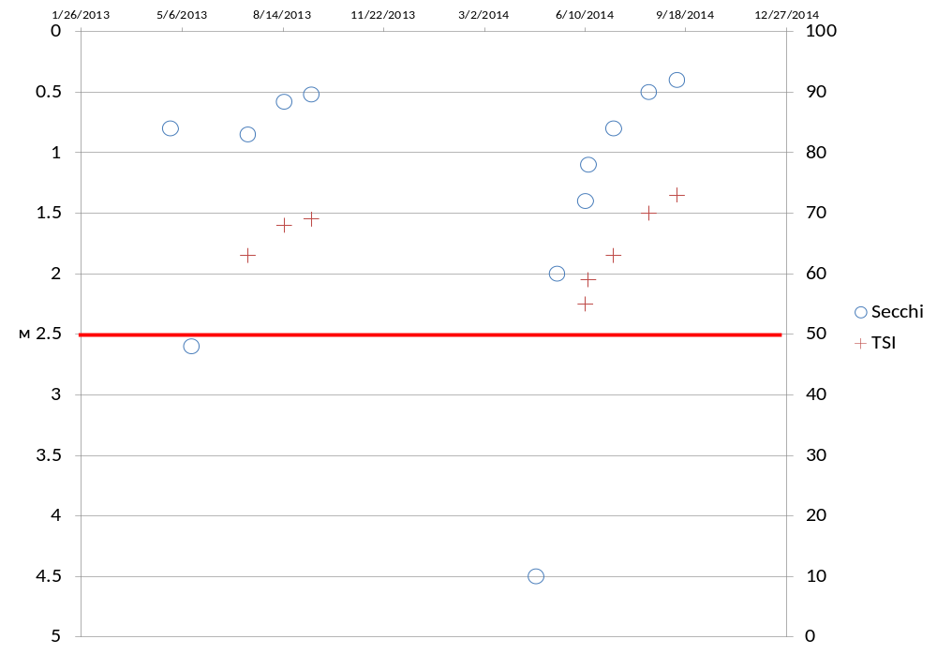Figure 18: 2013-14 Crystal Lake Chlorophyll a and TSI (TSI > 50 = eutrophic, red line)
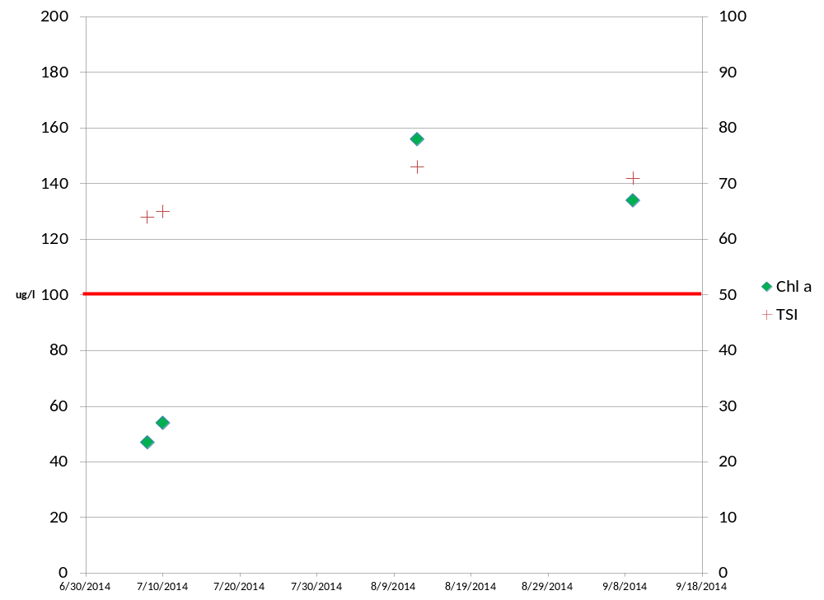
Figure 19: 2013-14 Crystal Lake Phosphorus Data and TSI (TSI > 50 = eutrophic, red line)
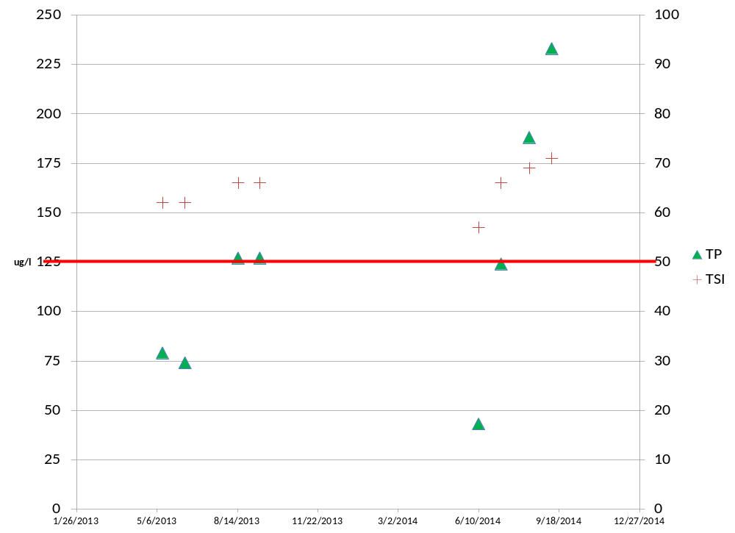
Figure 20: 2013-14 Crystal Lake Temperature Profiles for July, August and September
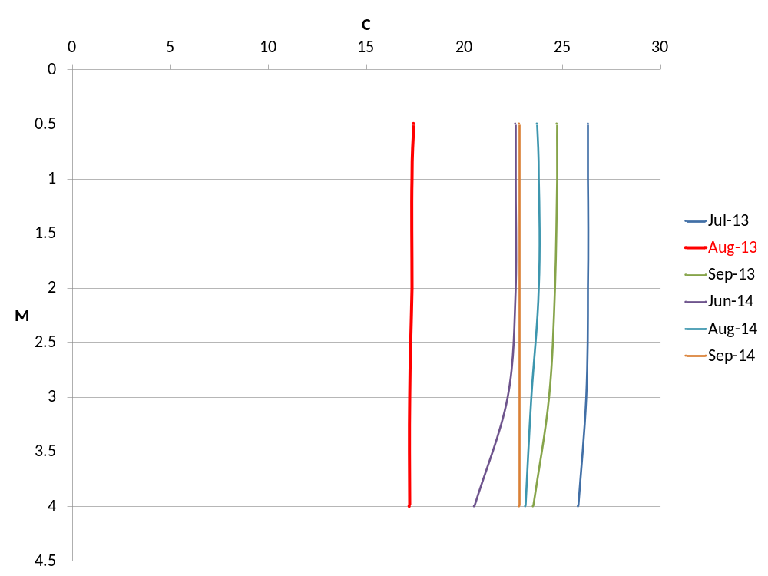
Figure 21: 2013-14 Crystal Lake Dissolved Oxygen Profiles for July, August and Sept.
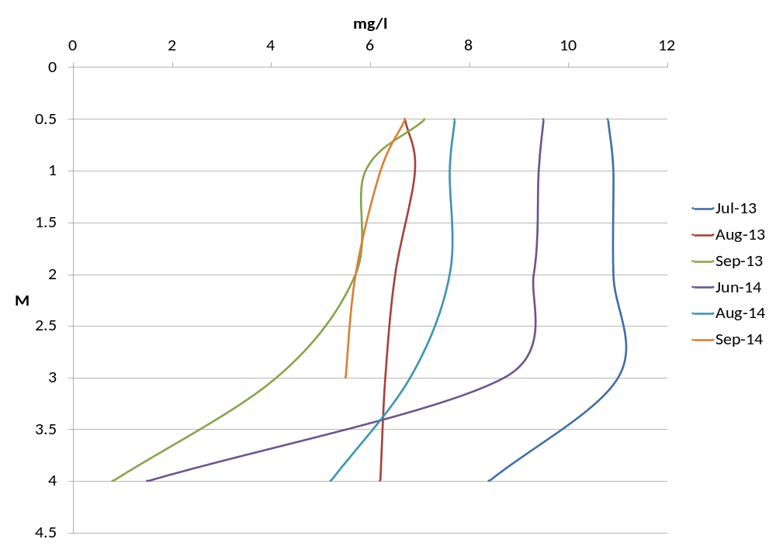
Crystal Lake Nearshore Electroshocking Results
Two shocking crews operated double probes and a single probe towed D.C. electroshocking barges on Crystal Lake. Eleven species (10 native) were found in the lake with bluegills most abundant followed by largemouth bass (Micropterus salmoides). No environmentally sensitive species were found in the lake. Macrophytes were very scarce in Crystal Lake due to poor water clarity and habitat consisted mostly of woody debris and emergent vegetation. White waterlilies also provided some habitat in a few areas. Figure 22 presents the results of the electroshocking survey and Figure 23 compares fish as environmental indicators for all three lakes sampled in 2013 and 2014. The fish environmental indicators reflected lake water chemistry data.
Information on the occurrence, distribution and management of aquatic plants in Crystal Lake can be found in the Aquatic Plant Management Plan – Fish, Crystal and Indian Lakes (http://danewaters.com/management/AquaticPlantManagement.aspx) and 2013 amendment.
Crystal Lake Aquatic Plant Management Recommendations (2013)

- Mechanical harvesting should be conducted during periods when Eurasian watermilfoil densities are high to improve boating access.
- Modest levels of native macrophytes (aquatic plants) provide important fish habitat and should not be eradicated. These conditions may change and Eurasian watermilfoil could expand under different water level conditions, warranting management.
- Recommend Critical Habitat Area designations to WDNR including bays supporting white water lily beds. (Designation of Critical Habitat Areas is a Wisconsin Department of Natural Resources decision.)
- Protect coarse woody habitat around the lake for fish and herptile populations.
- Encourage local land use planning and management to reduce nutrient loading into the lake. (Reducing blue-green algae blooms could ultimately improve native plant growth in the lake.)
- Consider coordinating the preparation of a comprehensive lake management plan with Columbia County.
- The Dane County Plant Scout should document occurrences of high value native plants in regular scouting reports, including shoreline reference and GPS location. Dane County staff should make an annual summary report of these occurrences available to the public.
- Dane County mechanical harvesting crews should continue to take steps to prevent the spread of exotic invaders across Dane County lakes and streams. These steps include removing any visible plants, mud, debris, water, fish or animals from the machinery and thoroughly washing the equipment.

Figure 22: Crystal Lake Nearshore Electroshocking Results from August 14, 2013

Figure 23: Fish Environmental Indicators

Watershed Land Uses and Estimated Phosphorus Loadings (WILMS)
Fish Lake and Mud Lake: Estimated phosphorus loading data from 1996 appear in Appendix 2A and 2B. Subwatersheds A, F, U and particularly D contributed the greatest amount of phosphorus at that time, primarily from winter manure spreading (monitored) and point sources (feedlots). Since 1990, land use changes have resulted in reduced phosphorus loading to Fish and Mud Lakes. Significant point sources have been eliminated and croplands, houses and related septic systems have declined. Dane County has also expanded park lands that contribute significantly less phosphorus than other developed sources. Figures 24 and 25 compare 1990 and 2010 land use changes and estimated phosphorus loading for the Dane County portion of the watershed. A reduction in croplands and houses resulted in about 18% reduction in phosphorus loading to the lakes. The actual phosphorus loading decline was much greater due to the removal of point sources and other changes. However, continued water quality decline in Fish Lake indicates that the fragile deepwater seepage lake will require additional phosphorus load reductions, particularly on the west slopes.
Crystal Lake: Figures 26 and 27 display the landuse changes and estimated changes in phosphorus loadings from 1990 to 2010 for the Dane County portion of the watershed. Consistent with the Fish Lake watershed, a reduction of croplands had occurred with an estimated overall decline of phosphorus loading by about 9%. This reduction is probably insignificant compared with internal loading and nutrient inputs from a failing wastewater treatment facility located in Columbia County.
Figure 24: Land Use Changes in the Dane County Portion of the Fish Lake Watershed 1990 and 2010

Figure 25: Estimated Phosphorus Loads in the Dane County Portion of the Fish Lake Watershed 1990 and 2010

Figure 26: Land Use Changes in the Dane County Portion of the Crystal Lake Watershed 1990 and 2010

Figure 27: Estimated Phosphorus Loads in the Dane County Portion of the Crystal Lake Watershed 1990 and 2010

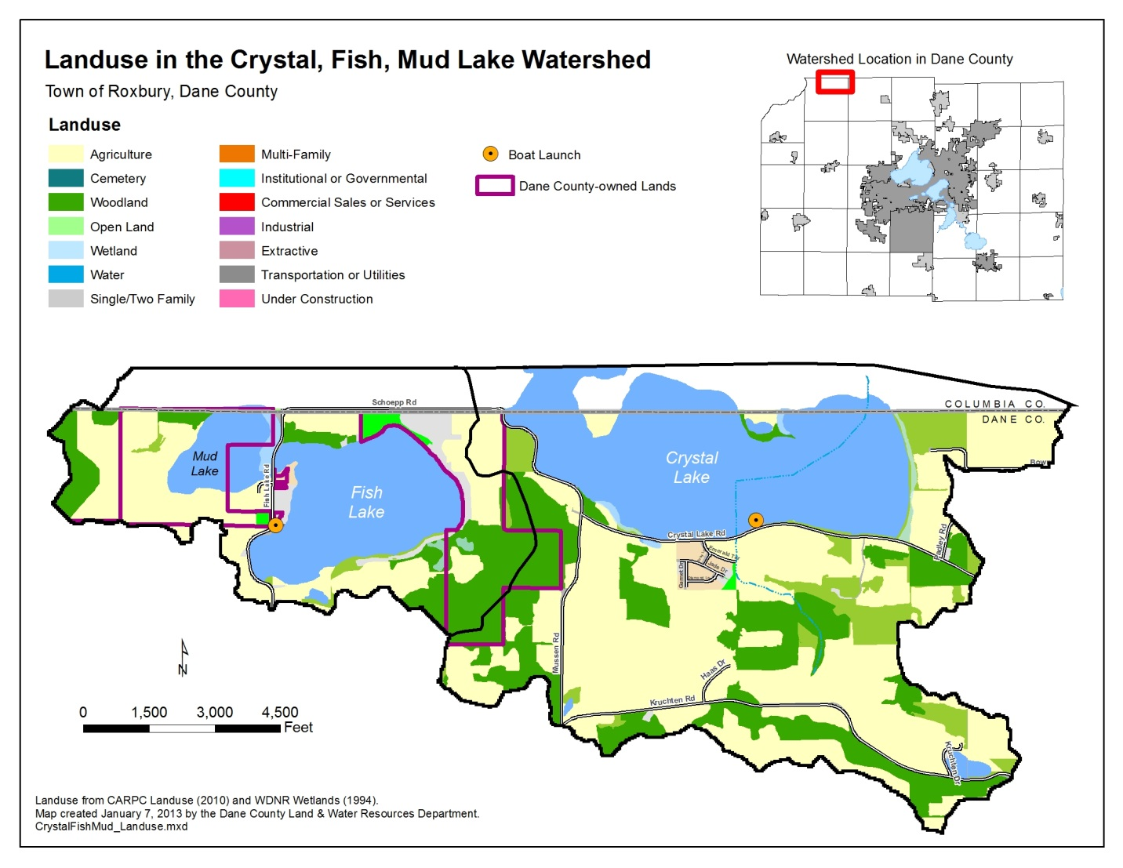References
Becker, G. 1983. Fishes of Wisconsin. University of Wisconsin Press.
Day, E.A., G.P. Grzebieneak, K.M. Osterby, C.L. Brynildson. 1985. Surface water resources of Dane County. WDNR lake and stream classification project. Second edition. p. 15-17.
Engel, S. 1987. The restructuring of littoral zones. Lake Reserv. Manage. 3: 235-242.
Jones, S. 2013. Amendment, Aquatic Plant Management Plan, Fish, Crystal and Indian Lakes, Lower Wisconsin Basin, Dane County, Wisconsin. Dane County Office of Lakes and Watersheds.
Krohelski, J.T., Y. Lin, W.J. Rose and R.J. Hunt. 2002. Simulation of Fish, Mud, and Crystal Lakes and the shallow ground-water system, Dane County, Wisconsin. U.S. G. S. Water Resources Investigations Report 02-4014.
Lillie, R.A. 2000. Temporal and spatial changes in milfoil distribution and biomass with weevils in Fish Lake, WI. J. Aquat. Plant Manage. 38:2000.
Lillie, R.A. 1996. A quantitative survey of the floating-leafed and submersed macrophytes of Fish Lake, Dane County, Wisconsin. Transactions Wisconsin Academy of Sciences, Arts and Letters. 84:111-125.
Marshall, D. W. 2007. Aquatic Plant Management Plan for Fish, Crystal and Indian Lakes. Dane County Office of Lakes and Watersheds..
Marshall, D.W., N.P. Nibbelink, P.J. Garrison, J. Panuska and S.R. Stewart. 1996. A management plan to protect and improve the Fish Lake ecosystem. U.S. EPA Clean Lakes Phase 1 Diagnostic and Feasibility Study report. 78 p.
Marshall, D.W. 1990. Managing deep water stands of Eurasian watermilfoil to improve fish habitat and boating access. WDNR Survey Report.
Mazzei, K.C., R.M. Newman, A. Loos and D. W. Ragsdale. 1999. Development rates of the native milfoil weevil, Euhrychiopsis lecontei, and damage to Eurasian watermilfoil at constant temperatures. Biological Control 16:139-143.
Nichols, S.A. and J.G. Vennie. 1991. Attributes of Wisconsin Lake Plants. Wisconsin Geological and Natural History Survey. Information Circular 73.
Olson, M.H., S.R. Carpenter, P. Cunningham, S. Gafny, B.R. Herwig, N.P. Nibbelink, T. Pellett, C. Storlie, A.S. Trebitz and K.A. Wilson. 1998. Managing macrophytes to improve fish growth: a multi-lake experiment. Fisheries. 23:6-12.
Savino, J.F. and R.A. Stein. 1982. Predator-prey interaction between largemouth bass and bluegills as influenced by simulated, submersed vegetation. Transactions of the Amercian Fisheries Society. 111: 255-265.
Sheldon, S.P. and R.P. Creed. 1995. Use of native insect as a biological control for an introduced weed. Ecological Applications 5:1122-1132.
Smith, C.S. and J.W. Barko. 1990. Ecology of Eurasian watermilfoil. J. Aquat. Plant Manage. 28:55-64.
Unmuth, J.M., R.A. Lillie, D.S. Dreiksosen and D.W. Marshall. 2000. Influence of dense growth of Eurasian watermilfoil on lake water temperature and dissolved oxygen. J. Freshwater Ecology. 15:498-503.
Unmuth, J.M. and M.J. Hansen. 1999. Effects of mechanical harvesting of Eurasian watermilfoil on largemouth bass and bluegill populations in Fish Lake, Wisconsin. North American Journal of Fisheries Management. 19:1089-1098.
Unmuth, J. and T. Larson. 1999. Crystal Lake Fishery Survey. WDNR Survey Report.

Appendix 1: 2013 Summer Air Temperatures
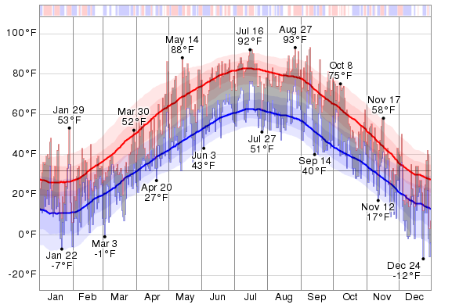
The daily low (blue) and high (red) temperature during 2013 with the area between them shaded gray and superimposed over the corresponding averages (thick lines), and with percentile bands (inner band from 25th to 75th percentile, outer band from 10th to 90th percentile). The bar at the top of the graph is red where both the daily high and low are above average, blue where they are both below average, and white otherwise.

Appendix 2A: 1996 Fish Lake Management Plan Map of Subwatersheds. (Estimated phosphorus loading for each subwatershed appears in 2B.)
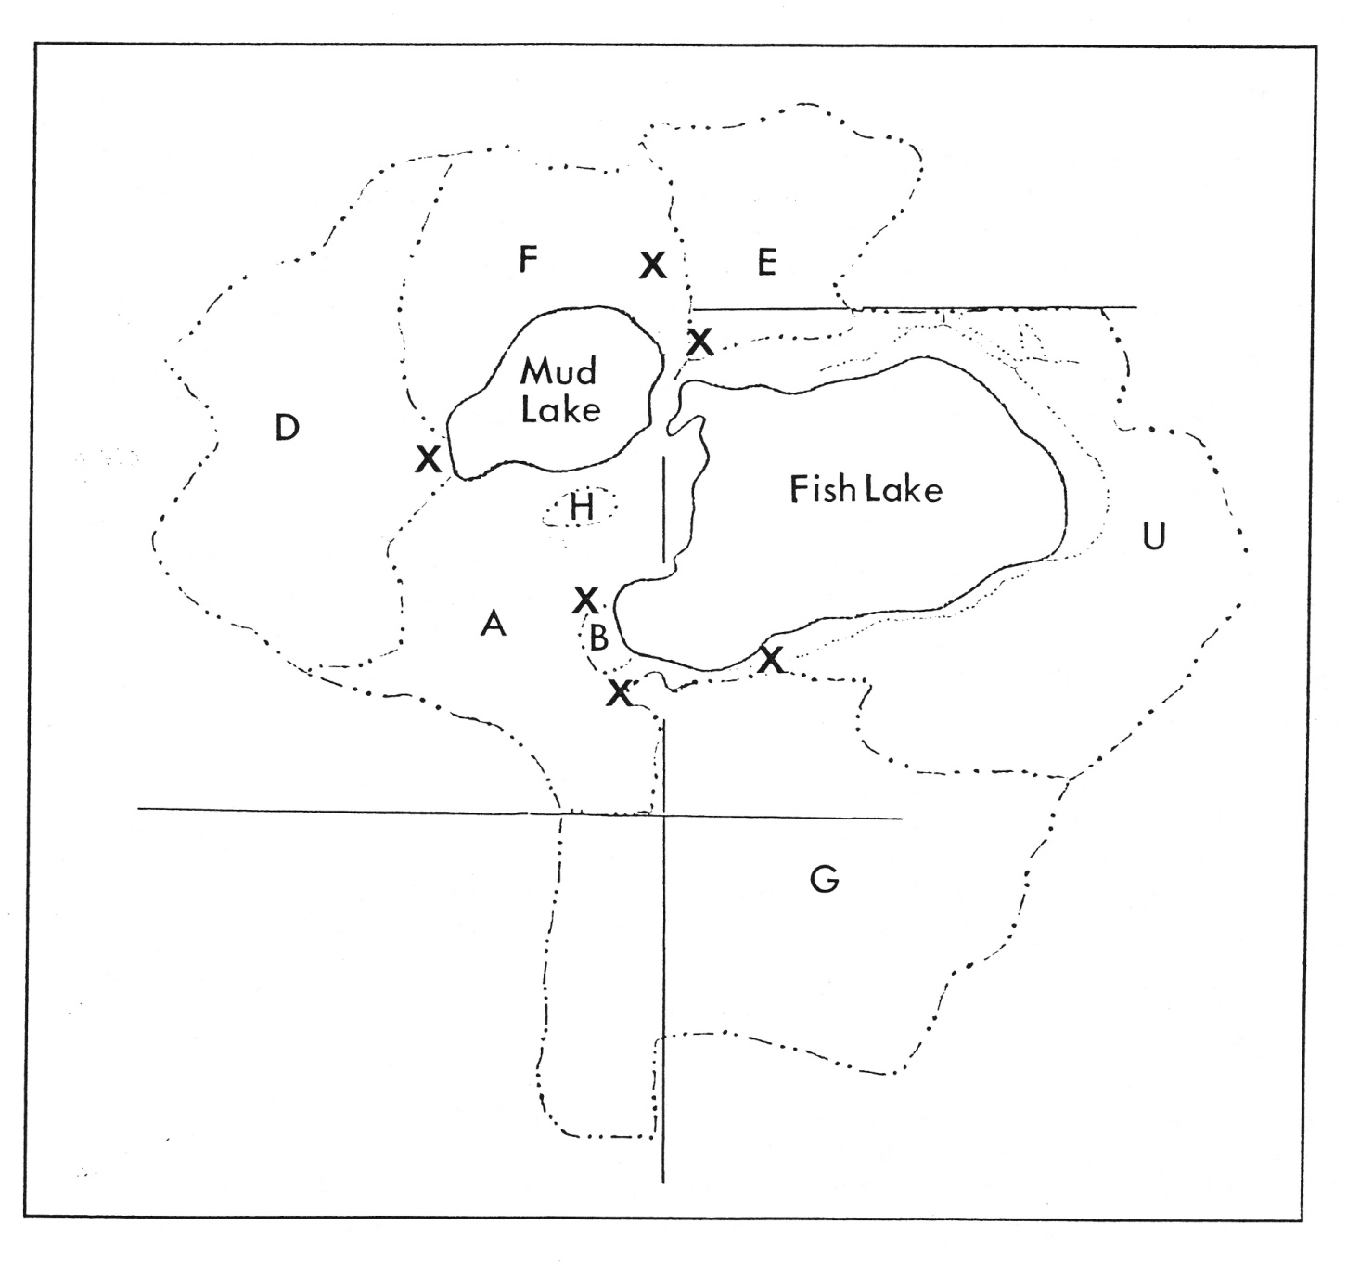

Appendix 2B: 1996 Fish Lake Management Plan Estimate Phosphorus Loading for each Subwatershed
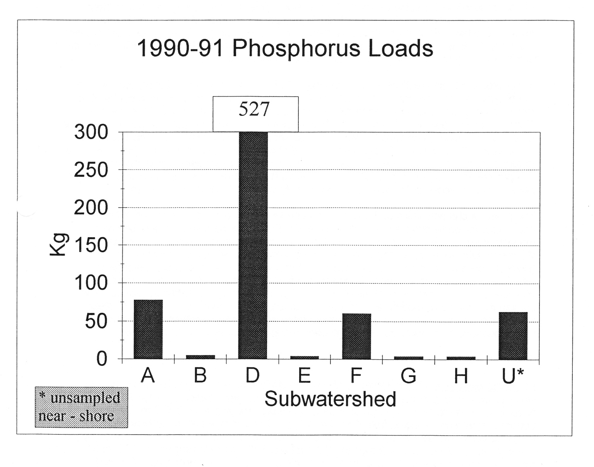

Appendix C: 1937 Aerial Photo of Fish Lake
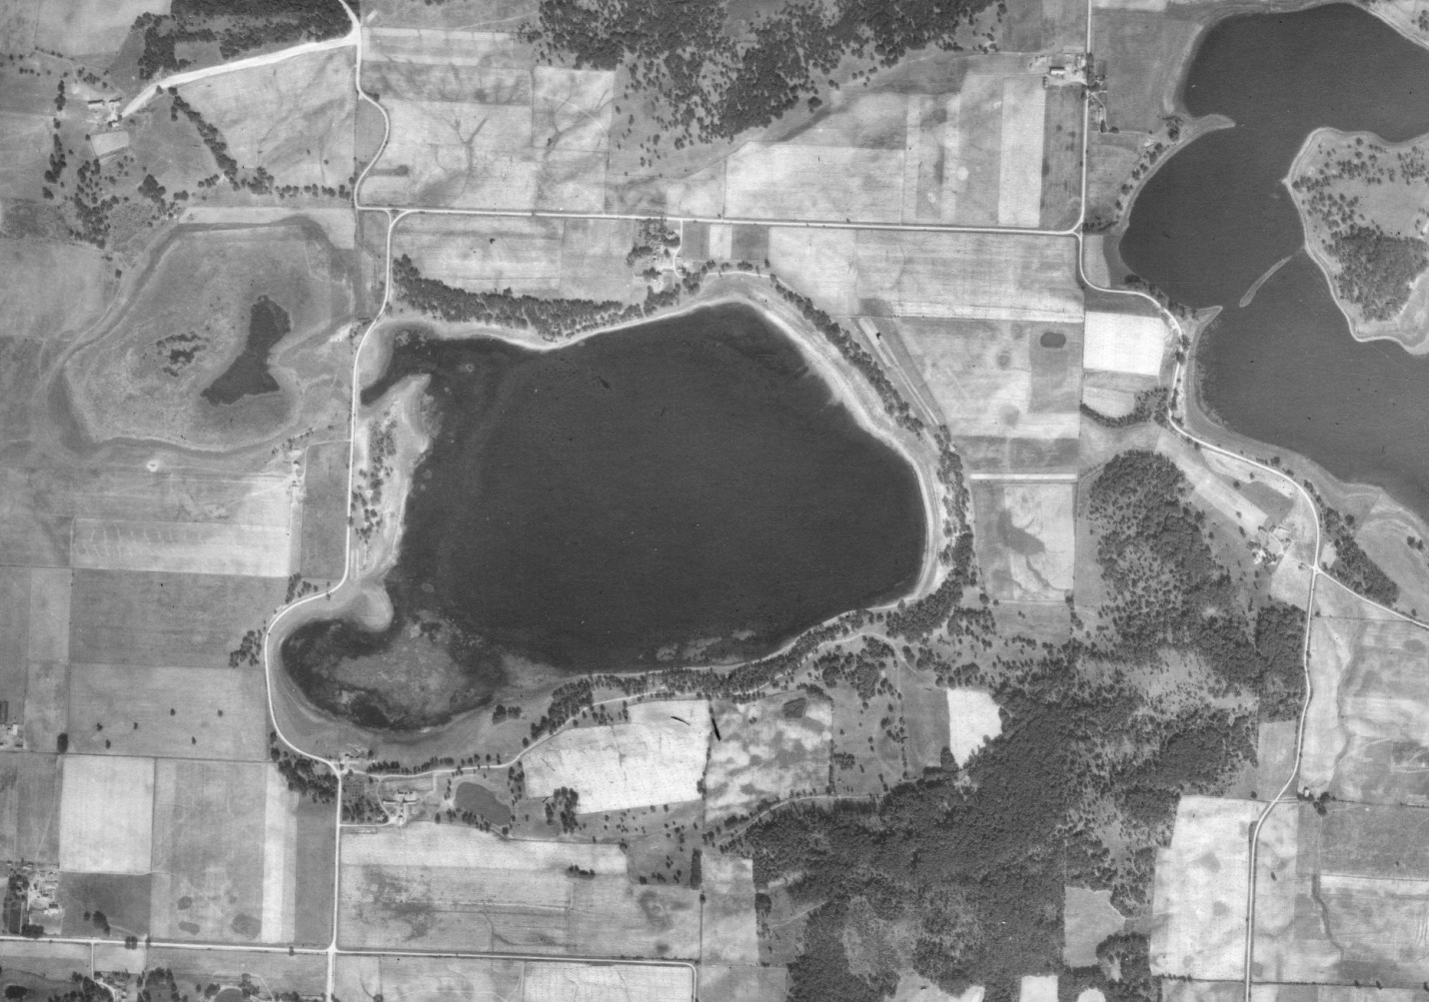
The aerial photo demonstrates that much of the Fish Lake watershed had been managed for intensive agriculture for many decades that the gradual long term water quality decline likely began in the early 20th Century. The photo indicates limited buffer areas around the lake and significantly lower water levels. It also shows extensive cattail beds in the SW bay of Fish Lake, and nearly covering Mud Lake.

Mud Lake Data
Temperature – C
M | 6/1/13 | 7/1/13 | 8/1/13 | 6/1/14 | 7/1/14 | 8/1/14
0.5 | 21.6 | 26.3 | 17.4 | 22.5 | 24.3 | 23.7
1 | 21.2 | 26.3 | 17.3 | 22.5 | 24.3 | 23.7
2 | 19.5 | 26.2 | 17.3 | 22.5 | 24.3 | 23.7
3 | 18.5 | 26.2 | 17.2 | 21.6 | 24.2 | 23.6

Dissolved oxygen - mg/l
M | 6/1/13 | 7/1/13 | 8/1/13 | 6/1/14 | 7/1/14 | 8/1/14
0.5 | 12.7 | 9.2 | 6.7 | 6.2 | 8.6 | 7.7
1 | 11.7 | 8.9 | 6.9 | 5.9 | 8.2 | 7.8
2 | 3.1 | 8.7 | 6.5 | 5.8 | 8.2 | 7.7
3 | 0.24 | 8.2 | 6.3 | 0.9 | 8.2 | 7.5
Secchi - M and Secchi TSI
Date | Secchi | TSI
4/24/2013 | 0.64
6/13/2013 | 0.24 | 81
7/10/2013 | 0.19 | 84
8/16/2013 | 0.12 | 91
9/11/2013 | 0.18 | 85
4/22/2014 | 2.5
5/13/2014 | 0.24
6/10/2014 | 0.3 | 77
7/8/2014 | 0.43 | 72
8/12/2014 | 0.24 | 81
9/9/2014 | 0.5 | 70
10/18/2014 | 0.5 | 70
Total phosphorus – mg/l and TP TSI
Date | TP | TSI
9/9/2014 | 157 | 67
8/12/2014 | 186 | 69
7/8/2014 | 178 | 68
6/10/2014 | 145 | 67
8/16/2013 | 301 | 73
7/10/2013 | 327 | 73
6/13/2013 | 232 | 71
4/24/2013 | 168 | 68
Chlorophyll a – ug/l and TSI
Date | Chl a | TSI
9/9/2014 | 131 | 71
8/12/2014 | 130 | 71
7/8/2014 | 87 | 68
7/10/2013 | 210 | 75
Mud Lake Aquatic Plant Rake Survey Summary Statistics
 |  | Tot. Veg. | A. lotus
Lake | Mud
County
WBIC
Survey Date
 | INDIVIDUAL SPECIES STATS:
 | Frequency of occurrence within vegetated areas (%) |  | 0.33
 | Frequency of occurrence at sites shallower than maximum depth of plants |  | 1.00
 | Relative Frequency (%) |  | 1.0
 | Relative Frequency (squared) | 1.00 | 0.33
 | Number of sites where species found |  | 1
 | Average Rake Fullness | 2.26 | 1.00
 | #visual sightings |  | 1
 | present (visual or collected) |  | Present
 | SUMMARY STATS:
 | Total number of sites visited | 223
 | Total number of sites with vegetation | 38
 | Total number of sites shallower than maximum depth of plants | 115
 | Frequency of occurrence at sites shallower than maximum depth of plants | 33.04
 | Simpson Diversity Index | 0.00
 | Maximum depth of plants (ft)** | 9.00
 | Number of sites sampled using rake on Rope (R) | 85
 | Number of sites sampled using rake on Pole (P) | 138
 | Average number of all species per site (shallower than max depth) | 0.33
 | Average number of all species per site (veg. sites only) | 1.00
 | Average number of native species per site (shallower than max depth) | 0.33
 | Average number of native species per site (veg. sites only) | 1.00
 | Species Richness | 1
 | Species Richness (including visuals) | 1

Fish Lake Data
Temperature – C
M | 7/1/13 | 8/1/13 | 9/1/13 | 6/1/14 | 8/1/14 | 9/1/14
0.5 | 26.4 | 17.8 | 24.7 | 22.6 | 24 | 23.5
1 | 26.3 | 17.8 | 24.7 | 22.6 | 24 | 23.3
2 | 26.4 | 17.7 | 24.7 | 22.6 | 24 | 23.2
3 | 26.3 | 17.7 | 24.5 | 22.6 | 24 | 23.2
4 | 23.6 | 17.7 | 24.3 | 22.5 | 23.9 | 23.1
5 | 18.5 | 17.7 | 23.9 | 17.4 | 24 | 23.1
6 | 18.5 | 17.6 | 23.3 | 14.5 | 23.7 | 22.2
7 | 16.2 | 17.5 | 17.5 | 12.7 | 23.3 | 17.6
8 | 13.4 | 17.3 | 14.4 | 11.8 | 14.5 | 14.1
9 | 11.8 | 17 | 14.4 | 10.9 | 12.2 | 12
10 | 11.8 | 10.8 | 9.9 | 10.5 | 10.6 | 10.5
11 | 8.7 | 10.5 | 8 | 9.9 | 9.9 | 9.9
12 | 8.7 | 9.5 | 9.9 | 9.4 | 9.5 | 9.4
13 | 7.8 | 8.7 | 8.1 | 9.1 | 9 | 9.1
14 | 7.8 | 8.1 | 7.7 | 8.5 | 9.2 | 9
15 | 7.6 | 7.9 | 7.7 | 8.7 | 9 | 8.8
16 | 7.6 | 7.9 | 7.7 | 8.7 | 9 | 8.7
17 | 7.4 | 7.9 | 7.7 | 8.6 | 9 | 8.6
18 | 7.4 | 7.9 | 7.7 | 8.5 | 9 | 8.6
19 | 7.3 | 7.9 | 7.7 | 8.5 | 9 | 8.6

Dissolved oxygen – mg/l
M | 7/1/13 | 8/1/13 | 9/1/13 | 6/1/14 | 8/1/14 | 9/1/14
0.5 | 10.3 | 8.3 | 8 | 10.4 | 8.3 | 7.9
1 | 10.2 | 8.3 | 7.9 | 10.3 | 8.3 | 7.5
2 | 10.2 | 8.3 | 7.9 | 10.5 | 8.4 | 7.4
3 | 9.7 | 8.3 | 7.2 | 10.5 | 8.3 | 7.4
4 | 6.3 | 8.2 | 6.5 | 10.5 | 8 | 7.2
5 | 6.3 | 8.2 | 5.7 | 8.2 | 8.3 | 7.1
6 | 2.8 | 8.2 | 4 | 6.2 | 6.9 | 3
7 | 3 | 8.2 | 0.15 | 5.2 | 5.6 | 0
8 | 3.3 | 7.6 | 0 | 5.6 | 0.15 | 0
9 | 3.5 | 6.6 | 0 | 6.3 | 0.13 | 0.04
10 | 3.5 | 0.3 | 0 | 6.4 | 0.13 | 0
11 | 1.7 | 0.3 | 0 | 5.7 | 0 | 0
12 | 1.7 | 0.3 | 0 | 3.5 | 0 | 0
13 | 0 | 0.2 | 0 | 3.2 | 0 | 0
14 | 0 | 0.2 | 0 | 0 | 0 | 0
15 | 0 | 0 | 0 | 0 | 0 | 0
16 | 0 | 0 | 0 | 0 | 0 | 0
17 | 0 | 0 | 0 | 0 | 0 | 0
18 | 0 | 0 | 0 | 0 | 0 | 0
19 | 0 | 0 | 0 | 0 | 0 | 0

Secchi – M and Secchi TSI
Date | Secchi | TSI
4/24/2013 | 3.3
5/15/2013 | 5.8
6/13/2013 | 2.5 | 47
7/10/2013 | 1.16 | 58
7/22/2013 | 1.1 | 59
8/16/2013 | 1 | 60
8/29/2013 | 1.28 | 56
9/11/2013 | 1.22 | 57
4/22/2014 | 2
5/13/2014 | 1.25
6/10/2014 | 1.3 | 56
7/8/2014 | 1.5 | 54
8/12/2014 | 1.5 | 54
9/9/2014 | 2.3 | 48
10/18/2014 | 2.44
Total Phosphorus – mg/l and TP TSI
Date | TP | TSI
6/13/2013 | 24 | 53
7/10/2013 | 33 | 55
7/22/2013 | 24 | 53
8/15/2013 | 26 | 53
8/16/2013 | 22 | 52
8/29/2013 | 48 | 58
6/10/2014 | 24 | 53
7/8/2014 | 29 | 54
8/12/2014 | 23 | 53
9/18/2014 | 16 | 50
11/3/2014 | 29 | 54

Chlorophyll a – ug/l and TSI
Date | Chl-a | TSI
7/10/2013 | 23.2 | 58
7/22/2013 | 18 | 56
8/16/2013 | 13.5 | 54
8/29/2013 | 17.9 | 56
7/8/2014 | 13 | 54
8/12/2014 | 22.9 | 58
9/18/2014 | 17.3 | 56
11/3/2014 | 13 | 54

Crystal Lake Data
Temperature – C
M | 7/1/13 | 8/1/13 | 9/1/13 | 6/1/14 | 8/1/14 | 9/1/14
0.5 | 26.3 | 17.4 | 24.7 | 22.6 | 23.7 | 22.8
1 | 26.3 | 17.3 | 24.7 | 22.6 | 23.8 | 22.8
2 | 26.3 | 17.3 | 24.6 | 22.6 | 23.8 | 22.8
3 | 26.2 | 17.2 | 24.3 | 22.2 | 23.4 | 22.8
4 | 25.8 | 17.2 | 23.5 | 20.5 | 23.1 | 22.8

Dissolved oxygen – mg/l
M | 7/1/13 | 8/1/13 | 9/1/13 | 6/1/14 | 8/1/14 | 9/1/14
0.5 | 10.8 | 6.7 | 7.1 | 9.5 | 7.7 | 6.7
1 | 10.9 | 6.9 | 5.9 | 9.4 | 7.6 | 6.2
2 | 10.9 | 6.5 | 5.7 | 9.3 | 7.6 | 5.7
3 | 11 | 6.3 | 4.1 | 8.7 | 6.8 | 5.5
4 | 8.4 | 6.2 | 0.8 | 1.5 | 5.2

Secchi – M and Secchi TSI
Date | Secchi | TSI
4/24/2013 | 0.8
5/15/2013 | 2.6
6/13/2014 | 1.1 | 59
7/10/2013 | 0.85 | 63
8/15/2013 | 0.58 | 68
9/11/2013 | 0.52 | 69
4/22/2014 | 4.5
5/13/2014 | 2
6/10/2014 | 1.4 | 55
7/8/2014 | 0.8 | 63
8/12/2014 | 0.5 | 70
9/9/2014 | 0.4 | 73

Total phosphorus – mg/l and TP TSI
Date | TP | TSI
5/13/2013 | 79 | 62
6/10/2013 | 74 | 62
8/15/2013 | 127 | 66
9/11/2013 | 127 | 66
6/10/2014 | 43 | 57
7/8/2014 | 124 | 66
8/12/2014 | 188 | 69
9/9/2014 | 233 | 71

Chlorophyll a – ug/l and TSI
Date | Chl a | TSI
7/10/2014 | 54 | 65
7/8/2014 | 47 | 64
8/12/2014 | 156 | 73
9/9/2014 | 134 | 71

