Restoring Lower Wisconsin State Riverway Oxbow Lakes
Phase 2 Diagnostic and Feasibility Study
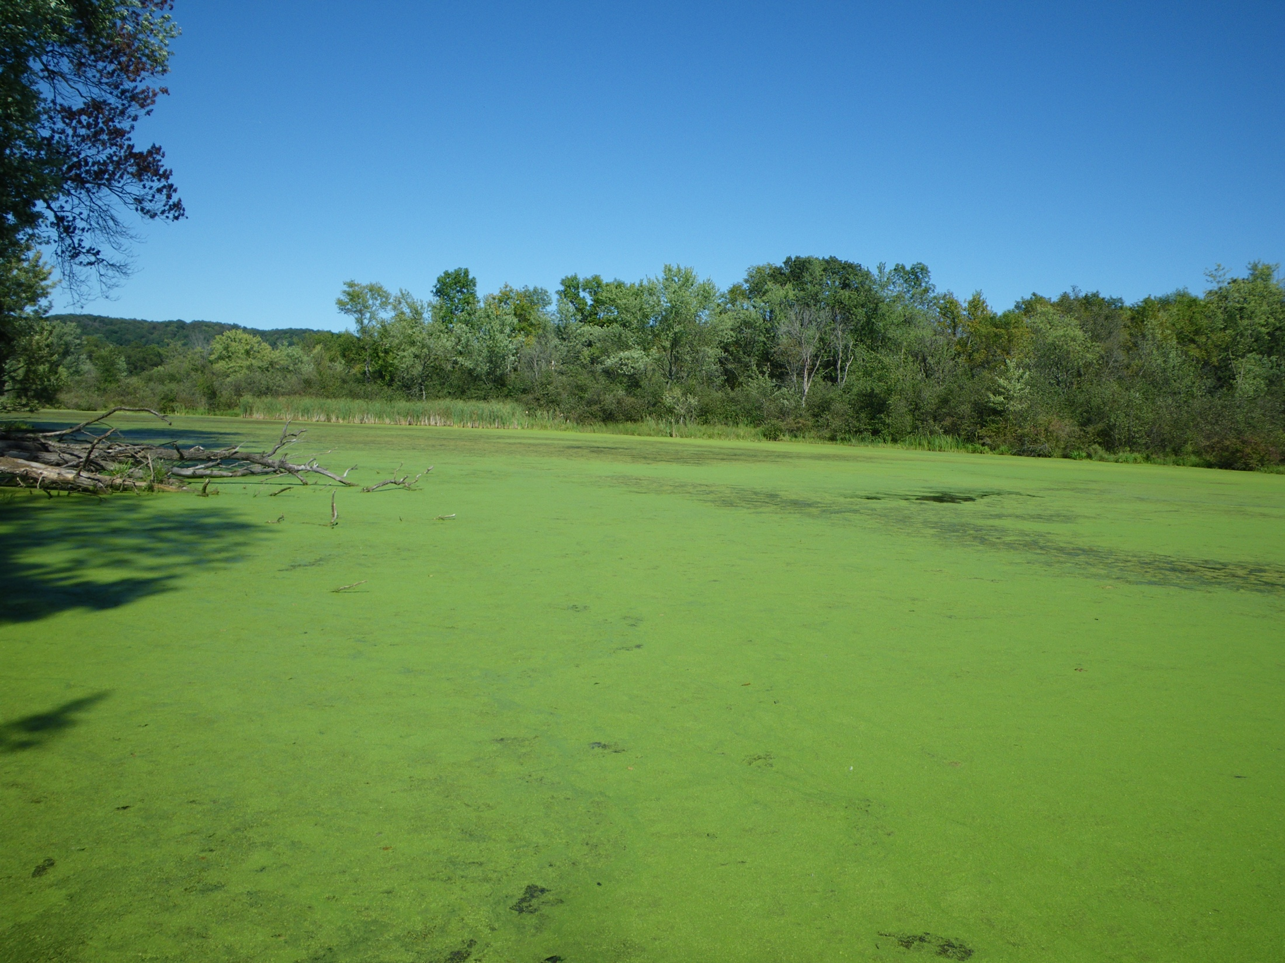
Jones Slough 9/9/15
WDNR Lakes Planning Grants Projects
Sponsored by
River Alliance of Wisconsin
In Cooperation with WDNR Water Quality Section
Prepared by
David W. Marshall, Kenneth Wade, Jean L. Unmuth and Elisabeth Schlaudt
April 2016
Abstract
The habitat of oxbow lakes is often dependent on the quantity and quality of the groundwater discharging to them. The Phase 1 study had demonstrated that increasing nitrogen concentrations in the oxbows and subsequent habitat degradation was most evident where the river terrace groundwater discharges into the lakes. A major goal of the hydrogeological study was to measure the quality of the groundwater water discharging into the lakes. This effort was coordinated with the continuing study of the of the lakes' surface water quality and biota.
The extensive School Forest, adjacent to Long Lake, demonstrates that conservation buffers is an option for reducing groundwater and oxbow pollution. However, the data also indicate that extensive buffers are likely needed along with nutrient application reductions. The highest groundwater nitrate concentrations coincided with greatest oxbow environmental degradation in the forms of toxic nitrate concentrations, extensive free floating plant (FFP) cover, and anoxia. Toxic nitrate concentrations occurred where FFP densities were lower, along with associated plant nutrient uptake while dense FFP resulted in anoxia and internal phosphorus loading.
Introduction
Below the Prairie du Sac dam, a large river ecosystem known as the Lower Wisconsin State Riverway (LWSR) flows within a floodplain that remains in a relatively natural state. The Lower Wisconsin River is considered one of the highest-quality large rivers remaining in the Midwestern U.S. (Lyons 2005). This braided river channel ecosystem supports 98 fish species and very high biodiversity in part due to a vast network of oxbow lakes and sloughs that support numerous species adapted to slow water currents. The existence of these unique ecosystem features and high biodiversity are reasons why the State Riverway has been recommended for nomination as a Ramsar Convention wetland of international importance.
The LWSR hydrology is greatly influenced by a “dynamic aquifer” across the Driftless Area (Pfeiffer et al. 2006). This massive groundwater system is an important environmental factor that sustains this large river ecosystem but also softened the historic impacts when industrial pollution degraded upstream sections of the river prior to implementation of the Clean Water Act (Marshall 2009). By the early 1980s, over 95% of the organic pollutants discharged to the river during the 1970s and before were eliminated (WDNR 1992).
Oxbow lakes and sloughs provide important habitats for species with ecological niches that avoid fast currents. Offchannel waterbodies also function as nurseries for many riverine fishes (Amoros 2001, Killgore and Miller 1995). Oxbow lakes had been degraded or completed eliminated due to floodplain aggradation and other anthropogenic factors along many Wisconsin rivers (Marshall 2012). However, rare fish species such as the State Endangered starhead topminnow (Fundulus dispar), State Special Concern mud darter (Etheostoma asprigene), State Special Concern pirate perch (Aphredoderus sayanus), State Special Concern weed shiner (Notropis texanus), pugnose minnow (Opsopoeodus emiliae) and lake chubsucker (Erimyzon sucetta) still thrive within the many LWSR oxbows and sloughs. They are often found where the Pleistocene river terrace aquifer discharges to oxbows lakes. Many of these oxbows are limnological definition of spring lakes and therefore should display excellent water quality given the hydrological influence of groundwater. However, beginning in the late 2000s, water quality declined rapidly in oxbows that had displayed near pristine conditions just a decade earlier (Marshall 2013 Phase 1 report). This report completes Phase 2 of the Diagnostic and Feasibility Study that expanded water quality monitoring beyond the oxbows to include the primary water source for the degraded oxbows, the groundwater discharge from the adjacent river terrace aquifer. The study was designed to better understand the groundwater dynamics as the primary nutrient delivery system to the oxbows and what measures, such as conservation buffers, can be recommended to restore and protect these environmentally sensitive off channel habitats.
Methods
Four oxbow lakes (Jones Slough, Norton Slough, Bakkens Pond and Long Lake) and the nine up-gradient clustered monitoring wells installed across the terrace and floodplain were sampled monthly during the open water seasons in 2014 and 2015. Jones Slough (WBIC 1247300), Norton Slough (WBIC 1247100) and Bakkens Pond (1236900) were selected for further monitoring since these waterbodies displayed the most severe water quality in 2013 (Phase 1 Diagnostic and Feasibility Study). Long Lake (WBIC 1236600) functioned as a reference site since it displays far less productivity and is buffered by the School Forest. A recent 12-acre conservation buffer was established (2013) adjacent to Norton Slough. Crop production and nutrient additions had ended in the twelve-acre parcel in 2010. A cluster of four monitoring wells was installed between the oxbow lake and buffer to detect potential changes in nitrate concentrations over time. Norton Slough was the only site where riparian land use changes had occurred recently.
Nitrate, ammonium and chloride were measured in the field using a YSI Pro Plus meter that was calibrated using 1 mg/l and 100 mg/l NO_{3,} 1mg/l and 100 mg/l NH₃, and 10 mg/l and 1000 mg/l chloride standards. Chlorides were collected for use as potential groundwater flow tracers, primarily from highway road salt applications. Water samples were collected separately WDNR and consultants but all were submitted to the State Laboratory of Hygiene (SLOH) for nitrate quality assurance, total nitrogen, chlorophyll a and total phosphorus analysis. The SLOH analysis of nitrate provided quality assurance for meter nitrate measurements. A YSI DO meter or similar meter was used to measure dissolved oxygen and temperature in the oxbows and wells. The meter was air calibrated according to specifications. A YSI Model 63 meter was used to measure pH and specific conductance. A standard secchi disc was used to measure water clarity. A Hach 2100P Turbidimeter was used for oxbow water sample analysis. Free floating cover (filamentous algae and duckweeds - FFP) was estimated using the following scale: 0 = no FFP present, 1 = 1 – 20 % FFP cover, 2 = 21 – 40 % FFP cover, 3 = 41 – 60 % FFP cover, 4 = 61 – 80 % FFP cover, and 5 = 81 – 100 % FFP cover. In late June 2015, WDNR conducted a point intercept survey on Jones Slough (84 sites) and Norton Slough (60 sites). Nearshore fish populations were sampled using towed DC electroshockers. A point intercept survey documented aquatic plant growths in Norton Slough and Jones Slough.
The hydrogeological study included water monitoring at 48 locations including: 42 wells of which 34 were installed as part of the study, two were established Town of Spring Green Flood Study monitoring wells, and six were private water supply wells monitored only for water quality. Onset pressure sensors were installed at six staff gages to monitor oxbow water levels. Soils were logged as part of the well installation and the logs provided in Appendix 1. This assessment reports on monitoring conducted from July 10, 2014 through November 4, 2015.
Study Area
The study area lakes and monitoring points are shown on Fig. 4. Nine groundwater monitoring well clusters were installed in the river terrace and floodplain to assess the aquifer that flows into Jones Slough and Norton Slough east of Spring Green and Bakkens Pond and Long Lake west of Spring Green, Sauk County. Three additional wells were installed to measure groundwater level changes in close proximity to the river which allowed determination of Wisconsin River stage elevations. Jones Slough (7.3 acres) and Norton Slough (13.6 acres) are cutoff channel oxbow lakes and both function as spring lakes (lakes with outlets but no inlets) due to the influence of the river terrace aquifer. Jones Slough has a maximum depth of 2.1 meters and Norton Slough 2.7 meters. A permanent twelve-acre conservation easement was established around the Norton Slough monitoring wells in 2014 and is a developing buffer as warm season grasses and forbs are becoming established with deep root systems. The conservation easement prohibits nutrient additions in the newly formed clean recharge buffer area. Bakkens Pond (19.1 acres) is a spring lake impoundment encompassed by a State Natural Area that begins as a series of large springs that discharge into the floodplain. The oxbow channel is impounded by two earthen dams with tin whistle structures designed to expand waterfowl habitat. Long Lake (48 acres) lies just downstream of Bakkens Pond and is classified a shallow lowland drainage lake. It is impounded by a low rock dam near the HW 130 bridge at the Wisconsin River. The north shore of Long Lake is heavily developed with seasonal and year round residences. Long Lake is also located within the Sauk County School Forest that has functioned as an extensive conservation buffer for decades. These four waterbodies and aquifer lie within the 136 square mile Bear Creek Watershed. While this watershed drains a significant area, the direct surface water drainage area around the floodplain lakes is not significant with the river terrace aquifer functioning as the primary water source except during infrequent periods of high river stages.
Findings
Groundwater Study
Historic hydrogeological information and past study in the region was reviewed and a conceptual groundwater flow model was formulated that included recharge in the bedrock highland to the north and in the adjacent Wisconsin River outwash terrace with flow to the south with discharge at the lakes and Wisconsin River. Figure 1 shows the general groundwater flow in the lake study area and Figure 2 is a cross-section showing the conceptual groundwater flow more locally. Figure 3 shows the conceptual groundwater flow into an oxbow lake. Groundwater modeling of Sauk County (Gotkowitz et al., 2005) indicates the hydraulic conductivity of the outwash and alluvial deposits is 162 ft./d with a recharge of 10.2 inches per year while the underlying sandstone bedrock and adjacent upland area has a hydraulic conductivity of 8 ft./d and a recharge rate of 5.2 inches per year. Continuous soil sampling at each well cluster location confirmed the presence of medium well sorted sand including some fine sand, coarse sand and gravel. No significant clay or organic material was observed in the saturated outwash terrace deposits nor did indications of staining, odor or mottling that would indicate the presence of reducing conditions. The near-surface floodplain deposits adjacent Norton Slough however did contain finer soils, organics and indicators of reducing conditions such as mottling and iron depletion.
A compilation of all the hydrogeological monitoring results are provided as a spreadsheet in Appendix 2. A groundwater flow map constructed for the Norton and Jones Sloughs area is presented as Fig. 5 and the flow map for the Bakkens Pond and Long Lake area is presented as Fig. 6. The Wisconsin River stage elevations used in the groundwater maps in the Jones/Norton area were interpolated and extrapolated from the water elevations measured at WR (Wisconsin River at HW 14) and WRFP (Wisconsin River adjacent Norton Slough) monitoring points. The river gradient was calculated to be 0.00033 ft./ft. (1.75 ft./mile). The Wisconsin River stage elevations used in the groundwater maps in the Bakkens Pond/Long Lake area were interpolated from the WRLR (Wisconsin River at HW 130 near Lone Rock) and WR (Wisconsin River at HW 14) monitoring points. The river gradient was calculated to be 0.00025 ft./ft. (1.33 ft./mile).
The groundwater maps demonstrate that the lakes are receiving groundwater discharge from the north. The recharge areas for the southward flowing groundwater includes significant outwash terrace agricultural development and associated nutrient additions, both as chemical fertilizer and manure. The three dams on the Bakkens Pond and Long Lake impoundments flatten the groundwater gradients in the downstream areas resulting in slower groundwater flow velocities in these floodplain areas. Table 1 displays the hydraulic gradients and calculated seepage velocities for each lake area. The location and width of the agricultural areas up-gradient from each of the lakes was determined from aerial photos. The distance of the agricultural area up-gradient from each lake was used with the groundwater seepage velocities to calculate the travel times necessary for nutrients to flow to both the lakes and the adjacent Wisconsin River location down-gradient from each lake. The nitrate component of the agricultural-derived nutrients is anticipated to act in a conservatively with negligible retardation or degradation expected due to the geochemical aquifer conditions. The results are provided in Table 2.
The time needed for nutrients to travel from the agricultural areas increases for each lake starting at Jones Slough in the eastern portion of the study area to Long Lake in the west. The longer travel time of 15.6 years calculated for Long Lake indicates the nitrate impacts from the up-gradient agricultural areas may continue to build through time.
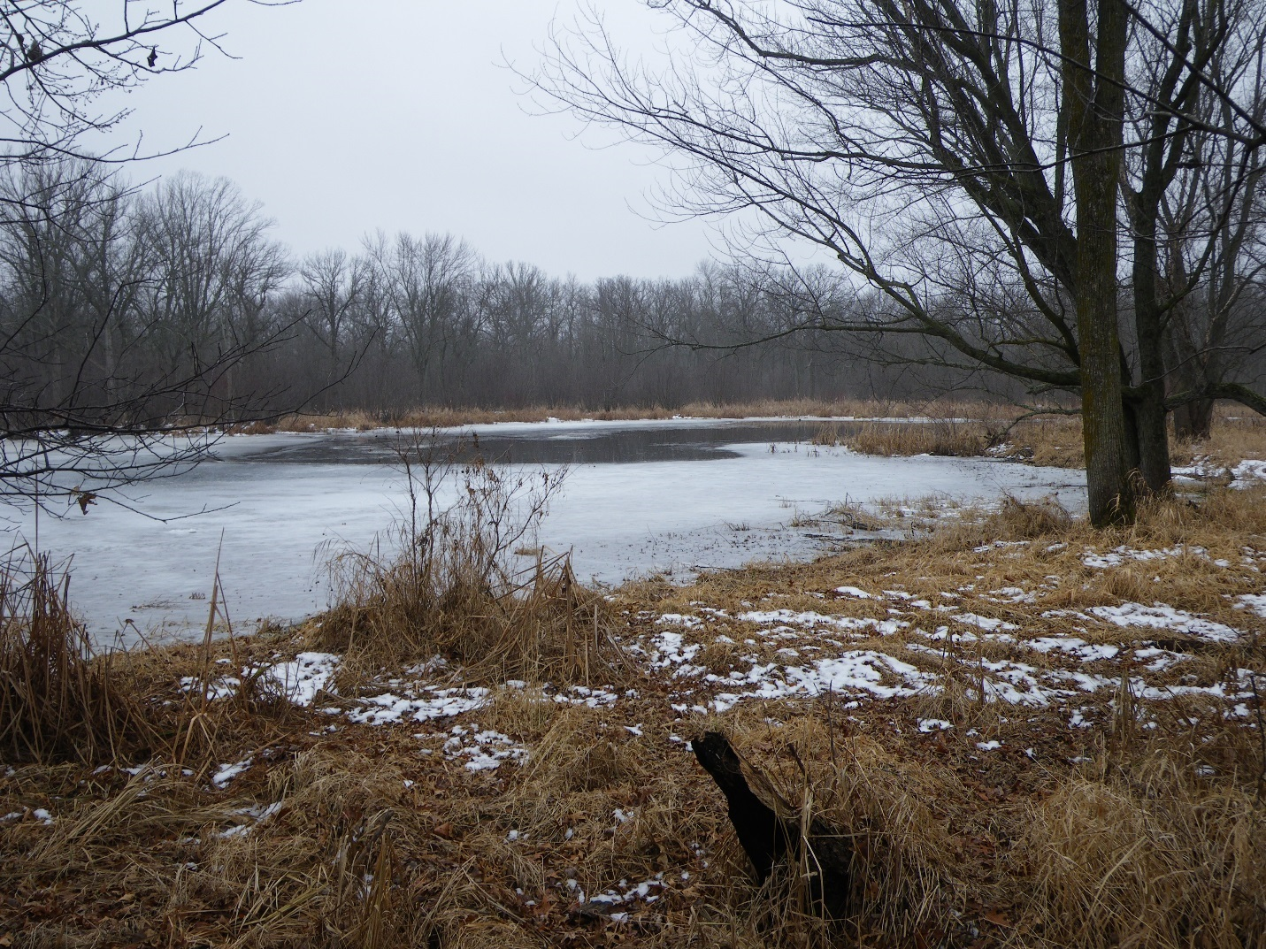
Open water in Jones Slough during winter due to groundwater discharge. The observations of lake ice cover in December of 2014 suggest groundwater discharge and associated nutrients may not be uniform along the edge of the discharging aquifer. Below are winter photos of the other lakes demonstrating variable groundwater discharges.
Table 1: Hydraulic Gradients and Seepage Values
Oxbow lake | Location | Hydraulic Gradient  (i) ft/ft | Seepage Velocity  (Vs)* ft/day
Jones Slough | Terrace | 0.00126 | 0.82
Jones Slough | Floodplain | 0.001 | 0.65
Norton Slough | Terrace | 0.0012 | 0.8
Norton Slough | Floodplain | 0.0015 | 1.0
Bakkens Pond | Terrace | 0.003 | 2.0
Bakkens Pond | Floodplain | 0.0007 | 0.45
Long Lake | Terrace | 0.002 | 1.3
Long Lake | Floodplain | 0.0002 | 0.13
*Seepage Velocity (Vs) = (K)(i/ᶲ) K = outwash & alluvial hydraulic conductivity of 162 ft/day. ᶲ = porosity of 0.25.
Table 2: Agricultural Nutrient Travel Times
Lake | Distance from  Ag Use Area, ft. | Lake Distance  To Wis. Rr. ft. | V_{S}*  Terrace  ft./d | V_{S}*  Floodplain  ft./d | Travel  Time  to Lake  yrs. | Travel  Time to Wis. Rr.  yrs. *** | N-S Width  of Ag. Use  Area, ft.
Jones Slough | 350 | 2200 | 0.82 | 0.65 | 1.2 | 10.5 | 1600
Norton Slough | 1200 | 2000 | 0.8 | 1.0 | 4.1 | 9.1 | 3700
Norton Slough | 150** | " | " | "" | 0.51 | 6.1 | "
Bakkens Pond | 4400 | 4400 | 1.94 | 0.45 | 6.2 | 33 | 8500
Long Lake | 7400 | 3700 | 1.3 | 0.13 | 15.6 | 94 | 12,700
* Seepage Velocities (V_{S}) calculated with K = 162 ft/d and porosity (_{ᶲ}) = 0.25
** 150 ft. distance used for time before 2010 when Jones field area was converted to prairie
*** Travel time to Wis. Rr. Includes both Terrace and Floodplain Travel Times
On June 10, 2015 a transect survey of Norton Slough sampled groundwater from six temporary piezometers (Table 3). The survey showed the groundwater discharging into Norton Slough with variations in nitrate of 0.9 to 11.1 mg/l NO3-N. The highest nitrate concentrations were adjacent the north shore with the greatest groundwater discharge during river low flow. A water column temperature profile at Norton Slough on the same day showed the lowest water temperatures occurred at the bottom of the water column in areas that corresponded to the highest groundwater nitrate concentrations found in the temporary piezometer transect.

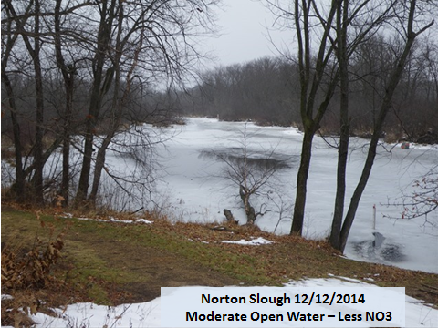
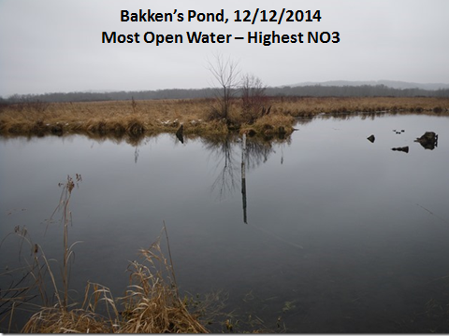

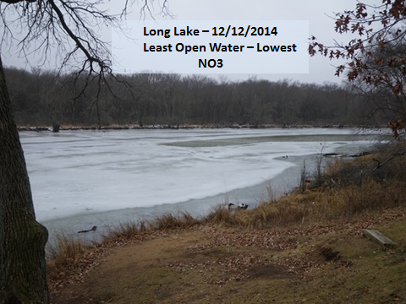
Table 3: Norton Slough Water Quality Profiles Near Temporary Piezometers
Site | Depth below water surface (m) | Nearby Temp. Peiz.  NO3-N mg/l | Slough water temperature C
1 | Surface  0.7 | 0.95 | 26.1  24.5
2 | Surface  0.5 | 0.9 | 27  24.8
3 | Surface  0.5 | 4.22 | 26.3  24.2
4 | Surface  1 | 3.45 | 27.3  19.2
5 | Surface  1  2 | 11.1 | 26.6  19  13.5
6 | Surface  1  2 | 11.1 | 26.5  19  13.5

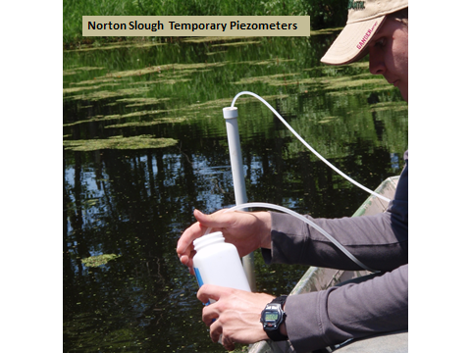
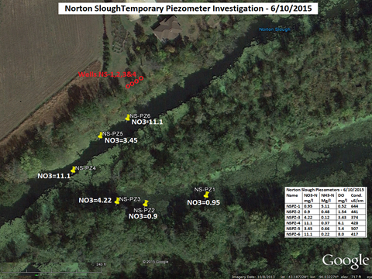

A cross-section of the study results at Jones Slough is presented as Fig. 7. A cross-section of the study results at Norton Slough is presented as Fig. 8. A cross-section of the study results at Bakkens Pond is presented as Fig. 9 and a cross-section of the study results at Long Lake is presented as Fig. 10. Jones Slough, Norton Slough and Bakkens Pond are over two feet higher than the Wisconsin River elevation. Long Lake is less than one foot higher than the river and may partly explain the classification differences in the lakes.
The results show that the hydraulic gradients adjacent each of the lakes indicate that groundwater is recharging from the north. The groundwater discharging into all four lakes contains significant concentrations of nitrate (Table 4). The nitrate concentration of the groundwater discharging into Long Lake was the lowest of the four lakes. This is most likely due to the greater width of non-agricultural buffer between the lake and the agricultural field to the north. The higher nitrate concentrations at the greatest depths monitored most likely represents water flowing from a greater distance to the north were the agricultural cropping is most intense. Some of the deeper water may be flowing under the lakes and ultimately discharge into the Wisconsin River. The shallow wells (JS1, NS1, LL1, BP1) had lower nitrate concentrations than in deeper wells since the shallow groundwater represented clean recharge within the variable buffer zones adjacent to the oxbow lakes.
Concentrations of phosphorus were measurable but were relatively modest (< 50 ug/l) when compared with nitrate concentrations. Ammonium levels were high in deeper DR and PR wells that lie within groundwater flow paths of Bakkens Pond and Long Lake and at JR2 that flows toward Jones and Norton.
The buffers can be an important factor in protecting the oxbows given both the clean recharge potential and terrestrial deep rooted plant nutrient uptake. Currently, both buffer zones and sand terrace nutrient applications areas are variable among the four study lakes. Across the sand terrace, Long Lake intercepts a polluted agricultural to buffer zone linear pathway ratio of approximately 3:1. In stark contrast, the Bakkens Pond agricultural to buffer recharge ratio is approximately 24:1 so that the clean recharge/terrestrial plant nutrient uptake zone is relatively short compared with polluted recharge. Jones Slough and Norton Slough have agricultural to buffer ratios of approximately 21:1 and 6:1 respectively. The ratios are surficial linear comparisons and do not represent actual more complex three dimensional and temporal changes in groundwater flow paths. However, Jones Slough and Bakkens Pond displayed the most degraded water quality and also have relatively longer polluted recharge zones compared with buffer zones.
Actual nitrogen and phosphorus loading rates to the oxbows will depend on a combination of factors including nutrient management, groundwater elevations intercepted by the oxbows, buffer dimensions, buffer vegetation types, and buffer locations relative to groundwater flow paths. The numerical groundwater modeling study (Sauk County River Planning Grant) now underway at the study area should be able to better determine potential groundwater flow paths including nutrient source and discharge locations along with more precise identification of the width of recharge buffers needed to insure discharging waters will not cause impacts to the sensitive lake habitats.
The floodplain wells adjacent to Norton Slough characterized the reduced conditions within alluvial aquifer. Nitrate concentrations were low while ammonium concentrations were high, suggesting denitrification within the wetland. Phosphorus concentrations were high while dissolved oxygen concentrations were very low.
Figure 1: General groundwater flow in the oxbow lake study area

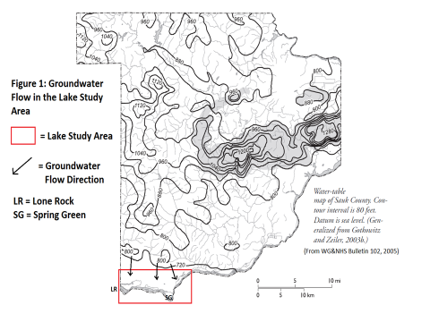

Table 4: Mean parameters concentrations from monitoring wells
Name | Sp. Cond. umhos/cm | NO3-N mg/l | NH3-N mg/l | Chloride mg/l | Total Phosphorus mg/l
JS1 | 390 | 9.7 | 0.50 | 56 | 0.041
JS2 | 432 | 16.6 | 0.22 | 31 | 0.022
JS3 | 389 | 19.1 | 0.16 | 14 | 0.016
NS1 | 322 | 8.6 | 0.33 | 11 | 0.026
NS2 | 476 | 12.5 | 0.46 | 27 | 0.018
NS3 | 457 | 13.1 | 0.33 | 24 | 0.022
NS4 | 450 | 16.4 | 0.18 | 24 | 0.031
JW | 395 | 12.3 | 0.27 | 21
JP1 | 711 | 8.9 | 0.59 | 79
JP2 | 441 | 10.7 | 0.50 | 19
JP3 | 460 | 14.3 | 0.39 | 14
JR1 | 190 | 3.0 | 0.30 | 7
JR2 | 423 | 16.1 | 1.21 | 18
JR3 | 395 | 11.8 | 0.161 | 14
AW | 387 | 1.0 | 0.16 | 3
NW | 329 | 4.6 | 0.87 | 17
FP1 | 613 | 0.6 | 2.20 | 26 | 0.716
FP2 | 477 | 0.3 | 0.28 | 10 | 0.156
BP1 | 58 | 0.8 | 0.43 | 5 | 0.012
BP2 | 413 | 13.6 | 0.24 | 19 | 0.013
BP3 | 464 | 23.0 | 0.20 | 20 | 0.013
BP4 | 526 | 33.3 | 0.15 | 24 | 0.017
BP5 | 493 | 32.5 | 0.09 | 21 | 0.046
BP6 | 513 | 28.1 | 0.07 | 23 | 0.042
BPS | 439 | 18.7 | 0.16 | 33
DR1 | 407 | 6.3 | 0.62 | 53
DR2 | 724 | 23.5 | 2.82 | 60
DR3 | 533 | 15.6 | 1.86 | 31
LW | 570 | 13.2 | 1.50 | 59
LL1 | 311 | 3.7 | 0.71 | 55 | 0.017
LL2 | 669 | 4.0 | 0.45 | 131 | 0.024
LL3 | 582 | 6.2 | 0.44 | 130 | 0.043
LL4 | 753 | 9.5 | 0.26 | 135 | 0.014
RW | 371 | 23.2 | 0.20 | 25
PW | 281 | 2.3 | 0.22 | 2
PR1 | 377 | 2.5 | 0.38 | 48
PR2 | 719 | 13.1 | 0.38 | 107
PR3 | 585 | 10.2 | 3.86 | 36 | 0.012

Figure 2: Cross-section showing the conceptual groundwater flow
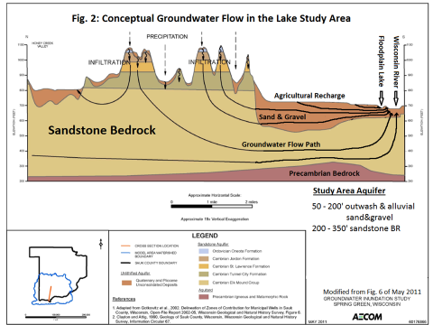

Figure 3: Conceptual groundwater flow into an oxbow lake
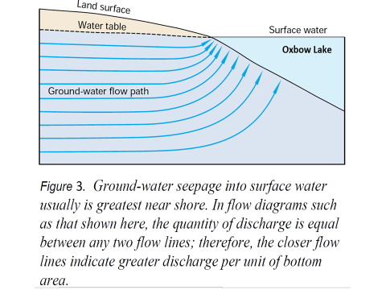

Figure 4: Study area lakes and monitoring points
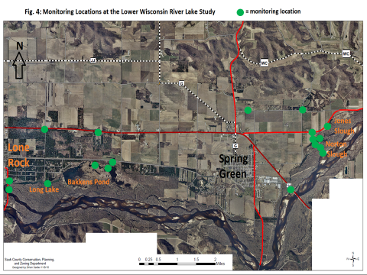

Figure 5: Groundwater flow map of the Norton and Jones Sloughs area
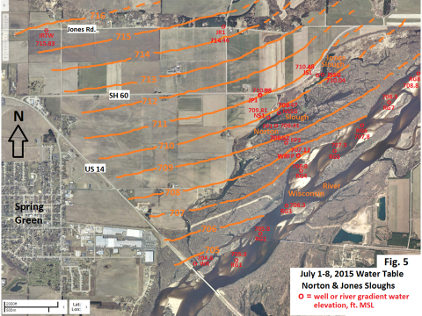

Figure 6: Groundwater flow map for the Bakkens Pond and Long Lake area
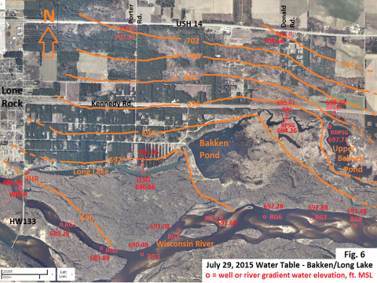

Figure 7: Elevation cross-section at Jones Slough
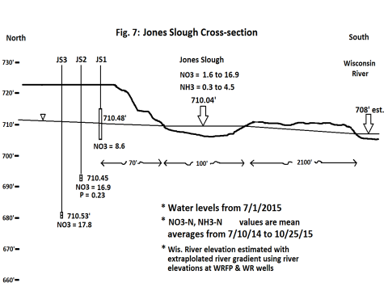

Figure 8: Elevation cross-section at Norton Slough
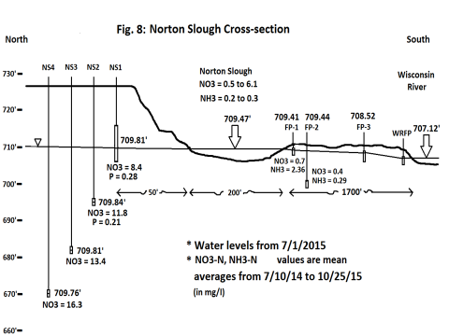

Figure 9: Elevation cross-section at Bakkens Pond
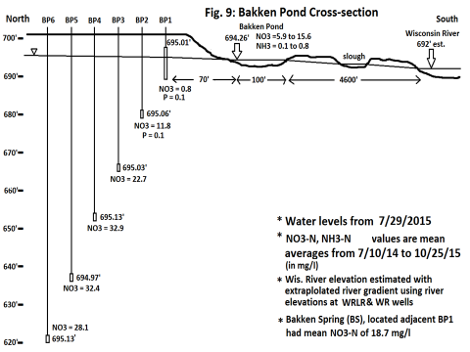

Figure 10: Elevation cross-section at Long Lake
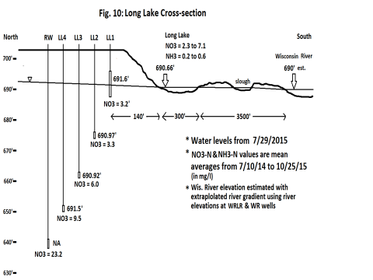
The groundwater elevations found at the well clusters adjacent each lake are very similar in that there is not much difference in elevation from the water table and each of the adjacent piezometers. Since the error associated with each of the noted values due to surveying or field reading accuracy is likely to be approximately 0.02 to 0.03 feet, it is difficult to determine relative vertical groundwater gradients for each cluster. However, from the comparison of the groundwater and lake elevations it is clear that there is always a potential upward gradient from each groundwater monitoring location to the adjacent lake. Based on water elevation data alone, it is difficult to determine the significance of potential groundwater underflow beneath the lakes before reaching the Wisconsin River discharge point. A summary of the maximum lake nitrate concentrations and the adjacent mean groundwater nitrate concentrations is provided below in Table 5.
The results indicate that for Jones Slough, Norton Slough, Bakkens Pond and Long Lake the adjacent groundwater is the source for the nutrients entering the lake. It was noted that while the upper portion of the aquifer adjacent to Bakkens Pond had low nitrate concentrations that correspond to the adjacent natural area land use, the lower portions must be discharging into Bakken Pond to account for the high nitrate concentration observed in the lake. The discharge of groundwater at the spring adjacent to the well cluster at Bakken Pond shows there can also be localized points of discharge of groundwater from the deeper portions of the aquifer with recharge originating at the agricultural sources located 4400 feet up-gradient. The mean nitrate in the spring was 18.7 mg/l. At Long Lake, the upper portion of the aquifer contained relatively low nitrate concentrations compared to the lake. The private water supply well adjacent the monitoring well cluster, screened approximately 10 feet below the deepest piezometer, had mean nitrate concentrations of 23.2 mg/l NO3-N. This suggests it is possible the upper aquifer water is discharging into Long Lake while the deeper water may underflow the lake with eventual discharge at the Wisconsin River. The 15.6-year travel time calculated for agricultural nutrient recharge to arrive at Long Lake also indicates the nitrate concentration in the deeper aquifer adjacent Long Lake is likely to increase over time.
The ongoing numerical modeling of the groundwater flow system in the study area being conducted by the UW-Madison Geosciences and Ken Wade under a WDNR River Planning Grant administered by Sauk County is scheduled to be completed by the end of 2016. This modeling will allow for more precise delineation of the groundwater flow paths and the recharge areas discharging to the oxbow lakes. This information will help to target the oxbow recharge areas where strategies for maintaining or improving recharge water quality can be applied.
Table 5: Mean Nitrate Concentrations for Lakes and Adjacent Groundwater
Lake | Maximum Lake NOx-N | Groundwater NOx-N*
Jones Slough | 16.9 | 17.4**
Norton Slough | 6.1 | 13.8
Bakkens Pond | 15.6 | 29.3
Long Lake | 7.1 | 6.3***
* Mean of piezometers (excluding water table wells)
** Only 2 piezometers at Jones Slough (shallower samples)
*** NO3-N of 23.2 mg/l observed in adjacent private well screened 10 ft. below piezometer LL4

Oxbow Lake Responses
Jones Slough and Norton Slough: These oxbow spring lakes lie in close proximity but exhibit different degrees of water quality degradation and nuisance levels of FFP growths (Figure 11). While both oxbows have a recent history of complete (100%) free floating plant cover (see Phase 1 report), in 2014 and 2015 the frequency occurrence was lower in Norton Slough (no FFP greater than 80% and mean FFP of 42.5%) compared with Jones Slough that exceeded 90 % cover every year (78% frequency of 90% FFP or greater and mean FFP of 80.6%). The water quality impacts of prolonged duckweeds and filamentous algae cover are evident by looking at vertical profile temperature and water chemistry. The June 2015 aquatic plant point intercept survey indicated that the FFP frequency of occurrence was 81% in Norton Slough and 88% in Jones Slough. The total relative frequency of FFP mats in Jones Slough (Table 6) was 47%, and 32.8% in Norton Slough (Table 7).
The vegetation statistics from the point intercept survey suggested that both Norton and Jones Sloughs exhibited relatively high biological integrity and a low level of disturbance impacts although there is no baseline data for comparison. Jones slough showed just slightly lower values than Norton Slough. Norton Slough supported greater species richness at 30 along with a higher Simpson diversity index of 0.92 and a higher floristic quality of 32 (Table 8). Species richness in Jones Slough was 25, along with a Simpson diversity index of 0.87 and floristic quality 29 (Table 9). Plants were found at all depths in Jones and Norton Sloughs, but the majority of plants growing in Jones Slough occurred in water depths three feet or less, while in Norton Slough the majority of plants grew in out to the five-foot contour. Greater aquatic plant growths in deeper zones within Norton Slough may reflect less FFP cover (Figure 30) as opposed to Jones Slough (Figure 31). Since the point intercept surveys were conducted after the recent water quality degradation, quantitative comparisons of aquatic plant communities that existed prior to recent water quality declines cannot be made. However, previous qualitative surveys suggested greater densities of floating leaf plant species including white water lily, spatterdock and large leaf pondweed.
The dominant submersed aquatic plants in Jones and Norton Sloughs were coontail (Ceratophyllum demersum), common waterweed (Elodea Canadensis), white water crowfoot (Ranunculus aquaticus), muskgrasses (Chara), and Long-leaf pondweed (Potamogeton nodosus), while the frequency of floating leaf plants such as white water lily (Nymphaea odorata) was much lower (Figure 32).
In Figures 12 and 13, water temperature profiles demonstrate the influence of the massive hillslope (terrace) aquifer since growing season temperatures remain very cold in these shallow spring lakes. The significant rapid water temperature changes with depth reflect a combination of heavier cold water that moves along the bottom and direct groundwater discharges. Despite the cold temperatures and associated high oxygen saturation potential, anoxic conditions were measured in Jones Slough but not in Norton Slough (Figures 14 and 15). Very high phosphorus concentrations in Jones Slough likely reflected internal loading under anoxic conditions. Nested well phosphorus concentrations adjacent to the oxbow (Md = 22 ug/l, u = 25 ug/l) were significantly lower (P = 0.07) than lake concentrations (Md = 71 ug/l, u = 236 ug/l) that exceeded 1 mg/l on two occasions (Figure 16). Phosphorus concentrations in Norton Slough (u = 46.3 ug/l) were also higher than in adjacent wells (22.8 ug/l), but were typically lower than Jones Slough phosphorus levels (Figure 17) where anoxia was more prevalent.
While phosphorus concentrations in Jones Slough were often higher than adjacent well concentrations, oxbow nitrate concentrations displayed (u = 4.36) were generally less than concentrations (u = 15.11) found in the adjacent wells (Figure 18). The loss of nitrogen in the oxbows likely reflected plant uptake since the lowest nitrate concentrations coincided when free floating plant densities were highest. Despite this observed reduction, nitrate concentrations in both Jones Slough and Norton Slough exceeded USEPA, USGS (Robertson et al. 2006) and Camargo et al. (2006) recommended criteria of < 2 mg/l in more than 50% of the samples (Figures 18 and 19). In both Norton Slough and Jones Slough, higher nitrate concentrations were detected where the groundwater entered the oxbows. In Norton Slough the highest NOx occurred in deeper water (2+ meters) but in Jones Slough highest NOx was found in shallow areas adjacent to the steep terrace bank. In Jones Slough, dense filamentous algal growths were often prevalent throughout the water column where plant uptake can occur. While high NOx concentration occurred in deeper water areas in Norton Slough, very high NH₃ was measured in deeper water (2 meters) on 9/9/15 when anoxia occurred in Jones Slough (Figure 20).
The nested well phosphorus concentrations were not particularly high, however nitrogen loading in the form of nitrates was very high (Figure 21). Nitrate concentrations were exceedingly high in comparison with phosphorus concentrations. Based on groundwater NOx concentrations, N:P ratios were approximately 696:1 in Jones Slough wells and 605:1 in Norton Slough wells. In both Jones Slough and Norton Slough, longitudinal nitrate sampling transects were completed on May 20, 2015 and indicated that the highest NOx concentrations in the oxbows occurred near the well clusters at both oxbows (Figures 22 and 23). This information suggested that the primary aquifer discharges were near the monitoring wells. Significant concentrations of dissolved oxygen were prevalent in the terrace monitoring wells adjacent to both Jones and Norton sloughs (JS1, JS2, JS3 – u = 7.3, 7.0, 8.6 mg/l respectively and NS1, NS2, NS3, NS4 – u = 7.0, 5.1, 4.1, 3.9 mg/l respectively). This source of cold dissolved oxygenated water is an important factor for sustaining environmentally sensitive fish and other aquatic organisms during periods of high river stages.
The water chemistry of the floodplain aquifer was significantly different from terrace aquifer. High phosphorus concentrations were found in the two floodplain wells located adjacent to Norton Slough. Floodplain well phosphorus concentrations ranged from 99 ug/l to 716 ug/l while levels were much lower in the terrace wells. Dissolved oxygen concentrations in the floodplain wells were very low, approaching anoxia, while ammonium levels were high in the shallow zone. As described in the Phase 1 report, the floodplain well data demonstrated how the river aquifer can be an infrequent but significant source of high nutrients and organic loading to the oxbows when river stages are high.
Specific conductance and pH data appear in the Appendix. Mean specific conductance levels in Jones Slough and Norton Slough were 497 and 397 uS/cm respectively. The adjacent wells were similar with levels at 403 uS/cm and 426 uS/cm respectively. Given that the Wisconsin River channel specific conductance levels are typically less than 300 uS/cm, the significantly higher oxbow levels reflect river terrace aquifer influence on the slough hydrology. Water clarity in the oxbows is also significantly different from the river. Mean turbidity levels in Jones Slough and Norton Slough were 2.1 and 2.5 NTU compared with mean river turbidity at 10.6 NTU. Secchi measurements also generally exceeded 2 meters in both oxbows that indicated minimal planktonic algal productivity.
Table 10 contains the fish electroshocking data for 2014 and 2014. State Endangered starhead topminnows still thrive in both oxbows although access to surface “topminnow” habitat is often limited, particularly in Jones Slough. State Special Concern lake chubsuckers were found in Jones Slough and State Special Concern pirate perch were found in both sloughs. State Special Concern mud darters were historically found in the slough but none were found recently. Mud darters, in part due to their benthic existence and sensitivity to degraded water quality, are particularly vulnerable to the recent environmental degradation in the oxbows.

Figure 11: Jones Slough and Norton Slough Estimated Free Floating Plant Cover
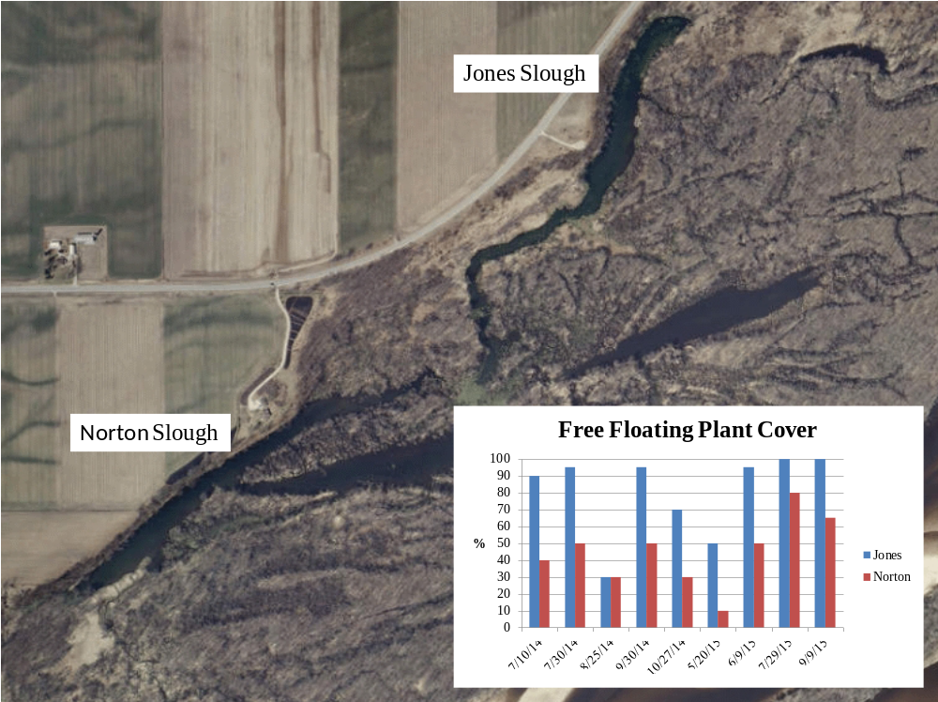

Figure 12: Jones Slough Temperature Profiles

Figure 13: Norton Slough Temperature Profiles

Figure 14: Jones Slough Dissolved Oxygen Profiles

Figure 15: Norton Slough Dissolved Oxygen Profiles

Figure 16: Jones Slough Phosphorus Concentrations
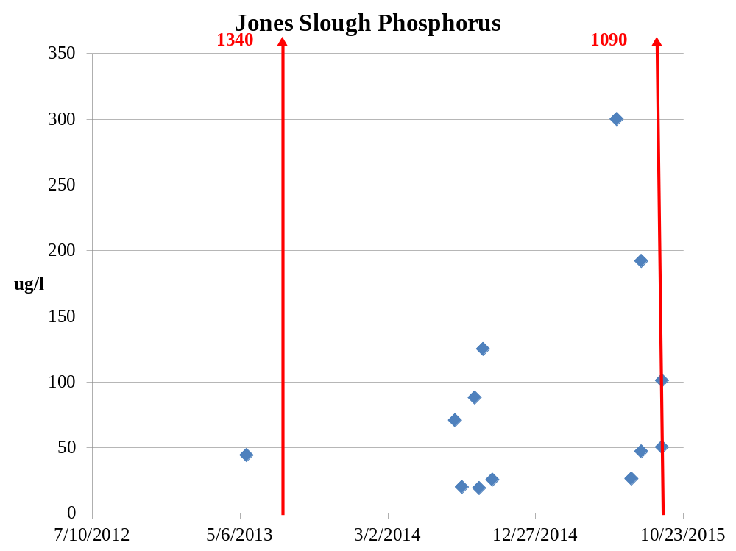
Figure 17: Norton Slough Phosphorus Concentrations

Figure 18: Jones Slough Nitrate Concentrations
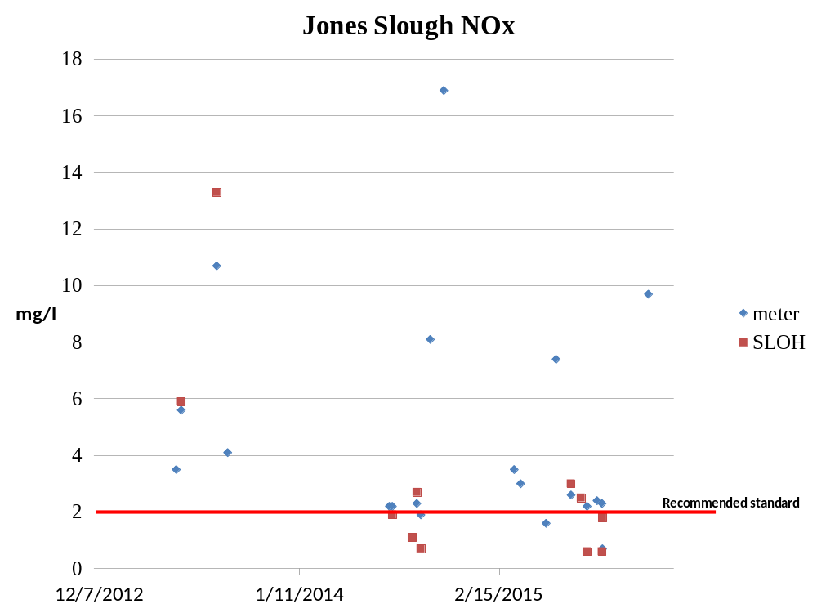
Figure 19: Norton Slough Nitrate Concentrations
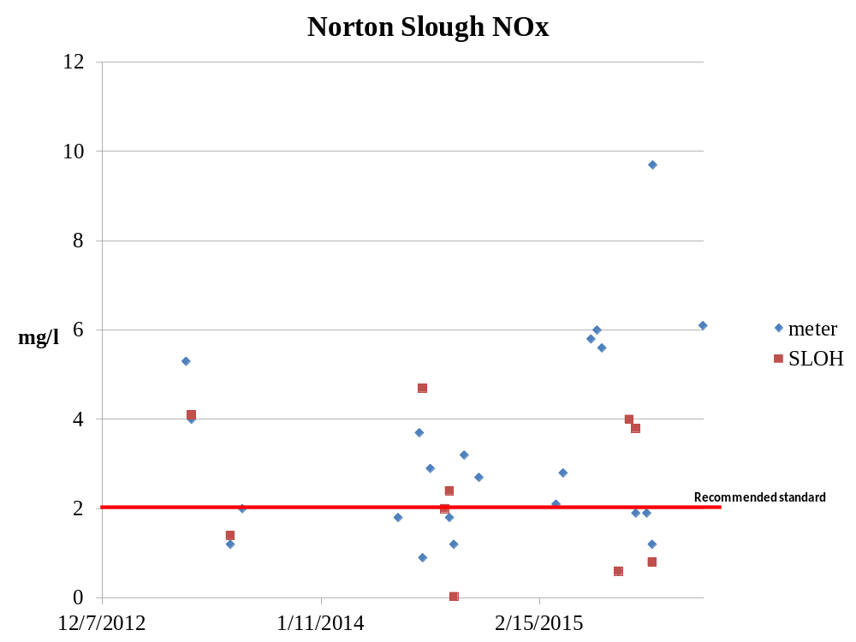
Figure 20: Jones Slough Ammonium and Nitrate Profiles

Figure 21: Mean Well Nitrate and Phosphorus Concentrations

Figure 22: Jones Slough Nitrate Transect in Relation to Monitoring Wells
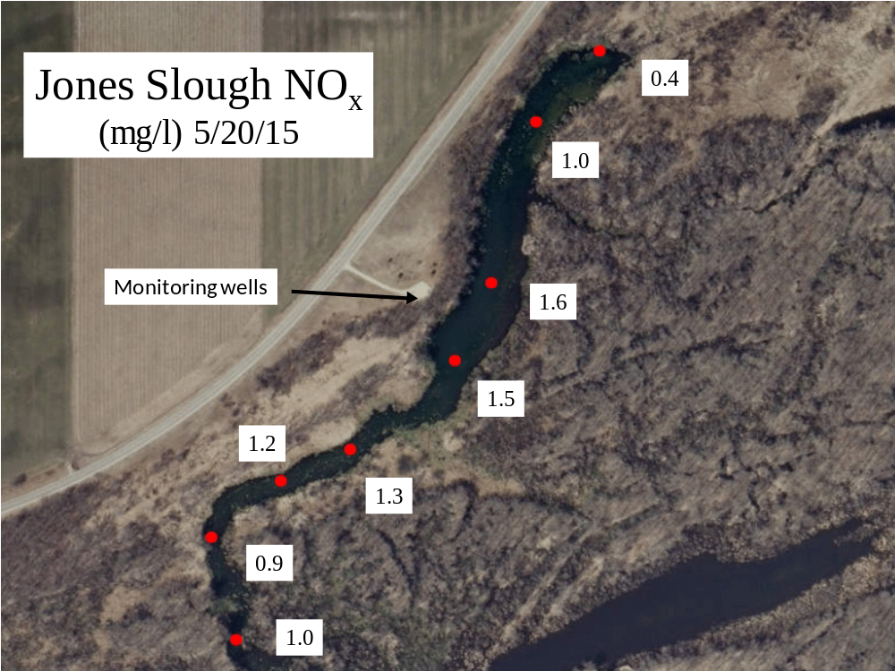
Figure 23: Norton Slough Nitrate Transect in Relation to Monitoring Wells
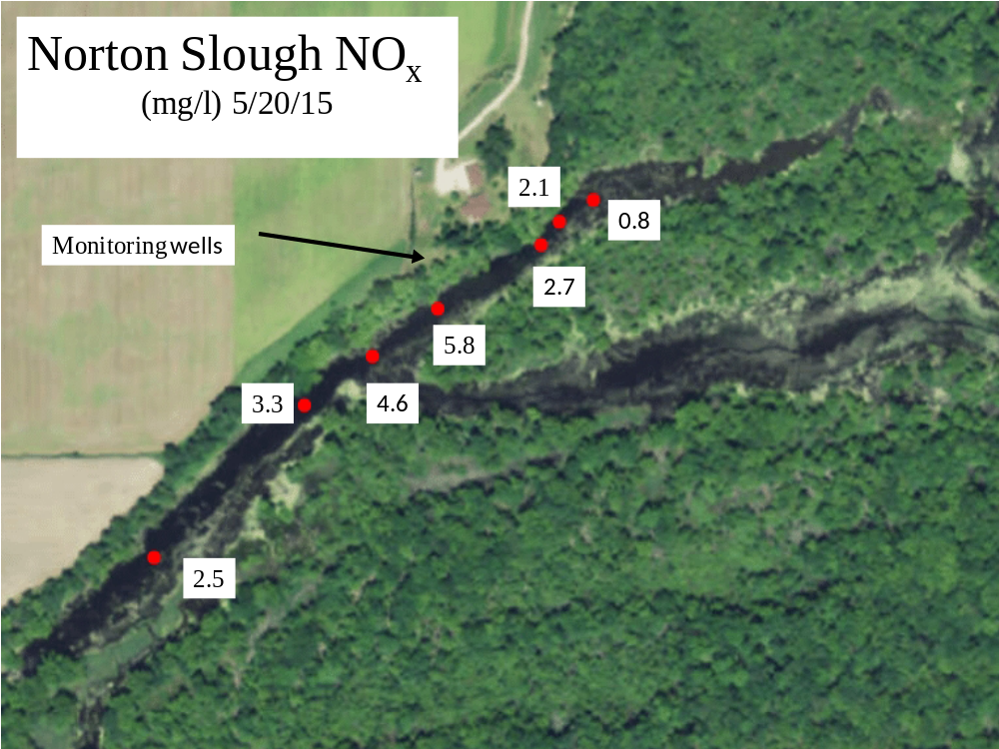
Bakkens Pond and Long Lake: Bakkens Pond is frequently covered with FFP within the impounded areas. The monitoring well cluster and surface water sampling site were located at a free flowing section of the pond (Figure 4) that was often choked with filamentous algae. The water column nitrate concentrations in the area averaged 11.3 mg/l (Md = 12.7). All of the NOx measurements in the channel exceeded recommended nitrogen criteria (Figure 24). The high nitrate concentrations were traced to springs that discharge in close proximity to the nested monitoring wells. These high values also coincided with very high well nitrate concentrations (u = 17.5 mg/l in Figure 21). Ignoring shallow well BP1 that represents the wooded buffer recharge zone that is located between Kennedy Road and the wells, then the average well nitrate concentration increased to 29.3 mg/l. This information suggested that the approximate 100 meter wooded buffer was not sufficient to reduce nitrate concentrations due to very high concentrations in deeper aquifer zones. Relative to the high nitrate concentrations, the phosphorus levels were relatively low in both the lake and well samples (Figure 25). Bakkens Pond mean, median and maximum phosphorus concentrations were 35, 39 and 42 ug/l respectively and the surface water N: P ratio was approximately 322:1. The monitoring wells mean, median and maximum phosphorus concentrations were 21, 14 and 46 ug/l respectively and the N:P ratio was about 1,395:1 based on NOx data.
Downstream of the second Bakkens Pond impoundment, Long Lake is a drainage oxbow that displays significantly lower levels of nuisance FFP growths. FFP occupy about 5% of the water surface throughout the summer. Low densities of FFP along with floating organic matter, that includes Oscillatoria sp., reflect a relatively moderate level of eutrophication in Long Lake compared with the other three lakes. Similar conditions were also found in Smith Lake and Crusan Slough located west of Lone Rock (Phase 1 report). Long Lake well nitrate concentrations were the lowest of the four oxbows surveyed in 2014 and 2015 even though the well cluster intercepts a septic system drain field (Figure 21). Clear evidence of the septic field influence included higher specific conductance measurements along with very high chloride concentrations that exceeded 300 mg/l on two occasions. Long Lake nitrate concentrations (u = 4.6 mg/l) consistently exceeded recommended criteria (Figure 26) but lacked the high densities of free floating plants found in the other three oxbows that can rapidly absorb nutrients. Based on two lake wide nitrate surveys conducted in 2015, the highest nitrate concentrations occurred near the east end of the lake, near Bakkens Pond outlet, and gradually decreased to the west (Figure 27). The mean and median phosphorus concentrations in Long Lake were 43.1 and 35 ug/l respectively (Figure 28) and the N: P ratio was about 258:1. Well phosphorus concentrations averaged 24.4 ug/l after removing an outlier concentration of 434 ug/l that was collected in the shallow well on September 20, 2015. The lower productivity in Long Lake likely reflects the influence of the School Forest as a buffer along with potentially greater dilution since Long Lake is significantly larger (~144 acre feet) that both Norton Slough (~54 acre feet) and Jones Slough (~30 acre feet) where groundwater could potentially have a greater influence. Another difference that Long Lake exhibited from the other three oxbows was clear evidence of significant groundwater discharge. The temperature profiles in Figure 29 demonstrate lack of cold water found in Long Lake compared with the Bakkens Pond springs or cold water layers at the bottom of both Jones Slough and Norton Slough.
Consistent with both Norton Slough and Jones Slough, specific conductance levels were higher in Bakkens Pond (u = 463 uS/cm) and Long Lake (u = 396 uS/cm) than in the river. Water clarity was also higher in both (Bakkens Pond = 1.4 NTU and Long Lake 4.2 NTU) than the river. These data again suggest greater river terrace influence on oxbows hydrology during lowflow conditions. Mean specific conductance in Bakkens Pond wells was 482 uS/cm without including the shallow well that had only 57.6 uS/cm. The low conductance in the shallow well reflected clean soft water recharge within the wooded buffer. Long Lake well specific conductance levels were very high (u = 579 uS/cm) and reflected influence of chlorides down gradient of the septic system.
Both Bakkens Pond and Long Lake support a number of rare and environmentally sensitive fish species even though nitrate toxicity is a concern. Table 11 displays electroshocking surveys conducted in 2014 and 2015. Mud darters and other darters are still found in both Bakkens Pond and Long Lake. Flowing water appears to mitigate some of the impacts of nitrogen loading and eutrophication in Bakkens Pond while more favorable water quality was likely a greater factor for darter survival in Long Lake.

Figure 24: Bakkens Pond Nitrate Concentrations
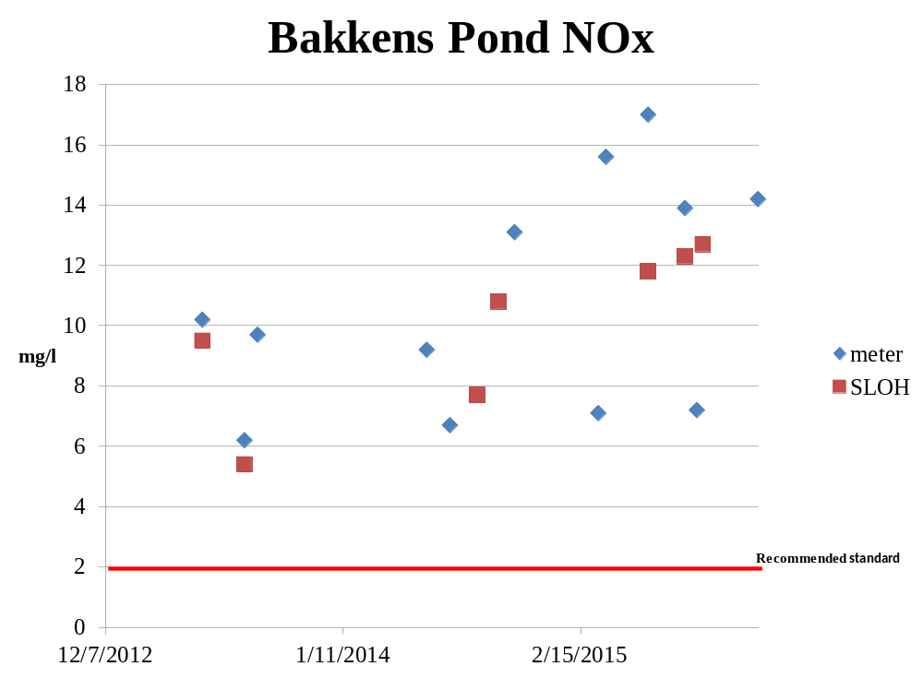
Figure 25: Bakkens Pond Phosphorus Concentrations

Figure 26: Long Lake Nitrate Concentrations
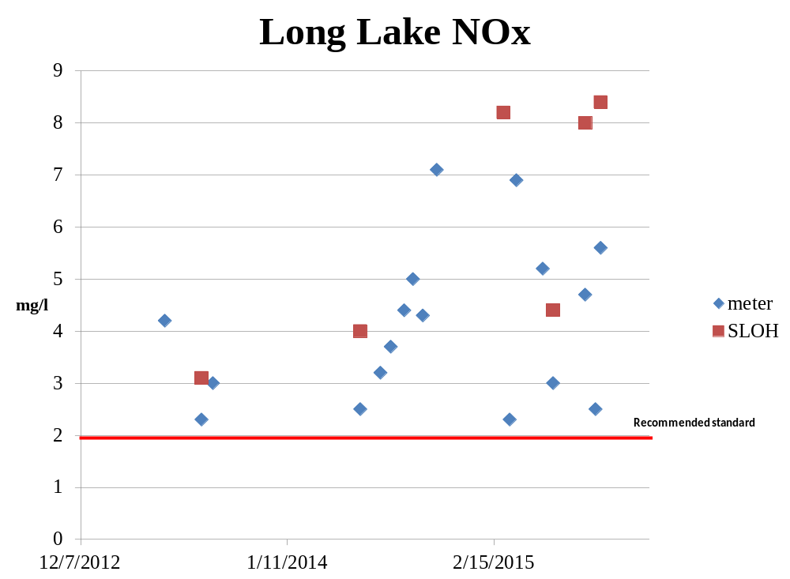
Figure 27: Nitrate Concentrations across Long Lake
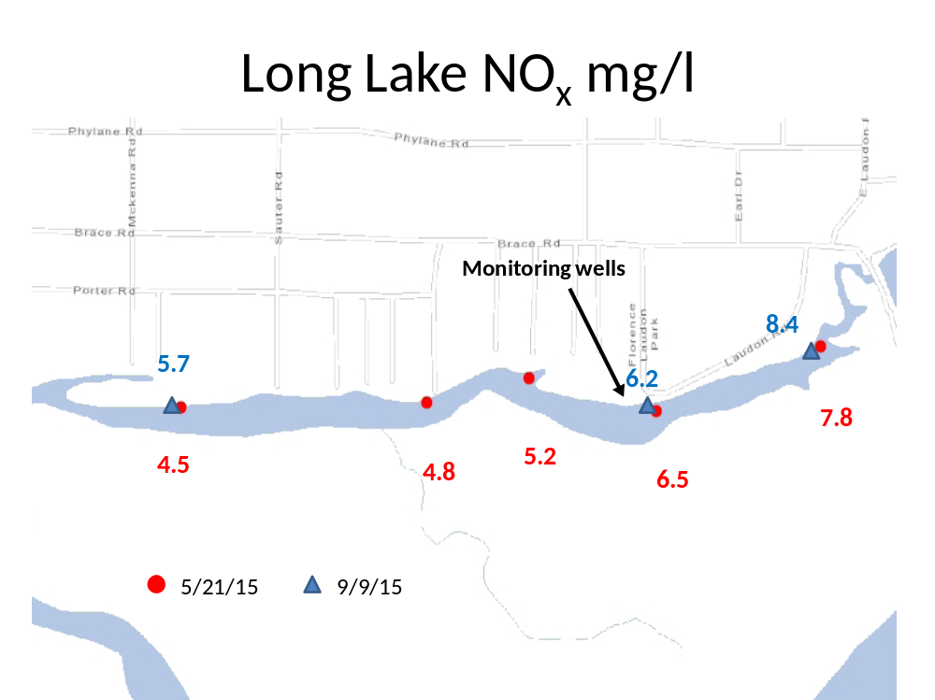
Figure 28: Long Lake Phosphorus Concentrations

Figure 29: Long Lake Temperature Profiles

Figure 30: Norton Slough sample sites with aquatic plant colonization by water depth
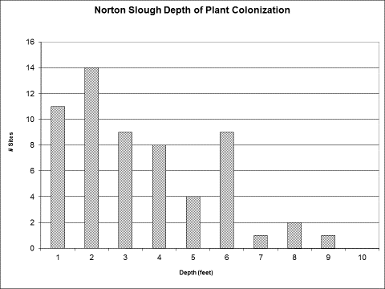
Figure 31: Jones Slough sample sites with aquatic plant colonization by water depth.
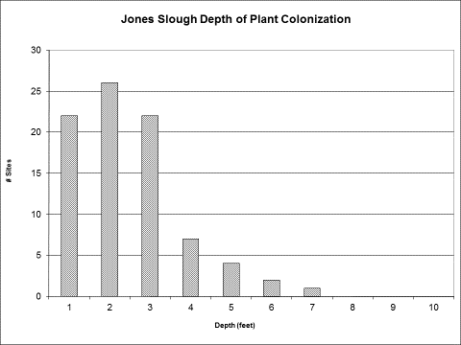
Figure 32: Relative Importance of dominant aquatic plants found in Jones and Norton Sloughs
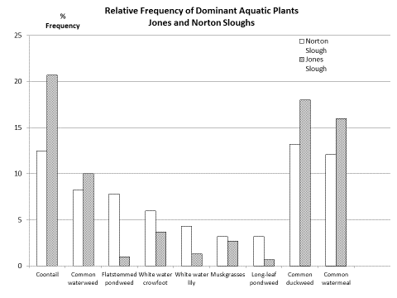

Table 6: Jones Slough relative importance of aquatic plants
Species | Common Name | % Frequency | No. of Sites
Bidens beckii | Water marigold | 1.3 | 4
Ceratophyllum demersum | Coontail | 20.7 | 62
Chara | Muskgrasses | 1.7 | 8
Elodea canadensis | Common waterweed | 10.0 | 30
Elodea nuttallii | Slender waterweed | 0.7 | 2
Heteranthera dubia | Water star-grass | 0.3 | 1
Lemna minor | Small duckweed | 18.0 | 54
Myriophyllum sibiricum | Northern water-milfoil | 1.3 | 4
Myriophyllum verticillatum | Whorled water-milfoil | 1.3 | 4
Nitella | Nitella | 2.7 | 8
Nymphaea odorata | White water lily | 1.3 | 4
Potamogeton confervoides | Algal-leaved pondweed | 0.3 | 1
Potamogeton foliosus | Leafy pondweed | 0.3 | 1
Potamogeton illinoensis | Illinois pondweed | 0.3 | 1
Potamogeton nodosus | Long-leaf pondweed | 0.7 | 2
Potamogeton obtusifolius | Blunt-leaf pondweed | 0.7 | 2
Potamogeton zosteriformis | Flat-stem pondweed | 1.0 | 3
Ranunculus aquatilis | White water crowfoot | 3.7 | 11
Spirodela polyrhiza | Large duckweed | 13.0 | 39
Stuckenia pectinatus | Sago pondweed | 1.0 | 3
Typha latifolia | Broad-leaved cattail | 0.3 | 1
Vallisneria americana | Wild celery | 0.3 | 1
Wolffia columbiana | Common watermeal | 16.0 | 48
Eurasian watermilfoil | Eurasian watermilfoil | 1.3 | 4
Potamogeton crispus | curly-leaf pondweed | 0.7 | 2

Table 7: Norton Slough relative importance of aquatic plants
Species | Common Name | %Frequency | No. of Sites
Ceratophyllum demersum | Coontail | 12.5 | 35
Chara | Muskgrasses | 3.2 | 9
Elodea canadensis | Common waterweed | 8.2 | 23
Elodea nuttallii | Slender waterweed | 1.4 | 4
Heteranthera dubia | Water star-grass | 0.4 | 1
Lemna minor | Small duckweed | 13.2 | 37
Lemna trisulca | Forked duckweed | 0.4 | 1
Myriophyllum sibiricum | Northern water-milfoil | 0.4 | 1
Nuphar variegata | Spatterdock | 1.8 | 5
Nymphaea odorata | White water lily | 4.3 | 12
Potamogeton amplifolius | Large-leaf pondweed | 1.1 | 3
Potamogeton foliosus | Leafy pondweed | 1.1 | 3
Potamogeton fresii | Fries' pondweed | 2.5 | 7
Potamogeton illinoensis | Illinois pondweed | 0.4 | 1
Potamogeton nodosus | Long-leaf pondweed | 3.2 | 9
Potamogeton oakesianus | Oakes' pondweed | 1.1 | 3
Potamogeton obtusifolius | Blunt-leaf pondweed | 1.8 | 5
Potamogeton praelongus | White-stem pondweed | 0.7 | 2
Potamogeton pusillus | Small pondweed | 1.8 | 5
Potamogeton richardsonii | Clasping-leaf pondweed | 2.1 | 6
Potamogeton zosterformus | Flat-stem pondweed | 7.8 | 22
Ranunculus aquaticus | White water crowfoot | 6.0 | 17
Sparganium eurycarpum | Common bur-reed | 0.4 | 1
Spirodela polyrhiza | Large duckweed | 7.1 | 20
Stuckenia pectinatus | Sago pondweed | 0.7 | 2
Utricularia vulgaris | Common bladderwort | 0.4 | 1
Wolffia columbiana | Common watermeal | 12.1 | 34

Table 8: Norton Slough aquatic vegetation summary statistics
Point Intercept Survey Parameters | Result
Total number of sites visited | 60
Total number of sites with vegetation | 59
Total number of sites shallower than maximum depth of plants | 60
Frequency of occurrence at sites shallower than maximum depth of plants | 98.3
Simpson Diversity Index | 0.92
Maximum depth of plants (ft)** | 9
Number of sites sampled using rake on Rope (R) | 1
Number of sites sampled using rake on Pole (P) | 59
Average number of all species per site (shallower than max depth) | 4.7
Average number of all species per site (veg. sites only) | 4.8
Average number of native species per site (shallower than max depth) | 4.5
Average number of native species per site (veg. sites only) | 4.7
Species Richness | 30
Floristic Quality Index | 32

Table 9: Jones Slough aquatic vegetation summary statistics
Point Intercept Survey Parameters | Result
Total number of sites visited | 84
Total number of sites with vegetation | 84
Total number of sites shallower than maximum depth of plants | 84
Frequency of occurrence at sites shallower than maximum depth of plants | 100.0
Simpson Diversity Index | 0.87
Maximum depth of plants (ft)** | 7
Number of sites sampled using rake on Rope (R) | 0
Number of sites sampled using rake on Pole (P) | 84
Average number of all species per site (shallower than max depth) | 3.5
Average number of all species per site (veg. sites only) | 3.6
Average number of native species per site (shallower than max depth) | 3.4
Average number of native species per site (veg. sites only) | 3.5
Species Richness | 25
Floristic Quality Index | 29

Table 10: 2014 and 2015 Nearshore Electroshocking Results for Jones Slough and Norton Slough
Species | Classification | Jones Slough | Jones Slough | Norton Slough | Norton Slough
 |  | 2014 | 2015 | 2014 | 2015
Central mudminnow |  | 1 | 84 | 2 | 9
Grass pickerel |  |  | 17 |  | 5
Lake chubsucker | Special Concern |  | 23 |  | 4
Starhead topminnow | State Endangered | 35 |  | 45 | 3
Pirate Perch | Special Concern | 1 | 40 | 2 | 10
Bluegill |  | 2 |  | 7 | 3
Warmouth sunfish |  | 3 | 2 | 26 | 4
Green sunfish
Largemouth bass |  | 1 |  |  | 2
Mud darter | Special Concern | 0 | 0 | 0 | 0

Table 11: Bakkens Pond and Long Lake Nearshore Fish Survey Results
Species | Classification | Bakkens Pond | Bakkens Pond | Long Lake | Long Lake
 |  | 2014 | 2015 | 2014 | 2015
Bowfin |  |  |  | 1
YOY gar |  |  |  | 2
Central mudminnow |  | 15 | 8 | 4
Grass pickerel |  |  |  | 1 | 2
Bluntnose minnow | Tolerant |  |  |  | 1
Yellow bullhead | Tolerant | 1 |  | 1 | 1
Tadpole madtom |  |  |  | 1
Starhead topminnow | State Endangered | 2 |  | 13 | 6
Pirate Perch | Special Concern |  |  | 1
Bluegill |  |  | 38 | 28 | 26
Warmouth sunfish |  |  |  | 3 | 5
Black crappie |  |  |  |  | 1
Pumpkinseed |  |  | 1
Largemouth bass |  |  |  | 1
Mud darter | Special Concern | 3 |  |  | 5
Least darter | Special Concern | 3 | 4
Iowa darter | Intolerant | 2 | 1 |  | 7
Rainbow darter | Intolerant | 2 | 2 |  | 1

Discussion
The SLOH and meter results for NOx demonstrated that the two datasets were not significantly different (R² = 0.98), as was the case during the Phase 1 part of the study (R² = 0.95). The well sampling indicated that deeper groundwater elevations contained greater nitrate concentrations. Shallow groundwater wells had lower nitrate concentrations that reflected clean recharge and plant uptake via root systems (Ranalli and Macalady 2010, Pfieffer et al. 2006, Mayer et al. 2006). Denitrification within the sand terrace is probably minimal given the relatively low organic matter content (Ranalli and Macalady 2010). High ammonium concentrations found in deep wells DR2, DR3, PR3 and JR2 may have reflected applied nitrification inhibitors applied to certain fields and not likely natural denitrification processes.
Quantitative nitrate loading to individual oxbows is unclear at this point without knowing what groundwater elevations that the oxbows intercept and what groundwater elevations pass beneath them. The results suggest that minimum buffer dimensions will have to be determined for each oxbow given multiple factors such as extent of relative polluted recharge area and local groundwater flow patterns. The proposed conservative minimum 100-meter buffer in the Phase 1 report was probably not sufficient given numerous agricultural nutrient sources that occur within the extensive sand terrace. At Long Lake, the approximate 3:1 terrace agricultural to buffer length ratio appears to significantly reduce nitrate concentrations in the groundwater but this ratio is probably unrealistic given that most of the land in the sand terrace are privately owned and are intensively farmed for row crops. The Long Lake wells contained the lowest NOx concentrations even though the wells lie within a private septic system field, as reflected by very high chloride concentrations. The volume of groundwater relative to surface water may also be a factor. Sustained winter open water areas in Jones Slough and Bakkens Pond may reflect greater groundwater discharge and therefore greater nitrate loading.
While both Jones Slough and Norton Slough function as the limnological definition of spring lakes (significant groundwater discharge and defined stream outlets) and are classified as spring lakes under the Lakes Management Program, the water quality criteria applied to these waterbodies is based on criteria developed for shallow lowland seepage lakes. Based on these criteria applied to six monthly phosphorus samples that were collected over two years, the lower 90% confidence interval was used to determine if phosphorus exceeded the impairment criteria of 40 ug/l for recreational use, and 100 ug/l for fish and aquatic life use in these lakes. Jones Slough phosphorus clearly exceeded the recreational use criteria with a mean value of 84.9 ug/l (CI, 52.5 to 137.2), but fish and aquatic life use criteria was met. By contrast, the mean phosphorus in Norton Slough was much lower at 44.5 ug/l (CI, 36.6 to 54.1) and clearly met both the recreation and fish and aquatic use impairment criteria.
The water quality criteria applied here represents shallow lowland lakes that typically intercept wetland drainage. These conditions only occur along the LWSR during infrequent brief periods of high river stages and may not be appropriate for assessing these spring lakes. Given the sand terrace aquifer driven hydrology that occurs most of the time, oligotrophic conditions would be expected if the landscape was unaltered. Near pristine conditions had occurred prior to recent increased nutrient applications over the sand terrace. Furthermore, lake criteria in general were developed using trophic state indicator (TSI) parameters and phosphorus as the limiting nutrient. These parameters do not match the type of eutrophication found in most oxbow lakes. As documented along the Mississippi River and elsewhere (Houser et al. 2013, Sullivan 2008, Giblin et al. 2010), eutrophication of oxbows and sloughs is often manifested as dense FFP mats and not phytoplankton that standard TSI parameters typically reflect. Integrated phosphorus and chlorophyll a samples will often miss surface blankets of FFP and filamentous algae that also growths on the bottom and on rooted plants. Secchi water clarity measurements can range from 0 to > 2 meters depending where the blankets of FFP mats occur within a single oxbow.
Nitrogen, in the inorganic form of NOx, instead of phosphorus is the primary cause for the oxbows eutrophication. Therefore, the standard phosphorus limited TSI criteria are of limited usefulness for assessing LWSR oxbow lakes. This finding is consistent with Conley et al. (2009), Lewis et al. (2011) and Howarth and Marino (2006) where nitrogen is at least as significant as phosphorus for controlling primary production and eutrophication.
Terrace groundwater phosphorus concentrations were relatively low (< 50 ug/l) compared with very high nitrate as the likely driver of eutrophication and environmental degradation in oxbow lakes. While high phosphorus concentrations were periodically detected in Jones Slough, internal loading linked to FFP cover and anoxia was likely a response to nitrogen loading and not the primary eutrophication driver. Bakkens Pond displays similar levels of eutrophication and FFP levels while phosphorus concentrations were much lower. Anoxia, and subsequent internal phosphorus loading, was not evident in Bakkens Pond at the monitoring sites, likely due to measurable water flow near the monitoring site.
At Norton Slough, the shallow lowland lake phosphorus criteria suggested that significant environmental degradation did not occur. However, recreational use and fish habitat impairments were evident due to thick mats of FFP. Blankets of FFP can significantly reduce water column dissolved oxygen levels, result in internal loading, reduce environmentally sensitive aquatic macrophytes and alter plankton communities (Fontanarrosa et al. 2010, Parr and Mason 2004), Janes et al. 1996, Houser et al. 2013). Mud darters in Jones Slough and Norton Slough appear to be impacted as well. High nutrient concentrations can result in a FFP alternative stable state in waterbodies previously dominated by rooted macrophytes (Scheffer et al. 2003). Surveys conducted by WDNR over a decade ago reported near pristine conditions in Jones Slough and other oxbows that lie adjacent to the sand terrace. The recent eutrophication appears to include a shift toward greater FFP cover and likely alternative stable state.
FFP cover on Long Lake remains low at around 5% or less even though mean lake nitrate concentrations are very high at 4.6 mg/l. Lower nitrate concentrations were frequently found in Jones Slough and Norton Slough except near the groundwater discharge locations. These differences may be related to plant uptake and densities are much lower in Long Lake. The dearth of FFP in Long Lake may also reflect lower nitrogen loading, as indicated by the well data, and greater fetch that limits quiet areas where FFP often proliferate. The much small surface areas of Jones Slough and Norton Slough, along with significant nutrient inputs, likely provide optimum conditions for FFP. Duckweeds are limited in the upper reaches of Bakkens Pond due to water movement but accumulate downstream in the impounded area.
Standard lake models typically reflect phosphorus loading associated with watershed land uses. The LWSR oxbows often have very small watersheds and the hydrology is dominated by groundwater. A groundwater model focusing on nitrate pollution appears to be more appropriate for this particular setting and is in the development stage.
Sullivan (2008) recommended water quality criteria of Mississippi River sloughs to include FFP cover. This approach appears to be reasonable given the impacts on ecology and recreational uses in the oxbows. Criteria should also include nitrogen and nitrates (Robertson et al. 2006, USEPA 2003) since nitrogen appears to be the primary driver of oxbow eutrophication.
The water quality decline in the Exceptional Resource Waters (ERW) classified oxbows is a recent event and in the public interest should be reversed. The following recommendations are designed to restore and protect LWSR oxbows:
Recommendations
- Adopt the USEPA (2003) and Robertson et al. (2006) total nitrogen criterion of about 2 mg/l. That would also limit nitrate concentrations to 2 mg/l as recommended by Camargo et al. (2006),
- Given that deeper groundwater elevations with high nitrates flow into oxbows but also beneath and ultimately discharge as springs along the Lower Wisconsin River, nutrient management planning should establish a goal of reducing groundwater nitrate concentrations below the drinking water standard of 10 mg/l, to protect the main channel, reduce nitrogen loading related to Gulf hypoxia, protect drinking water supplies and oxbow lakes.
- Oxbows FFP cover should not exceed 40% to prevent impairments to recreational uses and ecology.
- Extensive buffer zones (> 300 meters) are needed to increase clean recharge and terrestrial plant uptake of nutrients. Expanding buffer areas also enhances wildlife habitat along the LWSR. Grassland grazing is one alternative to nutrient intensive row cropping beyond buffer zones may help achieve the goal of less than 10 mg/l nitrate in groundwater.
- Norton and Jones Sloughs should be formally designated as critical habitat.
References
Amoros, C. and G. Bornette. 2002. Connectivity and biocomplexity in waterbodies of riverine floodplains. Freshwater Biology 47:761-776.
Camargo, J.A., A. Alsonso and A. Salamanca. 2005. Nitrate toxicity to aquatic animals: a review with new data for freshwater invertebrates. Chemosphere 58:1255-1267.
Conley, D.J., H.W. Paerl, R.W. Howarth, D.F. Boesch, S.P. Seitzinger, K.E. Havens, C. Lancelot and G.E. Likens. 2009. Controlling eutrophication: nitrogen and phosphorus. Science 323:1014-1015.
Fontanarrosa, M.S., G. Chaparro, P. de Tezanos Pinto, P. Rodriguez and I. O’Farrell. 2010. Zooplankton response to shading effects of free-floating plants in shallow warm temperate lakes: a field mesocosm experiment. Hydrobiologia 646:231-242.
Gotkowitz, M.B., K.K. Zeiler, C.P. Dunning, J.C. Thomas and Y. Lin. 2005. Hydrogeology and Simulation of Groundwater Flow in Sauk County Wisconsin. Wisconsin Geological and Natural History Survey, Bulletin 102
Houser, J.N., S.M. Giblin, W.F. James, H.A. Langrehr, J.T. Rogala, J.F. Sullivan and B.R. Gray. 2013. Nutrient cycling, connectivity and free-floating plant abundance in backwater lakes of the Upper Mississippi River. River Systems 21:71-89.
Howarth, R.W. and R. Marino. 2006. Nitrogen as the limiting nutrient for eutrophication in coastal marine ecosystems: Evolving views over three decades. Limnol. Oceanogr. 51:364-376.
Janes, R.A., J.W. Eaton and K. Hardwick. 1996. The effects of floating mats of Azolla filiculoides Lam. And Lemna minuta Kunth on the growth of submerged macrophytes. Hydrobiologia 340:23-26.
Lewis Jr., W.M., W.A. Wurtsbaugh and H.W. Paerl. 2011. Rationale for control of anthropogenic nitrogen and phosphorus to reduce eutrophication in inland waters. Environmental Science and Technology 45:10300-10305.
Lyons, J. 2005. Fish assemblage structure, composition, and biotic integrity of the Wisconsin River. American Fisheries Society Symposium 45:345-363.
Marshall, D.W. 2009. Surveys of Lower Wisconsin River Floodplain Fisheries. SP River PAL River Planning Grant Study Report.
Marshall, D.W. 2013. Lower Wisconsin River floodplain lakes water pollution investigation. Diagnostic and Feasibility Study Phase 1. River Alliance Lake Planning Grant Study Report.
Parr, L.B. and C.F. Mason. 2004. Causes of low oxygen in a lowland, regulated eutrophic river in Eastern England.
Pfeiffer, S.M., J.M. Bahr and R.D.Beilfuss. 2006. Identification of groundwater flowpaths and denitrification zones in a dynamic floodplain aquifer. Journal of Hydrology 325:262-272.
Ranalli, A.J. and D.L. Macalady. 2010. The importance of the riparian zone and in-stream processes in nitrate attenuation in undisturbed and agricultural watersheds – a review of the scientific literature. Journal of Hydrology 389:406-415.
Robertson, D.M., D.J. Graczyk, P.J. Garrison, L. Wang, G. LaLiberte and R. Bannerman. 2006. Nutrient concentrations and their relations to the biotic integrity of wadeable streams in Wisconsin. USGS Professional Pager 172.
Scheffer, M., S. Szabo, A. Gragnani, E.H. van Nes, S. Rinaldi, N. Kautsky, J. Norberg, R.M.M. Roijackers and R.J.M. Franken. 2003. Floating plant dominance as a stable state. Proc. Nat. Acad. Sci. U.S.A. 100:4040-4045.
Sullivan, J. 2008. The used of metaphyton to evaluate nutrient impairment and proposed nutrient criteria for wetlands and backwaters in the Upper Mississippi River. WDNR, LaCrosse, WI. 11 pp.
USEPA. 2003. National management measures for the control of nonpoint pollution from agriculture. EPA-841-B-03-004.

