Big Muskego Lake, Wuakesha County (WBIC 762400)
Rhodamine WT Dye and Herbicide Sample Plan, 2016
John Skogerboe

Big Muskego Lake is 2194 acres, and has a maximum depth of 23 ft. The lake is classified as a eutrophic, drainage lake in the WI DNR lake web site. A copper formulation is proposed to be applied to three sites within the lake in summer, 2016 to control starry stonewort (Nitellopsis obtusa). The proposed target application concentration is 1.0 mg/L metallic copper equivalent (mce) applied as Cutrine. Rhodamine WT dye (dye) will also be applied along with the herbicide to provide more detailed information water dissipation rates within the treated areas and to evaluate potential herbicide movement into non target areas.

Dye will be applied at a target concentration of 10 ppb (0.05 L/acre-ft) along with the herbicides.

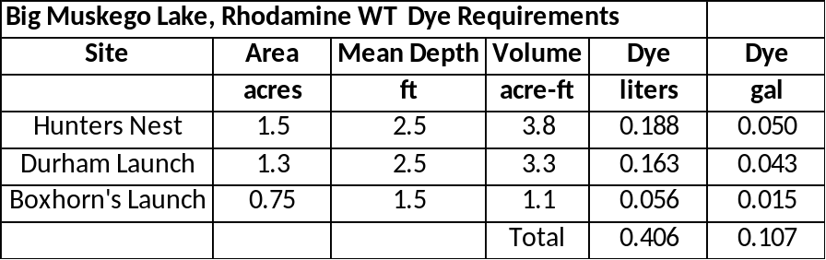

Sample grids will be established for each treatment area to evaluate dye movement and dissipation rates (Figure 1, Figure 2, and Figure 3). Dye will be measured at 1 hour intervals beginning immediately after treatment ends (HAT) in each treatment area.

Water samples will be collected at sites and depths listed below for herbicide analysis (Figure 4, Figure 5, and Figure 6). Each herbicide sample sites correspond to a dye sample site. A map of the herbicide sample site locations is attached and the coordinates are provided. Data are in degrees and the datum is WGS84.

Big Muskego Herbicide Sample Sites
Site | Sample Depth
A2 | Integrated
A3 | Integrated
A5 | Integrated
A6 | Integrated
A7 | Integrated
B2 | Integrated
B3 | Integrated
B4 | Integrated
B5 | Integrated
B6 | Integrated
C16 | Integrated
C17 | Integrated
C22 | Integrated
C23 | Integrated
C29 | Integrated
Samples will need to be collected at different time intervals throughout the project and are listed below. Late sampling intervals may be eliminated when dye concentrations drop to trace or background levels.

Big Muskego Herbicide Sample Intervals,
Interval | Samples/interval | Total Samples
1 HAT | 5 | 5
2 HAT | 5 | 10
3 HAT | 5 | 15
4 HAT | 5 | 20
6 HAT | 5 | 25
8 HAT | 5 | 30
24 HT | 5 | 35
HAT denotes hours after treatment

- Water samples can be collected using an integrated water sampler. I can provide one if necessary. Water is collected by pushing the pipe straight down to within 1 ft of the bottom or as far as it will go in deep water. The pipe is brought to the surface and emptied into a bucket using a screw driver to push open the check valve .

- Samples should be collected at each point using a GPS at each interval listed above (Figure 7). If you cannot collect a sample at the interval listed above please collect the sample as soon as reasonably possible and record the change. Sample bottles and labels will be provided. If you need a GPS please let us know.

- The SLOH will provide a sampling kit which will include bottles, labels, label pens, acid, pipettes, instructions, a shipping cooler, and sample handling instructions.

SLOH Sample Data Sheet: The SLOH will provide an example data sheet for use when collecting water samples. It is important to use a separate data sheet for each day that you monitor.
The WI DNR will need to provide the following information for the sample data sheet which can be reprinted by the sampling volunteer for each sample interval (Figure 8):
- Account number
- DNR user number
- Sample matrix
- Project
- WBIC
- Test Request
- Sample site number
- Station ID
- Sample Depth

The sampling volunteers will need to provide the following on a new data sheet for each sample date:
- Sampling Date
- Sampling Time
- Water Temperature: If water temperature is measured in F, then it should be converted to C using the table included on the data sheet. We suggest printing out the conversion table and bringing it in the field if your thermometer only reads in Fahrenheit.
- Wind Direction and Speed

If you have any questions, please call or email one of us. We can be reached at the following:

John Skogerboe
jskogerboe@comcast.net
Cell Phone (651) 328-0769

Curtis Hedman, PhD
SLOH
curtis.hedman@slh.wisc.edu
Office (608) 224-6271
Scott Van Egeren
WI DNR
scott.vanegeren@dnr.state.wi.us
Office (608) 264-8895
Figure 1. Hunters Nest Dye Sample Locations
(50 m x 50 m grid)
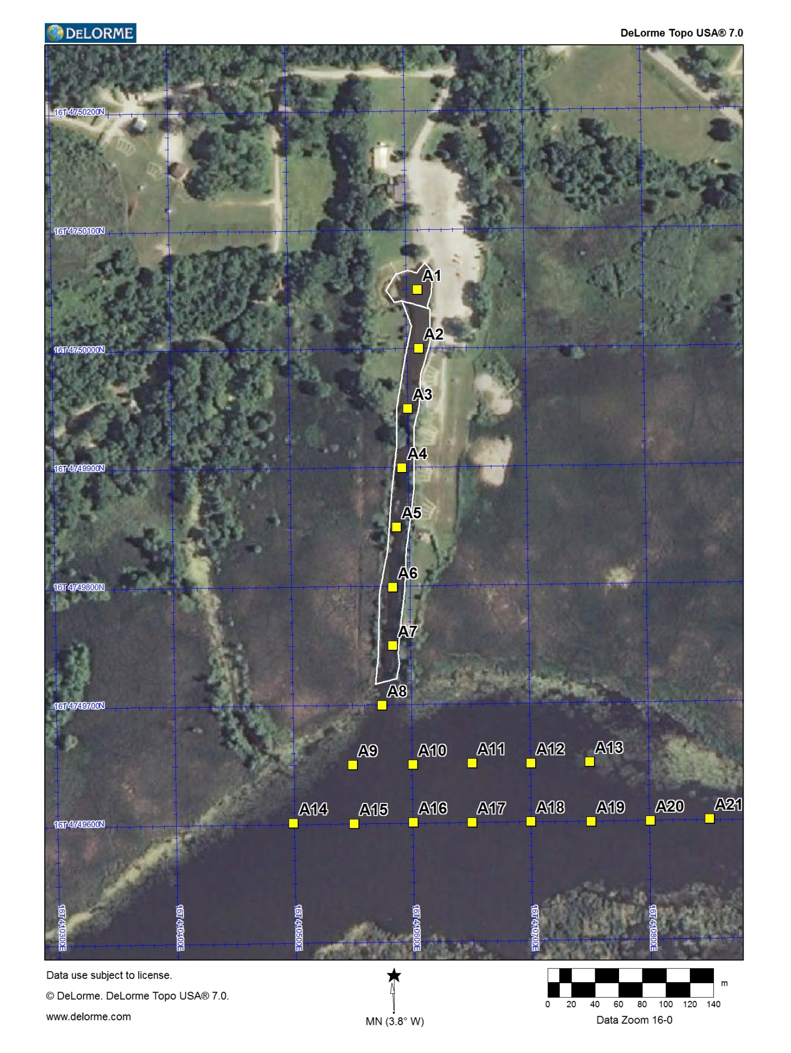

Figure 2. Durham Launch Dye Sample Locations
(50 m x 50 m grid)
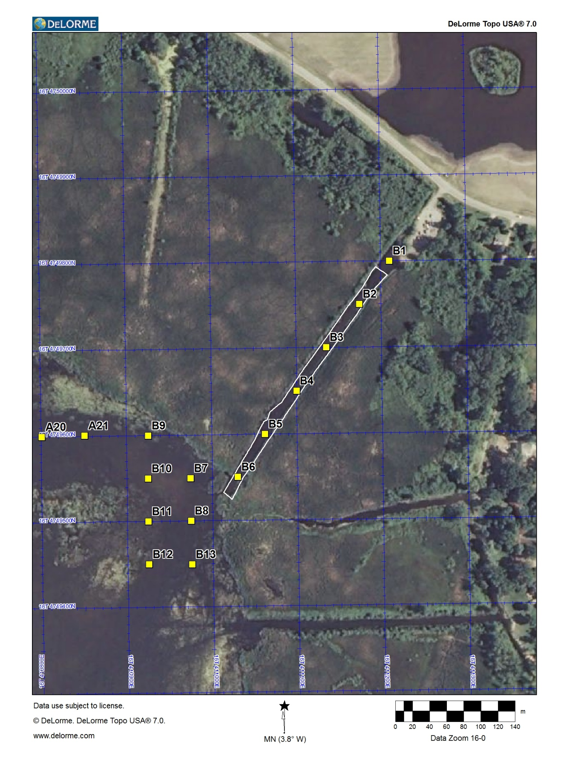

Figure 3. Hunters Nest Dye Sample Locations
(25 m x 25 m grid)
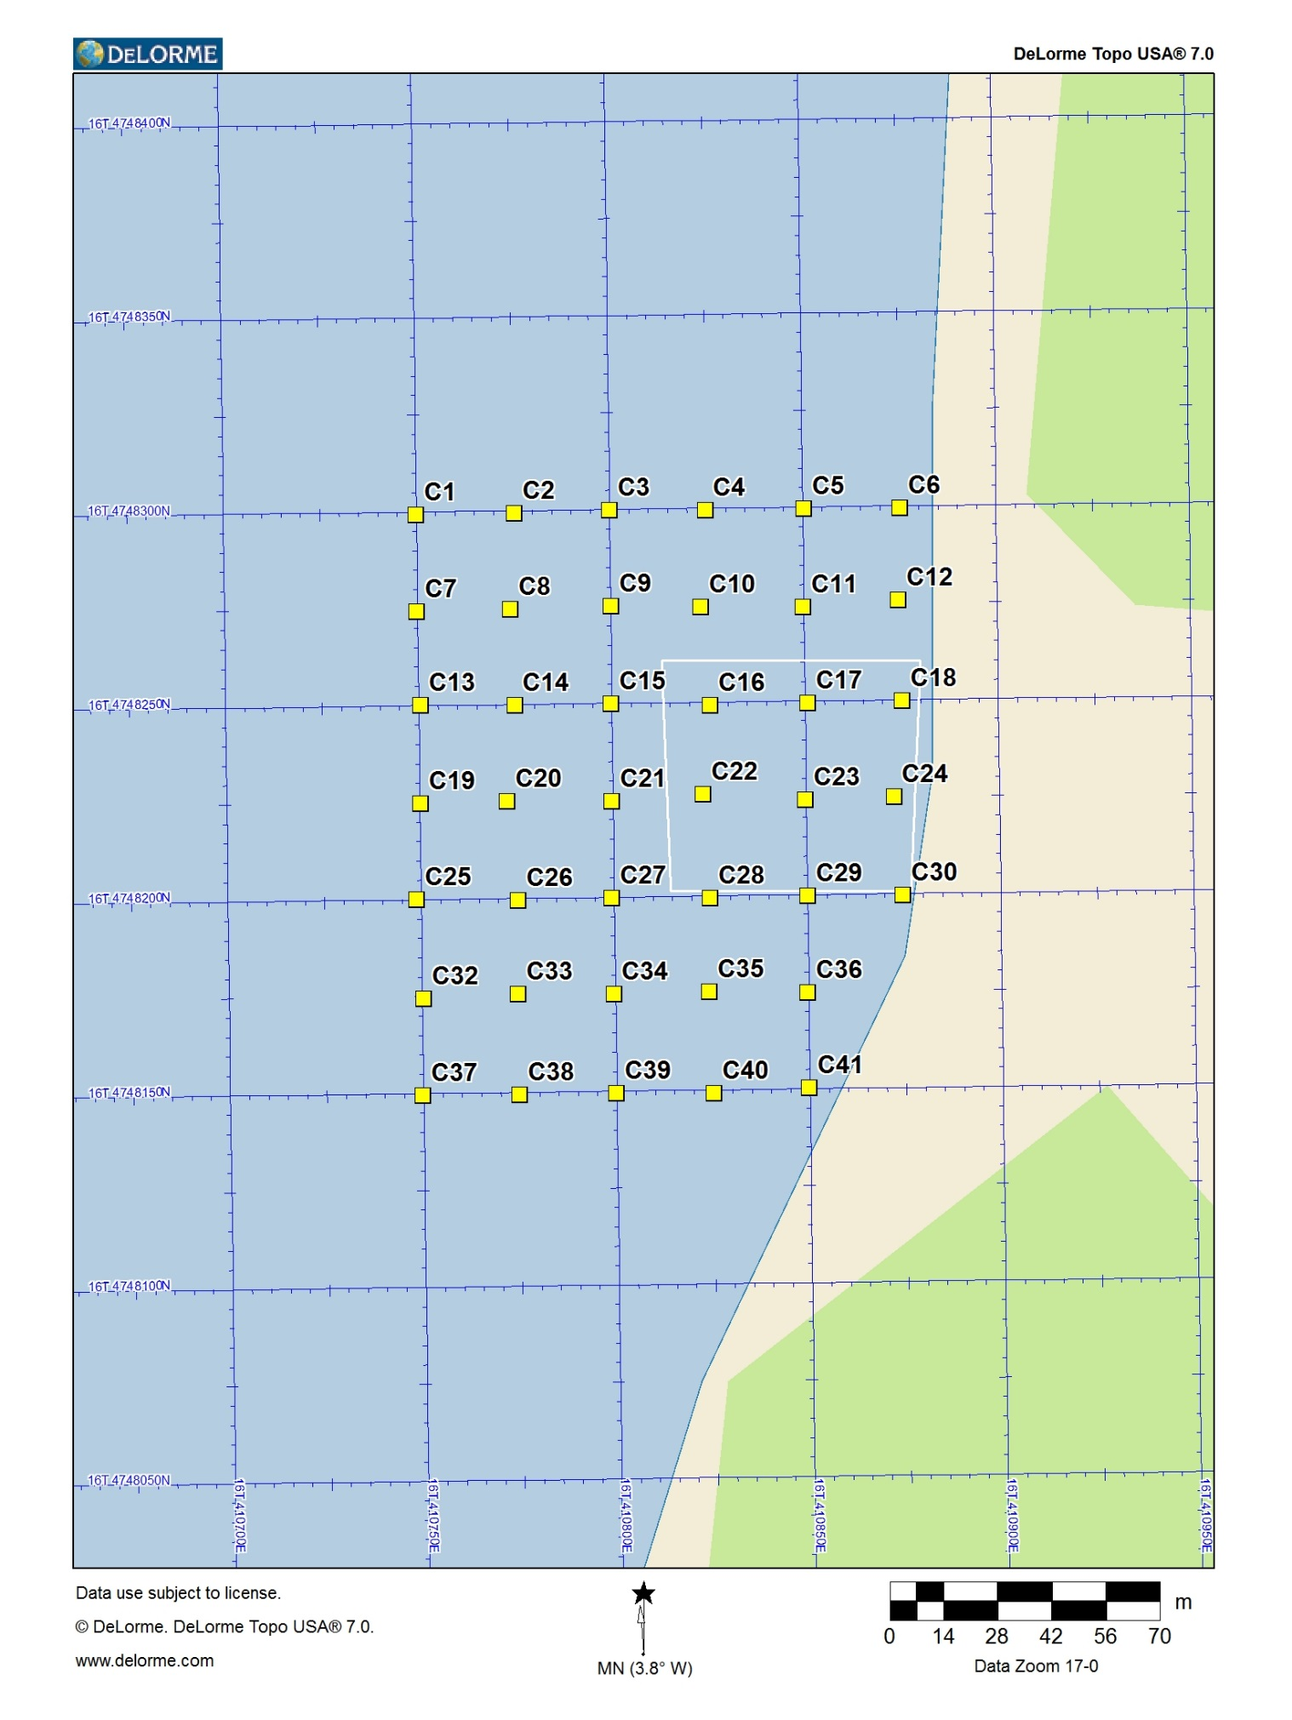

Figure 4. Hunters Nest Herbicide Sample Locations
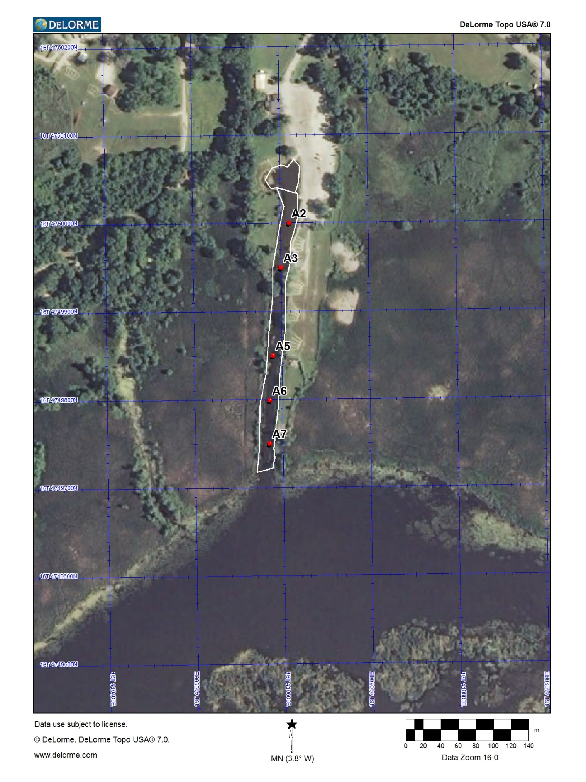

Figure 5. Durham Launch Herbicide Sample Locations
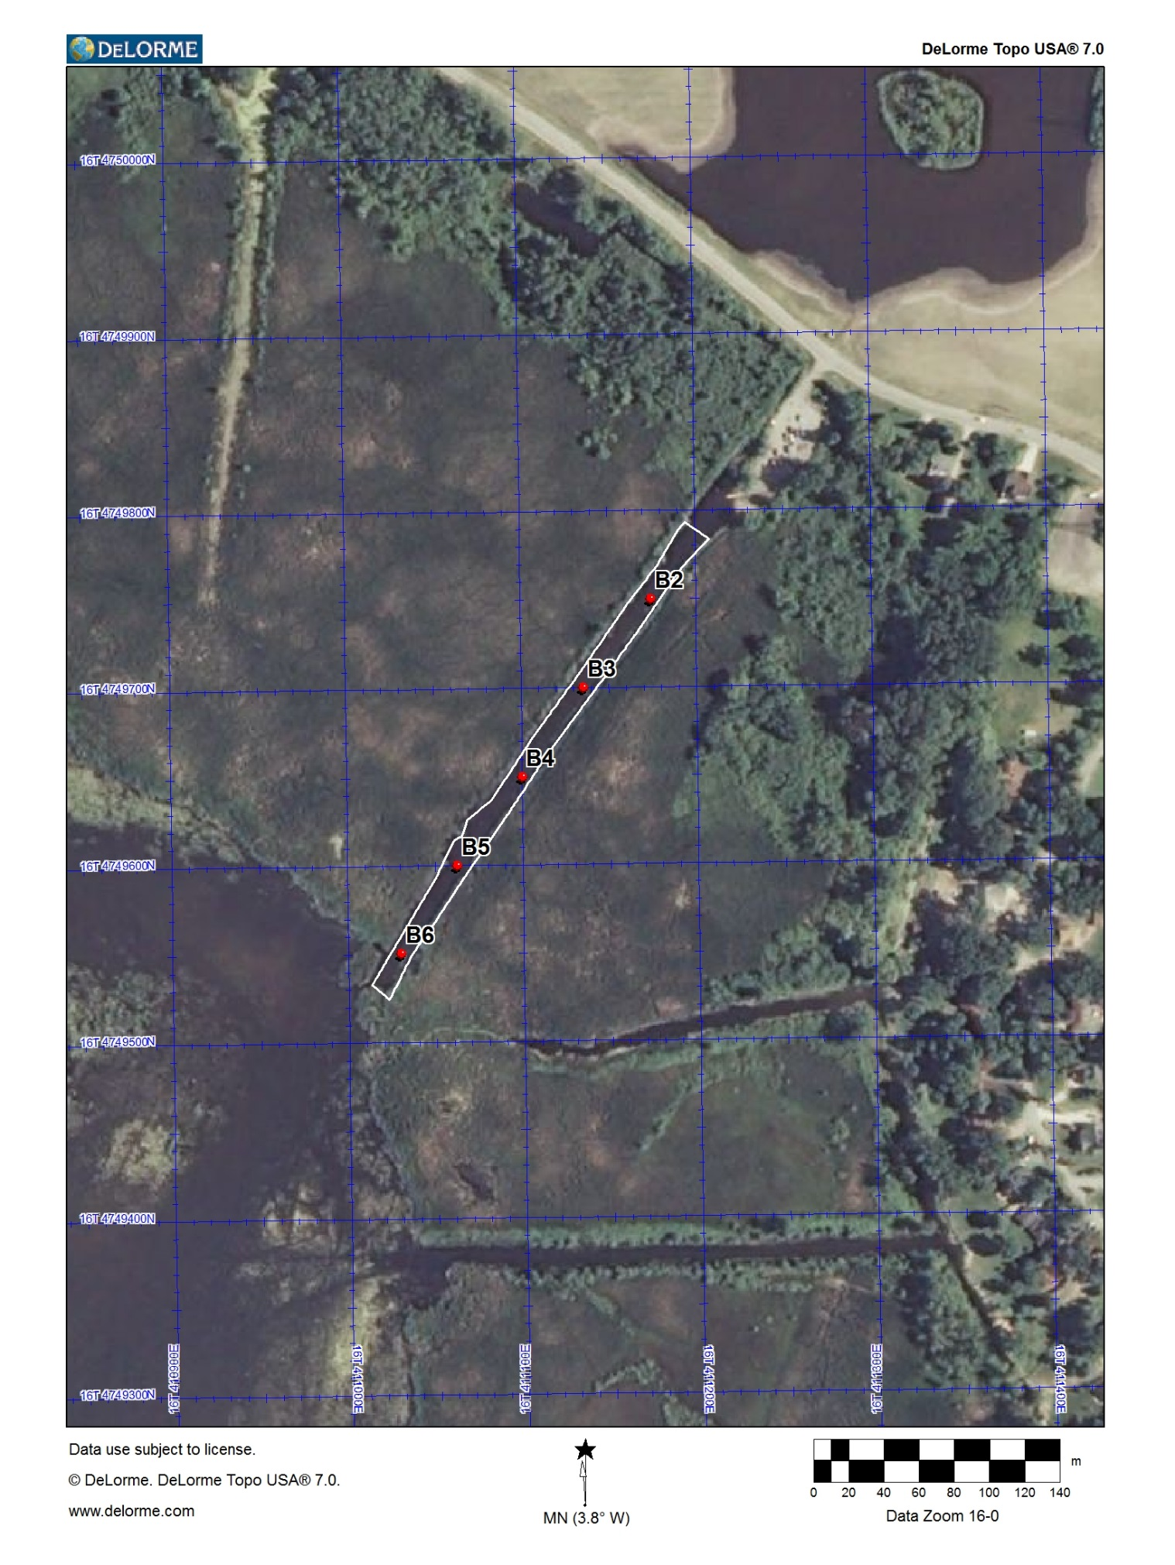

Figure 6. Boxhorn’s Launch Herbicide Sample Locations
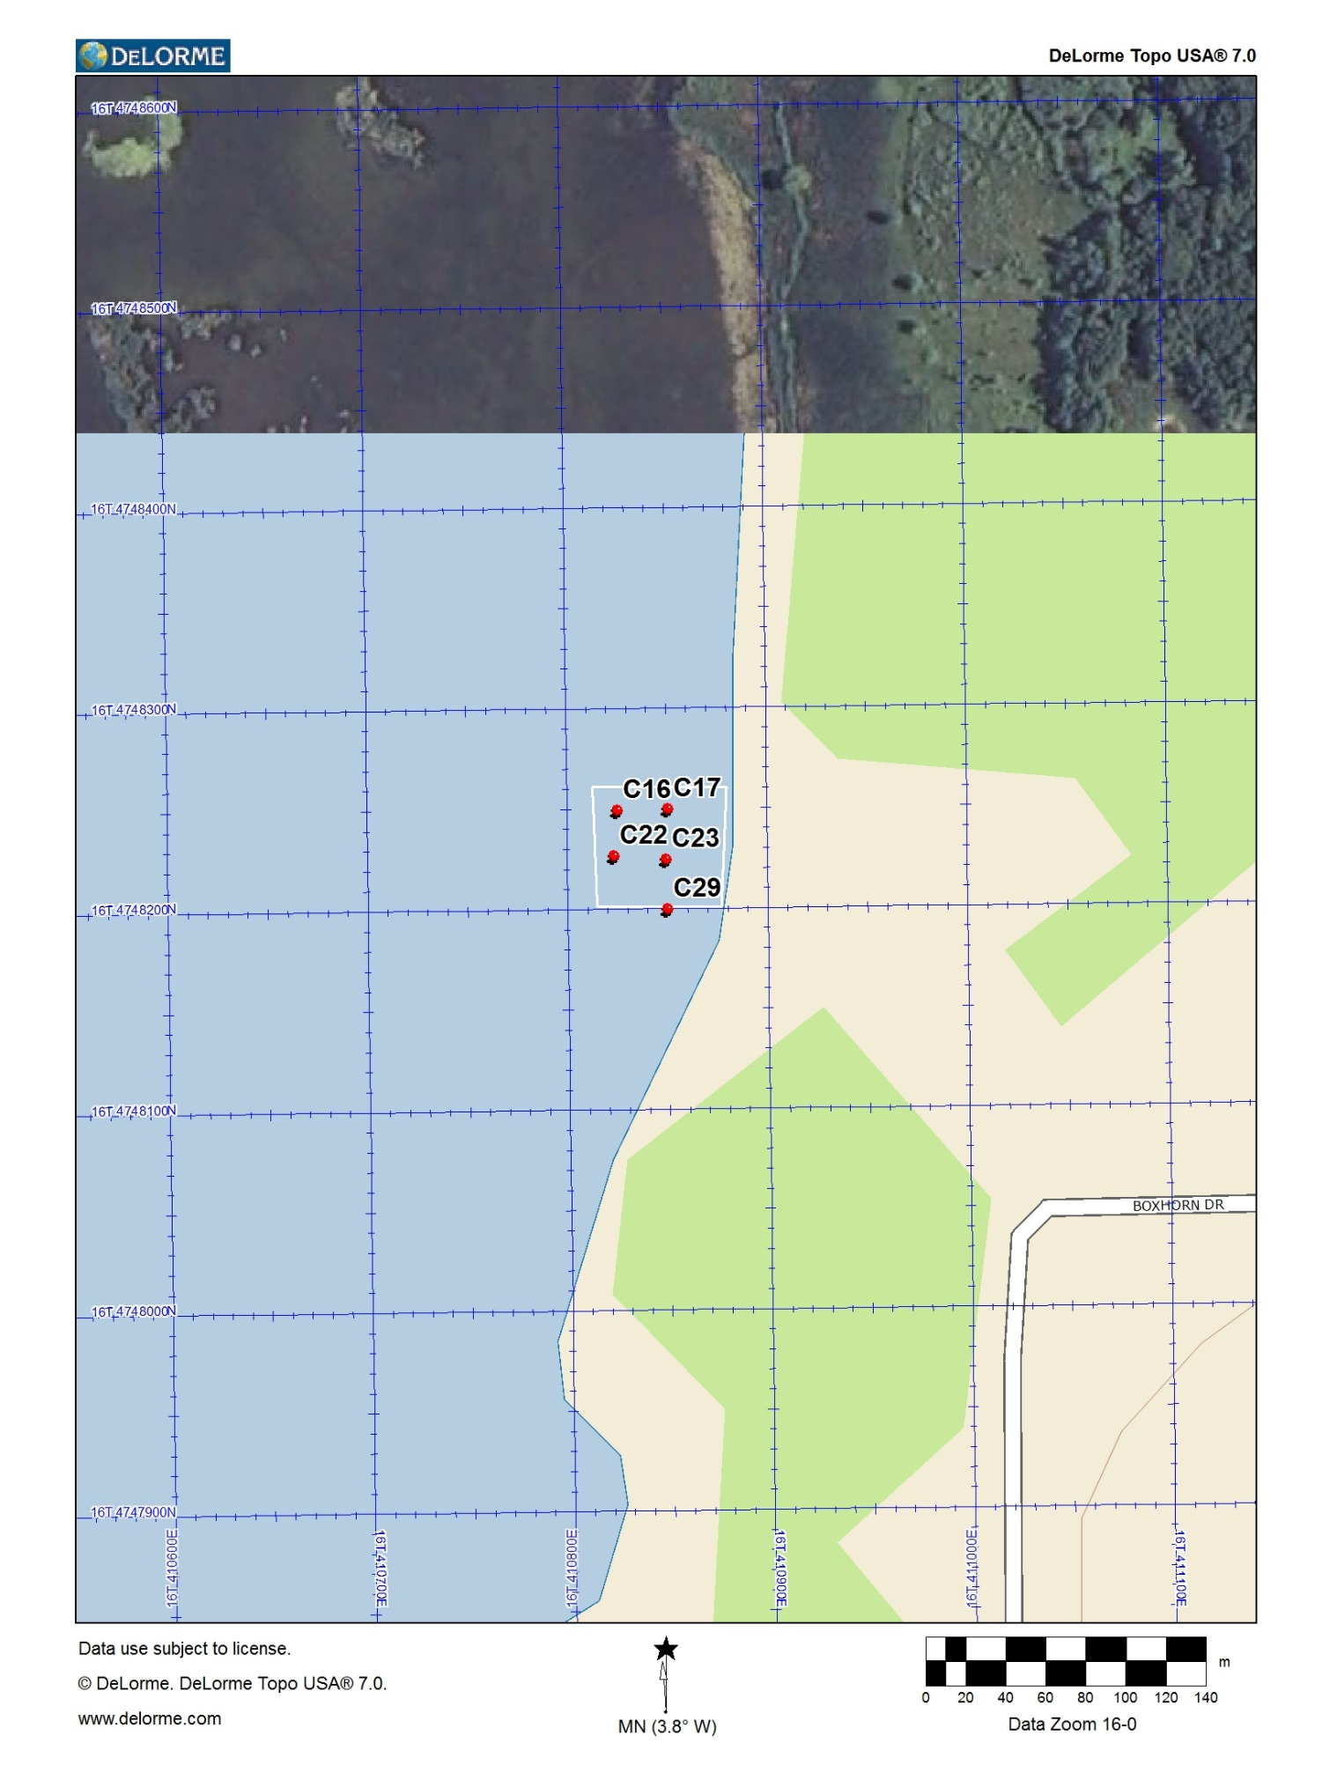

Figure 7. Big Muskego Lake 2016 herbicide sample site coordinates

North West Sample Site
Hunter’s Nest
42.897373 -88.094871 A2
42.896917 -88.094988 A3
42.896019 -88.095098 A5
42.895563 -88.095142 A6
42.895120 -88.095142 A7

Durham Launch
42.895190 -88.087918 B2
42.894737 -88.088390 B3
42.894278 -88.088815 B4
42.893825 -88.089269 B5
42.893377 -88.089657 B6

Boxhorn’s Launch
42.881642 -88.091649 C17
42.881417 -88.091656 C23
42.881637 -88.091956 C16
42.881430 -88.091978 C22
42.881194 -88.091649 C29

Figure 8. Example of a State Lab of Hygiene Sample Data Sheet
