Investigation into the extent of the faucet snail (Bithynia tentaculata) in Elton Creek, and nearby waterbodies in Langlade County, WI

The faucet snail (a prohibited aquatic invasive species) was identified in a sample collected by DNR water quality biologists downstream from state highway (STH) 64, (45.1684, -88.8852), Elton Creek, a Class 1 trout stream, Langlade County in December 2014. Additionally, one individual snail contained live tissue and was necropsied to find metacercariae of the parasite Sphaeridiotrema globulus/pseudoglobulus. These parasites have been responsible for large die-offs of greater scaup a diving duck, on the Mississippi River in Wisconsin. As a result of the discovery, regional reconnaissance was conducted to determine further distribution of the snail and parasite.

Methods
Concentric circles around the discovery site were used to identify 26 sampling sites to determine extent of the range of faucet snails and associated parasites. These sites were located primarily within a 7.6 mile radius from the discovery location, with two additional sites on the Wolf River beyond the eastern radius boundary. Additionally, staff from the Menominee Tribe conducted reconnaissance on water resources within their jurisdiction. Although the literature identifies faucet snails preferring warmer water habitats of lower velocities, both warm and cold waterbodies were identified for investigation. Elton Creek is a coldwater stream.

On July 21, 2015 three teams comprised of department staff from the Waters Program with the assistance of two Environmental Services Department staff from the Menominee Tribe of Wisconsin conducted surveys using a modified approach of the aquatic invasive species stream sampling protocol. River and stream locations were searched both upstream and downstream of identified road crossings and lake environments were searched multi-directional of the identified access points, maps 1-3. Faucet snails prefer bottom substrate comprised of boulders, rubble/cobble, macrophytes, and large woody debris. These habitats were searched in shallow and deep water areas, low and high velocity reaches, and warmer water near-shore lake and spring pond environments. Search methods included both visual observation and physical manipulation of rock, large woody debris along with removing plant material for observation.

Adult faucet snails may grow to approximately 5 mm in length and are readily observed in their habitat when present, photo 1.
(Photo 1)
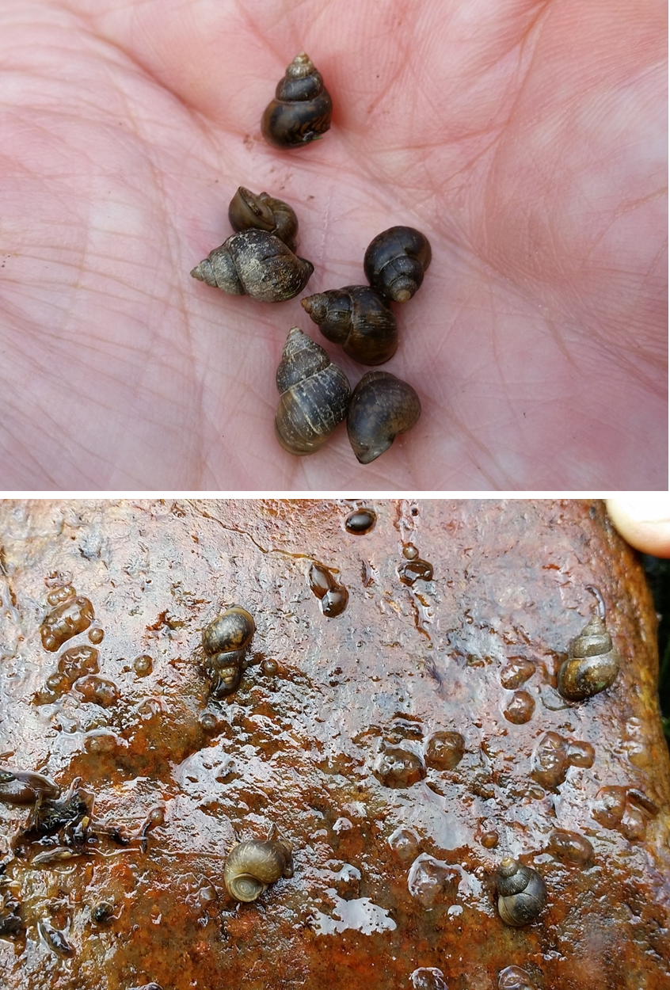
Materials to help with field identification were distributed to all teams. If staff was not able to positively identify snails observed in the field as native species they were collected and preserved in 100% ethyl alcohol and sent to Professor Greg Sandland, UW-La Crosse for identification. Additionally, if faucet snails were found, at least ten individuals were collected and sent to Professor Sandland for positive identification and necropsy.

Standard operating procedures for disinfection between all sites were adhered to by all staff involved.

Conclusion
We were able to positively field identify faucet snails at two locations in Elton Creek, sites 16-17, maps 1&2, table 1. The entire 240 meter reach between these two points harbored a large population of faucet snails. When a handful of curly-leaf pondweed was uprooted from the downstream end of the western STH-64 culvert and shook, an estimated 40-60 adult faucet snails fell out. Many additional young snails believed to be faucet snails approximately 1-1.5 mm in size were also observed. It is estimated that in this reach there may be up to 1,000 individual snails per square meter in the highest density locations. A combined sample of 44 individuals from these locations was sent to UW-La Crosse for further analysis and necropsy. “I necropsied 12 of these invasives - all were infected with at least one of the parasites associated with waterfowl disease, and many had two (both Sphaeridiotrema sp. and C. bushiensis), table 2. Interestingly the prevalence of the species appears to be opposite to what we see in the Mississippi River, with Sphaeridiotrema sp. showing the highest prevalence and intensities in these samples. Also, I think one of the snails actually had a primary infection with Sphaeridiotrema sp. which likely helps to explain the relatively high numbers of second stage parasites (metacercariae) that were found in these snails” (correspondence between Jim Klosiewski and Professor Sandland, 11/3/2015).

Faucet snails were not observed at any other locations during the field reconnaissance. Small field unidentifiable snails were collected at sites 8, 12 &13, map 1, table 1, preserved in alcohol and sent to UW-La Crosse for identification. These snails were positively identified by professor Sandland to be species native to Wisconsin, table 2. Additionally no faucet snails were found during the Menominee Tribe’s field investigation of tribal water resources (personal communication with Douglas Cox Environmental Program Coordinator,
Menominee Indian Tribe of Wisconsin).

Faucet snails appear to be limited to a relatively short stretch of Elton Creek between sites 15 and 18 at this time. This may be due to their inability to reproduce in colder water which may exist upstream and downstream of sites 15 and 16, or that their population is a fairly recent introduction. Further investigation of this stretch of stream may be warranted to identify the exact downstream extent before the site 18 location at Clubhouse Road where no faucet snails were found. Continuous water temperature monitoring through the deployment of thermistors is also advisable in order to identify any temperature variations between populated and non-populated stretches of Elton Creek.

Jim Klosiewski – Water Resources Management Specialist, Rhinelander (3/21/2016)

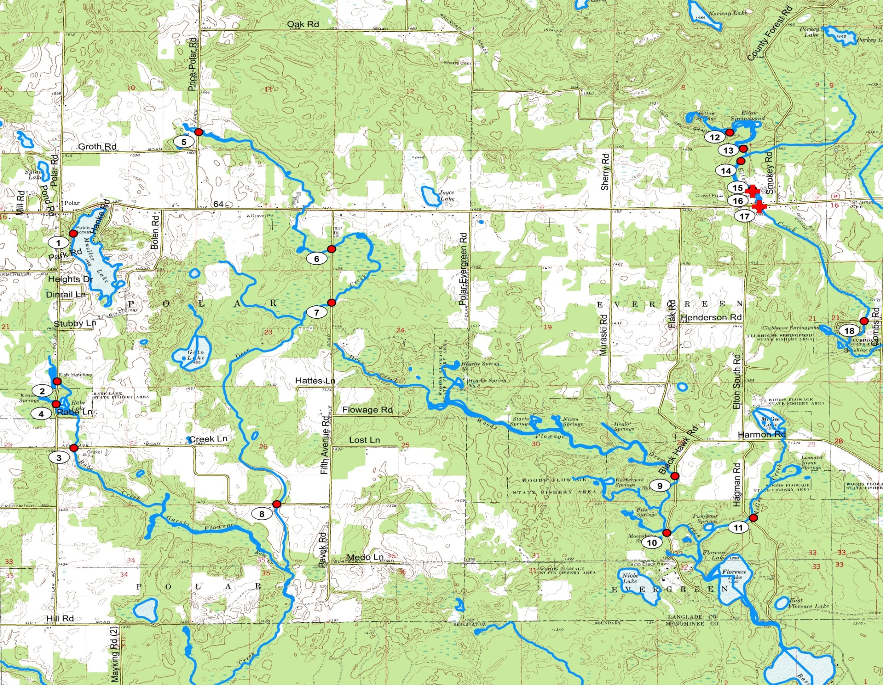
(Map 1)

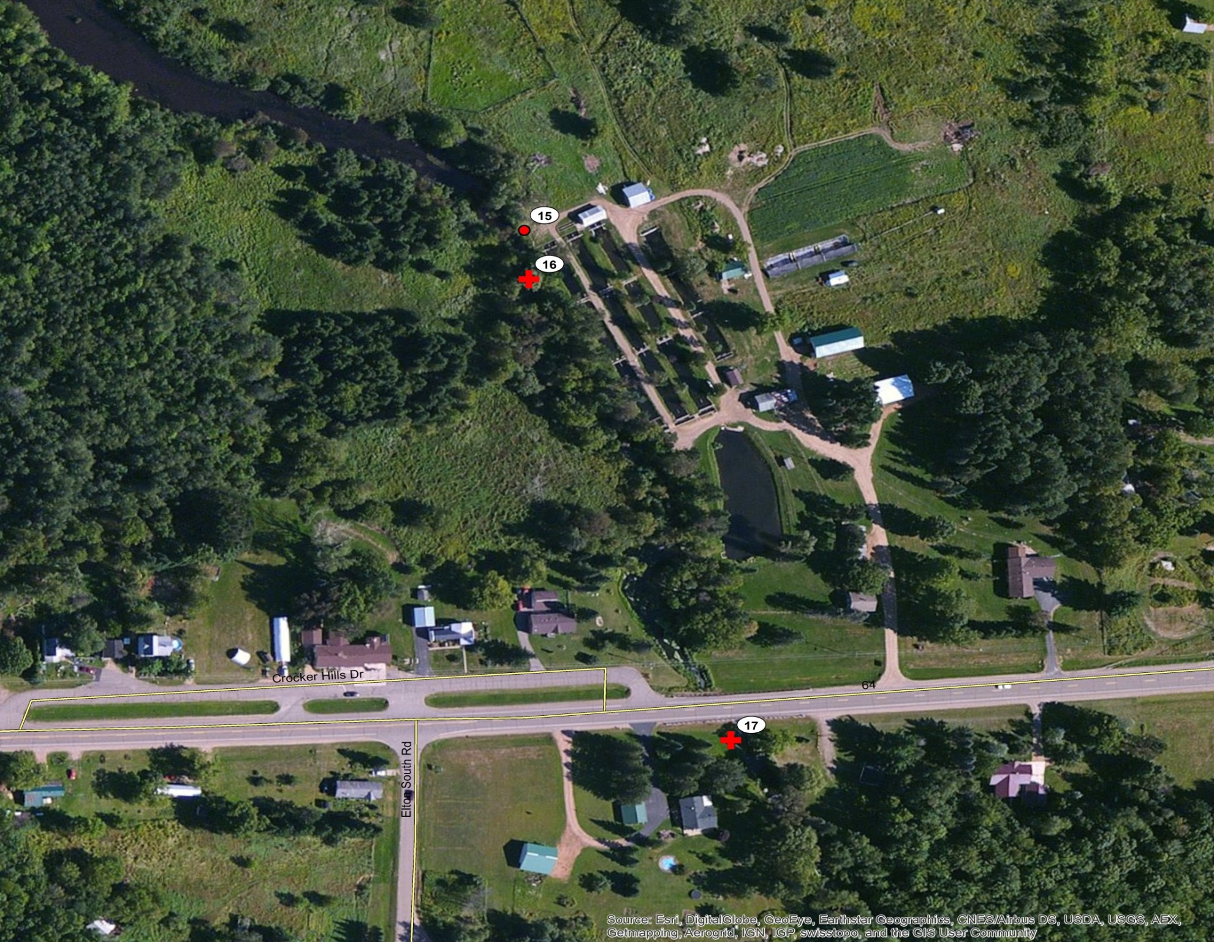
(Map 2)
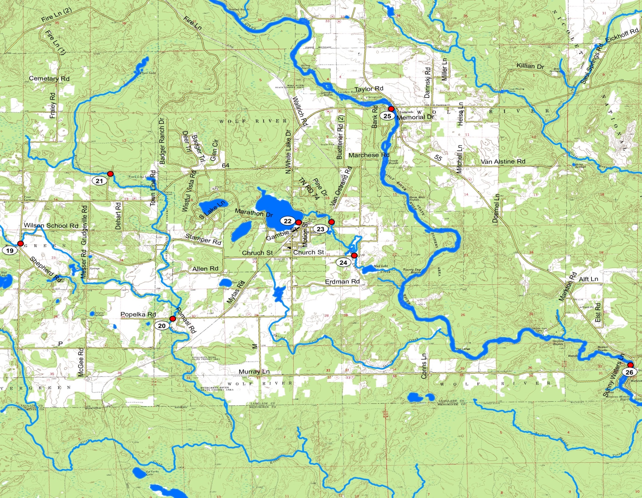
(Map 3)

(Table 1)
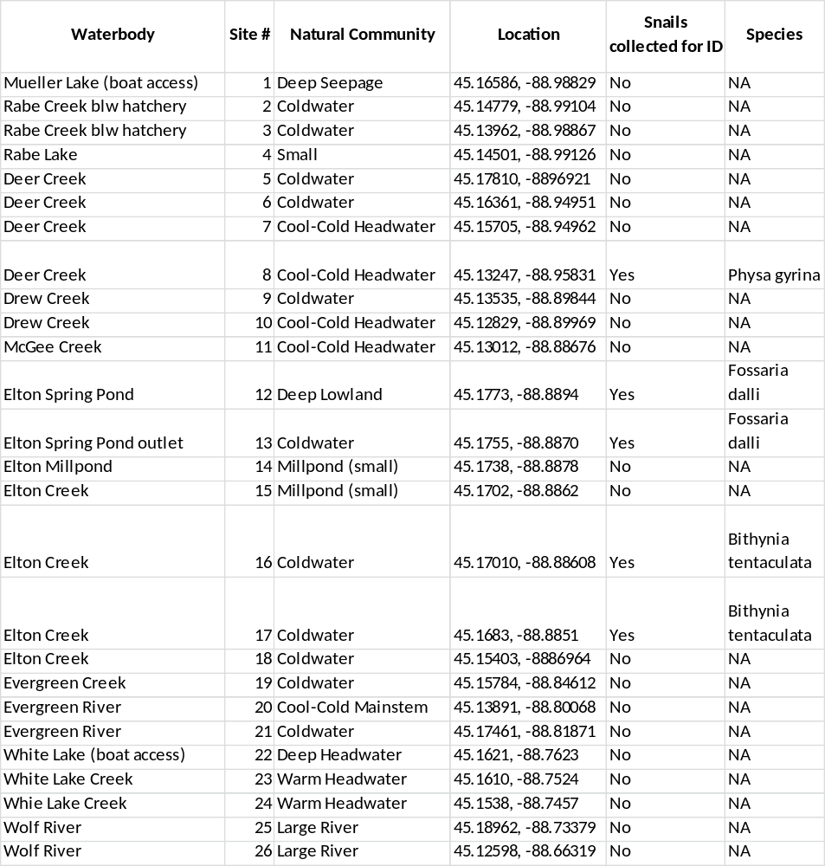

(Table 2)
LOCATION | SPECIES | Sample # | SNAILID | SIZE | SEX | INFECTION | SPECIES | STAGE 1 | NUMBER | SPECIES 2 | STAGE | NUMBER
Elton Spring Pond | Fossaria dalli | 8 | na | na | na | na | na | na | na | na | na | na
Elton Creek Spring Pond Outlet | Fossaria dalli | 6 | na | na | na | na | na | na | na | na | na | na
Deer Creek | Physa gyrina | 4 | na | na | na | na | na | na | na | na | na | na
Elton Creek S Hwy 64 | Bithynia tentaculata | 44 | BtEc1 | 11.4 | m | y | Sphaeridiotrema sp | metacercaria | 2
Elton Creek S Hwy 64 | Bithynia tentaculata |  | BtEc2 | 9.14 | f | y | Sphaeridiotrema sp | metacercaria | 4
Elton Creek S Hwy 64 | Bithynia tentaculata |  | BtEc3 | 12.12 | m | y | Sphaeridiotrema sp | metacercaria | 1 | Cyathocotyle bushiensis | metacercariae | 2
Elton Creek S Hwy 64 | Bithynia tentaculata |  | BtEc4 | 11.24 | f | y | Sphaeridiotrema sp | metacercaria | 5 | Cyathocotyle bushiensis | metacercariae | 3
Elton Creek S Hwy 64 | Bithynia tentaculata |  | BtEc5 | 9.73 | f | y | Sphaeridiotrema sp | metacercaria | 2
Elton Creek S Hwy 64 | Bithynia tentaculata |  | BtEc6 | 9.36 | m | y | Sphaeridiotrema sp | metacercaria | 5 | Sphaeridiotrema sp | rediae/cercariae | na
Elton Creek S Hwy 64 | Bithynia tentaculata |  | BtEc7 | 10.82 | m | y | Sphaeridiotrema sp | metacercaria | 9 | Cyathocotyle bushiensis | metacercariae | 1
Elton Creek S Hwy 64 | Bithynia tentaculata |  | BtEc8 | 9.15 | m | y | Sphaeridiotrema sp | metacercaria | 6
Elton Creek S Hwy 64 | Bithynia tentaculata |  | BtEc9 | 9.21 | f | y | Sphaeridiotrema sp | metacercaria | 6 | Cyathocotyle bushiensis | metacercariae | 2
Elton Creek S Hwy 64 | Bithynia tentaculata |  | BtEc10 | 10.11 | m | y | Sphaeridiotrema sp | metacercaria | 5
Elton Creek S Hwy 64 | Bithynia tentaculata |  | BtEc11 | 8.8 | f | y | Sphaeridiotrema sp | metacercaria | 3 | Cyathocotyle bushiensis | metacercariae | 1
Elton Creek S Hwy 64 | Bithynia tentaculata |  | BtEc12 | 9.75 | f | y | Sphaeridiotrema sp | metacercaria | 1 | Cyathocotyle bushiensis | metacercariae | 2

