An Examination of Fisheries Data for Badger Mill Creek

To Determine the Potential for Alternative Effluent Limits for Effluent Discharge

from the

Madison Metropolitan Sewerage District

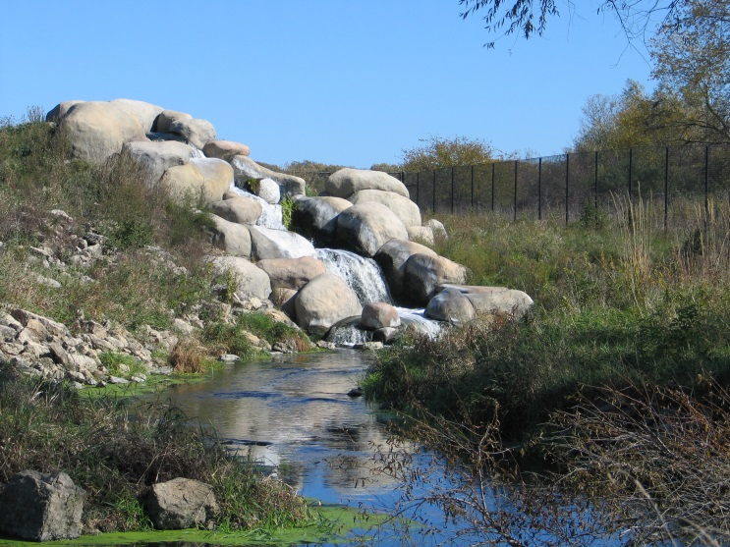

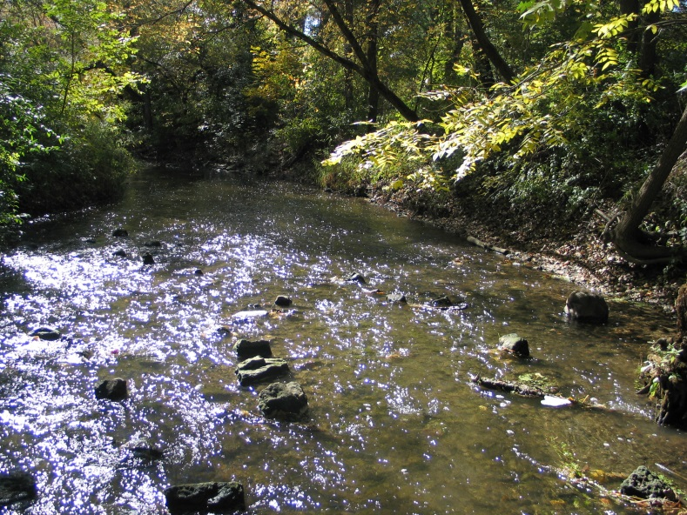

By
James Amrhein
Water Quality Biologist

Jake Zimmerman
Water Resources Engineer

Water District South
February, 2017
Background
Badger Mill Creek is an approximately 8 mile long stream with a 32.5 mi² drainage area that includes much of the southwest side of Madison as well as most of Verona. The upper 3 miles of stream are generally intermittent with flows only during times of significant runoff. Historically, the lower 5 miles contains more perennial flow due to the presence of wetlands and springs. Since 1998, flow has been augmented by effluent discharge from the Madison Metropolitan Sewerage District (MMSD) (WDNR, 2003).

In 1975, the Department of Natural Resources (DNR) classified a portion of Badger Mill Creek from the old Verona wastewater treatment plant at Bruce Street down to State Highway 69 as “intermediate fish and aquatic life” [equivalent of limited forage fishery (LFF)] and the remainder of the stream as fish and aquatic life (FAL) (See Figure 1). In 1978, the Verona sewerage treatment plant was upgraded and began discharging directly to the Sugar River. By 1985 both public and private wastewater discharges to Badger Mill Creek were removed. Subsequent monitoring revealed an improvement in stream conditions on Badger Mill Creek. In 1989, South Central District proposed to reclassify the LFF portion of the stream to FAL (Marshall, 1989). This reclassification was never promulgated pending an update of NR104. In 1988, the Department of Natural Resources began stocking brown trout in the creek. In 1994 and 1996, South Central Region fisheries staff documented the presence of brown trout and other coldwater indicator species in portions of Badger Mill Creek and recommended reclassifying a portion of the stream as Class II trout water [May 3, 1996 letter from Scot Stewart (WDNR) to Dave Taylor (MMSD)].

In August, 1998, MMSD began returning treated wastewater to Badger Mill Creek in response to concerns that by sending Verona’s wastewater to MMSD for treatment, the discharge of that effluent to a stream in the Lower Rock Basin upset the water balance in the Sugar-Pecatonica Basin. Treated wastewater equal to the amount of water generated/pumped out of the basin, or about 3 million gallons per day (mgd), is returned to the Sugar-Pecatonica Basin via Badger Mill Creek. In 2005, the department conducted a comprehensive survey of multiple sites along the creek to determine its status and provide management recommendations. The department concluded that Badger Mill Creek should be considered a “Coldwater B – Class IIx” system from the Lincoln Street footbridge downstream to its confluence with the Sugar River. It also recommended the section upstream of the Lincoln Street footbridge to the effluent discharge point be considered “Diverse Fish and Aquatic Life – Coolwater” (WDNR, 2005). In 2008, fisheries management designated Badger Mill from its mouth at the Sugar River upstream to the uppermost STH 18/151 crossing as a “Class II” trout water. As noted earlier, the water resources designation has not changed.

Throughout this period, fisheries surveys have been conducted for various reasons. This compendium of data has been reviewed in the context of an alternative effluent limit (AEL) in order to 1) demonstrate lack of prior appreciable harm (NR106.72(3)(a)) using historical data as a reference condition and 2) demonstrate protection and propagation of a balanced indigenous community (NR106.72 (3)(b)). More specifically, a weight of evidence of approach using species presence, natural community verification, and IBIs is being applied to historical and contemporary data to determine if the above conditions exist.

Species presence/absence
Table 1 shows the assemblage of fish species present during surveys conducted on Badger Mill Creek over the past 6 decades. Because the sites and number of sites surveyed varied from year to year, exact comparison is not possible. However, it is possible to get a general idea of the fish community prior to and after modifications of discharges to the creek. It should be noted not all the data is presented in this table as MMSD has been collecting fisheries data on the creek annually since 1994. However, it is felt the data presented is representative of all of the years for which data have been collected and is truncated for the sake of brevity.

The 1964 data is the earliest available and a likely indicator of the status of the fishery in the presence of effluent from the City of Verona and 2 other discharges, but prior to the greater influences of urban stormwater runoff to the system. In that period, agricultural nonpoint source pollution likely played a greater role that it does today. The surveys showed the presence of a half dozen non-game species, including the presence of mottled sculpin – a stenothermal coldwater species. A subsequent survey of the creek conducted in 1974 by Fago (1982) showed the presence of several other additional non-game species, most of which are considered warmwater species (Lyons, et. al., 2009).

The 1988 survey is of interest for a couple of reasons: 1) The Verona sewerage treatment plant no longer discharged to Badger Mill Creek, and 2) the department began stocking brown trout, an exotic coldwater game species, into the stream. The 1988 data showed the presence of those trout, as well as a more abbreviated species list, but still including the presence of the indigenous mottled sculpin.

Subsequent data collected throughout the 1990’s, but prior to the MMSD discharge, showed the presence of 12-18 different fish species and including mottled sculpin and brown trout. Immediately after the discharge, surveys conducted by MMSD in 1999 and 2000 showed no appreciable change in the fishery assemblage. Surveys continued up through 2016 by both the department and MMSD. These surveys showed the fishery made up of a similar assemblage – most routinely made up of 11 species including: bluntnose minnow, brook stickleback, central mudminnow, creek chub, fantail darter, fathead minnow, green sunfish, johnny darter, white sucker, mottled sculpin, and brown trout - with a variety of other species occasionally being present.

Natural Community Verification
Badger Mill Creek is modeled to be a cool-cold mainstem system (Lyons, 2008) from STH 18/151 east of Verona, downstream to its confluence with the Sugar River (See Figure 2). As such, there are certain species and relative numbers which could be expected to make up that community based on thermal, stream size, and tolerance guilds (Table 2).

Where quantitative data exists, the natural community verification process (Lyons, 2015) was conducted (Table 3). For the most part, the fisheries assemblages collected at the various sites throughout the years showed the community to most closely represent a cool-cold mainstem with the following caveat: the section of BMC upstream of Lincoln Street footbridge can vary between cool-cold and cool-warm mainstem depending on how many trout were present during the surveys at any given time. At most stations, the fish assemblage of Badger Mill Creek contains a majority of tolerant species, but for the purposes of natural community verification, their numbers do not violate the acceptable ranges for a human-caused disturbed system. It is important to note that even in the absence of (introduced) brown trout, the cold-cool community would be represented, particularly downstream of the Lincoln Street footbridge.

Based on very limited data and anecdotal reports, the natural community of Badger Mill Creek upstream of the Lincoln Street footbridge historically appeared to be a cool-warm headwater with limited flow (Tom Bainbridge, July 9, 1975 memo). The 1974 data showed there are/were many tolerant species present which violates the acceptable range of human caused disturbance. However, one would expect a high number of tolerant pioneer fish species in a headwater area of limited flow, as well as a stream impacted by urban and rural nonpoint source pollution.

Fishery Health
The coolwater IBI (Lyons, 2012) was applied to the datasets to determine overall health of the fishery. The cool-cold IBI ranged from 50 (good) to 90 (excellent) for all the sites downstream of the Lincoln Street footbridge over all the years evaluated (Table 3).

As previously mentioned, the section upstream of the Lincoln Street footbridge can vary by community depending on how many brown trout are present. Trout numbers, as well as the presence of intolerant, coolwater species drops dramatically. The health of the fishery is lower than downstream sections; however, this likely due to the fact there are dramatic changes to the habitat upstream of Lincoln Street. The channel is straight, wide, shallow, with a silt and sand bottom and offers little habitat. This section of stream above the Lincoln Street footbridge still contains a mix of species and, because of the presence of the brown trout at Old PB, this station can meet the definition as a cool-cold system as at least 5% of the fish collected represented a coldwater indicator species during certain surveys.

Given that this section of stream no longer represents pre-effluent conditions, which were reported to be limited in terms of flow which then inherently inhibited the robustness of the fishery; it is difficult to compare pre/post effluent fishery assemblages. In terms of this evaluation, it is felt it is more appropriate to consider the health of the fishery in terms of contemporary conditions. So while the quality of the stream as defined by the IBI may not be as good as downstream sections, this is most likely the result of habitat and stream morphology differences and not related to the discharge of effluent. In fact, discharge of 3 mgd of effluent likely enhanced the fishery to some extent by providing more habitat in the form of volume of flow.

Calculation of Thermal Tolerances
MMSD currently receives effluent limits based upon a limited forage fishery community in Badger Mill Creek. For development of an AEL, brown trout (introduced) and mottled sculpin (native) were selected as Representative Important Species as they are the most intolerant species found in Badger Mill Creek. The calculation of thermal tolerances can be found in the appendix.

Conclusions
From this data, the department concludes the following:

- The effluent discharge from MMSD to Badger Mill Creek has caused no appreciable harm to the resource based on the fact that 1) it has not appreciably altered the fish community from its historic state in the absence of effluent; 2) a balanced indigenous community remains which includes the presence of native or introduced important species, mottled sculpin and brown trout, respectively, and 3) the resource is in a healthy state based on the appropriately applied IBI.

- It can be argued that the introduction of 3 million gallons per day of MMSD effluent has enhanced the resource by maintaining a more steady state of flow which has resulted in increased numbers of brown trout (and an enhanced angling opportunity) as well as expansion of the full fish and aquatic life designation upstream of Lincoln Street footbridge to the effluent discharge point.

- The temperatures of the current MMSD discharge to Badger Mill Creek appear to meet sub-lethal water quality based criteria for fish life histories of two representative important species, brown trout and mottled sculpin, both of which are considered the most intolerant species in the stream to thermal impacts.

- Despite some exceedance of the thermal criteria for the spawning period of brown trout in September through October and for gametogenesis in mottled sculpin in October at Lincoln Street footbridge, reproduction of both species is much more likely to be limited by lack of suitable spawning habitat in the upper portions of the stream rather than thermal impacts. Brown trout optimally spawn on gravel substrate and in the absence of silt. Likewise, mottled sculpin spawn on rocky substrate or large gravel. This is habitat is lacking in the stream section upstream of Lincoln Street footbridge.

References:

Fago Don. 1982. Distribution and Relative Abundance of Fishes in Wisconsin 1. Greater Rock River Basin. Wisconsin Department of Natural Resources. Technical Bulletin No. 136.

Lyons, John. 2008. Using the Wisconsin Stream Model to Estimate the Potential Natural Community of Wisconsin Streams (DRAFT). Wisconsin Department of Natural Resources Fish and Aquatic Life Research Section. November, 2008.

Lyons, John. T. Zorn, J. Stewart, P Seelbach, K Wehrly, and L. Wang. 2009. Defining and Characterizing Coolwater Streams and Their Fish Assemblages in Michigan and Wisconsin, USA. North American Journal of Fisheries Management. 29:1130-1151.

Lyons, John. 2012. Development and Validation of Two Fish-based Indices of Biotic Integrity for Assessing Perennial Coolwater Streams In Wisconsin, USA. Ecological Indicators 23 (2012) 402-412.

Lyons, John. 2015. Methodology for Using Field Data to Identify and Correct Wisconsin Stream “Natural Community” Misclassifications. Version 5. May 29, 2015.

Marshall, Dave. 1989. Memo: Reclassification of Badger Mill Creek. Dane County, WI. Sugar River Drainage Basin. Wisconsin Dept. of Natural Resources. December, 1989.

WDNR. 2003. The State of the Sugar and Pecatonica River Basins. Wisconsin Department of Natural Resources.

WDNR. 2005. Stream Reclassification – Badger Mill Creek. Upper Sugar Watershed (SP15) WBIC # 888100. Submitted by James Amrhein. WDNR, South Central Region Headquarters. October, 2005.

Tables and Figures:

Table 1: Historic and Contemporary Fish Species Assemblages
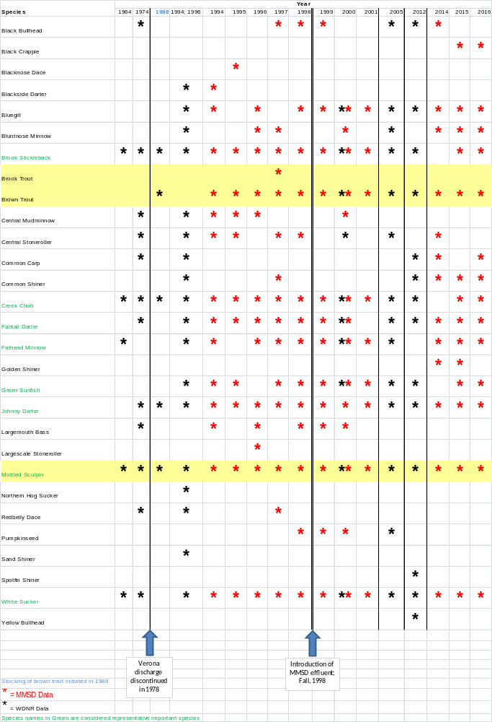
Table 2: Expected Species and Population Ranges for a Cool-Cold Mainstem System
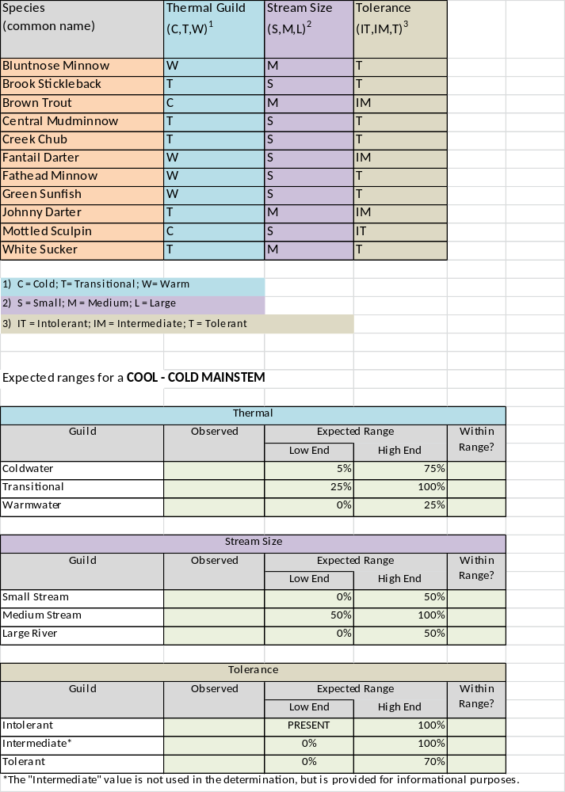

Table 3: Natural Community Verification and Coolwater IBIs
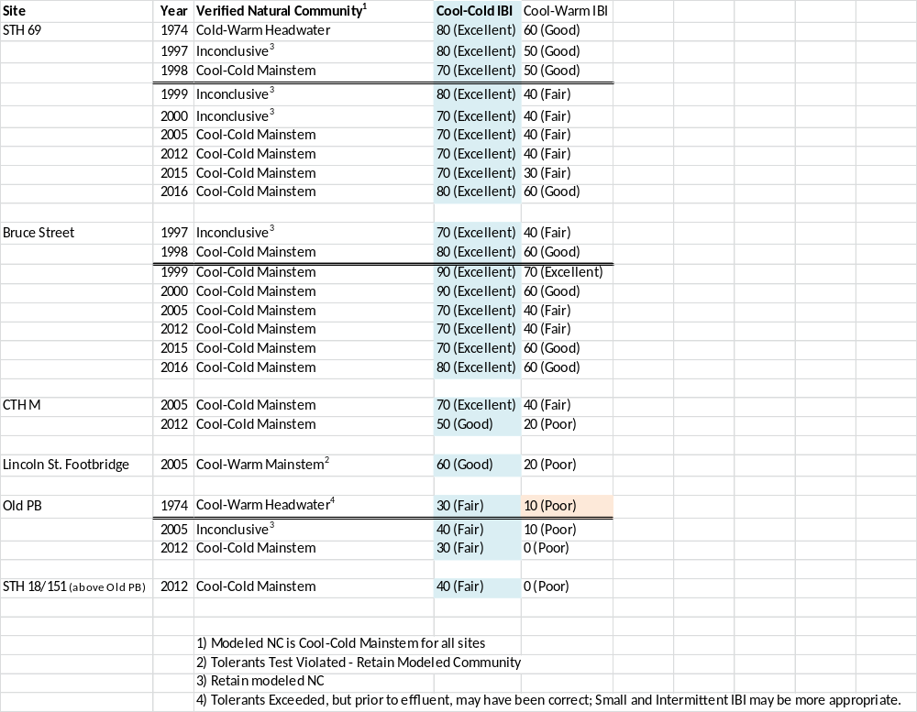
Figure 1: Water Resources Use Designations for Badger Mill Creek
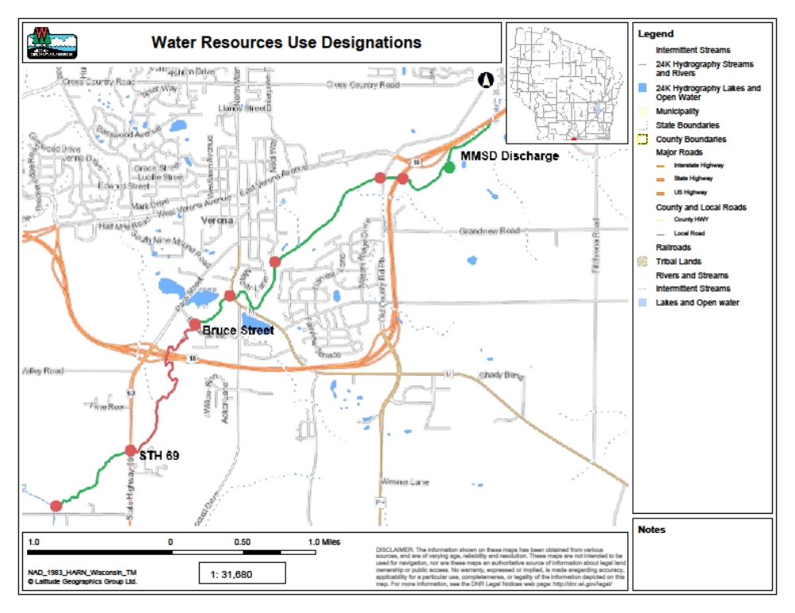
Red = Variance Water (LFF)
Green = Default (FAL)
Note: The current fisheries management designation (for fisheries management purposes) for Badger Mill Creek from the confluence with the Sugar River upstream to the uppermost crossing of STH 18/151 is Class II trout water.
Figure 2: Badger Mill Modeled Natural Community and Sampling Locations
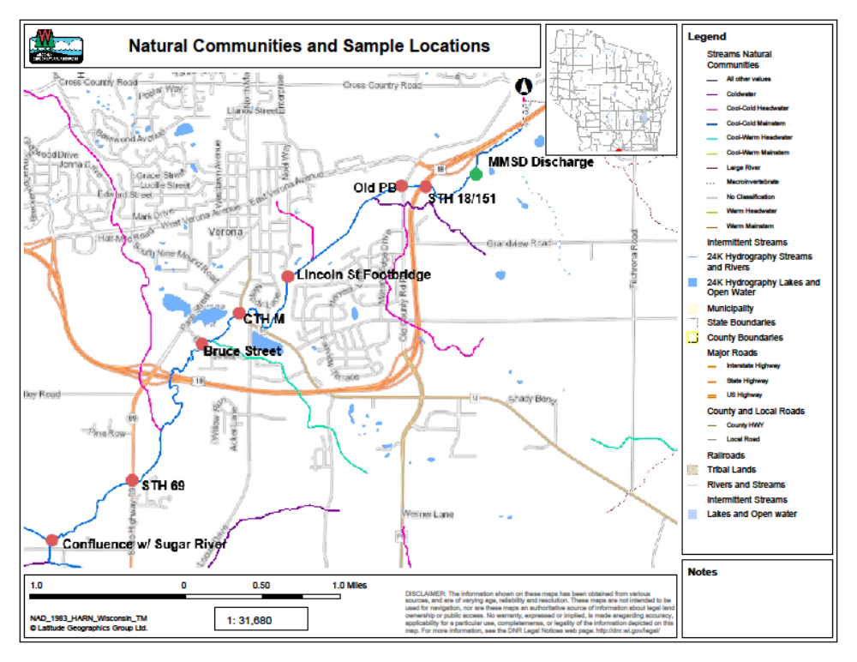
Appendix: Madison Metropolitan Sewerage District Thermal Tolerances for Badger Mill Creek

Draft Limits for the permit:
Month | Representative Highest Monthly Effluent Temperature |  | Calculated Effluent Limit
Month | Weekly Maximum | Daily Maximum | Weekly Average Effluent Limitation | Daily Maximum Effluent Limitation
 | (°F) | (°F) | (°F) | (°F)
JAN | 56 | 57 | 54 | 78
FEB | 54 | 55 | 54 | 79
MAR | 54 | 55 | 57 | 80
APR | 55 | 58 | 63 | 81
MAY | 61 | 63 | 70 | 84
JUN | 65 | 65 | 77 | 85
JUL | 69 | 70 | 81 | 86
AUG | 70 | 71 | 79 | 86
SEP | 70 | 71 | 73 | 85
OCT | 68 | 69 | 63 | 83
NOV | 63 | 64 | 54 | 80
DEC | 61 | 62 | 54 | 79

Limits in red are the calculated limits based upon a limited forage fish community in Badger Mill Creek. Since daily maximum limits are not needed to protect the acute water quality criteria, this analysis will focus on the species used to develop the sub-lethal criteria.

Representative Important Species: Brown trout (introduced) and mottled sculpin (native). Brown trout are considered a cold water species for purposes of thermal criteria development, while mottled sculpin are considered a limited forage fish species for criteria development. These species were selected as they represent the most intolerant species found in Badger Mill Creek.

Sub-Lethal Criteria
Sub-lethal water quality-based criteria for temperature represent maximum allowable temperatures that are generally protective of important life history activities of aquatic organisms from thermal loads. In particular, the sub-lethal criteria are based on data from three fish life history activities: gametogenesis, spawning, and growth. When developing a criterion, the most sensitive temperatures for an individual species for each of these three activities are compared, and the lowest tolerance is selected for each month. A similar approach will be used when comparing the thermal tolerance of brown trout and mottled sculpin to temperature data of the effluent and Badger Mill Creek. The Table on the following page summarizes the species tolerances for gametogenesis, growth, and spawning; effluent and instream data; and effluent limitations by month.

Month | Effluent* | Lincoln St. | Calculated Limit | Proposed Weekly Avg. Limit | Maximum Spawning Temp |  | Max Gametogenesis Temp |  | No Growth
 |  |  |  |  | Brown Trout | Mottled Sculpin | Brown Trout | Mottled Sculpin | Brown Trout | Mottled Sculpin
Jan | 54.2 | 39.8 | 54 | 55(+1) | 52.42 |  |  | 54 | 71.97 | -
Feb | 54.3 | 42.7 |  |  |  |  |  | 54 | 71.97 | -
Mar | 54.1 | 43.1 |  |  |  | 59.96 |  | 54 | 71.97 | -
April | 56.5 | 47.5 |  |  |  | 59.96 |  |  | 71.97 | -
May | 59.9 | 54.7 |  |  |  | 59.96 |  |  | 71.97 | -
Jun | 66 | 60.9 |  |  |  |  |  |  | 71.97 | -
July | 69.9 | 64.7 |  |  |  |  | 68 |  | 71.97 | -
Aug | 70.7 | 62.8 |  |  |  |  | 68 |  | 71.97 | -
Sep | 69.8 | 61.8 |  |  | 52.42 |  | 68 |  | 71.97 | -
Oct | 65.8 | 55.4 | 63 | 66(+3) | 52.42 |  |  | 54 | 71.97 | -
Nov | 62.4 | 52.5 | 54 | 63(+9) | 52.42 |  |  | 54 | 71.97 | -
Dec | 58 | 45.8 | 54 | 58(+4) | 52.42 |  |  | 54 | 71.97 | -
 | Spawning temperature not achieved at Lincoln St.
 | Spawning temperature achieved at Lincoln St.
 | Gametogenesis Temperature not achieved at Lincoln St.
 | Gametogenesis Temperature achieved at Lincoln St.
 | Effluent temperature and Temperature at Lincoln St. are below the growth inhibiting temperature
Note: Effluent temperature data and instream temperature data at Lincoln St. were submitted by Madison Met. The spawning, gametogenesis, and no growth data for brown trout and mottled sculpin are found in the draft Technical Support Document for Wisconsin’s Thermal Water Quality Rules (Wenholz).
Brown Trout:
Brown trout are known to be spawning during the months when temperature limits are required (Wenholz, Appendix 7). The maximum tolerated spawning temperature for brown trout was determined to be 52.42 °F (Wenholz, Appendix 9). When comparing the effluent to the maximum spawning temperature, only during the month of January is the effluent temperature below the spawning threshold. However, comparing the spawning temperature to those measured at the Lincoln St. Bridge, half of the spawning months with have instream temperatures below the threshold for brown trout. The remaining moths, October and November, average 2.98 °F and 0.08 °F above the spawning threshold respectively. While the data indicated these months are not necessarily suitable for brown trout spawning, the habitat upstream of the Lincoln Street Bridge does support the spawning for the species. As noted earlier, the channel is straight, wide, and shallow. The lack of brown trout spawning above this point is likely due to degraded habitat rather than thermal impacts.

The gametogenesis period for brown trout occurs during the months of July, August, and September, and is inhibited when stream temperatures are above 68°F (Wenholz, Table 3 and Table 6). During these months, the instream temperature at the Lincoln St. Bridge is always less that the 68°F criteria.

A final consideration for brown trout is the sub-lethal maximum no growth temperature. Above the no growth temperature, additional growth of the released fish is not expected to occur. For brown trout, that temperature is 71.97°F (Wenholz, Appendix 10). For all months of the year, the effluent and in steam temperatures are below the no growth criteria, meaning fish growth in Badger Mill Creek is not stunted by the thermal component of Madison Met’s discharge.

Mottled Sculpin:
Spawning for Mottled Sculpin typically occurs during the months of March, April, and May and is uninhibited at temperatures below 59.96 °F (Wenholz, Appendix 7 and Appendix 9). While temperature limits are not required during these months, a comparison of the discharge temperature and the spawning criteria was still completed. During March and April, the effluent was below the spawning criteria, and in May, the spawning criterion was only exceeded by 0.06°F. A channel comprised solely of effluent would still be suitable for mottled sculpin spawning.

Since mottled sculpin spawn in spring, gametogenesis occurs during the months of October through March (Wenholz, Table 3). Gametogenesis is hindered at temperatures above 54 °F (Wenholz, Table 6). Of the months a limit is needed, the instream temperature at the Lincoln St. Footbridge is below 54°F for all but October. The October steam temperature averages 1.4°F above the gametogenesis criteria for mottled sculpin. The stream achieves the gametogenesis criteria 5 out of 6 months, and 3 out of 4 months with a permit limit, indicating the effluent thermal discharge should have little impact on the development of mottled sculpin.

References

Wenholz, Mike. 2008. Technical Support Document for Wisconsin’s Thermal Water Quality Rules (Draft). Wisconsin Department of Natural Resources.

