Wisconsin DNR Office of Great Waters 2017 AOC Grant Application: Project 1 of *

Project Title: Sediment Budget and Sediment Source Apportionment Study for Apple Creek

Project Applicant:
Faith Fitzpatrick, USGS
USGS WI Water Science Center
8505 Research Way
Middleton, WI 53562
608-821-3818
fafitzpa@usgs.gov

Person responsible for quarterly reporting:
Megan O’Shea, WDNR
WDNR Green Bay Service Center
2984 Shawano Avenue
Green Bay, WI 54313-6727
920-662-5465
Megan.oshea@wisconsin.gov

Project Location:
Apple Creek – western watershed to the lower Fox River AOC

Problem Statement:
Apple Creek (drainage area of 54 mi²) is part of the Total Maximum Daily Load (TMDL) and watershed management plan for total phosphorus (TP) and total suspended solids (TSS) in the Lower Fox River Basin. Apple Creek has 24 miles of stream length on the Wisconsin state impaired waters list for TP and TSS. The confluence of Apple Creek with the Fox River is about 8 miles upstream of the Green Bay/Fox River AOC. The AOC has proposed BUI targets for eutrophication and undesirable algae based on achieving the load reductions identified in the TMDL for 7 subbasins, including Apple Creek. Based on SWAT modeling results, Apple Creek produces an estimated 35,100 lbs/yr of TP and 6,400 tons/yr of TSS (Cadmus, 2012). The TMDL goal is to reduce the TP loading by 79 percent and the TSS load by 56 percent from agricultural sources. Based on a SWAT model output, agricultural land in Apple Creek is estimated to contribute 87 and 82 percent of the annual loading of TP and TSS, respectively. Natural areas are estimated to contribute less than 1 percent of the TP and TSS. TP and TSS from bank erosion sources were not included in the modeling (Cadmus, 2012). However, recent stream inventories of neighboring Plum Creek by Outagamie County indicate that 24 of the 43 miles inventoried had actively eroding banks. Preliminary estimates are that these banks could be contributing 45 percent of the TSS annual loading measured at the USGS gage. If stream processes are similar in Apple Creek and producing almost half of the annual loading of TSS, the proposed TMDL goal to reduce TSS by 70 percent will not be achievable through upland soil conservation practices alone.

One of the first steps in the sediment TMDL process along with identifying targets is to identify the major sources of sediment, recognizing that the proportion of TSS and TP may vary in the watershed spatially as well as temporally with runoff events over different seasons. A stream corridor-based sediment budget and source apportionment study was started in nearby Plum Creek in 2016 to quantify the proportion of the TP and TSS loading originating from in-stream sources of bank and channel erosion compared to soil erosion. Gullying associated with headward extension of stream networks will be quantified as a possible TP and TSS source. The Apple Creek watershed has clayey soils, similar to Plum Creek (fig. 1) but Apple Creek has less relief and more urban land than Plum Creek (fig. 2). The local variability necessitates an additional study to better and more fully characterize conditions throughout the Lower Fox River. The results of this project and the Plum Creek project will be able to be applied to the other subwatersheds in the basin without a separate study needing to be done for each subwatershed.

This proposal for Apple Creek describes a combined sediment budget/fingerprinting approach that will help identify the proportion of annual loading of TP and TSS originating from stream corridor sources in Apple Creek. The glacial geology and landforms on the west side of the Fox River are considerably different than those on the east side. The results from the Apple Creek study will be compared to expected field contributions based on RUSLE2 calculations and SWAT estimated TP and TSS loadings. The results will be contrasted with apportionment results from Plum Creek. The source assessment results can be used in all subsequent steps of the TMDL process, including monitoring and targeted implementation of the plan.
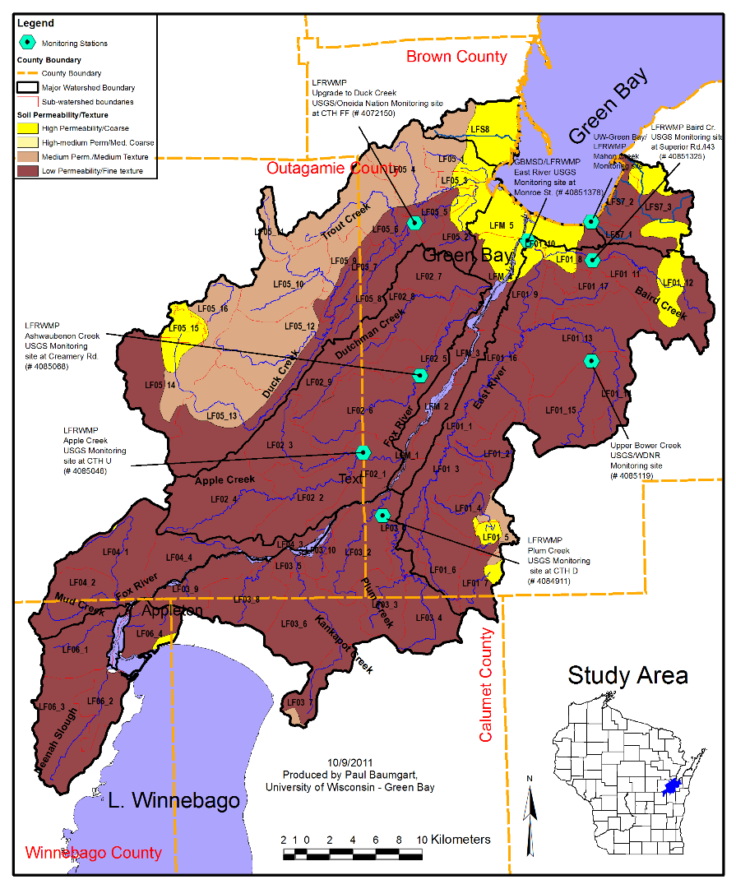
Figure 1. Permeability of soils for watersheds in the lower Fox Basin, from https://www.uwgb.edu/watershed/files/maps/LFox_SOIL_PermTexture.png

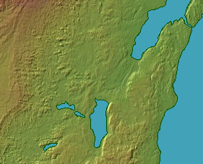
Figure 2. Shaded relief map of Wisconsin, from “Color Landform Atlas of the United States by r. Sterner. http://clean-water.uwex.edu/wav/monitoring/datasheet.htm.

Proposed Work:

The study will take two years to complete, the first year for writing a QAPP, compilation of existing data, watershed reconnaissance of geomorphic setting, and collection of sediment source and target samples. The second year is needed for laboratory analyses, data workup, and publishing results.

As part of the sediment budget approach, the USGS will conduct an inventory of sediment sources and sinks using a river walk approach and aerial photo analyses (Gellis et al., 2016; Fitzpatrick, 2014; Fitzpatrick et al., 1998). Mapping of potential channel sources of TP and TSS will include for bank erosion, valley side and terrace erosion, gully erosion and channel incision. For bank erosion rates, the WI NRCS published estimates of lateral recession rates will be employed. Sediment sinks will be measured in terms of volume and mapped including soft, fine-grained sediment deposited in the channel, depositional bars, and floodplain deposition. Sediment sources, transport, and sinks will be described in terms of a longitudinal continuum along the drainage system and mapped in a geographic information system (GIS).

Rapid geomorphic assessments of channel characteristics will be conducted at 20-30 sites in the Apple Creek watershed. Sediment samples will be collected from eroding banks and soft sediment deposition at approximately 15 of the sites and analyzed for TP, particle size, density, organic matter from loss on ignition, and a suite of trace elements used in sediment fingerprinting. Samples will be analyzed at the Wisconsin State Laboratory of Hygiene. A subset of soil and soft sediment samples will be analyzed with additional analytical methods including the commonly used soil P test used to determine if P is limiting crop growth (Bray and Kurtz, 1946; Frank et al., 1996). Another laboratory method will include analyses of bioavailable P, typically used to determine how much P is algal available in sediment from lakes and rivers. The specific method used for bioavailable P will be determined after consultation with other scientists at the USGS and WDNR working on wetlands, algal blooms in Wisconsin inland lakes, and Lake Michigan. Apportionment results from the soft-sediment samples, collected from depositional areas along the stream network, give an indication of spatial variations in the proportion of TSS and TP originating from different sources.

In situ suspended sediment samplers (Phillips, 2000) will be installed at two locations along Apple Creek, one near the watershed outlet at the Wisconsin DNR monitoring site ((LFRWMP) and USGS monitoring site #4085046 and one upstream. These samplers will be used to collect suspended sediment for fingerprinting and TP laboratory analyses. Samples will be collected monthly for approximately one year. Apportionment results from monthly suspended sediment samples will give an indication of seasonal and event-related variations in the proportion of TSS and TP originating from different sources.

Sediment fingerprinting and source apportionment will be conducted for agricultural upland and hillslope processes and channel sources such as bank erosion using techniques previously developed by Gellis and others (2015) and used in the Pecatonica watershed (Lamba et al., 2015a,b). Approximately 100 soil and sediment samples will be collected from cropland, ditches along roadways, forested slopes, gullies, and banks. The targets will include suspended sediment and soft sediment samples. Since the Apple Creek watershed is naturally rich in fine-grained sediment, the study will help toward distinguishing anthropogenic vs. natural sediment loading and distinguish reaches along the stream network with gullying, bank, and channel erosion.

Collaboration with partners:
The counties in the Lower Fox River TMDL Agriculture Committee have been supportive of this project. The assessment results will inform implementation efforts of the TMDL. Apple Creek is mainly in Outagamie County. The assessments of erosion and sedimentation along the channel network will be coordinated with Outagamie County staff as well as the NRCS and Wisconsin DNR.

Timetable (Federal Fiscal Year):

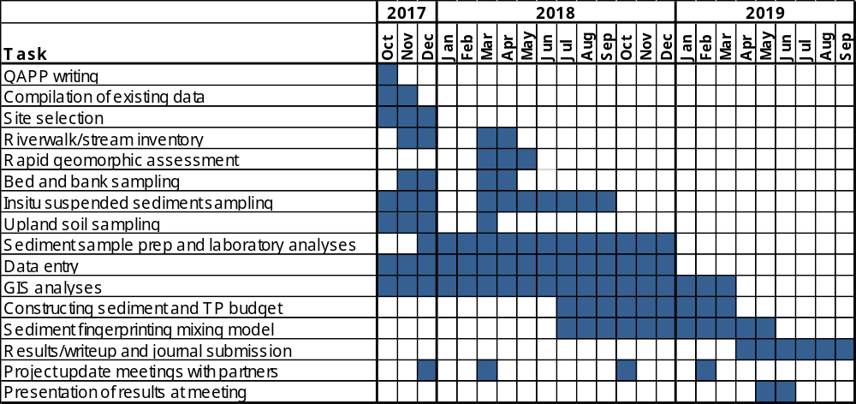

Deliverables:
Products from this study will include GIS maps and spreadsheets of stream corridor sources and sinks of sediment and TP. A presentation will be given and made available to project partners and local watershed groups. Data that do not fit in NWIS or Storet will be entered into USGS ScienceBase. A journal article will be published with the results, with submittal to a journal (to be selected with input from partners) in 2019.

Project Budget:
The DNR cost of the project, excluding $45,890 for State Lab of Hygiene Laboratory analyses, is $92,398 over two years. In order to lower costs associated with USGS salaries, the approach assumes three weeks of field assistance from two local agency personnel for stream inventories, rapid geomorphic assessment, and upland soil sampling. The work assumes the availability of USGS cooperative matching funds of $19,802 in 2018 and $10,997 in 2019.

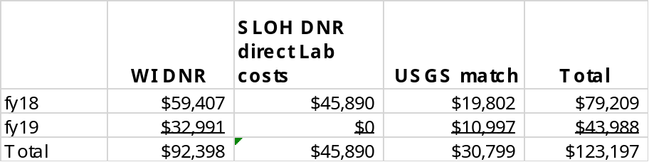

The total project cost is $169,087.

The breakdown of costs for the WI DNR share are as follows:

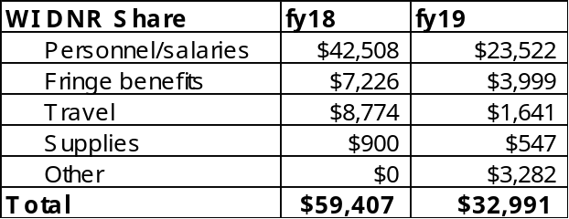

References:

Bray R.H., and L.T. Kurtz. 1945. Determination of total, organic and available forms of phosphorus in soils. Soil Sci. 59:39-45.
Frank, K.D. Beegle, and J. Denning. 1998. Phosphorus. p. 21-30. In J. R. Brown (ed.) Recommended Chemical Soil Test Procedures for the North Central Region. North Central Reg. Res. Publ. No. 221 (revised).
Cadmus, 2012, Total maximum daily load and watershed management plan for total phosphorus and total suspended solids in the lower Fox River Basin and Lower Green Bay: The Cadmus Group report.
U.S. Environmental Protection Agency, 1999, Protocol for developing sediment TMDLs, 1st Edition, EPA Report 841-B-99-004, Office of Water (4503F), United States Environmental Protection Agency, Washington D.C. 132 p.
Fitzpatrick, F.A., Knox, J.C., Whitman, H.E., 1999, Effects of historical land-cover changes on flooding and sedimentation, North Fish Creek, Wisconsin: US Geological Survey Water-Resources Investigations Report 99–4083, 12 p.
Fitzpatrick, F.A., 2014, A Geologic Approach to Field Methods in Fluvial Geomorphology, Chapter 5.2, in Thornbush, M.J., Allen, C.D., and Fitzpatrick, F.A., (eds.), Geomorphological Fieldwork, Volume 18, Developments in Earth Surface Processes: Amsterdam, Netherlands, Elsevier, p. 201-230.
Gellis, A.C., Fitzpatrick, F.A., and Schubauer-Berigan, J., (in prep), Identifying sediment sources in the sediment total maximum daily load process: EPA ORD Technical Manual.
Gellis, A.C., Noe, G.B., Clune, J.W., Myers, M.K., Hupp, C.R., Schenk, E.R., and Schwarz, G.E., 2015, Sources of fine-grained sediment in the Linganore Creek watershed, Frederick and Carroll Counties, Maryland, 2008–10: U.S. Geological Survey Scientific Investigations Report 2014–5147, 56 p.
Phillips, J.M., Russell, M.A., and Walling, D.E., 2000, Time-integrated sampling of fluvial suspended sediment: a simple methodology for small catchments, Hydrological Processes, 14(14), 2589-2602.
Lamba, J., Karthikeyan, K.G., and Thompson, A.M., 2015, Apportionment of suspended sediment sources in an agricultural watershed using sediment fingerprinting: Geoderma 239-40, p. 25-33.
Lamba, J., Thompson, A.M., Karthikeyan, K.G., and Fitzpatrick, F.A., Sources of fine sediment stored in agricultural lowland streams, Midwest, USA: Geomorphology 236, p. 44-53.

