Scope of Work
Project Title: Plankton BUI post-remediation follow-up monitoring in the Sheboygan River AOC

Project Manager:
Barb Scudder Eikenberry
Research Hydrologist (Biology)
USGS Wisconsin Water Science Center
8505 Research Way Middleton, WI 53562
Phone: (608) 821-3832
Email: beikenberry@usgs.gov
WDNR Project Contact:
Camille Bruhn
Sheboygan River AOC Coordinator
1155 Pilgrim Road, Plymouth, WI 53073
Phone: 920-893-8527
Email: camille.bruhn@wisconsin.gov

Project location: Sheboygan River Area of Concern (sampling location at the mouth of the river: 43.74887, -87.70352) and two reference sites (Manitowoc River: 44.09190, -87.66183 and Kewaunee River: 44.46073, -87.50205).

Problem Statement
The Wisconsin Department of Natural Resources (WDNR) is in the process of carrying out the Remedial Action Plan (RAP) and removing Beneficial Use Impairments (BUIs) in the Sheboygan River Area of Concern (AOC).
The Sheboygan River AOC includes the “Degradation of Phytoplankton and Zooplankton Populations” BUI. Due to lack of information on the benthic and planktonic communities in the Sheboygan River compared to reference sites, WDNR received GLRI grant funding for a comparison study. Benthos, phytoplankton and zooplankton communities were sampled and assessed in each of the four Lake Michigan AOCs in Wisconsin and in six non-AOC reference sites in 2012 by USGS (Benthos and plankton community data for selected rivers and harbors along Wisconsin's Lake Michigan shoreline, 2012, Scudder-Eikenberry, et al., 2014). Because 2012 was an unusual drought year, the study was also repeated in 2014 to increase data rigor. This study, Assessment of Benthos and Plankton in Wisconsin’s Lake Michigan Areas of Concern, was also carried out by USGS for WDNR and again included all four of the Lake Michigan AOCs and the same six non-AOC reference sites. Preliminary analysis of 2012 samples indicate that the Sheboygan River is not considered to be degraded for phytoplankton and zooplankton communities when compared to two non-AOC reference sites across all sampling events. USGS recently presented preliminary results from the 2014 data indicating that zooplankton diversity may be degraded overall for the Sheboygan River AOC. USGS is continuing to analyze the results of the 2014 samples and a report should be complete in 2016. This study will be used to evaluate the status of the “Degradation of Phytoplankton and Zooplankton Populations” BUI in the Sheboygan River AOC.
The 2008 removal target states:
- Sources causing nutrient enrichment to the Outer Harbor and near shore waters are identified and controlled if nutrients are the main contributor; OR
- Sources resulting in ambient water toxicity in the Outer Harbor and near shore waters are identified and controlled if toxicity is the main contributor.
- Phytoplankton or zooplankton bioassays confirm no toxicity in ambient waters and the community structure is diverse and contains species indicative of clean water.
- The phytoplankton and zooplankton communities within the site being evaluated are statistically similar to a reference site with similar habitat and minimal sediment contamination.

The preliminary results from USGS for the 2014 zooplankton community could be of concern when working to analyze the results in support of BUI removal targets. Another year of plankton collection will enhance the dataset for the Sheboygan River AOC zooplankton communities and allow for comparison to past data. Additional time will be allowed for post-remediation recovery of the zooplankton communities as well. Additional plankton collection will help WDNR to determine if zooplankton diversity is still an issue in the Sheboygan River AOC by comparing additional data to the past sampling efforts and the reference sites. WDNR will also consider effects of Lake Michigan wide (non-AOC specific) factors such as the degree and extent of the Dreissena (zebra) mussel infestation in the Lower River and the possible impact to zooplankton diversity resulting from that infestation. These data will provide additional lines of evidence that zooplankton communities are either impaired or not impaired, and if found to be impaired, what the causes might be. The analysis of these results and previous study results will be used to provide documentation in support of BUI removal, if appropriate, and will help determine if additional actions may be necessary.

Project Summary
WDNR will contract with USGS who will perform the work for this project. USGS will collect the plankton samples in the field in 2016, send the samples to a contracted laboratory to be analyzed, receive and review the data, analyze the data, provide interpretation of the data, and create a final interpretive report. Zooplankton sampling will be performed at three events throughout the growing season (once in June, once in July, and once in August) at the mouth of the Sheboygan River (43.74887, -87.70352) and at the reference sites at the mouths of the Manitowoc River (44.09190, -87.66183), and the Kewaunee River (44.46073, -87.50205). The use of the term “reference” in this case does not imply “pristine,” instead it refers to the non-AOC sites as comparison sites. This three-sampling event schedule will allow for comparison to the past data because seasonal timing and methods will be closely aligned with the 2012 and 2014 studies.
Plankton samples will be collected by conducting a 5-meter vertical tow with a plankton net to capture larger zooplankton. The zooplankton samples will be collected using the EPA’s Standard Operating Procedures (SOPs) for zooplankton sample collection and preservation (U.S. Environmental Protection Agency, 2005) as amended by Scudder Eikenberry and others (2014). A primary and a replicate sample will be collected at each of the sampling events throughout the season at the Sheboygan River site. Only one sample will be collected at the primary location at both the non-AOC reference sites, the Manitowoc River and the Kewaunee River, at each of the three sampling events throughout the season. This will yield a total of twelve samples to be analyzed. Additional in situ water quality measurements will be collected in the field at each site during each sampling event with a multi-parameter sonde. These measurements will include: pH, specific conductance, dissolved oxygen, and water temperature. Water depth will also be recorded at each sampling location. The Quality Assurance Project Plan (QAPP) from the 2014 Assessment of Benthos and Plankton in Wisconsin’s Lake Michigan Areas of Concern project will be revised by USGS with WDNR input to create the 2016 QAPP. The contracted laboratory must also have standard operating procedures for performing zooplankton analyses that are shared with WDNR.
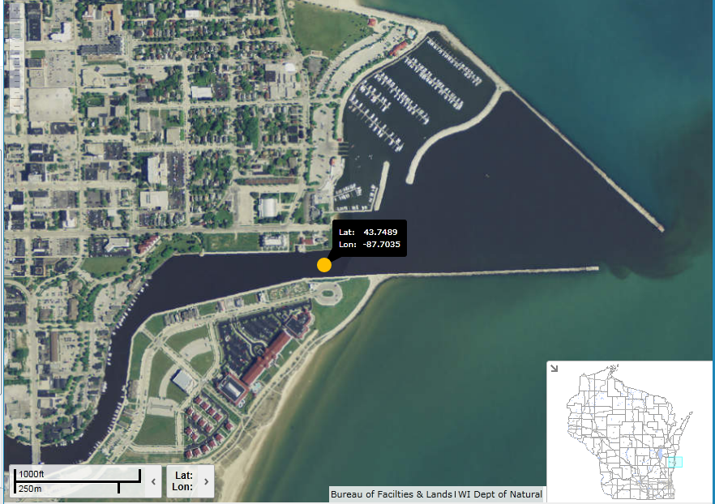

Sampling location at the mouth of the Sheboygan River (43.74887, -87.70352).

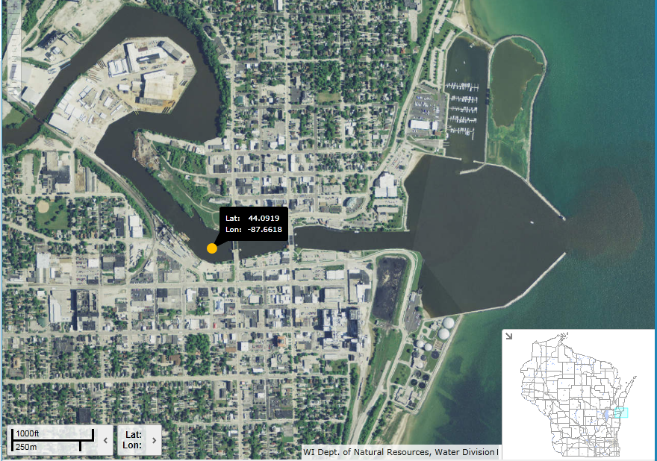

Sampling location on the Manitowoc River (44.09190, -87.66183).

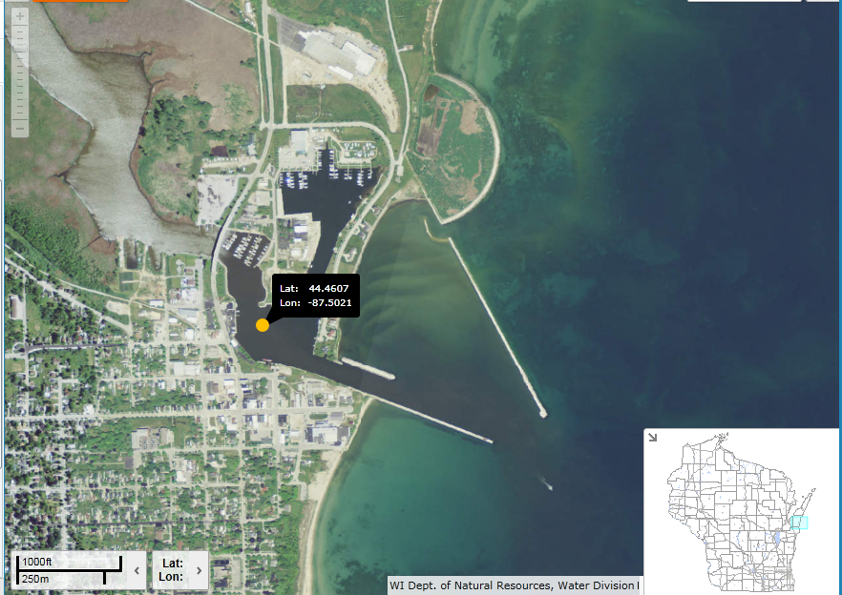

Sampling location on the Kewaunee River (44.46073, -87.50205).

Project Goals:
- Collect zooplankton data in the Sheboygan River AOC to supplement the datasets from 2012 and 2014. This data will be used to determine the current state of zooplankton communities in the AOC and how they differ from the reference sites (comparison rivers that are not AOCs).
- Use zooplankton data from 2012, 2014, and 2016 to draw conclusions about the plankton communities and whether they are impaired or not. The following measures can be used to determine zooplankton impairment: richness, abundance, diversity, and the presence and abundance of aquatic invasive species of zooplankton, such as zebra or quagga mussel veligers. The analysis of these results may provide documentation in support of BUI removal and determine if additional actions may be necessary.

WDNR will work closely with USGS (who will also work closely with the contracted laboratory that will analyze the zooplankton samples). It will be requested that the report from USGS include a comparison of the 2016 data to the zooplankton sampling that occurred in 2012 and 2014. Data results will be analyzed and shared with the Sheboygan River AOC Technical Advisory Committee.

To accomplish the project goals, the Wisconsin Department of Natural Resources (WDNR) will enter into a cooperative agreement with the USGS to quantify zooplankton communities of the Sheboygan River AOC. These communities will be compared with two non-AOC rivers and harbors along the Lake Michigan shoreline that will be used as comparison, or reference sites, for data analysis. The community data within the AOC and reference sites and between the AOC and non-AOCs will be analyzed and differences and similarities will assist in determining whether or not the “Degradation of Phytoplankton and Zooplankton Populations” beneficial use impairment (BUI) is still valid for the Sheboygan River AOC. By developing community-based metrics that can quantify subtle differences between sampled communities we will be able to determine if the plankton in the AOC are significantly different from those in the non-AOCs. If there is no statistically significant difference between the sampled communities from the AOC and a comparable non-AOC site, the data may be used to support removal of that BUI once all other components of the delisting target have been met. If statistically significant differences exist between the AOC and non-AOC sites, future examination of the potential causes of the impairment will be required. Characterization of current plankton populations is a critical first step that must occur before this BUI can be considered for removal.

Project Deliverables:
- Approved Quality Assurance Project Plan (QAPP) (Revisions to the 2014 Approved QAPP)
- Water quality measurement data
- Zooplankton community data (including any effects the Dreissena (zebra) mussel may be having)
- Comparison of zooplankton community data between the AOC and the non-AOC reference sites
- Final summary report comparing data from 2012, 2014, and 2016 for the Sheboygan River AOC

The WDNR Sheboygan River AOC Coordinator will be responsible for all quarterly reporting.

Project Coordination, Activities and Timeline:
WDNR will contract this work to USGS who will receive all of the funding for field sample collection, contracting a laboratory to perform sample analyses, review and analysis of the data from the lab, interpretation of the data, and a final report. Sample collections will be conducted at three events throughout the growing season, with collections in June, July, and August at the Sheboygan River as well as at two reference sites, the Manitowoc River and the Kewaunee River. The sampling events will be separated by at least 4 weeks, but can be up to 6 weeks. Only non-wadeable portions of the sites will be sampled to simplify comparisons between AOCs and non-AOCs. Data collected will include parameters to characterize the sites and the zooplankton communities. Details of all data to be collected and associated methods follow below under Methods. Sample analysis will be performed as samples are received with all zooplankton analyses being completed by March 1, 2017. Data analysis, interpretation, and a final report will be completed no later than June 30, 2017. The report will detail the methods, data, and results of this project.

Activity | Timeline
Data Collection at the Sheboygan River AOC and two reference sites (Manitowoc and Kewaunee Rivers) by USGS | June-August 2016
Zooplankton analyses completed by contracted laboratory | March 1, 2017
Data analysis, interpretation, and final report completed by USGS | June 30, 2017

Methods
All sample collections will be performed by boat. Coordinates of each sampling location will be recorded on a GPS unit. Flow measurements in the rivers will be recorded from the USGS gaging stations located upstream on each of the three rivers (Sheboygan-04086000; Manitowoc- 04085427; Kewaunee-04085200). Additional field measurements to be taken at each sampling event include dissolved oxygen, pH, specific conductance, and temperature using a water-quality sonde. Zooplankton samples will be collected using a 63-micrometer mesh tow net.

All methods for sample collection are based on reports published or used by the USEPA for large rivers and lakes, or are detailed in peer-reviewed papers publically available, including Scudder Eikenberry and others, 2014. The laboratory has standard operating procedures in place for sample analysis and quality assurance practices.

Details of each of the collection methods follow:

Sample structure summary
A total of 12 zooplankton samples will be collected, as follows:
• Zooplankton:
o Sheboygan AOC: 3 samples (1 in June, 1 in July, 1 in August)
o Replicates: 3 samples (one at each sampling event (June, July, August) at the Sheboygan River AOC only)
o Non-AOCs: 6 samples (Manitowoc- 1 in June, 1 in July, 1 in august; Kewaunee- 1 in June, 1 in July, 1 in august)

For each location, the following information will also be collected:
• Water quality data (water temperature, dissolved oxygen, specific conductance, pH)
• GIS location
• Flow of river (discharge from USGS gage upstream)

For each sample, the following analyses will be performed:
• 63µm (micrometer or micron) plankton tow
o Large-cell zooplankton community assessment

Zooplankton Collection
The methods for zooplankton collection are based on the United States Environmental Protection Agency’s (USEPA’s) Standard Operating Procedures (SOPs) LG 402 for zooplankton sample collection and preservation for Great Lakes National Program Office’s (GLNPO) Water Quality Survey (WQS) (U.S. Environmental Protection Agency, 2005); however, because the sampling will be performed in the harbors, bays and rivers, the deeper water sample will not be collected.

Briefly, one sampling tow is performed at each station from 5 meters below the water surface to the surface using a 63µm net. If the station depth is less than the specified depth, the tow is taken from about 0.5 meters above the bottom to the surface (and multiple tows are composited until 5 meters total are sampled). The tow net, with a screened sample bucket attached at the bottom, is lowered to the desired depth, and raised at about 0.5 meters/second to collect zooplankton from the water column. After lifting the net from the water, it is sprayed with tap water to wash the organisms down into the bucket. The sample is concentrated into the sample bucket and is transferred to a sample storage bottle. The organisms are narcotized with soda water or Alka Seltzer tablets and preserved with sucrose-formalin solution or glutaraldehyde before sending to the analysis laboratory.

The 63µm sample will be sent to the contracted laboratory for zooplankton identification and enumeration in accordance with GLNPO SOP LG 403, Zooplankton Analysis (U.S. Environmental Protection Agency, 2003). Taxonomic identification of plankton will be down to the lowest practical level.

Quality Assurance
A Quality Assurance Project Plan will be prepared by the WDNR and USGS to document quality assurance methods for this project. Duplicate zooplankton tows will be collected at one location (Sheboygan River) for each sampling event for a total of 25% sampling replicate. These co-located replicate samples will be collected within a 100-m2 area at each station. The data collected from the replicate samples will be compared to original samples to quantify variability in field sampling. If it is determined that the replicate sample data are at least 60% similar in taxa relative abundance to the original sample data, the original sample will be used for further data analysis. If the replicate samples are less than 60% dissimilar to the original sample data for each data type collected, then values of the two replicate samples will be averaged and that value will be used for further data analysis.

To minimize disturbance of the different sampling substrates, samples will be collected in the following order: water quality data followed by plankton tows. Because no other water or sediment samples are included in this proposal, the samples for this proposal will be collected without regard to other samples.

Data Analysis
The same multivariate and multimetric data analysis methods developed and peer reviewed during the 2012 and 2014 studies for zooplankton will be used. Software designed to incorporate the non-normality of ecological data will be used to analyze variability in the biological community data from the sampled AOCs and non-AOCs. Using non-parametric multivariate statistical analyses in the Primer statistical program (Clarke and Gorley, 2006), the community data will be compared among the sites and differences between taxa richness, composition, and abundance will be determined for zooplankton communities. Routines to be used in PRIMER will likely include nMDS (non-metric MultiDimensional Scaling) to derive plankton community site scores; and ANOSIM (ANalysis Of SIMilarity) to determine the extent plankton communities vary across sites. Probability values are based on 1,000 random permutations that are used to develop a nonparametric probability distribution. Site-specific scores based on similarities between communities will be used to determine whether a given site is statistically different from the others. Metrics will be compared across all seasons using statistical tests such as Mann-Whitney (non-parametric) or t-tests (parametric). This information will be used to determine if the BUI in the AOC is impaired when compared with the non-AOC site pairs and group, and if there are no differences to support delisting of beneficial use impairments for delisting the AOCs.

Facilitation of USEPA oversight & administration
The level of USEPA oversight and administration necessary to successfully implement this project is minimal. Assessment of the plankton beneficial use impairment at the Sheboygan River AOC has been performed in the past and is presented as a single proposal to minimize the reporting requirements associated with this grant proposal. WDNR and USGS have over 40 years of cooperative history collecting and analyzing data and publishing their findings in USGS and WDNR reports and peer-reviewed journals.
Education/outreach plan to disseminate results
USGS and WDNR will present the results to the Sheboygan River AOC Technical Advisory Committee (citizens and local volunteer monitoring groups may be invited to attend). This committee was consulted during the initial planning phase of the original studies and they approved of those original plans. WDNR personnel are welcome to accompany USGS staff in the field to capture photo and/or video for inclusion in AOC education and outreach materials. Final results of the data and analysis will be published as a USGS digital interpretive report.

Potential for transferability
The results of this project will assist other AOCs with degraded zooplankton populations to determine appropriate levels of monitoring to characterize AOCs. Non-AOC reference site data may be useful for comparison with other AOCs, if they have similar physical, chemical, and biological characteristics.

Outcomes, Outputs, and Expected Results
This project will definitively determine the status of and result in measurable progress towards delisting the “Degradation of Phytoplankton and Zooplankton Populations” BUI. Data will be collected and analyzed to re-evaluate this existing beneficial use impairment to determine if it is still applicable, an expected result from projects in this program (EPA GLRI RFP p I-2). The results will also help identify further actions needed to restore the beneficial uses.

The expected outcomes of this study are to determine the baseline conditions of a BUI in the Sheboygan River AOC along Wisconsin’s Lake Michigan shoreline. Species/taxa lists for zooplankton will be provided from the analytical laboratories. These community data will be summarized based on metrics such as richness (number of unique taxa) and diversity, and the relative abundances of zooplankton groups (daphnids, copepods, and rotifers). By determining the taxonomic differences between the AOC and non-AOC sites, the beneficial use impairment can be quantified for the site in question. Data from the non-AOC sites will be used to determine a preferred taxonomic composition for the Sheboygan River AOC which then may be re-evaluated for the zooplankton Beneficial Use Impairment.

Description of Project Result | Output | Outcome
Quantification of Zooplankton communities | Baseline: BUI status in the Sheboygan River AOC- zooplankton diversity may be degraded  Output: definitive determination of BUI status. Metrics including taxonomic richness and diversity generated for AOC and 2 non-AOCs. | Data will be used to characterize current zooplankton populations and determine appropriate metric for evaluating impairment.
Comparison of AOC and non-AOC zooplankton communities | Baseline:  - Degraded Zooplankton BUI  Output:  - Potential delisting of BUI | Evaluation is a necessary step to re-evaluate if the BUI is still applicable. All other relevant criteria in delisting target documents for this BUI will have to be met.
Final Peer-reviewed report | Publication of results in a widely accessible format. | Scientific peer review will lend additional credibility to decisions made based on data.
Coordination with AOC citizen committees (TAC, Community groups, etc) | - Presentation of results to AOC groups | Inclusion of AOC groups as project is developed and executed will increase public understanding and support for decisions about delisting based on the results of this project.

Collaboration, Partnerships, and Overarching Plans
The WDNR will collaborate with the USGS in Middleton, WI to perform necessary data collection, sampling, data analysis, and reporting. All phases of the project will be coordinated with AOC site managers and LaMP coordinators. Where feasible, effort will be made to coordinate with other ongoing studies at these sites by the WDNR, USGS, other agencies, and universities with regard to sampling timing, specific location within the AOC or non-AOCs, and data sharing. Additional collaboration with analytical laboratories to perform taxonomic identification of the samples includes the contracted Laboratory that will identify zooplankton.

AOC public stakeholder groups will be updated on the project prior to initiation of sampling, and results of the sampling will also be presented to them. Inclusion of AOC groups as the project is developed and executed will increase public understanding and support for decisions about delisting based on the results of this project.
Relevant overarching plans to this project include the AOC delisting targets, RAPs, and Wisconsin’s Great Lakes Strategy.
Programmatic Capability and Past Performance
The WDNR has had the opportunity to be an USEPA grant recipient for the past three decades and has been able to consistently demonstrate grant performance accountability. WDNR grant management is a joint effort that consists of multiple mechanisms to ensure expected outcomes and deliverables have been satisfactorily met.

Internal GPO’s (Grant Project Officer’s) are dedicated to each project to provide oversight and coordination. WDNR project officers have been able to satisfactorily meet reporting requirements as outlined in the grants programmatic and administrative conditions (annual, and/or semiannual, and final) for all grants received to date. Project Officers are responsible for meeting technical reporting and periodic project status requirements conveyed though reporting updates or communication/correspondence with USEPA.
Financial accountability has been demonstrated through systematic tracking by our staff grant accountants and financial accountants. State budgetary information systems track project activity and project related expenditures in order to provide accurate fiscal reporting. State procurement policies and processes provide guidelines to ensure funds are managed appropriately. Financial reporting is completed on a quarterly basis as required in programmatic terms and conditions to include a Final Federal Financial Reports (SF-425). Our financial representation has also established credibility for providing additional final reporting requirements; MBE/WBE reporting, Property Reports, Disclosure of Inventions, etc.
Historically, the WDNR has been successful in meeting grant recipient requirements and expectations. We appreciate the opportunity to continue to demonstrate our high performance standards and anticipate these to strengthen in the near future.
Budget
The following table outlines the total cost of the proposed project, which is a cooperative agreement between WDNR and the USGS. WDNR will use the grant funds to pay for costs of USGS performing this project. Contractual category includes salary, fringe, travel, and supply costs for USGS. The contracted laboratory will process the samples and provide all analyses associated with zooplankton.

Summary
Contract Costs | $41,000
USGS | $41,000
Personnel/Salaries | 27,200
Fringe Benefits | 4,570
Travel | 1,110
Supplies | 350
Laboratory Costs | 4200
Other Costs | 3160
Total Direct Charges | $41,000
Indirect Charges | $410
Total Cost | $41,000

References
Clarke, K.R and R.N. Gorley, 2006. PRIMER user manual, Plymouth UK, 190 p.
Scudder Eikenberry, B.C., Bell, A.H., Burns, D.J., and Templar, H.A., 2014, Benthos and plankton community data for selected rivers and harbors along Wisconsin’s Lake Michigan shoreline, 2012: U.S. Geological Survey Digital Data Series 824, 30 p. plus 8 appendixes. Available at: https://pubs.er.usgs.gov/publication/ds824.
U.S. Environmental Protection Agency, 2005, “Standard Operating Procedure for Zooplankton
Sample Collection and Preservation and Secchi Depth Measurement Field Procedures.” EPA-LG402. Great Lakes National Program Office, Chicago, IL. Available at: https://www3.epa.gov/greatlakes/monitoring/sop/chapter_4/LG402.pdf. Accessed Apr. 14, 2016

U.S. Environmental Protection Agency, 2003, “Standard Operating Procedure for Zooplankton
Analysis.” EPA-LG403. Great Lakes National Program Office, Chicago, IL. Available at: https://www3.epa.gov/greatlakes/monitoring/sop/chapter_4/LG403.pdf. Accessed Apr. 14, 2016

