WDNR Office of the Great Lakes AOC Capacity Grants
October 28, 2016
Quarterly Report
Reporting: Kelly Reyer, FWWA Outreach Coordinator
Project Title: Aesthetics Monitoring Program for the Green Bay AOC
Project Applicant: Fox-Wolf Watershed Alliance
PO Box 1861
1000 N Ballard Road
Appleton, WI 54911
Fiscal Agent: Fox-Wolf Watershed Alliance
Project Implementation Leader: Fox-Wolf Watershed Alliance
Person responsible for quarterly reporting: Kelly Reyer, Outreach Coordinator
Project Location: Lower Green Bay and Fox River AOC, Aesthetics Monitoring Sites 1-12 Deliverables:
Aesthetics Monitoring Promotional Materials (developed by Fox-Wolf)
Volunteer recruitment flyer/poster-This is attached to report e-mail
Program fact sheet This is attached to report e-mail. The Aesthetics Monitoring link on our website is: http://www.fwwa.org/volunteer-opportunites/aesthetics-monitoring/
Volunteer Contact Information
Names and contact information for all program volunteers. This will be provided next quarter.
Site Monitoring Forms
Completed monitoring forms. All paper forms have been submitted electronically. All electronic forms go directly to the DNR.
Quarterly Updates to DNR
Quarterly reports will include the following information:
  - Amount of money spent that quarter:
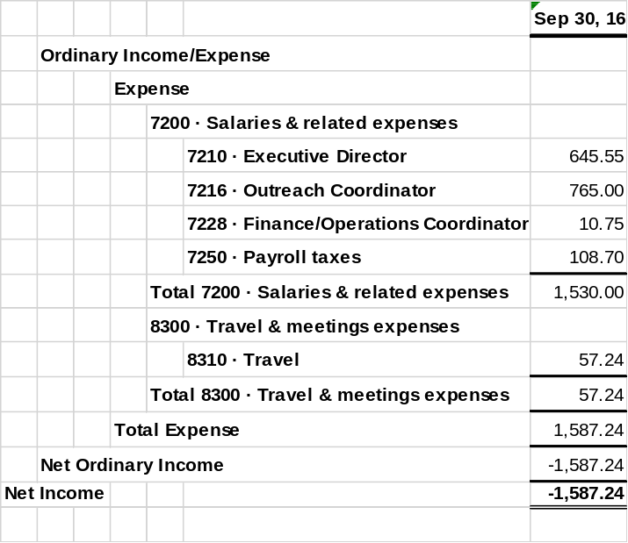
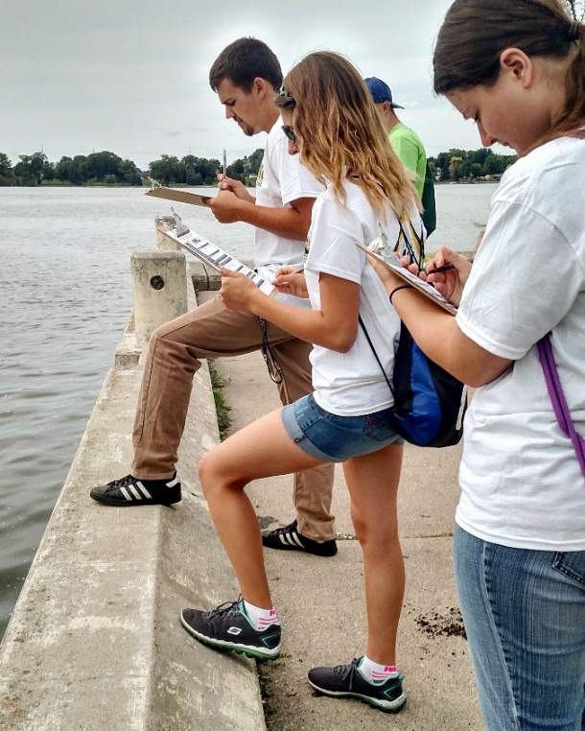
  - Deliverables and work accomplished during the quarter and any problems that were encountered and how they were resolved
The deliverables from the past quarter are attached to the e-mail containing this report. Photos from aesthetics monitoring can be found below. There were problems associated with having volunteers sign and return liability waiver forms for this project. We were able to create a digital waiver form that volunteers can fill out right from their phones. All information for Aesthetics Monitoring can be found on one page on our website, hopefully making the program easy for volunteers. One other problem I ran into is having completed, legible data sheets. Encouraging use of the digital form is will produce the best results for further monitoring. Partnering with St. Norbert College for their “Into the Streets” program helped introduce college freshman not only to the Aesthetics Monitoring program, but also general considerations of water quality in the area. There are currently three sites that have met the 10 monitoring surveys quota as outlined in the Scope of Work. Our work for the next quarter will be outlined below.
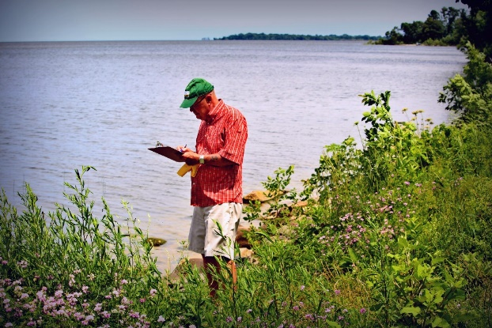
  - Planned tasks/deliverables for the next quarter
For the remainder of October, I will work to find as many volunteers as possible, with a focus on monitoring sites with the fewest submitted forms. I will advertise with the St. Norbert College volunteer center, Green Bay area school contacts, Time Warner Cable, Graymont (who volunteers for the Cleanup every year), and will continue advertising on our Facebook page. I will also advertise the program with an area schools where I have presentations in October.

