Priority Watershed Water Quality Evaluation for the Tomorrow-Waupaca River Watershed, Portage and Waupaca County, Wisconsin

November 2017

David Bolha-Water Quality Biologist-Oshkosh

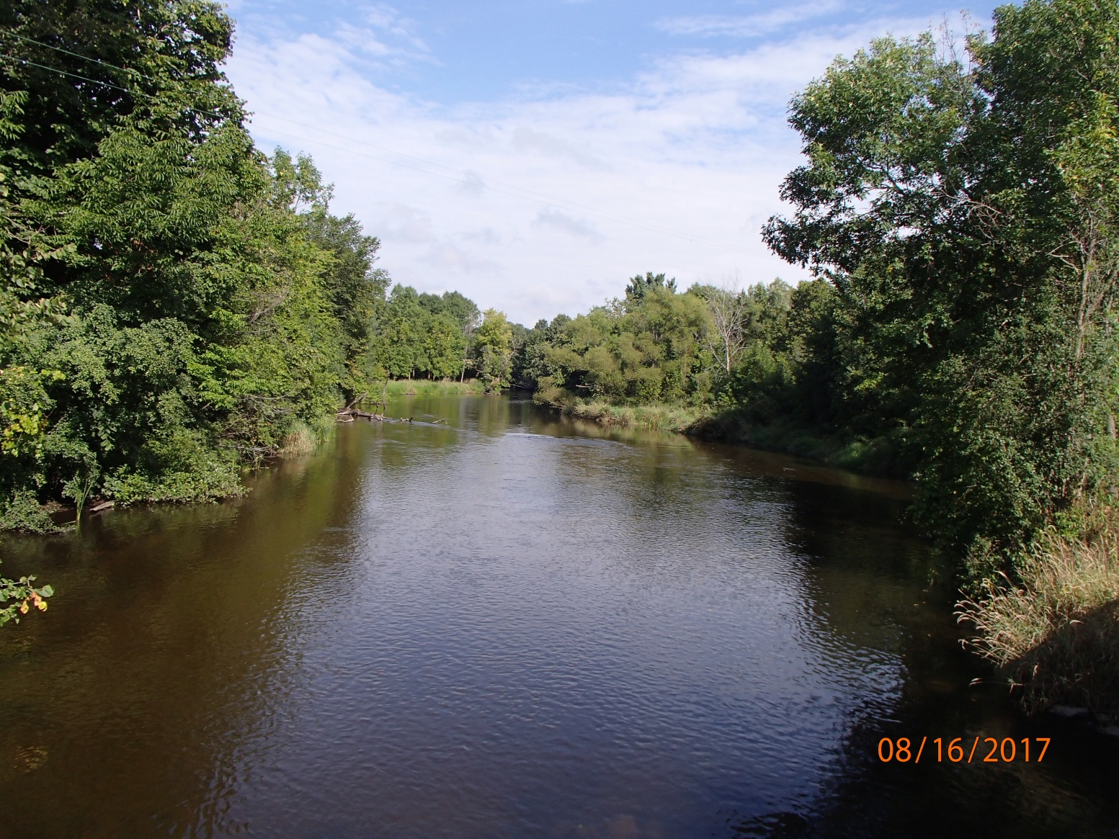

Purpose

This project evaluated water quality improvements made in the Tomorrow-Waupaca River Watershed from Best Management Practices installed in the watershed from 1995 through 2008 as part of the Tomorrow-Waupaca River Priority Watershed Project. This project determined if the goals of the Priority Watershed Project to protect and improve the watershed water quality were met by collecting fish, aquatic macroinvertebrate, habitat, temperature, and inorganic chemistry information throughout the watershed.

Methods

During the growing season of 2016, Total Phosphorus (TP) samples were collected at 22 locations once per month from May through October (Table 1, Map 1-4). In addition to the TP samples, Dissolved Nitrate + Nitrite as Nitrogen (NO₃+NO₂ as N) samples were collected in May through October 2016 at 22 locations in Table 1. Thirdly, Total Nitrogen (TN) samples were collected in May through October 2016 at 20 of the 23 locations listed in Table 1. All samples were collected using the standard WDNR grab sampling method for a total of 134 samples (WDNR 2014). Neither baseflow nor storm or snowmelt event sampling were targeted during this project, following the protocol of Wisconsin Consolidated Assessment and Listing Methodology (WisCALM 2016). All nutrient samples were shipped to Wisconsin State Laboratory of Hygiene (WISLOH) for analysis. The WISLOH entered all sample analysis data into the WDNR Surface Water Integrated Monitoring System (SWIMS) database.

SWIMS Station ID | Site Name | Surface Water WBIC
10044275 | Tomorrow R. @ Merryland Dr. | 270400
503169 | Tomorrow R. @ Clementson Rd | 270400
503050 | Tomorrow R. @ Hwy V Amherst | 270400
10013567 | Tomorrow R. @ West Buchholtz Rd. | 270400
10007975 | Waupaca R. @ Cobbtown Rd. | 257400
10021989 | Waupaca R. @ Anderson Rd. | 257400
10020691 | Waupaca R. @ Hwy 54/Riverside Park | 257400
693161 | Waupaca R. @ Harrington Rd. | 257400
693224 | Waupaca River Below Weyauwega Dam | 257400
10043985 | Poncho Creek @ River Rd | 269600
10042016 | Stoltenberg Creek @ County SS | 268700
10044738 | Mack Creek @ Spring Lake Rd | 267300
10044739 | Upper Spring Creek @ County Q | 267100
503171 | Spring Creek @ D | 266800
10038446 | Stedman Creek @ D | 266700
10016457 | Crystal River @ Shadow Lake Rd | 258200
10044684 | Crystal River @ County E Upstream Cary Millpond | 258200
10029308 | Crystal River Below Cary Millpond | 258200
10013685 | Radley Creek @ Dayton Rd | 259300
10022518 | Emmons Creek @ West Rd | 261300
10039108 | Murry Creek @ West Rd | 260200
693117 | Hartman Creek @ Rural Road | 263000
10044777 | Unnamed Trib to Waupaca River @ Den-Ed Rd | 5021414
Table 1: Inorganic Chemistry Monitoring Sites Sampled in the Tomorrow-Waupaca River Watershed May Through October 2016.

Map 1: Tomorrow River Watershed North Monitoring Locations in 2016.

Map 2: Tomorrow River Watershed South Monitoring Locations in 2016.

Map 3: Waupaca River Sample Locations in 2016.

Map 4: Crystal River Subwatershed Sample Locations in 2016.

Twenty-seven creek and river locations were sampled for aquatic macroinvertebrates (insects large enough to be seen without magnification) in October 2016 (Map 1-4, Table 2). All sites were sampled using the WDNR Guidelines for Collecting Macroinvertebrate Samples from Wadable Streams (2000). A D-shaped kicknet with 600 micron mesh was used at all sites by standing upstream from the net and placing it firmly on the stream bed while digging into the substrate with the heel or toe to free the macroinvertebrates from the substrate. Riffles were targeted at each of the sites, but if none were present then overhanging vegetation, woody debris, or other vegetation would be sampled. This was done by jabbing the net into the vegetation to free the invertebrates. For a representative sample of the aquatic macroinvertebrate community, a minimum of 100 aquatic macroinvertebrates collected in each sample was targeted. The aquatic macroinvertebrates were preserved in a 70-80% ethanol solution inside quart “Mason” jars. If necessary, multiple “Mason” jars were used per sample depending upon how much sediment and organic material was collected with the aquatic macroinvertebrates. Within the next 24 hours, the samples were represerved with another 70-80% ethanol solution. Samples were taken to the UWSP Aquatic Entomology Laboratory (AEL) for lowest possible taxonomic identification. Staff at the AEL entered the data into the SWIMS database in 2017.

SWIMS Station ID | Site Name | Surface Water WBIC
10044275 | Tomorrow R. @ Merryland Dr. | 270400
10046913 | Tomorrow R. US Cty I and US Studzinski Farm | 270400
10047118 | Tomorrow R. DS CTY I | 270400
503050 | Tomorrow R. @ Hwy V Amherst | 270400
10013567 | Tomorrow R. @ West Buchholtz Rd. | 270400
10007975 | Waupaca R. @ Cobbtown Rd. | 257400
10021989 | Waupaca R. @ Anderson Rd. | 257400
693224 | Waupaca R. @ Weyauwega Dam | 257400
10043985 | Poncho Cr. @ River Rd. | 269600
10042016 | Stoltenburg Cr. @ Cty Rd. SS | 268700
10039724 | Bear Cr. @ Fountain Grove Rd. | 267400
10039114 | Mack Cr. @ Maves Rd. | 267300
10044738 | Mack Cr. @ Spring Lake Rd | 267300
10044739 | Upper Spring Cr. US Cty Hwy Q | 267100
503171 | Spring Cr. @ Cty Rd. D | 266800
10038446 | Stedman Cr. @ Cty Rd. D | 266700
10044777 | Un Trib to Waupaca R. US Den Ed Rd. | 5021414
10045054 | Un Trib to Waupaca R. US Hwy 54 | 258100
693117 | Hartman Cr. @ Rural Rd. | 263000
10039108 | Murry Creek @ West Rd. | 260200
10013685 | Radley Creek @ Dayton Rd. | 259300
10022518 | Emmons Cr. @ West Rd. | 261300
693118 | Crystal R. @ Hwy 22 | 258200
10042816 | Crystal R. @ Sanders Rd. | 258200
10016457 | Crystal R. @ Shadow Lake Rd. | 258200
10044684 | Crystal R. US Cty Hwy E | 258200
10029308 | Crystal R. below dam in Waupaca | 258200
Table 2: Aquatic Macroinvertebrate Monitoring Locations Sampled in the Tomorrow-Waupaca River Watershed in 2016.

Between June and September 2016, wadable fish surveys were conducted at 27 sites in the Tomorrow-Waupaca River Watershed (Map 1-4, Table 3). The 27 wadable fish surveys were conducted following the WDNR Guidelines for Assessing Fish Communities of Wadable Streams in Wisconsin (2001). All 27 wadable sites were surveyed in June through September 2016 during the guidance-recommended summer time survey period. Stream flow and water chemistry data was recorded at each wadable site prior to conducting the fish survey. The wadable fish survey stations were a minimum of 35 times the mean stream width (overall minimum of 100 meters, overall maximum of 400 meters). An otter sled stream shocker with a 4000 Peak Watt generator was used for 20 of the 27 wadable sites with appropriate stream width and/or depth. A 12 Volt, 18 Amp Hour battery-powered backpack shocker was used for 7 of the 27 sites based upon the streams’ smaller width and depth. Catch per effort sampling procedures were used for this project (no particular species was targeted, all captured). A single upstream pass was made using 0.125 inch mesh nets to collect the fish. At the end of the station, captured fish were identified and counted and all game fish were measured for length. Once all data was collected, the fish were returned to the creek. Fish survey data was entered into the WDNR Fisheries and Habitat Management Database (FHMD) by WDNR Water Resources staff.

SWIMS Station ID | Site Name | Surface Water WBIC
10047114 | Tomorrow River @ Hwy 66 | 270400
10044275 | Tomorrow R. @ Merryland Dr. | 270400
10046913 | Tomorrow R. US Cty I and US Studzinski Farm | 270400
10047118 | Tomorrow R. DS CTY I | 270400
10011033 | Tomorrow R. @ Richard Hemp Fishery Area | 270400
10036969 | Tomorrow R. @ Lake Meyers Rd | 270400
10044318 | Tomorrow R. @ Keener Rd | 270400
10013567 | Tomorrow R. at West Buchholtz Rd. | 270400
10007975 | Waupaca R. @ Cobbtown Rd. | 257400
10021989 | Waupaca R. @ Anderson Rd. | 257400
693224 | Waupaca R. @ Weyauwega Dam | 257400
10043985 | Poncho Cr. @ River Rd. | 269600
10042016 | Stoltenburg Cr. @ Cty Rd. SS | 268700
10039724 | Bear Cr. @ Fountain Grove Rd. | 267400
10039114 | Mack Cr. @ Maves Rd. | 267300
10044738 | Mack Cr. @ Spring Lake Rd | 267300
10044739 | Upper Spring Cr. US Cty Hwy Q | 267100
503171 | Spring Cr. @ Cty Rd. D | 266800
10038446 | Stedman Cr. @ Cty Rd. D | 266700
10044777 | Un Trib to Waupaca R. US Den Ed Rd. | 5021414
10045054 | Un Trib to Waupaca R. US Hwy 54 | 258100
693117 | Hartman Cr. @ Rural Rd. | 263000
10022518 | Emmons Cr. @ West Rd. | 261300
10013685 | Radley Cr. @ Dayton Rd. | 259300
10042816 | Crystal R. @ Sanders Rd. | 258200
10016457 | Crystal R. @ Shadow Lake Rd. | 258200
10029308 | Crystal R. below dam in Waupaca | 258200
Table 3: Wadable Fish Survey Locations Sampled in the Tomorrow-Waupaca River Watershed between June and September 2016.

Onset Hobo Pendant thermistors were deployed by WDNR Water Resources and Fisheries staff to collect temperature data from May through October 2016 at 31 locations in the Tomorrow-Waupaca River Watershed (Table 4, Map 1-4). Temperature measurements were taken once per hour at each location from May through October. Temperature measurements were taken with an Onset Hobo Pendant thermistor attached to a fence post driven into the stream bed of the creek or river. The thermistor was attached to the fence post in such a manner as to suspend the thermistor in the water column low enough to stay under water in low flow conditions and high enough to not get buried in bottom substrate (~ 6 inches above the bottom). The thermistor was placed in a shaded location when possible. Temperature data were uploaded into the SWIMS database by WDNR Water Resources and Fisheries staff.

SWIMS Station ID | Site Name | Surface Water WBIC
10047114 | Tomorrow R. @ Hwy 66 | 270400
10044275 | Tomorrow R. @ Merryland Dr. | 270400
10046913 | Tomorrow R. US Cty I and US Studzinski Farm | 270400
10047118 | Tomorrow R. DS CTY I | 270400
10011033 | Tomorrow R. @ Richard Hemp Fishery Area | 270400
503169 | Tomorrow R. @ Clementson Rd | 270400
10029098 | Tomorrow R. @ Hwy 161 | 270400
10036969 | Tomorrow R. @ Lake Meyers Rd | 270400
503050 | Tomorrow R. @ Hwy V Amherst | 270400
10043193 | Tomorrow R. @ Cty T | 270400
10043192 | Tomorrow R. @ Cty DD and D | 270400
10044318 | Tomorrow R. @ Keener Rd | 270400
10013567 | Tomorrow R. @ West Buchholtz Rd. | 270400
10007975 | Waupaca R. @ Cobbtown Rd. | 257400
10021989 | Waupaca R. @ Anderson Rd. | 257400
693224 | Waupaca R. @ Weyauwega Dam | 257400
10043985 | Poncho Cr. @ River Rd. | 269600
10042016 | Stoltenburg Cr. @ Cty Rd. SS | 268700
10039724 | Bear Cr. @ Fountain Grove Rd. | 267400
10039114 | Mack Cr. @ Maves Rd. | 267300
10044738 | Mack Cr. @ Spring Lake Rd | 267300
10044739 | Upper Spring Cr. US Cty Hwy Q | 267100
10038446 | Stedman Cr. @ Cty Rd. D | 266700
10044777 | Un Trib to Waupaca R. US Den Ed Rd. | 5021414
693117 | Hartman Cr. @ Rural Rd. | 263000
10022518 | Emmons Cr. @ West Rd. | 261300
10039108 | Murry Creek @ West Rd. | 260200
10013685 | Radley Cr. @ Dayton Rd. | 259300
10042816 | Crystal R. @ Sanders Rd. | 258200
10016457 | Crystal R. @ Shadow Lake Rd. | 258200
10029308 | Crystal R. below dam in Waupaca | 258200
Table 4: Temperature Monitoring Locations in the Tomorrow-Waupaca River Watershed Sampled From May through October 2016.

Qualitative habitat surveys were conducted at 26 locations in the Tomorrow-Waupaca River Watershed in 2016 (Table 5, Map 1-4). All sites were surveyed following the WDNR Guidelines for Evaluating Habitat of Wadable Streams (2002). Each qualitative habitat survey assessed a stream length of 35 times the mean stream width at that location (overall survey length minimum of 100 meters, overall maximum of 400 meters). Qualitative habitat surveys rapidly assess characteristics such as bank erosion, width to depth ratio, % fine sediments, and cover for fish. WDNR Water Resources staff entered the qualitative habitat data into the WDNR Fisheries and Habitat Management Database (FHMD).

SWIMS Station ID | Site Name | Surface Water WBIC
10047114 | Tomorrow River at Hwy 66 | 270400
10044275 | Tomorrow R. @ Merryland Dr. | 270400
10046913 | Tomorrow R. US Cty I and US Studzinski Farm | 270400
10047118 | Tomorrow R. DS CTY I | 270400
10011033 | Tomorrow R. @ Richard Hemp Fishery Area | 270400
10036969 | Tomorrow R. @ Lake Meyers Rd | 270400
10044318 | Tomorrow R. @ Keener Rd | 270400
10013567 | Tomorrow R. @West Buchholtz Rd. | 270400
10007975 | Waupaca R. @ Cobbtown Rd. | 257400
10021989 | Waupaca R. @ Anderson Rd. | 257400
10043985 | Poncho Cr. @ River Rd. | 269600
10042016 | Stoltenburg Cr. @ Cty Rd. SS | 268700
10039724 | Bear Cr. @ Fountain Grove Rd. | 267400
10039114 | Mack Cr. @ Maves Rd. | 267300
10044738 | Mack Cr. @ Spring Lake Rd | 267300
10044739 | Upper Spring Cr. US Cty Hwy Q | 267100
503171 | Spring Cr. @ Cty Rd. D | 266800
10038446 | Stedman Cr. @ Cty Rd. D | 266700
10044777 | Un Trib to Waupaca R. US Den Ed Rd. | 5021414
10045054 | Un Trib to Waupaca R. US Hwy 54 | 258100
693117 | Hartman Cr. @ Rural Rd. | 263000
10022518 | Emmons Cr. @ West Rd. | 261300
10013685 | Radley Cr. @ Dayton Rd. | 259300
10042816 | Crystal R. @ Sanders Rd. | 258200
10016457 | Crystal R. @ Shadow Lake Rd. | 258200
10029308 | Crystal R. below dam in Waupaca | 258200
Table 5: Qualitative Habitat Survey Locations in the Tomorrow-Waupaca River Watershed in 2016.

Results

The 2016 TP sample analysis results in the Tomorrow-Waupaca River Watershed ranged from 0.0148 mg/L at Stedman Creek in October to 0.669 mg/L at Mack Creek in September (Table 7, Chart 2). The TP sample analysis results in the Tomorrow-Waupaca River Mainstem ranged from 0.0187 mg/L downstream of the Weyauwega dam in May to 0.0913 mg/L at County Hwy V downstream of the Amherst millpond in June (Table 6, Chart 1). Three of the 22 locations in this project had an average TP concentration (mg/L) exceeding the Wisconsin Administrative Code ch. NR 102.06(3)(b) water quality criteria (WQC) for creeks and rivers at 0.075 mg/L (Table 6-7, Chart 1-2). Nineteen of the 22 locations had average TP concentrations less than the WQC (Table 6-7, Chart 1-2). The average TP concentrations for the 22 sites in this project ranged from 0.0201 mg/L in Hartman Creek at Rural Road to 0.1789 mg/L in Mack Creek at Spring Lake Road (Table 6-7, Chart 1-2).

Month of Sampling Event | Tomorrow River at Merryland Dr  (mg/L) | Tomorrow River at Clementson Road  (mg/L) | Tomorrow River at Hwy V Amherst  (mg/L) | Tomorrow River at Buchholtz Rd  (mg/L) | Waupaca River at Cobbtown Rd  (mg/L) | Waupaca River at Anderson Rd  (mg/L) | Waupaca River at Riverside Park in Waupaca  (mg/L) | Waupaca River Below Lake Weyauwega  (mg/L)
May | 0.0225 | 0.0215 | 0.0279 | 0.0407 | 0.0309 | 0.0278 | 0.0202 | 0.0187
June | 0.0329 | 0.0249 | 0.0913 | 0.0822 | 0.0624 | 0.06 | 0.0505 | 0.0463
July | 0.0256 | 0.0286 | 0.061 | 0.0581 | 0.0635 | 0.0659 | 0.0424 | 0.0458
August | 0.0333 | 0.0225 | 0.0595 | 0.0246 | 0.0328 | 0.0293 | 0.0559 | 0.0476
September | 0.0231 | 0.0223 | 0.0274 | 0.0559 | 0.0365 | 0.0807 | 0.0358 | 0.0887
October | 0.0235 | 0.0528 | 0.0412 | 0.0273 | 0.0278 | 0.031 | 0.0354 | 0.0408
Average | 0.0268 | 0.0288 | 0.0514 | 0.0481 | 0.0423 | 0.0491 | 0.0400 | 0.0480
Table 6: Total Phosphorus Concentrations and Averages of Samples Collected in the Tomorrow-Waupaca River Mainstem from Upstream to Downstream in 2016.

Chart 1: Total Phosphorus Concentrations and Averages of Samples Collected in the Tomorrow-Waupaca River Mainstem from Upstream to Downstream in 2016 (with 0.075 mg/L WQC red line).

Sample Event  Month | Poncho Creek at River Rd | Stoltenberg Creek at County SS | Mack Creek at Spring Lake Rd | Upper Spring Creek at County Q | Spring Creek at County D | Stedman Creek at County D | Crystal River at Shadow Lake Rd | Crystal River at County E | Crystal River Below Cary Millpond | Radley Creek at Dayton Rd | Emmons Creek at West Rd | Murry Creek at West Rd | Hartman Creek at Rural Rd | Un Trib to Waupaca River at Den-Ed Rd
May | 0.015 | 0.0675 | 0.0666 | 0.0199 | 0.0207 | 0.0572 | 0.0199 | 0.0222 | 0.0229 | 0.0253 | 0.0193 | 0.0211 | 0.0226 | 0.0414
Jun | 0.027 | 0.102 | 0.107 | 0.058 | 0.0324 | 0.0286 | 0.0364 | 0.0293 | 0.0341 | 0.0419 | 0.0295 | 0.0537 | 0.0235 | 0.144
Jul | 0.0331 | 0.065 | 0.0907 | 0.0476 | 0.0232 | 0.0264 | 0.0211 | 0.0178 | 0.0214 | 0.0274 | 0.0219 | 0.0363 | 0.0198 | 0.103
Aug | 0.0282 | 0.0636 | 0.0781 | 0.0315 | 0.0273 | 0.0182 | 0.0219 | 0.0151 | 0.0187 | 0.0362 | 0.0186 | 0.0261 | 0.0193 | 0.108
Sep | 0.029 | 0.0835 | 0.669 | 0.0776 | 0.022 | 0.036 | 0.0263 | 0.0226 | 0.0247 | 0.0341 | 0.0183 | 0.0236 | 0.022 | 0.161
Oct | 0.0164 | 0.185 | 0.062 | 0.0303 | 0.0223 | 0.0148 | 0.0207 | 0.0359 | 0.0179 | 0.0248 | 0.0285 | 0.0271 | 0.0171 | 0.0887
Ave | 0.0248 | 0.0944 | 0.1789 | 0.0442 | 0.0247 | 0.0302 | 0.0244 | 0.0238 | 0.0233 | 0.0316 | 0.0227 | 0.0313 | 0.0207 | 0.108
Table 7: Total Phosphorus Concentrations and Averages of Samples Collected in the Tributaries of the Tomorrow-Waupaca River Watershed in 2016.

Chart 2: Total Phosphorus Concentrations and Averages of Samples Collected in the Tributaries of the Tomorrow-Waupaca River Watershed in 2016 (with 0.075 mg/L WQC red line).
At 22 of the 23 locations in Table 1, NO₃+NO₂ as N analysis was conducted on samples collected May through October 2016 (Table 8-9, Chart 3-4). The Tomorrow-Waupaca River Mainstem sample NO₃+NO₂ as N concentrations ranged from 0.105 mg/L at the Tomorrow River at Merryland Drive in June to 4.28 mg/L at the Tomorrow River Below Amherst Millpond in July (Table 8, Chart 3). The 2016 NO₃+NO₂ as N concentrations of the Tributaries of the Tomorrow-Waupaca River Watershed ranged from 0.0903 mg/L in August in Hartman Creek to 11.3 mg/L in August in the Unnamed Tributary to the Waupaca River at Den-Ed Rd near Weyauwega (Table 9, Chart 4).

Month of Sampling Event | Tomorrow River at Merryland Dr | Tomorrow River at Clementson Road | Tomorrow River at Hwy V Amherst | Tomorrow River at Buchholtz Rd | Waupaca River at Cobbtown Rd | Waupaca River at Anderson Rd | Waupaca River at Harrington Rd | Waupaca River Below Lake Weyauwega
May | 0.618 | 2.76 | 3.74 | 3.88 | 3.23 | 2.96 | 2.81 | 2.26
June | 0.105 | 2.49 | 1.82 | 2.68 | 3.52 | 3.32 | 2.29 | 1.8
July | 0.56 | 2.93 | 4.28 | 4.09 | 3.24 | 2.85 | 2.57 | 1.93
August | 0.467 | 2.97 | 3.98 | 4.12 | 3.32 | 2.97 | 2.63 | 1.91
September | 0.621 | 2.71 | 4.27 | 3.66 | 3.59 | 3.58 | 2.13 | 1.7
October | 0.584 | 3.05 | 3.57 | 4.04 | 3.75 | 3.57 | 2.92 | 1.88
Average | 0.49 | 2.82 | 3.61 | 3.75 | 3.44 | 3.21 | 2.56 | 1.91
Table 8: Dissolved Nitrates + Nitrites as Nitrogen Concentrations (mg/L) of Samples Collected in the Tomorrow-Waupaca River Watershed in 2016.

Chart 3: Dissolved Nitrates + Nitrites as Nitrogen Concentrations (mg/L) of Samples Collected in the Tomorrow-Waupaca River Watershed in 2016.

Sample Event  Month | Poncho Creek at River Rd | Stoltenberg Creek at County SS | Mack Creek at Spring Lake Rd | Upper Spring Creek at County Q | Spring Creek at County D | Stedman Creek at County D | Crystal River at Shadow Lake Rd | Crystal River at County E | Crystal River Below Cary Millpond | Radley Creek at Dayton Rd | Emmons Creek at West Rd | Murry Creek at West Rd | Hartman Creek at Rural Rd | Un Trib to Waupaca River at Den-Ed Rd
May | 2.5 | 4.19 | 2.31 | 1.96 | 2.25 | 2.19 | 2.46 | 2.31 | 2.23 | 4.22 | 2.13 | 2.82 | 1.06 | 9.77
Jun | 2.1 | 3.59 | 2.37 | 1.55 | 1.94 | 2.08 | 2.28 | 2 | 1.9 | 4.08 | 2.58 | 2.8 | 1.02 | 10
Jul | 2.64 | 3.86 | 2.44 | 2.29 | 1.836 | 2.26 | 2.29 | 2.11 | 1.85 | 4.16 | 2.37 | 3.26 | 1.03 | 11.1
Aug | 2.56 | 4.27 | 2.42 | 2.32 | 2.15 | 2.27 | 2.25 | 2.06 | 1.88 | 4.04 | 2.27 | 2.98 | 0.903 | 11.3
Sep | 2.6 | 4.96 | 1.27 | 0.915 | 2.36 | 1.44 | 2.24 | 2.15 | 1.92 | 4.1 | 2.44 | 3.12 | 1.07 | 3.91
Oct | 2.54 | 3.35 | 2.39 | 2.19 | 2.94 | 2.4 | 2.44 | 2.32 | 2.18 | 4.74 | 2.3 | 3.32 | 1.31 | --
Ave | 2.49 | 4.04 | 2.2 | 1.87 | 2.25 | 2.11 | 2.33 | 2.16 | 1.99 | 4.22 | 2.35 | 3.05 | 1.07 | 9.212
Table 9: Dissolved Nitrates + Nitrites as Nitrogen Concentrations (mg/L) of Samples Collected in the Tributaries of the Tomorrow-Waupaca River Watershed in 2016.

Chart 4: Dissolved Nitrates + Nitrites as Nitrogen Concentrations (mg/L) of Samples Collected in the Tributaries of the Tomorrow-Waupaca River Watershed in 2016.

Total Nitrogen samples were collected at 21 locations in the Tomorrow-Waupaca River Watershed in 2016 (Table 1). The 2016 TN concentrations in the Tomorrow-Waupaca River Mainstem ranged from 1.04 mg/L at Merryland Drive in September to 4.93 mg/L at Hwy V below the Amherst Millpond in July (Table 10, Chart 5). The Unnamed Tributary to the Waupaca River near Lake Weyauwega had the highest TN concentration at 13.6 mg/L in August; conversely, Hartman Creek had the lowest TN result at 1.23 mg/L in August (Table 11, Chart 6).

Month of Sampling Event | Tomorrow River at Merryland Dr | Tomorrow River at Hwy V Amherst | Tomorrow River at Buchholtz Rd | Waupaca River at Cobbtown Rd | Waupaca River at Anderson Rd | Waupaca River Below Lake Weyauwega
May | 1.27 | 4.39 | 4.55 | 4.15 | 3.8 | 2.83
June | 1.37 | 3.58 | 3.88 | 4.38 | 4.24 | 2.66
July | 1.12 | 4.93 | 4.89 | 4.07 | 3.84 | 2.56
August | 1.12 | 4.79 | 4.84 | 3.95 | 3.73 | 2.48
September | 1.04 | 4.54 | 4.17 | 4.07 | 4.07 | 2.73
October | 1.37 | 4.46 | 4.77 | 4.4 | 4.31 | 2.57
Average | 1.22 | 4.45 | 4.52 | 4.17 | 4.00 | 2.64
Table 10: Total Nitrogen Concentrations and Averages of Samples Collected in the Tomorrow-Waupaca River Mainstem in 2016.

Chart 5: Total Nitrogen Concentrations and Averages of Samples Collected in the Tomorrow-Waupaca River Mainstem in 2016.

Sample Event  Month | Poncho Creek at River Rd | Stoltenberg Creek at County SS | Mack Creek at Spring Lake Rd | Upper Spring Creek at County Q | Spring Creek at County D | Stedman Creek at County D | Crystal River at Shadow Lake Rd | Crystal River at County E | Crystal River Below Cary Millpond | Radley Creek at Dayton Rd | Emmons Creek at West Rd | Murry Creek at West Rd | Hartman Creek at Rural Rd | Un Trib to Waupaca River at Den-Ed Rd
May | 3.01 | 5.15 | 3.01 | 2.39 | 2.81 | 2.92 | 3.06 | 2.9 | 2.8 | 4.6 | 2.61 | 3.35 | 1.54 | 11.3
Jun | 3.07 | 4.95 | 3.23 | 2.56 | 2.61 | 2.62 | 2.91 | 2.65 | 2.53 | 4.84 | 2.62 | 3.69 | 1.59 | 12.4
Jul | 3.23 | 4.93 | 3.19 | 2.94 | 2.41 | 2.88 | 2.93 | 2.7 | 2.45 | 4.8 | 2.77 | 3.82 | 1.51 | 12.8
Aug | 3.07 | 5.02 | 2.92 | 2.82 | 2.75 | 2.74 | 2.81 | 2.55 | 2.4 | 4.56 | 2.71 | 3.57 | 1.23 | 13.6
Sep | 2.98 | 5.2 | 4.12 | 2.09 | 2.72 | 2.18 | 2.64 | 2.47 | 2.32 | 4.52 | 3.02 | 3.43 | 1.57 | 6
Oct | 3.1 | 4.94 | 3.21 | 2.81 | 3.7 | 2.89 | 3.09 | 2.95 | 2.9 | 4.94 | 2.76 | 3.96 | 1.69 | 6.38
Ave | 3.08 | 5.03 | 3.28 | 2.60 | 2.83 | 2.71 | 2.91 | 2.70 | 2.57 | 4.71 | 2.75 | 3.64 | 1.52 | 10.41
Table 11: Total Nitrogen Concentrations and Averages of Samples Collected in Tributaries of the Tomorrow-Waupaca River Watershed in 2016.

Chart 6: Total Nitrogen Concentrations and Averages of Samples Collected in Tributaries of the Tomorrow-Waupaca River Watershed in 2016.

Aquatic macroinvertebrate communities were sampled at 27 locations in October 2016 (Table 2). Some aquatic macroinvertebrate species are tolerant of environmental degradation, while some species are moderately tolerant, and some others are intolerant. Based upon the representative macroinvertebrate sample collected and their associated tolerance to environmental degradation, an Index of Biotic Integrity (MIBI) was calculated to indicate the water quality condition of the stream or river (Table 12, Chart 7-8). In general, the higher the MIBI score, the better the water quality rating for a waterbody. The MIBI scores of the Tomorrow-Waupaca River ranged from 6.33 at Merryland Drive to 10.65 Upstream of County I, with Condition Categories ranging from Good to Excellent (Table 12, Chart 7). The 8 Tomorrow-Waupaca River Mainstem samples demonstrated a macroinvertebrate community that ranged from having some slight to no apparent impact from environmental degradation. The MIBI scores of the tributaries to the Tomorrow-Waupaca River ranged from 3.97 in the Unnamed Tributary to the Waupaca River at Den-Ed to 9.89 in Spring Creek at D (Table 12, Chart 8). The 18 tributary macroinvertebrate communities indicated no apparent to a significant impact from environmental degradation.

SWIMS Station ID | Stream Name and Location | Macroinvertebrate IBI Score | Condition Category
10044275 | Tomorrow R. @ Merryland Dr. | 6.33 | Good
10046913 | Tomorrow R. US Cty I | 10.65 | Excellent
10047118 | Tomorrow R. DS CTY I | 10.41 | Excellent
503050 | Tomorrow R. @ Hwy. V Amherst | 6.44 | Good
10013567 | Tomorrow R. @West Buchholtz Rd. | 8.21 | Excellent
10007975 | Waupaca R. @ Cobbtown Rd. | 7.52 | Excellent
10021989 | Waupaca R. @ Anderson Rd. | 8.46 | Excellent
693224 | Waupaca R. @ Weyauwega Dam | 6.61 | Good
10043985 | Poncho Cr. @ River Rd. | 6.31 | Good
10042016 | Stoltenburg Cr. @ Cty Rd. SS | 6.99 | Good
10039724 | Bear Cr. @ Fountain Grove Rd. | 6.20 | Good
10039114 | Mack Cr. @ Maves Rd. | 4.52 | Fair
10044738 | Mack Cr. @ Spring Lake Rd | 4.67 | Fair
10044739 | Upper Spring Cr. US Cty Hwy Q | 6.46 | Good
503171 | Spring Cr. @ Cty Rd. D | 9.89 | Excellent
10038446 | Stedman Cr. @ Cty Rd. D | 5.62 | Good
10044777 | Un Trib to Waupaca R. US Den Ed Rd. | 3.97 | Fair
10045054 | Un Trib to Waupaca R. US Hwy 54 | 3.70 | Fair
693117 | Hartman Cr. @ Rural Rd. | 5.52 | Good
10039108 | Murry Creek @ West Rd. | 4.37 | Fair
10013685 | Radley Creek @ Dayton Rd. | 8.60 | Excellent
10022518 | Emmons Cr. @ West Rd. | 6.85 | Good
693118 | Crystal R. @ Hwy 22 | 5.24 | Good
10042816 | Crystal R. @ Sanders Rd. | 7.31 | Good
10016457 | Crystal R. @ Shadow Lake Rd. | 7.10 | Good
10044684 | Crystal R. US Cty Hwy E | 4.71 | Fair
10029308 | Crystal R. below dam in Waupaca | 5.01 | Good
Table 12: Aquatic Macroinvertebrate Index of Biotic Integrity Scores and Water Quality Condition Category in the Tomorrow-Waupaca River Watershed in 2016.

Chart 7: Aquatic Macroinvertebrate Index of Biotic Integrity Scores and Water Quality Condition Category in the Tomorrow-Waupaca River in 2016.

Chart 8: Aquatic Macroinvertebrate Index of Biotic Integrity Scores and Water Quality Condition Category in the Tributaries of the Tomorrow-Waupaca River Watershed in 2016.
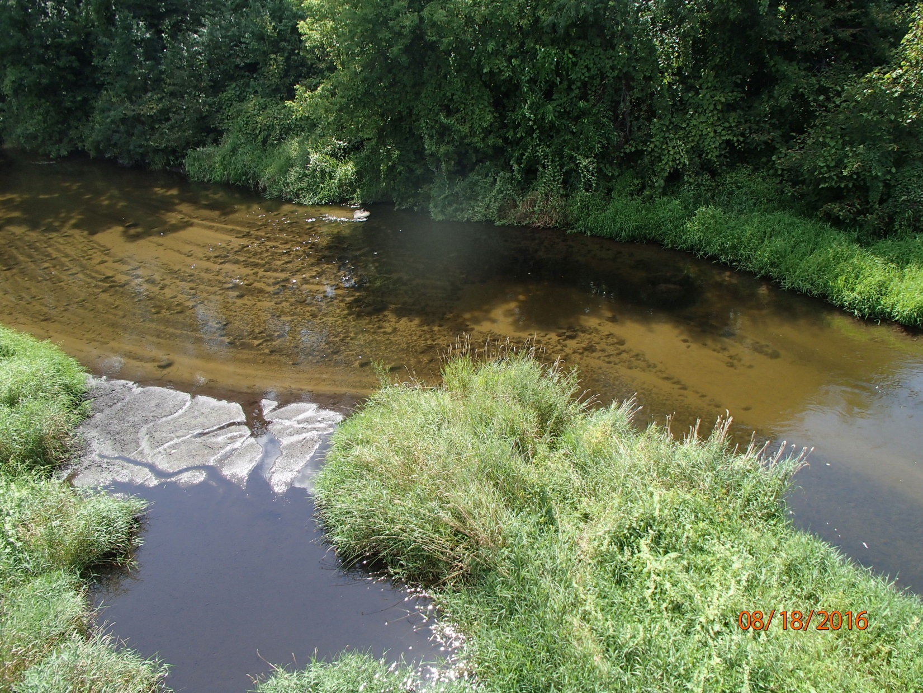
Photo 1: Tomorrow River at Hwy 10 facing downstream. Photo taken by D. Bolha on August 18th, 2016.

Between June and September 2016, 27 sites in the Tomorrow-Waupaca River Watershed were surveyed for representative fish communities (Map 1-4, Photo 2). Some fish species are tolerant of environmental degradation, while some species are moderately tolerant, and some others are intolerant. Based upon the representative fish collected during the survey and their associated tolerance to environmental degradation, an Index of Biotic Integrity (FIBI) was calculated to indicate the water quality of each creek or river (Table 13, Chart 9-10). The FIBI scores ranged from 30 in the Unnamed Tributary to the Waupaca River at Hwy 54 to 100 in the Tomorrow-Waupaca River (Table 13, Chart 9-10). The Condition Category for the 26 sites ranged from Poor to Excellent. All 11 fish surveys in the Tomorrow-Waupaca River Mainstem indicate a Condition Category of Good to Excellent, with the FIBI scores ranging from 70 to 100. The Tomorrow-Waupaca River tributary fish survey scores ranged from 30 to 100. Eight of the 16 tributary sites demonstrated a Condition Category of Excellent (Table 13, Chart 10). Five tributaries had a Condition Category of Good, while 2 sites showed a Condition Category of Fair. The Unnamed Tributary to the Waupaca River at Hwy 54 was the only site to have a Condition Category of Poor based upon the fish surveys (Table 13, Chart 10).

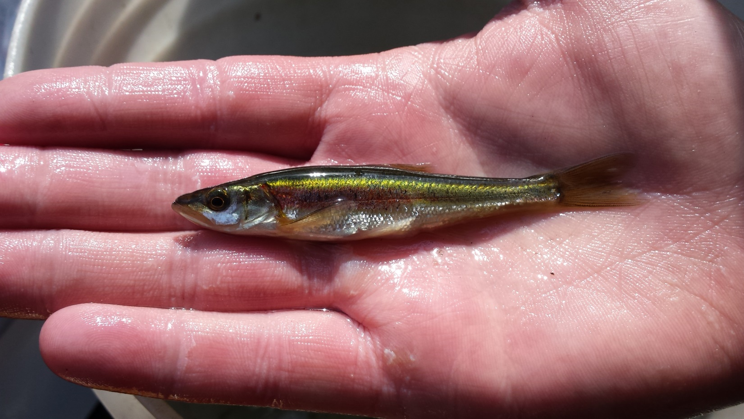
Photo 2: Wisconsin Special Concern Species Redside Dace Collected During an FIBI Survey in Bear Creek Upstream of Fountain Grove Road, Portage County. Photo taken by D. Bolha on July 20th, 2016.

Each fish community surveyed was used to verify or update the modeled Natural Community for that stream segment. Each of the 15 tributary streams’ Natural Community was verified or changed based upon the fish caught in the survey (and any historical known surveys in that stream segment). Verifying or changing the modeled Natural Community was important since the Natural Community determines which FIBI was used to determine the water quality of that stream segment. The results of the FIBI calculations displayed in Table 13 and Charts 9-10 are based upon the verified or changed Natural Community.

SWIMS Station ID | Site Name | Fish IBI Score | Condition Category | Natural Community
10047114 | Tomorrow River @ Hwy 66 | 100 | Excellent | Cool-Cold Headwater
10044275 | Tomorrow R. @ Merryland Dr. | 100 | Excellent | Cool-Warm Headwater
10046913 | Tomorrow R. US Cty I | 90 | Excellent | Cool-Cold Mainstem
10047118 | Tomorrow R. DS Cty I | 80 | Excellent | Cool-Cold Mainstem
10011033 | Tomorrow R. @ Richard Hemp Fishery Area | 70 | Good | Coldwater
10036969 | Tomorrow R. @ Lake Meyers Rd | 100 | Excellent | Cool-Cold Mainstem
10044318 | Tomorrow R. @ Keener Rd | 100 | Excellent | Cool-Cold Mainstem
10013567 | Tomorrow R. @ West Buchholtz Rd. | 100 | Excellent | Cool-Cold Mainstem
10007975 | Waupaca R. @ Cobbtown Rd. | 100 | Excellent | Cool-Cold Mainstem
10021989 | Waupaca R. @ Anderson Rd. | 100 | Excellent | Cool-Cold Mainstem
693224 | Waupaca R. @ Weyauwega Dam | 100 | Excellent | Cool-Warm Mainstem
10043985 | Poncho Cr. @ River Rd. | 90 | Excellent | Coldwater
10042016 | Stoltenburg Cr. @ Cty Rd. SS | 80 | Good | Coldwater
10039724 | Bear Cr. @ Fountain Grove Rd. | 80 | Excellent | Cool-Cold Mainstem
10039114 | Mack Cr. @ Maves Rd. | 80 | Excellent | Coldwater
10044738 | Mack Cr. @ Spring Lake Rd | 70 | Good | Coldwater
10044739 | Upper Spring Cr. US Cty Hwy Q | 70 | Good | Cool-Cold Headwater
503171 | Spring Cr. @ Cty Rd. D | 100 | Excellent | Cool-Cold Mainstem
10038446 | Stedman Cr. @ Cty Rd. D | 80 | Good | Coldwater
10042816 | Crystal R. @ Sanders Rd | 100 | Excellent | Cool-Warm Mainstem
10016457 | Crystal R. @ Shadow Lake Rd | 100 | Excellent | Cool-Warm Mainstem
10029308 | Crystal R. Below Cary Millpond | 80 | Excellent | Warm Mainstem
10013685 | Radley Cr. @ Dayton Rd. | 100 | Excellent | Cool-Cold Mainstem
10022518 | Emmons Cr. @ West Rd. | 70 | Good | Coldwater
693117 | Hartman Cr. @ Rural Rd. | 45 | Fair | Warm Mainstem
10045054 | Un Trib to Waupaca R. US Hwy 54 | 30 | Poor | Cool-Warm Headwater
10044777 | Un Trib to Waupaca R. US Den Ed Rd. | 40 | Fair | Cool-Cold Headwater
Table 13: Fish Survey Results in the Tomorrow-Waupaca River Watershed Conducted in 2016.

Chart 9: Fish Survey Results for the Tomorrow-Waupaca River in June through September 2016.

Chart 10: Fish Survey Results for the Tomorrow-Waupaca River Tributaries in June through September 2016.

Water temperature data in Fahrenheit (F) was collected from May through October 2016 at 31 locations in the Tomorrow-Waupaca River Watershed (Table 14-15, Chart 11-12, Map 1-4). Monthly average temperatures were reported for months with complete data only. The temperatures at the sites monitored in 2016 during the time of deployment ranged from 39.9F in the Tomorrow River at Hwy 66 on 5/15/2016 to 80.7F in the Waupaca River below the Weyauwega Lake dam on 7/26/2016. The average monthly temperatures ranged from 54.9F in Poncho Creek at River Road in September to 74.5F in the Waupaca River below the Weyauwega Lake dam in July and August (Table 14-15, Chart 11-12). The Maximum Daily Averages (MDM) ranged from 62.3F in Mack Creek at Spring Lake Rd to 78.4F in the Waupaca River below the Weyauwega Lake dam (Table 14-15, Chart 11-12).

Location | June Average Temperature | July Average Temperature | August Average Temperature | September Average Temperature | Maximum Daily Average Temperature
Tomorrow R. @ Hwy 66 | 61.3 | 63.3 | 63.0 | -- | 67.2
Tomorrow R. @ Merryland Dr. | 65.3 | 68.4 | 67.5 | 61.0 | 73.1
Tomorrow R. US Cty I | 64.2 | 65.8 | 65.0 | 59.7 | 70.3
Tomorrow R. DS Cty I | 64.6 | 66.5 | 65.6 | 60.1 | 70.9
Tomorrow R. @ Richard Hemp Fishery Area | 62.5 | 63.2 | 62.6 | -- | 68.7
Tomorrow R. @ Clementson Rd | 59.2 | 59.2 | 58.8 | 55.9 | 64.4
Tomorrow R. @ Hwy 161 | 59.1 | 59.1 | 58.7 | -- | 64.1
Tomorrow R. @ Lake Meyers Rd | 60.0 | 60.3 | 59.8 | -- | 65.1
Tomorrow R. @ Cty V Amherst | 62.6 | 63.2 | 62.9 | -- | 68.3
Tomorrow R. @ Keener Rd | 63.4 | 64.4 | 64.1 | 59.8 | 69.4
Tomorrow R. Double Hwy 10 Crossing West Buchholtz Rd. | 64.5 | 66.0 | 65.4 | 60.4 | 70.7
Tomorrow R. @ Cty T | 64.2 | 65.5 | 65.1 | -- | 70.7
Tomorrow R. @ Cty D and DD | 64.9 | 66.6 | 66.0 | -- | 71.1
Waupaca R. @ Cobbtown Rd. | 65.0 | 66.7 | 66.1 | 60.6 | 71.2
Waupaca R. @ Anderson Rd. | 66.2 | 68.2 | 67.6 | 61.4 | 72.5
Waupaca R. @ Harrington Rd. | 68.9 | 71.8 | 71.4 | 63.8 | 75.7
Waupaca R. @ Weyauwega Dam | -- | 74.5 | 74.5 | 66.8 | 78.4
Table 14: Monthly Average and Maximum Daily Average Temperatures in the Tomorrow-Waupaca River in 2016.

Location | June Average Temperature | July Average Temperature | August Average Temperature | September Average Temperature | Maximum Daily Average Temperature
Poncho Cr. @ River Rd. | 56.7 | 57.3 | 57.1 | 54.9 | 62.8
Stoltenburg Cr. @ Cty SS | 61.6 | 62.8 | 62.7 | 58.4 | 68.0
Bear Cr. @ Fountain Grove Rd. | 65.2 | 66.8 | 66.2 | 60.5 | 70.7
Mack Cr. @ Maves Rd. | 60.8 | 62.0 | 63.1 | 59.3 | 68.6
Mack Cr. @ Spring Lake Rd | 55.5 | 56.7 | 56.9 | 55.3 | 62.3
Upper Spring Cr. US Cty Q | 56.8 | 57.1 | 56.8 | 56.0 | 63.7
Stedman Cr. @ Cty D | 58.3 | 59.0 | 59.0 | 56.3 | 64.2
Crystal R. @ Sanders Rd | 67.8 | 70.0 | 69.6 | 63.4 | 73.1
Crystal R. @ Shadow Lake Rd | 68.6 | 71.0 | 70.6 | 64.0 | 74.2
Crystal R. Below Cary Millpond | 70.2 | 72.7 | 72.3 | 65.0 | 76.8
Radley Creek @ Dayton Rd. | 61.1 | 62.4 | 62.4 | 58.4 | 66.6
Emmons Cr. @ West Rd. | 58.3 | 59.4 | 59.2 | 56.1 | 63.7
Hartman Cr. @ Rural Rd. | 66.6 | 68.7 | 68.6 | 63.1 | 72.1
Un Trib to Waupaca R. US Den Ed Rd. | 62.5 | 63.2 | 64.2 | 61.2 | 67.3
Table 15: Monthly Average and Maximum Daily Average Temperatures in the Tomorrow-Waupaca River Tributaries in 2016.

Chart 11: Monthly Average and Maximum Daily Average Temperatures in the Tomorrow-Waupaca River in 2016.

Chart 12: Monthly Average and Maximum Daily Average Temperatures in the Tomorrow-Waupaca River Tributaries in 2016.

Between June and September 2016, qualitative habitat surveys were conducted at 26 locations in the Tomorrow-Waupaca River Watershed (Map1-4, Table 5). Qualitative habitat assessments rapidly evaluate a representative stream reach (35 X Mean Stream Width) for the quantity and quality of habitat for game fish and compare the habitat to reference streams in Wisconsin. Based upon the assessment data collected during the 2016 surveys, a habitat rating was calculated for the 26 locations (Table 16, Chart 13-14). The qualitative habitat scores ranged from 20 in Stedman Creek at County D to 90 in the Crystal River below the Carey Millpond dam (Table 16, Chart 14). Six of the 26 habitat assessments demonstrated a habitat Condition Category of Excellent. Of the 26 locations, 14 surveys demonstrated a habitat Condition Category of Good, with scores ranging from 53-73. A Fair Condition Category was indicated at 5 assessment locations. Stedman Creek at County D was the only location to receive a Condition Category of Poor based upon the habitat assessment.

SWIMS Station ID | Site Name | Qualitative Habitat Score | Condition Category
10047114 | Tomorrow River @ Hwy 66 | 45 | Fair
10044275 | Tomorrow R. @ Merryland Dr. | 48 | Fair
10046913 | Tomorrow R. US Cty I and US Studzinski Farm | 63 | Good
10047118 | Tomorrow R. DS CTY I | 63 | Good
10011033 | Tomorrow R. @ Richard Hemp Fishery Area | 80 | Excellent
10036969 | Tomorrow R. @ Lake Meyers Rd | 82 | Excellent
10044318 | Tomorrow R. @ Keener Rd | 60 | Good
10013567 | Tomorrow R. @West Buchholtz Rd. | 56 | Fair
10007975 | Waupaca R. @ Cobbtown Rd. | 65 | Good
10021989 | Waupaca R. @ Anderson Rd. | 48 | Fair
10043985 | Poncho Cr. @ River Rd. | 63 | Good
10042016 | Stoltenburg Cr. @ Cty Rd. SS | 65 | Good
10039724 | Bear Cr. @ Fountain Grove Rd. | 55 | Good
10039114 | Mack Cr. @ Maves Rd. | 63 | Good
10044738 | Mack Cr. @ Spring Lake Rd | 73 | Good
10044739 | Upper Spring Cr. US Cty Hwy Q | 58 | Good
503171 | Spring Cr. @ Cty Rd. D | 73 | Good
10038446 | Stedman Cr. @ Cty Rd. D | 20 | Poor
10045054 | Un Trib to Waupaca R. US Hwy 54 | 53 | Good
10044777 | Un Trib to Waupaca R. US Den Ed Rd. | 43 | Fair
693117 | Hartman Cr. @ Rural Rd. | 65 | Good
10022518 | Emmons Cr. @ West Rd. | 75 | Excellent
10013685 | Radley Cr. @ Dayton Rd | 82 | Excellent
10042816 | Crystal R. @ Sanders Rd. | 73 | Good
10016457 | Crystal R. @ Shadow Lake Rd. | 82 | Excellent
10029308 | Crystal R. below dam in Waupaca | 90 | Excellent
Table 16: Qualitative Habitat Survey Scores and Condition Categories for theTomorrow-Waupaca River Watershed in 2016.

Chart 13: Qualitative Habitat Survey Scores and Condition Categories for the Tomorrow-Waupaca River in 2016.

Chart 14: Qualitative Habitat Survey Scores and Condition Categories for the Tomorrow-Waupaca River Tributaries in 2016.

Discussion

The purpose of this project was to evaluate water quality improvements made in the Tomorrow-Waupaca River Watershed from Best Management Practices installed in the watershed from 1995 through 2008 and determine if the goals of the 1995 Tomorrow-Waupaca River Priority Watershed Project were met. The overall goal for the Priority Watershed Project was to enhance and protect the water quality of the surface water and groundwater in the watershed. Nutrient samples, aquatic biological community evaluations, temperature analyses, and habitat assessments were conducted to determine the water quality of the Tomorrow-Waupaca River Watershed. The nutrient, aquatic macroinvertebrate, and fish monitoring in this project demonstrated that the water quality in the Tomorrow-Waupaca River Watershed is between poor and excellent condition.

The Tomorrow-Waupaca River Watershed drains a 291 square-mile watershed before discharging into the Wolf River near Weyauwega, Wisconsin. The Tomorrow-Waupaca River Watershed is located within Portage, Waupaca, and Waushara Counties. The Tomorrow River originates near Rosholt, WI, about 15 miles northeast of Stevens Point and flows southeast approximately 63 miles until its confluence with the Wolf River (Map 1-4). There are 468 named and unnamed stream miles along with over 2,132 acres of lakes and ponds in the watershed. The watershed is dominated by agricultural land use at 48%, while 35% is wooded. Less than 3% is considered urban and suburban. Typically, as increases in agricultural land use occur, there is a correlating increase in TP and TN concentrations in creeks in the watersheds in Wisconsin. The Winnebago Comprehensive Management Plan (WDNR 1989) rated the Tomorrow-Waupaca Watershed a medium priority watershed due to the critical local surface water problems from animal waste and high for the risk of groundwater contamination. The greatest overall water quality threat in the watershed is excess nutrients, specifically nitrates, entering groundwater (WDNR 1995). Nitrates and phosphorus infiltrate into the groundwater due to the high sandy soil permeability.

Between March and November 1994, biological, physical and chemical monitoring was conducted by the WDNR, Portage and Waupaca County LWCDs, and University of Wisconsin-Stevens Point to summarize the existing conditions of the surface waters in the Tomorrow-Waupaca River Watershed prior to the implementation of the Priority Watershed Project. In early 1995, the “Tomorrow/Waupaca River Priority Watershed Surface Water Resources Appraisal Report” and the “Tomorrow/Waupaca River Priority Watershed Groundwater Resource Appraisal Report” were prepared by WDNR staff Jim Klosiewski and Charles Weister, respectively (WDNR 1995), documenting the sampling effort in 1994. A comparison of the 1994 data to the data that was collected in 2016 can provide some indication of water quality changes over time as a result of the Priority Watershed Project.

In 1994, NO₃+NO₂ as N concentration data were collected during baseflow conditions on March 1st (WDNR 1995) (Table 17, Chart 15). Baseflow can be described as the contribution which groundwater flow makes in sustaining water yields in a stream during periods of no rainfall. In 2016, baseflow NO₃+NO₂ as N conditions (typically August and October) were monitored as part of this project. If multiple sampling events were conducted during baseflow conditions in 2016, then the average concentration was calculated for that set of monitoring results (Table 17, Chart 15).

The concentrations of NO₃+NO₂ as N varied from year to year and from location to location during baseflow conditions in the Tomorrow-Waupaca River Watershed. The change in average baseflow NO₃+NO₂ as N concentrations in the Tomorrow-Waupaca River Mainstem in 2016 ranged from a 6.7% increase at Clementson Rd to a 35.3% decrease below the Lake Weyauwega Dam from the 1994 Watershed Appraisal concentrations (Table 17, Chart 15). The changes in baseflow NO₃+NO₂ as N concentrations in tributaries of the watershed ranged from a 130.7% increase at the Unnamed Tributary to the Waupaca River at Den-Ed Rd to a decrease of 18.4% in Spring Creek at County D from the 1994 concentration. The Tomorrow River at Amherst and the Waupaca River at Anderson Rd maintained relatively similar concentrations from pre-BMP to the 2016 baseflow concentrations. The 2016 baseflow NO₃+NO₂ as N increased slightly at Clementson Rd on the Tomorrow River; conversely, a significant decrease was documented in the Waupaca River at Riverside Park in Waupaca and below the Lake Weyauwega Dam in Weyauwega. Poncho and Stoltenberg Creeks maintained relatively similar concentrations from pre-BMP to the 2016 baseflow concentrations. Spring and Emmons Creeks and the Crystal River significantly decreased in baseflow NO₃+NO₂ as N concentration from 1994 to the 2016 baseflow concentrations. Radley, Murry, and Hartman Creeks significantly increased in baseflow NO₃+NO₂ as N concentration from pre to post Priority Watershed implementation. In the 1995 Nonpoint Source Control Plan for the Tomorrow-Waupaca River Priority Watershed Project, one of the primary objectives was to achieve NO₃+NO₂ as N levels in all groundwater-fed streams to below the 1995 WDNR preventative action limit (PAL) of 2.0 mg/L (WDNR 1995) (Chart 15). Baseflow monitoring in the groundwater-fed streams of the watershed indicate NO₃+NO₂ as N concentrations above 2.0 mg/L (Table 17).

Location | 1994 Baseflow  NO2 + NO3 (N) | Average 2016 Baseflow  NO2 + NO3 (N) | % Change in Baseflow Concentration
Tomorrow River @ Clementson Rd | 2.82 | 3.01 | 6.7
Tomorrow River @ Amherst | 3.73 | 3.78 | 1.2
Waupaca River @ Anderson Rd | 3.32 | 3.27 | -1.5
Waupaca River @ Riverside Park | 3.45 | 2.86 | -17.1
Waupaca River Below Lake Weyauwega Dam | 2.96 | 1.91 | -35.5
Poncho Creek @ River Rd | 2.58 | 2.55 | -1.2
Stoltenberg Creek @ County SS | 3.72 | 3.81 | 2.4
Spring Creek @ D | 3.12 | 2.55 | -18.4
Crystal River @ County E | 2.59 | 2.19 | -15.4
Radley Creek @ Dayton Rd | 3.51 | 4.39 | 25.1
Emmons Creek @ West Rd | 2.48 | 2.29 | -7.9
Murry Creek @ West Rd | 2.77 | 3.15 | 13.7
Hartman Creek @ Rural Road | 0.94 | 1.1 | 17.7
Un Trib to Waupaca River @ Den-Ed Rd | 4.9 | 11.3 | 130.6
Table 17: Pre-existing and Post Priority Watershed Project NO2 + NO3 as N Concentrations during Baseflow Conditions in the Tomorrow-Waupaca River Watershed.

Chart 15: Pre and Post Priority Watershed Project NO2 + NO3 as N Concentrations during Baseflow Conditions in the Tomorrow-Waupaca River Watershed. Orange line indicates the 1995 Preventative Action Limit (PAL) for NO₃+NO₂ as N and goal for baseflow in groundwater-fed streams.

An impairment assessment was conducted to verify whether the Tomorrow-Waupaca River Watershed TP concentrations meet the Wisconsin Administrative Code ch. NR 102 WQC or if the waterbodies should be placed on the United States Environmental Protection Agency Clean Water Act Section 303d Impaired Waters List (CWA 303d IWL). The sampling requirements to demonstrate if WQC for TP were being met, clearly exceeded, or overwhelmingly exceeded were accomplished through this project. The impairment assessment protocol requires a parametric statistical approach to assess stream and river TP data against the applicable water quality criterion found in NR 102 (WisCALM 2016). This approach involves the calculation of a 90% confidence limit around the median of a TP sample dataset. If the lower 90% confidence limit (LCL) exceeds the criterion for TP, then that stream or river segment (assessment unit) is considered to be exceeding the criterion. The LCLs were calculated for each complete set of TP samples (Table 18). All of the Tomorrow-Waupaca River Mainstem sample sets met the WQC of 0.075mg/L. One of the fourteen tributary LCLs exceeded (LCL of >0.075mg/L) the water quality criterion for TP (Table 18, Chart 16). The Unnamed Tributary to the Waupaca River at Den-Ed Rd will be recommended for the 2020 CWA 303d IWL due to the pollutant phosphorus.

Location | TP Lower 90%  Confidence Limit
Tomorrow River @ Merryland Dr | 0.0238
Tomorrow River @ Clementson Rd | 0.0215
Tomorrow River @ Hwy V Amherst | 0.0367
Tomorrow River @ Buchholtz Rd | 0.0350
Waupaca River @ Cobbtown Rd | 0.0325
Waupaca River @ Anderson Rd | 0.0354
Waupaca River @ Riverside Park in Waupaca | 0.0324
Waupaca River Below Weyauwega Dam | 0.0343
Poncho Creek @ River Rd | 0.0204
Stoltenberg Creek @ County SS | 0.0663
Mack Creek @ Spring Lake Rd | 0.0339
Upper Spring Creek @ County Q | 0.0254
Spring Creek @ D | 0.0220
Stedman Creek @ D | 0.0210
Crystal River @ Shadow Lake Rd | 0.0206
Crystal River @ County E | 0.0192
Crystal River Below Cary Millpond | 0.0197
Radley Creek @ Dayton Rd | 0.0275
Emmons Creek @ West Rd | 0.0196
Murry Creek @ West Rd | 0.0240
Hartman Creek @ Rural Road | 0.0193
Un Trib to Waupaca River @ Den-Ed Rd | 0.0822
Table 18: Total Phosphorus Lower 90% Confidence Limits in the Tomorrow-Waupaca River Watershed in 2016.

Chart 15: Total Phosphorus Lower 90% Confidence Limits in the Tomorrow-Waupaca River Watershed in 2016. Red line indicates the NR 102 WQC for Total Phosphorus for the Tomorrow-Waupaca River and its Tributaries.
In 1994, aquatic macroinvertebrate surveys were conducted at 16 locations in the Tomorrow-Waupaca River Watershed (WDNR 1995). The WDNR aquatic macroinvertebrate protocol was followed during the surveys (WDNR 2000); thus, the biotic index scores from 1994 can be compared with the surveys conducted in 2016 as part of this project. Fifteen of the 16 locations surveyed in 1994 were close enough to the locations in this project for comparison to the 2016 surveys (Table 20, Chart 16-17). At the time of the 1994 surveys, William Hilsenhoff’s 1982 “Using a Biotic Index to Evaluate Water Quality in Streams” was referenced to calculate the Family Biotic Index (FBI) score and water quality condition category for each aquatic macroinvertebrate sample. For the FBI score, the lower the score, the better the condition category (Table 19).

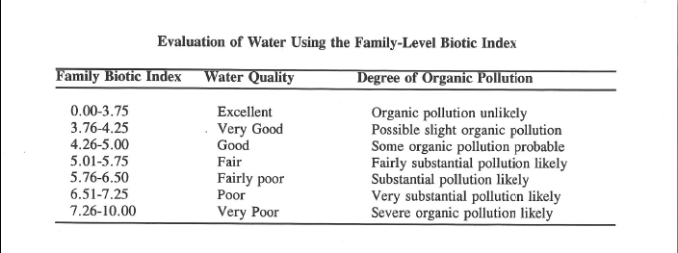
Table 19: William Hilsenhoff’s 1982 Macroinvertebrate Family Biotic Index Score Scale and Water Quality Condition Categories.

In addition, the 2016 samples were given a FBI score and condition category (Table 20, Chart 16-17). The largest decrease, thus water quality improvement, observed between 1994 and 2016 was in Poncho Creek at River Rd (-1.22). The largest increase in FBI score and water quality degradation was in Hartman Creek at Rural Rd (2.68). Six of the 15 2016 FBI scores were similar (+<0.70) when compared to the 1994 FBI scores (Table 19, Chart 16-17). The 2016 FBI score of the sample collected upstream of County I from the Tomorrow-Waupaca River Mainstem remained similar to the 1994 sample. However, the samples downstream of County I and the Lake Weyauwega Dam showed significant decreases in water quality score. Two of the 12 tributary samples showed significant increases in water quality condition (Poncho and Stoltenberg Creeks) (Table 20, Chart 17). Five of the 12 tributaries were similar from 1994 to 2016; while, 5 demonstrated a decrease in water quality condition (Table 20, Chart 17).

Location | 1994 FBI Score | 2016 FBI Score | Difference of 1994 and 2016 FBI Scores | 1994 Condition Category | 2016 Condition Category
Tomorrow River @ Merryland Rd | -- | 4.47 | -- | -- | Good
Tomorrow River US County I | 2.78 | 3.02 | 0.24 | Excellent | Excellent
Tomorrow River DS County I | 3.26 | 3.98 | 0.72 | Excellent | Good
Tomorrow River @ Cty V Amherst | -- | 5.65 | -- | -- | Fair
Tomorrow River @ West Buchholz Rd | -- | 3.97 | -- | -- | Very Good
Waupaca River @ Cobbtown Rd | -- | 3.4 | -- | -- | Excellent
Waupaca River @ Anderson Rd | -- | 3.85 | -- | -- | Very Good
Waupaca River @ Riverside Park | 2.7 | -- | -- | Excellent | --
Waupaca River DS Weyauwega Dam | 5.49 | 7.24 | 1.75 | Fair | Poor
Poncho Creek @ River Rd | 4.64 | 3.42 | -1.22 | Good | Excellent
Stoltenberg Creek DS County SS | 6.0 | 5.13 | -0.87 | Fairly Poor | Fair
Mack Creek DS Maves Rd | 3.91 | 4.61 | 0.7 | Very Good | Good
Mack Creek @ Spring Lake Rd | -- | 3.81 | -- | -- | Very Good
Spring Creek @ County D | 3.12 | 3.5 | 0.38 | Excellent | Excellent
Upper Spring Creek @ County Q | -- | 3.72 | -- | -- | Excellent
Stedman Creek @ County D | 3.70 | 3.92 | 0.22 | Excellent | Very Good
Bear Creek @ Fountain Grove Rd | 4.57 | 4.74 | 0.17 | Good | Good
Hartman Creek @ Rural Rd | 2.8 | 5.48 | 2.68 | Excellent | Fair
Emmons Creek @ West Rd | 3.08 | 3.56 | 0.48 | Excellent | Excellent
Murry Creek @ West Rd | 3.61 | 4.31 | 0.7 | Excellent | Good
Radley Creek @ Dayton Rd | 2.6 | 4.64 | 2.04 | Excellent | Good
Crystal River @ Hwy 22 | -- | 5.34 | -- | -- | Fair
Crystal River @ Sanders Rd | 3.36 | 3.62 | 0.25 | Excellent | Excellent
Crystal River @ Shadow Lake Rd | 3.0 | 4.31 | 1.31 | Excellent | Very Good
Crystal River @ County E | -- | 4.58 | -- | -- | Good
Crystal River Below Cary Millpond | -- | 3.98 | -- | -- | Very Good
Un Trib to Waupaca R. US Hwy 54 | -- | 5.63 | -- | -- | Fair
Un Trib to Waupaca R. US Den Ed Rd. | -- | 4.34 | -- | -- | Good
Table 20: Comparison of 1994 Family Biotic Index Scores to 2016 Family Biotic Index Scores at 28 Locations in the Tomorrow-Waupaca River Watershed.

Chart 16: Comparison of 1994 Macroinvertebrate Family Biotic Index Scores (Left Column) to 2016 Family Biotic Index Scores (Right Column) in the Tomorrow-Waupaca River.

Chart 17: Comparison of 1994 Macroinvertebrate Family Biotic Index Scores (Left Column) to 2016 Family Biotic Index Scores (Right Column) in the Tomorrow-Waupaca River Tributaries.

Conclusions

The water quality monitoring in 2016 demonstrated some water quality improvements and declines in the surface waters of the watershed since the implementation of the Priority Watershed Project of the late 1990s and early 2000s. The upper portions of the Tomorrow River maintained its excellent aquatic macroinvertebrate communities and indicated comparable concentrations in baseflow NO₃+NO₂ as N. The fish communities throughout the Tomorrow-Waupaca River Mainstem indicate good to excellent water quality. The aquatic macroinvertebrates in the Waupaca River Mainstem demonstrate a decrease in water quality from upstream of Lake Weyauwega to downstream and from 1994 to 2016. Water quality monitoring indicates the two Unnamed Tributaries to the Waupaca River near Lake Weyauwega are not meeting their potential uses, demonstrate high nutrient concentrations, and sedimentation which limits available fish and aquatic macroinvertebrate habitat. The observed concentrations of TN throughout the watershed indicate levels above reference conditions and response thresholds in wadable streams in this area of Wisconsin (Robertson et. al. 2006). One of the goals of the Priority Watershed Project was to bring NO₃+NO₂ as N concentrations in groundwater-fed streams to the PAL of 2 mg/L (WDNR 1995). As demonstrated by the monitoring in 2016, the baseflow NO₃+NO₂ as N concentrations were above 2 mg/L in many of the groundwater-fed streams (Table 17, Chart 15). Therefore, the need for improvements remains throughout portions of the Tomorrow-Waupaca River Watershed.

There are a few challenges to consider when comparing the pre-Priority Watershed monitoring results with the results of 2016. First, the majority of the BMPs installed during the Priority Watershed Project implementation were soft practices (tillage and nutrient management). These practices may have been discontinued by the farmers in the watershed. Second, there may be unaccounted farming changes, such as fertilizer application rates and tillage adjustments throughout the watershed over time, that had an impact on the water quality of the Tomorrow-Waupaca River and its tributaries observed in 2016. Thirdly, there may have been an increase in the land disposal of manure within the watershed since the beginning of the Priority Watershed Project. Lastly, watershed improvements may have been made since the implementation of the Priority Watershed that impacted the water quality observed in 2016. Therefore, the monitoring in 2016 does not solely reflect the changes in the watershed from the Priority Watershed Project implementation.

The BMPs that were implemented during the Priority Watershed Project were nutrient, residue, and barnyard-runoff management, streambank shaping, and manure storage throughout the watershed. Some of the land use characteristics observed during the 2016 monitoring project that can have a negative impact to the water quality of the Tomorrow-Waupaca River and its tributaries were limited buffer protection along the stream corridors, eroding streambanks, cropland erosion, channelization, cattle access, tile drainage, thermal and organic load impacts from impoundments, presence of aquatic invasive species, and sedimentation of fish and aquatic life habitat (Photo 3-5). Although good efforts were made to decrease the pollutant load during the Priority Watershed implementation, there are more opportunities to install practices to lower the nutrients and sediment reaching the Tomorrow-Waupaca River.
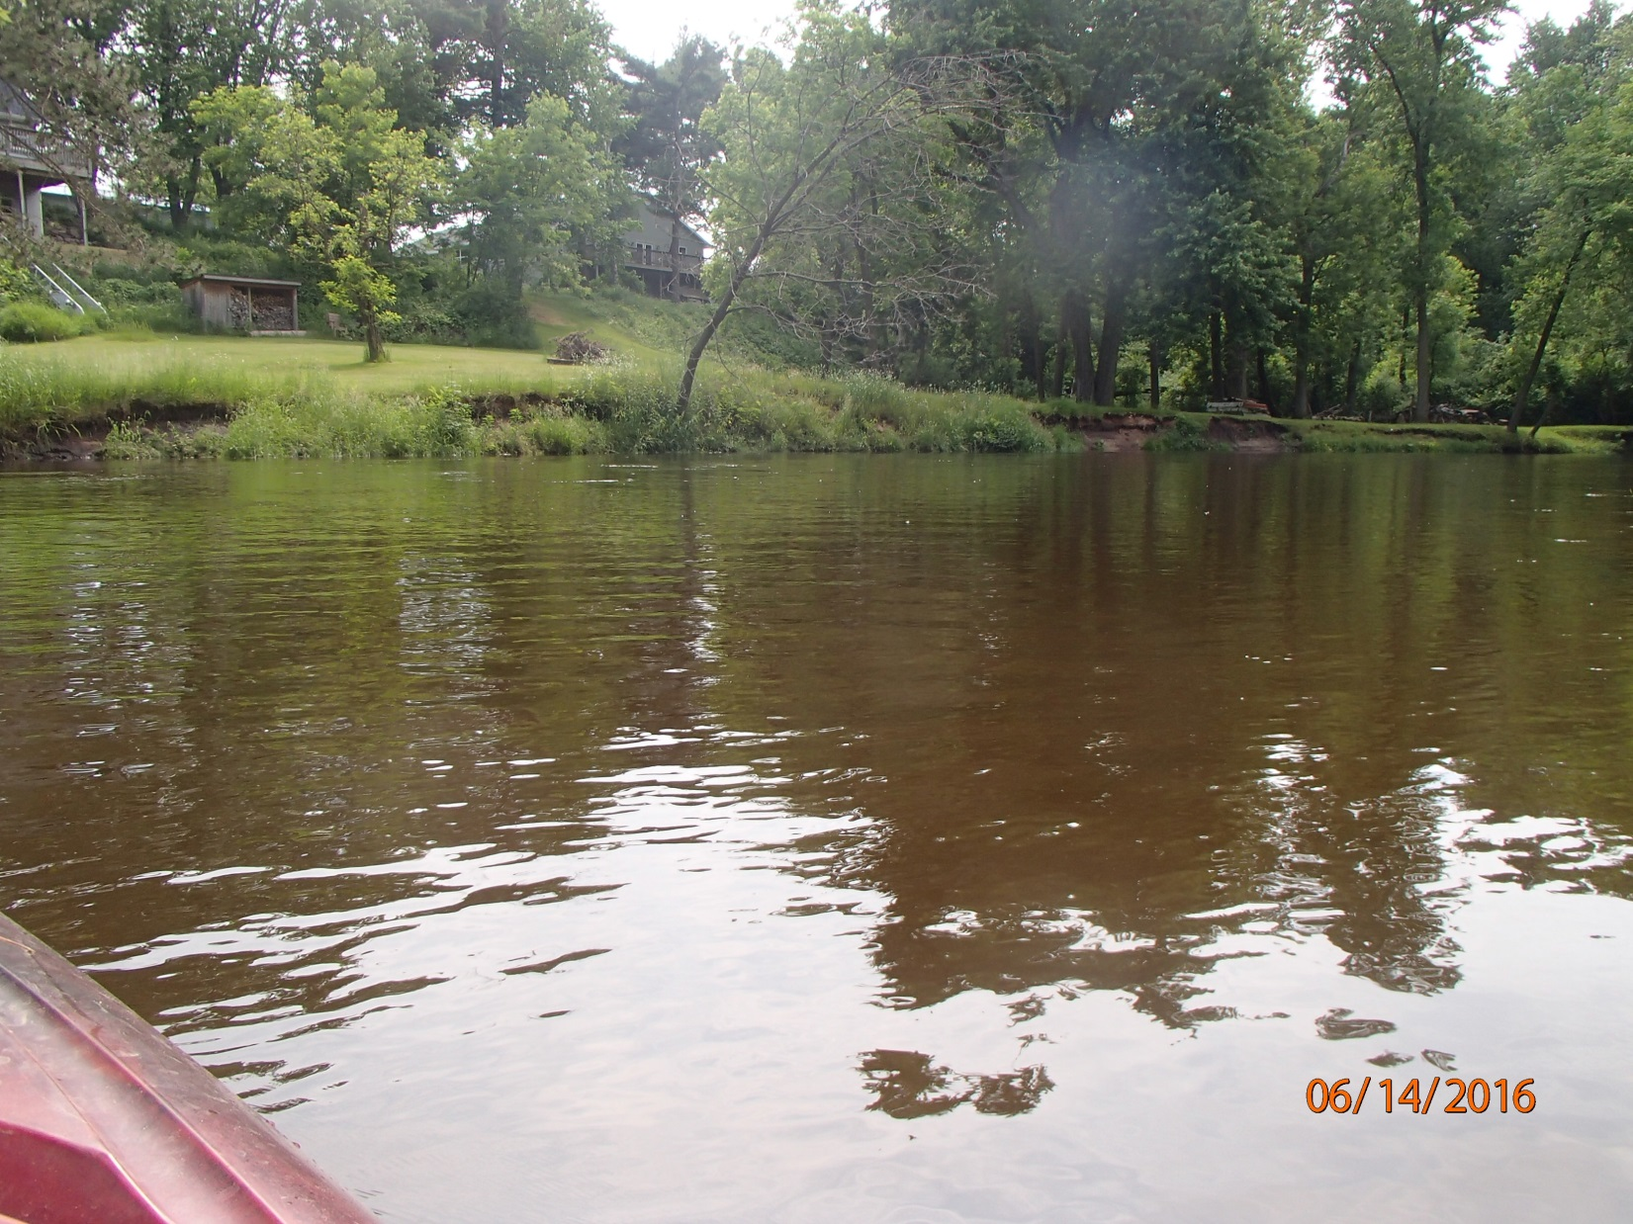
Photo 3: Waupaca River Downstream of Lake Weyauwega. Photo taken by D. Bolha on June 14th, 2016.

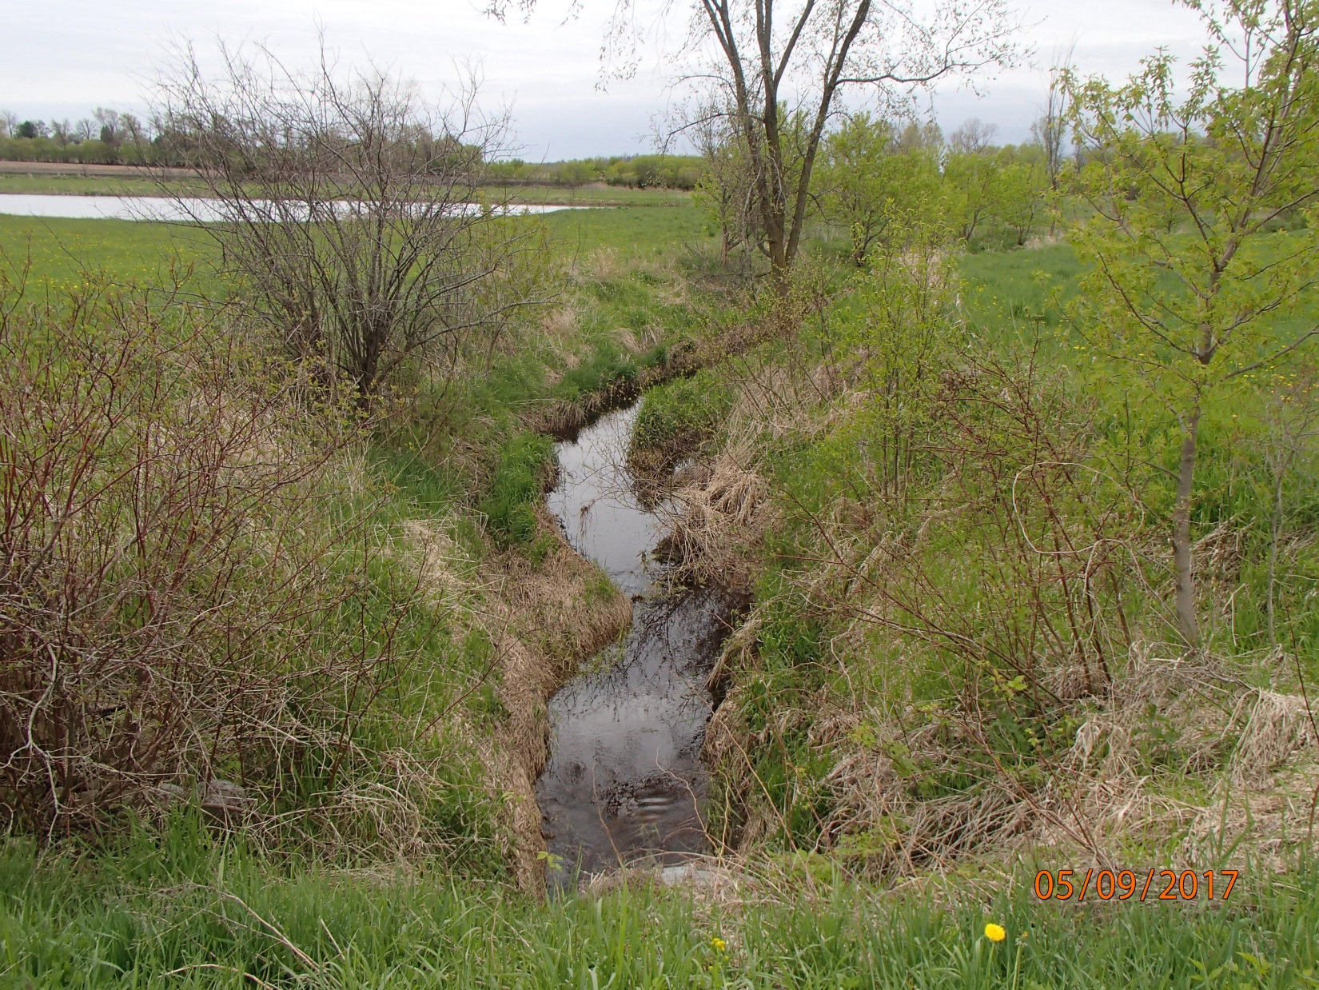
Photo 4: Unnamed Tributary to the Waupaca River at Galilee Road near Weyauwega. Photo taken by D. Bolha on May 9th, 2017.

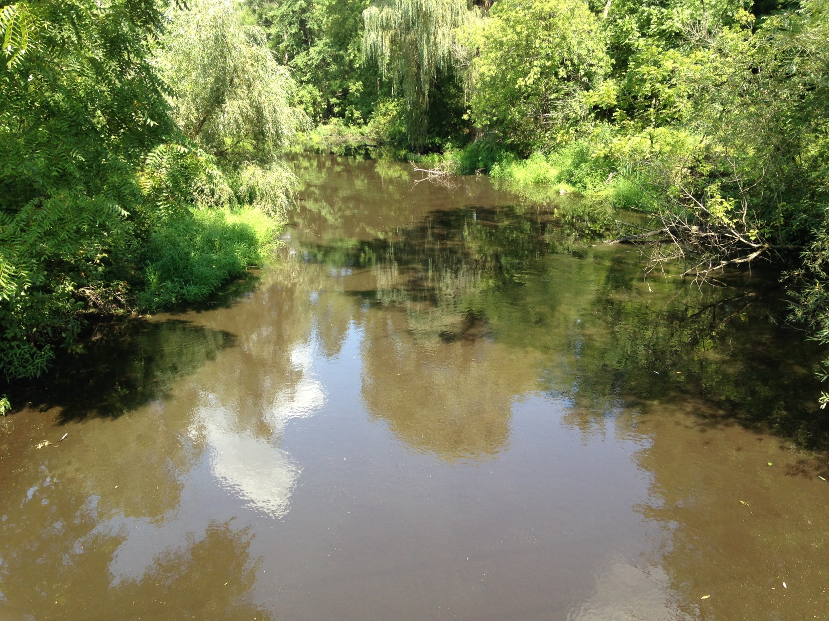
Photo 5: Tomorrow River Dowstream of Amherst Millpond at Washington Street/County V. Photo taken by D. Bolha on August 18th, 2016.

References

Cook, R.C. 2000. Relationships between private well water, stream base flow water, and land use in the Tomorrow-Waupaca River Watershed. M.S. Thesis. University of Wisconsin Stevens Point.

Miller, et. al. 2014. Field Guide to Wisconsin Streams: Plants, Fishes, Invertebrates, Amphibians, and Reptiles.

NOAA (National Oceanic and Atmospheric Administration). 2016. Precipitation data, accessed October 2017, at http://water.weather.gov/precip/.

USGS (United States Geological Survey) (Robertson, D.M. et. al.). 2006. Nutrient Concentrations and Their Relations to the Biotic Integrity of Wadeable Streams in Wisconsin.

USGS (United States Geological Survey). 2016. Real-time data for USGS Station 04080798 Tomorrow River Near Nelsonville, WI USGS Water Resources of Wisconsin. Accessed June 6th, 2017.

USGS (United States Geological Survey). 2016. Real-time data for USGS Station 04081000 Waupaca River Near Waupaca, WI. USGS Water Resources of Wisconsin. Accessed September 29th, 2017.

WDNR (Wisconsin Department of Natural Resources. 1989. Winnebago Comprehensive Management Plan.

WDNR (Wisconsin Department of Natural Resources). 1994. Tomorrow/Waupaca River Priority Watershed Groundwater Resources Appraisal Report.

WDNR (Wisconsin Department of Natural Resources). 1995. Tomorrow/Waupaca River Priority Watershed Surface Water Resources Appraisal Report.

WDNR (Wisconsin Department of Natural Resources). 1995. Nonpoint Source Control Plan for the Tomorrow/Waupaca River Priority Watershed Project.

WDNR (Wisconsin Department of Natural Resources). 2000. Guidelines for Collecting Macroinvertebrate Samples from Wadable Streams.

WDNR (Wisconsin Department of Natural Resources). 2001. Guidelines for Assessing Fish Communities of Wadable Streams in Wisconsin.

WDNR (Wisconsin Department of Natural Resources). 2002. Guidelines for Evaluating Habitat of Wadable Streams.

WDNR (Wisconsin Department of Natural Resources). 2010. Wisconsin Administrative Code ch. NR 102: Water Quality Standards for Wisconsin Surface Waters.

WDNR (Wisconsin Department of Natural Resources). 2014. Total Phosphorus Sampling Methods: Water Action Volunteers Manual 2014.

WDNR (Wisconsin Department of Natural Resources). 2016. Wisconsin Consolidated Assessment and Listing Methodology Guidance Document.

