An Assessment of

Water Quality

in the

Sinsinawa River Watershed

HUC 12 = 070600050203

2016

Grant County, Wisconsin

Project: South TWA_2_2016

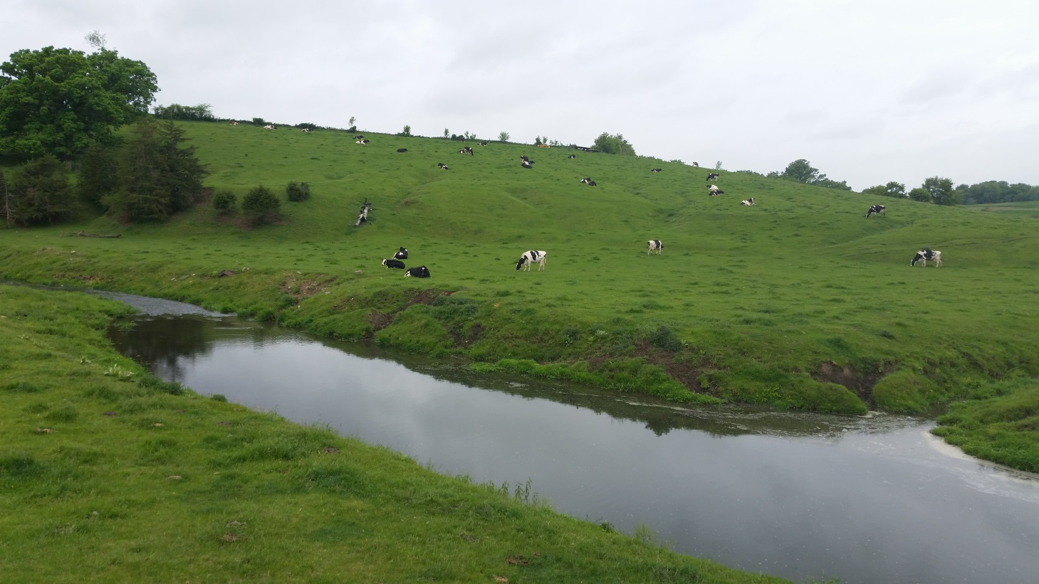
Sinsinawa River at Louisberg Rd

By James Amrhein
Water Quality Biologist – Water District South

May, 2017

The Sinsinawa River watershed (HUC 12 = 070600050203) lies in extreme southeastern Grant County (Figure 1). This watershed extends into Jo Daviess County, IL. The Sinsinawa River itself is a 21.1 mile long seepage and spring fed stream beginning 2 miles east of Louisburg in the township of Hazel Green. The river flows south approximately 10 miles into Illinois and another 10 miles toward the southwest where it joins the Mississippi River about 3 miles west of Galena, IL.

The Wisconsin portion of the watershed encompasses 24.7 mi² (21,190 acres). Several unnamed tributaries add flow to the main river along the way. The vast majority of the land use is in cropland or pasture, with scattered woodlands, open space, and residential making up the balance (see graphic at right). The communities of Cuba City and Hazel Green both have portions of their boundaries in the watershed, but neither has a wastewater discharge to the watershed.
Land Use in the Sinsinawa River Watershed
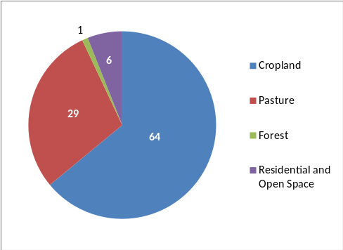

Historically, the Sinsinawa River has had a good smallmouth bass fishery and in general has good smallmouth bass habitat. The smallmouth bass fishery, however, has periodically been affected by fish kills that can be attributed to manure spills and runoff events that lead to low dissolved oxygen levels (WDNR, 2001). Water quality and habitat best management practices (BMPs) were installed at some locations on the river as part of the Galena River priority watershed project in the 1980’s. As with other streams in the watershed, water quality improvements due to the BMP installations has been less than successful due to the relative lack of participation, the scattered nature of implementation, and masked by uncontrolled non-point pollution sources (Kroner et. al., 1992). The entire length of the Sinsinawa River in Illinois is on their state’s 303(d) list of impaired waters due to sedimentation/siltation (IL EPA, 2014).

The Sinsinawa River has historically fair to poor macroinvertebrate index of biotic integrity (MIBI) ratings (Weigel, 2003) – a sign of significant riparian and watershed perturbations. The Hilsenhoff Biotic Index (HBI) (Hilsenhoff, 1987) has shown “some” to “fairly significant” organic loading to the river. Known fish kills were reported in 1978, 1988, 2009 and 2016. The river corridor is intensively grazed. Despite this, smallmouth bass seem to do quite well in the river. The primary purpose of this study was to assess the overall conditions of the Sinsinawa River and the watershed as a whole and potentially identify areas of management to help the bass and other non-game species to thrive in this agriculturally dominated watershed. A secondary purpose was to determine if other streams in the watershed can serve as nursery streams for smallmouth bass and provide an important role in maintaining healthy bass populations.
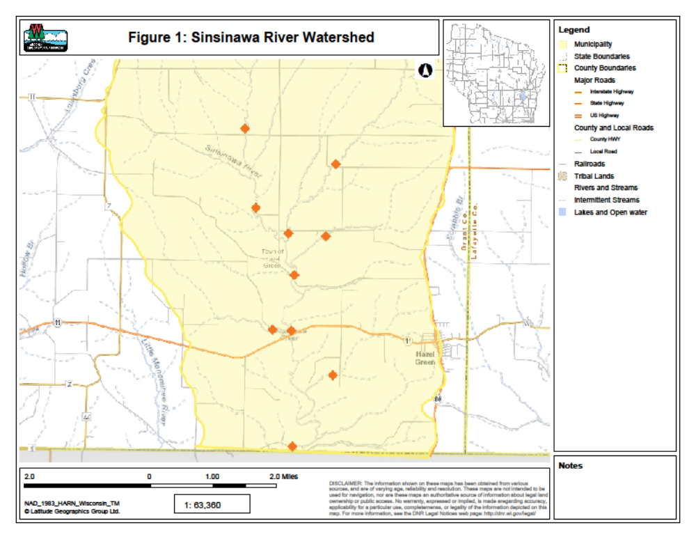
Methods
The 2016 watershed survey was conducted by water resources biologists on 10 sites in the HUC 12 (Figure 1). Sites were selected to cover a variety of stream reaches as predicted by the Targeted Watershed Site Selection Tool (TWSST) model (WDNR, 2015). With this model, stream network homogeneity or heterogeneity are estimated based on stream channel and landscape level physical characteristics. By this method, one can assess differing stream types within a watershed and predict the status of other, similar streams in the watershed where very little know information exists and without sampling each stream individually.

The fisheries assemblage was determined by electroshocking a section of stream with a minimum station length of 35 times the mean stream width (Lyons, 1992). A stream tow barge with a generator and two probes was used at most sites. A backpack shocker with a single probe was used at sites generally less than 2 meters wide. All fish were collected, identified, and counted. All gamefish were measured for length. At each site, qualitative notes on average stream width and depth, riparian buffers and land use, evidence of sedimentation, fish cover and potential management options were also recorded. A qualitative habitat survey (Simonson, et. al., 1994) was also performed at each site. Macroinvertebrate samples were obtained by kick sampling and collecting using a D-frame net at a subset of these sites in the watershed in fall, 2016 and sent to the University of Wisconsin-Stevens Point for analysis.

Continuous water temperature loggers were also placed at two sites on the Sinsinawa River at Louisberg and Sinsinawa Roads and programmed to take hourly water temperatures throughout the “summer” (June – August) period.

Results
The results of the fisheries surveys are summarized in Table 1. Because the Wisconsin Streams model (Lyons, 2008) predicted most of the waters in the watershed to be cool transitional waters, the coolwater index of biotic integrity (IBI) developed by Lyons (2012) was applied to all streams. Where appropriate and based on natural community verification (Lyons, 2015), additional IBIs were applied.

A total of 19 species were found in the watershed. Despite the natural community model predicting most of these systems to be “cool-cold” transitional streams, no stenothermal coldwater species were found in the watershed. Conversely, most of the species found were considered to be warmwater species (Lyons, et. al., 2012). On the mainstem of the Sinsinawa River, 12 to 15 warm and transitional species were present and generally dominated by common shiner and white suckers. Common shiner and central stoneroller were the most widely distributed species in the watershed, followed by creek chubs, fantail darters, and johnny darters. The species assemblages of the unnamed tributaries were made up of a subset of the species found in the river. The number of species varied by size of stream and/or place in the watershed with larger streams containing enhanced numbers of species.

Smallmouth bass were found at 3 of the 4 sites sampled on the Sinsinawa River and an individual was found at 1 site on a tributary. The numbers of bass and associated catch per unit effort increased as one moved downstream on the Sinsinawa River.

Qualitative habitat surveys (Table 2) showed overall habitat to be “fair” to “good” at most sites. The site on unnamed tributary 941000 had an overall habitat score of 20 or “poor”. The overall scores were buoyed by the width-to-depth ratio, riffle/bend, and fine sediment scores. The lack of a riparian buffer and lack of pools tended to depress the scores. Bank erosion and fish cover varied by site.

Temperature data was collected hourly from June to October on the Sinsinawa River at Louisberg Road and Sinsinawa Road. As defined in Lyons et. al. (2009), temperatures at Louisberg Road closely resembled a cool-warm transitional stream in that the maximum daily mean, summer (June – August) mean, and July mean were all within the ranges for that temperature subclass (Table 3). Further downstream at Sinsinawa Road, temperatures for these same periods more closely resembled a warmwater system.

Table 1: Fisheries Assemblage, IBI, and Natural Community Analysis for sites in the Sinsinawa River Watershed - 2016
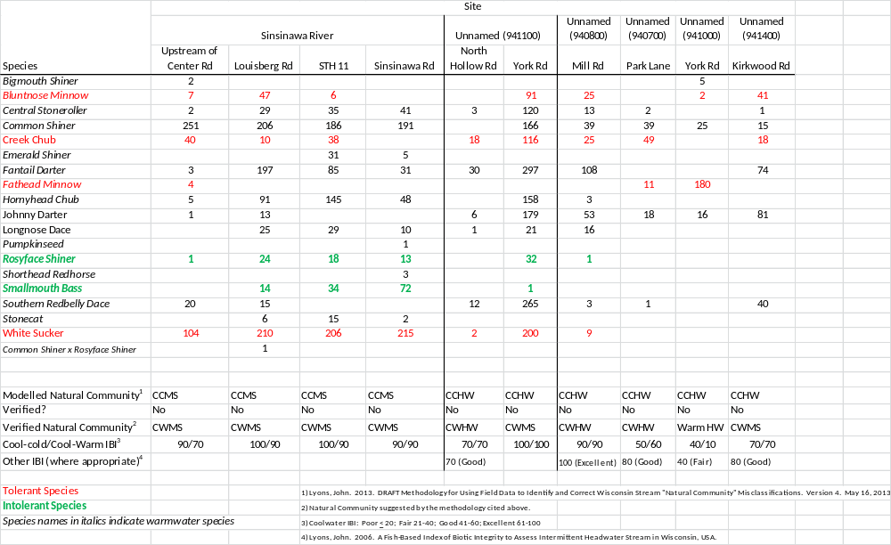
Table 2: Qualitative Habitat Surveys of sites in the Sinsinawa River Watershed - 2016

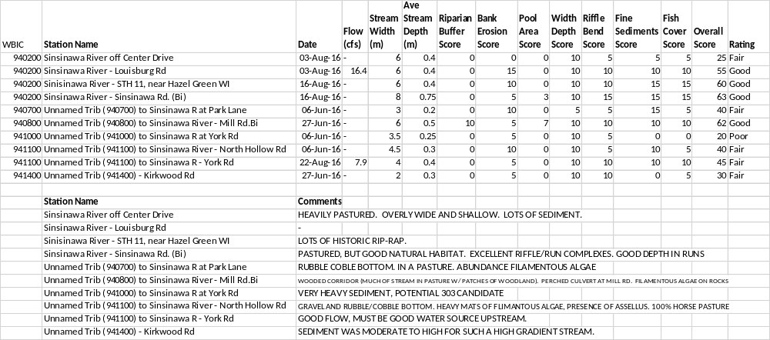
Table 3: Comparison of Temperature Data, Modeled Community and Verified Community
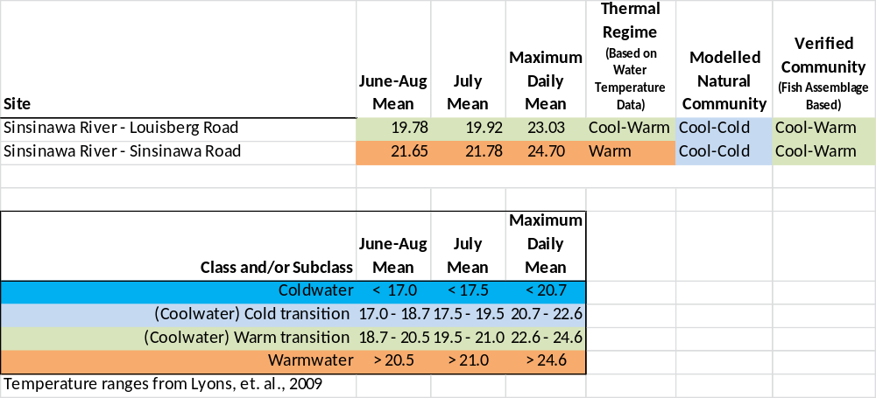

Macroinvertebrate data was collected on 3 sites on the mainstem of the Sinsinawa River and on 3 unnamed tributaries in the fall of 2016 (Table 4). The macroinvertebrate IBI (mIBI) as developed by Weigel (2003) shows the main branch of the Sinsinawa River to be “poor” to low “fair”, while the 3 tributaries are in the “fair” category. HBI varied between “good” and “fair”, indicating there is some organic loading reaching the streams. One site on unnamed tributary 940700 showed a “poor” score, indicating that there is significant organic loading to that system.

Table 4: Macroinvertabrate Data for the Sinsinawa River Watershed
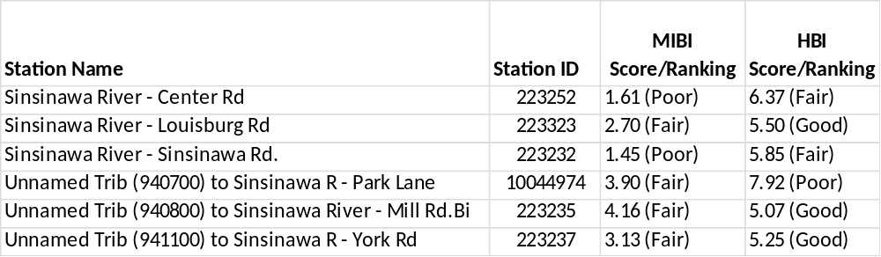

Discussion
Most of the streams in this HUC 12 are modelled to be cool-cold transitional headwaters or mainstems (Lyons, 2008). The department has recently developed a draft method to determine whether or not the modeled natural community is accurate based on the fishery assemblage and climate conditions (Lyons, 2015). There were no coldwater species found in the watershed, which immediately disqualifies the systems from being cold or cool-cold communities. A majority of species found in these streams are considered to be warmwater species (Lyons, 2012). These species, combined with several transitional species also found in these streams, showed the streams to more closely resemble cool-warm systems. As reflected in Table 3, water temperature and the verified natural community match up better than the modeled community.

Environmental degradation can sometimes explain the discrepancy between the modeled and actual community where there is a lack of intolerant species and a dominance of tolerant ones (Lyons, 2015). For most systems in this HUC 12, the percentage of tolerant fish fall within expected ranges for cool-cold transitional systems, and therefore a degraded community is not the principle reason for the discrepancy. The discrepancy between the temperature data, the modeled community and the actual fishery community can happen for several other reasons: either the year of the thermal measurement wasn’t representative of the long-term average, the modeled thermal values were inaccurate, or both (Lyons, personal communication). In this case, air temperatures during the 2016 “summer” season over which the thermisters were deployed, while above the respective monthly averages for the period, were not considered abnormal as air temperatures were within the lower 10th and upper 90th percentile. The fishery is a long-term gauge of conditions in the stream and is therefore most important for bioassessment. That’s not to say measured water temperatures or the modeled community aren’t useful, but for natural community determination and IBI purposes, and in the absence of moderate to severe environmental perturbation, the fishery assemblage trumps water temperature data or the model (Ibid).

Stream biologic health as indicated by the fishery IBI varies by site, but generally shows good to excellent quality. As discussed earlier and shown in Table 1, the fishery assemblages show the natural communities to be cool-warm transitional at all but one site. The IBIs for these systems range from 10-100. According to WisCALM (WDNR, 2017), streams that are considered headwaters (90th percentile exceedance flow < 3 cubic feet per second) should be evaluated using the “Small and Intermittent Stream IBI” (Lyons, 2006). When this is applied to the streams where the verified community is confirmed as a headwater, sites are between 40 (fair) and 100 (excellent).

The fishery IBI reflects better environmental health than indicated by the qualitative habitat. These habitat metrics were very reflective of the nature of the streams in the watershed in that they had high gradient and shallow depth to bedrock, lending themselves to hard substrate, numerous riffles and lack of sediment due to scouring. The shallow depth to bedrock tended to limit the presence of pools, and the extensive grazing of the riparian corridors was reflected in the buffer metric and the bank erosion metric to some extent. It is often times more indicative to look at individual metrics within the habitat rating rather than the overall scores to get a better picture of the factors affecting stream habitat. While overall habitat scores can be “fair” or even “good”, lack of buffers, the presence of bank erosion, and lack of fish cover can greatly affect the presence/absence of fish species.

In this watershed, there were few buffers because most of the stream valleys are in pasture, which also exacerbates bank erosion. While the width-to-depth ratios were generally good, the shallow depth to bedrock limits depth. The bank erosion caused by pasturing lends itself to widening of the stream, reducing width-to-depth ratios. While depth, in and of itself, can be a form of fish cover, overall fish cover (i.e. overhanging vegetation, submerged macrophytes, boulders, or woody debris) was lacking in most of the tributary streams, but very good in most of the sites surveyed on the Sinsinawa River itself.
Based on the 2018 Wisconsin Consolidated Assessment and Listing Methodology (WisCALM) guidance (WDNR, 2017), the fishery IBI scores indicating a non-impaired status are in contrast to the macroinvertebrate community which indicate an impaired status for all or parts of many streams in this watershed. The macroinvertebrate community, as seen in Table 4, tends to reflect the land use and to some extent the overall habitat score. All of the MIBI scores are in the “poor” to “fair” range. The macroinvertebrate IBI has shown the combination of watershed land cover and local riparian and instream conditions strongly influence one another (Weigel, 2003). While watershed and local variables explain a significant portion of variance among sites, Weigel found that in the driftless region, localized stressors were of greater importance to explain the IBI than in other parts of the state. Livestock grazing measured disturbance intensity and indicated its proximity to the stream. A majority of stream sites had poor buffer scores due to the prevalence of pasturing in stream valleys throughout the watershed. Overall, macroinvertebrate scores were typical of streams in the driftless area south of the Military Ridge, which tend to be depressed. This is likely a reflection of the intensity of agriculture in the region combined with a vulnerable landscape (i.e. steep slopes, shallow soils, and highly erodible land). The HBI scores varied, but show there is organic loading to these systems. Potential sources of this include unfettered cattle access to streams, and runoff from barnyards and loafing areas. Historic macroinvertebrate data suggests this is a chronic issue (WDNR, unpublished data).

Over 90 percent of the land use in these watersheds is in agriculture, either row crops or grazing. Intense grazing in the riparian stream corridors is fairly common. Spring melt and early season rains, especially before crops are of sufficient size to reduce rain impact, or in fall after crops are harvested, can greatly increase the amount of sediment and nutrients reaching the streams.
The landscape of the watershed is predominantly agriculture
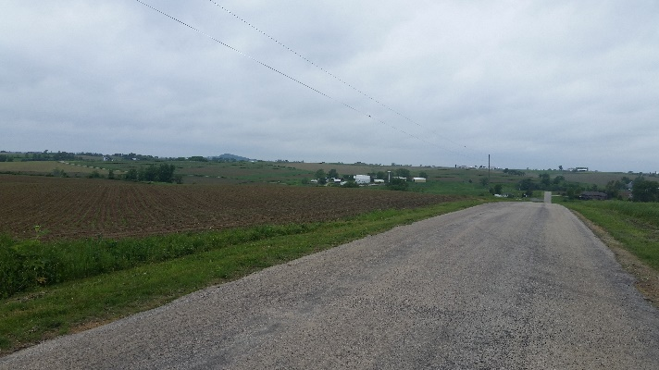

Nutrient enrichment has been a problem in this watershed. Periodic fish kills appear to be caused by excessive nutrient loading from cumulative barnyard runoff throughout the watershed that lead to low dissolved oxygen levels (Mason, et. al., 1993, WDNR, 2003, WDNR, 2016). In addition to lending itself to reduced oxygen levels, the nutrient loads enhance algal and periphyton growth, which then enhances available food for grazers and this pattern is repeated up the food chain. Contrary to the conventional thinking that more fish equates to a healthier system, the enhanced abundance of fish, particularly omnivores, is actually a sign of nonpoint source pollution impact. While these streams may not necessarily be considered as impaired, it does indicate excessive eutrophication of these systems.

************************************************************************

Phosphorus
Although not a part of this particular study, total phosphorus data was collected during the growing season – May through October – in 2014 and 2015 as part as follow up to an impairment decision (WDNR, 2013). Data was collected a Louisberg Road by volunteer monitors taking grab samples once per month (see adjacent table). Although Sinsinawa is named a “river”, by definition, it is considered a stream as the 90th percentile exceedance flow is less than 110 ft³/second (Lyons, 2008). Thus, it is subject to the 0.075 mg/l phosphorus criterion that is applied to streams (WDNR, 2017). Based on the 2 years of monitoring, in addition to the median concentration being 0.104 mg/l, the lower 95th percentile of 0.087 mg/l exceeded the criteria as well.
All values in mg/L

Total Phosphorus – Sinsinsawa River at Louisberg Rd – 2014 and 2015
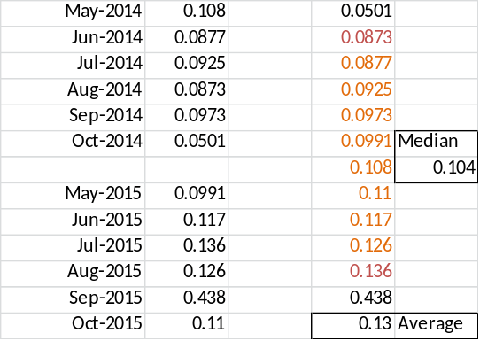

************************************************************************

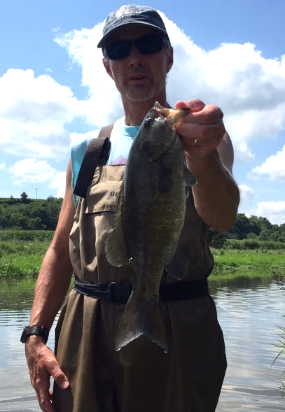
One of the most important aspects of the Sinsinawa River is that it supports a fishable population of smallmouth bass. In fact, portions of the river contain some of the highest catch per unit effort populations for wadable systems in the state (Bradd Sims, personal communication). One reason for this 2016 survey was to determine if other streams in the watershed can serve as nursery streams for smallmouth bass and provide an important role in maintaining healthy bass populations. Only one of the several small unnamed headwater streams, which are primarily spring and seepage fed, contained a single fish. The lack of smallmouth in these tributaries is unknown, but may be related to: 1) the small size of the tributaries and corresponding lack of flow and habitat, 2) recent weather events which rendered them undesirable for bass or, 3) because of a decrease in overall numbers during the sample period, or a combination of the three.

For the past two decades, the department’s Fisheries and Habitat Research section has been conducting annual surveys of smallmouth bass population structure on streams in the driftless region, including a site on the Sinsinawa River between Sinsinawa Road and STH 11 (Lyons and Kanehl, 2016). They have found that, even with adequate habitat and good water quality, populations fluctuate widely because of annual variations in weather - particularly droughts and floods (Figure 2). This is a feature of riverine smallmouth bass populations throughout the region. During favorable weather conditions, such as those that occurred in 2012 which was a drought year with reduced runoff, the populations often explode with good populations augmented by large numbers of young-of-year bass. Even in unfavorable weather years, the populations never are eliminated by bad weather and there’s always some level of reproduction and a fair number of adults (John Lyons, personal communication).

However, the runoff issues in the southwest have more severe effects than weather. Polluted runoff can eliminate a population in a matter of hours or days. For example, Otter Creek in Lafayette County has suffered from multiple fish kills over a relatively short period of time. The stream has essentially no bass population despite reasonable habitat and a history of stocking (Lyons and Kanehl, 2016). During the 1970’s and 80’s nearly all the SMB streams in southwest Wisconsin had depressed or near absent bass populations from polluted runoff. Many, such as Rattlesnake Creek in Grant County, have recovered due to implementation of best management practices such as feedlot and manure management. Thus, continued good land and manure management is essential to maintaining SMB in these streams (John Lyons, personal communication).

Figure 2: Sinsinawa River Smallmouth Bass Trend Analysis

The potential for a catastrophic event is enhanced because it does not appear as if the feeder streams to the Sinsinawa River serve as nursery streams. Therefore a kill on the river itself can greatly affect the population of the river – particularly if it affects adult bass of reproducing age. Known kills have occurred in 1978, 1988, and in 2009. Coincidentally, a fish kill was reported on the Sinsinawa River while biologists were conducted in a survey in August, 2016. The investigation found hundreds of dead non-game fish, mostly white sucker and common shiner and several (1+ year old) smallmouth bass in a reach upstream of Louisberg Road. Investigation of sites downstream of Louisberg Road did not reveal any dead fish. As was the case with previous kills, because the kill was reported days after it occurred, the source was never determined.

Results and Conclusions
The Sinsinawa River flows through a highly agricultural watershed which results in phosphorus loading in excess of the criteria and a biological impact in the form of a depressed macroinvertebrate community. While the Sinsinawa River is on the Illinois list of impaired waters due to sedimentation and siltation, the high gradient of the river in Wisconsin allows adequate scouring of sediment. However, this does not mean there are not high loads of sediment reaching the streams in the watershed. Habitat scores are depressed by the extensive grazing which occurs in the riparian stream corridors. On the other hand, fish communities of the Sinsinawa watershed have shown themselves to be resilient as indicated by the fish IBI. This is not to say that the fishery is not impacted. Periodic fish kills affect the stream and could limit what could potentially be an exceptional smallmouth bass fishery.

Controlling sediment and nutrient - particularly manure - runoff will 1) enhance spawning habitat and prevent valuable spawning areas from becoming covered in silt; 2) maintain good pool depth so that older fish can seek refuge in winter or in periods of low flow; and 3) prevent potentially fatal dissolved oxygen sags or ammonia induced toxicity. The department should continue to work with the Grant County Land Conservation Department (LCD) and landowners to encourage best management practices in this watershed to enhance water quality and protect a valuable fishery. This includes:

- Proper manure management such good housekeeping of barnyards and no spreading on steep slopes and during periods of ice and snow cover or prior to significant rain events would reduce the delivery of potentially deadly amounts of nutrients.

- Managed grazing would help protect streambanks and reduce sediment loads from bank erosion.

- The planting of cover crops would help prevent soil erosion during the vulnerable months.

The department and Grant County LCD should explore ways to educate landowners on the valuable resources of the Sinsinawa River and to gain consensus and interest in ways to increase profitability of farms while protecting and enhancing water quality of the watershed potentially through farmer-led programs and/or demonstration areas.

The department should update is natural community classification for the Sinsinawa River and tributaries from cool-cold to cool-warm where warranted using the guidance provided by Lyons (2015).
References

Hilsenhoff, William L. 1987. An Improved Biotic Index of Organic Stream Pollution. The Great Lakes Entomologist. 20: 31-39.

IL EPA, 2014. Galena, Sinsinawa Rivers Watershed TMDL. Stage 1 Report. Final Report for Public View. October, 2014. Prepared by CDM Smith.
http://www.epa.illinois.gov/Assets/iepa/water-quality/watershed-management/tmdls/reports/galena/stage1-final.pdf

Kroner, Ron, J. Ball, and M. Miller. 1992. The Galena River Priority Watershed Project: Bioassessment Final Report. Wisconsin Department of Natural Resources Publication WR-306-92. May, 1992.

Lyons, John. 1992. Using the Index of Biotic Integrity (IBI) to Measure Environmental Quality in Warmwater Streams of Wisconsin. United States Department of Agriculture. General Technical Report NC-149.

Lyons, John. 2006. A Fish-based Index of Biotic Integrity to Assess Intermittent Headwater Streams in Wisconsin, USA. Environmental Monitoring and Assessment 122: 239-258.

Lyons, John. 2008. Using the Wisconsin Stream Model to Estimate the Potential Natural Community of Wisconsin Streams (DRAFT). Wisconsin Department of Natural Resources Fish and Aquatic Life Research Section. November, 2008.

Lyons, John. T. Zorn, J. Stewart, P Seelbach, K Wehrly, and L. Wang. 2009. Defining and Characterizing Coolwater Streams and Their Fish Assemblages in Michigan and Wisconsin, USA. North American Journal of Fisheries Management. 29:1130-1151.

Lyons, John. 2012. Development and Validation of Two Fish-based Indices of Biotic Integrity for Assessing Perennial Coolwater Streams In Wisconsin, USA. Ecological Indicators 23 (2012) 402-412.

Lyons, John. 2015. Methodology for Using Field Data to Identify and Correct Wisconsin Stream “Natural Community” Misclassifications. Version 5. May 29, 2015.

Lyons, John and Paul Kanehl. 2016. Status and Trends in Sportfish Populations of Southwestern Wisconsin Warmwater Streams. Period Covered: July 1, 2015 – June 30, 2016. Fisheries and Habitat Research Section. Project F-95-P.

Mason, John W., John D. Lyons, and Roger A. Kerr. 1993. Smallmouth Bass Populations, in Surface Water Hydrology and Quantity and Macroinvertebrate and Smallmouth Bass Populations in Four Stream Basins in Southwestern Wisconsin, 1987-90. U.S. Geological Survey, Water Resources Investigation Report 93-4024.
References (continued)

Simonson, Timothy D., J. Lyons, and P.D. Kanehl. 1994. Guidelines for Evaluating Fish Habitat in Wisconsin Streams. U.S. Department of Agriculture. Forest Service. General Technical Report NC-164.

WDNR. 2001. The State of the Grant, Platte, and Galena River Basins. Volume One. PUBL-WT-660-2001. A report by the Wisconsin Department of Natural Resources in cooperation with the Grant-Platte Basin Partnership Team and Stakeholders.

WDNR. 2003. Galena (Fever) River Priority Watershed Project. Final Report. Wisconsin Department of Natural Resources, Bureau of Watershed Management, Runoff Management Section.

WDNR. 2015. Optimizing a Monitoring Design in Targeted Watersheds: The Targeted Watershed Site Selection Tool. Wisconsin Dept. of Natural Resources, Madison, WI. EGAD #3200-2015-05.

WDNR. 2016. WDNR/FH Biology Database. Fish Kill Summary Reports. Bureau of Fisheries Management. Tabular Database. Unpublished Data.

WDNR. 2017. Wisconsin 2018 Consolidated Assessment and Listing Methodology (WisCALM). Clean Water Act Section 305(b), 314, and 303(d) Integrated Reporting. Wisconsin Department of Natural Resources. Bureau of Water Quality Program Guidance. September, 2013.

Weigel, Brian. 2003. Development of Stream Macroinvertebrate Models That Predict Watershed and Local Stressors in Wisconsin. Journal of the North American Benthological Society. 22(1): 123-142.

