Water Quality Evaluation of the Pigeon River Watershed
Waupaca and Shawano Counties, Wisconsin

December 2017

David Bolha-Water Quality Biologist-Oshkosh

Purpose

The Pigeon River Watershed evaluation in 2015 and 2016 provided chemical, physical, and biological data to assess water quality impacts in the watershed from the installation of agricultural Best Management Practices (BMPs) to reduce nutrient and sediment loads. This watershed evaluation supported the watershed improvement efforts by the Natural Resource Conservation Service (NRCS) and the Waupaca County Land and Water Conservation Department (Waupaca LWCD) through the National Water Quality Initiative (NWQI) program. An additional goal of the project was to conduct fish and aquatic life use impairment assessments based on phosphorus water quality standards of the Pigeon River and its tributaries.

Methods

Total Phosphorus (TP) samples were collected at 15 locations once per month from May through October 2015 (Table 1, Map 1-2). TP samples were collected at 6 additional locations once per month from May through October 2016. All samples were collected using the standard WDNR grab sampling method for a total of 126 samples (WDNR 2014). Neither baseflow nor storm or snowmelt event sampling were targeted during this project, following the protocol of Wisconsin Consolidated Assessment and Listing Methodology (WisCALM 2014). All samples were shipped to Wisconsin State Laboratory of Hygiene (WISLOH) for analysis. The WISLOH entered all sample analysis data into the WDNR Surface Water Integrated Monitoring System (SWIMS) database.

SWIMS Station ID | Site Name | Surface Water WBIC
10043172 | N Br Pigeon R. @ Fishery area | 293900
10038319 | N Br Pigeon R. DS Parkview Ave. | 293900
693125 | N Br Pigeon R. @ Knitt Rd. | 293900
10014783 | S Br Pigeon R. @ Brewer Rd. | 295600
10014784 | S Br Pigeon R. @ HWY 110 | 295600
10030525 | S Br Pigeon R. @ Buckbee Rd. | 295600
693135 | Pigeon R. @ Klemp Rd. | 272400
10043176 | Mehlberg Cr. US Burma Rd. | 283100
10043173 | Un Trib to N Br Pigeon R. @ Gruenstern Rd. | 284900
10043171 | Un Trib to N Br Pigeon R. @ Kopitzke Rd. | 279600
10017231 | Hydes Cr. @ Swamp Rd. | 280100
10014791 | Geskey Cr. @ County E | 297200
10042814 | Un Trib to S Br Pigeon R. @ County E | 297400
10043174 | Un Trib to S Br Pigeon R. @ Hauschultz Rd. | 295800
10043175 | Un Trib to S Br Pigeon R. @ Nietzke Rd. | 295700
10043230 | Un Trib to Pigeon Lk. @ River Rd. | 5015321
10043365 | Un Trib to Pigeon Lk. @ Green Tree Rd. | 5015231
10043229 | Brandy Cr. @ Lakeshore Rd. | 293700
10043366 | Pfeiffer (Grady) Lake Outlet to Pigeon Lake @ Lakeshore Rd. | 293500
10016706 | Un Trib to Pigeon R. @ Knitt Rd. | 293800
10042359 | Honey Cr. @ 1st Ave. | 5016138
Table 1: Total Phosphorus Monitoring Locations Sampled in the Pigeon River Watershed.

Map 1: Lower Pigeon River Watershed Sample Locations.

Map 2: North and South Branches of the Pigeon River Sample Locations.

Thirteen creek and river locations were sampled for aquatic macroinvertebrates (insects large enough to be seen without magnification) in October 2015 (Map 1-2, Table 2). An additional 7 locations were sampled in 2016 for aquatic macroinvertebrates (Map 1, Table 2). All sites were sampled using the WDNR Guidelines for Collecting Macroinvertebrate Samples from Wadable Streams (2000). A D-shaped kicknet with 600 micron mesh was used at all sites by standing upstream from the net and placing it firmly on the stream bed while digging into the substrate with the heel or toe to free the macroinvertebrates from the substrate. Riffles were targeted at each of the sites, but if none were present then overhanging vegetation, woody debris, or other vegetation would be sampled. This was done by jabbing the net into the vegetation to free the invertebrates. For a representative sample of the aquatic macroinvertebrate community, a minimum of 100 aquatic macroinvertebrates collected in each sample was targeted. The aquatic macroinvertebrates were preserved in a 70-80% ethanol solution inside quart “Mason” jars. If necessary, multiple “Mason” jars were used per sample depending upon how much sediment and organic material was collected with the aquatic macroinvertebrates. Within the next 24 hours, the samples were represerved with another 70-80% ethanol solution. Samples were taken to the UWSP Aquatic Entomology Laboratory (AEL) for lowest possible taxonomic identification. Staff at the AEL entered the data into the SWIMS database in 2016 and 2017.

SWIMS Station ID | Site Name | Surface Water WBIC
10043172 | N Br Pigeon R. @ Fishery area | 293900
10038319 | N Br Pigeon R. DS Parkview Ave. | 293900
693125 | N Br Pigeon R. @ Knitt Rd. | 293900
10014783 | S Br Pigeon R. @ Brewer Rd. | 295600
10014784 | S Br Pigeon R. @ HWY 110 | 295600
10030525 | S Br Pigeon R. @ Buckbee Rd. | 295600
10044929 | Pigeon R. DS of North and South Branch Confluence | 272400
693135 | Pigeon R. @ Klemp Rd. | 272400
10043176 | Mehlberg Cr. US Burma Rd. | 283100
10043173 | Un Trib to N Br Pigeon R. @ Gruenstern Rd. | 284900
10043171 | Un Trib to N Br Pigeon R. @ Kopitzke Rd. | 279600
10017231 | Hydes Cr. @ Swamp Rd. | 280100
10014791 | Geskey Cr. @ County E | 297200
10042814 | Un Trib to S Br Pigeon R. @ County E | 297400
10043174 | Un Trib to S Br Pigeon R. @ Hauschultz Rd. | 295800
10043175 | Un Trib to S Br Pigeon R. @ Nietzke Rd. | 295700
10043230 | Un Trib to Pigeon Lk. @ River Rd. | 5015321
10043365 | Un Trib to Pigeon Lk. @ Green Tree Rd. | 5015231
10043229 | Brandy Cr. @ Lakeshore Rd. | 293700
10042359 | Honey Cr. @ 1st Ave. | 5016138
Table 2: Aquatic Macroinvertebrate Monitoring Locations Sampled in the Pigeon River Watershed.

Wadable fish surveys were conducted at 16 locations (Map 1-2, Table 3) between June and September 2015 and 2016. The fish surveys were conducted following the WDNR Guidelines for Assessing Fish Communities of Wadable Streams in Wisconsin (2001). All 16 locations were surveyed in June through September during the guidance-recommended summer time survey period. Stream flow and water chemistry data was recorded at each wadable site prior to conducting the fish survey. The wadable fish survey stations were a minimum of 35 times the mean stream width (overall minimum of 100 meters, overall maximum of 400 meters). An otter sled stream shocker with a 4000 Peak Watt generator was used for 6 of the 16 wadable sites with appropriate stream width and/or depth. A 12 Volt, 18 Amp Hour battery-powered backpack shocker was used for 10 of the 16 sites based upon the streams’ smaller width and depth. Catch per effort sampling procedures were used for this project (no particular species was targeted, all captured). A single upstream pass was made using 0.125 inch mesh nets to collect the fish. At the end of the station, captured fish were identified and counted and all game fish were measured for length. Once all data was collected, the fish were returned to the creek. Fish survey data was entered into the WDNR Fisheries and Habitat Management Database (FHMD) by WDNR Water Resources staff.

SWIMS Station ID | Site Name | Surface Water WBIC
10043172 | N Br Pigeon R. @ Fishery area | 293900
10038319 | N Br Pigeon R. DS Parkview Ave. | 293900
693125 | N Br Pigeon R. @ Knitt Rd. | 293900
10014783 | S Br Pigeon R. @ Brewer Rd. | 295600
10014784 | S Br Pigeon R. @ HWY 110 | 295600
693135 | Pigeon R. @ Klemp Rd. | 272400
10043176 | Mehlberg Cr. US Burma Rd. | 283100
10043173 | Un Trib to N Br Pigeon R. @ Gruenstern Rd. | 284900
10043171 | Un Trib to N Br Pigeon R. @ Kopitzke Rd. | 279600
10017231 | Hydes Cr. @ Swamp Rd. | 280100
10014791 | Geskey Cr. @ County E | 297200
10043174 | Un Trib to S Br Pigeon R. @ Hauschultz Rd. | 295800
10043175 | Un Trib to S Br Pigeon R. @ Nietzke Rd. | 295700
10043230 | Un Trib to Pigeon Lk. @ River Rd. | 5015321
10043365 | Un Trib to Pigeon Lk. @ Green Tree Rd. | 5015231
10043237 | Brandy Cr. @ Lakeshore Rd. | 293700
Table 3: Wadable Fish Survey Locations Sampled in the Pigeon River Watershed.

Onset Hobo Pendant thermistors were deployed to collect temperature data from May through October between 2015 and 2016 at 19 locations in the Pigeon River Watershed (Table 4, Map 1-2). Temperature measurements were taken once per hour at each location from May through October. Temperature measurements were taken with a thermistor attached to a fence post driven into the stream bed of the creek or river. The thermistor was attached to the fence post in such a manner as to suspend the thermistor in the water column low enough to stay under water in low flow conditions and high enough to not get buried in bottom substrate (~ 6 inches above the bottom). The thermistor was placed in a shaded location when possible. Temperature data were uploaded into the SWIMS database by WDNR Water Resources staff.

SWIMS Station ID | Site Name | Surface Water WBIC
10043172 | N Br Pigeon R. @ Fishery area | 293900
10038319 | N Br Pigeon R. DS Parkview Ave. | 293900
693125 | N Br Pigeon R. @ Knitt Rd. | 293900
10014783 | S Br Pigeon R. @ Brewer Rd. | 295600
10014784 | S Br Pigeon R. @ HWY 110 | 295600
10030525 | S Br Pigeon R. @ Buckbee Rd. | 295600
10043176 | Mehlberg Cr. US Burma Rd. | 283100
10043173 | Un Trib to N Br Pigeon R. @ Gruenstern Rd. | 284900
10043171 | Un Trib to N Br Pigeon R. @ Kopitzke Rd. | 279600
10017231 | Hydes Cr. @ Swamp Rd. | 280100
10014791 | Geskey Cr. @ County E | 297200
10042814 | Un Trib to S Br Pigeon R. @ County E | 297400
10043174 | Un Trib to S Br Pigeon R. @ Hauschultz Rd. | 295800
10043175 | Un Trib to S Br Pigeon R. @ Nietzke Rd. | 295700
10016706 | Un Trib to Pigeon R. @ Knitt Rd. | 293800
10043230 | Un Trib to Pigeon Lk. @ River Rd. | 5015321
10043365 | Un Trib to Pigeon Lk. @ Green Tree Rd. | 5015231
10043229 | Brandy Cr. @ Lakeshore Rd. | 293700
10042359 | Honey Cr. @ 1st Ave. | 5016138
Table 4: Temperature Monitoring Locations in the Pigeon River Watershed.

Quantitative habitat surveys were conducted at 18 locations in the Pigeon River Watershed between October 2015 and 2016 (Table 5, Map 1-2). All sites were surveyed following the WDNR Guidelines for Evaluating Habitat of Wadable Streams (2002). Each quantitative habitat survey station length was 35 times the mean stream width of the survey station. Following the determination of station length, the station was divided into 12 transects. At each transect, substrate, sedimentation, erosion, water depth, and riparian land use data were collected. WDNR Water Resources staff entered the quantitative habitat data into the FHMD.

SWIMS Station ID | Site Name | Surface Water WBIC
10043172 | N Br Pigeon R. @ Fishery area | 293900
10038319 | N Br Pigeon R. DS Parkview Ave. | 293900
693125 | N Br Pigeon R. @ Knitt Rd. | 293900
10014783 | S Br Pigeon R. @ Brewer Rd. | 295600
10014784 | S Br Pigeon R. @ HWY 110 | 295600
10030525 | S Br Pigeon R. @ Buckbee Rd. | 295600
693135 | Pigeon R. @ Klemp Rd. | 293100
10043176 | Mehlberg Cr. US Burma Rd. | 283100
10043173 | Un Trib to N Br Pigeon R. @ Gruenstern Rd. | 284900
10043171 | Un Trib to N Br Pigeon R. @ Kopitzke Rd. | 279600
10017231 | Hydes Cr. @ Swamp Rd. | 280100
10014791 | Geskey Cr. @ County E | 297200
10043174 | Un Trib to S Br Pigeon R. @ Hauschultz Rd. | 295800
10043175 | Un Trib to S Br Pigeon R. @ Nietzke Rd. | 295700
10016706 | Un Trib to Pigeon R. @ Knitt Rd. | 293800
10043230 | Un Trib to Pigeon Lk. @ River Rd. | 5015321
10043365 | Un Trib to Pigeon Lk. @ Green Tree Rd. | 5015231
10043229 | Brandy Cr. @ Lakeshore Rd. | 293700
Table 5: Quantitative Habitat Survey Locations in the Pigeon River Watershed.

Results

The TP sample analysis results in the Pigeon River Watershed ranged from 0.0176 mg/L at Unnamed Tributary to Pigeon Lake at River Rd in October to 0.832 mg/L at the Unnamed Tributary to the North Branch of the Pigeon River at Kopitzke Rd. in August (Table 6-7, Chart 1-2). The TP sample analysis results in the South and North Branches and Pigeon River Mainstems ranged from 0.0221 mg/L at the South Branch of the Pigeon River at Brewer Rd in May to 0.222 mg/L at North Branch of the Pigeon River at the Doty Creek Fishery Area in June (Table 6, Chart 1). Nine of the 21 locations in this project had an average TP concentration (mg/L) exceeding the Wisconsin Administrative Code ch. NR 102.06(3)(b) water quality criteria (WQC) for creeks and rivers at 0.075 mg/L (Table 6-7, Chart 1-2). Twelve of the 21 locations had average TP concentrations less than the WQC (Table 6-7, Chart 1-2). The average TP concentrations for the 21 sites in this project ranged from 0.032 mg/L in the Unnamed Tributary to Pigeon Lake at River Rd to 0.3553 mg/L in Honey Creek at 1st Ave (Table 6-7, Chart 1-2).

Month of Sampling Event | N Br Pigeon R. @ Fishery area | N Br Pigeon R. DS Parkview Ave. | N Br Pigeon R. @ Knitt Rd. | S Br Pigeon R. @ Brewer Rd. | S Br Pigeon R. @ HWY 110 | S Br Pigeon R. @ Buckbee Rd. | Pigeon R. @ Klemp Rd.
May | 0.0636 | 0.0428 | 0.0605 | 0.0221 | 0.0313 | 0.0364 | 0.0697
June | 0.222 | 0.0393 | 0.0836 | 0.0636 | 0.0655 | 0.0955 | 0.152
July | 0.0438 | 0.0345 | 0.0727 | 0.0504 | 0.0456 | 0.0575 | 0.0785
August | 0.0595 | 0.0273 | 0.056 | 0.0365 | 0.0364 | 0.0386 | 0.152
September | 0.0384 | 0.0389 | 0.0602 | 0.0406 | 0.0481 | 0.0538 | 0.081
October | 0.0574 | 0.0232 | 0.0439 | 0.0343 | 0.0347 | 0.0485 | 0.0575
Average | 0.08078 | 0.03433 | 0.06282 | 0.04125 | 0.0436 | 0.05505 | 0.09845
Table 6: Total Phosphorus Concentrations and Averages of Samples Collected in the North and South Branches and the Pigeon River Mainstem.

Chart 1: Total Phosphorus Concentrations and Averages of Samples Collected in the North and South Branches and the Pigeon River Mainstem (with 0.075 mg/L WQC red line).

Month of Sampling Event | Mehlberg Cr. US Burma Rd.  (mg/L) | Un Trib to N Br Pigeon R. @ Gruenstern Rd.  (mg/L) | Un Trib to N Br Pigeon R. @ Kopitzke Rd.  (mg/L) | Hydes Cr. @ Swamp Rd.  (mg/L) | Geskey Cr. @ County E  (mg/L) | Un Trib to S BR Pigeon R. @ County E  (mg/L) | Un Trib to S Br Pigeon R. @ Hauschultz Rd.  (mg/L) | Un Trib to S Br Pigeon R. @ Nietzke Rd.  (mg/L) | Un Trib to Pigeon Lk. @ River Rd.  (mg/L) | Un Trib to Pigeon Lk. @ Green Tree Rd.  (mg/L) | Brandy Cr. @ Lakeshore Rd.  (mg/L) | Pfeiffer (Grady) Lake Outlet to Pigeon Lk @ Lakeshore Rd.  (mg/L) | Un Trib to Pigeon R. @ Knitt Rd.  (mg/L) | Honey Cr. @ 1st Ave.  (mg/L)
May | 0.0357 | 0.0779 | 0.36 | 0.0401 | 0.0262 | 0.0266 | 0.214 | 0.0414 | 0.0248 | 0.0742 | 0.0673 | 0.0554 | 0.0602 | 0.178
June | 0.0434 | 0.0775 | 0.104 | 0.0448 | 0.0806 | 0.0587 | 0.449 | 0.0528 | 0.0193 | 0.185 | 0.1 | 0.101 | 0.279 | 0.18
July | 0.0496 | 0.092 | 0.337 | 0.04 | 0.0556 | 0.043 | 0.308 | 0.0431 | 0.0908 | 0.16 | 0.0598 | 0.163 | 0.0213 | 0.474
August | 0.0406 | 0.0888 | 0.832 | 0.0363 | 0.0422 | 0.0364 | 0.151 | 0.0433 | 0.0199 | 0.249 | 0.0441 | 0.085 | 0.0579 | 0.631
September | 0.0396 | 0.0683 | 0.119 | 0.0369 | 0.0373 | 0.0321 | 0.14 | 0.035 | 0.0196 | 0.112 | 0.0714 | 0.0853 | 0.0715 | 0.519
October | 0.0534 | 0.0842 | 0.09 | 0.0388 | 0.0311 | 0.0356 | 0.178 | 0.0205 | 0.0176 | 0.102 | 0.0859 | 0.0615 | 0.0532 | 0.15
Average | 0.0437 | 0.0815 | 0.307 | 0.0395 | 0.0455 | 0.0387 | 0.24 | 0.0394 | 0.032 | 0.147 | 0.0714 | 0.0919 | 0.0905 | 0.355
Table 7: Total Phosphorus Concentrations and Averages of Samples Collected in the Tributaries of the Pigeon River Watershed.

Chart 2: Total Phosphorus Concentrations and Averages of Samples Collected in the Tributaries of the Pigeon River Watershed (with 0.075 mg/L WQC red line).

Aquatic macroinvertebrate communities were sampled at 19 locations between October 2015 and 2016 (Table 2). Some aquatic macroinvertebrate species are tolerant of environmental degradation, while some species are moderately tolerant, and some others are intolerant. Based upon the representative macroinvertebrate sample collected and their associated tolerance to environmental degradation, an Index of Biotic Integrity (MIBI) was calculated to indicate the water quality condition of the stream or river (Table 8, Chart 3-4). In general, the higher the MIBI score, the better the water quality rating for a waterbody. The MIBI scores ranged from 1.59 in Honey Creek at 1st Ave to 7.85 in Hydes Creek at Swamp Rd (Table 8, Chart 3-4). The Condition Categories for the 19 sites ranged from Poor to Excellent. The North and South Branches and Pigeon River Mainstem samples demonstrated a macroinvertebrate community that ranged from some slight to significant apparent impact from environmental degradation. The 12 tributary macroinvertebrate communities indicated no apparent to significant impact from environmental degradation. Ten of the 19 locations indicate a Condition Category of Good, while 7 indicate a Condition Category of Fair (Table 8, Chart 3-4). Honey Creek and the North Branch of the Pigeon River in Marion indicate a water quality Condition Category of Poor based upon the macroinvertebrates collected.

SWIMS Station ID | Stream Name and Location | Macroinvertebrate IBI Score | Condition Category
10043172 | N Br Pigeon R. @ Fishery area | 2.55 | Fair
10038319 | N Br Pigeon R. DS Parkview Ave. | 2.13 | Poor
693125 | N Br Pigeon R. @ Knitt Rd. | 6.33 | Good
10014783 | S Br Pigeon R. @ Brewer Rd. | 5.08 | Good
10014784 | S Br Pigeon R. @ HWY 110 | 6.56 | Good
10030525 | S Br Pigeon R. @ Buckbee Rd. | 5.88 | Good
10044929 | Pigeon R. DS of North and South Br Confluence | 3.99 | Fair
693135 | Pigeon R. @ Klemp Rd. | 2.98 | Fair
10043176 | Mehlberg Cr. US Burma Rd. | 7.27 | Good
10043173 | Un Trib to N Br Pigeon R. @ Gruenstern Rd. | 7.07 | Good
10043171 | Un Trib to N Br Pigeon R. @ Kopitzke Rd. | 6.48 | Good
10017231 | Hydes Cr. @ Swamp Rd. | 7.85 | Excellent
10014791 | Geskey Cr. @ County E | 6.08 | Good
10042814 | Un Trib to S Br Pigeon R. @ County E | 7.23 | Good
10043174 | Un Trib to S Br Pigeon R. @ Hauschultz Rd. | 4.68 | Fair
10043175 | Un Trib to S Br Pigeon R. @ Nietzke Rd. | 5.3 | Good
10043230 | Un Trib to Pigeon Lk. @ River Rd. | 3.19 | Fair
10043365 | Un Trib to Pigeon Lk. @ Green Tree Rd. | 3.13 | Fair
10043229 | Brandy Cr. @ Lakeshore Rd. | 4.28 | Fair
10042359 | Honey Cr. @ 1st Ave. | 1.59 | Poor
Table 8: Aquatic Macroinvertebrate Index of Biotic Integrity Scores and Water Quality Condition Categories in the Pigeon River Watershed.

Chart 3: Aquatic Macroinvertebrate Index of Biotic Integrity Scores and Water Quality Condition Category in the North and South Branches and Pigeon River Mainstem.

Chart 4: Aquatic Macroinvertebrate Index of Biotic Integrity Scores and Water Quality Condition Category in the Pigeon River Tributaries.

Between June and September 2015 and 2016, 16 locations in the Pigeon River Watershed were surveyed for representative fish communities. Some fish species are tolerant of environmental degradation, while some species are moderately tolerant, and some others are intolerant. Based upon the representative fish collected during the survey and their associated tolerance to environmental degradation, an Index of Biotic Integrity (FIBI) was calculated to indicate the water quality of each creek or river (Table 9, Chart 5). The FIBI scores ranged from 40 in Brandy Creek to 100 in the North and South Branches of the Pigeon River and Geskey Creek (Table 9, Chart 5). The Condition Category for the 16 sites ranged from Fair to Excellent. All 6 fish surveys in the North and South Branches and the Pigeon River Mainstems indicate a Condition Category of Excellent, with the FIBI scores ranging from 75 to 100. Three of the 10 tributary sites demonstrated a Condition Category of Excellent (Table 9, Chart 5). Four of the Unnamed Tributaries had a Condition Category of Good while the remaining 3 sites had a Condition Category of Fair based upon the fish surveys (Table 9, Chart 5).

Each fish community surveyed was used to verify or update the modeled Natural Community for that stream segment. Each of the 10 tributary streams’ Natural Community was verified or changed based upon the fish caught in the survey (and any historical known surveys in that stream segment). Verifying or changing the modeled Natural Community was important since the Natural Community determines which FIBI was used to determine the water quality of that stream segment. The results of the calculated FIBI calculations displayed in Table 9 and Chart 5 are based upon the verified or changed Natural Community.

SWIMS Station ID | Stream Name and Location | Fish IBI Score | Condition Category | Natural Community
10043172 | N Br Pigeon R. @ Fishery area | 100 | Excellent | Cool-Cold Mainstem
10038319 | N Br Pigeon R. DS Parkview Ave. | 80 | Excellent | Cool-Warm Mainstem
693125 | N Br Pigeon R. @ Knitt Rd. | 80 | Excellent | Cool-Warm Mainstem
10014783 | S Br Pigeon R. @ Brewer Rd. | 90 | Excellent | Cool-Cold Mainstem
10014784 | S Br Pigeon R. @ HWY 110 | 100 | Excellent | Cool-Warm Mainstem
693135 | Pigeon R. @ Klemp Rd. | 75 | Excellent | Warm Mainstem
10043176 | Mehlberg Cr. US Burma Rd. | 90 | Excellent | Coldwater
10043173 | Un Trib to N Br Pigeon R. @ Gruenstern Rd. | 70 | Good | Cool-Warm Headwater
10043171 | Un Trib to N Br Pigeon R. @ Kopitzke Rd. | 50 | Fair | Cool-Cold Headwater
10017231 | Hydes Cr. @ Swamp Rd. | 80 | Excellent | Cool-Cold Mainstem
10014791 | Geskey Cr. @ County E | 100 | Excellent | Cool-Warm Headwater
10043174 | Un Trib to S Br Pigeon R. @ Hauschultz Rd. | 70 | Good | Cool-Warm Headwater
10043175 | Un Trib to S Br Pigeon R. @ Nietzke Rd. | 70 | Good | Cool-Cold Headwater
10043230 | Un Trib to Pigeon Lk. @ River Rd. | 70 | Good | Cool-Warm Headwater
10043365 | Un Trib to Pigeon Lk. @ Green Tree Rd. | 50 | Fair | Cool-Cold Headwater
10043237 | Brandy Cr. @ Lakeshore Rd. | 40 | Fair | Cool-Warm Mainstem
Table 9: Fish Index of Biotic Integrity Scores and Condition Categories in the Pigeon River Watershed.

Chart 5: Fish Index of Biotic Integrity Scores and Condition Categories in the Pigeon River Watershed.

Water temperature data in Fahrenheit (F) was collected at 19 locations in the Pigeon River Watershed between 2015 and 2016 (Table 10, Map 1-2). Monthly average temperatures were reported for months with complete data only. The average monthly temperatures ranged from 52.5F in the Unnamed Tributary to the North Branch of the Pigeon River at Kopitzke Rd in July to 77.4F in the North Branch of the Pigeon River downstream of
Parkview Ave in August (Table 10, Chart 6-7). The Maximum Daily Averages (MDM) of the North and South Branches of the Pigeon River ranged from 66.2F in the North Branch of the Pigeon River at the Doty Creek Fishery Area to 81.2F in the North Branch of the Pigeon River downstream of Parkview Ave (Table 10, Chart 6). The MDM of the Tributaries of the Pigeon Watershed ranged from 61.6F in the Unnamed Tributary to the North Branch of the Pigeon River at Kopitzke Rd to 72.3F Unnamed Tributary to the North Branch of the Pigeon River at Gruenstern Rd (Table 10, Chart 7).

Location | June Average Temperature | July Average Temperature | August Average Temperature | September Average Temperature | Maximum Daily Mean
N Br Pigeon R. @ Fishery area | 61.0 | 61.8 | 61.5 | 58.7 | 66.2
N Br Pigeon R. DS Parkview Ave. | 72.9 | 77.3 | 77.4 | 69.5 | 81.2
N Br Pigeon R. @ Knitt Rd. | 63.5 | 67.4 | 65.8 | 64.2 | 71.6
S Br Pigeon R. @ Brewer Rd. | 60.8 | 64.1 | 62.7 | 61.3 | 69.0
S Br Pigeon R. @ HWY 110 | 65.8 | 70.8 | 68.1 | 65.4 | 75.8
S Br Pigeon R. @ Buckbee Rd. | 64.5 | 68.8 | 66.4 | 64.5 | 73.3
Mehlberg Cr. US Burma Rd. | 60.3 | 61.9 | 62.0 | 58.9 | 66.7
Un Trib to N Br Pigeon R. @ Gruenstern Rd. | 66.7 | 67.7 | 65.9 | 61.3 | 72.3
Un Trib to N Br Pigeon R. @ Kopitzke Rd. | 54.4 | 52.5 | 52.5 | 53.0 | 61.6
Hydes Cr. @ Swamp Rd. | 61.7 | 64.0 | 64.7 | 59.9 | 67.9
Geskey Cr. @ County E | 59.0 | 63.5 | 62.9 | 60.6 | 70.4
Un Trib to S Br Pigeon R. @ County E | 57.9 | 61.0 | 60.0 | 59.1 | 66.5
Un Trib to S Br Pigeon R. @ Hauschultz Rd. | 61.1 | 60.3 | 59.8 | 59.5 | 67.5
Un Trib to S Br Pigeon R. @ Nietzke Rd. | 54.3 | 57.4 | 57.5 | 57.7 | 63.2
Un Trib to Pigeon R. @ Knitt Rd. | 56.2 | 59.1 | 58.5 | 58.0 | 66.3
Un Trib to Pigeon Lk. @ River Rd. | 60.5 | 64.9 | 64.3 | 61.4 | 69.3
Un Trib to Pigeon Lk. @ Green Tree Rd. | 60.6 | 63.0 | 62.0 | 60.9 | 69.6
Brandy Cr. @ Lakeshore Rd. | 62.5 | 62.4 | 61.3 | 61.6 | 67.9
Honey Cr. @ 1st Ave | 64.1 | 66.4 | 63.3 | 63.5 | 70.9
Table 10: Monthly Average and Maximum Daily Average Temperatures in the Pigeon River Watershed.

Chart 6: Monthly Average and Maximum Daily Average Temperatures in the North and South Branches of the Pigeon River.

Chart 7: Monthly Average and Maximum Daily Average Temperatures in the Tributaries of the Pigeon River Watershed.

During the field seasons of 2015 and 2016, quantitative habitat surveys were conducted at 18 locations in the Pigeon River Watershed (Table 11, Map 1-2). Quantitative habitat assessments evaluate a representative stream reach (35 X Mean Stream Width) for the quantity and quality of habitat for game fish and compare the habitat to reference streams in Wisconsin. Based upon the assessment data collected during the 2015 and 2016 surveys, a habitat rating was calculated for the 18 locations (Table 11, Chart 8). The quantitative habitat scores ranged from 25 in Unnamed Tributary to the South Branch of the Pigeon River at Nietzke Rd to 73 in the South Branch of the Pigeon River at Brewer Rd (Table 11, Chart 8). Eleven of the 18 surveys demonstrated a habitat Condition Category of Good, with scores ranging from 55-73 (Table 11, Chart 8). Seven of the 18
habitat assessments had a Fair Condition Category, with scores ranging from 25 to 57 (Table 11, Chart 8). None of the habitat surveys demonstrated Excellent or Poor habitat.

SWIMS Station ID | Site Name | Quantitative Habitat Score | Condition Category
10043172 | N Br Pigeon R. @ Fishery area | 58 | Good
10038319 | N Br Pigeon R. DS Parkview Ave. | 65 | Good
693125 | N Br Pigeon R. @ Knitt Rd. | 55 | Good
10014783 | S Br Pigeon R. @ Brewer Rd. | 73 | Good
10014784 | S Br Pigeon R. @ HWY 110 | 55 | Good
10030525 | S Br Pigeon R. @ Buckbee Rd. | 57 | Fair
693135 | Pigeon R. @ Klemp Rd. | 48 | Fair
10043176 | Mehlberg Cr. US Burma Rd. | 63 | Good
10043173 | Un Trib to N Br Pigeon R. @ Gruenstern Rd. | 63 | Good
10043171 | Un Trib to N Br Pigeon R. @ Kopitzke Rd. | 63 | Good
10017231 | Hydes Cr. @ Swamp Rd. | 55 | Good
10014791 | Geskey Cr. @ County E | 57 | Good
10043174 | Un Trib to S Br Pigeon R. @ Hauschultz Rd. | 28 | Fair
10043175 | Un Trib to S Br Pigeon R. @ Nietzke Rd. | 25 | Fair
10016706 | Un Trib to Pigeon R. @ Knitt Rd. | 55 | Good
10043230 | Un Trib to Pigeon Lk. @ River Rd. | 48 | Fair
10043365 | Un Trib to Pigeon Lk. @ Green Tree Rd. | 40 | Fair
10043229 | Brandy Cr. @ Lakeshore Rd. | 45 | Fair
Table 11: Quantitative Habitat Survey Scores and Condition Categories for the Pigeon River Watershed.

Chart 7: Quantitative Habitat Survey Scores and Condition Categories for the Pigeon River Watershed.

Discussion

The purpose of this project was to provide chemical, physical, and biological data to assess water quality impacts in the watershed from the installation of BMPs to reduce nutrient and sediment loads into the Pigeon River. This watershed evaluation supports the watershed improvement efforts by the NRCS and the Waupaca LWCD through the NWQI program. An additional goal of the project was to conduct fish and aquatic life use impairment assessments based on phosphorus water quality standards of the Pigeon River and its tributaries. The total phosphorus, aquatic macroinvertebrate, and fish monitoring in this project demonstrated that the water quality in the Pigeon River Watershed is between poor and excellent condition.

The Pigeon River Watershed drains a 116.3 square-mile watershed in Waupaca and Shawano Counties before discharging into the Embarrass River near Clintonville, Wisconsin. The North and South Branches of the Pigeon River flow generally easterly between 15 and 25 miles until they meet and form the Pigeon River Mainstem (Map 1-2). A 116-acre impoundment of the North Branch of the Pigeon River forms Marion Millpond. The Pigeon River Mainstem flows roughly 11 miles east until its confluence with the Embarrass River. A 173-acre impoundment of the Pigeon River forms Pigeon Lake (locally known as Pigeon Pond) in the City of Clintonville. There are 146 named and unnamed stream miles in the watershed. The watershed is dominated by mixture of forested and agricultural land uses. Less than 10% is considered developed. Typically, as increases in agricultural land use occur, there is a correlating increase in TP and TN concentrations in creeks in the watersheds in Wisconsin. Water clarity decreases and chlorophyll a concentration (which is an indication of algae populations) increases as TP increases. Water clarity and chlorophyll a concentration are indicators of water quality in Wisconsin lakes (WisCALM 2014).

Nine of the 21 locations in the Pigeon River Watershed monitored for TP demonstrated average concentrations above reference conditions for USEPA North Central Hardwood Forest Ecoregion (Omernik et al 2000) and the United States Geological Survey Environmental Phosphorus Zone 1 (EPZ 1) (Robertson et al 2006), and the Wisconsin Administrative Code ch. NR 102 Water Quality Criteria (WQC) of 0.075 mg/L for rivers and streams in Wisconsin. Therefore, an impairment assessment was conducted to verify whether the Pigeon River Watershed TP concentrations meet the WQC or if the waterbodies should be placed on the United States Environmental Protection Agency Clean Water Act Section 303d Impaired Waters List (CWA 303d IWL). The sampling requirements to demonstrate if WQC for TP were being met, clearly exceeded, or overwhelmingly exceeded were accomplished through this project. The impairment assessment protocol requires a parametric statistical approach to assess stream and river TP data against the applicable water quality criterion found in NR 102 (WisCALM 2014). This approach involves the calculation of a 90% confidence limit around the median of a TP sample dataset. If the lower 90% confidence limit (LCL) exceeds the criterion for TP, then that stream or river segment (assessment unit) is considered to be exceeding the criterion. The LCLs were calculated for each complete set of TP samples (Table 12, Chart 8-9). All 7 South and North Branches and Pigeon River Mainstem sample sets met the WQC of 0.075mg/L. Eight of the 14 tributary LCL met the WQC (Table 12, Chart 9). A LCL was calculated for the Grady Lake outlet location for comparison; however, the streams water quality criterion does not apply. Three tributary LCL exceeded 0.075mg/L TP. Two of the 14 tributary LCL overwhelmingly exceeded (LCL of >0.15mg/L) the water quality criterion for TP (Table 12, Chart 9). Honey Creek (WBIC 5016138), the Unnamed Tributary to the South Branch of the Pigeon River (WBIC 295800), and the Unnamed Tributary to Pigeon Lake (WBIC 5015231) have been proposed for the 2018 CWA 303d IWL due to the pollutant phosphorus. The Unnamed Tributary to the North Branch of the Pigeon River (WBIC 3000102) will be recommended for the 2020 CWA 303d IWL. The Pigeon River from the confluence of the North and South Branches down to its discharge into the Embarrass River is on the 2016 303d IWL for the pollutant phosphorus. The LCL calculated based upon the 2015 samples from the Pigeon River at Klemp Rd met the 0.075mg/L WQC (Table 12, Chart 8). To delist the Pigeon River, both the median (0.080 mg/L in 2015) and the Upper Confidence Limit (0.117 mg/L in 2015) would need to be below 0.075 mg/L. The Pigeon River will remain on the 2018 CWA 303d IWL.

Location | TP Lower 90%  Confidence Limit | Exceedance Level
N Br Pigeon R. @ Fishery area | 0.039 | Meets
N Br Pigeon R. DS Parkview Ave. | 0.030 | Meets
N Br Pigeon R. @ Knitt Rd. | 0.055 | Meets
S Br Pigeon R. @ Brewer Rd. | 0.033 | Meets
S Br Pigeon R. @ HWY 110 | 0.036 | Meets
S Br Pigeon R. @ Buckbee Rd. | 0.042 | Meets
Pigeon R. @ Klemp Rd. | 0.073 | Meets
Mehlberg Cr. US Burma Rd. | 0.040 | Meets
Un Trib to N Br Pigeon R. @ Gruenstern Rd. | 0.076 | Exceeds
Un Trib to N Br Pigeon R. @ Kopitzke Rd. | 0.136 | Exceeds
Hydes Cr. @ Swamp Rd. | 0.038 | Meets
Geskey Cr. @ County E | 0.034 | Meets
Un Trib to S Br Pigeon R. @ County E | 0.032 | Meets
Un Trib to S Br Pigeon R. @ Hauschultz Rd. | 0.168 | Overwhelmingly Exceeds
Un Trib to S Br Pigeon R. @ Nietzke Rd. | 0.033 | Meets
Un Trib to Pigeon Lk. @ River Rd. | 0.015 | Meets
Un Trib to Pigeon Lk. @ Green Tree Rd. | 0.108 | Exceeds
Brandy Cr. @ Lakeshore Rd. | 0.058 | Meets
Pfeiffer (Grady) Lake Outlet to Pigeon Lake @ Lakeshore Rd. | 0.069 | Not Applicable-Not a stream
Un Trib to Pigeon R. @ Knitt Rd. | 0.034 | Meets
Honey Cr. @ 1st Ave. | 0.229 | Overwhelmingly Exceeds
Table 12: Total Phosphorus Lower 90% Confidence Limits in the Pigeon River Watershed.

Chart 8: Total Phosphorus Lower 90% Confidence Limits in the North and South Branches and Pigeon River Mainstem. Red line indicates the NR 102 WQC for Total Phosphorus.

Chart 9: Total Phosphorus Lower 90% Confidence Limits in the Pigeon River Tributaries. Red line indicates the NR 102 WQC for Total Phosphorus. Maroon line indicates level of overwhelming exceedance of NR 102 WQC for Total Phosphorus.

Water quality monitoring was conducted in 2005 and 2006 in the Pigeon River at Klemp Rd. The TP results from that monitoring were used during the 2014 CWA 303d IWL assessment. The 2005-2006 monitoring results exceeded the WQC with at LCL of 0.082 mg/L; thus, the Pigeon River was added to the 2014 list. The median of the 2005-2006 TP samples used for the 2014 assessment was 0.107 mg/L; whereas, the 2015 median was
0.079 mg/L. Based on the difference in median TP concentrations from 2005-2006 to 2015, there may have been a reduction of phosphorus in the Pigeon River from BMPs installed as part of the NWQI program. The water quality of the North Branch of the Pigeon River has been impacted from the watershed land use and the Marion Millpond. The North Branch of the Pigeon River is proposed for the 2018 CWA 303d IWL due to the pollutant temperature. Temperature data collected in 2015 indicated temperatures above NR 102 thermal standards and biological impairment was observed (Poor MIBI at Parkview Ave). Honey Creek and three unnamed tributaries demonstrated phosphorus water quality criteria exceedances. The land use characteristics observed during the 2015 and 2016 monitoring project that can have a negative impact to the water quality of the Upper and Lower Pigeon River and its tributaries were limited buffer protection along the stream corridors, eroding streambanks, barnyard runoff, cropland erosion, channelization, sedimentation of fish and aquatic life habitat, thermal impacts from impoundments, and the presence of aquatic invasive species. The documented degraded stream health (Nordin-Pedersen 1997, NRCS 1999, and WDNR 2015-2016) and the potential for improved water quality indicate that the need for watershed improvements remains throughout the Pigeon River Watershed. Good efforts were made to decrease the pollutant load during the NWQI implementation as demonstrated by the manure storage and concrete barnyard installed in 2016 (Photo 1-3); however, there are more opportunities to install practices to lower the nutrients and sediment reaching the Pigeon River.

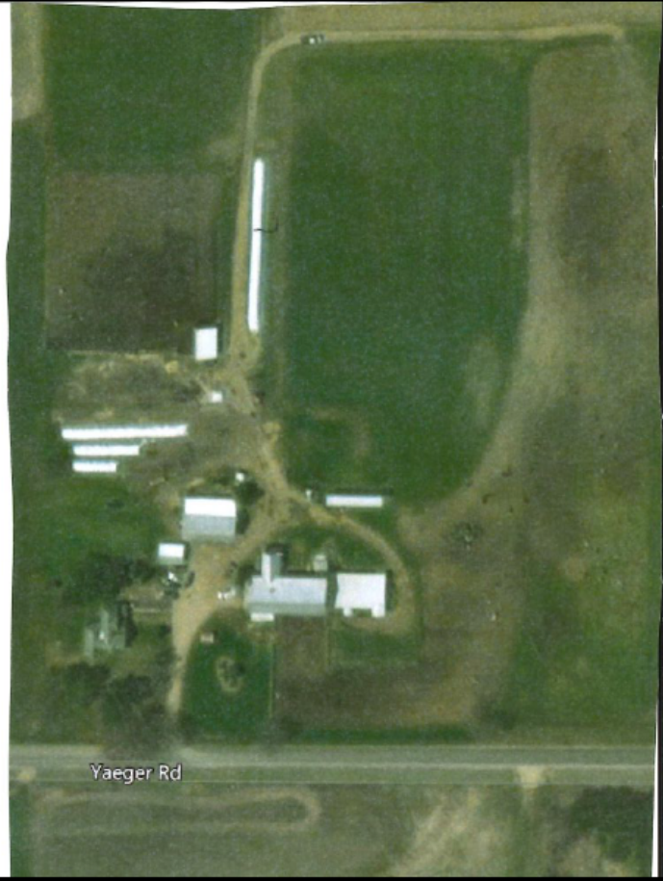
Photo 1: Aerial Image of Ken Yaeger’s Farm Before BMP Installation
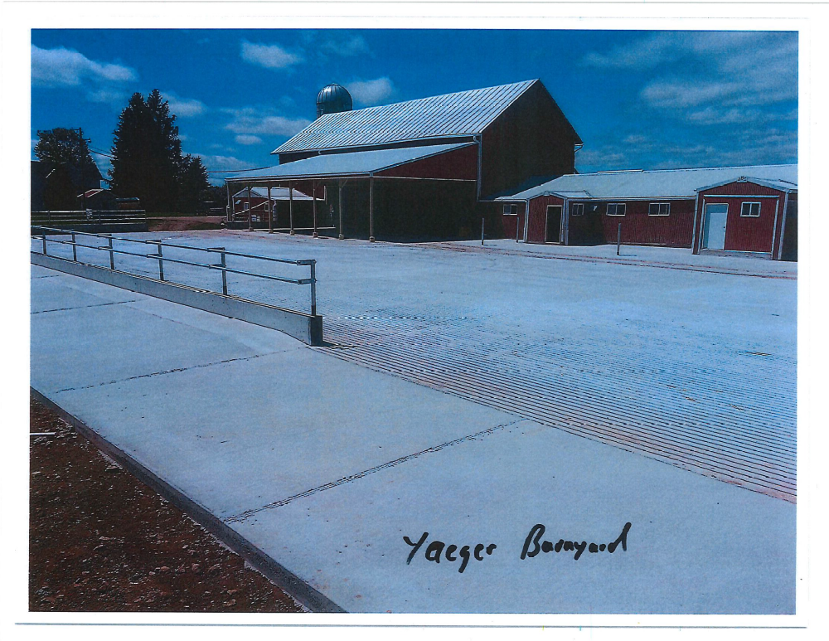
Photo 2: Post-Construction Image of Concrete Barnyard Taken by Waupaca LWCD in 2016.
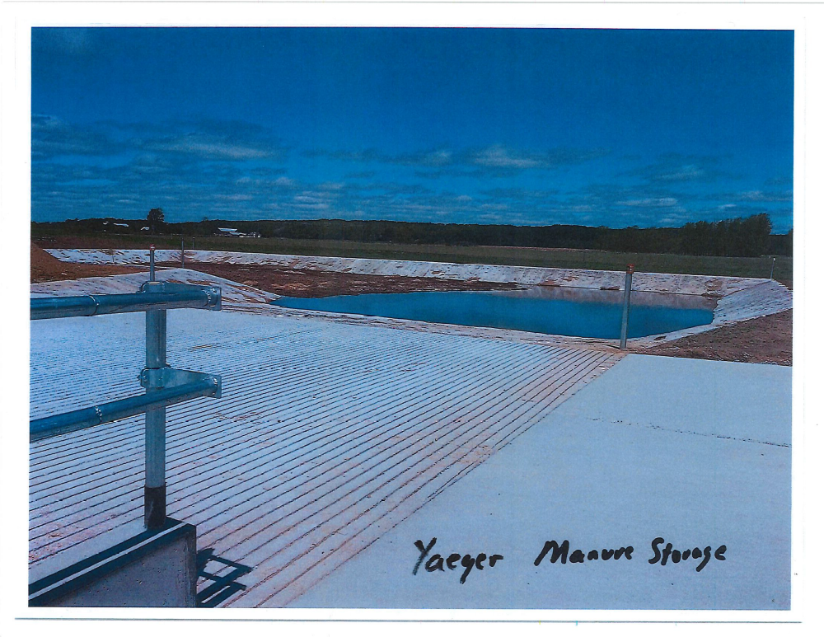
Photo 3: Manure Storage Pit on Ken Yaeger’s Farm. Photo taken by Waupaca LWCD in 2016.

Water Quality Management Recommendations

- Reduce the transportation of phosphorus and sediment by implementing Best Management Practices such as streamside buffer strips, nutrient management, conservation tillage, cover crops, manure storage and barnyard runoff practices, and streambank and wetland restorations
- Reduce the thermal impacts from impoundments to the North Branch of the Pigeon River and the Pigeon River
- Preserve the Good to Excellent water quality and biotic communities of Geskey, Mehlberg, and Hydes Creeks, and the Unnamed Tributaries WBIC 297400 and 295700
- Continue to conduct water quality monitoring of the Pigeon Lake and River and Honey Creek to understand the role each have in the water quality of the River

References

Nordin-Pederson Associates, LTD. 1997. Pigeon Lake Management Study, Waupaca County, Wisconsin.
NRCS (Natural Resources Conservation Service). 1999. Environmental Quality Incentive Program Proposal for Pigeon River Watershed.

USGS (United States Geological Survey) (Robertson, D.M. et. al.). 2006. Nutrient Concentrations and Their Relations to the Biotic Integrity of Wadeable Streams in Wisconsin.

WDNR (Wisconsin Department of Natural Resources). 2000. Guidelines for Collecting Macroinvertebrate Samples from Wadable Streams.

WDNR (Wisconsin Department of Natural Resources). 2001. Guidelines for Assessing Fish Communities of Wadable Streams in Wisconsin.

WDNR (Wisconsin Department of Natural Resources). 2002. Guidelines for Evaluating Habitat of Wadable Streams.

WDNR (Wisconsin Department of Natural Resources). 2010. Wisconsin Administrative Code ch. NR 102: Water Quality Standards for Wisconsin Surface Waters.

WDNR (Wisconsin Department of Natural Resources). 2014. Total Phosphorus Sampling Methods: Water Action Volunteers Manual 2014.

WDNR (Wisconsin Department of Natural Resources). 2014. Wisconsin Consolidated Assessment and Listing Methodology Guidance Document.

